Supplemental Online Content
Methods 2
Treatment protocol 2
Transarterial Chemoembolisation (TACE) Procedure 2
Results 3
Table 1. Agents use before matching 3
Table 2. Agents administration protocol 4
Table 3. Subsequent therapy excluding TACE and first-line systemic treatment after PSM 5
Table 4 Univariate and Multivariate Predictors of Progression-Free Survival and Overall Survival before PSM 6
Table 5. Summary of response rates before and after PSM according to mRECIST 8
Table 6. Summary of a series of CAHNCE trials that evaluated the combination of TACE plus anti-TKI antibody/TKIs and ICIs for HCC 9
Figure 1. Absolute standardized mean difference of propensity score matching 10
Figure 2. Kaplan–Meier analysis of progression-free survival before matching 11
Figure 3. Kaplan–Meier analysis of overall survival before matching 12

This appendix has been provided by the authors to give readers additional information about their work.

Methods

Treatment protocol

Transarterial Chemoembolisation (TACE) Procedure
Hepatic artery angiography was performed with a 5-F RH catheter (Terumo) to assess the tumour location, number, size, and blood supply of target tumours. All the feeding arteries of tumours should be adequately obtained during the procedure, including vessels’ origin, variant anatomy, and ectopic or collateral blood supply. Subsequently, a microcatheter (Progreat; Terumo, Japan) was inserted into the feeding arteries of tumours.
Conventional TACE (cTACE) was an intra-arterial injection of 40–60 mg of epirubicin (Pharmorubicin; Pfizer, Wuxi, China) mixed with 5–15 mL of lipiodol (Jiangsu Hengrui Medicine Co., Ltd., Jiangsu, China). When needed, embosphere (100–300 μm or 300-500 μm) was used for further embolization to achieve stasis.
Drug-eluting bead TACE (DEB-TACE) was performed by CallSpheres® (Jiangsu Hengrui Medicine Co., Ltd.,Jiangsu, China) beads (100–300 μm) loaded with doxorubicin (40–60 mg) or HepaSpheres (Biosphere Medical, Inc., South Jordan, UT) with a diameter of 30-60 μm loaded with epirubicin (with a maximum dose of 50-80 mg). CalliSpheres® /HepaSpheres beads and non-ionic contrast agent were mixed by 1:1 and injected at a speed of 1 mL/min. The injection was completed during the stasis flow of contrast agent.
TACE was discontinued in cases of severe liver function (uncontrollable ascites, coagulation disorders, abnormal albumin, severe jaundice, overt hepatic encephalopathy), ECOG-PS > 2, and continuous progression of target lesions after 3 TACE sessions according to the clinical practice of every center.

Table 1. Agents use before matching.
Therapy modality | TACE-TKI-ICI (n = 263) | TACE-TKI (n = 251)
Sorafenib | 60 | 63
Lenvatinib | 105 | 95
Donafenib | 73 | 78
Apatinib | 25 | 15
Sintilimab | 159 | 0
Camrelizumab | 96 | 0
Tislelizumab | 8 | 0
TACE-TKI-ICI, transarterial chemoembolisation plus tyrosine kinase inhibitors with immune checkpoint inhibitors; TACE-TKI, transarterial chemoembolisation plus tyrosine kinase inhibitors.

Table 2. Agents administration protocol.
Agents | Administration
Molecular targeted agents administration
Sorafenib, Nexavar®, Bayer AG Kaiser-Wilhelm-Allee, Leverkusen, Germany | 400 mg, po, bid
Lenvatinib, Lenvanix®, Eisai Inc., Japan | 8 mg, po, qd (for bodyweight < 60 kg) or 12 mg, po, qd (for bodyweight ≥ 60 kg)
Donafenib, Zepsun®, Suzhou Zelgen Biopharmaceuticals Co, Ltd., Suzhou, China | 200 mg, po, bid
Apatinib, Aitan®, Jiangsu Hengrui Medicine Co. Ltd, Lianyungang, China | 250 mg, po, qd
Immune checkpoint inhibitors administration
Sintilimab, Tyvyt®, Innovent Biologics, Inc., Suzhou, China | 200 mg, ivgtt, q3w
Camrelizumab, AiRuiKa®, Jiangsu Hengrui Medicine Co. Ltd, Suzhou, China | 200 mg, ivgtt, q3w
Tislelizumab, Baize’an®, BeiGene Ltd., Beijing, China | 200 mg, ivgtt, q3w

Table 3. Subsequent therapy excluding TACE and first-line systemic treatment after PSM.
Subsequent therapy | TACE-TKI-ICI  (n = 241) | TACE-TKI  (n = 241)
Conversion operation | 25 (10.4) | 5 (2.1)
radiotherapy for metastatic sites | 12 (5.0) | 0 (0)
radiotherapy for PVTT | 2 (0.8) | 0 (0)
Radiofrequency ablation | 2 (0.8) | 2 (0.8)
Switch to second-line systemic treatment | 54 (22.4) | 51 (21.2)

Table 4. Univariate and Multivariate Predictors of Progression-Free Survival and Overall Survival before PSM.
Variables | Univariate Analysis |  |  |  | Multivariate Analysis
 | HR | 95%CI | P |  | HR | 95%CI | P
PFS analyses
Cirrhosis (Present vs. Absent) | 0.97 | 0.77-1.22 | 0.792
BCLC stage (C vs. B) | 1.30 | 1.00-1.69 | 0.052
Tumour size (cm) (≥5 vs. <5) | 1.88 | 1.32-2.69 | < 0.001 |  | 1.70 | 0.97-2.98 | 0.064
Tumour distribution  (Multiple lobes vs. Single lobe) | 1.27 | 1.02-1.59 | 0.035 |  | 1.07 | 0.84-1.37 | 0.585
Tumour number (>3 vs. ≤ 3) | 1.36 | 1.08-1.70 | 0.008 |  | 1.21 | 0.95-1.58 | 0.125
Macroscopic portal vein invasion  (Present vs. Absent) | 1.19 | 0.95-1.48 | 0.125
Extrahepatic spread (Present vs. Absent) | 1.15 | 0.92-1.43 | 0.220
Etiology (Hepatitis B virus vs. Others) | 1.09 | 0.84-1.42 | 0.524
Child-Pugh class (B vs. A) | 1.42 | 1.08-1.86 | 0.012 |  | 1.27 | 0.96-1.68 | 0.100
ALBI grade (2+3 vs. 1) | 1.37 | 1.04-1.80 | 0.023 |  | 1.16 | 0.88-1.54 | 0.292
ECOG PS (1 vs. 0) | 2.33 | 1.86-2.93 | < 0.001 |  | 2.12 | 1.68-2.67 | <0.001
TACE type (DEB-TACE vs. cTACE) | 0.85 | 0.69-1.06 | 0.149
AFP (ng/mL) (≥400 vs. <400) | 1.39 | 1.11-1.73 | 0.003 |  | 1.24 | 0.99-1.56 | 0.065
UP-to-seven criteria  (Beyond vs. Within) | 1.78 | 1.21-2.63 | 0.003 |  | 1.19 | 0.64-2.17 | 0.589
TACE sessions (≥3 vs. 1-2) | 0.83 | 0.67-1.03 | 0.093
Treatment  (TACE-TKI-ICI vs. TACE-TKI) | 0.71 | 0.57-0.88 | 0.002 |  | 0.71 | 0.57-0.89 | 0.002
OS analyses
Cirrhosis (Present vs. Absent) | 0.95 | 0.74-1.22 | 0.702
BCLC stage (C vs. B) | 1.90 | 1.40-2.57 | < 0.001 |  | 1.26 | 0.77-2.08 | 0.358
Tumour size (cm) (≥5 vs. <5) | 2.19 | 1.47-3.27 | < 0.001 |  | 2.48 | 1.32-4.68 | 0.005
Tumour distribution  (Multiple lobes vs. Single lobe) | 1.32 | 1.04-1.67 | 0.023 |  | 1.18 | 0.90-1.54 | 0.234
Tumour number (>3 vs. ≤ 3) | 1.33 | 1.05-1.69 | 0.019 |  | 1.27 | 0.96-1.67 | 0.099
Macroscopic portal vein invasion  (Present vs. Absent) | 1.47 | 1.16-1.87 | 0.002 |  | 1.08 | 0.76-1.53 | 0.670
Extrahepatic spread (Present vs. Absent) | 1.45 | 1.15-1.84 | 0.002 |  | 1.11 | 0.82-1.50 | 0.509
Etiology (Hepatitis B virus vs. Others) | 1.04 | 0.79-1.37 | 0.800
Child-Pugh class (B vs. A) | 1.29 | 0.96-1.73 | 0.089
ALBI grade (2+3 vs. 1) | 1.30 | 0.97-1.73 | 0.076
ECOG PS (1 vs. 0) | 3.26 | 2.53-4.20 | < 0.001 |  | 2.76 | 2.12-3.58 | <0.001
TACE type (DEB-TACE vs. cTACE) | 0.82 | 0.65-1.04 | 0.100
AFP (ng/mL) (≥400 vs. <400) | 1.56 | 1.23-1.98 | < 0.001 |  | 1.35 | 1.05-1.73 | 0.019
Up-to-seven criteria  (Beyond vs. Within) | 1.58 | 1.05-2.36 | 0.027 |  | 2.12 | 1.10-4.00 | 0.024
TACE sessions (≥3 vs. 1-2) | 0.59 | 0.46-0.74 | < 0.001 |  | 0.72 | 0.57-0.91 | 0.007
Treatment  (TACE-TKI-ICI vs. TACE-TKI) | 0.69 | 0.55-0.88 | 0.002 |  | 0.66 | 0.52-0.83 | 0.001
PSM, propensity score matching; HR, hazard ratio; CI, confidence intervals; PFS, progression-free survival; OS, overall survival; BCLC, Barcelona Clinic Liver Cancer; HBV, Hepatitis B virus; ALBI, albumin-bilirubin; ECOG PS, Eastern Cooperative Oncology Group performance status; TACE, transarterial chemoembolisation; cTACE, conventional transarterial chemoembolisation; DEB-TACE, drug-eluting beads transarterial chemoembolisation; AFP, alpha-fetoprotein; TACE-TKI-ICI, transarterial chemoembolisation plus tyrosine kinase inhibitors with immune checkpoint inhibitors; TACE-TKI, transarterial chemoembolisation plus tyrosine kinase inhibitors.

Table 5 Summary of response rates before and after PSM according to mRECIST.
Variable | Before PSM |  |  |  |  |  | After PSM
 | TACE-TKI-ICI (n=263) |  | TACE-TKI (n=251) | P value |  | TACE-TKI-ICI (n=241) |  | TACE-TKI (n=241) | P value
CR | 40 (15.2) | 22 (8.8) |  |  |  | 36 (14.9) |  | 19 (7.9)
PR | 115 (43.7) | 84 (33.5) |  |  |  | 106 (44.0) |  | 81 (33.6)
SD | 67 (25.5) | 86 (34.3) |  |  |  | 62 (25.7) |  | 85 (35.3)
PD | 41 (15.6) | 59 (23.5) |  |  |  | 37 (15.4) |  | 56 (23.2)
ORR | 155 (58.9) | 106 (42.2) |  | <0.001 |  | 142 (58.9) |  | 100 (41.5) | <0.001
DCR | 222 (84.4) | 192 (76.5) |  | 0.023 |  | 204 (84.6) |  | 185 (76.8) | 0.028
PSM, propensity score matching; TACE-TKI-ICI, transarterial chemoembolisation plus tyrosine kinase inhibitors with immune checkpoint inhibitors; TACE-TKI, transarterial chemoembolisation plus tyrosine kinase inhibitors; CR, complete response; PR, partial response; SD, stable disease; PD, progressive disease; ORR, objective response rate; DCR, disease control rate.

Table 6. Summary of a series of CAHNCE trials that evaluated the combination of TACE plus anti-TKI antibodies/TKIs and ICIs for HCC.
 | CHANCE001  (N = 228) | CHANCE2211  (N = 84) | CHANCE2201  (N = 802)
Characteristics (%)
Hepatitis B virus | 71.5 | 77.4 | 84.6
Cirrhosis | 72.8 | 73.8 | 74.4
ECOG PS [(2 vs.) 1 vs. 0)] | 27.6 vs. 72.4 | 31.0 vs. 69.0 | (4.1) vs. 37.1 vs. 58.8
Child-Pugh class (B vs. A) | 14.0 vs. 86.0 | 15.5 vs. 84.5 | 18.3 vs. 81.7
BCLC stage (C vs. B) | 65.8 vs. 34.2 | 66.7 vs. 33.3 | 100.0 vs. 0.0
Portal vein invasion | 45.6 | 46.4 | 70.5
Extrahepatic spread | 33.3 | 36.9 | 59.0
Efficacy data
OS (95% CI), months | 19.2 (16.1-27.3) | 24.1 (20.0-NR) | 22.6 (21.2-23.9)
PFS (95% CI), months by mRECIST | 9.5 (8.4-11.0) | 13.5 (9.0-18.0) | 9.9 (9.1-10.3)
ORR by mRECIST | 60.1% | 59.5% | 47.3%

Figure 1. Absolute standardized mean difference of propensity score matching

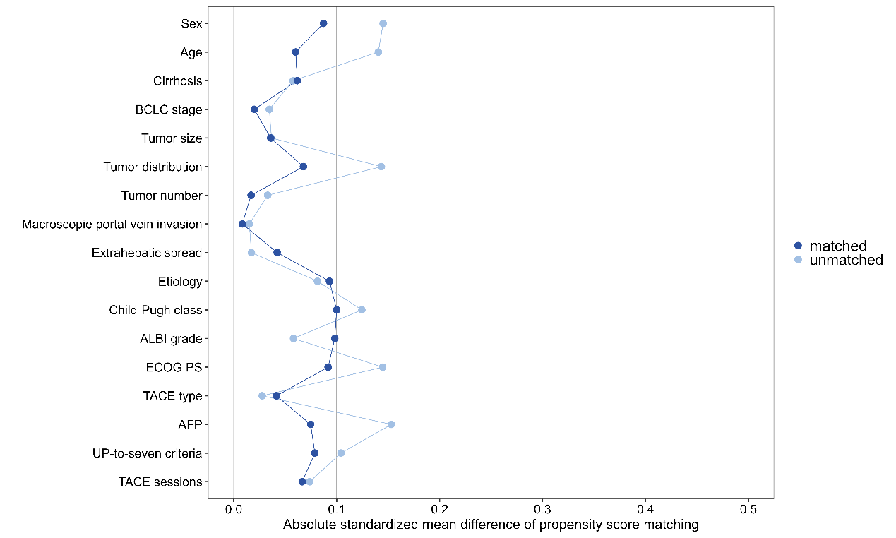

Figure 2. Kaplan–Meier analysis of progression-free survival before matching
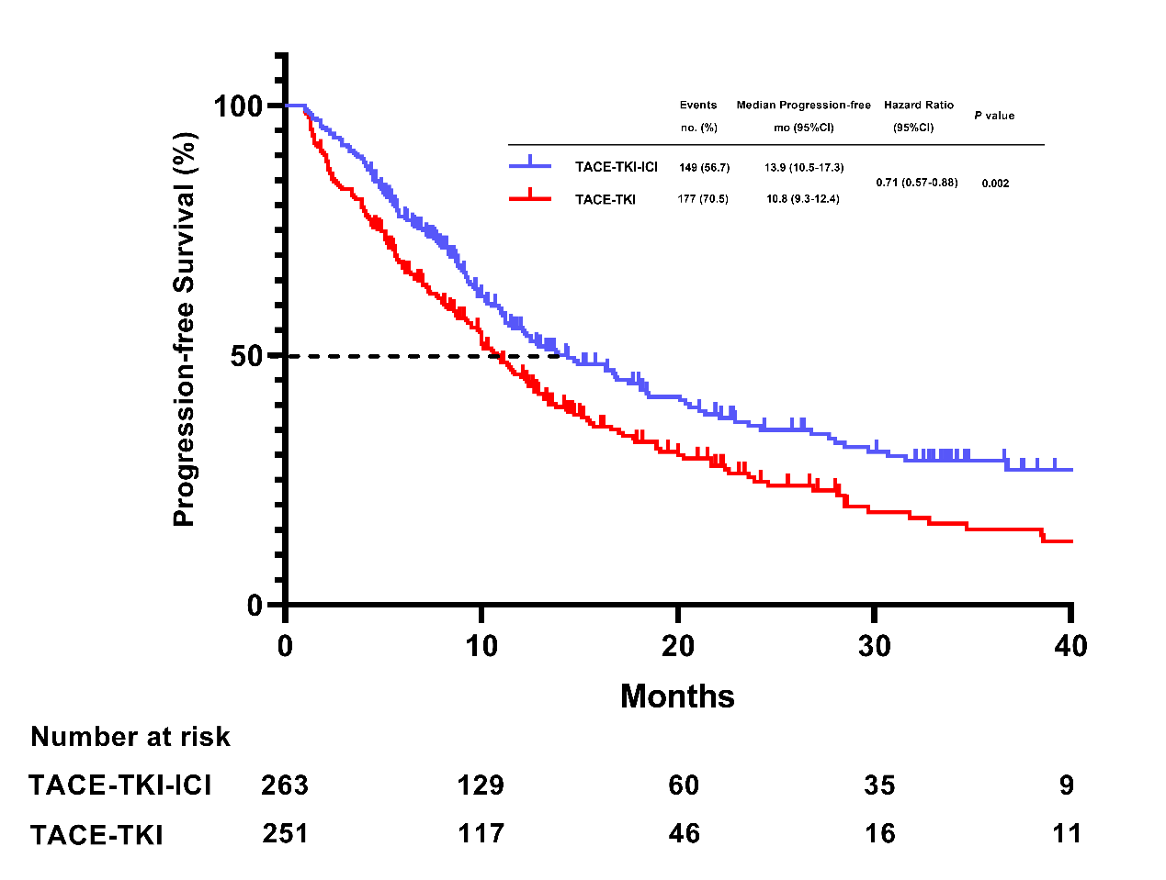

Figure 3. Kaplan–Meier analysis of overall survival before matching
