Supplementary Information

Scalable and sustainable slurry processing unlocks practical aqueous zinc batteries

Xuan Gao^{1,2,3}, Jiayan Zhu⁴, Chang Su⁵, Kejiang Liu⁶, Yuhang Dai^{2,*}, Yiyang Liu¹, Zhiyuan Chen⁷, Nan Gao⁴, Wei Zong², Siyu Zhao², Peie Jiang², Ruwei Chen¹, Ivan P. Parkin¹, Paul R. Shearing², Haobo Dong^{8,*}, Hongdong Li^{4,*}, Claire J. Carmalt^{1,*}, Zhengxiao Guo³, Guanjie He^{1,*}

¹Christopher Ingold Laboratory, Department of Chemistry, University College London, 20 Gordon Street, London, WC1H 0AJ, UK
²Department of Engineering Science, University of Oxford, Parks Road, Oxford, OX1 3PJ, UK
³Department of Chemistry, The University of Hong Kong, Hong Kong (SAR), Pokfulam 999077, China
⁴State Key Laboratory of High Pressure and Superhard Materials, Jilin University, Qianjin Street, Changchun, 130000, China
⁵Nuffield College, University of Oxford, New Road, Oxford, OX1 1NF, UK
⁶School of Mechanical and Aerospace Engineering, Queen's University Belfast, Stranmillis Road, BT9 5AH, UK
⁷Department of Chemistry Engineering, University of Ningbo Nottingham, Shoukang East Road, Ningbo, 315100, China
⁸School of Future Technology, South China University of Technology, 777 Xingye Ave East, Guangzhou, 510641, China
*Email: yuhang.dai@eng.ox.ac.uk; dhbhubble@scut.edu.cn; hdli@jlu.edu.cn; c.j.carmalt@ucl.ac.uk; g.he@ucl.ac.uk.

Supplementary Table 1. Physicochemical Properties of the Insertion Cations Commonly Encountered in Zn-Ion Batteries (AZIBs) Electrodes

 | Cationic Species
 | H⁺ | H₃O⁺ | Zn²⁺
Common coordination number (C.N.) | 1, 2 | varies | 4, 6
Shannon crystal radius (Å) | –0.24 (C.N. 1) | <1.38ª | 0.74 (C.N. 4)
charge density (e Å^{–3})^{b} | N/A | 0.091 | 1.178
standard reduction potential, E⁰ (V) | 0.00 | 0.00 | –0.76
theoretical specific capacity (mA h g^{–1}) | 26536 | 1409 | 820

ªThe configuration is not well-established. As an approximation, the kinetic radius of H₂O can be assumed (1.38 Å), with the fact that H coordination reduces the molar volume of H⁺₂O¹.
^{b}Obtained from the Shannon crystal radius.

Protons dehydrated on the cathode surface
The electrochemical performance of BE and DE was initially investigated using coin cell configurations, which is a common method in AZIBs research. To understand the effect of HAcT on the cathode's electrochemical behavior, cyclic voltammogram (CV) curves for BE and DE, fabricated with the same method (including binder, carbon agent, and carbon-coated stainless steel foil), were measured at scan rates ranging from 0.1 to 1 mV s⁻¹ within a potential window of 0.8 to 1.9 V. As shown in Figures S1a and S1e, at low scan rates, DE exhibited two pairs of reduction and oxidation peaks at 1.37, 1.28 V, 1.55 and 1.61 V, respectively. In contrast, BE displayed redox peaks at 1.36, 1.25, 1.56, and 1.62 V, indicating larger polarization compared to DE. Notably, the full cell with the HAcT MnO₂ cathode demonstrated a redox peak shape similar to that of BE, suggesting a proton and Zn²⁺ co-storage mechanisms^{2,3}. Furthermore, DE's CV curves at various scan rates were very similar, indicating consistent reaction behaviors and kinetics across different rates. The potential difference (Δφ) between the oxidation and reduction peaks in a quasi-reversible electrochemical reaction increased with scan rate⁴. However, in a well-reversible electrochemical system, this increase would be alleviated⁵. Figure S1a shows that as the scan rate increased, the shifts for BE's peaks P1, P2, P3, and P4 were 0.091, 0.057, 0.064, and 0.075 V, respectively. In comparison, DE's peak shifts (shown in Figure S1e) were 0.056, 0.023, 0.050, and 0.048 V, respectively, indicating a more reversible electrochemical system formed by the HAcT cathode. These findings suggest that HAcT not only effectively reduced the polarization of the cathode material but also enhanced the reversibility of its redox reactions, contributing to improved electrochemical performance.
To further investigate the kinetic processes of different cathodes, their diffusion-controlled and capacitive contributions were evaluated based on the 4 peaks in Figures S1a and S1d. According to theoretical predictions, the peak current (i) and sweep rate (𝑣) should follow Equation (S1)⁶:
i = a𝑣^{b} (S1)
hence, log (i) = log (a) + blog (𝑣), where a and b can be calculated by fitting a linear curve to the log-log plot of the peak current and the sweep rates (Figures S2a and S2b). When the value of b is close to 1, the electrochemical reaction is primarily governed by capacitive-controlled kinetic process, while a value near 0.5 indicates a dominance of the diffusive-controlled kinetic process⁷. For the BE cathode, the b values for peaks P1, P2, P3, and P4 were found to be 0.66, 0.72, 0.50, and 0.79, respectively, suggesting that the kinetic behavior of the BE cathode is mainly diffusion-controlled. The DE cathode exhibited b values of 0.62, 0.71, 0.50, and 0.75 for peaks P1, P2, P3, and P4, respectively, indicating that diffusion also predominates in the DE cathode kinetics. Comparing the b values of BE and DE reveals that HAcT significantly influences the electrochemical reaction of protons during the charge/discharge process. Peaks P1 and P4 correspond to the redox peaks of proton electrochemical reactions. A lower b value for them in the DE cathode indicates that HAcT makes the storage of protons more inclined to the (de)intercalation mechanism of the battery compared to the bare MnO₂ cathode. However, HAcT has a minimal effect on the electrochemical reaction behavior of Zn²⁺ (P2 and P3).
As shown in Figures S1b and S1f, ex-situ SEM images of BE and DE (both with the mass loading of ~5 mg cm⁻²) under 2 A g⁻¹ current density conditions show the surface morphology of the cathodes under different potential conditions (0.8, 1.2, 1.7, 1.9 V, respectively). During the discharge process, both BE and DE generated flaky ZHS on the surface. When the discharge process reaches 1.2 V, large flakes of ZHS with a size of 10-30 μm begin to be generated in the BE. When fully discharged to 0.8 V, ZHS in BE maintains 1.2 V. In contrast, when fully discharged to 0.8 V, the ZHS in DE was relatively smaller than BE, only exhibiting a uniform 2 μm. During the charging process, at the same potential of 1.7 V, DE formed uniform flower-like Zn_{x}MnO(OH)_{y}, while BE did not form, which corresponds to the CV curves, showing smaller polarization of DE. In the fully charged state, uniform flower-like Zn_{x}MnO(OH)_{y} is formed on both BE and DE surfaces, indicating a conversion-type mechanism rather than reversible proton storage, which is in agreement with previous studies⁸. In-situ Raman spectra of BE and DE were acquired to investigate the HAcT cathode evolution process. As shown in Figures S1g, a broad band at 1601 cm⁻¹ was observed in the Raman spectra. As the level of carboxymethylation increased, the intensity of this band also increased. The broad band generated at 1601 cm⁻¹ corresponds to salt form (COO⁻R⁺) rather than the carboxylic acid form⁹. The stretching vibration of C=O can be distinguished as two types, according to the location of the bands, a strong band at 1550–1720 cm⁻¹ region attributed to carbonyl compounds, and a band in 1740–1800 cm⁻¹ ascribed to carboxylic acid¹⁰. Although the bands at 907, 1310 and 1402 cm⁻¹, and the shoulder band at 1253 cm⁻¹, attributed to the carboxymethyl groups, also showed progressive increases after carboxymethylation, they were not suitable marker bands since they were attributed to other vibrations such as C-H stretching, anomeric skeleton and C-O-H stretching and bending, whereas the 1601 cm⁻¹ band was attributed solely to the substituted carboxymethylate species.
During the discharge process of BE, although cations (protons and Zn²⁺) migrate towards the cathode, there is no significant surface change. In the charge process, free OH⁻ move towards the cathode, facilitating an enolization reaction, which increases the C=O stretching vibration. Comparing Figures S1c and S1g, HAcT introduced new surface reactions and divides the DE discharge process into three stages. In the initial stage (1.5 to 1.22 V), the intensity of the broad peaks for carboxylate (O-C=O) and carbonyl (C=O) groups weakens as anions interact with protons and Zn²⁺, indicating the coordination between Zn²⁺/proton and carbonyl groups to form Zn-O-C or C-OH groups. During the platform stage (around 1.2 to 1.20 V), the intensity of carboxylate increases, suggesting a dehydration and an initial de-coordination process from Zn²⁺(C-O⁻)₂ (or C-OH) to Zn²⁺/H, as cations detach from the surface and move into the bulk⁷. In the final stage of discharge (1.2 to 0.8 V), the carboxylate intensity weakens again while the carbonyl group regains strength, indicating further de-coordination of cations to form C=O. Based on previous studies, a structural model for bulk γ-MnO₂ was constructed, as depicted in Figure S3a, for density functional theory (DFT) calculations^{11,12}. The model features a one-dimensional tunnel for proton transport, leading to the construction of the γ-MnO₂ (100) surface shown in Figure S3b. Both O and Mn atoms are present on this surface. When carboxylate is introduced onto the γ-MnO₂ surface, the O atoms in carboxylate form covalent bonds with Mn atoms on the (100) surface, as illustrated in Figure S3c. The energy profile for the pristine MnO₂ surface (Figure S4a) indicates that a proton requires 0.275 eV to diffuse from far away to adsorb on the surface and faces an energy barrier of 0.901 eV to diffuse to a stable adsorbed structure. For the MnO₂ surface functionalized with carboxylate, these energy barriers are reduced to 0.165 eV for proton diffusion to the surface and 0.234 eV for diffusion to the stable structure. This suggests that proton diffusion from the surface to the interior is facilitated after functionalizing the MnO₂ surface with carboxylate.
Ex-situ XRD analysis was carried out to investigate the influence of dehydration of proton on regulating byproduct ZHS of HAcT at different voltage, as depicted in Figures S5 and S6. We examined the structural evolution of DE and BE at similar unit mass loading (~5 mg cm⁻²) by performing ex-situ XRD measurements at specific states of charge and discharge processes, ranging from 0.8 to 1.9 V, at a current density of 2 A g^{–1}. The reversibility of ZHS can be expressed by Equation (2)¹³.
$12{OH}^{-}+2SO_{4}^{2-}+8{Zn}^{2+}+2nH_{2}O ⇌2Zn_{4}{(OH)}_{6}SO_{4}·nH_{2}O (n=4 or 5)$ (S2)
During the discharge process to 0.8 V, the amount of ZHS would be increased on the cathode, which is also consistent with previous studies. There would be two different ZHS phases, namely Zn₄SO₄(OH)₆·4H₂O (ICDD No. 00-044-0673) and Zn₄SO₄(OH)₆·5H₂O (ICDD No. 00-039-0688). During the cycling of BE, as shown in Figure S1i, the phase of ZHS was dominated by Zn₄SO₄(OH)₆·4H₂O during the discharge process. Zn₄SO₄(OH)₆·5H₂O was gradually produced with the change of potential, which is consistent with the previous literature. At the initial potential, H₃O⁺ has not been completely dehydrated, and the cathode surface is at a local low concentration of H₂O molecules, so Zn₄SO₄(OH)₆·4H₂O is dominant at this time. As part of H₃O⁺ gradually dehydrates on the cathode surface, the local concentration of water molecules increases, generating a small amount of Zn₄SO₄(OH)₆·5H₂O. As shown in Figure S1j, the cycle of the DE cathode follows the law of a typical MnO₂-based cathode, but the HAcT increased the proportion of Zn₄SO₄(OH)₆·5H₂O during the discharge process. When the HAcT cathode loading increased to ~15 mg cm⁻², the peak intensity of ZHS was significantly enhanced (Figure S7). It is worth noting that during the cycling process of the HAcT cathode, the proportion of Zn₄SO₄(OH)₆·5H₂O in ZHS further significantly increased and became dominant and showed excellent reversibility (Figure S1k). As shown in Figure S8, DFT results show that when carboxylate and carboxyl are on the γ-MnO₂ surface, water molecules tend to remain on the cathode surface after proton dehydration and form a water-rich interface between the electrolyte and the cathode. However, Zn₄SO₄(OH)₆·4H₂O still dominates at the low mass loading conditions after HAcT, because there is no enough bulk space to allow free protons to intercalate, so the protons are not dehydrated enough. Under high mass loading conditions, more surface is provided to generate more ZHS. Thick cathodes provided sufficient bulk phase for the dehydrated protons to intercalate, which increases the local concentration of free water molecular on the surface, making Zn₄SO₄(OH)₆·5H₂O the dominant ZHS byproduct.

Supplementary Figure 1. XRD pattern of raw material commercial γ-MnO₂.

Supplementary Figure 2. SEM images and corresponding EDS mapping of BE (a) and DE (b) cathodes after electrode cutting.

Supplementary Figure 3. CV curves of (a) BE and (e) DE with different scan rate, which shows HAcT reduced the polarization of charge and discharge in AZIBs. Ex-situ SEM images of (b) BE and (f) DE at various discharge and charge states: 1.2 V and 0.8 V during the discharge process, 1.7 V and 1.9 V during the charge process. In-situ Raman spectra of (c) BE and (g) DE and the corresponding charge and discharge profiles of (d) BE and (h) DE. Ex situ XRD pattern of (i) BE, (j) low mass loading HAcT cathodes, and (k) high mass loading HAcT cathodes at various state of discharge/charge (discharge: DC 1.2 V, DC 0.8 V; charge: C 1.2 V, C1.7 V, C 1.9 V) in the first charge and discharge process with focusing on 2θ between 7-10 degree, showing the ratio of Zn₄SO₄(OH)₆·4H₂O and Zn₄SO₄(OH)₆·5H₂O in generated ZHS.

Supplementary Figure 4. Diffusion-capacitive control contribution of (a) BE and (b) DE based on cyclic voltammogram (CV) curves.

Supplementary Figure 5. (a) Structural model for γ-MnO₂, the purple and red atoms represent Mn and O atoms, respectively. Top and side views of (b) pristine and (c) COO⁻ functionalized γ-MnO₂ (100) surface.

Supplementary Figure 6. The energy profile of a proton diffuse far from the surface into the interstitial layer for (a) pristine MnO₂ (100) surface, (b) MnO₂ surface functionalized with COO⁻.

Supplementary Figure 7. Ex-situ XRD of BE cathodes at various charge of state in the first charge and discharge process.

Supplementary Figure 8. Ex-situ XRD of HAcT low mass loading cathodes at various charge of state in the first charge and discharge process.

Supplementary Figure 9. Ex-situ XRD of HAcT high mass loading cathodes at various charge of state in the first charge and discharge process.

Supplementary Figure 10. Side views of (a) pristine MnO₂ (100) surface, (b) MnO₂ surface functionalized with COO⁻, (c) MnO₂ surface functionalized with COOH⁻ adsorbing H₃O before and after optimization.

Supplementary Figure 11. (a) The reconstructed micro-Computed Tomography (CT) model of low loading MnO₂ cathode without HAcT. (b) The comparison of tortuosity factor (TF) and effective diffusion coefficient (D_{eff}) of low loading MnO₂ cathodes with HAcT (DE) and without HAcT (BE).

Supplementary Figure 12. Ex-situ (a) SEM of surface morphology and (b) XPS of O1s of BE MnO₂ cathode in fully charged state.

Supplementary Figure 13. Ex-situ (a) SEM of surface morphology and (b) XPS of O1s of low loading HAcT MnO₂ cathode in fully charged state.

Supplementary Figure 14. Ex-situ XPS of O1s of high loading HAcT MnO₂ cathode in (a) fully discharged and (b) fully charged state.

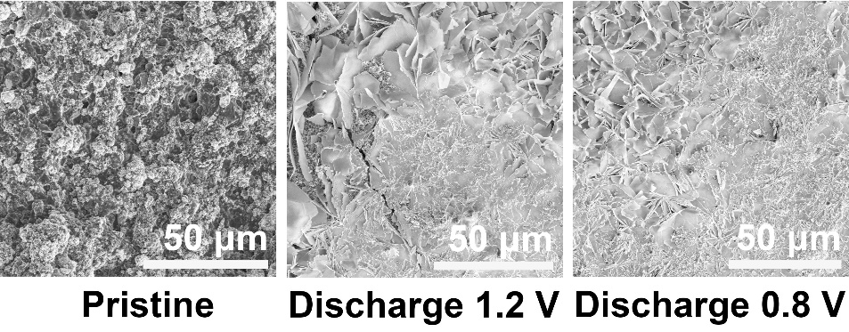
Supplementary Figure 15. Ex-situ SEM images of surface morphology of high loading HAcT MnO₂ cathode during discharge process.

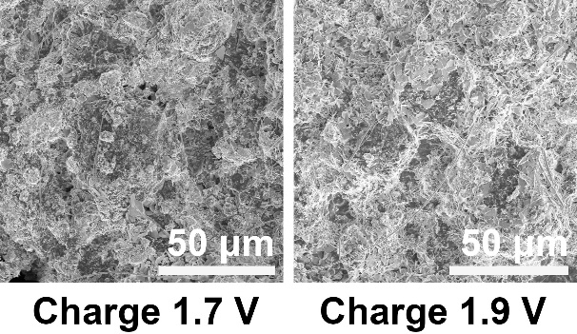
Supplementary Figure 16. Ex-situ SEM images of surface morphology of high loading HAcT MnO₂ cathode during charge process.

Supplementary Figure 17. Gravimetric specific capacity of DE cathodes at various mass loadings (from low to high): 0.5, 2.8, 6.5, 7.3, 16.9, 19.3, and 21.2 mg cm⁻².

Supplementary Figure 18. Long-term and high-rate cycle performance of DE with a mass loading of 6 mg cm⁻² at a current density of 1 A g⁻¹ (10 C), which shows that the HAcT cathode can exhibit a reversible specific capacity of 68 mAh g⁻¹ and ~100% retention after 1500 cycles.
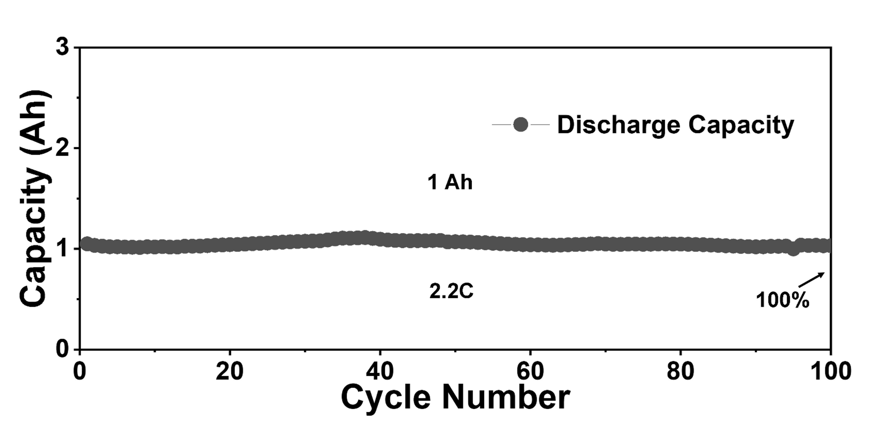
Supplementary Figure 19. Cycle performance of standardized 1-Ah prototype AZIBs with HAcT cathodes with a discharge rate of 2.2C, showing ~100% retention after 100 cycles.

Supplementary Figure 20. Nail penetration test of the pouch cell. (a) Top view; (b) side view.

Supplementary Figure 21. In-situ infrared temperature measurement under 1.5C rate charging.

Supplementary Figure 22. Comparison of the AZIBs accomplished in this work with recent advances in Ah-level Zn-based batteries.
Supplementary Figure 23. Cycle performance of 6.5-Ah prototype AZIBs without HAcT cathodes at a current density of 0.2 A g⁻¹ with a discharge rate of 1.2 C.

Reference
1. Marcus, Y. Volumes of aqueous hydrogen and hydroxide ions at 0 to 200 °C. J. Chem. Phys. 137, 154501 (2012).
2. Chu, J. et al. Boosting H⁺ storage in aqueous zinc ion batteries via integrating redox‐active sites into hydrogen‐bonded organic frameworks with strong π‐π stacking. Angew. Chem. Int. Ed. 136, e202314411 (2024).
3. Xu, Z. et al. An ultrafast, durable, and high‐loading polymer anode for aqueous zinc‐ion batteries and supercapacitors. Adv. Mater. 34, 2200077 (2022).
4. Fan, X., Lu, Y., Xu, H., Kong, X. & Wang, J. Reversible redox reaction on the oxygen-containing functional groups of an electrochemically modified graphite electrode for the pseudo-capacitance. J Mater. Chem. 21, 18753-18760 (2011).
5. Xia, J. et al. Triggering high capacity and superior reversibility of manganese oxides cathode via magnesium modulation for Zn//MnO₂ batteries. Small 19, 2301906 (2023).
6. Kong, S. et al. Anchoring polar organic molecules in defective ammonium vanadate for high‐performance flexible aqueous zinc‐ion battery. Small 19, 2304462 (2023).
7. Chao, D. et al. A high‐rate and stable quasi‐solid‐state zinc‐ion battery with novel 2D layered zinc orthovanadate array. Adv. Mater. 30, 1803181 (2018).
8. Qin, D. et al. Addressing challenges and enhancing performance of manganese-based cathode materials in aqueous zinc-ion batteries. Acta Phys. Chim. Sin. 40, 2310034 (2024).
9. Yuen, S.-N., Choi, S.-M., Phillips, D. L. & Ma, C.-Y. Raman and FTIR spectroscopic study of carboxymethylated non-starch polysaccharides. Food Chem. 114, 1091-1098 (2009).
10. Colthup, N. B., Daly, L. H. & Wiberley, S. E. Vibrational and rotational spectra. Introd. Infrared Raman Spectrosc. 1-73 (1990).
11. Kitchaev, D. A. et al. Energetics of MnO₂ polymorphs in density functional theory. Phys. Rev. B 93, 045132 (2016).
12. Ma, S. et al. First principles calculation of mechanical, dynamical and thermodynamic properties of MnO₂ with four crystal phases. J. Alloys Compd. 852, 157007 (2021).
13. Gao, X. et al. When it's heavier: interfacial and solvation chemistry of isotopes in aqueous electrolytes for Zn‐ion batteries. Angew. Chem. Int. Ed. 62, e202300608 (2023).

