Supplementary Information

Climate risks to port infrastructure for future global trade

Contains:
Supplementary Note 1-3
Supplementary Figure 1-13
Supplementary Table 1-5
Supplementary Note 1: Port planning and cost model
The area of a port can be divided in the total terminal area (A_{tot}) and the gross terminal area (A_{gr}). The gross terminal area only includes the stacks and internal infrastructure of the storage area, while the total terminal area covers the total landside (e.g. gross terminal area, buildings) and seaside areas (e.g. apron).

The investment cost of a port terminal refers to the greenfield cost of the terminal only, ignoring costs associated with supporting infrastructure (e.g. roads, rail, electricity), and the construction of breakwaters. We can distinguish between the total direct costs (C_{dir}) (sometimes referred to as base costs), which include the labour, equipment and materials needed to construct the terminal and the construction costs (C_{con}), which also include allowances (15%), indirect costs (25%), and contingencies (20%). In line with common practise, we assume:

$$C_{con}=1.7*C_{dir}$$

Below we describe how C_{dir} and A_{tot} are estimated per terminal type. The investment costs in the main manuscript all refer to the C_{con}. We use cost scaling factors per region to reflect broad-scale differences in construction costs (Supplementary Table 1). These cost ratios are derived in earlier work¹.

Container terminal
Area requirement
The container terminal storage area is predicted using the following formula:

$$A_{tot}=α_{C}*\frac{T*t*A_{TEU}}{V_{TEU}*r*m*365}$$

With $α_{C}$ the terminal conversion factor for container terminal (the conversion from storage to gross terminal area), T the throughput in tonnes per year, t the dwell time, A_{teu} the gross storage density of containers, r the ratio of average over maximum stacking height, m the storage occupancy ratio, and V_{teu} the tonnes to TEU conversion factor. A_{teu} and r depend on the equipment used in the storage yard (reach stacker, straddle carrier, gantry crane), see Supplementary Table 4 for the general ranges. Transhipment ports often have smaller space requirement, because of lower dwell times and lower values of $α_{C}$. Hence, we adopt the following formula:

$$A_{tot}=f_{T}*0.5*A_{tot}+\left(1-f_{T}\right)*A_{tot}$$

With f_{T} the fraction of throughput that is transhipment. T and f_{T} come from the Oxford Maritime Transport model output, while for the other parameters we use a range of values from the literature (see Supplementary Table 2). For the construction of new container terminals, we use Rubble Tyred Gantry (RTG) cranes as main yard equipment type, since this is the most common equipment type across modern container ports, in particular for larger ports which handle the majority of containers (and where most port expansions will take place)².

Cost
The cost of a container terminal consists of the costs of the quay wall, the pavement, yard, container cranes, and yard equipment.

We can write the total costs as:

$$C_{dir}=L_{q,c}*C_{quay}\left(H\right)+A_{gr}*C_{yard}+L_{q,c}/n_{crane}*C_{crane}+1.2\left({{L_{q,c}/n}_{yard,eq}*C}_{yard,eq}\right)+0.5*C_{dredge}*A_{gr}*H*F_{dredge}$$

With L_{q,c} the length of the quay, C_{quay} the construction costs of the quay as a function of the retaining height (H), C_{yard} the cost of the yard, n_{crane} the number of ship-to-shore cranes per quay length, C_{crane} the costs per ship-to-shore crane, n_{yard,eq} the amount of main yard equipment per quay length, C_{yard,eq} the cost of the yard equipment, C_{dredge} the cost of dredge materials for the landfill, and F_{dredge} the fraction of the hypothetical landfill that needs to be filled. The factor 1.2 covers that other yard equipment (e.g. side lifter, chassis) are ~20% of the main yard equipment costs.

The cost of the quay wall depends critically on the retaining height of the quay wall (i.e. the depth of the wall and sheet piles). To estimate the costs of the quay wall per running meter of quay, we use the formula of de Gijt³ that is based on an analysis of a large number of quay walls globally, which is corrected from 2008 Euros to 2015 USD:

$$C_{quay}\left(H\right)=1130 H^{1.2729}$$

With H the retaining height. The retaining height depends on the design draft (d_{design}) of the largest vessel that calls at the port (which determines the freeboard and design water depth). Here, we assume that the retaining height is equal to 1.8 to 2.5 times the design draft (H_{ratio}) of the vessel in line with Kox (2016)⁴ and as mentioned in ITF-OECD (2015)⁵.

$$H=H_{ratio}* d_{design}$$

The design draft of the largest vessel is estimated per port based on Automatic Identification System (AIS) data for 2019 – 2020 as derived in previous work⁶.

The length of the quay (L_{q,c}) depends on the number of container handled per year. Based on data in Wiese et al², we find this relationship (R² = 0.92) to be:

$$L_{q,c}=0.62 (TEU/1000)$$

With TEU the number of TEUs handled, which is derived by dividing T/C_{TEU}

The yard costs (C_{yard}) are derived from Becker et al.⁷, who estimate the yard costs (which include pavement, warehouse, unpaved areas, buildings) to be 100 - 153 USD/m².

The number of ship-to-shore cranes depends on the length of the berth. Based on data in Wiese et al.² we find approximately one crane per 80 – 120 meter quay length at a cost of approximately 7 - 11 million USD per crane. For the yard equipment, one uses approximately 1 RTG per 40-60 m quay wall at a cost of 1 - 2 USD million per RTG.

The cost of land reclamation is related to the volume to be filled, assumed to be half of the gross area times the retaining depth (i.e. half because it is assumed that the original land has a sloping side), and the cost of dredging suitable materials (C_{dredge}). The cost of the landfill material depends a lot on the availability of suitable materials (e.g. imported or locally available) and the costs to extract and transport it. The cost range can therefore be large, and based on different unit costs found in the literature⁷, we set this value to 10 – 25 USD/m³. Supplementary Table 3 provides an overview of all parameters.

RoRo terminal
Area requirement
There are no general guidelines for the design of RoRo terminals. Therefore, we use the terminal area and throughput dataset to come up with a suitable scaling factor (Supplementary Note 2). We find a global average value of 4.1 tonnes/m², with a 25-75% uncertainty (for 66 ports) of 1.5 to 9.7 tonnes/m². We therefore model this using a triangular distribution function to sample possible tonnes-to-area conversion values.

Cost
The total cost of a RoRo terminal consists of the costs of the quay wall and the yard pavement. Equipment is not considered for RoRo terminals, as little landside equipment is required. The costs can be written as

$$C_{dir}=A_{gr}*R_{a}*C_{quay}\left(H\right)+A_{gr}*C_{pav} +0.5*C_{dredge}*A_{gr}*H*F_{dredge}$$

With R_{a} the quay wall length to storage area ratio and C_{pav} the pavement costs of heavy duty pavement including buried service infrastructure.

Based on the design of existing RoRo terminals as described in HPA (2017)⁸, R_{a} is found to be around 0.001 – 0.005 m/m², and the C_{pav} around 150 – 250 USD/m².

General cargo terminal
Area requirement
The general cargo storage area can be predicted using the following formula:

$$A_{tot}=α_{GC}*\frac{T*t*f_{area}*f_{bulk}}{h_{s}*m*ρ_{cargo}*365}$$

With f_{area} the area factor of bulk, f_{bulk} the bulk factor, h_{s} the average stacking height, and $ρ_{cargo}$the average density of cargo. We use a range of values from the literature (see Supplementary Table 2).

Cost
The total cost of a general cargo terminal consists of the costs of the quay wall, equipment and pavement.
$$C_{dir}={1.2 (A}_{gr}*R_{a}*C_{quay}\left(H\right)+A_{gr}*C_{pav}) +0.5*C_{dredge}*A_{gr}*H *F_{dredge}$$

To estimate the quay length, we use R_{a} values of 0.001 - 0.005 m/m², which are common values found for a range of general cargo terminals across geographies⁸, and pavements costs of 150 - 250 USD/m². The equipment costs are very much dependent on the type of general cargo terminal (e.g. types of goods, storage requirement). Here, we assume equipment costs to be 20% of the costs of quay walls and pavement. See Supplementary Table 3 for all details.

Liquid bulk terminal
Area requirement
The liquid bulk storage area can be predicted using the following formula:

$$A_{tot}=α_{L}*\frac{T*t}{V_{area}*m*ρ_{cargo}*365}$$

With V_{area} the storage area of a volume of goods (m³/m²). We use a range of values from the literature (see Supplementary Table 2).

Cost
In comparison with the other terminals, liquid bulk terminal often use jetties for berthing (instead of a quay wall) and do not require (or require small amounts of) pavement. The total costs cover the costs of storage tanks (~50% of construction costs⁴), jetties, pipelines, and bunds. Estimating the costs of the individual components is difficult. Instead we use the unit storage costs (Sc), in terms of USD per storage volume (USD/m³), which range between 350 – 700 USD/m³ as found in the literature^{4,9}. In short, we can write:

$$C_{dir}=\frac{T*t}{ρ_{cargo}*365}*Sc$$

Details of the parameters are included in Supplementary Table 3.

Dry bulk
Area requirement
The liquid bulk storage area can be predicted using the following formula:

$$A_{tot}=α_{L}*\frac{T*t*f_{area}}{hs*m*ρ_{cargo}*365}$$

We calculate this separately for cargo that is stored in silos (e.g. grains, cement) and cargo stored in stockpiles (e.g. iron ore, coal), either open or with a shed around it. Some correction factors apply. Export terminals of iron ore/coal have 50% lower storage factors than importing terminals, and the area requirement of silos is around a third of the area requirement of an open storage⁴. We therefore estimate the total bulk area requirement for a port to be:

$$A_{tot}=f_{silo} * 1/3*A_{tot,s}+{\left(1-f_{silo}\right) * (f}_{export}*A_{tot,o}*0.5+\left(1-f_{export}\right)*A_{tot,o})$$

With A_{tot,s} the area derived for cargo in silos (e.g. grains) , A_{tot,o} the area derived for cargo in open storage (e.g. coal), f_{silo} the fraction of bulk that will likely be stored in silos and f_{export} the fraction of throughput that is export. We estimate f_{silo} as the fraction of agricultural bulk trade (silos) compared to the total bulk trade, which includes both agricultural bulk trade and mining bulk trade. T, f_{silo} and f_{export} come from the Oxford Maritime Transport model output while for other parameters we use a range of values from the literature (see Supplementary Table 2).

Cost
The cost of a dry bulk terminal consists of the costs of the quay wall, storage facilities, pavement (if used) and equipment. The costs of silos and open storage differ and we therefore treat them separately. There are no common planning tools for silos. Instead, we directly adopt unit cost values expressed as the cost per tonnes goods handled (C_{silo}):

$$C_{dir, silo}=T*C_{silo}$$

C_{silo} is based on the unit costs of six grain terminals globally, which we estimate to be 15-25 USD/tonnes (see Supplementary Note 2).

For open storage terminals, planning tools do exist. The costs can be written as:

$$C_{dir, open}=L_{q,b}*C_{quay}\left(H\right)+A_{gr}*C_{pav}+C_{eq,b} +0.5*C_{dredge}*A_{gr}*H*F_{dredge}$$

With L_{q,b} the length of the quay and C_{eq,b} the costs of the equipment. The length can be derived by multiplying the annual throughput with the quay length factor (QLF):

$$L_{q,b}=T/ QLF$$

A comparison of bulk terminals globally found that the QLF varies between 10,000 - 30,000 t/m for import terminals and 25,000 - 75,000 t/m for export terminals¹⁰.

The cost of the equipment depends on the installed capacity of the equipment (in tonnes/hour), which is often several factors higher than the minimum capacity (T / (24*365)). According to van Vianen¹⁰ the total equipment costs of bulk terminals can be written as:

$$C_{eq,b}=M_{c}*(0.077*I_{eq} (T/(24*365)))$$

With M_{c} the investment of machinery as a function of weight and I_{eq} the installed capacity of the equipment. According to van Vianen et al.¹¹, M_{c} is between 7000 - 9000 USD/kg, and I_{eq} is 14.5 - 26.5 times the minimum capacity for import terminals and 7.6 – 13 times the minimum capacity for export terminals.

We can therefore estimate the total cost of bulk terminals using the fraction of bulk being stored in silos and open storage:

$$C_{dir}=C_{dir,silo}*f_{silo}+C_{dir,open}*\left(1-f_{silo}\right)$$

Details of all parameters are included in Supplementary Table 3.

Supplementary Note 2: External validation PPC model

As external validation, we compare the empirical model output with various external data sources covering both the unit area requirement (tonnes per m²) and the unit construction cost (USD per tonnes).

Unit area requirement
In terms of unit area requirement, we compare our results with two sources. First, we collate general rules of thumb reported in the literature. Second, we derive empirical tonnes to area ratios by combining terminal-specific port capacity estimates for around 200 ports globally, obtained from the ITF-OECD¹², with the manually mapped gross terminal area of these ports, as done in¹ (henceforth ‘externally estimated ratios’). The results are summarised in Supplementary Table 5 per terminal type. We report the median values and 10 – 90th percentiles in brackets.

For container terminals, the modelled values depend on the type of main yard equipment adopted. The PPC model predicts values of 17.3 (11.0-27.0) tonnes/m² for RTG cranes, 19.8 (13.7 - 29.0) tonnes/m² for RMG cranes, 10.9 (6.9 – 17.1) tonnes/m² for straddle carriers and 5.9 (3.7 – 9.1) tonnes/m² for reach handlers. This within the range of values based on the rules of thumb from the literature and the externally estimated ratios, which are mainly for larger container terminals that use RTG and RMG equipment. However, as suggested by Drewry (2010)¹³, there is a stark geographical divide in area needs, and it is not feasible to include all these nuances in our PPC model.

For general cargo terminals, the PPC predicts a value of 7.5 (4.7 - 11.6) tonnes/m², which is within the range of values based on the rules of thumb from the literature and the externally estimated ratios. It should be noted that the area requirement critically depends on the density of the cargo and the way it can be stored, which can vary widely between terminals. We have therefore used ratios that are quite general instead of modelling the space requirement for specialised general cargo terminals (e.g. steel, wood).

For liquid bulk terminals, the unit area requirement we find is 33.1 (20.8 - 53.7) tonnes/m². This is in line with the rules of thumb for oil and LNG terminals, which both have slightly different design requirements. Our model is based on oil terminal design requirements as this is the dominant liquid bulk terminal type. Our values are higher than found using the externally estimated ratios, which is mainly because the externally mapped areas include areas beyond the storage area alone, such as refineries/processing plants, which can increase the size of the terminal considerably.

For dry bulk terminals, the PPC predicts a value of 19.4 (11.0 – 35.1) tonnes/m² for bulk stored in silos and 17.7 (9.8 – 34.3) tonnes/m² for open storage of raw material goods. These values are in line with the range of values based on the rules of thumb from the literature and the externally estimated ratios. However, bulk terminal space requirements differ widely between import and export terminals, which we tried to capture in the PPC model as well.

For RoRo terminals, we directly used the values of the externally estimated ratios in the model. This aligns well with values found for five new RoRo projects at the port of Tilbury (1.5 tonnes/m²), Brunswick (0.7 tonnes/m²), Mobile (1.3 tonnes/m²), Melbourne (4.2 tonnes/m²) and Port Said (5.2 tonnes/m²).

Unit construction cost
In terms of unit construction costs (median and 10 – 90th percentile confidence interval), we compare our unit cost estimates to several external data sources collected. The PPC model estimates container ports to be around 420 (310 – 594) USD per TEU across all ports. A sample of 15 ports financed by the IFC captured within the World Bank’s PPI database¹⁴ provides an average value of 450 USD per TEU, but with a range between 220 USD per TEU and 652 USD per TEU. The Asian Development Bank sets a value of 300 USD per TEU for ports in Asia to predict infrastructure investment needs¹⁵, while we estimate the value across Asia countries to be 348 (241 – 524) USD per TEU. Hence, differences are small between the PPC model output and reported container terminal construction costs.

An overview of 11 LNG terminals in Japan reported an average unit construction cost of 42.6 USD per tonnes⁹. For liquid bulk terminals, the PPC model estimates to be around 38.4 (23.9 – 58.4) USD per tonnes in Japan. LNG terminals are likely at the upper end of this range as they are generally more expensive compared to oil terminals (per tonnes throughput).

We estimate the unit construction costs of RoRo terminals to be 160.6 (99 – 281) USD per tonnes. The construction costs of three recently completed RoRo terminals are found to be 300 USD per tonnes (port of Tilbury), 200 USD per tonnes (port of Mobile), and 133 USD per tonnes (port of Port Said).

As mentioned in Supplementary Note 1, the unit costs of grain terminals are directly based on observed port construction projects at the ports of Varna (25 USD per tonnes), Yuzhny (21 USD per tonnes), Yanbu (22 USD per tonnes), Pivdenny (17 USD per tonnes) and Quequen (32.5 USD per tonnes).

Supplementary Note 3: Future climate change projections

We use different methodologies and data input to predict the changes in hazard occurrence under the three climate scenarios considered (RCP2.6, RCP4.5, RCP8.5). The methodology for estimating present day climate risks is explained in previous work¹. Earthquakes are assumed to be unrelated to climate change and will remain constant over time.

In short, tropical cyclone wind, we use the expected change in extreme wind speed to derive new risk estimates. For fluvial flooding, coastal flooding and fluvial flooding, we use climate change scaling factors (CC scaling factors), that capture how the present-day return period will change in the future (e.g. the current 1-in-100 year event will become an 1-in-50 year event in the future). This allows us to re-run the risk calculations as outlined in¹. For the operational thresholds, we evaluate the average yearly number of days that operations thresholds are exceeded. These thresholds are specified in¹ for waves, wind, overtopping and temperature. We do not evaluate changes in extreme waves given that climate models are not able to capture wave dynamics properly, alongside the large uncertainties associated with global wave projections¹⁶.

Tropical cyclone wind
We use predicted extreme wind speed changes per cyclone basin from Knutson et al. (2020), and apply these percentage changes to the maximum wind speed for all return periods derived previously. This does not take into consideration that the frequency of extremes might decrease in the future, as is predicted for some regions (Knutson et al. 2020), as there is a lack of consistent information to include this effect.

Pluvial flooding
The current pluvial flood hazard maps are based on global hydrological model output, which are provided by JBA Consulting for six return periods. Here, we use precipitation projections from CMIP6 models to scale the return periods of pluvial flooding. For every CMIP6 model considered (22 in total), we evaluate per port the change in the extreme precipitation in the future (2035 – 2065, and 2070-2100) compared to the historical baseline (1979 – 2018). To do this, we use a peak over threshold procedure (considering the 95% quantile) to cluster extreme precipitation events. Consecutive exceedances are grouped into a single event to ensure independent events being identified. We consider the maximum rainfall intensity per event and fit a Generalized Pareto function. Using the fitting parameters, we compute the expected intensity for a specified return period, and derive the return-period scaling factors for each model, scenario and time frame. We apply this procedure to all model-scenario combinations to compute the scaling factors. We use the multi-model median CC scaling factor per port to derive the new return periods.

Fluvial flooding
The current fluvial flood hazard maps are based on global hydrological model output and a flood routing model, which are provided by JBA consulting for six return periods. To derive the CC scaling factor, we use the discharge output of six hydrological models (Jules-W1, CLM45, H08, LPJML, Orchidee, Watergap2) that are forced by four climate models (GFDL-ESM2M, HadGEM2-ES, IPSL-CM5a-LR, MIROC5), as included in the ‘Inter-Sectoral Impact Model Inter-comparison Project (ISIMIP2a)’. Please refer to earlier work for details and model evaluation^{17,18}. We compare historical discharge time series (1981-2020) with future time series (2035-2065 and 2070-2100) at every port and estimate the CC scaling factors by extracting the monthly maxima and fitting a Gumbel distribution to both the present and future time series. We use the multi-model median CC scaling factor per port to derive the new return periods.

Coastal flooding
Coastal flood risk is estimated by the construction a number of return periods of an extreme water level (EWL) time series at every port and overlaying the EWL with a global digital elevation model for these number of return periods (see ¹ for details). Here, we use sea-level rise projections from Jackson and Jevrejeva (2016)¹⁹ to create future EWL time series. The sea-level rise projections predict the regional sea-level rise changes for in the future compared to the historical period (1986 – 2005). We first correct the projections such that 2015 is the base year, and fit a GEV to the historical and future time series to analyse the change in occurrence of the EWLs and derive the CC scaling factors.

Operational thresholds
The baseline exceedance of wind, waves, overtopping and temperature are based on ERA5 reanalysis data. To project the operational exceedances of wind and temperature into the future, we derive, per port, the quantile the threshold corresponds in the reanalysis data and use the 22 CMIP6 climate models to project the changes in the exceedance of this quantile in the future (2035 – 2065 and 2070 - 2100). We use the change in threshold exceedance to estimate the future downtime risk (average expected number of days per year). To derive future overtopping exceedance, we apply sea-level rise scenarios for 2050 and 2100 based on Jackson and Jevrejeva (2016)¹⁹ to the modelled present-day overtopping discharges (which changes the storm surge in front of the breakwater or quay wall), and re-evaluate the number of times the overtopping discharges exceed the operational threshold set.

Supplementary Figures

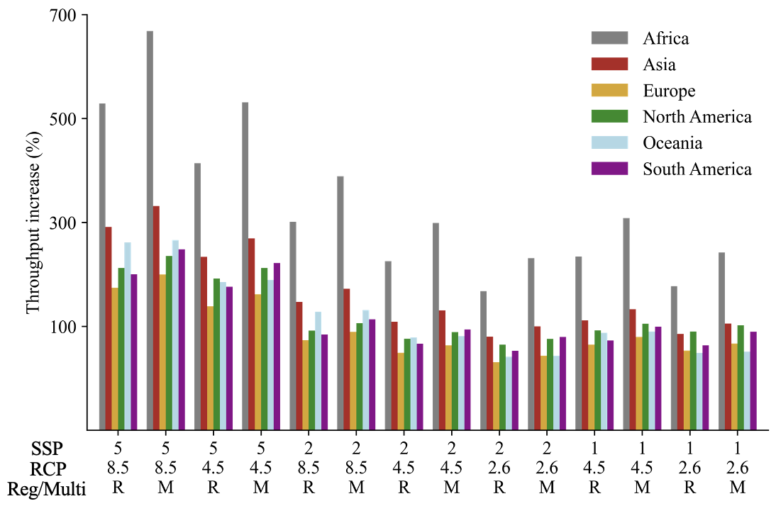
Supplementary Fig. 1. Throughput growth per continent. Change in global throughput in 2050 compared to the 2015 per continent and trade scenario.

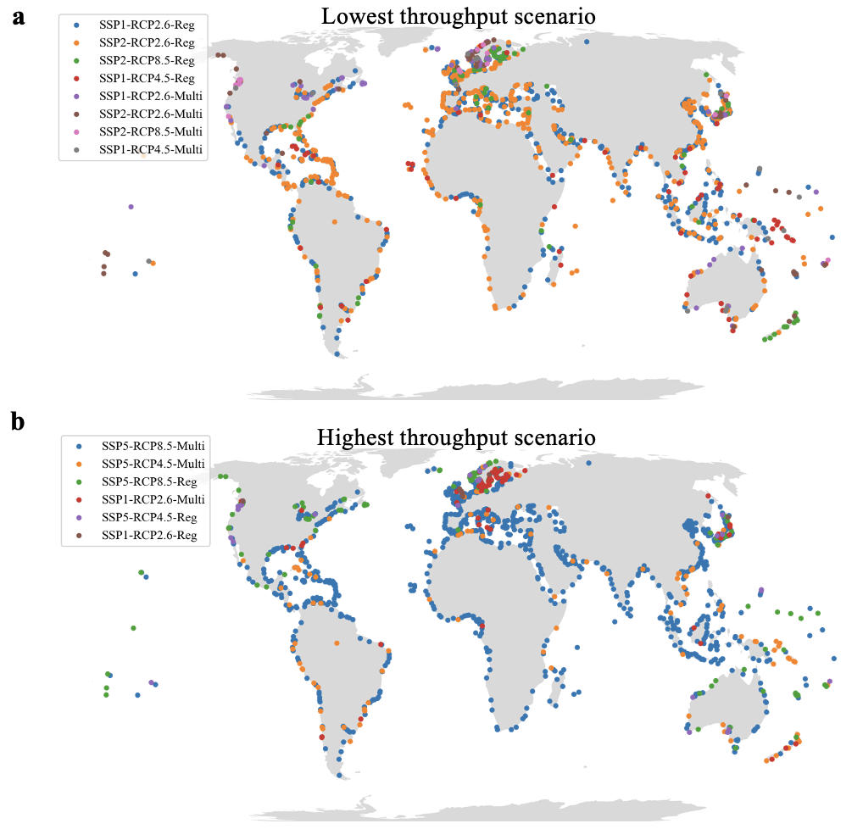

Supplementary Fig. 2. Highest and lowest throughput scenario per port. Overview of the trade scenario that cause the lowest port throughput (a) and the highest port throughput (b).

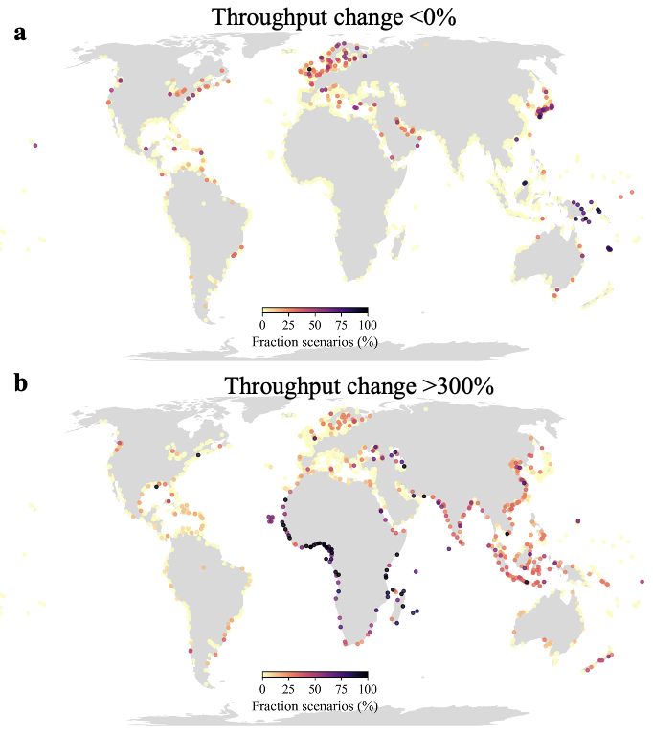
Supplementary Fig. 3. Likelihood of negative and fast throughput change. The fraction of scenarios (out of 14) that indicate a negative throughput change per port (a) and a fast throughput growth, defined as a change of >300% (b).

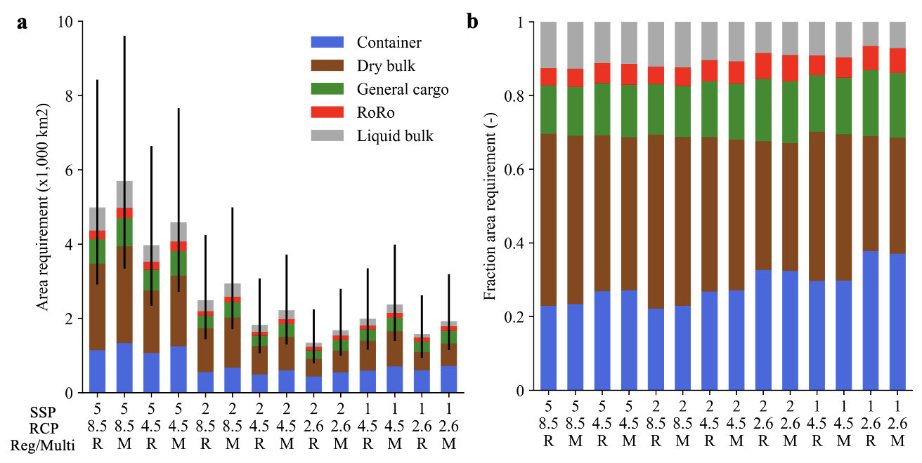
Supplementary Fig. 4. Port area requirement for new port expansions. (a) The global area requirement for new port expansions to meet throughput demand for 2050, disaggregated by the terminal type. The uncertainty bar show the 10 to 90th percentile confidence interval based on the Monte Carlo analysis (Methods). (b) The relative contribution of the five terminal types to the area requirement.

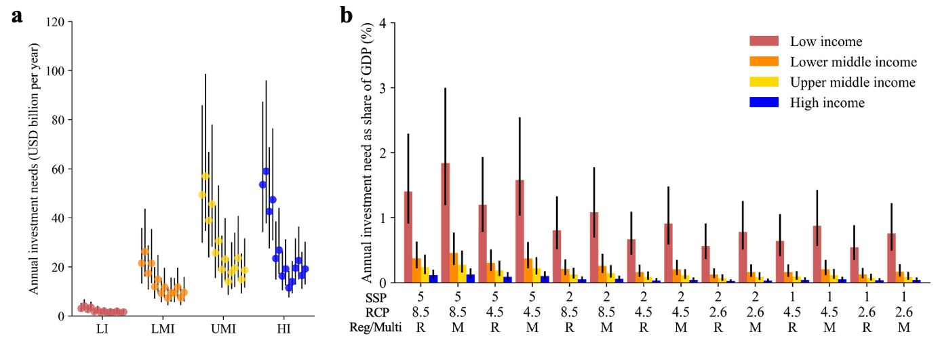Supplementary Fig. 5. Investment needs per income group. (a) The annual average investments needs in USD billion for the period 2015 to 2050 aggregated per income group per trade scenario. (b) The annual average investments needs as fraction of Gross Domestic Product (GDP) for the period 2015 to 2050 aggregated per income group per trade scenario.

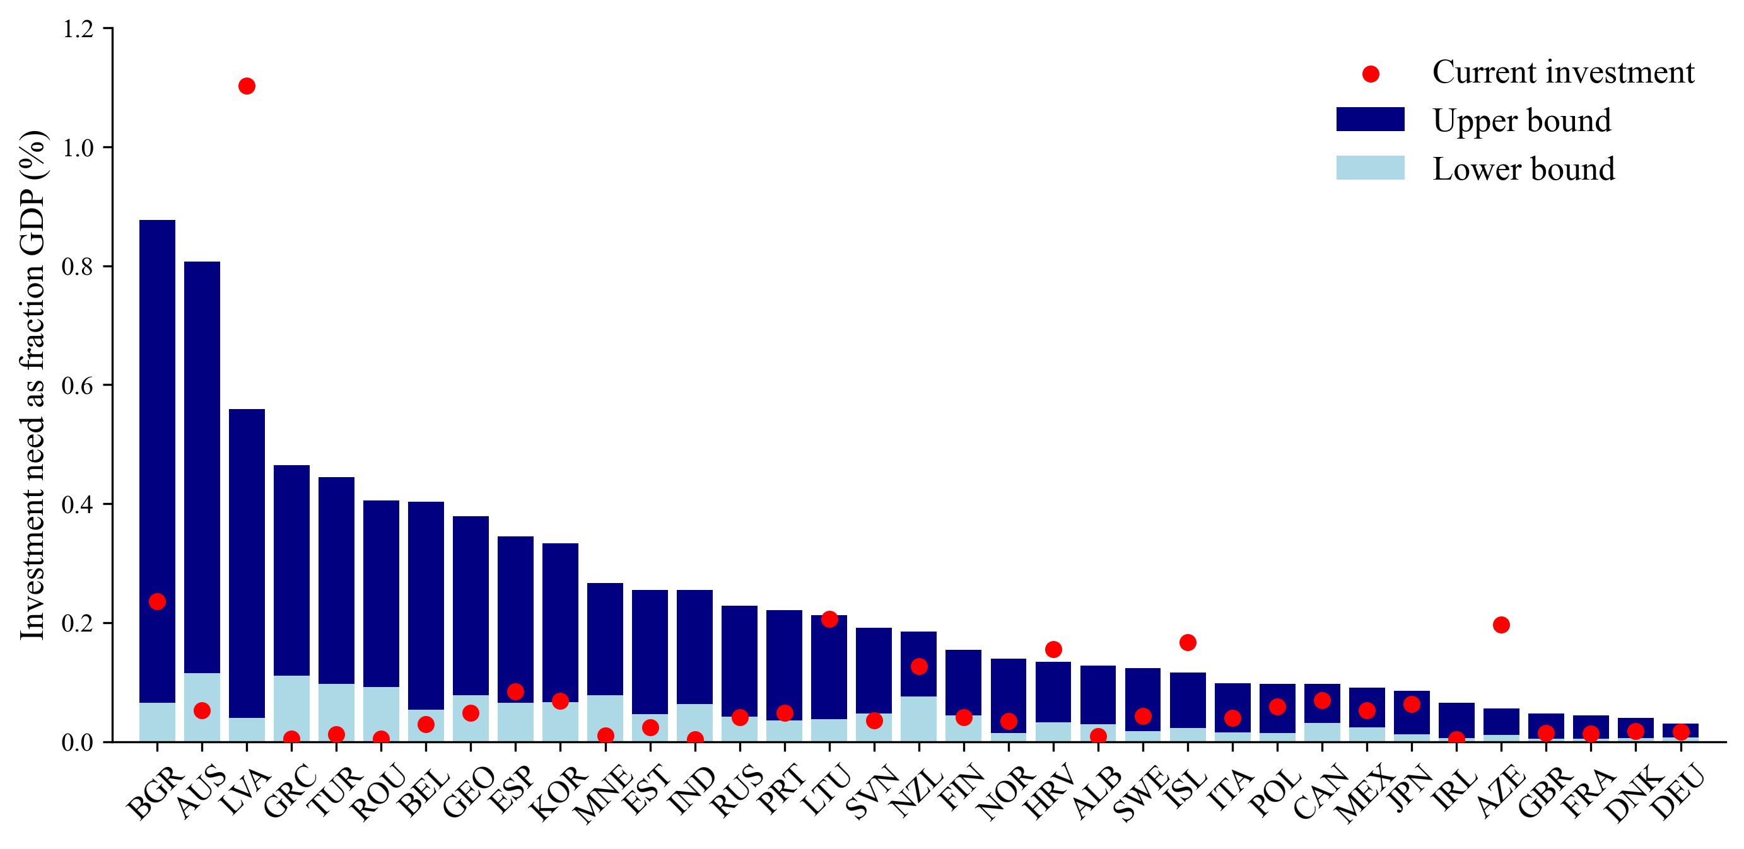
Supplementary Fig. 6. Investment need as fraction of GDP in OECD countries. The light blue bar shows the lowest possible investment need as fraction of GDP, whereas the dark blue bar shows the highest possible investment need as fraction of GDP. The red marker indicates the current public expenditure on maritime infrastructure as included in the OECD infrastructure investment database (https://data.oecd.org/transport/infrastructure-investment.htm). The latter includes both spending on new construction and the improvement of the existing network.

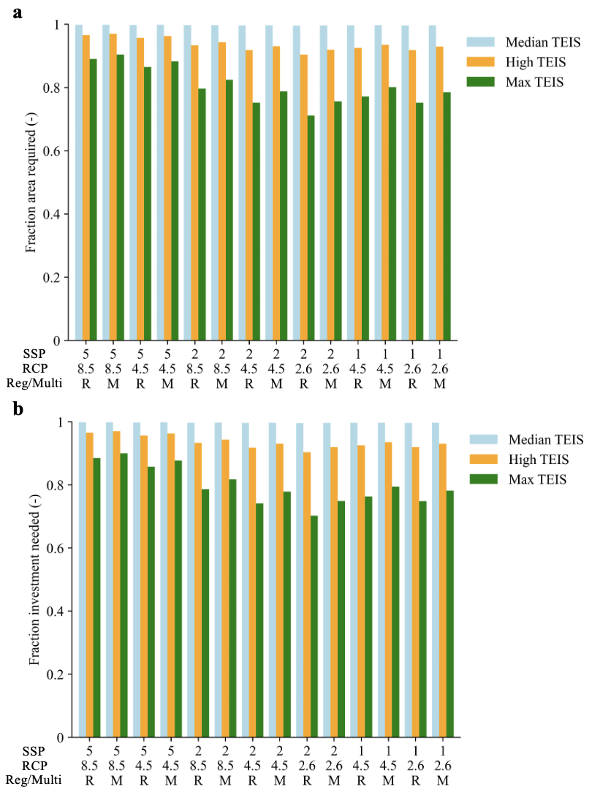
Supplementary Fig. 7. Influence of the terminal efficiency improvement strategies on the area and investment needs. (a) the fraction of the area required (1 indicating the baseline results in the main paper) for the median TEIS, high TEIS and Max TEIS scenarios (see Methods). (b) Same as (a) but in terms of the investment needs.

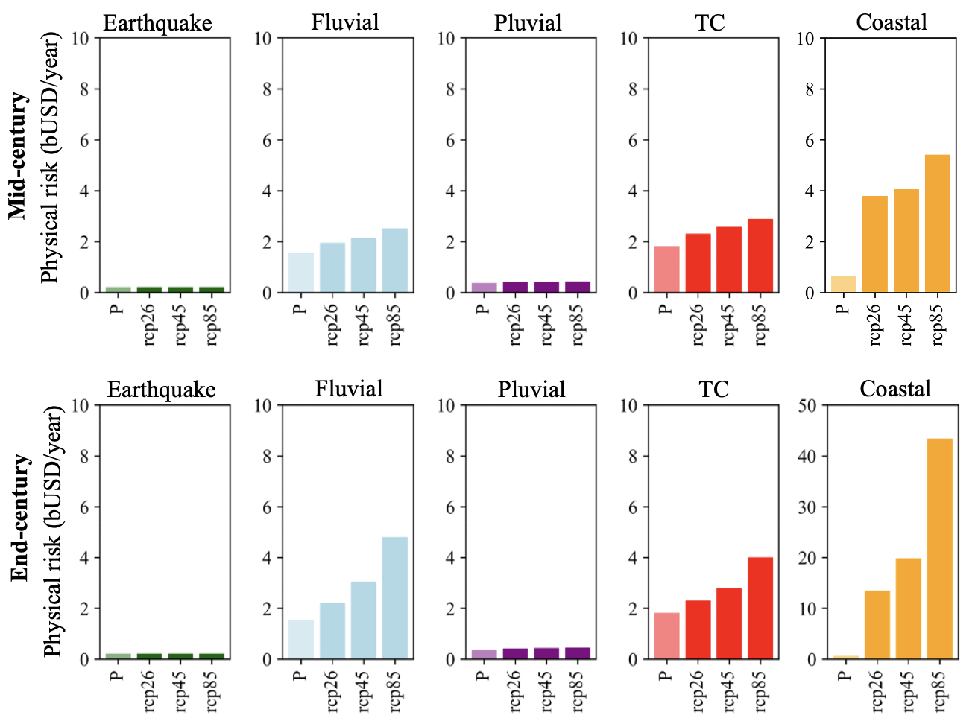
Supplementary Fig. 8. Present and future physical asset risk per hazard. Expected annual physical asset damages per hazard and climate scenario. The top row is for the mid-century time period and the bottom row for the end-century time period. Note that y-axis for the end-century coastal hazard is a factor five larger for visibility purposes.

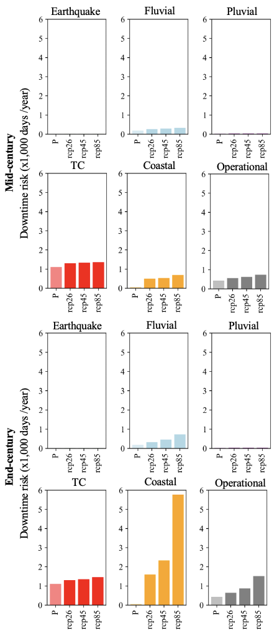
Supplementary Fig. 9. Present and future physical asset risk per hazard. Expected annual total downtime across all 1350 ports per hazard and climate scenario. The top row is for the mid-century time period and the bottom row for the end-century time period.
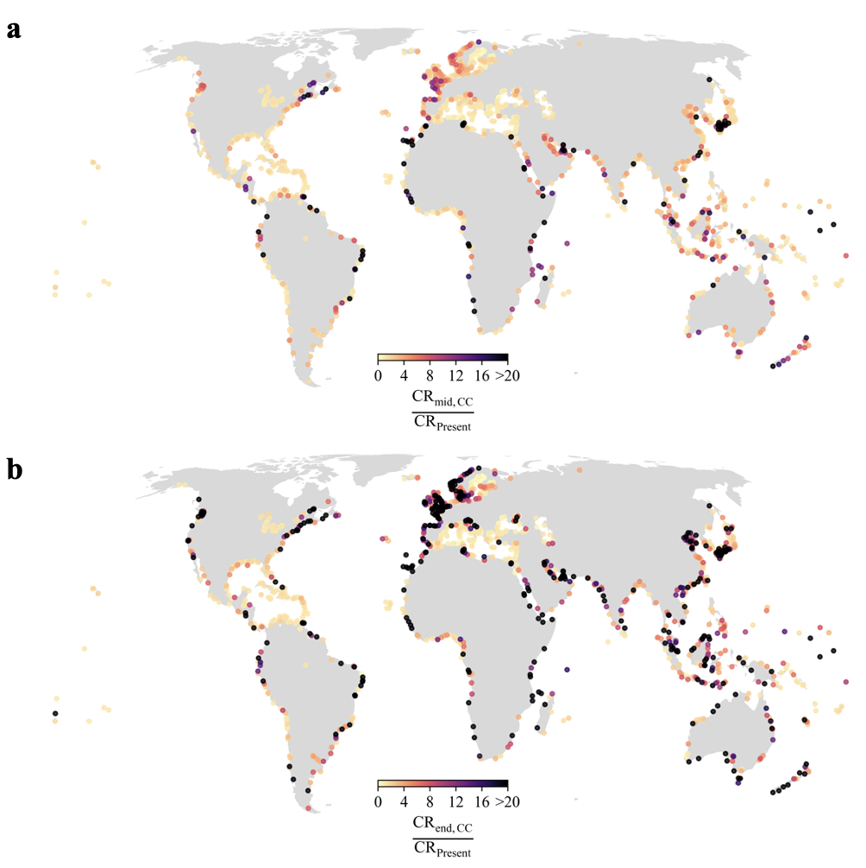
Supplementary Fig. 10. Change in climate risk due to climate change alone. (a) The climate risk in the mid-century climate compared to the climate risk in 2015 because of a change in climate change alone (so no port expansions). The figure shows the mean across the scenarios. (b) same as (a) but for the end-century climate.

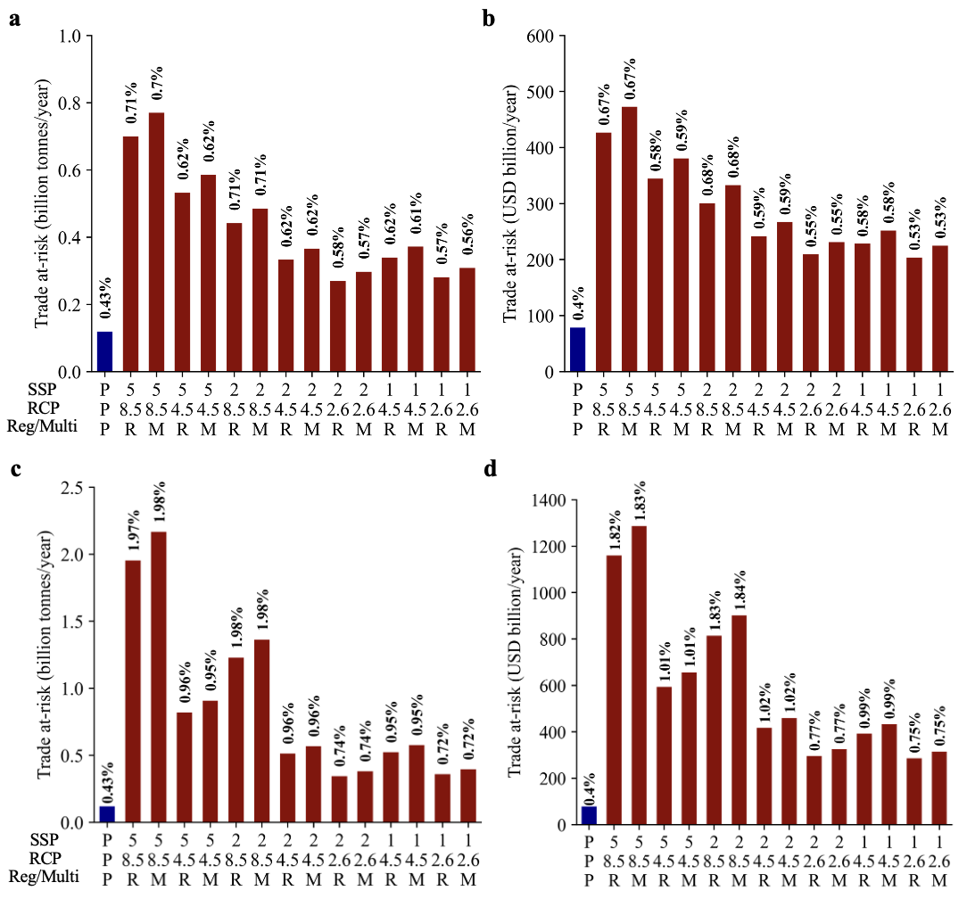
Supplementary Fig. 11. The trade at-risk due to port downtime. (a) The yearly average global trade at-risk at present (P) and under the future scenarios expressed in billion tonnes per year. The numbers on top of the bars indicate the trade at-risk as percentage of the global port throughput at present or in the future. (b) Same as (a) but expressed in terms of value (USD billion per year). (c) and (d) are same as (a) and (b) but for under the end-century climate projections.

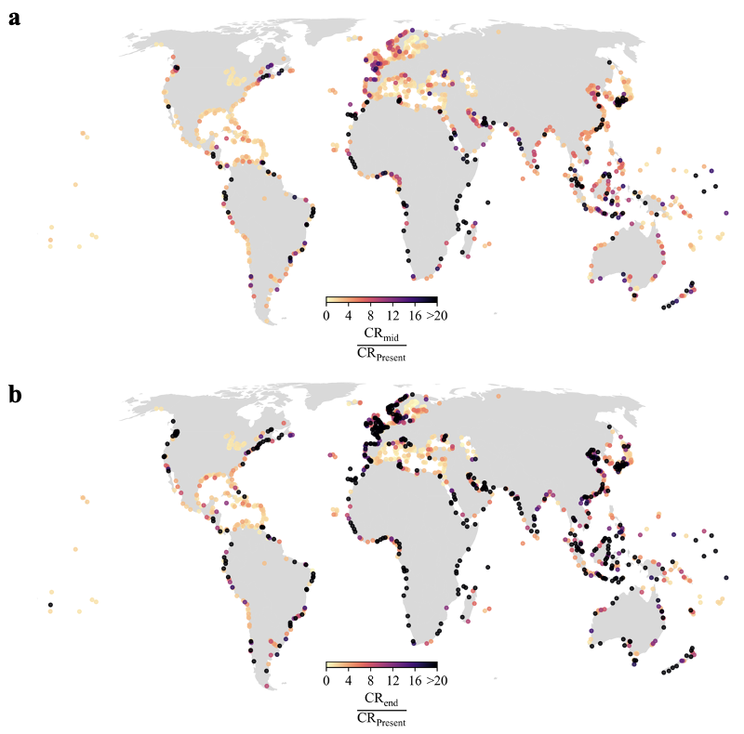
Supplementary Fig. 12. Change in climate risk due to climate change and port expansions. (a) The climate risk in the mid-century climate compared to the climate risk in 2015 because of a change in climate change and port expansions. The figure shows the mean across the scenarios. (b) same as (a) but for the end-century climate.

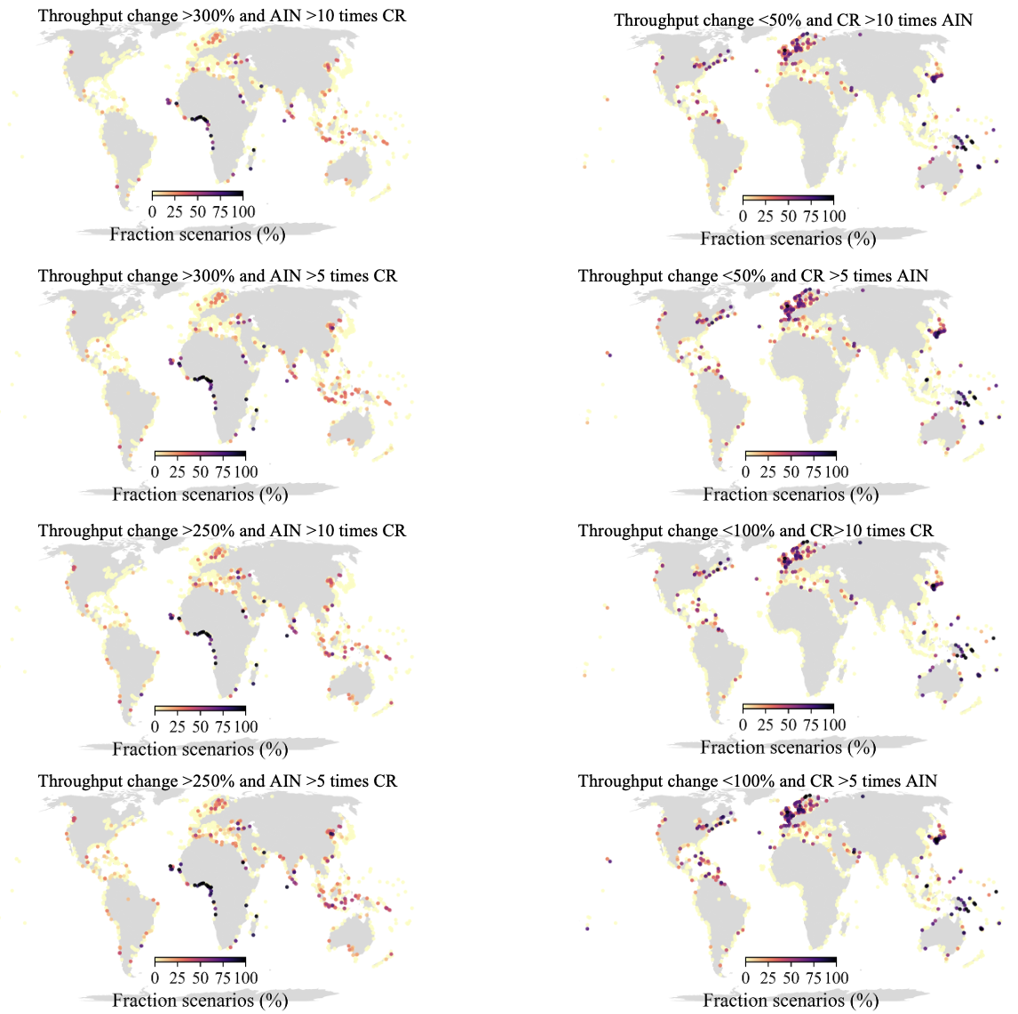

Supplementary Fig. 13. Sensitivity analysis of hotspots of expensive retrofitting and mainstreaming of adaptation. A comparison of different criteria used to evaluate the hotspots of adaptation mainstreaming (left) and expensive retrofitting (right). The top panel includes the criteria used in the main paper, whereas the bottom three panels show the result for different criteria by changing the throughput change threshold and the AIN to CR fraction.

Supplementary Tables
Supplementary Table 1: Cost scaling factor across different regions globally
Regions | Cost factor (-)
Rest of Europe, North America, Australia, New Zealand | 1
Southern Africa | 1.1
Asia | 0.5
Middle-East and Northern Africa | 0.6
South America, Caribbean, Pacific, Eastern Europe | 0.8

Supplementary Table 2. Parameters used in this study to derive the port area requirement. All parameters are modelled using a uniform distribution function between the lower and upper bound.
Parameter | Container | Dry bulk | Liquid bulk | General cargo | Source
t | 4 - 8 | 12 - 18 for silo  25 - 45 for open | 15 - 30 | 7 - 13 | Kox (2016)⁴  Kleinheerenbrink (2012)²⁰  Ligteringen and Velsink (2012)²¹  Merk and Dang (2012)²²
V_{TEU} | 10 - 12 | - | - | - | Expert judgement based on statistics from several ports
A_{TEU} | Supplementary Table 4 | - | - | - | Ligteringen and Velsink (2012)²¹
r | Supplementary Table 4 | - | - | - | Ligteringen and Velsink (2012)²¹
m | 0.6 – 0.8 | 0.6 – 0.85 | 0.5 – 0.8 | 0.65 – 0.75 | Kox (2016)⁴
hs | - | 5 – 10 for silo  10 – 20 for open | - | 1.5 – 2.5 | Kox (2016)⁴  Kleinheerenbrink (2012
$$α$$ | 1.3 – 1.9 | 1.2 – 2.0 | 1.3 – 2 | 2.0 – 2.6 | Kox (2016)⁴
$$ρ_{cargo}$$ | - | 0.6 – 0.9 for silo  0.7 – 1.5 for open | 0.5 – 0.9 | 0.4 – 0.8 | Kox (2016)⁴Ligteringen and Velsink (2012)²¹
f_{area} | - | 5 - 15 | - | 1.3 – 1.7 | Ligteringen and Velsink (2012)²¹
f_{bulk} | - | - | - | 1.0 – 1.4 | Ligteringen and Velsink (2012)²¹
V_{area} | - | - | 20 - 30 | - | Kox (2016)⁴

Supplementary Table 3. Parameters used in this study to derive the terminal construction costs. All parameters are modelled using a uniform distribution function between the lower and upper bound.
Parameter | Container | Dry bulk | Liquid bulk | General cargo | RoRo | Source
H_{ratio} | 1.8 – 2.2 | 1.8 – 2.2 | - | 1.8 – 2.2 | 1.8 – 2.2 | Kox (2016)⁴, expert judgment
C_{dredge} | 10 - 25 | 10 - 25 | - | 10 - 25 | 10 - 25 | Becker et al. (2017)⁷
F_{dredge} | 0.5 - 1 | 0.5 - 1 | - | 0.5 - 1 | 0.5 - 1 | Expert judgment
C_{yard} | 105 - 155 | - | - | - | - | Becker et al. (2017)⁷
C_{crane} | 7 - 11 | - | - | - | - | Kox (2016)⁴
n_{crane} | 80 – 120 | - | - | - | - | Own analysis based on data in Wiese et al. (2009)²
C_{yard,eq} | 1 - 2 | - | - | - | - | Kox (2016)⁴
n_{yard,eq} | 40 - 60 | - | - | - | - | Own analysis based on data in Wiese et al. (2009)²
R_{a} | - | - | - | 0.001 – 0.005 | 0.001 – 0.005 | Hamburg Port Authority (2017)⁸
S_{c} |  |  | 350 - 700 |  |  | Kox (2016)⁴
C_{pav} | - | 150 - 250 | - | 150 - 250 | 150 - 250 | Hamburg Port Authority (2017) ⁸
C_{silo} | - | - | 15 - 25 | - | - | Own analysis of several grain terminals (see Supplementary Note 2)
QLF | - | 10,000 – 30,000 for import  25,000 – 75,000 for export | - | 1.3 – 1.7 | - | Van Vianen (2015)¹⁰
M_{c} | - | 7000 - 9000 | - | 1.0 – 1.4 | - | Van Vianen (2015)¹⁰
I_{eq} | - | 14.5 - 26.5 for import  7.6 – 13 for export | - | - | - | Van Vianen et al. (2011)¹¹

Supplementary Table 4. The gross storage density and ratio of average over maximum stacking height for different type of container yard equipment. Values taken from Ligteringen and Velsink (2012).

Equipment | Ateu (m²/TEU) | r (-)
Straddle carrier | 10 - 13 | 0.25 – 0.50
Reach handler | 20 - 30 | 0.29 – 0.57
Rubber Tyred Gantry Cranes (RTG) | 7.5 - 16 | 0.50 – 0.67
Rail Mounted Gantry Crane (RMG) | 7.5 - 11 | 0.50 – 0.57

Supplementary Table 5. Comparison on area unit needs using the PPC model, the externally estimated ratios and existing rules of thumb.
Terminal type | PPC model (tonnes per m²) | Externally estimated ratios (tonnes per m²) | Rules of thumb (tonnes per m²)
RoRo | - | 4.1 (1.5 - 9.7) | 2 (Hamburg Port Authority, 2017)⁸
General Cargo | 7.5 (4.7 – 11.6) | 9.44 (3.3 – 15.6) | 4 - 6 (Ligteringen and Velsink, 2012)²¹  2.6 – 11.6 (Hamburg Port Authority, 2017) ⁸
Liquid | 33.1 (20.8 – 53.7) | 14.4 (2.1 – 23.2) | Oil terminals have around 40 – 50, while a LNG terminal has around 13 to 17 (Ligteringen and Velsink, 2012)²¹
Dry bulk | 19.4 (11.0 – 35.1) bulk in silos and 17.7 (9.8 – 34.3) bulk in open storage | 14.2 (4.2 – 31.4) for bulk overall, 36.5 (12.9 – 56.9) for bulk in silos and 18.9 (10.6 – 33.9) for bulk in open storage | Dry bulk terminals for coal have around 7 – 38 for import terminals and 20 – 80 for export terminals (Kox 2016)⁴
Container | 17.3 (11.0 – 27.0) for RTG,  19.8 (13.7 - 29.0) for RMG,  10.9 (6.9 – 17.1) for straddle carrier, and  5.9 (3.7 – 9.1) for reach handlers | 21.0 (12.3 – 29.9) | 0.7 – 5.7 TEU/m² (Drewry 2010)¹³  0.6 – 1.0 TEU/m² (Ligteringen and Velsink)²¹  2.2 – 3.5 TEU/m² (Wiese et al. 2009)²  Note: a TEU is around 10 – 12 tonnes

Supplementary references

1. Verschuur, J., Koks, E. E., Li, S. & Hall, J. W. Multi-hazard risk to global port infrastructure and resulting trade and logistics losses. Commun. Earth Environ. 4, 5 (2023).
2. Wiese, J., Kliewer, N., Suhl, L. & Str, W. A Survey of Container Terminal Characteristics and Equipment Types. Oper. Res. (2009).
3. J.G. de Gijt. Cost of quay walls. 3rd Int. Conf. EACEF 83–89 (2011).
4. Kox, S. A. J. A Tool for Determining Marine Terminal Dimensions and Costs in a Project’s Feasibility Phase. 203 (2016).
5. OECD-ITF. The Impact of Mega-Ships. Case-Specific Policy Analysis (2015).
6. Verschuur, J., Koks, E. E. & Hall, J. W. Global economic impacts of COVID-19 lockdown measures stand out in high-frequency shipping data. PLoS One 16, e0248818 (2021).
7. Becker, A., Hippe, A. & Mclean, E. Cost and Materials Required to Retrofit US Seaports in Response to Sea Level Rise: A Thought Exercise for Climate Response. J. Mar. Sci. Eng. 5, 44 (2017).
8. Hamburg Port Authority. Optimized Modern Multi-Purpose Terminals. (2017).
9. ERIA. Investment in LNG Supply Chain Infrastructure Estimation. in Formulating Policy Options for Promoting Natural Gas Utilization in the East Asia Summit Region Volume II: Supply Side Analysis (eds. Uemura, T. & Ishigami, K.) II, 67–80 (2018).
10. van Vianen, T. Simulation-integrated Design of Dry Bulk Terminals. (2015).
11. van Vianen, T., Ottjes, J. & Lodewijks, G. Dry bulk terminal characteristics. in Bulk Solids India 2011 1–10 (2011).
12. ITF. Capacity to grow. (2015).
13. Drewry. Global container terminal operators 2010: Annual review and forecast. (2010).
14. World Bank. Private Participation in Infrastructure Database. Port Sector Snapshot (2021). Available at: https://ppi.worldbank.org/en/snapshots/sector/ports. (Accessed: 4th June 2021)
15. Asian Development Bank. Meeting Asia’s Infrastructure Needs. (2017). doi:10.22617/FLS168388-2
16. Morim, J. et al. Robustness and uncertainties in global multivariate wind-wave climate projections. Nat. Clim. Chang. 9, 711–718 (2019).
17. Zaherpour, J. et al. Worldwide evaluation of mean and extreme runoff from six global-scale hydrological models that account for human impacts. Environ. Res. Lett. 13, (2018).
18. Hattermann, F. F. et al. Sources of uncertainty in hydrological climate impact assessment: A cross-scale study. Environ. Res. Lett. 13, (2018).
19. Jackson, L. P. & Jevrejeva, S. A probabilistic approach to 21st century regional sea-level projections using RCP and High-end scenarios. Glob. Planet. Chang. 146, 179–189 (2016).
20. Kleinheerenbrink, A. J. A. A Design Tool for Dry Bulk Terminals. (Delft University of Technology, 2012).
21. Ligteringen, H. & Velsink, H. Ports and Terminals. (Delft University Press, 2012).
22. Merk, O. & Dang, T. T. Efficiency of world ports in container and bulk cargo ( oil , coal , ores and grain ). Reg. Dev. Work. Pap. 1–28 (2012).

