Supplementary Information
for
Crystal Structure and Cellular Functions of uPAR Dimer
Shujuan Yu¹, Yaqun Sui¹, Jiawei Wang², Yongdong Li¹, Hanlin Li¹, Longguang Jiang¹, Cai Yuan^{3,4*}, Mingdong Huang^{1,3*}
¹College of Chemistry, Fuzhou University, Fujian 350116, China
²Tsinghua University, Beijing 100084, China;
³College of Biological Science and Engineering, Fuzhou University, Fuzhou, Fujian, 350116, China
⁴Fujian Key Laboratory of Marine Enzyme Engineering, Fuzhou University, Fuzhou, P.R. China

* Corresponding authors: Yuan C. (cyuan@fzu.edu.cn) and Huang M. (hmd_lab@fzu.edu.cn)

Table S1. List of oligo nucleotide primers

Primer name | DNA sequenceª
Plaur full-length (uPAR)-f | GACGATAAGGAATTCATGGGTCACCCGCCGCTG
Plaur full-length (uPAR)-r | GAACTAGTCTCGAGTTAGGTCCAGAGGAG
uPAR-f | TTTCCGGTGAATTCATGAAGTGGGTAACCTTT
uPAR-r | GAACTAGTCTCGAGTTAGGTCCAGAGGAG
uPAR H47A-f | AGAAAAGCTGTACCGCCTCAGA
uPAR H47A-r | GTTGGTCTTCTCTGAGGCGGTAC
uPAR H47C-f | AGCTGTACCTGCTCAGAGAAGACCAACAGG
uPAR H47C-r | CTTCTCTGAGCAGGTACAGCTTTTCTCCAC
uPAR H47F-f | AGAAAAGCTGTACCTTCTCAGA
uPAR H47F-r | GTTGGTCTTCTCTGAGAAGGTAC
uPAR S48P-f | AGCTGTACCCACCCAGAGA
uPAR S48P-r | TGTTGGTCTTCTCTGGGTGG
uPAR E49A-f | AGCTGTACCCACTCAGCGAAGAC
uPAR E49A-r | GTCCTGTTGGTCTTCGCTGAGT
uPAR E49F-f | GCTGTACCCACTCATTCAAGAC
uPAR E49F-r | GTCCTGTTGGTCTTGAATGAGTG
uPAR E49P-f | CACTCACCGAAGACCAACAGGACCCTGA
uPAR E49P-r | GTCTTCGGTGAGTGGGTACAGCTTTTCT
uPAR T51C-f | GAGAAGTGCAACAGGACCCTGAGCTATCG
uPAR T51C-r | CTGTTGCACTTCTCTGAGTGGGTACAGCT
uPAR V70C-f | GAGGTTTGTTGTGGGTTAGACTTGTGCAA
uPAR V70C-r | ACCCACAACAAACCTCGGTAAGGCTGGTGAT
uPAR N259C-f | TTCAGCATGTGCCACATTGATGTCTCCTGC
uPAR N259C-r | ATCAATGTGGCACATGCTGAAGGCGTCACC

ªThe restriction sites and the mutant sites were underlined and in bold.
Table S2. Data collection and refinement statistics of dimeric suPAR crystals at two different pH values.
Crystals | pH 4.6 | pH 7.4
Data collection and scaling
Beamline | NSBL X29 | SSRF BL17U
Spacegroup | P4₃22 | P4₃2₁2
Cell parameters | a = 77.45 Å | a = 79.58 Å,
Cell parameters | b = 77.45 Å | b =79.58 Å,
Cell parameters | c =275.53 Å | c = 270.53 Å
Wavelength (Å) | 0.979 | 0.979
Resolution (Å) | 47.04- 2.91 (3.01- 2.91) | 55.09 - 2.96 (3.066 - 2.96)
Rsym or Rmerge | 0.126 (0.313) | 0.175 (1.23)
Number of unique reflections | 17341 (839) | 18913 (1347)
I/σ(I) | 9.87 (3.24) | 10.09 (2.16)
Completeness (%) | 89.23 (44.58) | 99.25 (99.95)
Multiplicity | 9.0 (5.3) | 6.7(7.3)
Phasing
Number of sites | 12
figure of merit | 0.384
Refinement
R_{work} | 0.2375 (0.2512) | 0.2479 (0.3259)
R_{free} | 0.2897 (0.3937) | 0.2995 (0.3345)
Average B factor (Å²) | 81.50 | 61.34
Protein residues | 376 | 457
Validation
RMS deviations from ideal
Bond lengths (Å) | 0.010 | 0.010
Bond angles (°) | 1.59 | 1.26
Ramachandran plot
Ramachandran favored (%) | 91 | 91.3
Ramachandran outliers (%) | 1.7 | 0
Values in parentheses are given for the highest resolution shells.

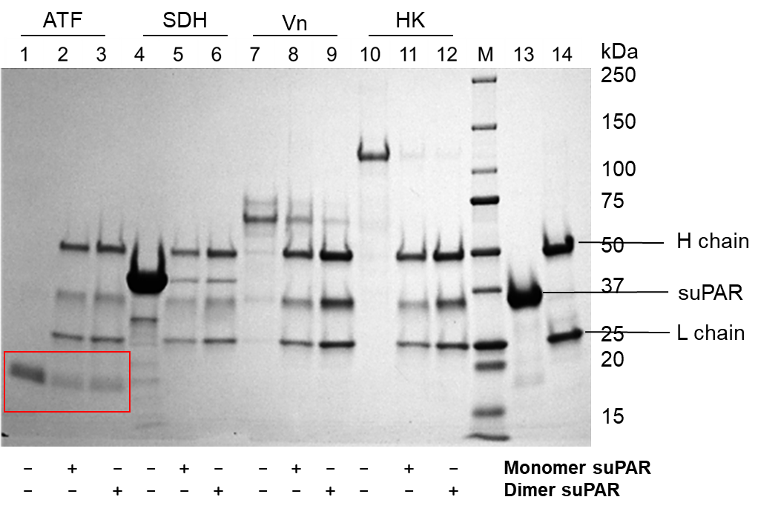

Figure S1. Both suPAR dimer or dimer binds to the ligands, ATF, SDH (streptoccocal surface dehydrogenase), vitronectin, and high molecular weight kinninogen (HK). The monomer or dimer was loaded onto an anti-uPAR affinity column (ATN658 cross-linked to Dynabeads). Different ligands were then flowed to the column and eluted with a low pH buffer after wash. The eluents were analyzed by a 4-15% SDS–PAGE.

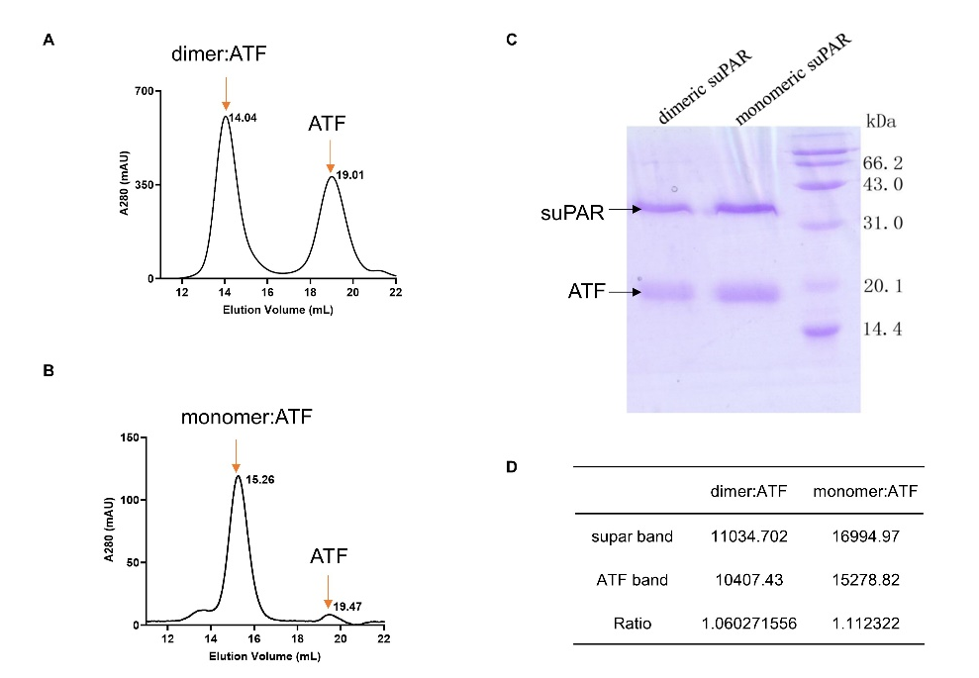

Figure S2. ATF binds to dimeric suPAR at 2:1 molar ratio. Dimer:ATF complex (A) and monomer:ATF complex (B) were purified by gel filtration and identified by electrophoretic analysis with 15% SDS-PAGE (C). (D) The ATF binding to dimeric suPAR molar ratio was imaged and analyzed with the ChemDoc Touch imaging system (Bio-Rad) using monomeric suPAR-ATF as the standard.

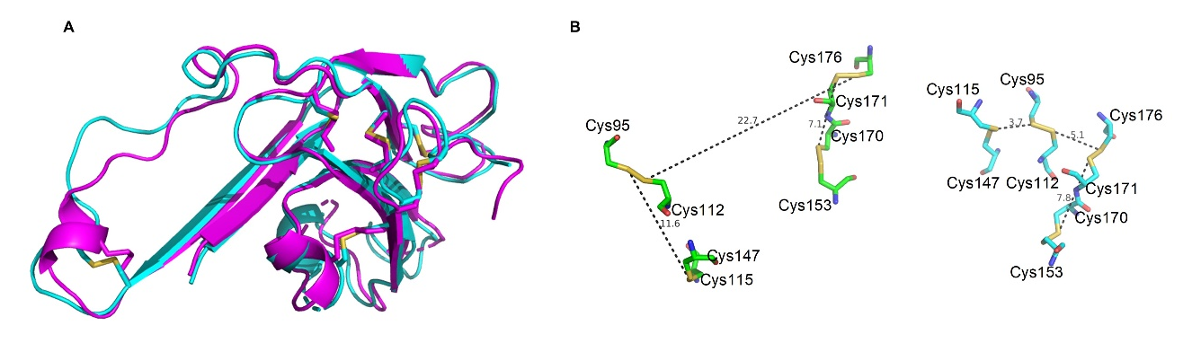
Figure S3. Structure comparison of uPAR dimer and monomer. (A) Residues 155-277 of uPAR dimer (purple) and monomer (blue) adopted similar conformation. (B) The large repositioning of the disulfide bonds in the palm region of the D2 of dimeric suPAR (left) was seen comparing to highly conserved disulfide bonding pattern of three-fingered fold (right).

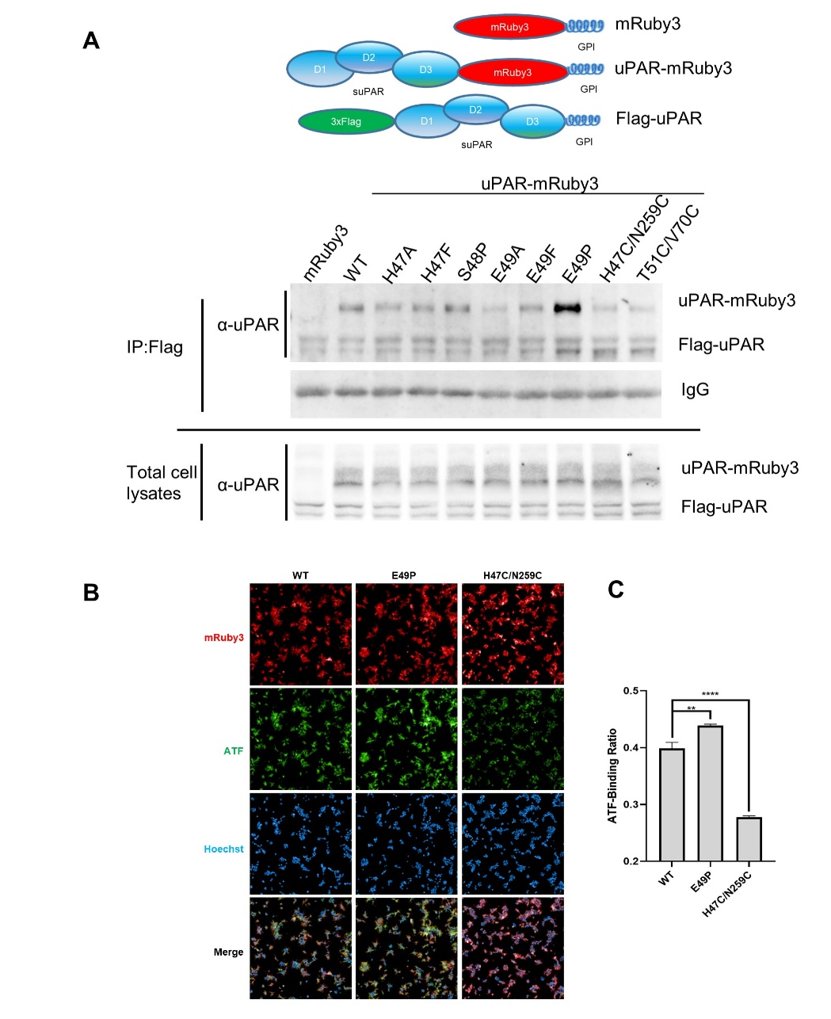
Figure S4. The effect of hinge region mutation for uPAR dimerization. (A) Anti-uPAR immunoblotting of Flag-tagged uPAR and mRuby3-tagged uPAR mutants (top panel) expressed on 293T cells in the anti-Flag immunoprecipitants (IP: Flag) (above) and the total cell lysates (bottom) of 293T cells co-expressing Flag-tagged uPAR and mRuby3-tagged uPAR. (B) Microscopic images of the uptake of FITC-ATF by the uPAR-mRuby3 293T cells. The stable cell lines overexpressed uPAR-mRuby3 mutants were treated with FITC conjugated ATF for 6 hour and Hoechst for 10 min before fixation. mRuby3, red fluorescence of mRuby3-tagged proteins; ATF, FITC fluorescence of FITC conjugated ATF; Hoechst, nuclear staining with Hoechst dye; Merge, merge of all three channels. Scale bars, 50 µm. (C) Quantification of ATF-binding ratio for B. ATF-binding ratio was measured by comparing the summed intensity of FITC to the summed intensity of mRuby3 in each well. The summed intensity of FITC and the summed intensity of mRuby3 were calculated by Operetta CLS software. Data are representative of three independent experiments.

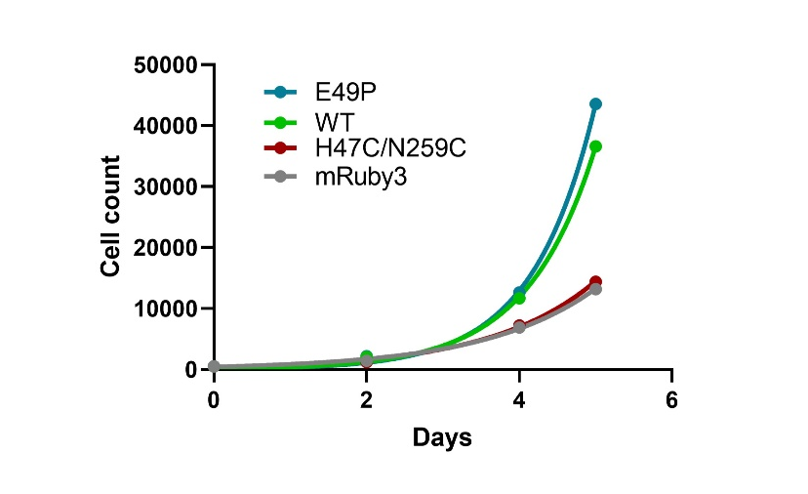
Figure S5. Dimerization of uPAR on cell surface promoted cell proliferation. Cell proliferation of mRuby3-tagged uPAR 293T stable cell lines measured with CCK-8 assay.

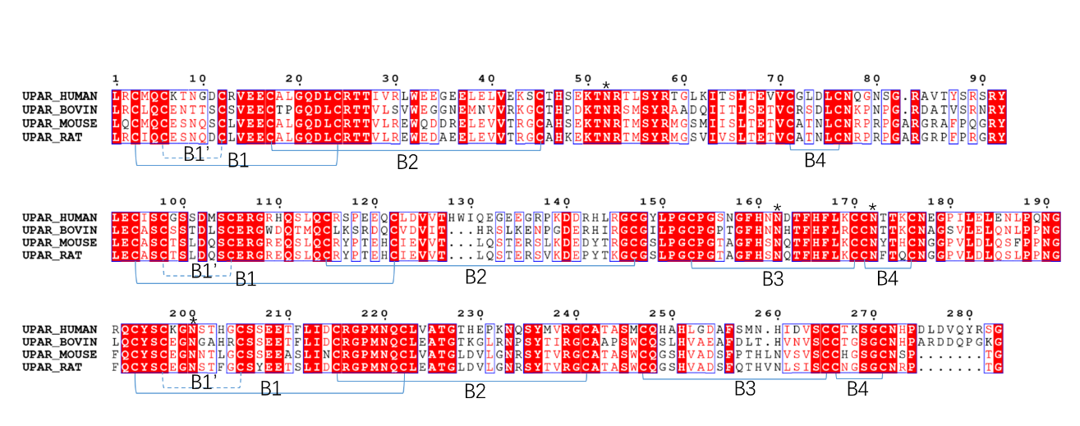
Figure S6. Sequence alignments of the uPAR from different species. The consensus disulfide bonds in the palm of three fingered fold domain are show in solid line, disulfide bonds in the fingers of three fingered fold domain are shown in dotted line. The potential glycosylation sites (N52, N162, N172 and N200) are marked with stars, which are conserved in these species and do not interfere with the dimer formation.

