Novel Azo-benzoyl acetone metal complexes for inhibition of atmospheric steel corrosion

Yusif S. El-Sayedª, Nadia El-Wakiel^{a*}, Kamal El-Baradieª, Basma M. Salem^{a*}
ªChemistry Department, Faculty of Science, Tanta University, 31527 Tanta, Egypt

2.1. Chemicals and Instrumentations

5-aminoindazole (97%), benzoyl acetone (99%), Cobalt (II) chloride hexahydrate (98%), Nickel (II) chloride hexahydrate (99.9%), and Copper (II) chloride (99%), dimethyl sulfoxide (DMSO, 99.9%), triethylamine (99%), and ethanol (95%) were obtained purchased from Sigma-Aldrich and used as received.
C, H, and N analyses of the synthesized compounds were carried out using a FLASH 2000 CHNS/O analyzer. The ¹H-NMR and ¹³C-NMR spectra were recorded on a DELTA2-NMR (500 MHz) in DMSO-d₆ at 25 cº with tetramethylsilane (TMS) as an internal standard. The FT-IR spectra were taken on an FT-IR-4100 (JASCO, Japan) spectrophotometer in the range of 4000-400 cm⁻¹. The standard electron impact mass spectra of the ligand and metal chelates were performed at room temperature, utilizing the mass analyzer's direct inlet component in the thermal scientific GCMS model ISQ. The direct insertion probe (DIP) was gradually heated from 50 to 3000 cº while the ion source was maintained at 25 cº. The molar conductance in 10⁻³ M DMSO was calculated. The electronic absorption spectra were obtained using a Shimadzu UV-Vis 240 spectrophotometer. The X-ray diffractometer (GNR, APD 2000 PRO, Italy) was employed to have the XRD patterns of the solid compounds. The magnetic susceptibility of the chelates was carried out at 25 cº using the magnetic susceptibility balance Johnson Matthey 436 Devon Park Drive by Gouy's method [31]. The Shimadzu TG-50 thermogravimetric analyzer was used to perform the thermogravimetric analysis (TGA) of the solid chelates in the range of 25–800 cº, at a heating rate of 10 cº /min in an N₂ atmosphere. An Inductive Coupled Plasma spectrometer (Optima 7000 DV, ICP-OES) was used to measure and identify the elements within the chelate samples.

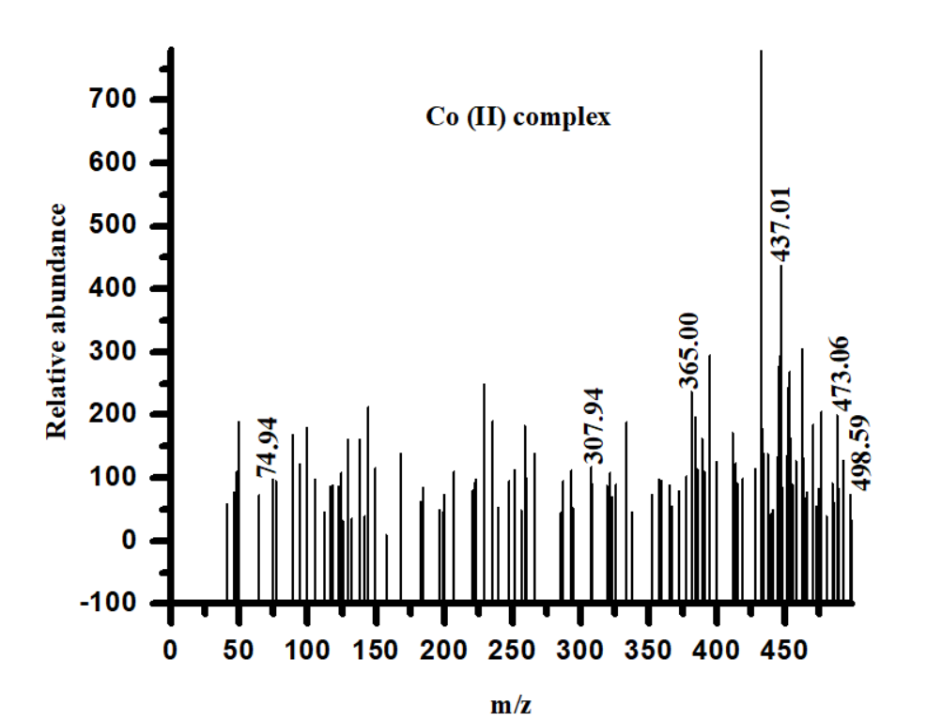

Figure S1. EI‐Mass spectrum of Co (II) complex

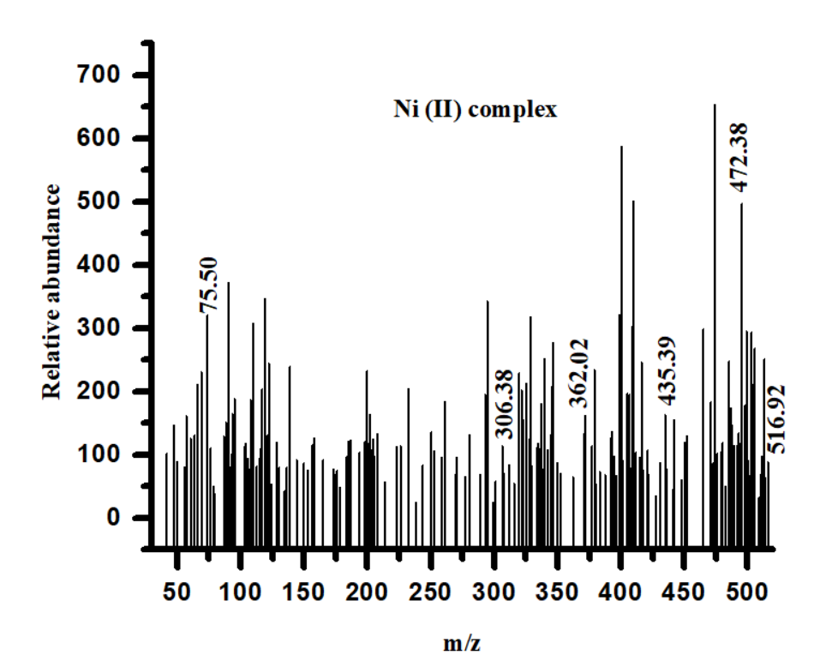

Figure S2. EI‐Mass spectrum of Ni (II) complex

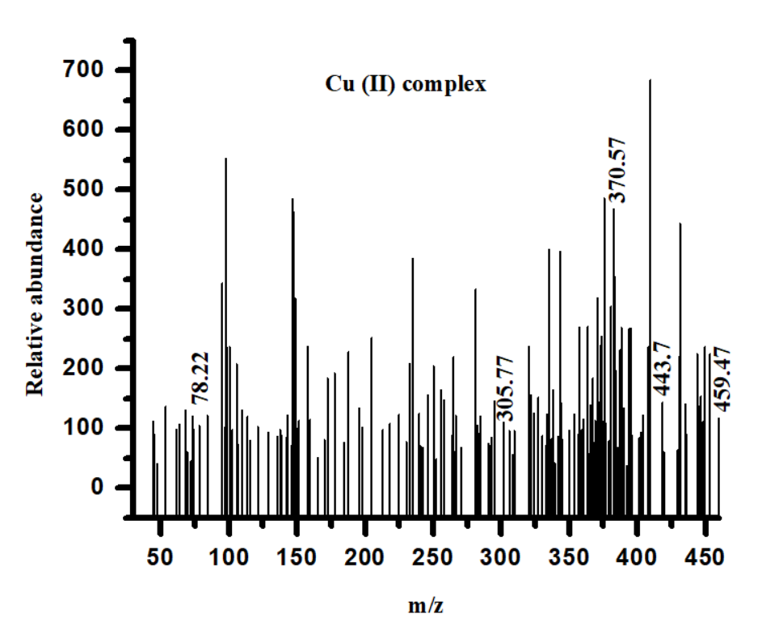
Figure S3. EI‐Mass spectrum of Cu (II) complex

Table S1. Bond lengths, and bond angles of Azo-dye ligand
Bond Length (ºA) |  | Bond angles (º)
C1-C2 | 1.396 | C4-C5-C7 | 123.5
C2-C3 | 1.393 | C3-C4-C5 | 120.3
C3-C4 | 1.392 | C5-C7-O9 | 121.6
C4-C5 | 1.400 | C5-C7-C8 | 120.9
C5-C6 | 1.402 | C1-C6-C5 | 120.5
C5-C7 | 1.494 | C7-C8-C10 | 115.5
C7-C8 | 1.549 | C7-C8-N23 | 111.9
C7-O9 | 1.212 | C8-C10-C11 | 116.4
C8-C10 | 1.549 | C8-C10-O22 | 120.4
C10-O22 | 1.206 | C11-C10-O22 | 123.2
C10-C11 | 1.511 | C6- C5-C7 | 117.4
C8-N23 | 1.464 | C10-C8-N23 | 111.9
N23-N12 | 1.248 | C8-N23-N12 | 112.4
N12-C13 | 1.421 | N23-N12-C13 | 116
C13-C18 | 1.392 | N12-C13-C14 | 114.5
C13-C14 | 1.417 | N12-C13-C18 | 124.4
C18-C17 | 1.396 | C15-C16-N19 | 132.4
C14-C15 | 1.380 | C16-N19-N20 | 112.7
C15-C16 | 1.403 | N19-N20-C21 | 106
C16-C17 | 1.421 | N20-C21-C17 | 111.5
C16-N19 | 1.421 | C21-C17-C18 | 135.8
N19-N20 | 1.361 | C16-C17-C18 | 120
N20-C21 | 1.315 | C16-C17-C21 | 104.2
C21-C17 | 1.432 | C17-C18-C13 | 118

Table S2. Bond lengths, and bond angles of Co (II) complex
Bond Length (ºA) |  | Bond angles (º)
Co-N14 | 2.066 | O8-Co-O25 | 167.5
Co-O25 | 2.290 | Cl28-Co-N14 | 168.6
Co-Cl28 | 2.444 | Cl27-Co-O26 | 174.9
Co-O8 | 2.137 | O8-Co-Cl28 | 91.8
Co-Cl27 | 2.331 | Cl28-Co-O25 | 78.80
Co-O26 | 2.071 | O25-Co-N14 | 106.18
O8-C7 | 1.257 | N14-Co-O8 | 84.60
C7-C3 | 1.482 | Cl28-Co-O26 | 78.20
C3-C2 | 1.417 | O26-Co-O25 | 91.81
C3-C4 | 1.421 | N14-Co-Cl27 | 90.52
C4-C5 | 1.401 | Cl27-Co-O8 | 90.68
C7-C9 | 1.563 | Co-O8-O7 | 127.39
C9-C10 | 1.539 | O8-C7-C9 | 113.98
C10-O11 | 1.248 | C7-C9-N13 | 109.69
C10-C12 | 1.513 | C9-N13-N14 | 118.67
C9-N13 | 1.496 | N13-N14-Co | 124.03
N13-N14 | 1.285 | N13-N14-C15 | 113.59
N14-C15 | 1.446 | N14-C15-C20 | 117.30
C15-C16 | 1.403 | N14-C15-C16 | 120.77
C15-C20 | 1.427 | C18-N23-N22 | 112.36
C18-N23 | 1.380 | N23-N22-C21 | 105.60
N23-N22 | 1.395 | O8-C7-C3 | 119.45
N22-C21 | 1.342 | C7-C3-C4 | 116.12
C21-C17 | 1.442 | C7-C3-C2 | 124.30
C17-C16 | 1.406 | C3-C2-C1 | 119.84
C20-C19 | 1.394 | C3-C4-C5 | 120.23
C19-C18 | 1.413 | C15-C20-C19 | 120.82
C18-C17 | 1.433 | C15-C16-C17 | 117.86

Table S3. Bond lengths, and bond angles of Ni (II) complex
Bond Length (ºA) |  | Bond angles (º)
Ni-N14 | 2.035 | N14-Ni-O25 | 168.30
Ni-O25 | 1.949 | O26-Ni-Cl28 | 164.88
Ni-O26 | 2.003 | O8-Ni-Cl27 | 83.22
Ni-O8 | 1.947 | Cl27-Ni-O26 | 46.58
Ni-Cl28 | 2.452 | O26-Ni-N14 | 93.67
Ni-Cl27 | 3.932 | N14-Ni-Cl28 | 90.21
O8-C7 | 1.279 | Cl28-Ni-O8 | 89.59
C7-C3 | 1.514 | Cl27-Ni-O25 | 47.11
C3-C2 | 1.422 | Ni-O8-C7 | 127.33
C3-C4 | 1.423 | O8-C7-C9 | 124.15
C4-C5 | 1.405 | C7-C9-N13 | 123.19
C7-C9 | 1.569 | C9-N13-N14 | 115.53
C9-C10 | 1.629 | N13-N14-Ni | 132.62
C10-O11 | 1.247 | N13-N14-C15 | 111.49
C10-C12 | 1.554 | N14-C15-C20 | 117.19
C9-N13 | 1.537 | N14-C15-C16 | 120.84
N13-N14 | 1.331 | C18-N23-N22 | 113.16
N14-C15 | 1.486 | N14-N22-C21 | 102.93
C15-C16 | 1.412 | O8-C7-C3 | 118.05
C15-C20 | 1.440 | C7-C3-C4 | 117.29
C18-N23 | 1.400 | C7-C3-C2 | 122.86
N23-N22 | 1.442 | C3-C2-C1 | 119.60
N22-C21 | 1.370 | C3-C4-C5 | 120.07
C21-C17 | 1.451 | C15-C20-C19 | 120.96
C17-C16 | 1.416 | C15-C16-C17 | 117.90
C20-C19 | 1.394 | C16-C17-C18 | 119.52
C19-C18 | 1.426 | C16-C17-C21 | 135.12
C18-C17 | 1.441 | C20-C19-C18 | 117.21

Table S4. Bond lengths, and bond angles of Cu (II) complex
Bond Length (ºA) |  | Bond angles (º)
Cu-N12 | 2.142 | O9-Cu-Cl25 | 120.12
Cu-O9 | 2.260 | Cl25-Cu-Cl26 | 94.05
Cu-Cl25 | 2.359 | Cl26-Cu-N12 | 97.63
Cu-Cl26 | 2.419 | N12-Cu-O9 | 85.93
O9-C7 | 1.264 | Cu-O9-C7 | 118.84
C7-C8 | 1.587 | O9-C7-C5 | 120.79
C8-C10 | 1.576 | O9-C7-C8 | 118.84
C10-C11 | 1.553 | C7-C8-C10 | 109.39
C10-O22 | 1.262 | C7-C8-N23 | 110.11
C8-N23 | 1.558 | N23-C8-C10 | 110.70
N23-N12 | 1.336 | C8- C10-O22 | 120.97
C7-C5 | 1.520 | C8-C10-C11 | 117.05
C5-C4 | 1.419 | C7-C5-C6 | 116.17
C5-C6 | 1.422 | C7-C5-C4 | 124.29
C4-C3 | 1.407 | C8-N23-N12 | 110.46
N12-C13 | 1.473 | N23-N12-C13 | 112.55
C13-C18 | 1.413 | N23-N12-Cu | 127.69
C18-C17 | 1.416 | N12-C13-C18 | 116.81
C13-C14 | 1.444 | N12-C13-C14 | 121.28
C14-C15 | 1.390 | C14-C15-C16 | 117.26
C15-N16 | 1.429 | C16-N19-N20 | 113.19
N19-N20 | 1.445 | N19-N20-C21 | 102.84
N20-C21 | 1.370 | N20-C21-C17 | 112.99
C16-N19 | 1.398 | C13-C18-C17 | 117.84
C16-C17 | 1.440 | C13-C14-C15 | 120.96

Table S5. The Milliken charge distribution for the ligand and its metal complexes
Ligand |  | Co (II) complex |  | Ni (II) complex |  | Cu (II) complex
Atom | Charge | Atom | Charge | Atom | Charge | Atom | Charge
C1 | -0.094 | C1 | -0.241 | C1 | -0.069 | C1 | -0.069
C2 | -0.059 | C2 | -0.330 | C2 | -0.070 | C2 | -0.060
C3 | -0.111 | C3 | 0.278 | C3 | -0.015 | C3 | -0.072
C4 | -0.02 | C4 | -0.313 | C4 | -0.049 | C4 | -0.068
C5 | -0.142 | C5 | -0.226 | C5 | -0.067 | C5 | -0.018
C6 | -0.017 | C6 | -0.205 | C6 | -0.056 | C6 | -0.056
C7 | 0.294 | C7 | 0.251 | C7 | 0.201 | C7 | 0.177
C8 | -0.156 | O8 | -0.244 | O8 | -0.103 | C8 | -0.043
O9 | -0.234 | C9 | -0.297 | C9 | -0.034 | O9 | -0.103
C10 | 0.214 | C10 | 0.190 | C10 | 0.181 | C10 | 0.197
C11 | -0.303 | O11 | -0.237 | O11 | -0.140 | C11 | -0.235
N12 | -0.175 | C12 | -0.706 | C12 | -0.241 | N12 | -0.090
C13 | 0.001 | N13 | -0.072 | N13 | -0.061 | C13 | 0.074
C14 | -0.061 | N14 | -0.198 | N14 | -0.091 | C14 | -0.063
C15 | -0.037 | C15 | 0.429 | C15 | 0.071 | C 15 | -0.082
C16 | 0.310 | C16 | -0.439 | C16 | -0.063 | C16 | 0.093
C17 | -0.298 | C17 | 0.239 | C17 | -0.019 | C17 | -0.913
C18 | 0.029 | C18 | 0.271 | C18 | 0.092 | C18 | -0.039
N19 | -0.358 | C 19 | -0.349 | C 19 | -0.078 | N19 | -0.201
N20 | -0.164 | C20 | -0.309 | C20 | -0.053 | N20 | -0.116
C21 | 0.137 | C21 | -0.435 | C21 | -0.018 | C21 | -0.009
O22 | -0.274 | N22 | -0.005 | N22 | -0.116 | O22 | -0.091
N23 | -0.175 | N23 | -0.423 | N23 | -0.201 | N23 | -0.069
H24 | 0.101 | Co24 | 0.078 | Ni24 | 0.148 | Cu24 | 0.197
H25 | 0.100 | O25 | -0.693 | O25 | -0.272 | Cl25 | -0.432
H26 | 0.096 | O26 | -0.684 | O26 | -0.276 | Cl26 | -0.428
H27 | 0.105 | Cl27 | -0.352 | Cl27 | -0.700 | H27 | 0.098
H28 | 0.113 | Cl28 | -0.402 | Cl28 | -0.562 | H28 | 0.095
H29 | 0.164 | H29 | 0.235 | H29 | 0.095 | H29 | 0.092
H30 | 0.134 | H30 | 0.270 | H30 | 0.098 | H30 | 0.084
H31 | 0.137 | H31 | 0.287 | H31 | 0.117 | H31 | 0.115
H32 | 0.137 | H32 | 0.239 | H32 | 0.100 | H32 | 0.107
H33 | 0.109 | H33 | 0.235 | H33 | 0.097 | H33 | 0.106
H34 | 0.100 | H34 | 0.357 | H34 | 0.127 | H34 | 0.116
H35 | 0.115 | H35 | 0.237 | H35 | 0.098 | H35 | 0.107
H36 | 0.243 | H36 | 0.239 | H36 | 0.108 | H36 | 0.107
 |  | H37 | 0.253 | H37 | 0.109 | H37 | 0.095
 |  | H38 | 0.260 | H38 | 0.109 | H38 | 0.134
 |  | H39 | 0.244 | H39 | 0.104 | H39 | 0.247
 |  | H40 | 0.321 | H40 | 0.103 | H40 | 0.115
 |  | H41 | 0.271 | H41 | 0.105
 |  | H42 | 0.334 | H42 | 0.250
 |  | H43 | 0.414 | H43 | 0.254

