Extended data
Supplementary Results
Validation of ΔRER as a robust measure of metabolic flexibility
While RER is strongly influenced by nutritional status⁶ (Extended Data Fig. 1a–c), the effect on ΔRER was unclear. To test this, we analysed indirect calorimetry data from 194 Western diet (WD)–fed and 68 chow-fed wild-type mice phenotyped at the Wellcome Trust Sanger Institute (WTSI). Unlike mean RER, ΔRER showed only a weak correlation with body weight change (ΔBW) or food intake (FI) (Extended Data Fig. 1d,e).
Prolonged fasting is expected to compress ΔRER, as substrate utilisation relies on internal stores. In chow-fed mice, maximal RER (~1.0) would fall to ~0.74 due to reduced carbohydrate oxidation and suppressed de novo lipogenesis, while minimal RER, typically reached during the light phase, would decline only modestly from ~0.78 to ~0.74. RER rarely reaches 0.7 in mice, as gluconeogenesis sustains baseline glucose oxidation even during prolonged fasting. These observations indicate that ΔRER is relatively resilient to fluctuations in energy balance, supporting its validity as a stable and physiologically meaningful index of metabolic flexibility.
Examining the highest and lowest 10% of RER values revealed tight correlations in both chow- and WD-fed mice (Extended Data Fig. 1f), indicating that shifts in energy balance alter the entire RER curve rather than disproportionately affecting one phase. Consistent with this, mice fasted acutely in the early afternoon still exhibited the characteristic RER rise at dark onset, comparable to those with immediate food access (Extended Data Fig. 1g), suggesting that this initial RER increase is driven primarily by mobilisation of endogenous glycogen stores rather than acute feeding.
Together, these findings establish ΔRER as a stable and physiologically meaningful measure of circadian substrate switching, largely independent of acute feeding status.
Reproducibility of ΔRER phenotypes across sites and alleles
Within the IMPC screen, Akt2 knockout mice displayed compressed RER profiles under WD feeding at WTSI (Extended Data Fig. 2a). We confirmed this phenotype independently at the University of Cambridge in both chow- and high-fat diet cohorts (Extended Data Fig. 2b). The reproducibility across sites and alleles underscores the robustness of ΔRER as a screening metric.

Extended Data Figures
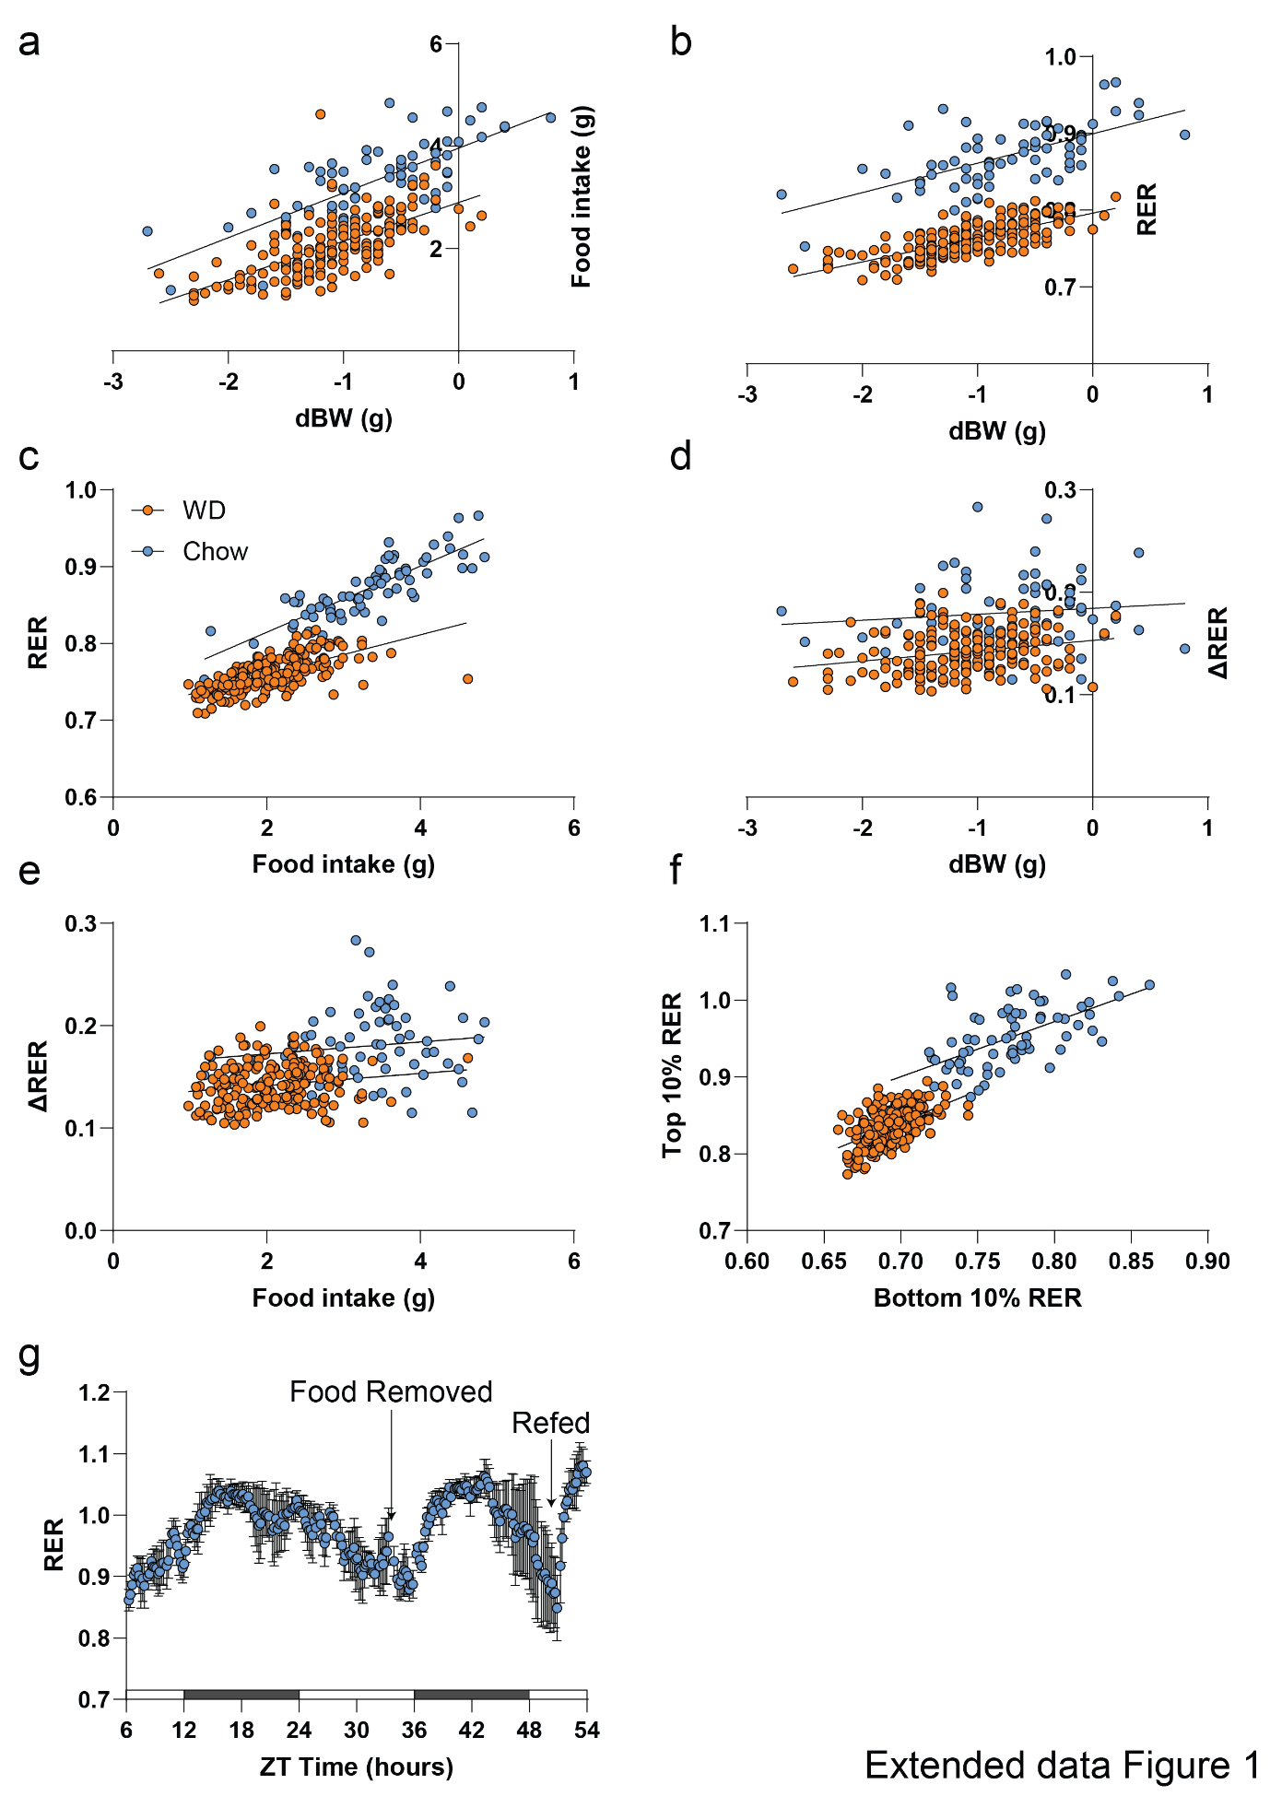

Extended Data Figure 1. Validation of ΔRER as a measure of metabolic flexibility.
a-f, Correlations between food intake (FI), change in body weight (dBW), RER, and ΔRER in male C57BL/6N mice (n=194 for western diet; n=68 for chow; 13 weeks old mice).
g, RER profile of mice fasted during early afternoon (n=3 males). Data are mean ± SEM.

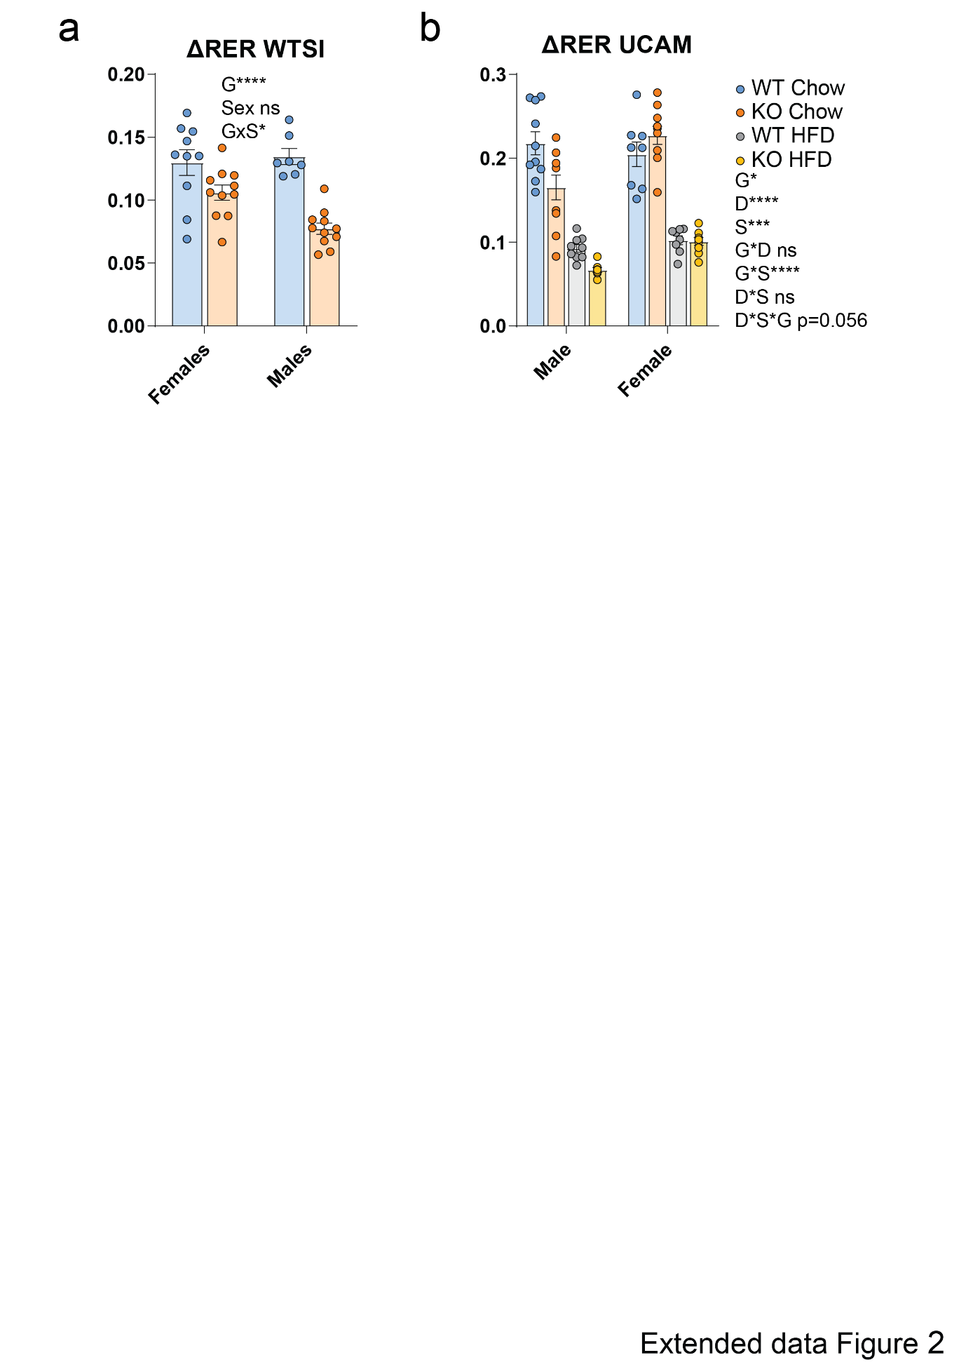

Extended Data Figure 2. Akt2-KO mice exhibit reduced ΔRER.
a, ΔRER of WT and Akt2-KO (AKT2^{tm1a(EUCOMM)Wtsi} ) mice on western diet at WTSI (females: WT n= 10, KO n=11; males: WT n=7, KO n=11).
(B) ΔRER of WT and Akt2-KO (AKT2^{tm1.1mbb} KO) mice at UCAM on chow or HFD (males: CHOW WT n=10, KO n=10; HFD WT n=9, KO n=8; females: CHOW WT n=8, KO n=10; HFD WT n=8, KO n=9).
Data are mean ± SEM and analysed by two-way ANOVA.

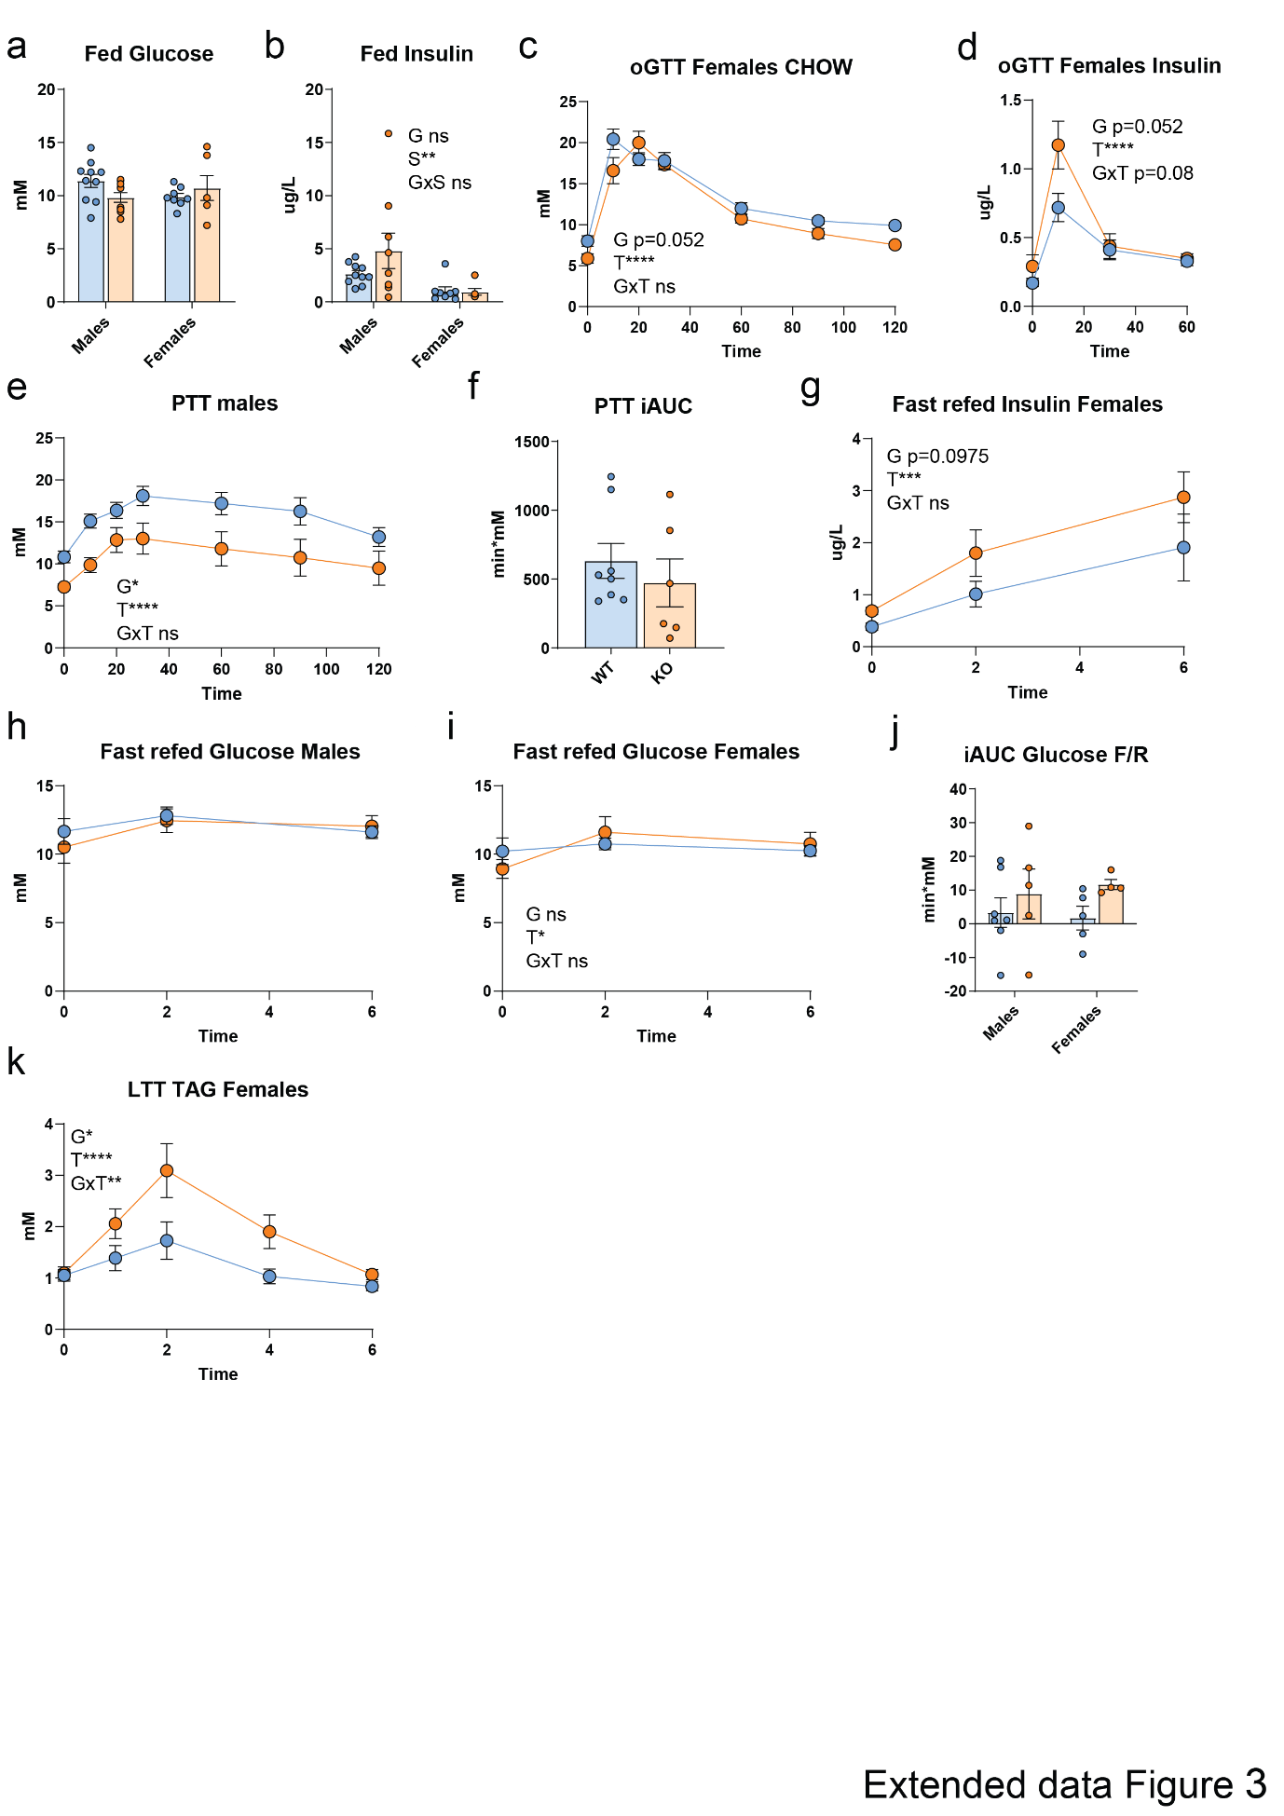
Extended Data Figure 3. Metabolic phenotyping of Cyb561-KO mice.
a, b, Fed blood glucose and insulin in chow-fed WT and KO mice (males: WT n=10, KO n=10 for glucose, 9 for insulin; females: WT n=8, KO n=6).
c, d, Glucose and insulin levels during oral glucose tolerance test (oGTT) in chow-fed female mice (WT n=8, KO n=6; insulin WT n=5, KO n=4).
e, f, Glucose levels during pyruvate tolerance test (PTT) in chow-fed WT and KO male mice (WT n=8, KO n=6).
g, Plasma insulin during fast–refed challenge in chow-fed females (WT n=5, KO n=4).
h-j, Blood glucose during fast–refed challenge (males: WT n=7, KO n=4; females: WT n=5, KO n=4).
k, Serum TAG during lipid tolerance test (LTT) in WT and Cyb561-KO female mice (WT n=9, KO n=7).
Data are mean ± SEM and analysed by two-way ANOVA (a-e, g-k) or Student’s t-test (f). G, genotype; S, sex; T, time. All mice phenotyped at 4–5 months.

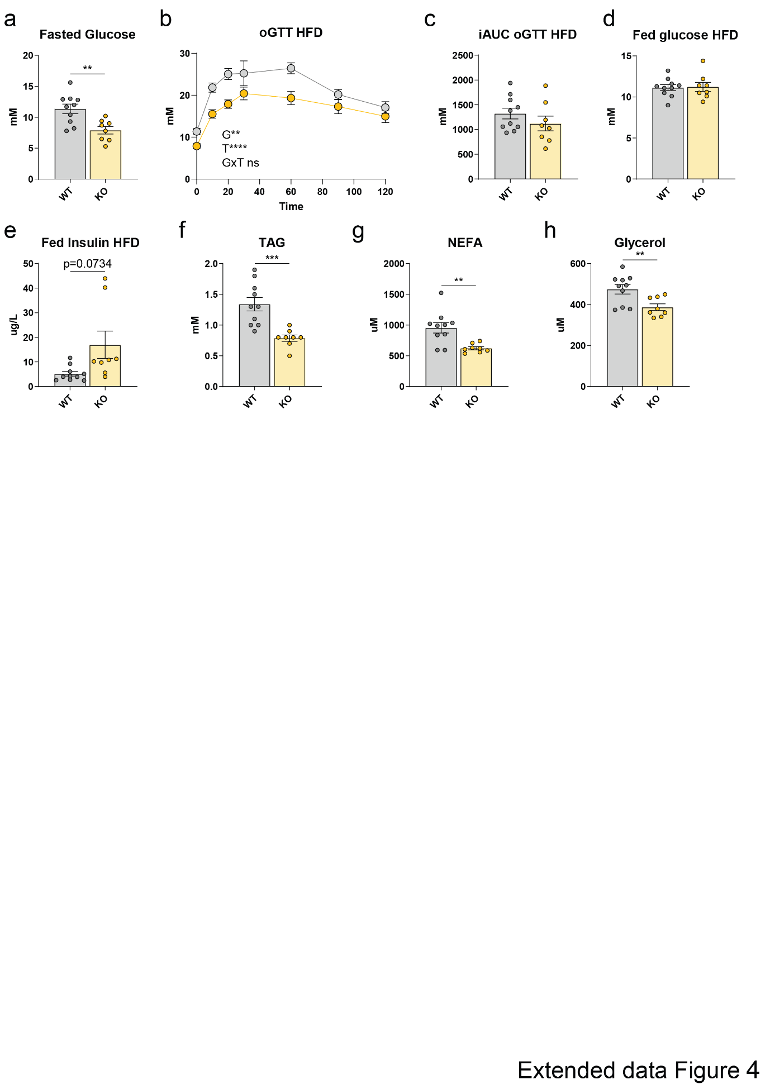
Extended Data Figure 4. HFD reveals insulin resistance in Cyb561-KO mice
a, Fasted glucose in WT and Cyb561-KO male mice fed high fat diet (HFD) (WT n=10, KO n=8).
b, c, Glucose levels during oral glucose tolerance test (oGTT) in WT and Cyb561-KO male on HFD (WT n=10, KO n=8).
d, e, Fed glucose and insulin levels in WT and Cyb561-KO male mice on HFD (WT n=10, KO n=8).
f-h, Serum TAG, NEFA, and glycerol in in WT and Cyb561-KO male mice on HFD (WT n=10, KO n=8).
Data are mean ± SEM and analysed by Student’s t-test (a, c-h) or two-way ANOVA (b). G, genotype; T, time. All mice phenotyped at 4–5 months.

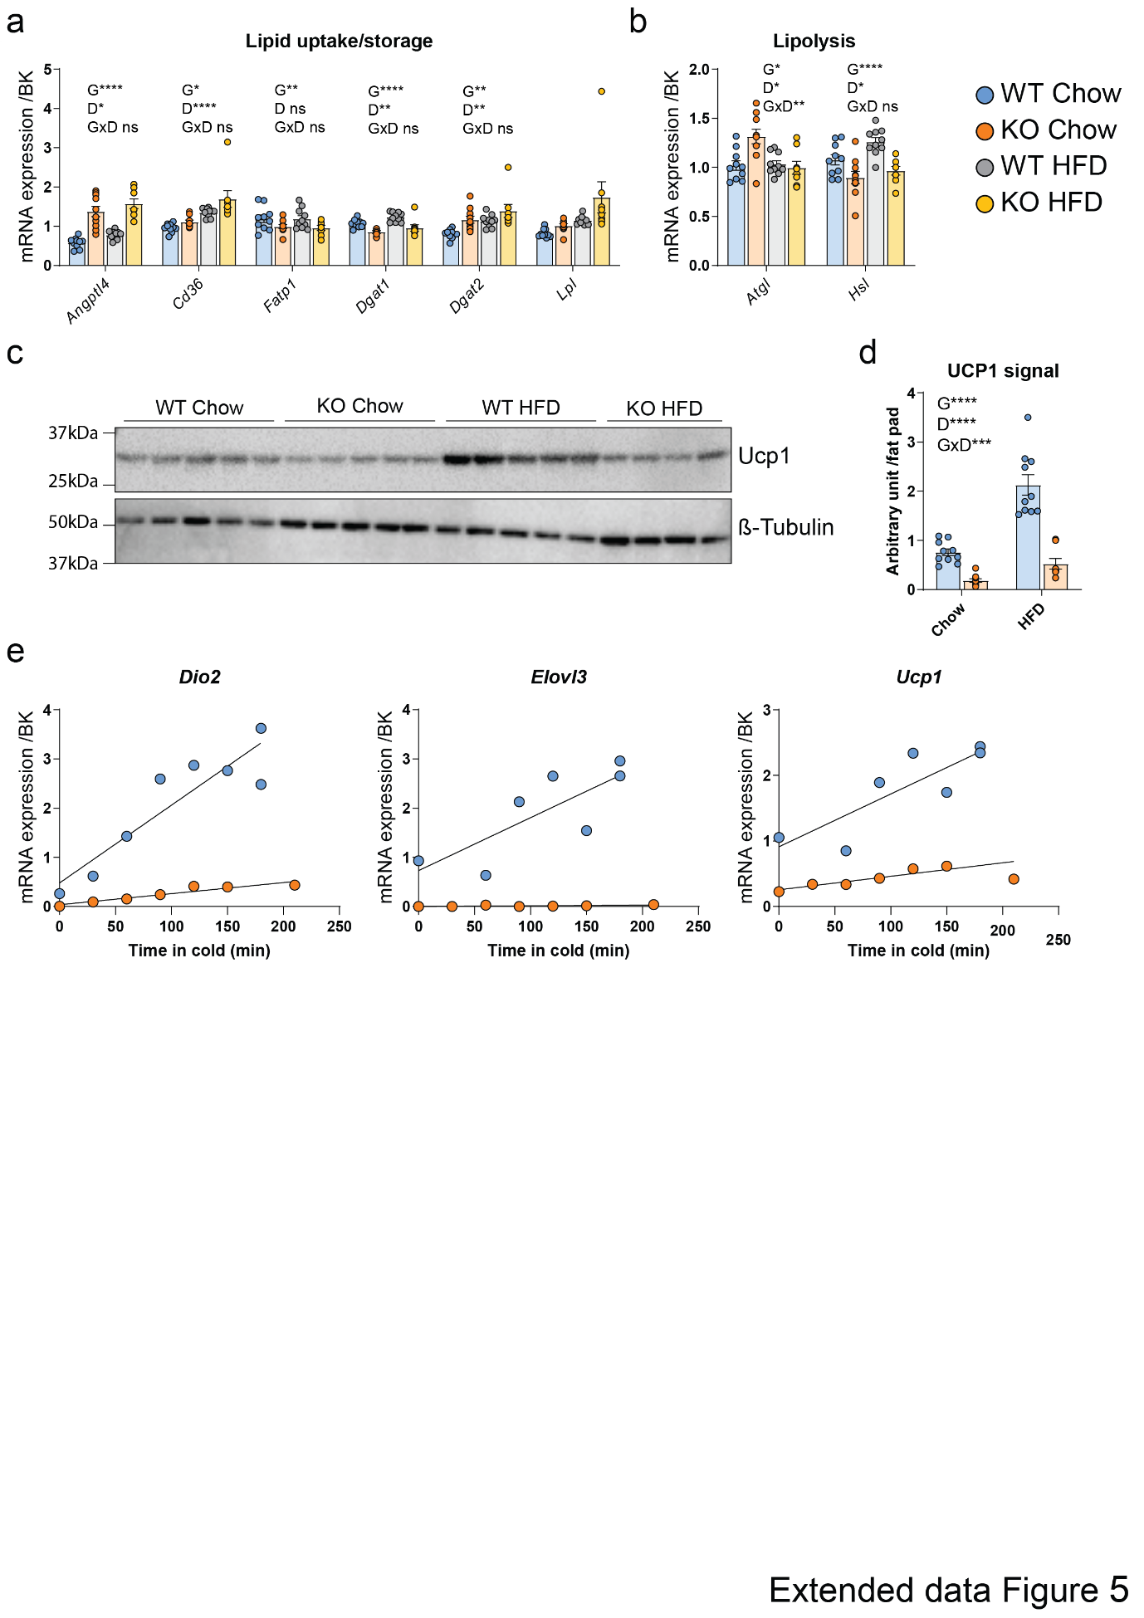
Extended Data Figure 5. Cyb561-KO mice show reduced BAT activity
a, b, Lipid uptake/esterification and lipolytic gene expression in BAT of chow- and HFD-fed WT and Cyb561-KO male mice (n = 10 per group, KO HFD n = 8).
c, d, Western blot and quantification of UCP1 protein per BAT pad in chow- and HFD-fed WT and Cyb561-KO male mice (n = 10 per group, KO HFD n = 8).
e, Thermogenic gene response to cold exposure; each dot represents an individual female mouse.
Data are mean ± SEM and analysed by two-way ANOVA (a-d) or linear regression analysis (e). G, genotype; D, diet. All mice phenotyped at 4–5 months.

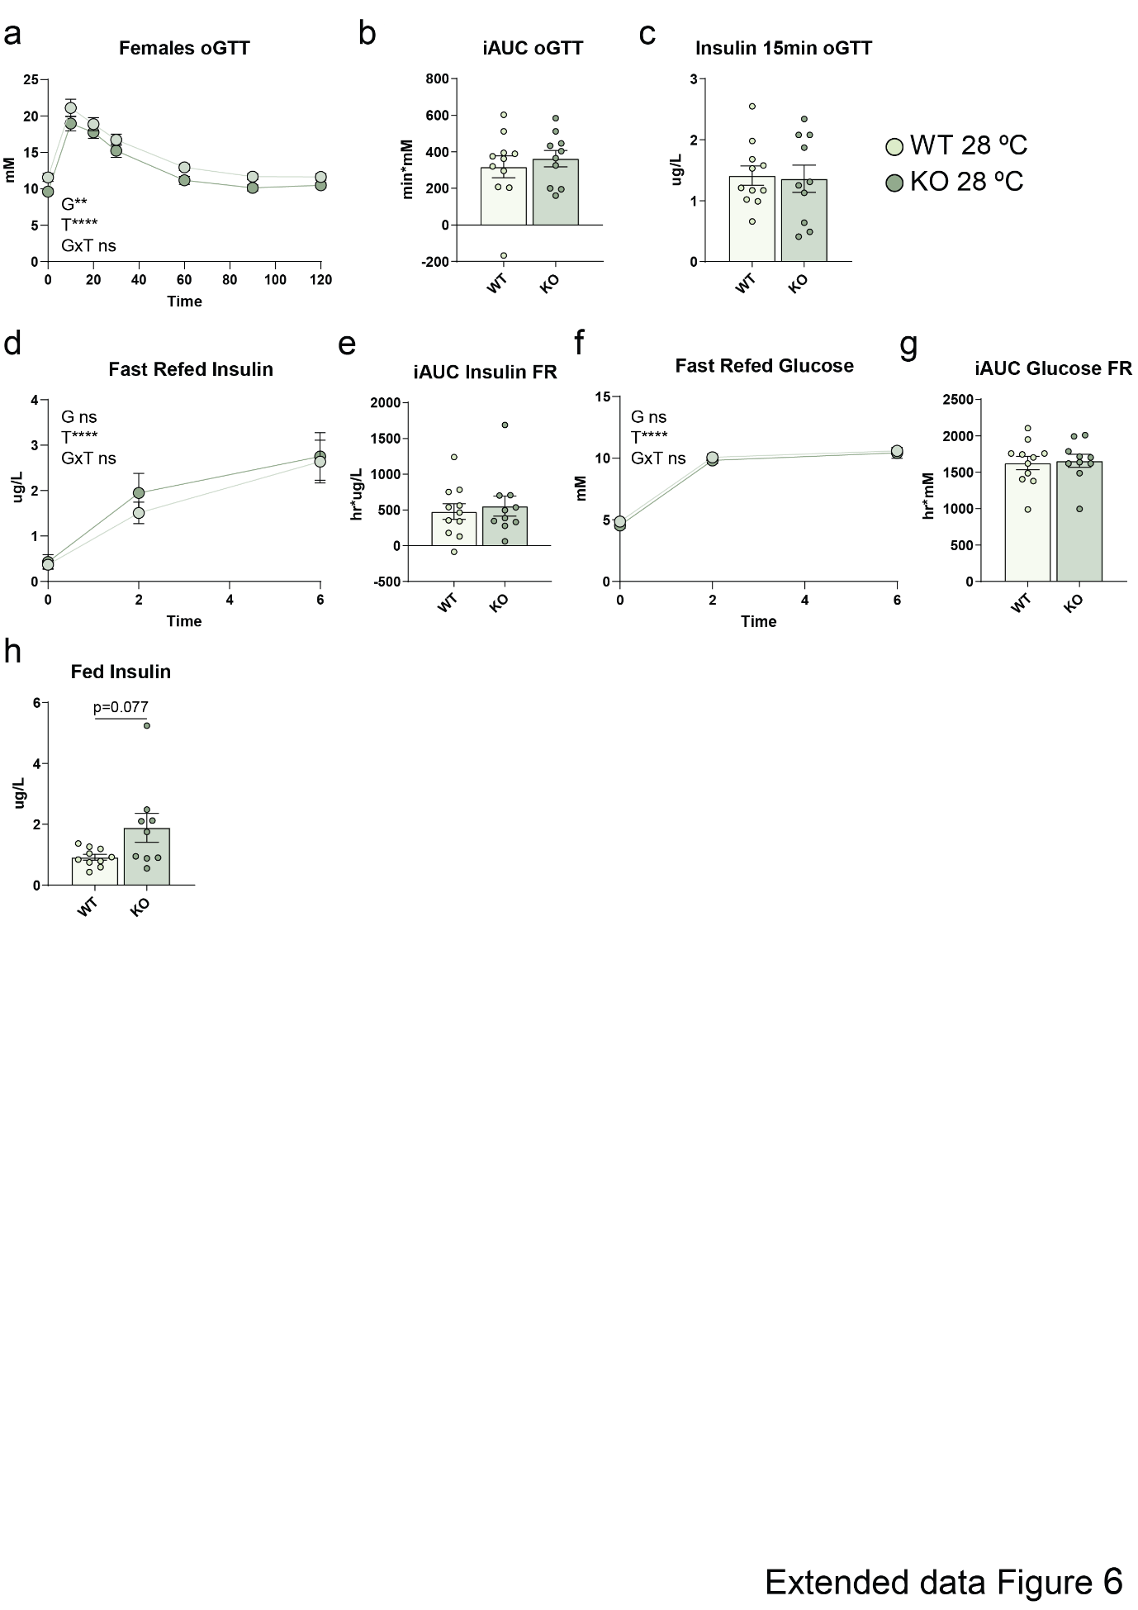

Extended Data Figure 6. Cyb561-KO mice are metabolically inflexible at 28°C
a, b, Glucose levels during oral glucose tolerance test (oGTT) in WT and Cyb561-KO female mice housed at 28°C (WT n=11, KO n=10).
c, Insulin levels 15 minutes post-glucose gavage in WT and Cyb561-KO female mice housed at 28°C (WT n=11, KO n=10).
e-g, Glucose and insulin levels during fast–refed challenge in WT and Cyb561-KO female mice housed at 28°C (WT n=11, KO n=10).
H, Fed insulin levels in WT and Cyb561-KO female mice housed at 28°C (WT n=11, KO n=10).
Data are mean ± SEM and analysed by two-way ANOVA (a, d, f) or by Student’s t-test (b, c, e, g, h). G, genotype; T, Time. All mice phenotyped at 4–5 months.

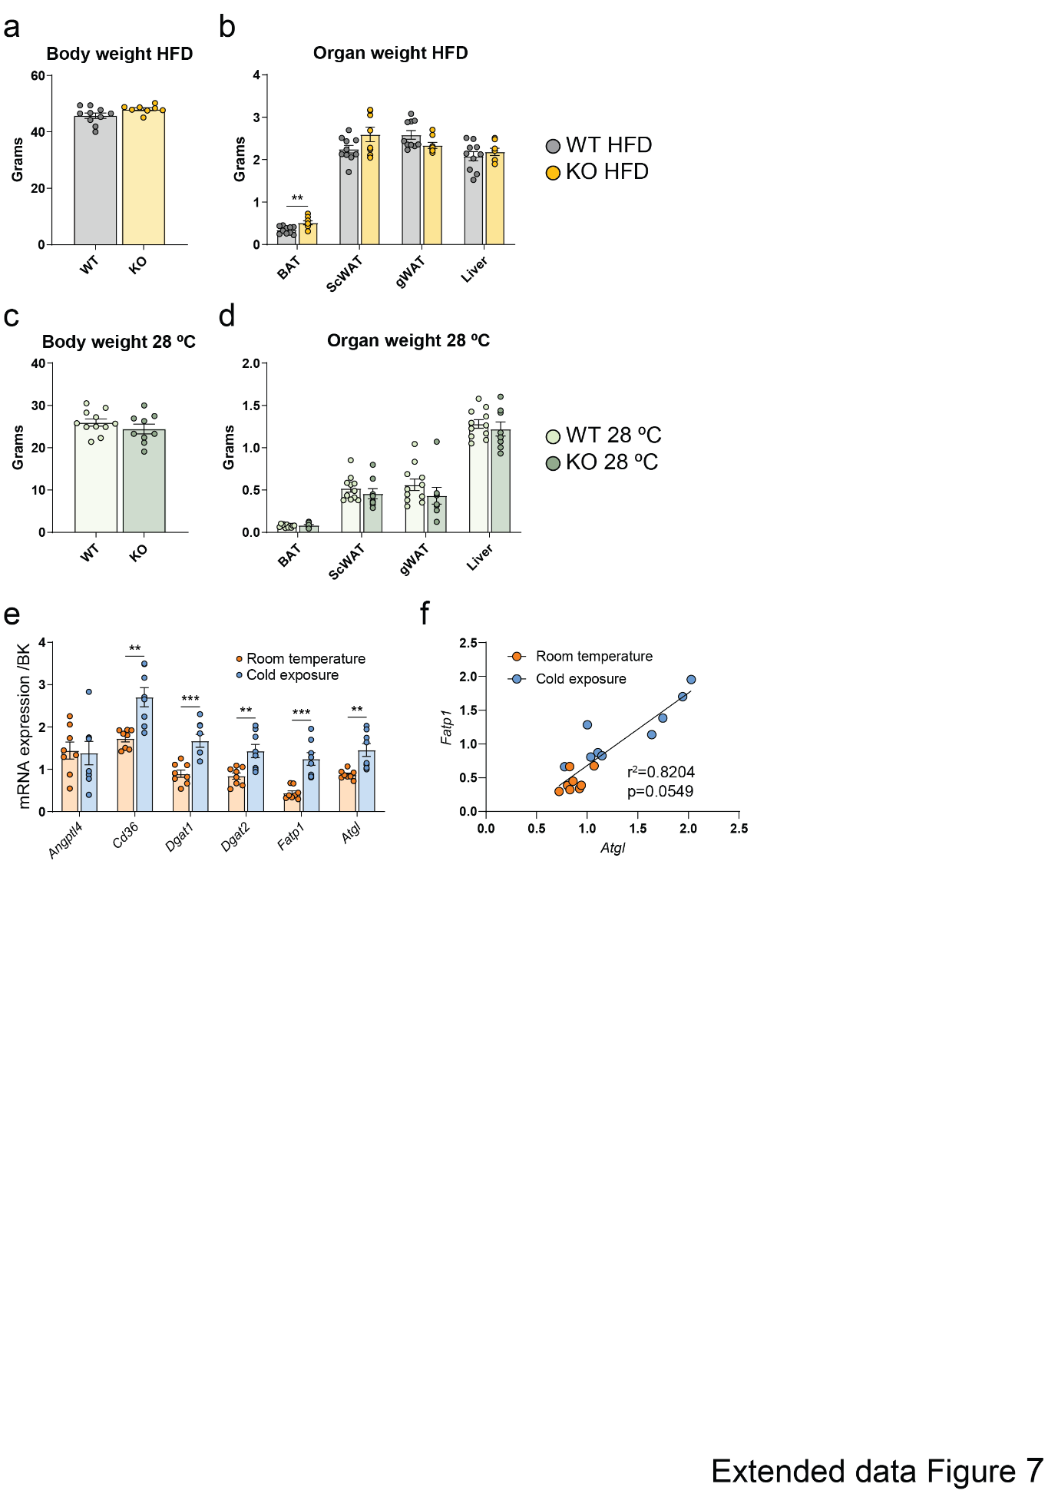
Extended Data Figure 7. Catecholamines coordinate lipid uptake and release in WAT.
a-d, Body and organ weights of WT and Cyb561-KO mice (male HFD: WT n=10, KO n=8; female 28 °C: WT n=11, KO n=10).
e, Lipid uptake/esterification and lipolytic gene expression in scWAT under cold (5°C) and room temperature (24°C) conditions (n=8).
f, Correlation between Atgl and Fatp1 in scWAT under cold (5°C) and room temperature (24°C) conditions.
Data are mean ± SEM and analysed by Student’s t-test (a-e) or linear regression analysis (f). All mice phenotyped at 4–5 months.

