Rebel Lexicons:
Annex A: List of 66 initialisms together with their meanings and circulation count.
A-1 Pinyin
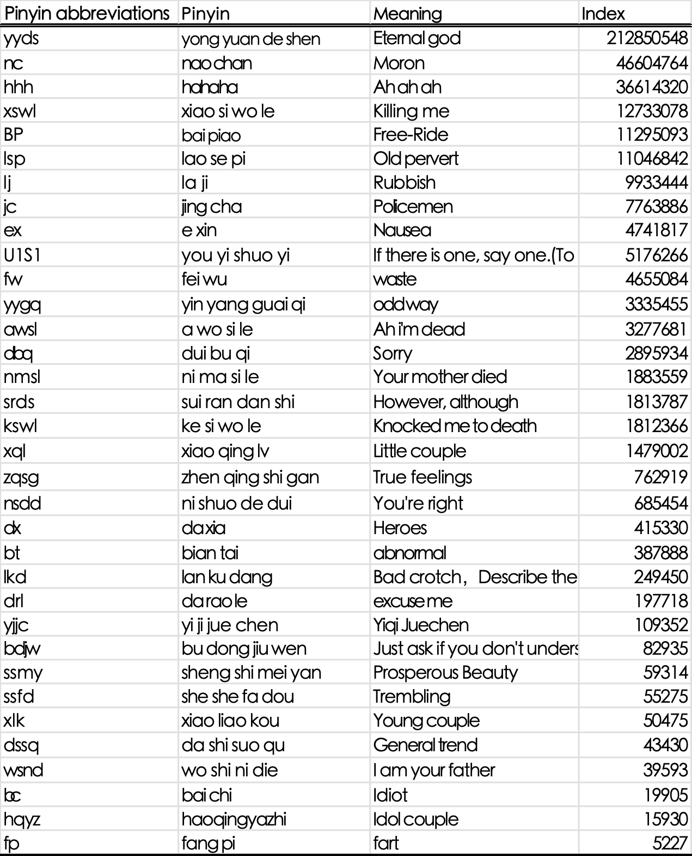

A-2 Others
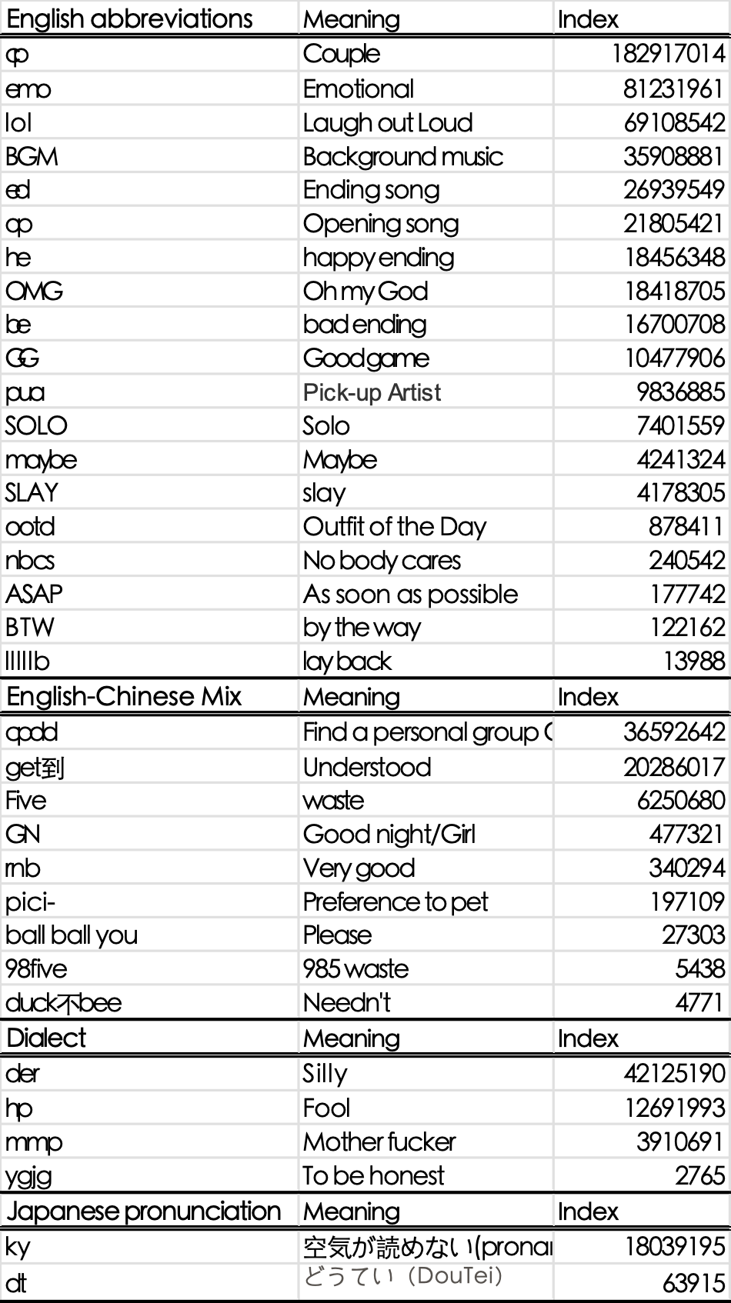

Annex B: Adoption intensity index.
Initialisms | View count | Bullet-comment count | Comment count | Like count | Coin count | Share count | Adoption intensity index
98five | 19071 | 43 | 216 | 259 | 371 | 146 | 3351
ASAP | 1014157 | 809 | 1499 | 10256 | 2323 | 2852 | 171983
awsl | 85389368 | 228252 | 125303 | 2227391 | 1107899 | 399979 | 14913032
ball ball you | 1768547 | 9060 | 6730 | 22091 | 18359 | 3262 | 304675
bc | 4493610 | 33236 | 17253 | 53912 | 51302 | 16889 | 777700
bdjw | 64629 | 350 | 144 | 1111 | 120 | 117 | 11079
be | 49652655 | 246304 | 87526 | 1173678 | 874264 | 289440 | 8720645
BGM | 102458155 | 266607 | 87523 | 3315718 | 2803871 | 383808 | 18219280
BP | 33498520 | 125595 | 93817 | 365464 | 402161 | 100589 | 5764358
bt | 11653557 | 67601 | 26761 | 173665 | 92174 | 41121 | 2009147
BTW | 798360 | 4872 | 3399 | 9043 | 5503 | 833 | 137002
cp | 33562419 | 316178 | 54423 | 945196 | 754987 | 157420 | 5965104
cpdd | 3157241 | 14984 | 6901 | 10508 | 8980 | 4670 | 533881
dbq | 3480839 | 15879 | 10906 | 69661 | 19728 | 13484 | 601750
der | 22868058 | 51780 | 33818 | 266555 | 164818 | 57854 | 3907147
drl | 304893 | 535 | 1548 | 7105 | 2255 | 7132 | 53911
dssq | 2000461 | 10985 | 6895 | 25223 | 9779 | 4257 | 342933
dt | 4834061 | 21456 | 14518 | 101862 | 43076 | 19842 | 839136
dx | 25203522 | 74282 | 50627 | 164506 | 171472 | 82213 | 4291104
ed | 114681807 | 340589 | 198488 | 3988378 | 3177706 | 597620 | 20497431
emo | 16867566 | 53718 | 15056 | 359314 | 275718 | 236457 | 2967972
ex | 52255441 | 161895 | 99066 | 538859 | 910046 | 223678 | 9031498
Five | 11268836 | 41302 | 19953 | 180552 | 75921 | 42833 | 1938233
fp | 4079402 | 12027 | 16905 | 106393 | 36947 | 24964 | 712773
fw | 37650360 | 61410 | 41512 | 283107 | 91997 | 216094 | 6390747
get到 | 21080699 | 89649 | 43488 | 365934 | 169508 | 53744 | 3633837
GG | 36944236 | 132150 | 67362 | 667717 | 154594 | 108650 | 6345785
GN | 2914606 | 23792 | 17318 | 19943 | 24630 | 10613 | 501817
he | 23337770 | 513992 | 54250 | 801304 | 452238 | 93085 | 4208773
hhh | 32787012 | 73604 | 31986 | 443930 | 169653 | 110326 | 5602752
hp | 51525951 | 248967 | 73205 | 2066962 | 1218961 | 297076 | 9238520
hqyz | 93167 | 545 | 323 | 3116 | 1558 | 592 | 16550
jc | 5440651 | 18635 | 16057 | 94424 | 64929 | 24001 | 943116
kswl | 12090809 | 32424 | 15618 | 146828 | 44670 | 28371 | 2059787
ky | 15399022 | 75126 | 31297 | 316436 | 173346 | 49785 | 2674169
lj | 2362996 | 3378 | 9129 | 19721 | 4109 | 3748 | 400514
lkd | 221567 | 398 | 745 | 2162 | 948 | 308 | 37688
lllllb | 250981 | 1197 | 1238 | 3704 | 2084 | 838 | 43340
lol | 7410358 | 24718 | 18686 | 60639 | 130900 | 25037 | 1278390
maybe | 12183905 | 45544 | 20830 | 129094 | 133987 | 46443 | 2093301
mmp | 7971468 | 16836 | 13345 | 30144 | 19468 | 13633 | 1344149
nbcs | 294295 | 1615 | 1244 | 4609 | 1552 | 1229 | 50757
nc | 8885424 | 85914 | 44574 | 98744 | 112190 | 40181 | 1544505
nmsl | 2022613 | 6165 | 8558 | 22894 | 10846 | 16318 | 347899
nsdd | 7123783 | 116892 | 70005 | 174612 | 189113 | 32783 | 1284531
OMG | 30480963 | 339738 | 89420 | 130981 | 180420 | 58083 | 5213268
ootd | 2552386 | 12064 | 6789 | 37419 | 19761 | 2845 | 438544
op | 232677579 | 612522 | 323529 | 6492924 | 7652441 | 1721893 | 41580148
pici- | 697 | 4 | 8 | 10 | 16 | 1 | 123
pua | 54862554 | 544824 | 186696 | 541812 | 909385 | 559257 | 9600755
rnb | 630310 | 918 | 3114 | 27234 | 9826 | 2331 | 112289
SLAY | 28360671 | 119127 | 46946 | 421191 | 204640 | 72073 | 4870775
SOLO | 1574094 | 22517 | 7000 | 42262 | 34242 | 7179 | 281216
srds | 766130 | 3542 | 2330 | 9529 | 3375 | 1654 | 131093
ssfd | 10824 | 2752 | 198 | 112 | 158 | 42 | 2348
ssmy | 187515 | 550 | 218 | 1507 | 204 | 138 | 31689
U1S1 | 16558200 | 63155 | 44650 | 159916 | 184515 | 25418 | 2839309
wsnd | 136125 | 482 | 569 | 1670 | 1347 | 231 | 23404
xlk | 353256 | 3622 | 1537 | 8274 | 3640 | 991 | 61887
xql | 11278197 | 32227 | 13000 | 336135 | 66900 | 36373 | 1960472
xswl | 25983240 | 48347 | 28420 | 249637 | 109336 | 96888 | 4419311
ygjg | 248 | 0 | 1 | 7 | 0 | 1 | 43
yjjc | 792468 | 7878 | 1895 | 8509 | 2215 | 2028 | 135832
yyds | 1914819 | 3172 | 1765 | 13500 | 11065 | 3568 | 324648
yygq | 7715500 | 47370 | 16487 | 124367 | 49163 | 15603 | 1328082
zqsg | 3258361 | 27036 | 9347 | 54680 | 26284 | 11594 | 564550

Annex C: Information fragmentation index.
 | Distribution across communities |  |  |  |  |  |  |  |  | Topic diversity
Initialisms | Fandom | Gaming | Daily life | Animation | Technology | Fashion | Sports | Others | Simpson’s index
ASAP | 98% | 0% | 1% | 0% | 0% | 0% | 0% | 0% | 0.05
rnb | 95% | 0% | 3% | 0% | 1% | 0% | 0% | 0% | 0.11
dx | 0% | 2% | 1% | 95% | 2% | 0% | 0% | 0% | 0.13
ex | 2% | 90% | 2% | 6% | 0% | 0% | 1% | 0% | 0.24
ootd | 1% | 0% | 9% | 0% | 0% | 89% | 0% | 0% | 0.24
kswl | 86% | 1% | 4% | 2% | 0% | 0% | 1% | 6% | 0.30
xql | 86% | 2% | 9% | 0% | 0% | 0% | 1% | 2% | 0.30
ky | 84% | 6% | 3% | 6% | 0% | 0% | 0% | 0% | 0.36
BP | 9% | 81% | 2% | 3% | 3% | 1% | 1% | 0% | 0.39
maybe | 16% | 77% | 2% | 3% | 1% | 0% | 1% | 1% | 0.44
nmsl | 1% | 77% | 16% | 1% | 0% | 0% | 1% | 2% | 0.45
yjjc | 80% | 0% | 17% | 0% | 2% | 0% | 2% | 0% | 0.45
bt | 5% | 76% | 7% | 4% | 6% | 0% | 0% | 0% | 0.47
cp | 75% | 6% | 11% | 5% | 0% | 0% | 1% | 2% | 0.50
OMG | 16% | 72% | 7% | 0% | 2% | 3% | 1% | 0% | 0.54
dssq | 2% | 70% | 13% | 13% | 0% | 0% | 2% | 1% | 0.57
SLAY | 69% | 12% | 3% | 1% | 1% | 12% | 2% | 0% | 0.57
ed | 64% | 2% | 4% | 25% | 1% | 1% | 1% | 2% | 0.59
SOLO | 66% | 18% | 8% | 3% | 2% | 0% | 1% | 1% | 0.60
lol | 3% | 65% | 7% | 15% | 7% | 1% | 1% | 1% | 0.63
wsnd | 6% | 63% | 23% | 1% | 2% | 1% | 4% | 0% | 0.63
he | 65% | 4% | 11% | 15% | 4% | 0% | 2% | 0% | 0.65
hqyz | 0% | 71% | 14% | 0% | 14% | 0% | 0% | 0% | 0.67
cpdd | 5% | 54% | 33% | 2% | 1% | 2% | 1% | 3% | 0.68
ssmy | 62% | 5% | 30% | 0% | 0% | 0% | 0% | 3% | 0.70
GG | 33% | 57% | 6% | 2% | 0% | 0% | 0% | 2% | 0.70
zqsg | 51% | 4% | 33% | 5% | 1% | 3% | 1% | 3% | 0.71
op | 49% | 8% | 4% | 37% | 1% | 1% | 0% | 1% | 0.71
hp | 60% | 11% | 4% | 13% | 12% | 0% | 0% | 1% | 0.72
lj | 55% | 25% | 13% | 1% | 5% | 0% | 2% | 0% | 0.73
get到 | 56% | 7% | 16% | 3% | 6% | 8% | 3% | 1% | 0.74
be | 55% | 6% | 23% | 13% | 2% | 0% | 1% | 0% | 0.74
BGM | 49% | 31% | 9% | 2% | 5% | 0% | 1% | 3% | 0.76
ball ball you | 25% | 50% | 9% | 3% | 7% | 1% | 3% | 1% | 0.77
dbq | 45% | 11% | 33% | 4% | 1% | 3% | 2% | 2% | 0.77
mmp | 14% | 54% | 12% | 8% | 4% | 0% | 6% | 3% | 0.78
xswl | 49% | 17% | 20% | 5% | 2% | 1% | 3% | 3% | 0.78
yygq | 32% | 38% | 24% | 3% | 1% | 0% | 0% | 1% | 0.79
srds | 39% | 22% | 32% | 2% | 1% | 1% | 0% | 2% | 0.79
bc | 15% | 48% | 17% | 3% | 7% | 0% | 8% | 2% | 0.83
lkd | 35% | 34% | 21% | 6% | 2% | 1% | 1% | 0% | 0.83
jc | 44% | 22% | 20% | 5% | 3% | 0% | 6% | 1% | 0.83
emo | 29% | 19% | 38% | 5% | 4% | 3% | 1% | 1% | 0.84
dt | 28% | 45% | 3% | 10% | 10% | 0% | 3% | 0% | 0.84
awsl | 20% | 20% | 13% | 43% | 1% | 2% | 0% | 1% | 0.84
ssfd | 9% | 44% | 21% | 12% | 3% | 3% | 6% | 3% | 0.84
bdjw | 50% | 11% | 22% | 0% | 11% | 0% | 0% | 6% | 0.84
Five | 43% | 22% | 16% | 13% | 3% | 1% | 2% | 0% | 0.84
hhh | 41% | 16% | 24% | 6% | 3% | 3% | 6% | 1% | 0.84
fw | 8% | 36% | 32% | 9% | 4% | 8% | 2% | 1% | 0.85
lllllb | 46% | 8% | 46% | 0% | 0% | 0% | 0% | 0% | 0.85
nsdd | 25% | 40% | 21% | 1% | 6% | 3% | 0% | 4% | 0.85
der | 27% | 14% | 38% | 4% | 7% | 7% | 2% | 2% | 0.86
U1S1 | 22% | 39% | 19% | 5% | 7% | 3% | 4% | 2% | 0.86
BTW | 27% | 25% | 31% | 5% | 4% | 7% | 2% | 1% | 0.87
pici- | 11% | 32% | 37% | 0% | 5% | 5% | 11% | 0% | 0.88
98five | 30% | 22% | 30% | 4% | 4% | 4% | 4% | 0% | 0.89
nbcs | 33% | 24% | 24% | 2% | 7% | 0% | 10% | 1% | 0.89
fp | 35% | 10% | 11% | 7% | 18% | 0% | 15% | 4% | 0.91
drl | 2% | 33% | 20% | 0% | 26% | 0% | 16% | 3% | 0.91
xlk | 19% | 31% | 13% | 1% | 19% | 10% | 1% | 5% | 0.91
pua | 26% | 8% | 22% | 8% | 26% | 5% | 1% | 5% | 0.92
GN | 5% | 23% | 10% | 32% | 19% | 2% | 11% | 0% | 0.92
yyds | 22% | 15% | 30% | 5% | 5% | 13% | 7% | 4% | 0.93
nc | 15% | 22% | 15% | 18% | 11% | 3% | 15% | 1% | 0.96
ygjg | 0% | 40% | 20% | 0% | 40% | 0% | 0% | 0% | 0.96

Annex D: Gender diversity index.
 | Gender distribution |  |  | Gender diversity |  | Gender distribution |  |  | Gender diversity
Initialisms | Undisclosed | Male | Female | Simpson’s index | Initialisms | Undisclosed | Male | Female | Simpson’s index
yyds | 38% | 27% | 35% | 0.99 | mmp | 44% | 46% | 10% | 0.88
emo | 41% | 25% | 33% | 0.98 | be | 56% | 18% | 26% | 0.87
der | 38% | 38% | 24% | 0.98 | BTW | 57% | 21% | 22% | 0.87
hqyz | 29% | 29% | 43% | 0.98 | dssq | 45% | 45% | 9% | 0.87
yygq | 39% | 23% | 37% | 0.98 | dt | 50% | 41% | 9% | 0.87
nc | 39% | 39% | 23% | 0.98 | ssfd | 44% | 47% | 9% | 0.86
pua | 44% | 25% | 32% | 0.97 | cpdd | 58% | 24% | 18% | 0.86
fp | 41% | 38% | 21% | 0.97 | cp | 51% | 8% | 40% | 0.85
pici- | 42% | 37% | 21% | 0.96 | ball ball you | 56% | 33% | 11% | 0.85
op | 41% | 38% | 21% | 0.96 | srds | 49% | 7% | 43% | 0.85
awsl | 46% | 31% | 23% | 0.96 | rnb | 39% | 52% | 8% | 0.85
jc | 44% | 20% | 36% | 0.96 | nmsl | 52% | 40% | 8% | 0.84
ed | 47% | 28% | 25% | 0.96 | xql | 43% | 5% | 51% | 0.82
lkd | 47% | 27% | 26% | 0.96 | ASAP | 59% | 9% | 32% | 0.82
bt | 37% | 45% | 19% | 0.95 | wsnd | 59% | 31% | 10% | 0.82
SLAY | 47% | 19% | 34% | 0.94 | GN | 57% | 36% | 8% | 0.82
hhh | 49% | 21% | 30% | 0.94 | GG | 62% | 22% | 16% | 0.81
he | 44% | 17% | 39% | 0.94 | nbcs | 63% | 22% | 15% | 0.80
Five | 51% | 24% | 25% | 0.93 | dbq | 55% | 5% | 40% | 0.80
BGM | 45% | 40% | 15% | 0.92 | lol | 60% | 33% | 7% | 0.79
maybe | 25% | 52% | 23% | 0.92 | kswl | 47% | 3% | 50% | 0.79
zqsg | 49% | 15% | 36% | 0.91 | dx | 52% | 47% | 1% | 0.76
get到 | 44% | 13% | 42% | 0.91 | drl | 57% | 42% | 1% | 0.74
U1S1 | 37% | 49% | 14% | 0.91 | ssmy | 65% | 5% | 30% | 0.73
SOLO | 54% | 25% | 21% | 0.91 | ex | 31% | 64% | 4% | 0.73
fw | 43% | 44% | 13% | 0.90 | yjjc | 63% | 2% | 36% | 0.72
nsdd | 49% | 38% | 13% | 0.90 | xlk | 69% | 19% | 12% | 0.72
BP | 44% | 44% | 12% | 0.90 | OMG | 68% | 24% | 8% | 0.71
ky | 46% | 12% | 42% | 0.90 | ootd | 24% | 4% | 72% | 0.63
hp | 45% | 11% | 43% | 0.89 | lj | 77% | 17% | 7% | 0.57
bdjw | 56% | 22% | 22% | 0.89 | 98five | 78% | 13% | 9% | 0.54
bc | 45% | 45% | 11% | 0.89 | lllllb | 77% | 0% | 23% | 0.53
xswl | 54% | 15% | 30% | 0.88 | ygjg | 0% | 80% | 20% | 0.48

