Supplemental Material

Supplementary Table 1: Comparison of some methods for containing pandemic
Approach | Pros | Cons
Vaccine | Immunized resistance | Slow to develop; limited to a specific infectious agent; mutations of the target pathogen can defeat a vaccine; possible side-effects³⁴
Directly sense the presence of infectious agent (e.g., surfaces, in the air, in the water, etc.) | Early warning of threat | Requires custom development; limited to a specific infectious agent; limited range; collecting samples to test can be labor-intensive³⁵
Contact tracing regarding proximity to positively-diagnosed individuals | Warning of exposure | Privacy issues; does not warn of contact with infected and contagious people who are not yet diagnosed; compliance problems³⁶
Symptom tracking | Pre-diagnosis warning of risk³⁷ | Before symptoms appear, people may have already been contagious and spreading infection to others for multiple days³⁸
Diagnostic testing of an individual sample | Diagnose infection in an individual³⁹ | Tests are narrowly specific to particular pathogens, and must be developed custom for each new type of infectious agent; there is a delay in development and deployment of tests; mutations of the pathogen can defeat the test; producing test results can take significant time; can be difficult and costly to administer; and must be frequently repeated⁴⁰
Diagnostic testing of pooled samples from multiple individuals | More economical than individual testing; a negative result can clear an entire group | (Similar 'Cons' as testing for individuals) if results are positive, the entire group must additionally be individually tested (so the delay for receiving results is doubled)⁴¹
Work remotely; work from home; general isolation | Prevent exposure | Multiple essential types of work cannot be done remotely; degraded productivity for many other types of work; social isolation negatively affects mental health⁴²
Screening for key indicators of infection: presence of symptoms, travel history, spot-check temperature | Screening of symptomatic or other high-risk individuals²⁵ | Does not identify people who are pre-symptomatic or asymptomatic; subjective; vulnerable to deception; can create crowded choke points that increase the risk of transmission⁴³
Personal protective equipment | Prevent the physical spread of pathogens | Widespread compliance is extremely difficult, especially for: individuals without symptoms, children, and disabled adults; and it is uncomfortable and interferes with normal activities like eating and social interaction⁴⁴
Physical barriers at key points of human-human interaction in the workplace | Prevent the physical spread of pathogens | Many types of human-human interaction take place in locations that are impractical to protect with barriers; partial barriers only offer partial protection⁴⁵
Hand sanitization methods | Removes pathogens from hands | Requires frequent repetition; no protection from airborne threats; no protection between sanitization events; inconvenient; widespread compliance is very difficult⁴⁶
Surface sanitization processes | Removes pathogens from surfaces | Infeasible on some surfaces; requires frequent repetition; can be labor-intensive; no protection from airborne threats; large-scale deployment is difficult⁴⁷
Social distancing | Reduces contact | Limited effectiveness; compliance is very difficult; does not prevent the deposition of pathogens in the environment⁴⁸
Context-based predictions – nexus | An estimation of general risk | Requires accurate information about the context; no identification of infected individuals; limited scope⁴⁹
Support for context | Decrease general risk by improving the context | Impractical for some contexts; difficult to maintain context change⁵⁰
Physiological monitoring with wearables and real-time machine learning to infer pre-symptomatic infection (the topic of this article) | Early warning of threat; potential early warning of unknown pathogens; effective with mobile workers | Compliance is somewhat challenging; dependent on the quality of the wearable device(s) deployed; Requires data for training/tuning a machine learning model
Supplementary Table 2: Summary of physiological measurements captured by the COTS devices
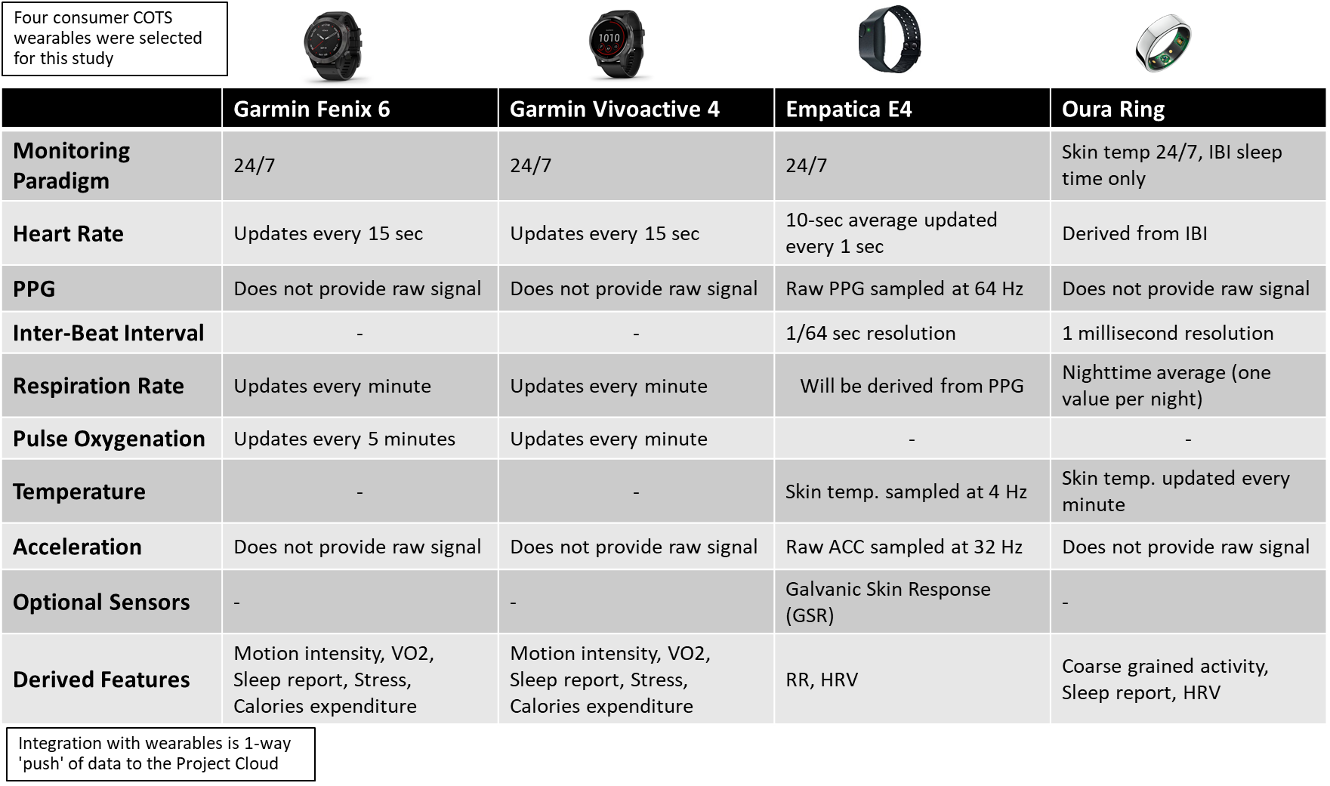

Supplementary Table 3: Daily survey questions. Note the responses outlined below – ‘>’ indicates ‘button’,‘●’ indicates radio button (single response only),‘□’ indicates checkbox (multiple options available).
Questions | Response options
Have you been tested for infection since the last time you completed this survey? (Regardless of whether the results are available yet.) | No new testing  ● Yes, I was tested for...  □ COVID-19, SARS-CoV-2  ● No symptoms  ● Feeling ill  □ Flu, influenza  ● No symptoms  ● Feeling ill  □ Strep throat  ● No symptoms  ● Feeling ill  □ Other bacterial  ● No symptoms  ● Feeling ill  □ Other viral  ● No symptoms  ● Feeling ill  □ Other fungal  ● No symptoms  ● Feeling ill  □ Other don't know  ● No symptoms  ● Feeling ill
When did you receive this test(s)? | ● Last 1-2 hours  ● Last 12 hours  ● Last 24 hours  ● More than 24 hours  ● I’m not sure
Have you received results of a test(s) for infection that you have not yet reported here? | No new results >  ● Yes, I received results of testing for...  □ COVID-19 (SARS-CoV-2) test results  ● Positive – no symptoms  ● Positive – feeling ill  ● Negative  □ Flu (influenza) test results  ● Positive – no symptoms  ● Positive – feeling ill  ● Negative  □ Strep throat test results  ● Positive – no symptoms  ● Positive – feeling ill  ● Negative  □ Other bacterial test results  ● Positive – no symptoms  ● Positive – feeling ill  ● Negative  □ Other viral test results  ● Positive – no symptoms  ● Positive – feeling ill  ● Negative  □ Other fungal test results  ● Positive – no symptoms  ● Positive – feeling ill  ● Negative  □ Other don't know test results  ● Positive – no symptoms  ● Positive – feeling ill  ● Negative
When did you receive the result(s)? | ● Last 1-2 hours  ● Last 12 hours  ● Last 24 hours  ● More than 24 hours  ● I’m not sure
Have you felt any symptoms since the last time you completed this survey? | No new symptoms >  ● Yes, I have had symptoms...  □ Fever  ● Under 99.1 F (37.3 C)  ● 99.1-100.4 F (37.3-38.0C)  ● 100.5-102.2 F (38.1-39.0 C)  ● Over 102.2 F (39.0 C)  □ Cough  □ Shortness of breath or difficulty breathing  □ Chills  □ Repeated shaking with chills  □ Muscle pain  □ Headache  □ Sore throat  □ New loss of taste of smell  □ Fatigue  □ Sputum, congestion, runny nose  □ Other
When did you first start feeling these symptoms? | ● Last 1-2 hours  ● Last 12 hours  ● Last 24 hours  ● More than 24 hours  ● I’m not sure
Have you taken any medications or received any vaccinations since you reported last? | ● Yes, new medications or vaccinations...  □ COVID Vaccine  - Moderna (1st of 2)  - Moderna (2nd of 2)  - Pfizer (1st of 2)  - Pfizer (2nd of 2)  - Other single dose vaccine  - Other 2 dose vaccine (1st of 2)  - Other 2 dose vaccine (2nd of 2)  □ Advil®, Motrin® (ibuprofen)  □ Tylenol® (acetaminophen)  □ Aspirin (acetylsalicylic acid)  □ DayQuil®, NyQuil® (Cold & Flu)  □Benadryl®(antihistamine, diphenhydramine)  □ Sudafed® (pseudoephedrine)  □ Antibiotics  □ Other medication  □ Flu shot, influenza vaccination  □ Other vaccination
When did you take these medications or receive these vaccinations? | ● Last 1-2 hours  ● Last 12 hours  ● Last 24 hours  ● More than 24 hours  ● I’m not sure

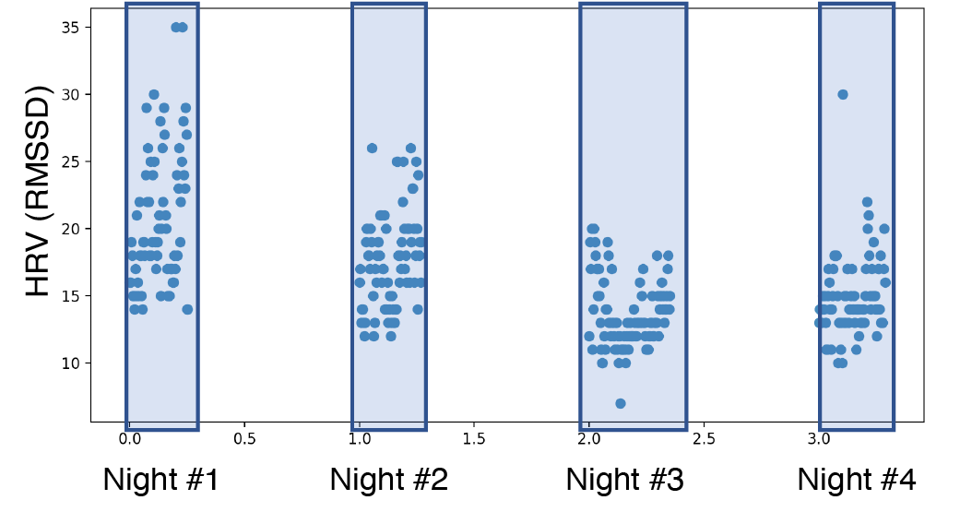
Supplementary Figure 1: Illustration of heart-rate variability (RMSSD) data after sleep period segmentation.

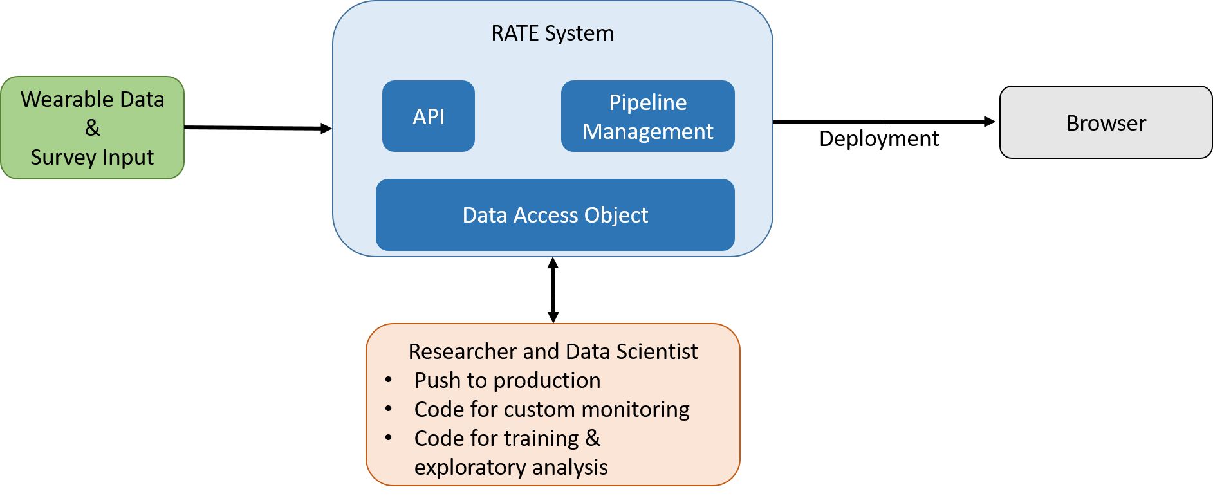
Supplementary Figure 2: The study platform was designed to facilitate efficient development and deployment of new machine learning models into the runtime execution environment.

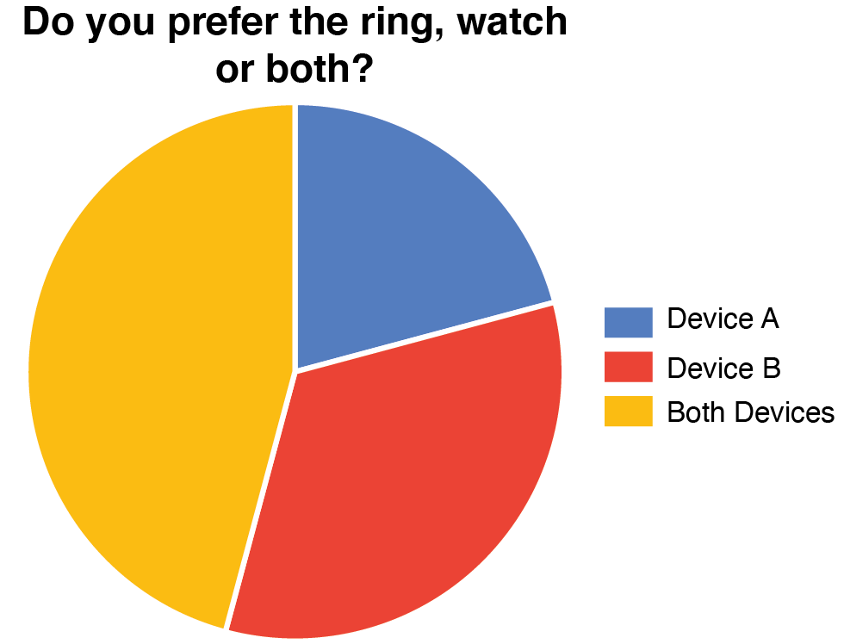
Supplementary Figure 3a: Survey results (Most responses were collected in March 2021). Principal investigators (24) commented about their preference for selection of wearable(s) for use with the RATE service. The actual survey question was, "Do you prefer the ring, watch or both?" Responses of "watch" or "ring" are commercially-sensitive and coded here without a key as "Device A" and "Device B." Results highlight a strong individual differences effect with no clear one-size-fits-all wearable solution. About 46% responded that they prefer both, and the remaining 54% disagree over which single wearable they favor.

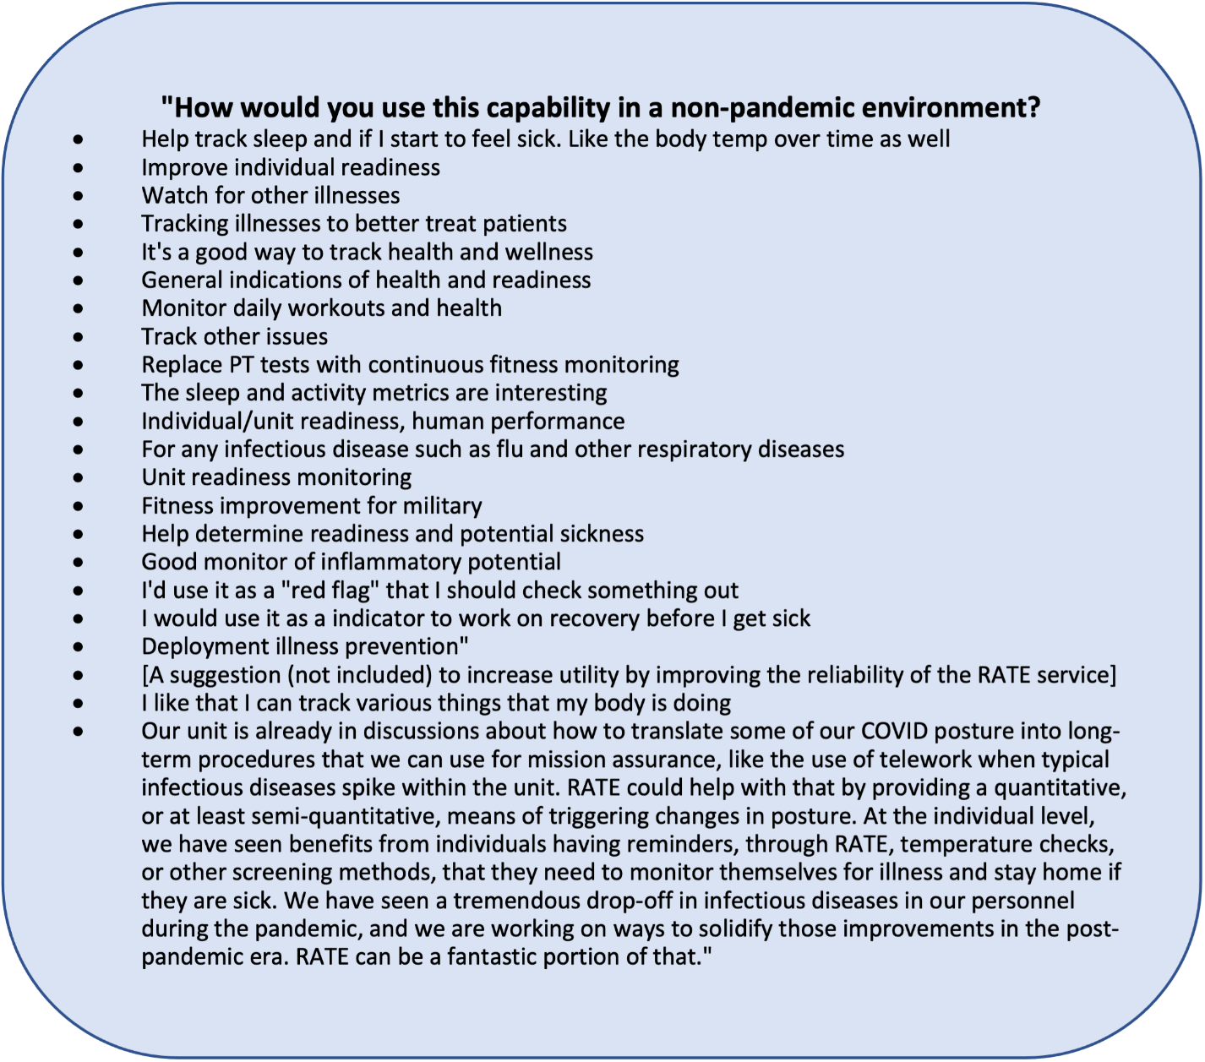
Supplementary Figure 3b: Survey results (Most responses were collected in March 2021). Principal investigators (24) were asked to share their ideas for future use of RATE after the end of the current COVID-19 pandemic. The actual survey question was,, "How would you use this capability in a non-pandemic environment?" Results highlight the broad potential utility for RATE in supporting maintenance of workforce readiness. Ideas for use include general monitoring, tracking, and early warning for physiological changes related to: infection, physical fitness, activity, wellness, health, and illness.

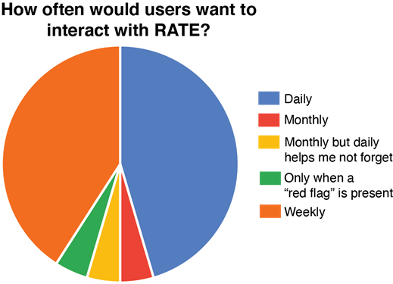
Supplementary Figure 3c: Survey results (Most responses were collected in March 2021). Principal investigators (24) commented about their preference for how often they would like to use the RATE UI for principal investigators (the "RATE Tracker Dashboard"). This question was asked within the context of an envisioned future version of the RATE UIs that alerts users to important changes with a 'push' interaction (something not included in the version used for this study). The actual survey question was, "How often would users want to interact with RATE?" From this context of a future 'push' capability, the question being asked could be more precisely described as, "If the RATE UI continuously alerted you to important changes, how often would you like to additionally open the RATE UI and review the information?" Results highlight a strong individual differences effect with about 86% of respondents indicating either "Daily" or "Weekly.
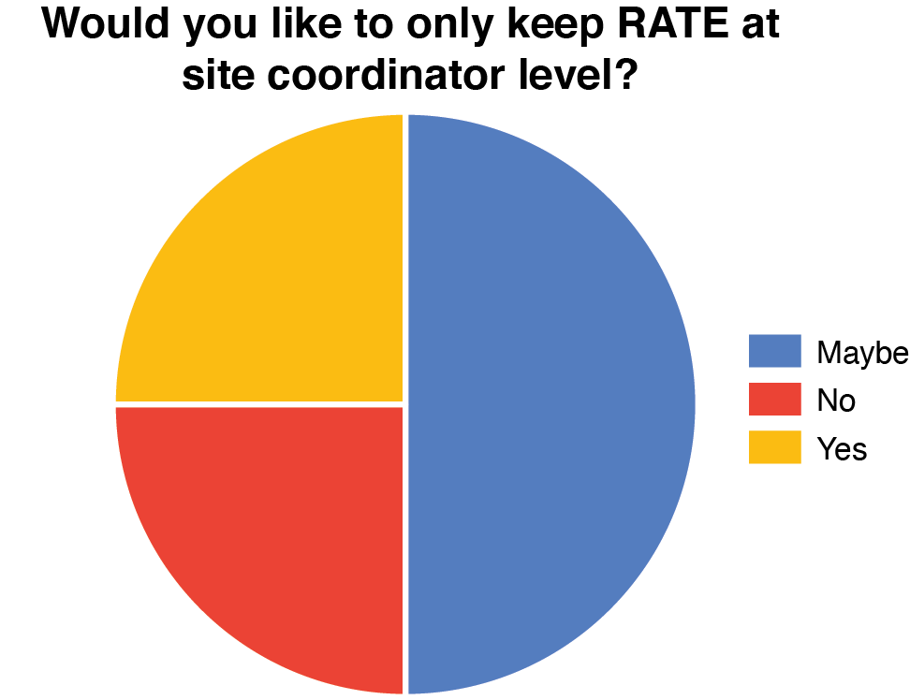
Supplementary Figure 3d: Survey results (Most responses were collected in March 2021). Principal investigators (24) commented about their preference for whether to enable individual military servicemembers to use the RATE UI (the "RATE Tracker" UI), as was the case for this study. The actual survey question was, "Would you like to only keep RATE at site coordinator level?" Results highlight a strong individual differences effect with disagreement on this question.

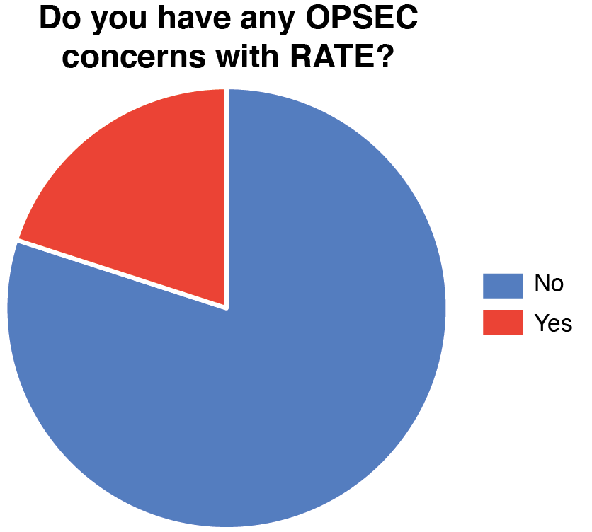
Supplementary Figure 3e: Survey results (Most responses were collected in March 2021). Principal investigators (24) commented about whether they had concerns about the operational security (OPSEC) relative to using the RATE service. The actual survey question was, "Do you have any OPSEC concerns with RATE?" Results highlight that most respondents (80%) had no OPSEC concerns for the use of RATE. This is a strong positive result given the US military's extreme sensitivities and requirements for high OPSEC.

