Impacts of the pest wood-boring beetle, Eupromus ruber, on Lauraceae species in temperate coastal forests

Ryota Asano 1, 2*, Makoto Nakata 3, Akihiro Nakamura 4, Tomohiro Yoshida 5

1 Department of Child Education and Welfare, Shiraume Gakuen College, Kodaira, Tokyo 187-8570, Japan
2 United Graduate School of Agricultural Science, Tokyo University of Agriculture and Technology, Fuchu, Tokyo, 183-8509, Japan
3 Faculty of Agriculture, Niigata University, Nishi-ku, Niigata 950–2181, Japan
4 Yunnan Key Laboratory of Forest Ecosystem Stability and Global Change Response, Xishuangbanna Tropical
Botanical Garden, Chinese Academy of Sciences, Menglun, Mengla, Yunnan 666303, China
5 Field Science Center, Faculty of Agriculture, Tokyo University of Agriculture and Technology, Fuchu, Tokyo,
183-8509, Japan

* Corresponding author
E-mail addresses: r-asano@shiraume.ac.jp (R. Asano)

Email addresses of all the authors
Ryota Asano: r-asano@shiraume.ac.jp
Makoto Nakata: nakata@agr.niigata-u.ac.jp
Akihiro Nakamura: canopy.aki@gmail.com
Tomohiro Yoshida: yoshitom@cc.tuat.ac.jp

Appendix
Supplementary materials

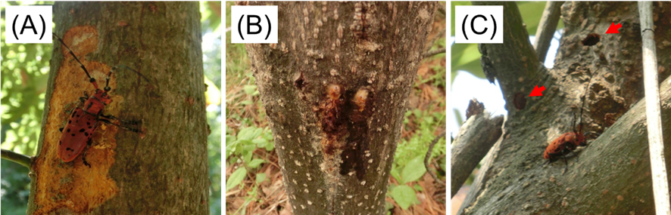
Appendix Fig.1 Characteristics of trees affected by Eupromus ruber. (A) Ovipositing Eupromus ruber female and the formation of oviposition scars, (B) frass produced by larvae, and (C) exit holes and newly emerged Eupromus ruber adult.

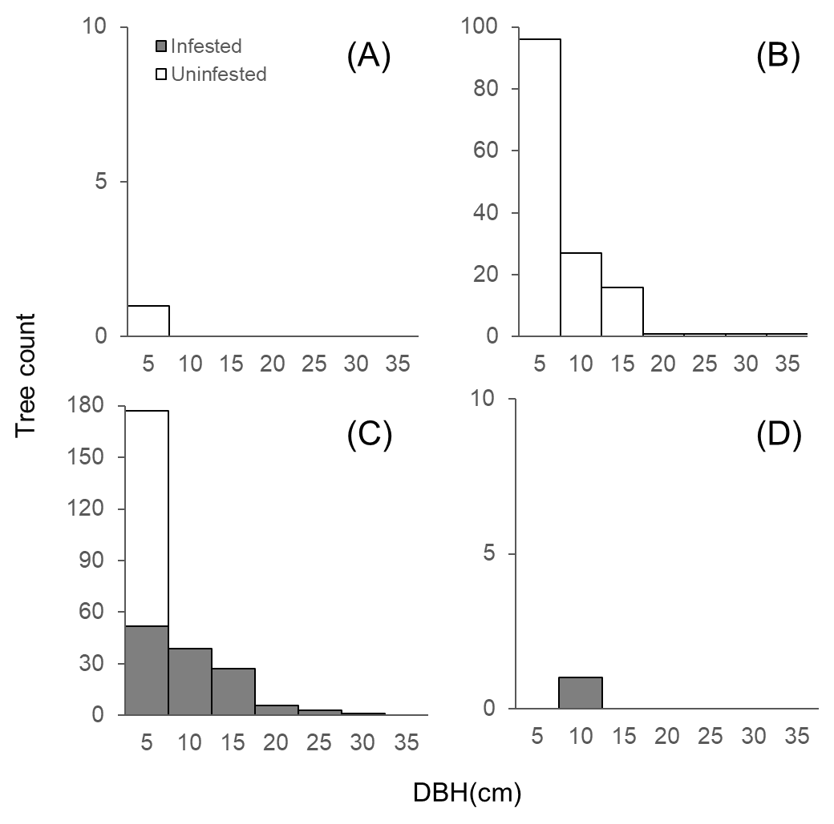
Appendix Fig.2 Distribution of tree count by tree size (DBH) classes and presence of Eupromus ruber infestation in (A) Laurus nobilis, (B) Neolitsea sericea, (C) Machilus thunbergii, and (D) Cinnamomum japonicum. Trees are grouped into those with and without infestation.

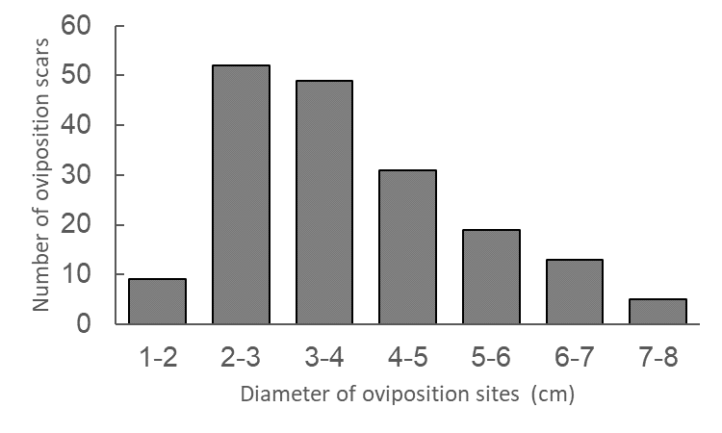
Appendix Fig.3 Diameter distribution of oviposition sites (branches or stems) of Eupromus ruber.

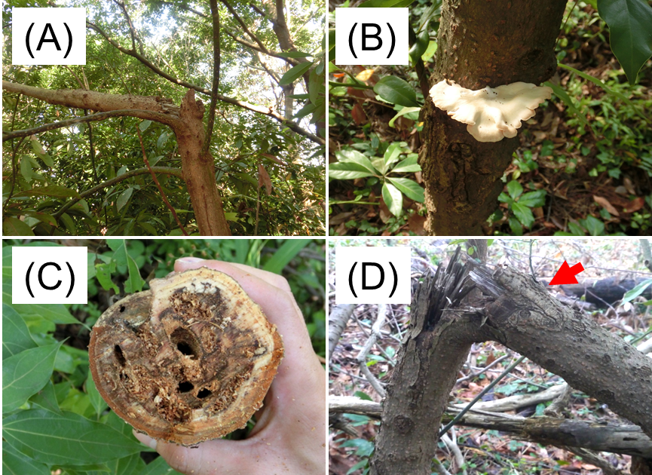
Appendix Fig.4 Damage to Machilus thunbergii by Eupromus ruber: (A) broken Machilus thunbergii tree, (B) Machilus thunbergii tree with fruiting bodies of decay fungi, (C) boring marks of Eupromus ruber larvae at the broken area, and (D) oviposition marks of Eupromus ruber at the broken area.
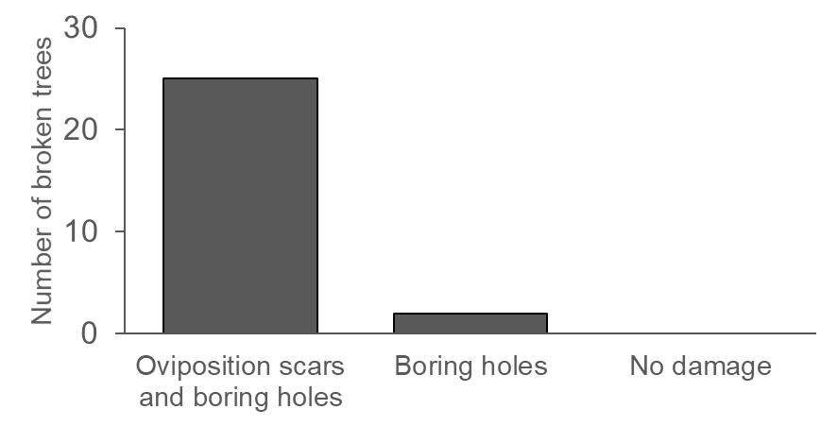
Appendix Fig.5 The number of trees with stem breakages that sustained oviposition scars and boring holes by Eupromus ruber. Note that all trees with stem breakage sustained oviposition scars or boring holes.

