Supplementary information

Atomic-Level Insights into Singlet Oxygen-Induced Catalyst Degradation in Li-CO₂ Batteries

Tianchen Wei^{1#}, Hang Wang^{1#}, Cong Han¹, Yuchun Liu¹, Jing Zhang¹, Xingwu Zhai¹, Leyi Su¹, Zhaodi Fan¹, Chenglong Peng¹, Chengjie Lu^{2*}, and Min Zhou^{1*}

¹Hefei National Laboratory for Physical Sciences at the Microscale, School of Chemistry and Materials Science, University of Science and Technology of China, Hefei, Anhui, 230026 P. R. China
²Jiangsu Key Laboratory of Advanced Structural Materials and Application Technology, School of Materials Science and Engineering, Nanjing Institute of Technology, Nanjing 211167, P. R. China

E-mail: mzchem@ustc.edu.cn; lucj008@hotmail.com

Table of Contents
Supplementary Fig. 1 Mechanism of ¹O₂ trapping by 4-Oxo-TEMP | 1
Supplementary Fig. 2 Parameters of pre-discharged electrode for in situ EPR and UV-vis | 2
Supplementary Fig. 3 EPR spectra of the 0 h and 24 h electrolyte with 0.1 M 4-oxo-TEMP | 3
Supplementary Fig. 4 UV-vis absorption spectra and Fitting curve | 4
Supplementary Fig. 5 Schematic diagram of the in situ UV-vis and EPR testing device | 5
Supplementary Fig. 6 UV-vis absorption spectra of DMA in electrolyte | 6
Supplementary Fig. 7 SEM images of the catalyst | 7
Supplementary Fig. 8 TEM and HRTEM images of the catalyst | 8
Supplementary Fig. 9 Bending Energy of Flat-, Defective (Up)- and Defective (Down)-TMC | 9
Supplementary Fig. 10 XRD patterns of LA-TMC, MA-TMC and HA-TMC | 10
Supplementary Fig. 11 Raman spectra of LA-TMC, MA-TMC and HA-TMC | 11
Supplementary Fig. 12 CV curves of LA-TMC, MA-TMC and HA-TMC | 12
Supplementary Fig. 13 CV curves of HA-TMC (first and second cycle) | 13
Supplementary Fig. 14 GDC curves of LA-TMC | 14
Supplementary Fig. 15 GDC curves of MA-TMC | 15
Supplementary Fig. 16 GDC curves of HA-TMC | 16
Supplementary Fig. 17 Energy efficiencies of LA-TMC, MA-TMC and HA-TMC | 17
Supplementary Fig. 18 Cycling performance of LA-TMC, MA-TMC and HA-TMC at 20 μA cm⁻² | 18
Supplementary Fig. 19 Cycling performance of LA-TMC, MA-TMC and HA-TMC at 100 μA cm⁻² | 19
Supplementary Fig. 20 Cycling performance of LA-TMC, MA-TMC and HA-TMC at 200 μA cm⁻² | 20
Supplementary Fig. 21 Energy Efficiency at various current densities for different cycle numbers | 21
Supplementary Fig. 22 The Rct results fitted from EIS at different cycling stages | 22
Supplementary Fig. 23 Deep discharge curves to 2.4 V and subsequent recharge curves | 23
Supplementary Fig. 25 Electrochemical performance comparison of reversible capacity | 24
Supplementary Fig. 25 Ti K-edge XANES of LA-TMC, MA-TMC and HA-TMC | 25
Supplementary Fig. 26 SEM images at pristine state and after 10th discharge, 10th charge, 100th charge | 26
Supplementary Fig. 27 XRD patterns of LA-TMC, MA-TMC and HA-TMC electrodes after 10th discharge | 27
Supplementary Fig. 28 GDC curves of in situ Raman based on LA-TMC, MA-TMC and HA-TMC electrodes | 28
Supplementary Table 1. Electrochemical performance comparison of cycle time, initial charge voltage and polarization charge voltage among reported catalysts | 29
Supplementary Table 2. Resistance of electrodes at different cycling stages, calculated from EIS simulations | 30
Supplementary Table 3. Parameters of discharge capacity and recharge capacity | 31
Supplementary Table 4. Electrochemical performance comparison of reversible capacity | 32

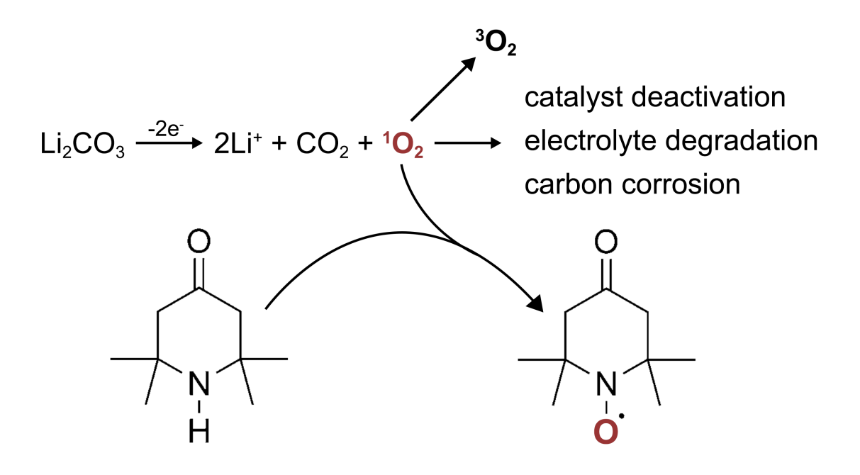
Supplementary Fig. 1 Mechanism of ¹O₂ trapping by 2,2,6,6-tetramethyl-4-piperidone (4-Oxo-TEMP). The reaction between 4-Oxo-TEMP and ¹O₂ forms a stable 4-Oxo-2,2,6,6-tetramethyl-1-piperidinyloxy (4-Oxo-TEMPO) radical, which is detected via EPR spectroscopy. The trapping reaction kinetically competes with ¹O₂ relaxation to ³O₂ and other side reactions, necessitating high 4-Oxo-TEMPO concentrations (0.1 M) in the electrolyte as a trapping agent.
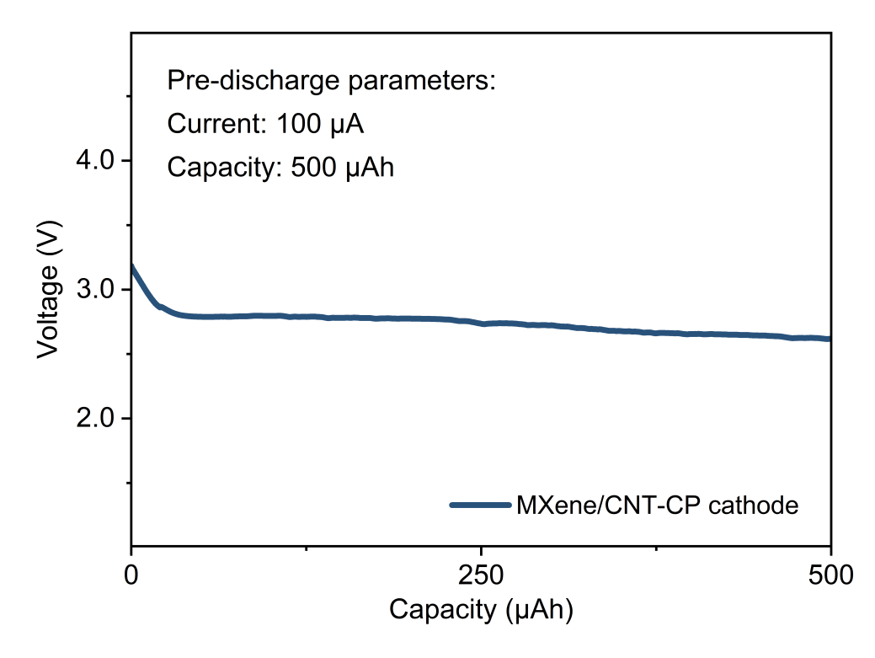
Supplementary Fig. 2 Parameters of pre-discharged electrode for in situ Electron Paramagnetic Resonance (EPR) and Ultraviolet-Visible Spectroscopy (UV-vis): The electrode was 1 cm² MXene/CNT-carbon paper (CP) with the mass loading of 5 mg cm⁻². The pre-discharge procedure involved discharging at 100 μA for 5 h in standard electrolyte. The discharge capacity was set to five times the charge capacity to maximize EPR signal intensity. Pre-discharged electrode for subsequent in situ UV-vis was prepared under identical parameters.
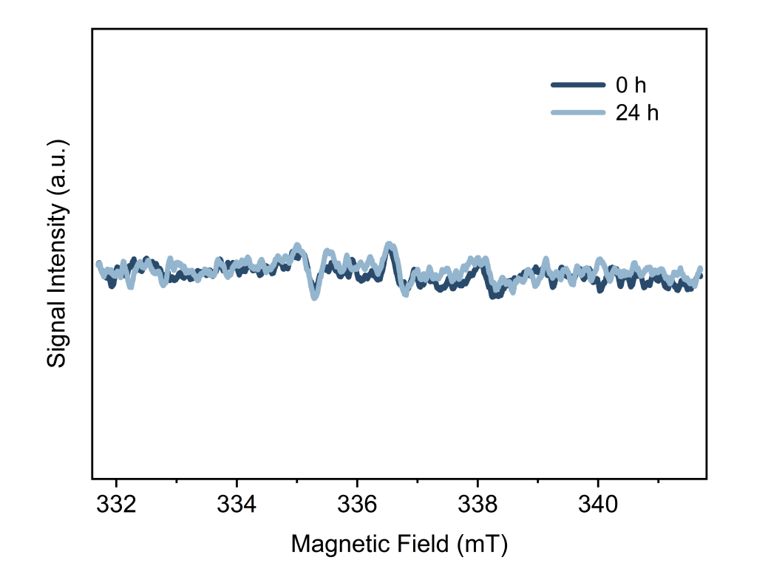
Supplementary Fig. 3 EPR spectra of the 0 h and 24 h electrolyte with 0.1 M 4-oxo-TEMP. The 24 h electrolyte with 0.1 M 4-oxo-TEMP extracted from an Ar-protected cell using few-layer Ti₃C₂T_{x} MXene/CNT as cathode after 24-hour aging. The EPR spectrum of the 0 h electrolyte shows a weak 1:1:1 triplet signature from 4-Oxo-TEMPO impurity; this does not affect trend analysis. After 24 h the triplet intensity is unchanged, indicating no redox reaction between the catalyst and 4-Oxo-TEMP.
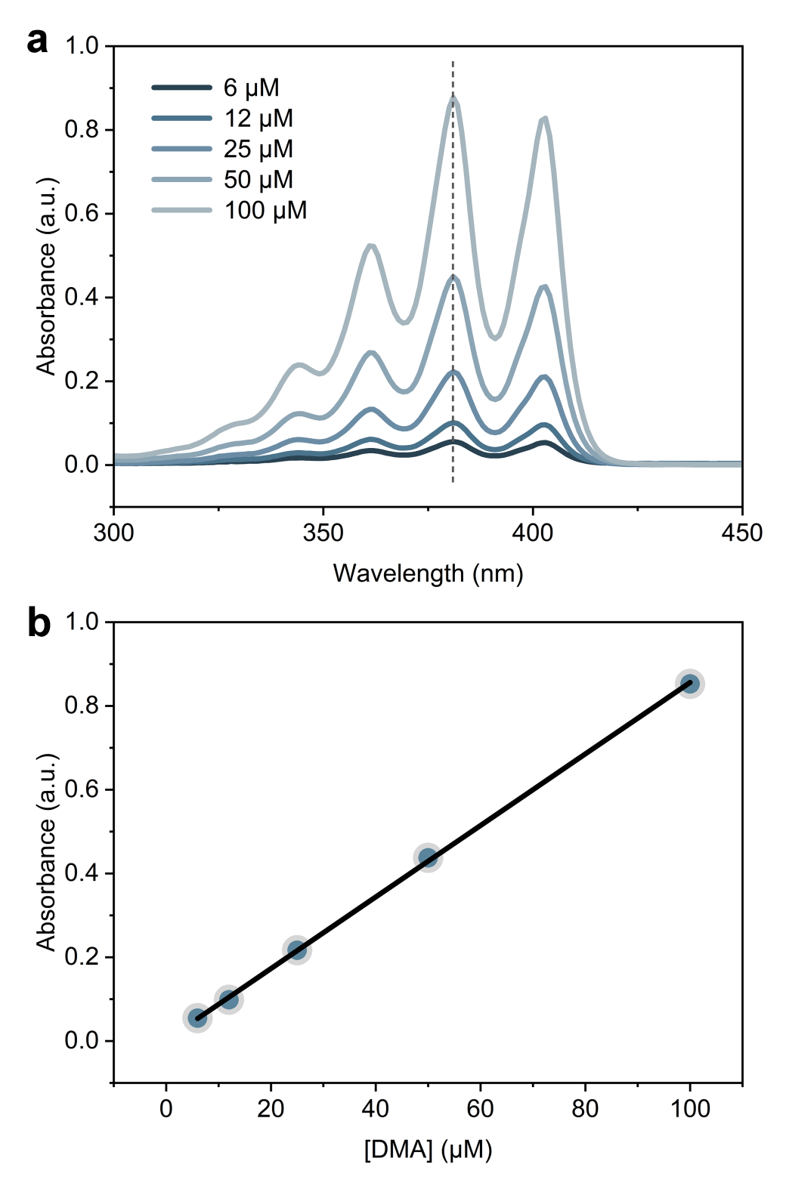
Supplementary Fig. 4 UV-vis absorption spectra and Fitting curve. a, UV-vis absorption spectra of electrolytes containing different 9,10-dimethylanthracene (DMA) concentrations. b, Fitting curve of dependence of relative absorbance on DMA concentration at 380 nm.
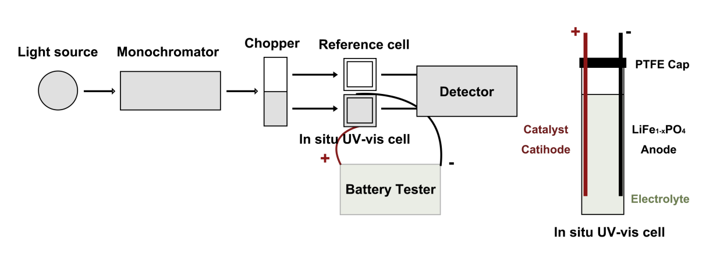
Supplementary Fig. 5 Schematic diagram of the in situ UV-vis testing device. In UV–vis was performed in 10 mm high-precision quartz cell with a custom-made gasproof polytetrafluoroethylene (PTFE) lid. The cell contained a 1 cm² catalyst-loaded cathode, a 1 cm² Li_{1-x}FePO₄-loaded anode and 4 mL electrolyte with DMA. The DMA concentration of 50 μM was chosen to balance an effective trapping concentration with the excellent detecting precision of the instrument. For the in situ UV–Vis, the cell was charged at 300 μA for 40 min. In situ EPR was tested in the same in situ cell.
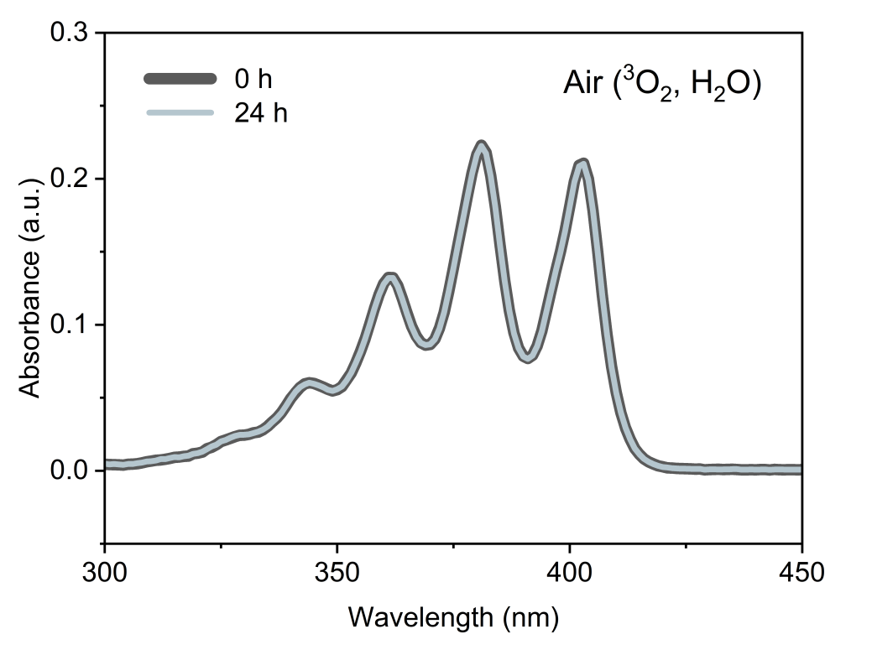
Supplementary Fig. 6 UV-vis absorption spectra of DMA in electrolyte before and after contacting with air for 24 h.
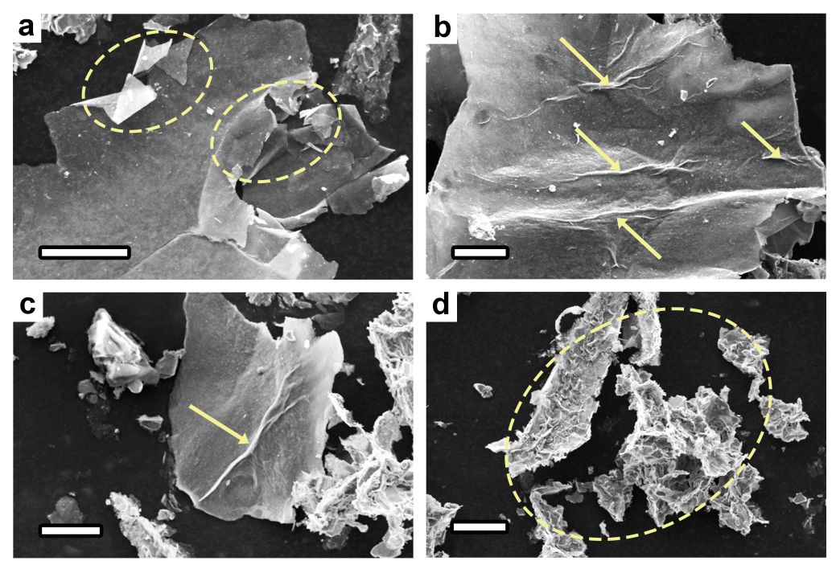
Supplementary Fig. 7 Scanning Electron Microscopy (SEM) images of the catalyst. As marked in yellow, abundant macroscopic wrinkles are observed on the catalyst surface. All scale bars in the supplementary fig. 7 represent 20 μm.
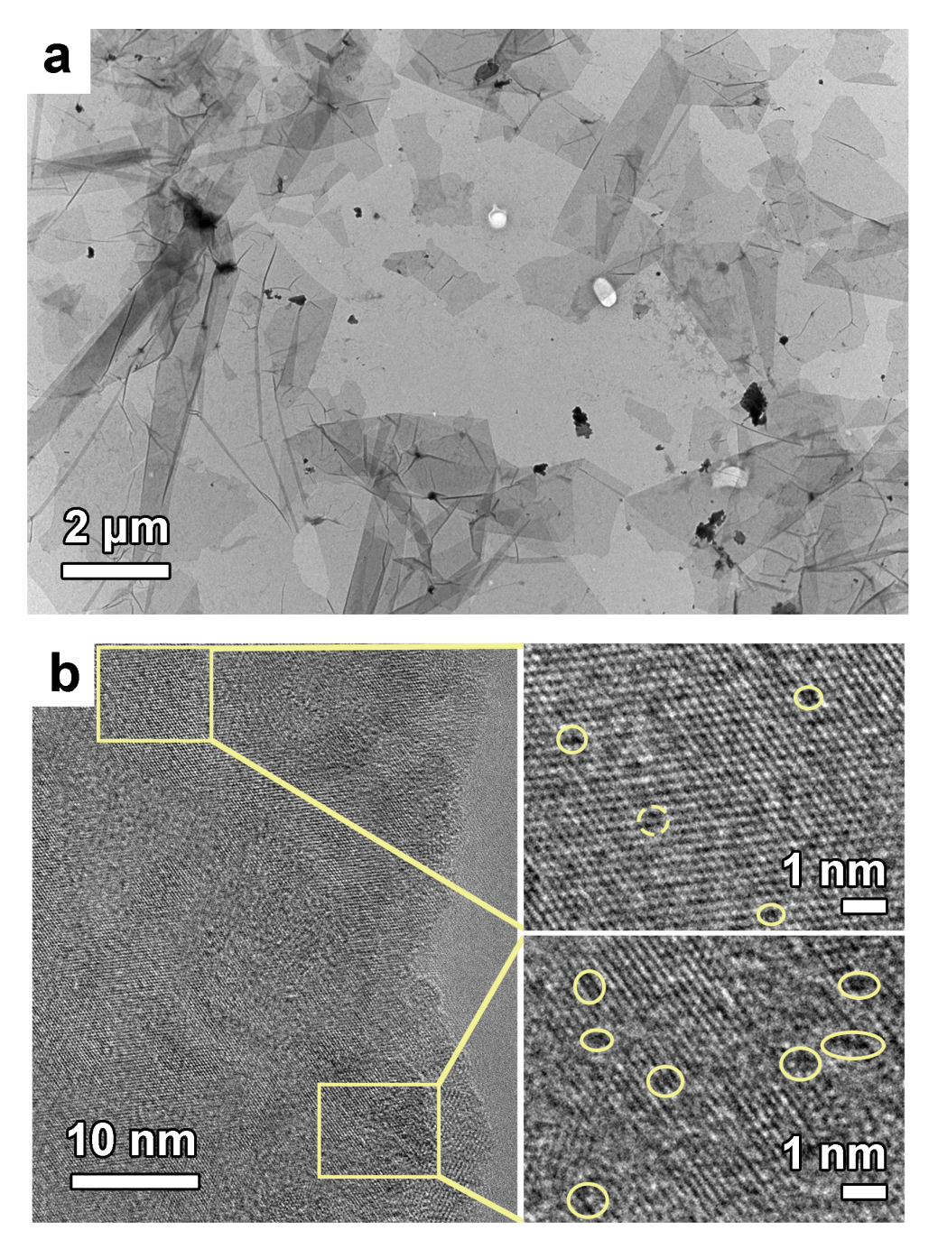
Supplementary Fig. 8 Transmission Electron Microscopy (TEM) and High-Resolution Transmission Electron Microscopy (HRTEM) images of the catalyst. a, TEM image of the catalyst. Abundant macroscopic wrinkles are observed on the catalyst surface. b, HRTEM images of the catalyst. The zoomed-in image reveals abundant metal-vacancy defects on the catalyst surface.
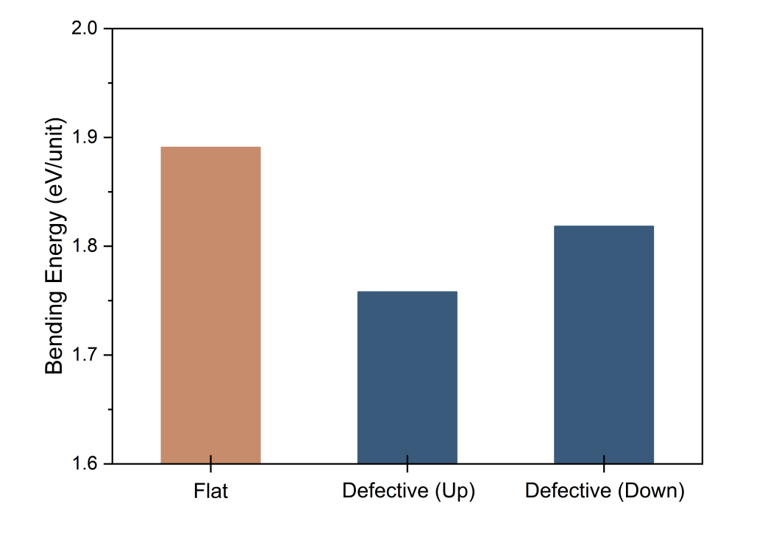
Supplementary Fig. 9 Bending Energy of Flat-, Defective (Up)- and Defective (Down)-TMC.
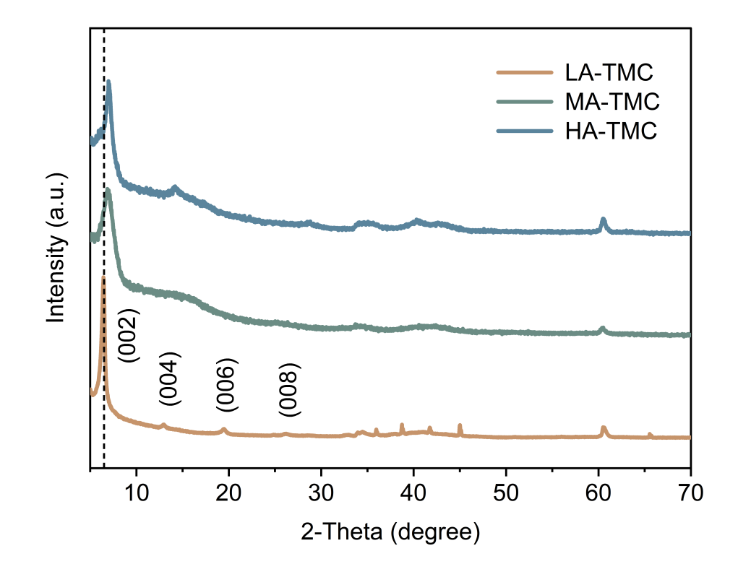
Supplementary Fig. 10 X-Ray Diffraction (XRD) patterns of low anion exposure MXene (LA-TMC), medium anion exposure MXene (MA-TMC), and high anion exposure MXene (HA-TMC).
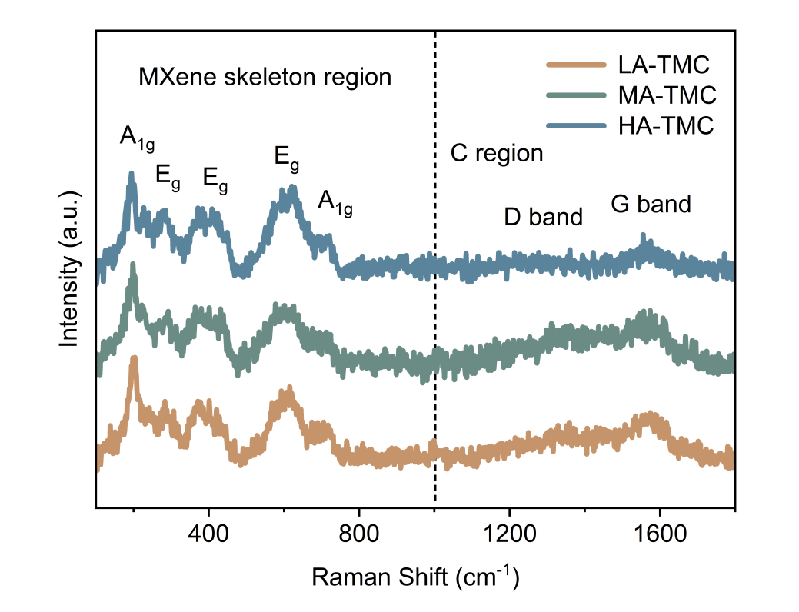
Supplementary Fig. 11 Raman spectra of LA-TMC, MA-TMC, and HA-TMC. In the MXene skeletal region, the peaks located at 202.8 cm⁻¹ and 718.5 cm⁻¹ are attributed to the out-of-plane phonon modes involving Ti atoms, C atoms, and terminal groups. The peaks at approximately 268.1 cm⁻¹, 405.2 cm⁻¹, and 613.5 cm⁻¹ are associated with in-plane vibrational modes of Ti atoms, C atoms, and terminal groups. In the carbon region, the peaks observed at around 1355.7 cm⁻¹ and 1580.9 cm⁻¹ correspond to the D-band and G-band, representing defective carbon lattices and sp²-hybridized C atoms, respectively.
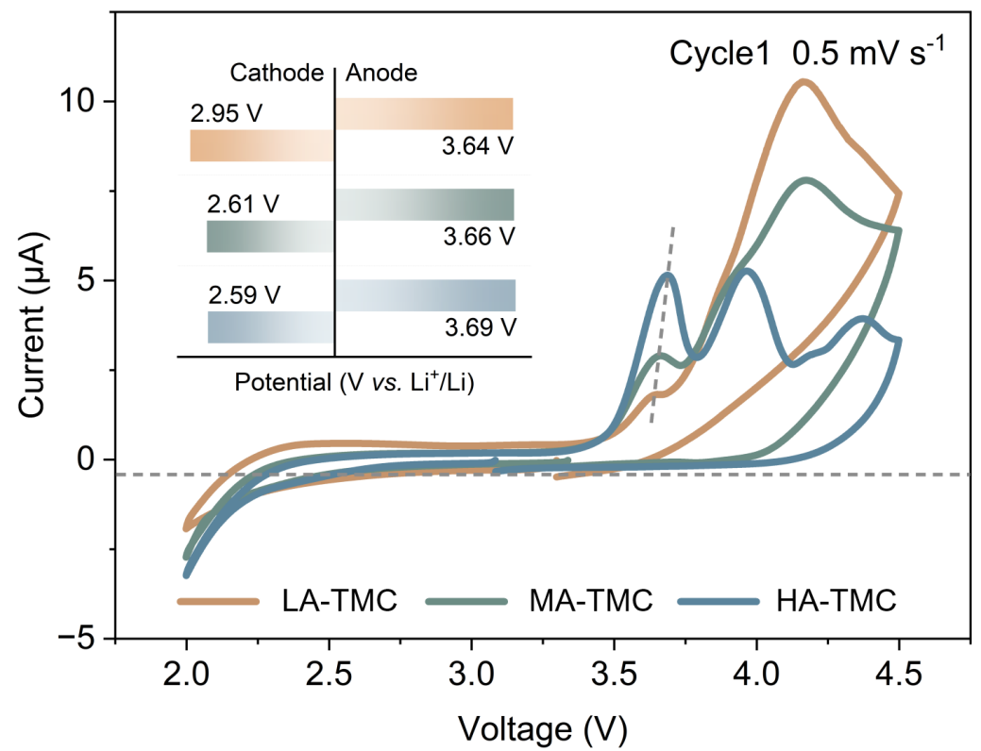
Supplementary Fig. 12 Cyclic Voltammetry (CV) curves at 0.5 mV s⁻¹ in 2.0-4.5 V of LA-TMC, MA-TMC and HA-TMC. The inset shows the onset potentials during charge and the discharge voltage corresponding to a discharge current of 0.3 mA.
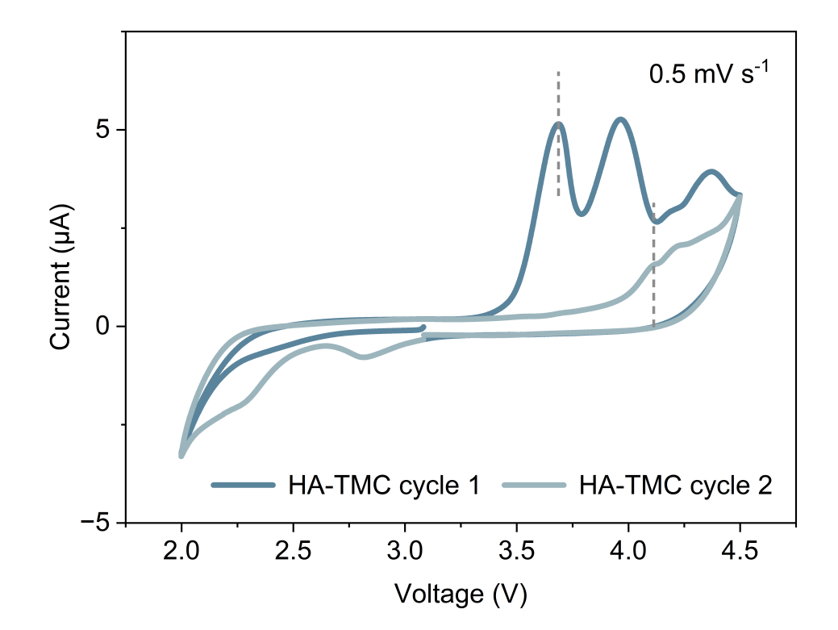
Supplementary Fig. 13 CV curves at 0.5 mV s⁻¹ in 2.0-4.5 V of HA-TMC (first and second cycle).
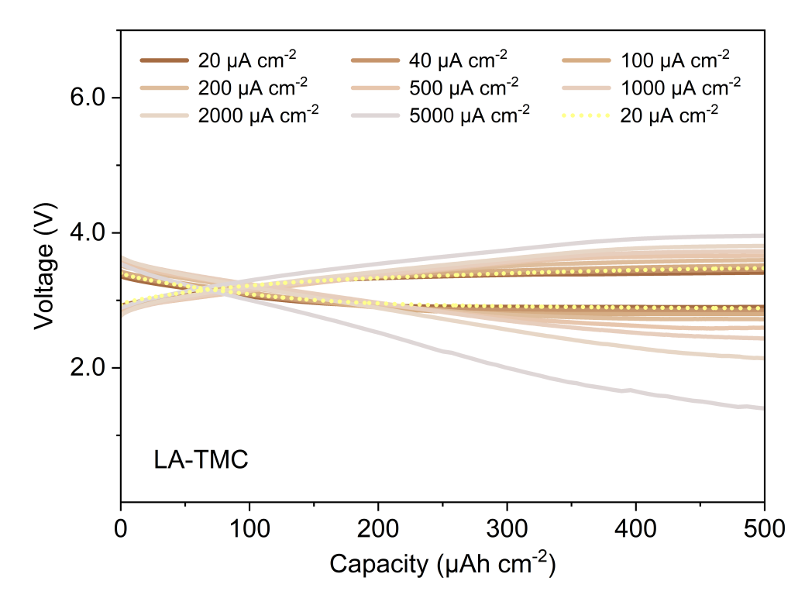
Supplementary Fig. 14 Galvanostatic discharge-charge (GDC) curves of LA-TMC with a limited capacity of 500 μAh cm⁻² at different current densities.
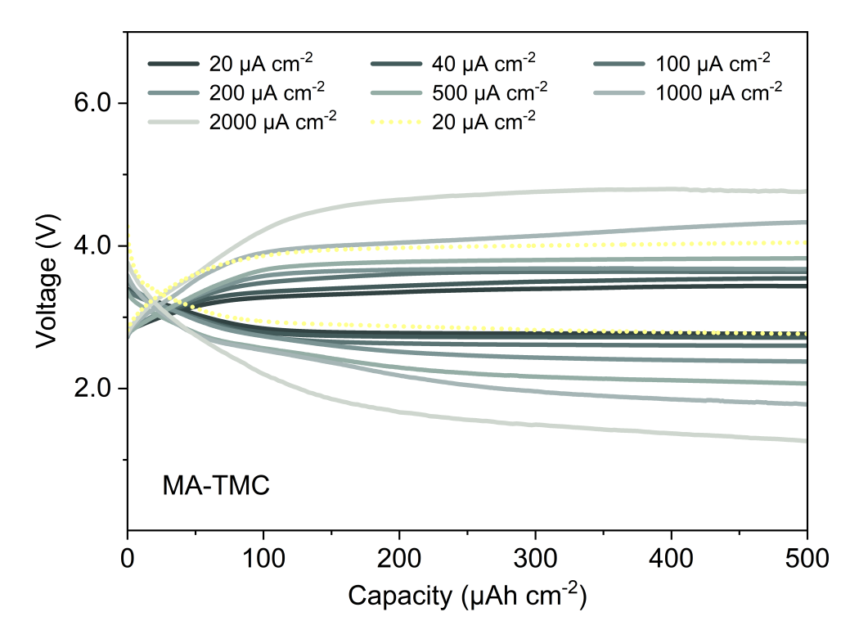
Supplementary Fig. 15 GDC curves of MA-TMC with a limited capacity of 500 μAh cm⁻² at different current densities.
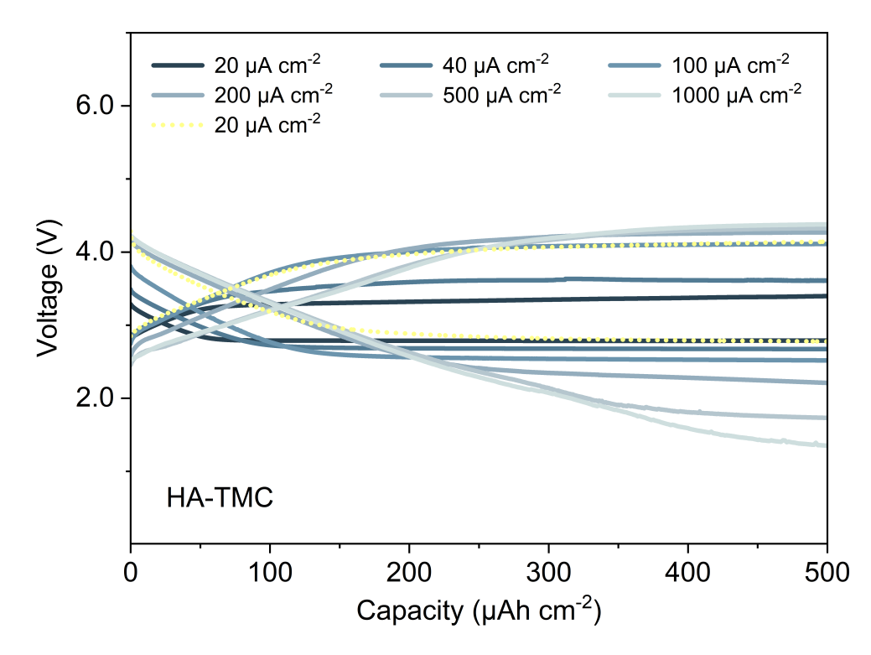
Supplementary Fig. 16 GDC curves of HA-TMC with a limited capacity of 500 μAh cm⁻² at different current densities.
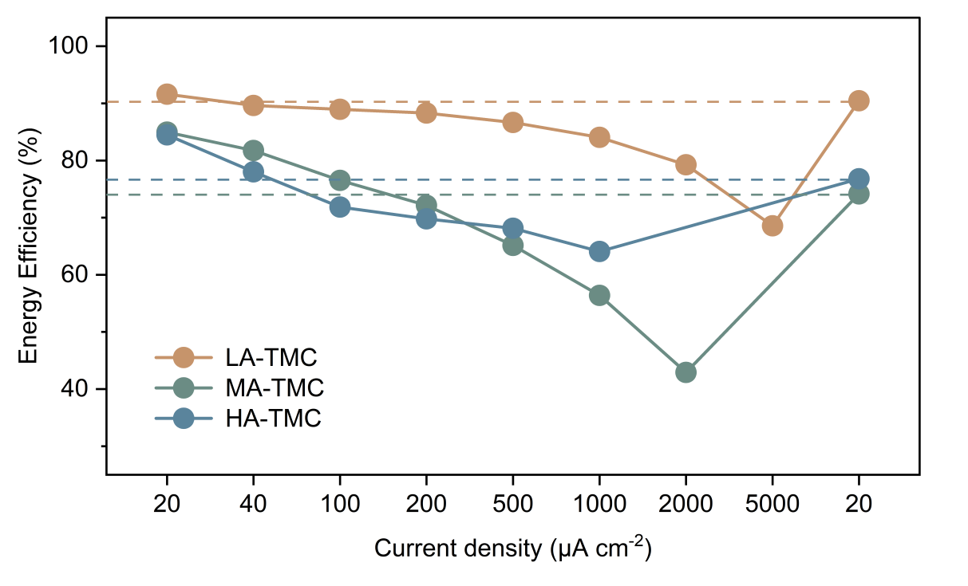
Supplementary Fig. 17 Energy efficiencies of LA-TMC, MA-TMC and HA-TMC with a limited capacity of 500 μAh cm⁻² at different current densities.
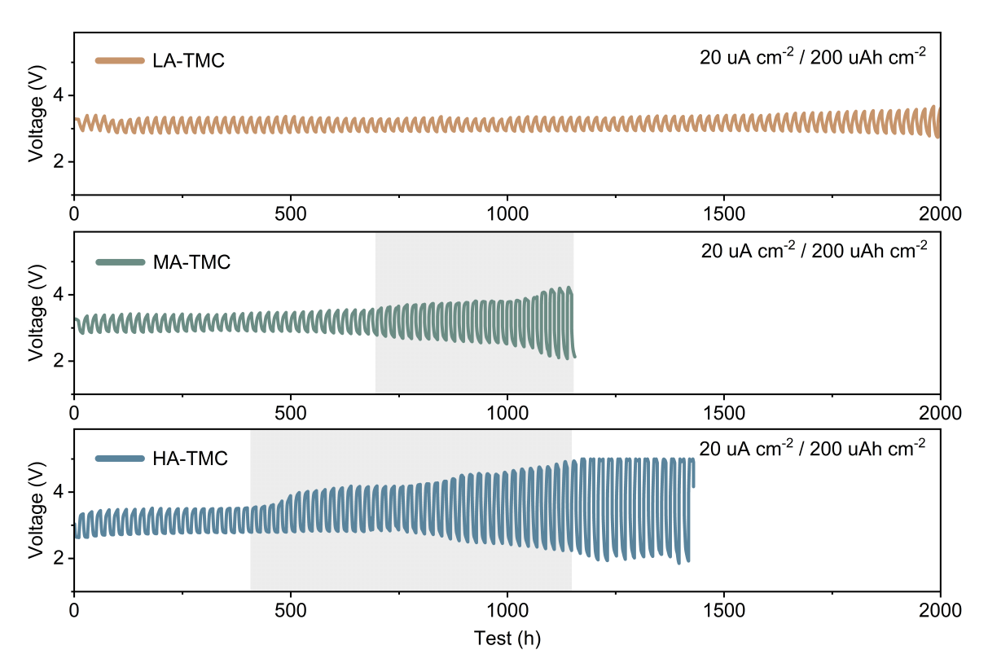
Supplementary Fig. 18 Cycling performance of LA-TMC, MA-TMC, and HA-TMC with a limited capacity of 200 μAh cm⁻² at 20 μA cm⁻².
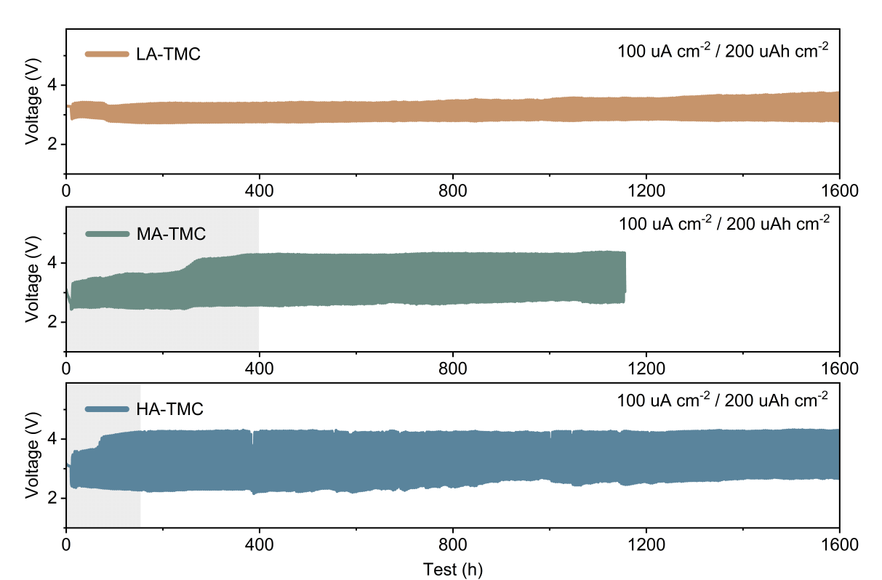
Supplementary Fig. 19 Cycling performance of LA-TMC, MA-TMC, and HA-TMC with a limited capacity of 200 μAh cm⁻² at 100 μA cm⁻².
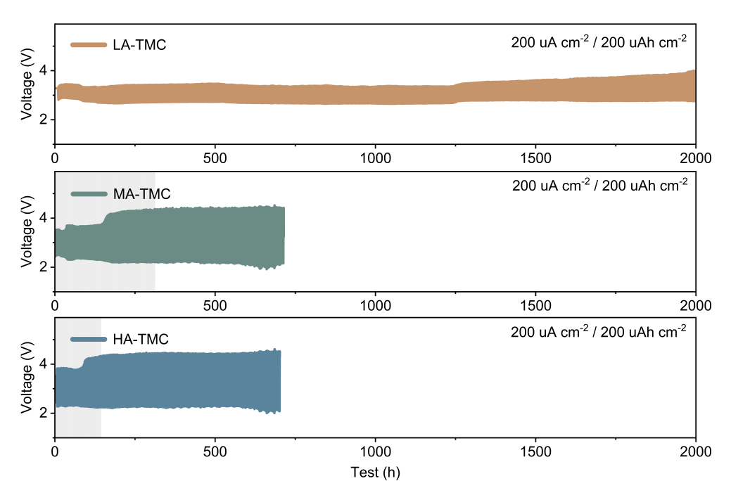
Supplementary Fig. 20 Cycling performance of LA-TMC, MA-TMC, and HA-TMC with a limited capacity of 200 μAh cm⁻² at 200 μA cm⁻².
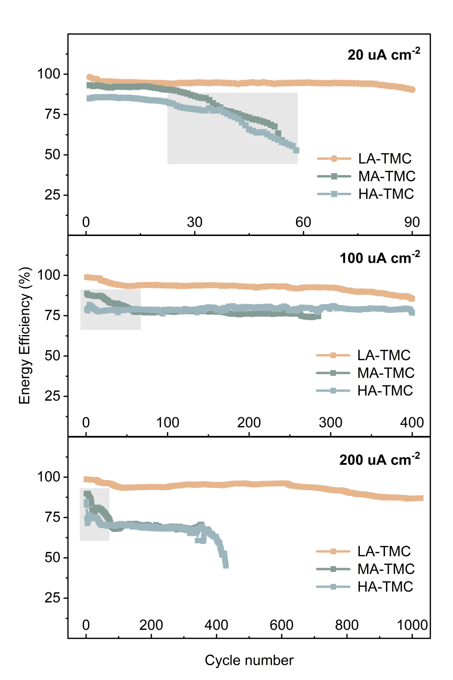
Supplementary Fig. 21 Energy Efficiency at various current densities (20, 100 and 200 μA cm⁻²) for different cycle numbers.
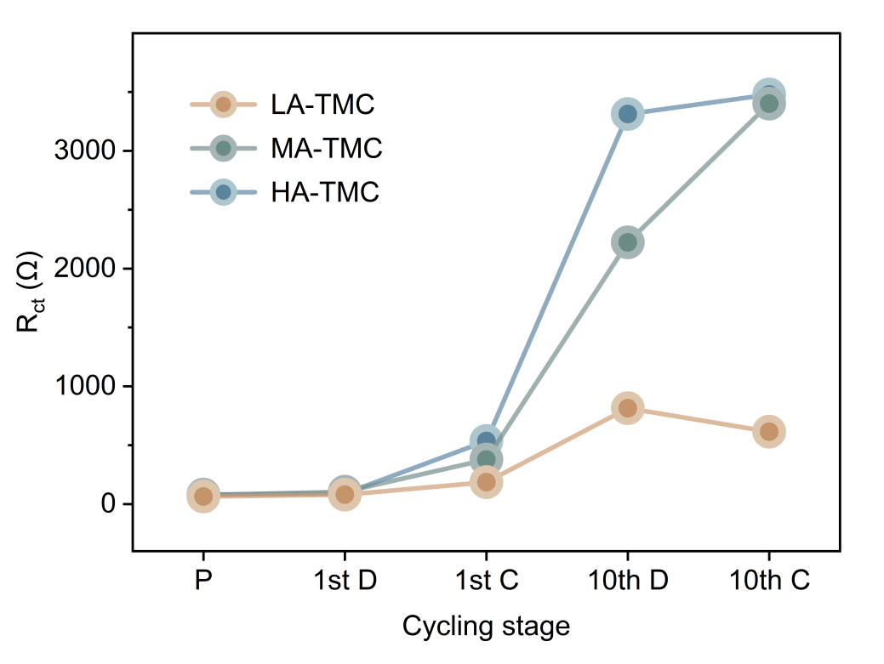
Supplementary Fig. 22 The charge transfer resistance (Rct) results fitted from EIS at different cycling stages (fitting results provided in Supplementary Table 3).
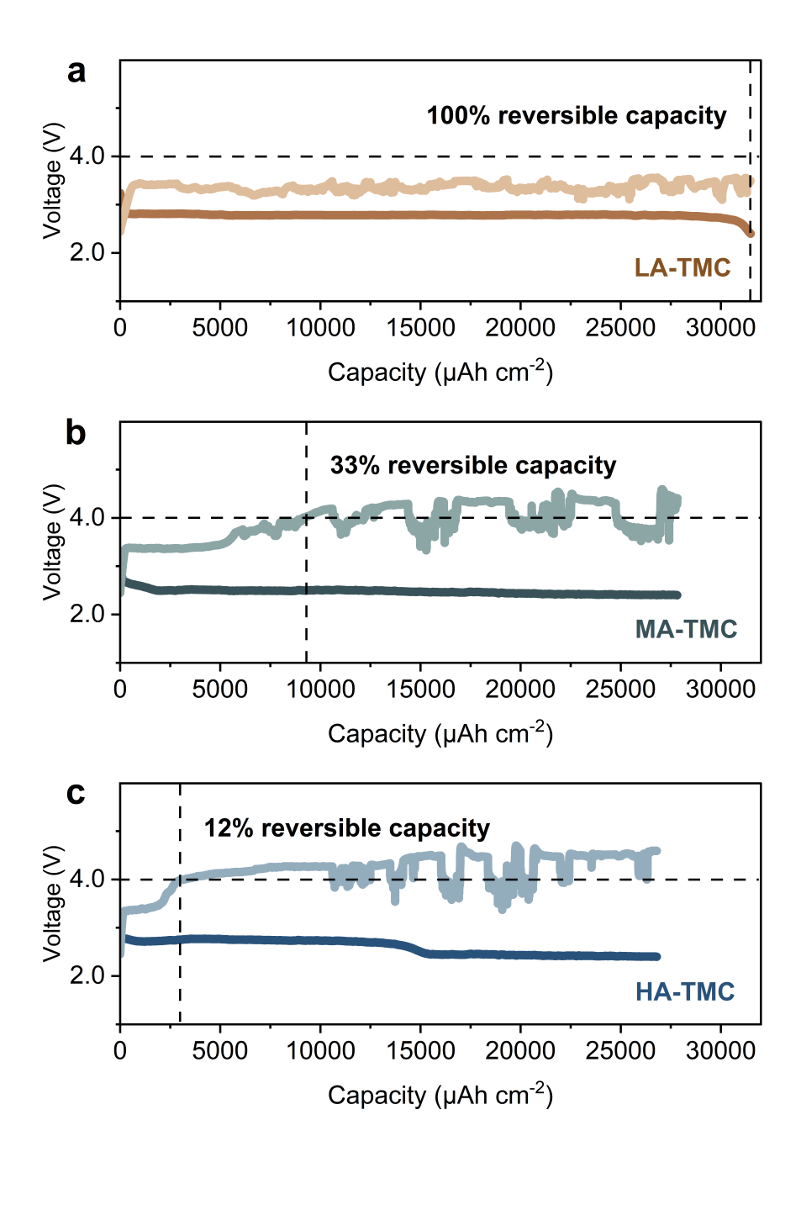
Supplementary Fig. 23 Deep discharge curves to 2.4 V and subsequent recharge curves of a LA-TMC, b MA-TMC, and c HA-TMC. The fluctuations in the charging curve originate from localized conductivity discontinuities and uneven current distribution caused by the heterogeneous accumulation of insulating Li₂CO₃ after deep discharge. However, LA-TMC can still complete the full-capacity charging with potential oscillations around 3.4 V. During this process, the charging potential of LA-TMC does not polarize beyond 4.0 V as observed in MA-TMC and HA-TMC, indicating its superior anti-oxidation capability.
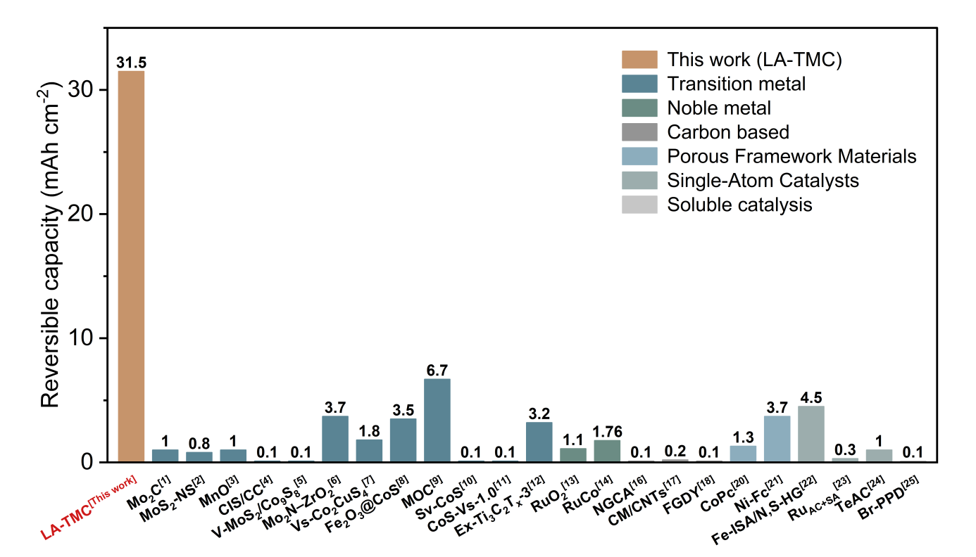
Supplementary Fig. 24 Electrochemical performance comparison of reversible capacity among reported catalysts (Supplementary Table 4).
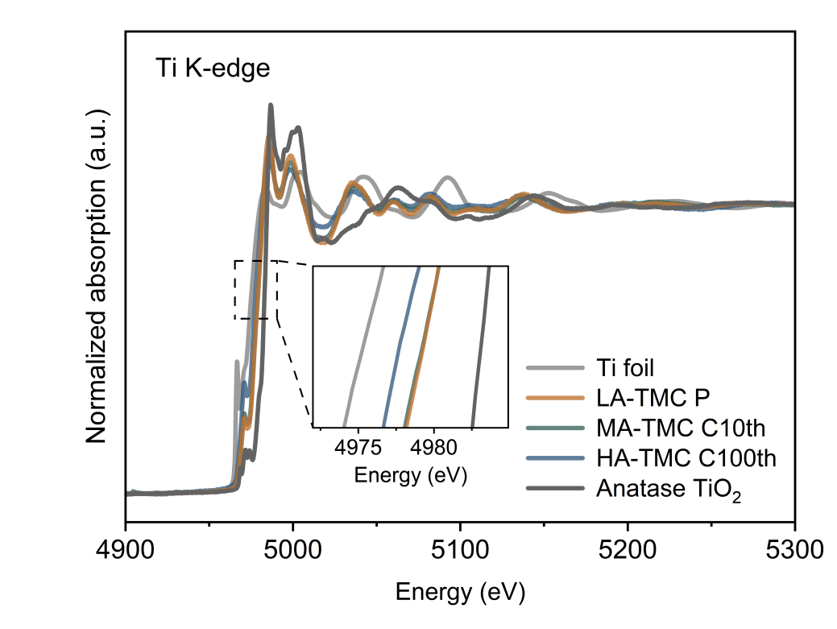
Supplementary Fig. 25 Ti K-edge XANES of LA-TMC, MA-TMC and HA-TMC.
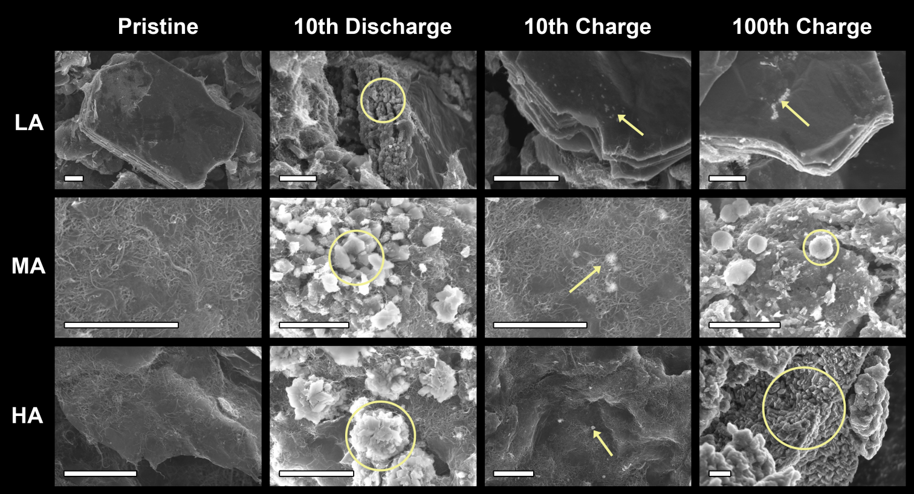
Supplementary Fig. 26 SEM images of LA-TMC, MA-TMC, and HA-TMC electrodes at pristine state and after 10th discharge, 10th charge, 100th charge. All scale bars in the Supplementary Fig. 25 represent 2 μm. To clearly display the cycled electrodes and discharge products, the scales were not unified due to the size differences between catalysts and discharge products. The yellow annotations indicate solid discharge products.
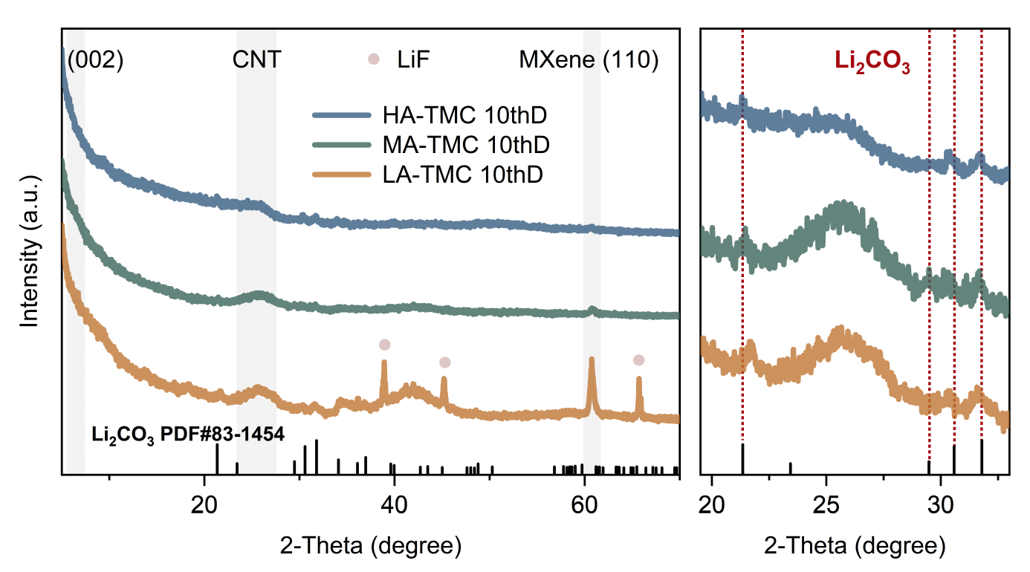
Supplementary Fig. 27 XRD patterns of LA-TMC, MA-TMC, and HA-TMC electrodes after 10th discharge.
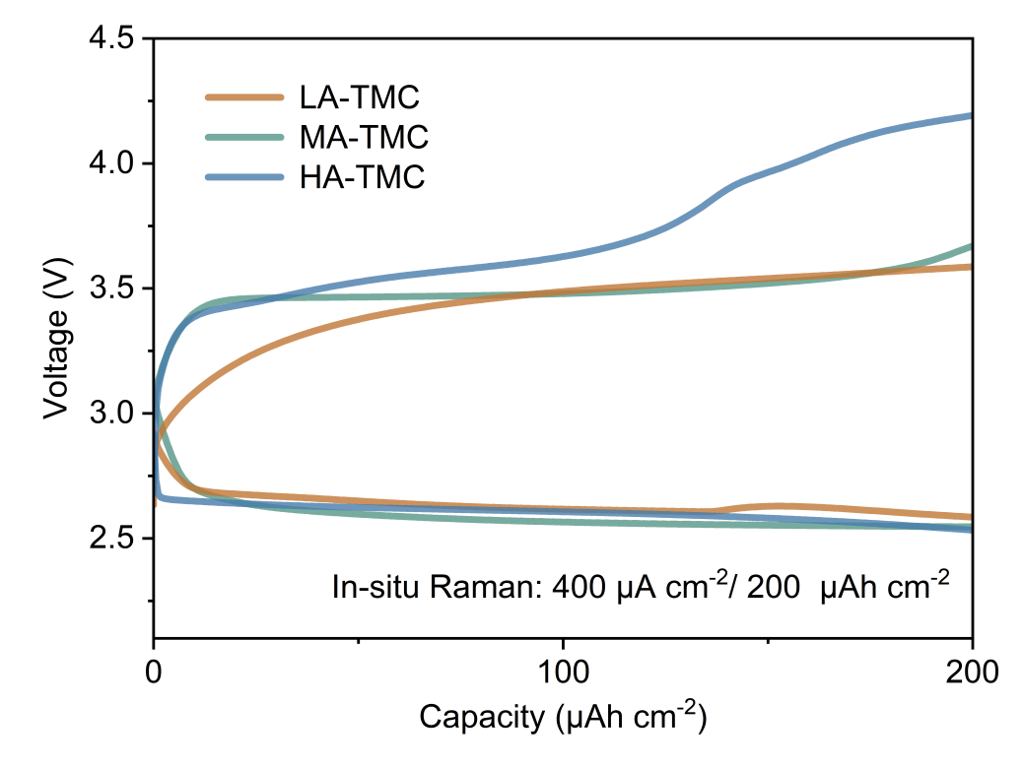
Supplementary Fig. 28 GDC curves of in situ Raman test based on LA-TMC, MA-TMC, and HA-TMC electrodes.
Supplementary Table 1. Electrochemical performance comparison of cycle time, initial charge voltage and polarization charge voltage among reported catalysts.
Species | Cathode | Cycle Time (h) | Initial charge potential (V) | Cyclic Polarization Voltage (V) | References
Transition metal | CC@Mo₂C NPs | 200 | 3.52 | 0.24 | 1
Transition metal | MoS₂-NS | 500 | 3.5 | 0.37 | 2
Transition metal | MnO@NMCNFs | 1300 | 4.25 | 0.35 | 3
Transition metal | CIS/CC | 1050 | 3.53 | 0.55 | 4
Transition metal | V-MoS₂/Co₉S₈@CP | 620 | 3.71 | 0.24 | 5
Transition metal | Mo₂N–ZrO₂@NCNF | 1650 | 3.79 | 0.33 | 6
Transition metal | Vs-Co₂CuS₄ | 580 | 3.81 | 0.29 | 7
Transition metal | Fe₂O₃@CoS | 550 | 3.36 | 0.94 | 8
Transition metal | MOC@NCNT | 1000 | 4.33 | 0.17 | 9
Transition metal | Sv-CoS | 400 | 3.61 | 0.49 | 10
Transition metal | CoS-Vs-1.0 | 600 | 3.5 | 1.5 | 11
Transition metal | Ex-Ti₃C₂T_{x}-3 | 1380 | 3.2 | 1.1 | 12
Noble metal | RuO₂@CNT | 1100 | 4 | 0.25 | 13
Noble metal | RuCo NSs/CNT | 172 | 3.79 | 0.79 | 14
Noble metal | G-III | 1300 | 3.86 | 0.9 | 15
Carbon based | NGCA | 1500 | 3.65 | 0.55 | 16
Carbon based | CM/CNTs | 488 | 4.1 | 0.36 | 17
Carbon based | FGDY | 480 | 4.3 | 0.18 | 18
Porous Framework Materials | HOF-FJU-1-Ru/CNT | 1800 | 4.01 | 0.29 | 19
Porous Framework Materials | CoPc | 1600 | 3.88 | 0.52 | 20
Porous Framework Materials | Ni-Fc | 2000 | 4.21 | 0.39 | 21
Single-Atom Catalysts | Fe-ISA/N,S-HG | 420 | 4.3 | 0.2 | 22
Single-Atom Catalysts | Ru_{AC+SA}@NCB | 200 | 4.19 | 0.28 | 23
Single-Atom Catalysts | TeAC@NCNS | 600 | 4.25 | 0.24 | 24
Soluble catalysis | Br-PPD | 200 | 3.98 | 0.87 | 25

Supplementary Table 2. Resistance of LA-TMC, MA-TMC and HA-TMC at different cycling stages, calculated from EIS simulations.
 |  | R_{s} | R_{sei} | R_{ct}
LA-TMC | Pristine | 5.51 | 5.64 | 63.93
LA-TMC | 1st Discharge | 5.91 | 3.94 | 80.43
LA-TMC | 1st Charge | 6.43 | 4.52 | 186.50
LA-TMC | 10th Discharge | 9.38 | 149.80 | 813.90
LA-TMC | 10th Charge | 8.87 | 62.43 | 614.50
MA-TMC | Pristine | 6.29 | 2.24 | 76.26
MA-TMC | 1st Discharge | 6.87 | 2.38 | 104.90
MA-TMC | 1st Charge | 7.90 | 223.30 | 378.70
MA-TMC | 10th Discharge | 12.79 | 380.10 | 2223.00
MA-TMC | 10th Charge | 13.47 | 323.90 | 3401.00
HA-TMC | Pristine | 10.52 | 3.84 | 80.87
HA-TMC | 1st Discharge | 11.78 | 4.93 | 89.51
HA-TMC | 1st Charge | 6.531 | 239.20 | 535.90
HA-TMC | 10th Discharge | 17.56 | 485.90 | 3312.00
HA-TMC | 10th Charge | 19.51 | 439.20 | 3478.00
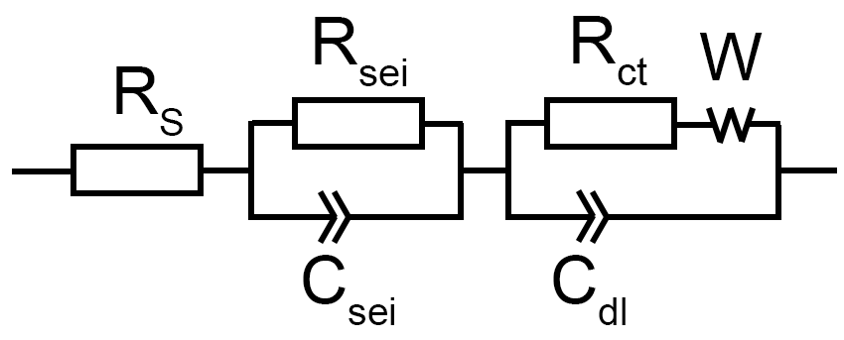
R_{s}: ohmic resistance from the electrolyte, electrodes, current leads, and other components.
R_{ct}: charge-transfer resistance.
C_{dl}: double-layer capacitance.
W: Warburg impedance of the diﬀusion process.

Supplementary Table 3. Parameters of discharge capacity and recharge capacity.
Discharge capacity: capacity discharged to 2.4 V.
Reversible capacity/Recharge capacity: capacity recharged with voltage not exceeding 4.0 V.
Rechargeability = Recharge capacity / Discharge capacity.
Sample | Recharge capacity  (mAh cm⁻²) | Discharge capacity  (mAh cm⁻²) | Rechargeability  (%)
LA-TMC | 31.5 | 31.5 | 100
MA-TMC | 27.8 | 9.1 | 33
HA-TMC | 26.8 | 3.2 | 12

Supplementary Table 4. Electrochemical performance comparison of reversible capacity among reported catalysts.
Species | Cathode | reversible capacity(mAh cm⁻²) | References
Transition metal | LA-TMC | 31.5 | This work
Transition metal | CC@Mo₂C NPs | 1 | 1
Transition metal | MoS₂-NS | 0.8 | 2
Transition metal | MnO@NMCNFs | 1 | 3
Transition metal | CIS/CC | 0.1 | 4
Transition metal | V-MoS₂/Co₉S₈@CP | 0.1 | 5
Transition metal | Mo₂N–ZrO₂@NCNF | 3.7 | 6
Transition metal | Vs-Co₂CuS₄ | 1.8 | 7
Transition metal | Fe₂O₃@CoS | 3.5 | 8
Transition metal | MOC@NCNT | 6.7 | 9
Transition metal | Sv-CoS | 0.1 | 10
Transition metal | CoS-Vs-1.0 | 0.1 | 11
Transition metal | Ex-Ti₃C₂T_{x}-3 | 3.2 | 12
Noble metal | RuO₂@CNT | 1.1 | 13
Noble metal | RuCo NSs/CNT | 1.8 | 14
Carbon based | NGCA | 0.1 | 16
Carbon based | CM/CNTs | 0.2 | 17
Carbon based | FGDY | 0.1 | 18
Porous Framework Materials | CoPc | 1.3 | 20
Porous Framework Materials | Ni-Fc | 3.7 | 21
Single-Atom Catalysts | Fe-ISA/N,S-HG | 4.5 | 22
Single-Atom Catalysts | Ru_{AC+SA}@NCB | 0.3 | 23
Single-Atom Catalysts | TeAC@NCNS | 1 | 24
Soluble catalysis | Br-PPD | 0.1 | 25

References
1.Zhou, J., et al. A quasi-solid-state flexible fiber-shaped li-co(2) battery with low overpotential and high energy efficiency. Adv Mater 31, e1804439 (2019).
2.Pipes, R., He, J., Bhargav, A., Manthiram, A. Efficient li–co2 batteries with molybdenum disulfide nanosheets on carbon nanotubes as a catalyst. ACS Applied Energy Materials 2, 8685-8694 (2019).
3.Li, S., et al. Improving areal capacity of flexible li–co2 batteries by constructing a freestanding cathode with monodispersed mno nanoparticles in n-doped mesoporous carbon nanofibers. Journal of Materials Chemistry A 8, 10354-10362 (2020).
4.Chen, L., Zhou, J., Zhang, J., Qi, G., Wang, B., Cheng, J. Copper indium sulfide enables li‐co2 batteries with boosted reaction kinetics and cycling stability. Energy & Environmental Materials 6, (2023).
5.Lu, B., et al. Engineering the interfacial orientation of mos(2)/co(9)s(8) bidirectional catalysts with highly exposed active sites for reversible li-co(2) batteries. Proc Natl Acad Sci U S A 120, e2216933120 (2023).
6.Cheng, Z., et al. Mo(2) n-zro(2) heterostructure engineering in freestanding carbon nanofibers for upgrading cycling stability and energy efficiency of li-co(2) batteries. Small 19, e2301685 (2023).
7.Lu, B., et al. Energy band engineering guided design of bidirectional catalyst for reversible li-co(2) batteries. Adv Mater 36, e2308889 (2024).
8.Lu, B., et al. Recycled tandem catalysts promising ultralow overpotential li-co(2) batteries. Adv Mater 36, e2309264 (2024).
9.Liu, L., et al. Revealing the indispensable role of in situ electrochemically reconstructed mn(ii)/mn(iii) in improving the performance of lithium-carbon dioxide batteries. Adv Mater 36, e2403229 (2024).
10.Mao, R., et al. Tailoring li2co3 configuration and orbital structure of cos to improve catalytic activity and stability for li‐co2 batteries. EcoMat 6, (2024).
11.Lu, B., et al. Steering the orbital hybridization to boost the redox kinetics for efficient li-co(2) batteries. J Am Chem Soc 146, 20814-20822 (2024).
12.Li, X., et al. Interlayer expanded mxene film cathodes with rich defects for flexible 2-electron oxalate-based li–co2 batteries: A new path to enhanced energy efficiency and durability. Advanced Materials 37, 2500064 (2025).
13.Bie, S., et al. Carbon nanotube@ruo(2) as a high performance catalyst for li-co(2) batteries. ACS Appl Mater Interfaces 11, 5146-5151 (2019).
14.Wang, Y., et al. Decreasing the overpotential of aprotic li‐co2 batteries with the in‐plane alloy structure in ultrathin 2d ru‐based nanosheets. Advanced Functional Materials 32, (2022).
15.Hao, Q. Q., Cai, Z. P., Zhao, X. H., Wang, L. Y., Wang, K. X., Chen, J. S. Boosting the efficiency and stability of li-co(2) batteries via a ruthenium-based olefin-metathesis catalyst. J Am Chem Soc 146, 27802-27808 (2024).
16.Yu, W., et al. N, o-diatomic dopants activate catalytic activity of 3d self-standing graphene carbon aerogel for long-cycle and high-efficiency li-co2 batteries. Chemical Engineering Journal 465, (2023).
17.Ji, X., Liu, Y., Zhang, Z., Cui, J., Fan, Y., Qiao, Y. Porous carbon foam with carbon nanotubes as cathode for li-co(2) batteries. Chemistry 30, e202303319 (2024).
18.Zhang, J., Ding, D., Fang, Q., Cheng, J., Xiao, H., Wang, B. High-energy-density li-co(2) battery at elevated temperatures: Advances with fluorine-substituted graphdiyne and ionic liquid. Angew Chem Int Ed Engl 64, e202420892 (2025).
19.Cheng, Z., et al. Hydrogen-bonded organic framework to upgrade cycling stability and rate capability of li-co(2) batteries. Angew Chem Int Ed Engl 62, e202311480 (2023).
20.Zhao, N., et al. Elevating discharge voltage of li(2)co(3)-routine li-co(2) battery over 2.9 v at an ultra-wide temperature window. Angew Chem Int Ed Engl 63, e202407303 (2024).
21.Chen, H., et al. Ferrocene‐based nickel metal–organic framework nanosheets as efficient, long‐cycle cathode catalyst for li‐co2 battery. Advanced Functional Materials 35, (2024).
22.Hu, C., et al. High-performance, long-life, rechargeable li-co(2) batteries based on a 3d holey graphene cathode implanted with single iron atoms. Adv Mater 32, e1907436 (2020).
23.Lin, J., et al. Boosting energy efficiency and stability of li-co(2) batteries via synergy between ru atom clusters and single-atom ru-n(4) sites in the electrocatalyst cathode. Adv Mater 34, e2200559 (2022).
24.Wang, K., et al. Isolated metalloid tellurium atomic cluster on nitrogen-doped carbon nanosheet for high-capacity rechargeable lithium-co(2) battery. Adv Sci (Weinh) 10, e2205959 (2023).
25.Dan, B., et al. Halogenated functional electrolyte additive for li-co2 batteries. ACS Applied Materials & Interfaces 15, 49116-49122 (2023).

