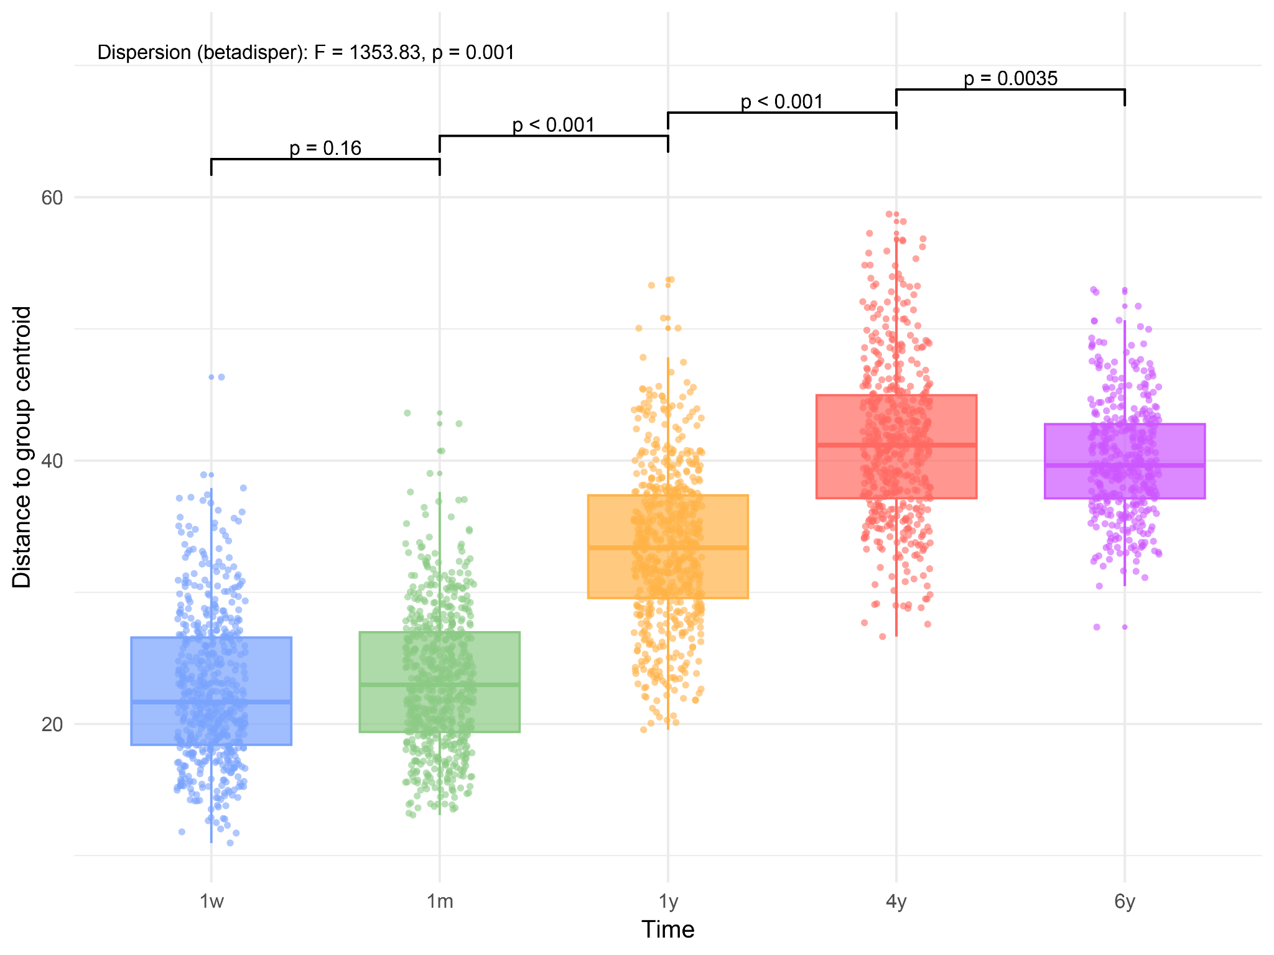
Sup. 1: Group dispersion of the gut microbiome across childhood in COPSAC₂₀₁₀
Group dispersion was calculated as the distance of each sample to the group centroid based on Aitchison dissimilarity from PCoA ordinations. Boxplots show the distribution of dispersions at 1 week, 1 month, 1 year, 4 years, and 6 years. Significant differences between timepoints were assessed using pairwise comparisons with Tukey’s HSD, with p-values indicated.

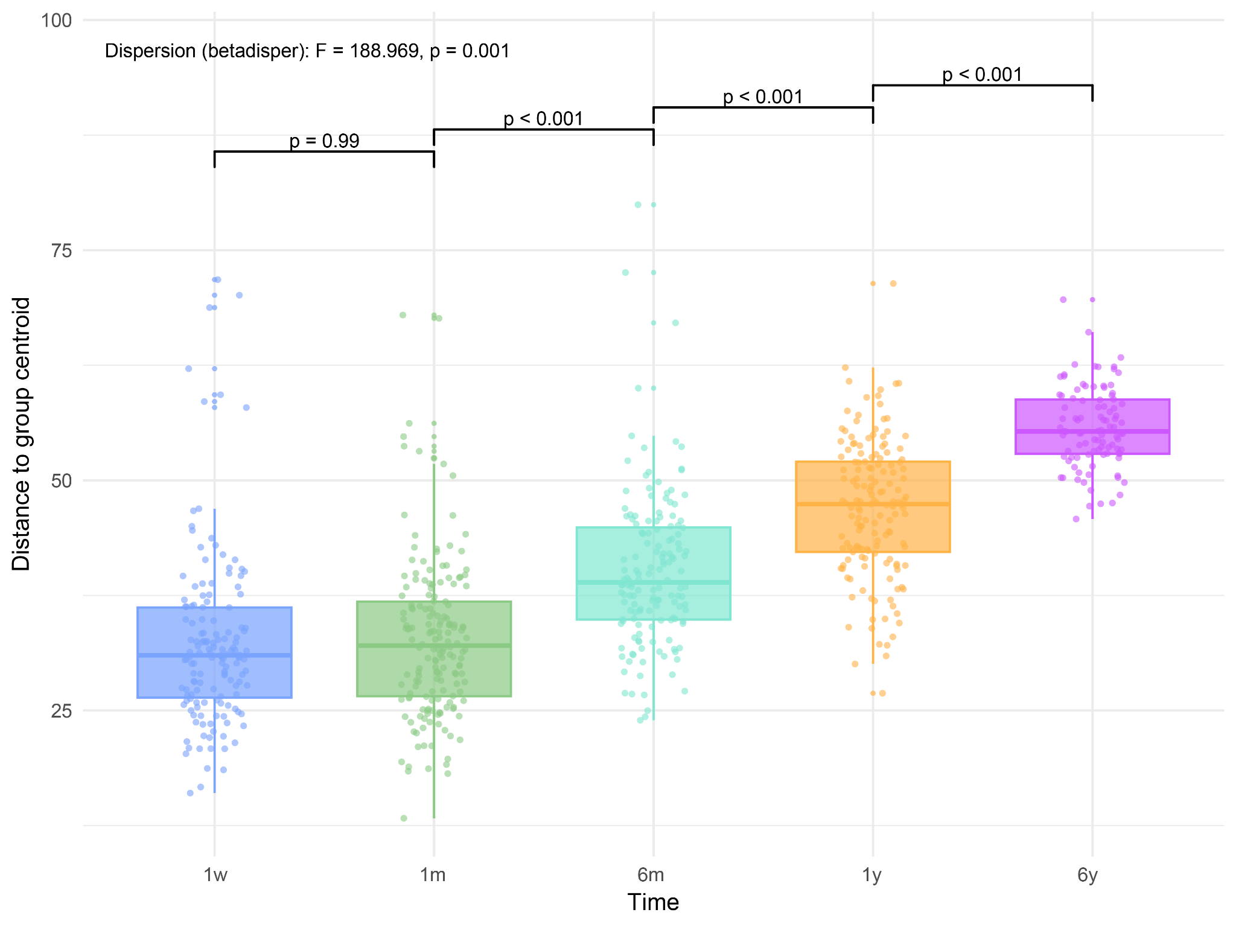
Sup 2: Group dispersion of the gut microbiome across childhood in MAMI
Group dispersion was calculated as the distance of each sample to the group centroid (betadisper) based on Aitchison dissimilarity from PCoA ordinations. Boxplots show the distribution of dispersions at 1 week, 1 month, 6 month, 1 year, and 6 years. Significant differences between timepoints were assessed using pairwise comparisons with Tukey’s HSD, with p-values indicated.

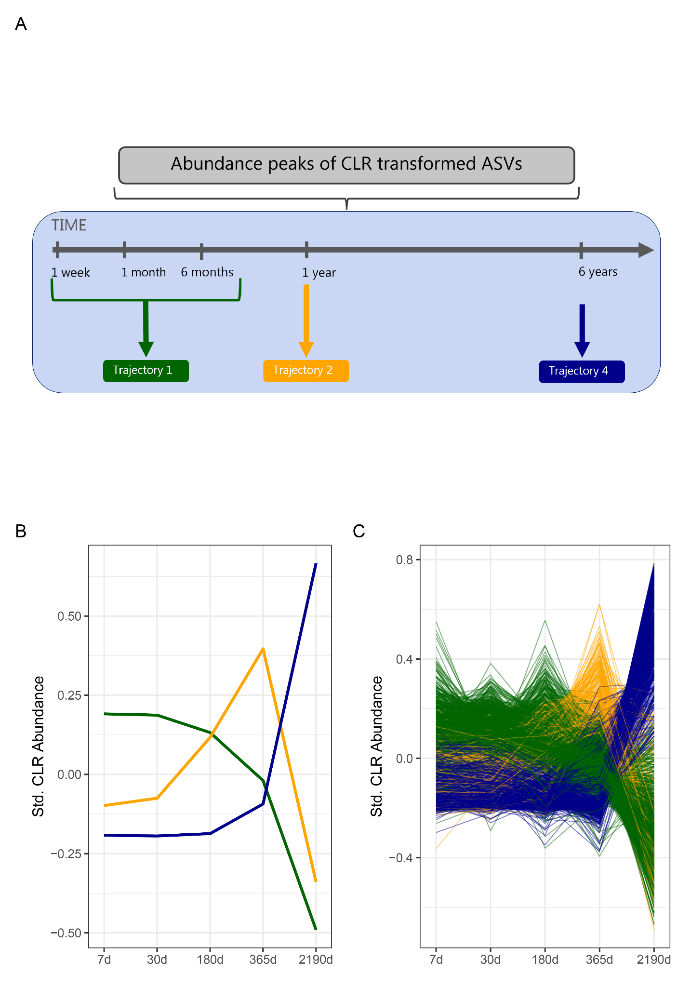
Sup. 3: Schematic of MAMI Trajectory assignment.
a) CLR transformed ASVs were assigned a Trajectory based on the time point of abundance peak (trajectory 1: peak at 1w, 1m, or 6m, trajectory 2: peak at 1y, trajectory 4: peak at 6y). b) Standardized mean abundance of averaged ASV within each Trajectory. c) Standardized mean abundance of ASVs (averaged across participants), colored by assigned Trajectory

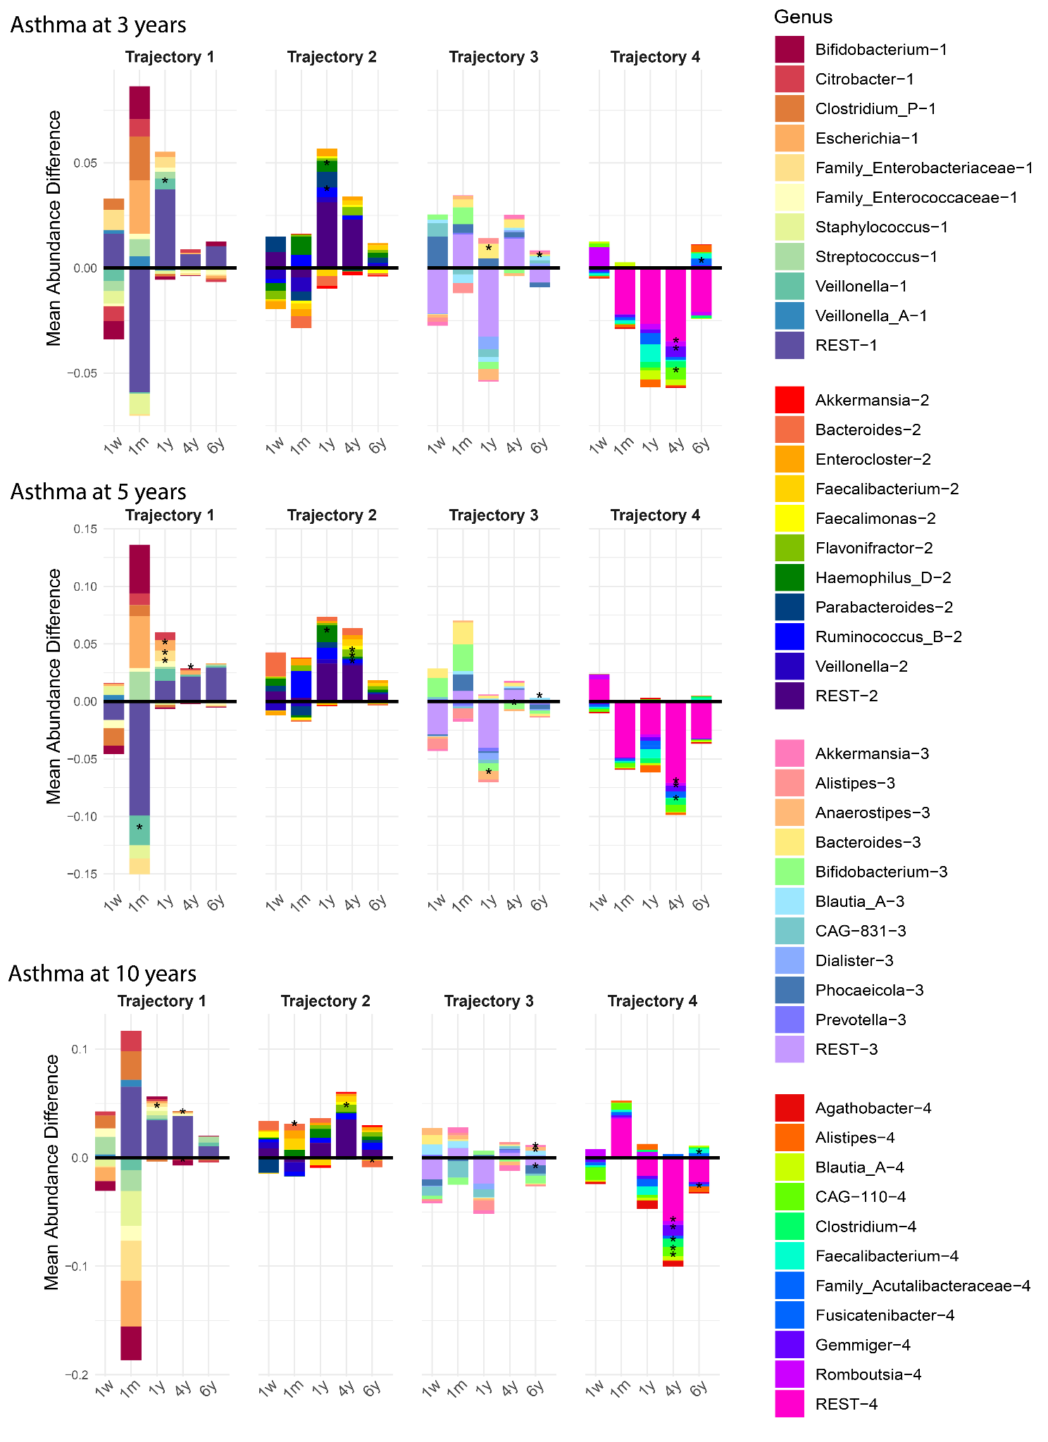
Sup 4: Genus-level differences in relative abundance between asthma diagnosed and undiagnosed groups across time points and trajectories. Mean relative abundances at genus level were calculated per exposure, genus, time point, and trajectory. Differences were computed as the abundance in the exposed group minus the unexposed group. Statistical significance was assessed using Wilcoxon rank-sum tests with FDR correction. Statistical significance is indicated as: *** FDR p < 0.001, ** FDR p < 0.05, * unadjusted p < 0.05. a) Children diagnosed with Asthma at 3 years of age. b) Children diagnosed with Asthma at 5 years of age. c) Children diagnosed with Asthma at 10 years of age.

Sup 5: Detailed protocol for DNA extraction from fecal samples in COPSAC₂₀₁₀
The following description is adapted from Stokholm et al, Nat Comm 2018 (4):
DNA extraction: Genomic DNA was extracted from the infants’ samples using the PowerMag® Soil DNA Isolation Kit optimized for epMotion® (MO-BIO Laboratories, Inc., Carlsberg, CA, USA) using the epMotion® robotic platform model 5075 (Eppendorf) according to the manufacturer’s protocol with the following alterations to the workflow: 150–250 μL of the samples were added to the 96-well bead plate containing 750 μL bead/RNase A Solution and 60 μL lysis solution. Centrifugation steps were performed at 3220xRCF for 9min. Removal of enzymatic inhibitors and DNA purification was performed as described by the manufacturer. Finally, the DNA was eluted with 100 μL Tris buffer (10 mM, pH 7.5). DNA concentrations were determined using the Quant-iT™ PicoGreen® quantification system (Life Technologies, CA, USA). Extracted DNA was stored at −20 °C. 16S gene amplicon sequencing: The 16S rRNA gene amplification procedure was divided into two PCR steps. In the first PCR reaction, the hypervariable V4 region of the 16S rRNA gene was amplified using the modified broad range primers 515F (5′-GTGCCAGCMGCCGCGGTAA-3′) and 806R (5′-GGACTACHVGGGTWTCTAAT-3′(66). Amplification was performed in 96-well microtiter plates with a reaction mixture consisting of 1× AccuPrime PCR Buffer II, 0.6 U AccuPrime Taq DNA Polymerase (Invitrogen, Life technologies, CA, USA), 0.5 μM primer 515 F, 0.5 μM primer 806 R, and 2 μL template DNA, giving a total volume of 20 μL per sample. Reactions were run in a 2720 thermal cycler (Applied Biosystems®, Life Technologies, CA, USA) according to the following cycling program: 2 min of denaturation at 94 °C, followed by 30 cycles of 20 s at 94 °C (denaturing), 30 s at 56 °C (annealing), and 40 s at 68 °C (elongation), with a final extension at 68 °C for 5 min. For each plate, a negative template-free control and a positive control containing 2 μL DNA from a known bacterial mock community (1 ng/μL; HM-782D, BEI Resources, VA, USA) were included. The PCR products were quantified using the Quant-iT™ PicoGreen® quantification system (Life Technologies) and samples with a concentration above 6 ng/μL were diluted to ~3–6 ng/μL prior to further analysis. Sequencing primers and adaptors were added to the amplicon products in the second PCR step as follows: 2 μL of the diluted amplicons were mixed with a reaction solution consisting of 1× AccuPrime PCR Buffer II, 0.6 U AccuPrime Taq DNA Polymerase (Invitrogen, Life Technologies) and 0.5 μM fusion forward and 0.5 μM fusion reverse primer (total volume 20 μL). The PCR was run according to the cycling program above except with a reduced cycling number of 15. The amplification products were purified with Agencourt AMPure XP Beads (Beckman Coulter Genomics, MA, USA) according to the manufacturer’s specifications using 0.7× volume beads and quantified as described above. Equimolar amounts of the amplification products were pooled together in a single tube. The pooled DNA samples were concentrated using the DNA Clean & Concentrator™−5 Kit (Zymo Research, Irvine, CA, USA) according to the manufacturer’s instructions. The concentration of the pooled libraries was determined using the Quant-iT™ HighSensitivity DNA Assay Kit (Life Technologies) following the specifications of the manufacturer. Amplicon sequencing was performed on the Illumina MiSeq System (Illumina Inc., CA, USA). For each run, a 1.0% PhiX internal control was included. All reagents used were from the MiSeq Reagent Kits v2 (Illumina Inc.). Automated cluster generation and 2 × 250 bp paired-end sequencing with dual index reads were performed. The sequencing output was generated as demultiplexed fastq-files for downstream analysis. Up to 192 samples were sequenced per run.

Sup. 6: Detailed protocol for DNA extraction from fecal samples in MAMI—
The following description is adapted from García-Mantrana et al, BMC Pediatrics (2019) (23,67):
DNA extraction: The genomic DNA was extracted using the Master-Pure DNA Extraction Kit (Epicentre, Madison, WI, USA), which uses an enzymatic and mechanical step for cell disruption.
16S gene amplicon sequencing: Previous to sequencing, a purification was carried out using DNA Purification Kit (Macherey-Nagel, Duren, Germany), which was used as described by the manufacturer. To build the amplicon libraries, the samples were normalized to 5 ng/μl and measured using Qubit® 2.0 Fluorometer (Life Technology, Carlsbad, CA, USA). A two-step PCR was conducted as described in Illumina protocols (cite?). The 16S rRNA gene was amplified in the V₃-V₄ region using 341F (5′-CCTACGGGNGGCWGCAG-3′) and 806R (5′-GACTACHVGGGTATCTAATCC-3′). The multiplexing was done as indicated by the manufacturer, using Nextera XT Index Kit. Sequencing was run on MiSeq-Illumina platform (FISABIO sequencing service, Valencia, Spain).

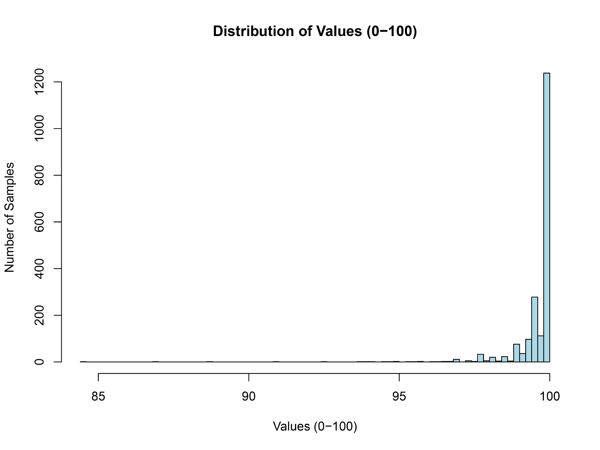
Sup 7: Percent sequence identity of ASVs from MAMI to COPSAC₂₀₁₀.
Distribution of percent sequence identity of the ASVs from the two cohorts using BLAST.

Sup 8: Species list with trajectory assignments
List of species analyzed in this study and corresponding trajectories assigned.
Attached as Excel table

Sup 9: Environmental Exposures and sample size at each Timepoint in COPSAC₂₀₁₀

Characteristic | No/Yes
antibiotics_atbirth | 466/80
antibiotics_pregnancy | 445/254
cesarean | 549/151
pets | 459/225
rural | 372/314 (quantile 171/172)
siblings | 321/374

Sup 10: Environmental Exposures and sample size at each Timepoint in MAMI
Characteristic | No/Yes
Antibiotics_atbirth | 128/6
Antibiotics_pregnancy | 131/62
Cesarean | 135/60
Pets | 113/64
Siblings | 109/84

Sup. 11: Summary of medical endpoints and sample size at each time point in COPSAC₂₀₁₀

Characteristic | Level | 1m | 1w | 1y | 4y | 6y
Samples | - | 615 | 552 | 627 | 498 | 407
asthma_10y | No/Yes | 503 / 30 | 455 / 23 | 523 / 28 | 426 / 24 | 353 / 22
asthma_3y | No/Yes | 496 / 105 | 460 / 82 | 518 / 103 | 417 / 81 | 340 / 66
asthma_5y | No/Yes | 535 / 57 | 481 / 50 | 552 / 59 | 446 / 50 | 362 / 43
asthma_6y | No/Yes | 540 / 37 | 487 / 33 | 560 / 37 | 455 / 29 | 371 / 26
asthma_7y | No/Yes | 528 / 34 | 479 / 30 | 544 / 36 | 443 / 28 | 365 / 24
asthma_8y | No/Yes | 524 / 35 | 474 / 30 | 542 / 35 | 443 / 28 | 367 / 22

