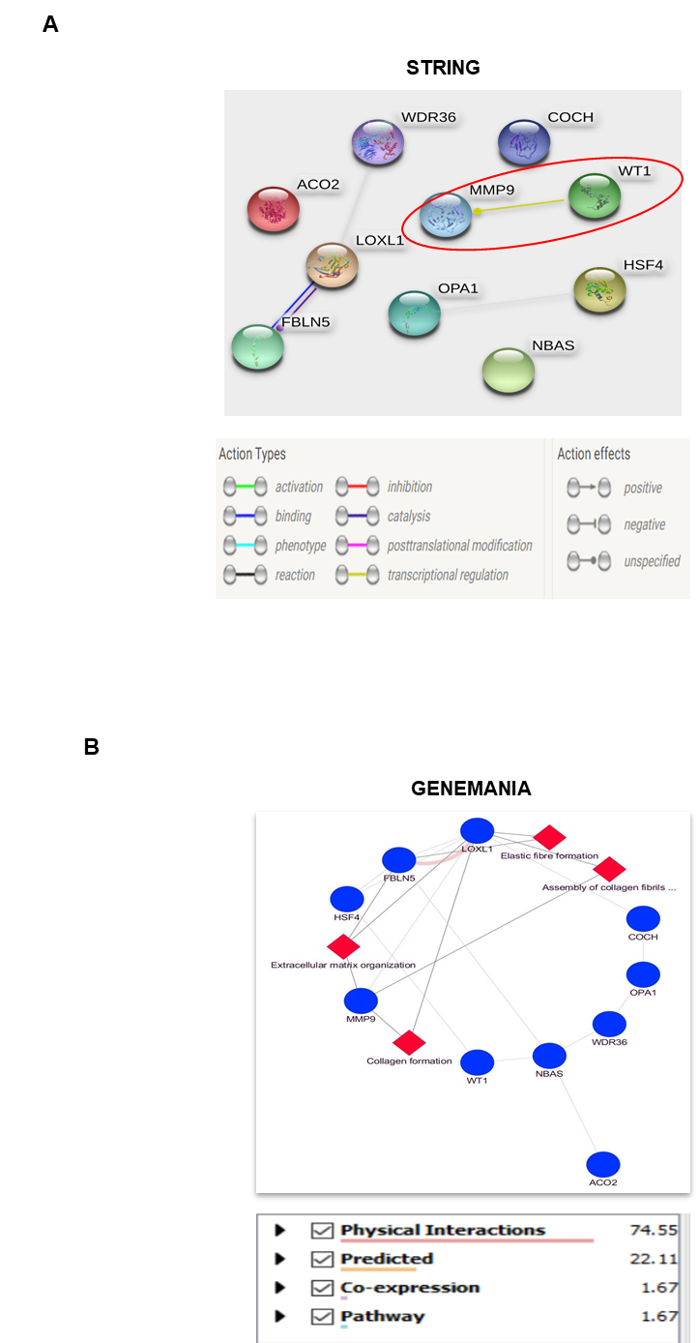
Fig. S1: PPI network analysis reveals WT1 and MMP9 interaction. A) STRING analysis revealed interacting partners of WT1 and its predicted transcriptional regulation on MMP9. B) Genemania analysis elucidated the involvement of MMP9 in biological functions namely extracellular matrix organisation, collagen formation and assembly of collagen fibrils.

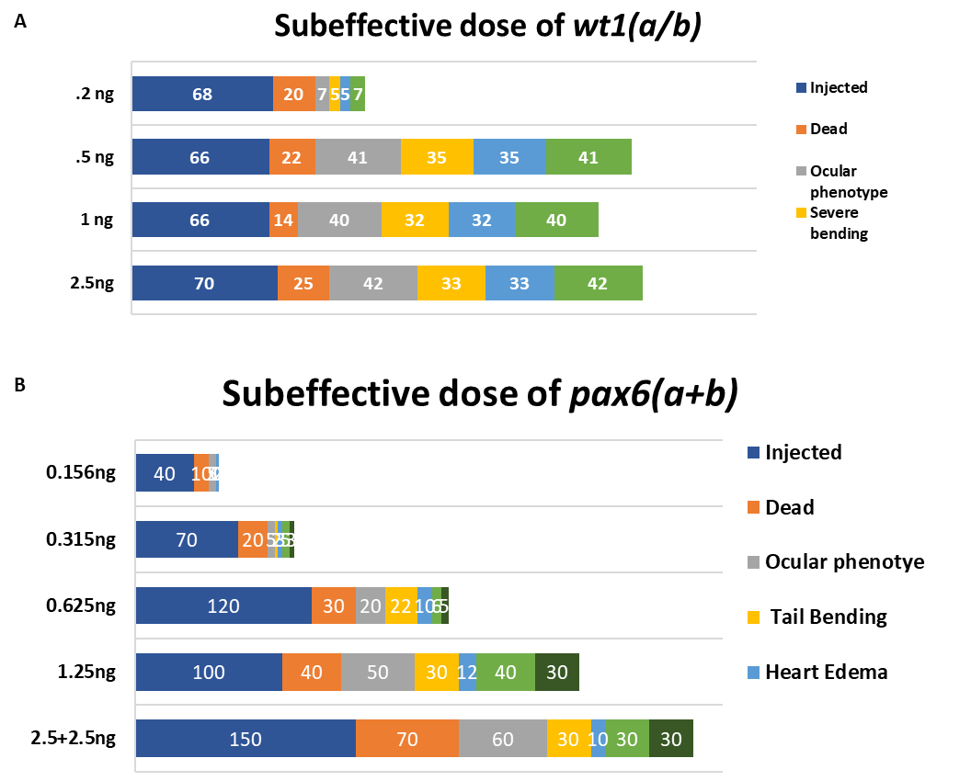
Fig S2- Subeffective dose standardization of wt1 and pax6. Sub effective dose for wt1 and pax6 were considered as 0.2ng and 0.625ng respectively.

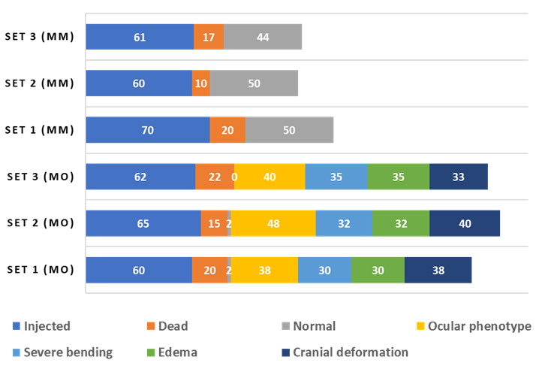
Fig S3: Gross morphological phenotypes observed in wt1a/b morphants

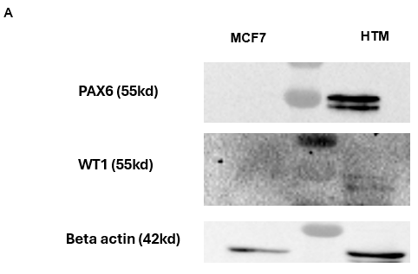
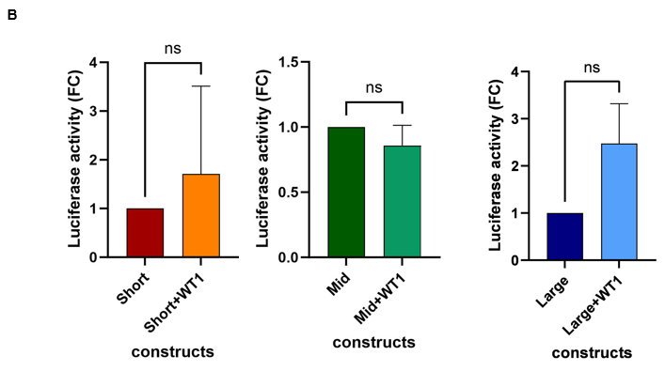

Fig S4:(A) WT1 and PAX6 relative expression levels in MCF7 and HTM cells, B) Luciferase assay of MMP9 promoter constructs in MCF7 cell line

A
B
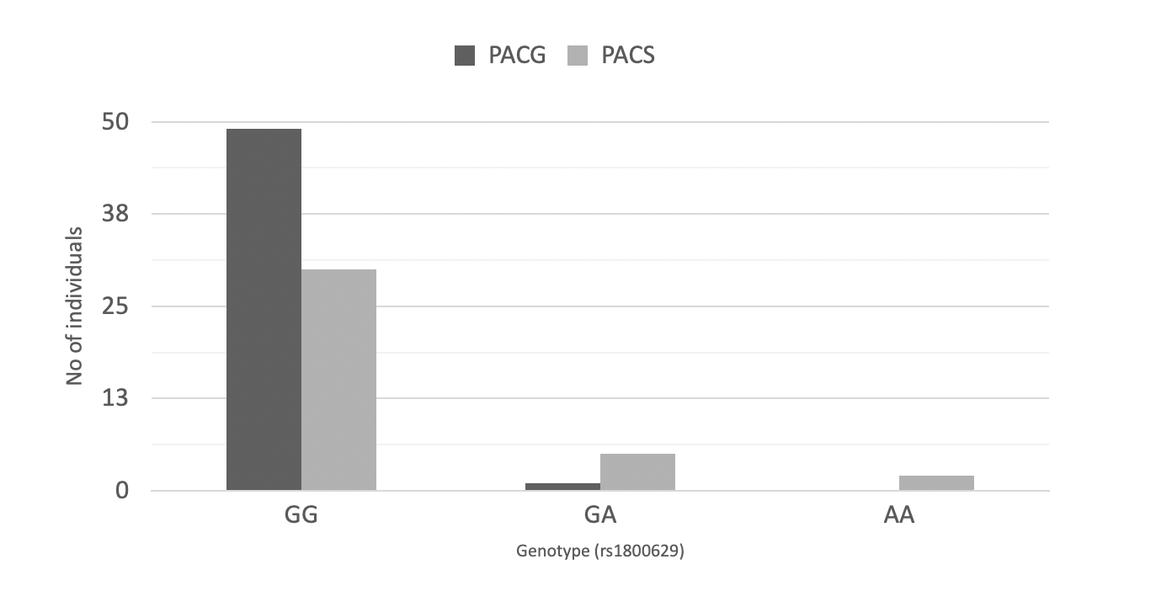
Fig. S5: Association rs1800629 in PACG GWAS. A) Manhattan plot showing association of significant SNPs. B) Genotype data of rs1800629 in the replication cohort.

A
Study​ | Ethnicity​ | Disease/ Trait | OR per A allele (95% CI)​ | Remarks
Lin et al., 2003​ | Chinese​ | POAG | 2.72 (1.76 - 4.45)​ | Risk
Fan et al., 2010​ | Chinese​ | POAG | 0.52 (0.31-0.87)​ | Protective
Tekeli et al., 2008​ | Turkish​ | PEXG | 0.34 (0.13- 0.87)​ | Protective
Bozkurt et al.,2012 ​ | Turkish​ | POAG | 2.45 (1.76-4.45)​ | Risk
Razeghinejad et al., 2009​ | Iranian​ | POAG, PEXG | 4.33 (1.67-11.34)​ | Risk
Ruxandra et al., 2015​ | Romanian​ | POAG | 0.95 (0.23-3.8)​ | No association
Mossbock et al., 2006​ | Caucasian​ | POAG | 0.96 (0.51-1.78)​ | No association
Hamid et al., 2016​ | Egyptian​ | OAG | 8.37 (4.78-14.81)​ | Risk
Chakraborty et al., 2013​ | East Indian​ | POAG | 0.957 (0.6-1.56)​ | No association
Vanita et al., 2019​ | North Indian​ | POAG, PACG, PCG | 2.36 (1.65-3.38)​ | Risk
Current study​ | North Indian​ | PACG | 0.17 (0.07-0.40) | Protective
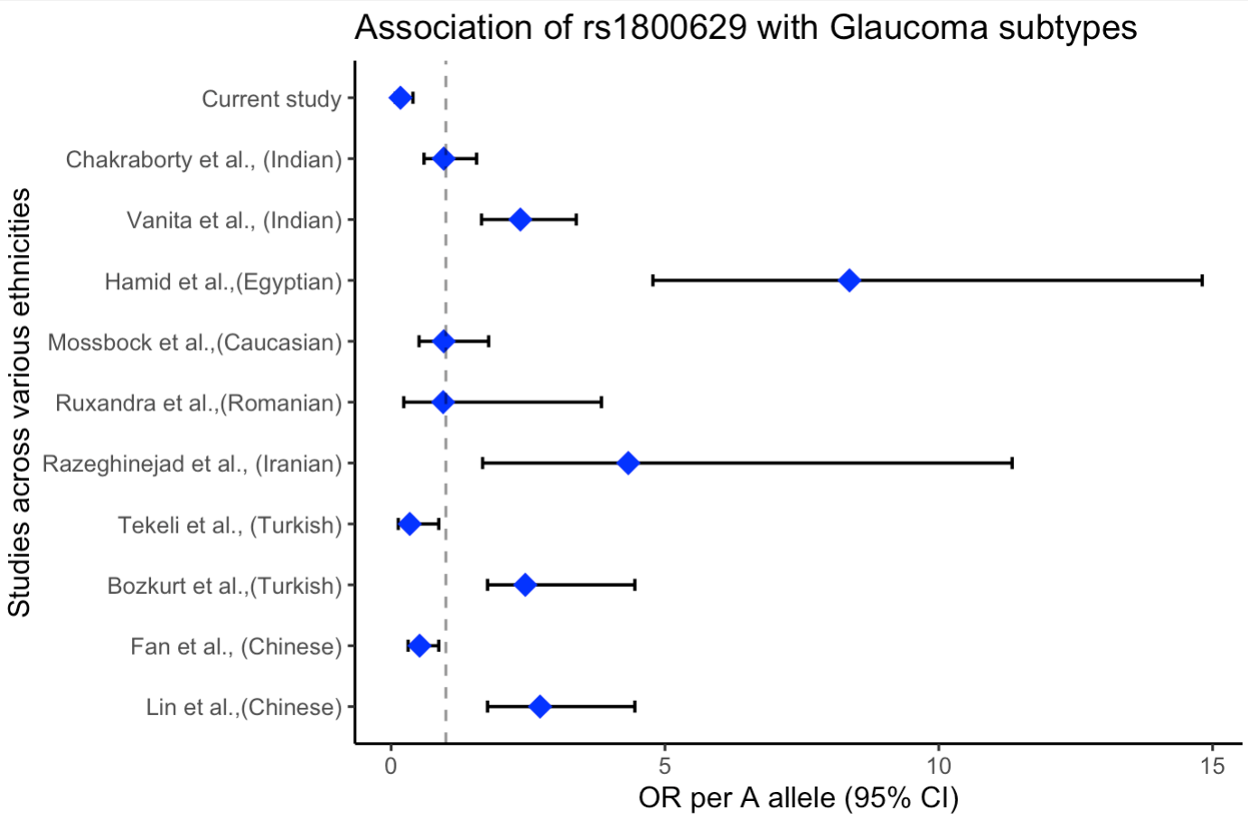
B
Association of rs1800629

Fig S6: rs1800629 in glaucoma. A) List of studies reporting association of rs1800629 in different subtypes of glaucoma across ethnicities. B) Forest plot showing OR per A allele across the studies

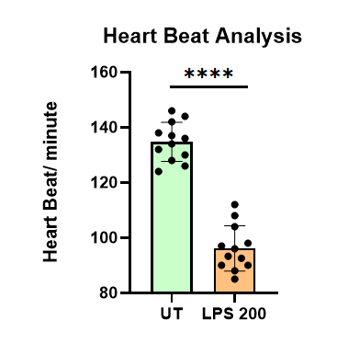
Fig S7: Barplot showing heart beats per minute in untreated and LPS treated 3dpf zebrafish embryos

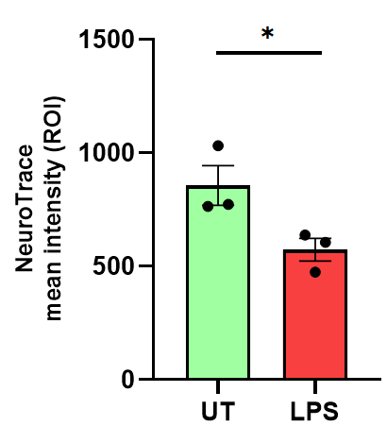
A
B
UT
LPS
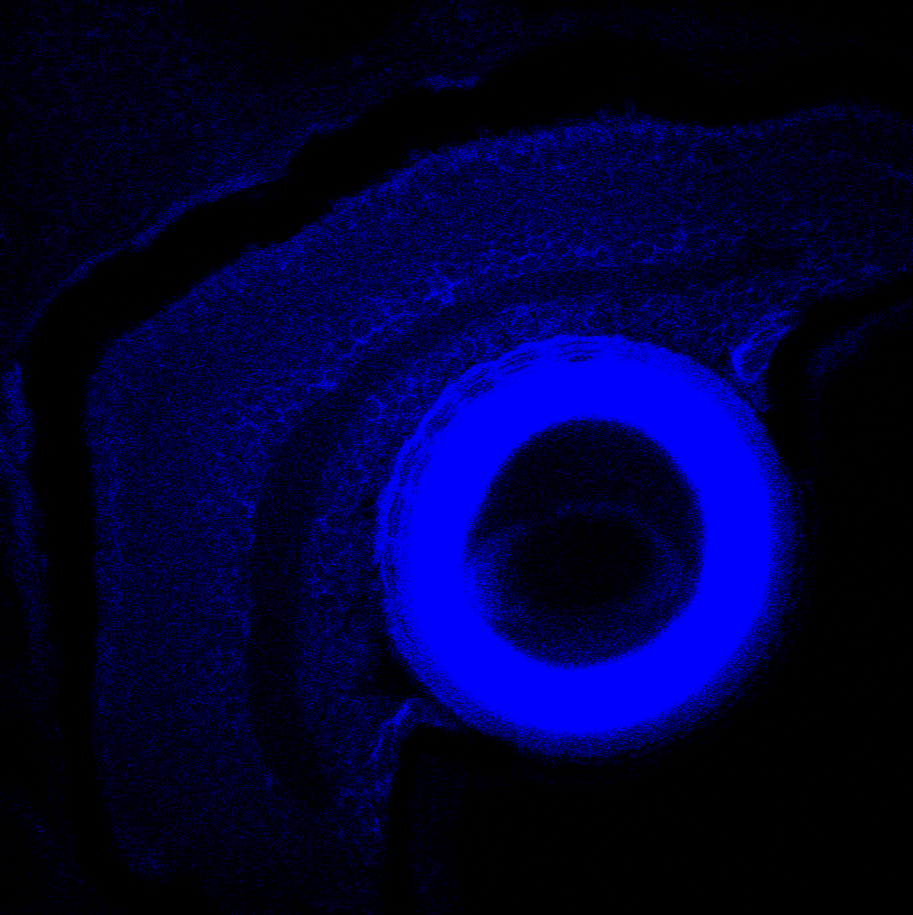
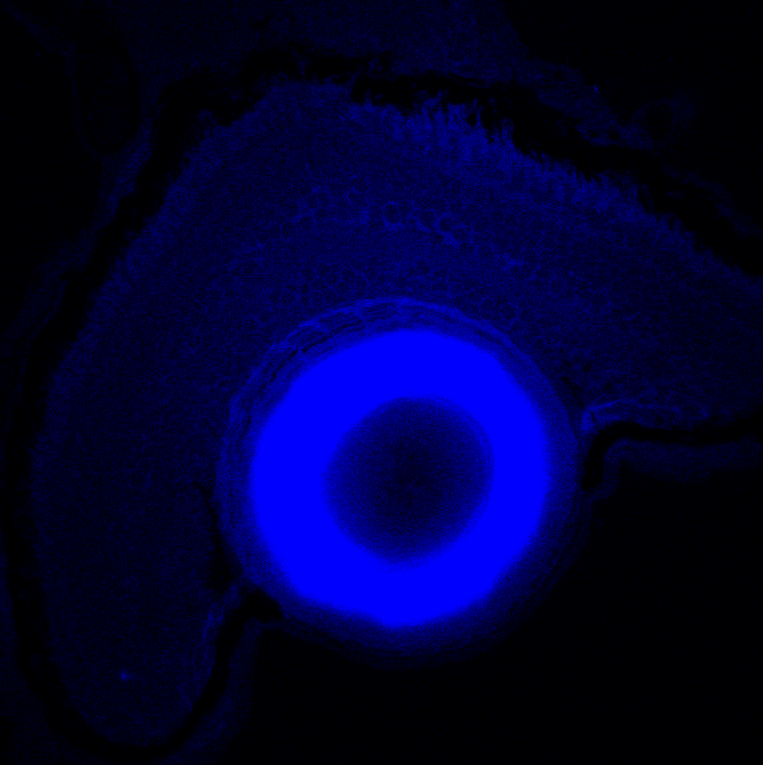
50um

Fig S8: A. LPS treated embyonic eyes showed lesser intensity of neurotrace staining. B) Neurotrace ROI mean intensity analysis of the treatment conditions.

