Figure-Supplementary materials
Figure 1.Density profiles of vitamin A and homocysteine
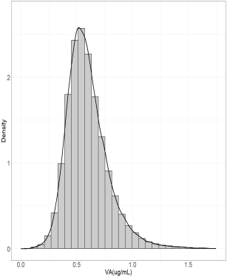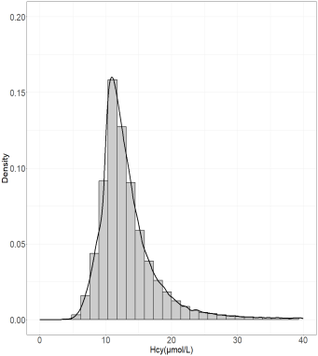
Figure2.Smooth fitting curve between plasma VA and HCY
Adjusted for age,sex,BMI,smoking,alcohol,FA,VB12,MTHFRC677T,hypertension,stroke,coronary heart disease
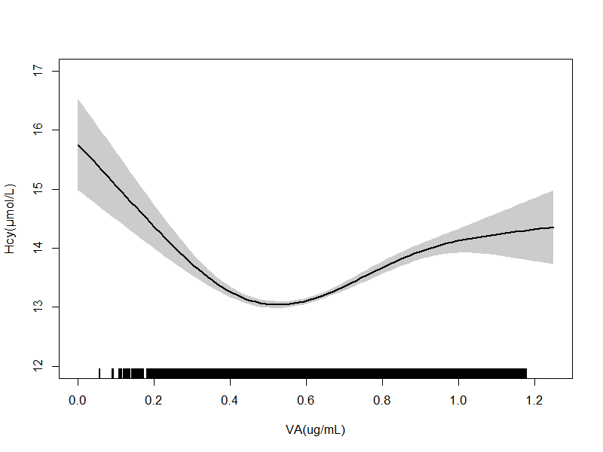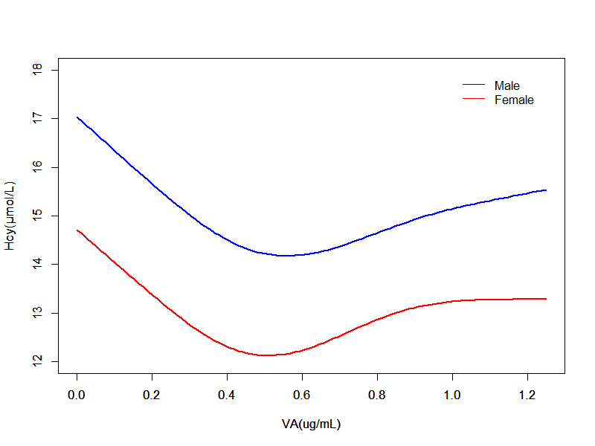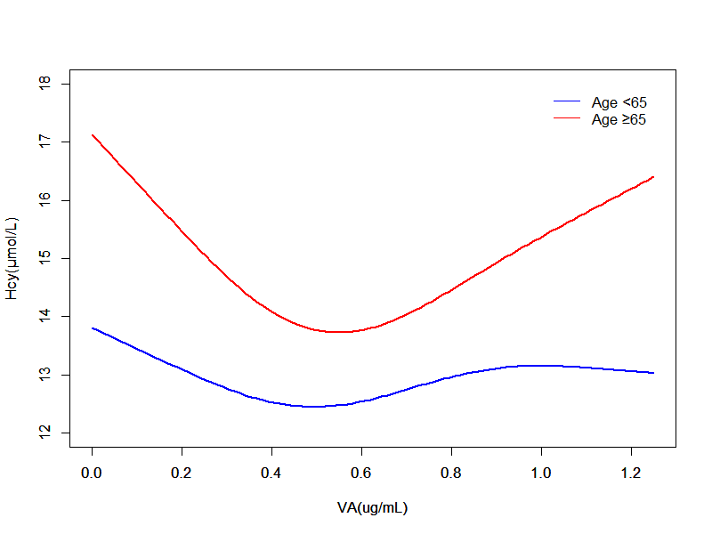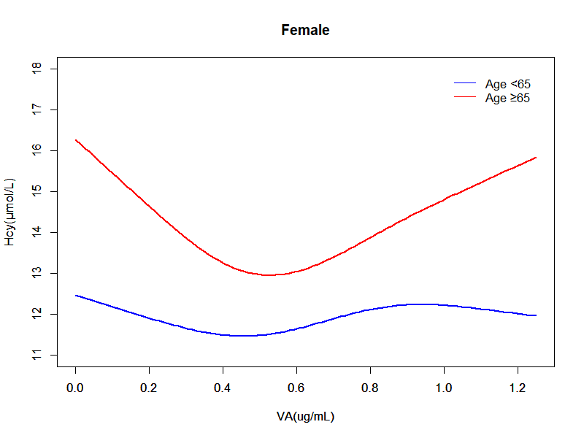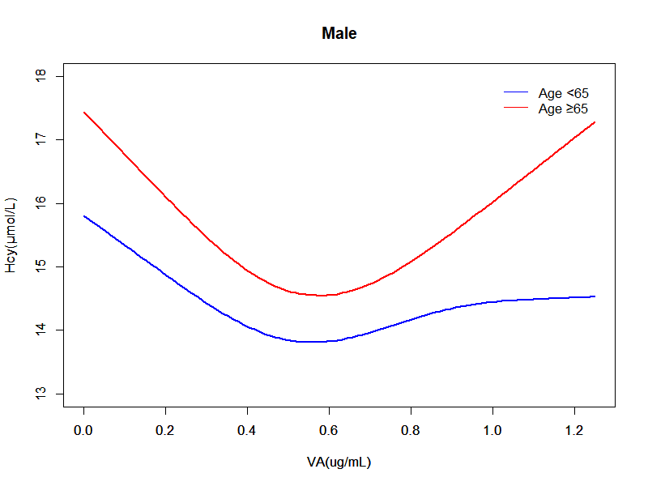
Figure 3. Restricted spline curve for associations of plasma VA with the prevalence of hyperhomocysteinemia by age. P for nonlinear <0.001.
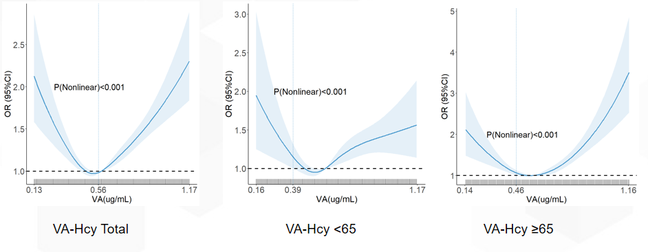
Variables adjusted for: age, sex, BMI, smoking, alcohol consumption, folate, vitamin B12, methyltransferase MTHFR C677T, hypertension, stroke, coronary artery disease.
Figure 4. Restricted spline curve for associations of plasma VA with the prevalence of hyperhomocysteinemia by sex. P for nonlinear <0.001.
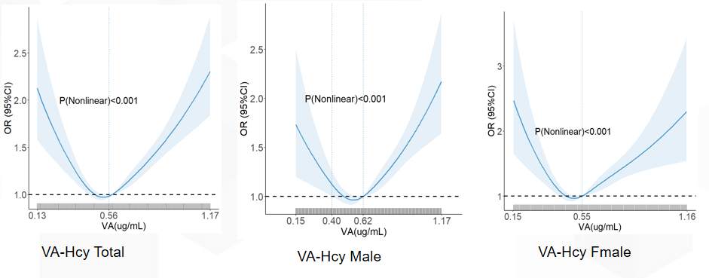
Variables adjusted for: age, sex, BMI, smoking, alcohol consumption, folate, vitamin B12, methyltransferase MTHFR C677T, hypertension, stroke, coronary artery disease.
Figure 5. Forest plots on the association of plasma VA levels with the risk of hyperhomocysteinemia (adjusted OR and 95% CI), stratified by pertinent covariables（the second quintile of the dataset as the reference group).
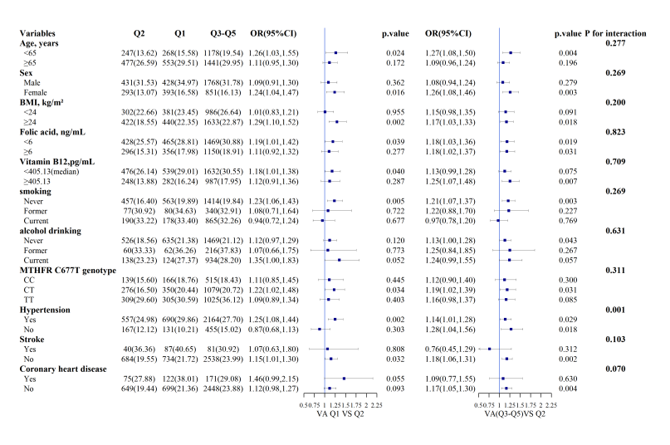
Figure 6. Forest plots on the association of VA and HCY by potential effect modifiers in various subgroups divided by VA concentration of 0.514 ug/mL
