Supplementary material - Comparison and predesign cost assessment of ozonation, membrane filtration and activated carbon for the treatment of recalcitrant organics, a conceptual study.
Christine Peyrelasse^{1*}, Matthieu Jacob^{2,3}, Audrey Lallement¹
¹APESA, Plateau technique, Cap Ecologia, Avenue Fréderic Joliot Curie, 64230 Lescar, France.
²RECORD, Campus LyonTech La Doua, 66, boulevard Niels Bohr CEI 1, CS 52132, 69603 Villeurbanne Cedex, France.
³TOTAL Energies, pôle d’étude et de recherche de Lacq, 64170 Lacq, France.
*(E-mail: christine.peyrelasse@apesa.fr).
A. Results of cost calculation
The annual O&M and capital costs for all the scenarios have been calculated based on the assumptions mentioned in the publication. Results are presented in Fig. SM1.
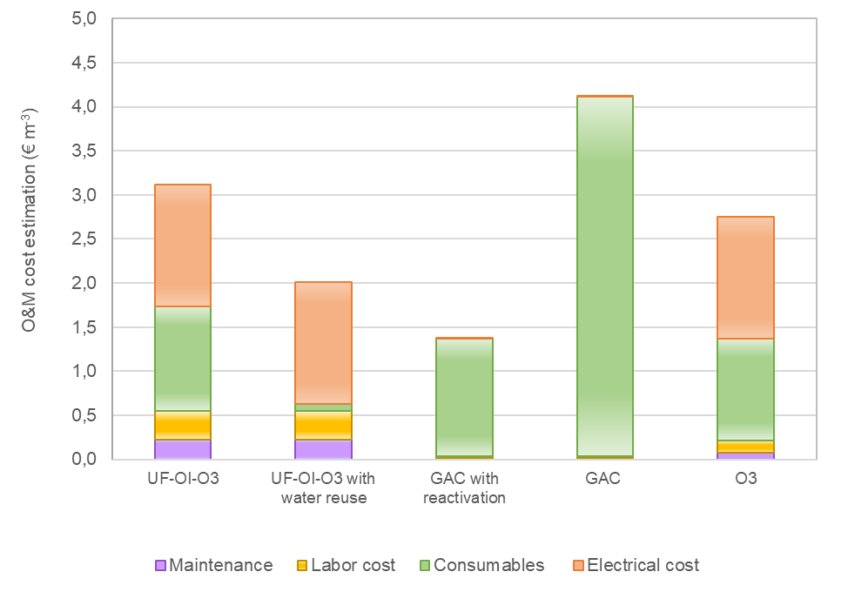
Fig. SM1. Annual O&M cost estimation (€ m⁻³) of the conceptual channels studied UF-RO-O₃ (channel 1), UF-RO-O₃-H₂O saved (channel 1 bis), GAG reactivation (channel 2), GAG elimination (channel 2 bis) and O₃ (channel 3).
The higher costs are obtained for channel 2 bis. It can be explained by a very high operating costs due to the elimination of spent AC and the buying of new activated carbon. On the contrary, the reactivation of the GAC drastically reduces the costs (low quantity of new GAC), only to compensate the loss of GAC during the reactivation (95% of regeneration efficiency considered). The ozonation process presents a medium O&M cost, explained by high electrical and oxygen consumptions. Reuse of water for channel 1 bis decreases interestingly the O&M costs showing the interest of the RO for sites that have difficulties for water access.
Capital costs calculated for each channel are presented in Table SM1.
Table SM1. Capital cost estimation (k€) of the conceptual channels studied
Channels | Processes | Total capital cost | Amortized annual capital cost
Channel 1 and 1 bis | UF + RO + O₃ | 11 555 | 888
Channel 2 and 2 bis | GAC | 1 123 | 86
Channel 3 | O₃ | 7 715 | 593
Activated carbon process presents a very low capital cost compared to the other wastewater tertiary treatment plants. The higher investment costs are evaluated for channel 1 and 1 bis using both membrane filtration and ozonation for the treatment of the RO retentate.
The total annual O&M costs and the amortized annual capital costs are used to calculate the cost in m³ of the wastewater treated for each channels. Results are presented in Fig. SM2.
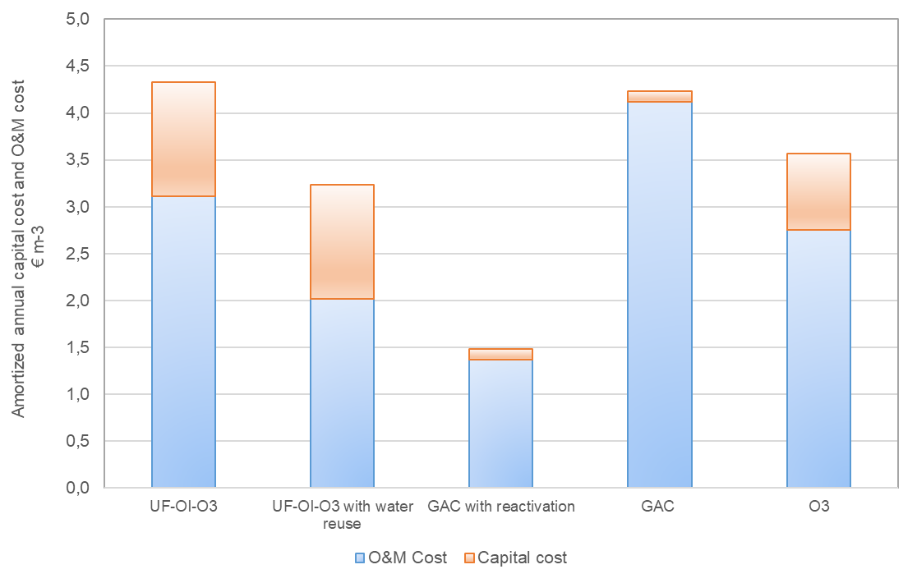
Fig. SM2. Costs of the conceptual channels studied considering the annual O&M cost and the capital cost for the treatment of 1 m³. Investment costs are calculated with an interest rate of 4.5% y⁻¹ and an amortization period of 20 years.
B. Description of the scoring used for the evaluation of the processes.
- Level of development
Ozonation and activated carbon adsorption are widespread processes, they obtains the score of 5. The reverse osmosis process has less industrial references.
- Technical reliability
Reverse osmosis may encounter problems of fouling or scaling that need cleaning for the membranes. Ozonation and adsorption seem to be more robust providing process control and maintenance well done. The adsorption need specifically a periodical change of the activated carbon before the degradation of process performances.
- Performances
The performances of theses processes are high. The reverse osmosis allows higher performances (c.f. §3.2).
- Flexibility / Adaptability
Ozonation and adsorption are quite flexible. Adjustments of the quantities of ozone applied can be made in the operating range of the generator of ozone. The frequency of spent activated carbon reactivation can be adapted to the load of pollution treated. Reverse osmosis has lower possibility for adaptation and high quantity of pollution could create problem of fouling or scaling. Its score is 3 while adsorption and ozonation have a rating of 4.
- Level of complexity for operability
Adsorption is a very simple process contrary to reverse osmosis that requires a qualified staff to operate the process.
- Energy consumption
Adsorption has very high energy consumption. The electrical consumptions of ozonation and reverse osmosis are linked to the quality of the wastewater to be treated. In our simulation, the ozonation requires higher electricity that reverse osmosis.
- Toxicity of the water treated
Ozonation can lead to the production of oxidation by-products. The water treated by adsorption could present bacterial pollution or pollutant if the maintenance of the filter is not adapted. On the contrary, water treated by reverse osmosis will always be of good quality.
- Possibility of recycling water
Reverse osmosis is the best suitable process to recycle water because it retains the minerals contrary to the other processes.
- Wastes
The ozonation process receives the highest score because no wastes are generated. The reactivation of activated carbon reduces the environmental impact of the adsorption process.
- Operating and investment costs:
An adsorption on AC have presented the lower investment cost. Operating cost of adsorption is decreased when the spent AC is reactivated. In our simulation, the investment cost of the ozonation is high due to the high concentration of COD in the wastewater simulated. Altogether, water treated by reverse osmosis is considered as recycled allowing a reduction of the operating costs.
It should be note that the following conditions have been chosen:
- Considered costs are linked to the treatment of a particular effluent (nature, flow rate) and are partly linked to performance and consumption (ozone, activated carbon).
- The technical, environmental and economic criteria studied have the same weight in the overall score.

