Supporting Information
Orbital coupling in bridge-mediated FeCu dual-atom catalysts for water decontamination
Ke Zhu, Yuheng Yao, Yongjian Zeng, Bin Liu, Huiming Wen, Yuchen Wang, Kai Yan*
Affiliations
Guangdong Provincial Key Laboratory of Environmental Pollution Control and Remediation Technology, School of Environmental Science and Engineering, Sun Yat-sen University, Guangzhou 510275, China.
Corresponding authors
*Prof. Kai Yan, orcid.org/0000-0001-9001-6337, E-mail: yank9@mail.sysu.edu.cn

Table of Contents
1. Supplementary Methods 1 to 15
2. Supplementary Figures 1 to 54
3. Supplementary Tables 1 to 15
4. References

1. Supplementary Methods
1.1. Chemical reagents and materials
Iron phthalocyanine (FePc), copper phthalocyanine (CuPc), potassium chloride (KCl), magnesium chloride (MgCl₂), melamine polyphosphate, glucose, potassium iodide (KI), calcium chloride (CaCl₂), sodium fluoride (NaF), sodium bicarbonate (NaHCO₃), disodium dihydrogen phosphate (NaH₂PO₄), sodium hydroxide (NaOH) and sodium sulfate (Na₂SO₄) were purchased from Aladdin Co., Shanghai, China. Sodium chloride (NaCl), methanol (MeOH), furfuryl alcohol (FFA), benzoic acid (BA), acetic acid (HAC), p-benzoquinone (p-BQ), and tert-butanol (TBA) were purchased from Guangzhou Chemical Reagent Factory. Ethanol (CH₃CH₂OH), methanol (CH₃OH), 2,2,6,6-tetramethylpiperidine (TEMP), 5,5-dimethyl-2-pyrrolidone-N-oxyl (DMPO), potassium thiocyanate (KSCN), nitrotetrazolium blue chloride (NBT), methyl phenyl sulfone (PMSO₂), and methyl phenyl sulfoxide (PMSO) were purchased from Macklin Co., Shanghai, China. Hydrochloric acid (HCl) was purchased from Guangdong Guanghua Sci-Tech Co., Ltd. Peroxymonosulfate (PMS, KHSO₅·0.5KHSO₄·0.5K₂SO₄) was purchased from Sigma-Aldrich. All the other chemicals were at least of analytic grade and used without further purification. Deionized water (DW) was obtained through a ULUPURE UPT-11-20T water purification system.
1.2. Catalytic activity evaluation
The catalytic degradation of ciprofloxacin (CIP) was evaluated in a batch reaction system. Experiments were conducted in a 100 mL glass beaker containing 50 mL of CIP solution (10 mg L⁻¹) with constant mechanical stirring at 400 rpm and maintained at 25 °C. The reaction was initiated by adding PMS (0.1 mM) and catalyst (50 mg L⁻¹, 2.5 mg). At predetermined time intervals, 0.5 mL aliquots were sampled, immediately filtered through a 0.22 μm membrane, and quenched with 0.5 mL methanol to terminate the reaction. CIP concentrations were quantified using high-performance liquid chromatography (HPLC, Shimadzu LC-20A).
Several influential factors, including catalyst dosage (10-100 mg L⁻¹), PMS dosage (0.025-0.2 mM), and initial pH value (2.00-12.00), were investigated. Besides, various concentrations of inorganic ions and humic acid were used to study the anti-interference performance. To investigate the stability and reusability of the catalyst, the used catalysts were collected through centrifugation, washed several times with ultrapure water, and dried at 80 °C for the next cycles. A series of scavengers, such as MeOH, tert-butanol (TBA), p-Benzoquinone (p-BQ), and 2,2,6,6-tetramethylpiperidine (TEMP), were used to identify the ROS in the system. All results were repeated in triplicate.
1.3. Evaluation of catalytic activity
The modified kinetic rate constant (k-value) was calculated by dividing the observed rate constant of organic contaminants by the catalyst dosage and PMS concentration, followed by multiplying the organic contaminant concentration.
The calculation of k-value (min⁻¹•M⁻¹):
k-value = (C₀ × k)/(C_{cata.} × C_{PMS})
Where C₀ is the initial concentration of organic (g L⁻¹), t is the reaction time, C_{PMS} is the metal element concentration (M), and C_{cata.} is the concentration of the catalyst (g L⁻¹).
The degradation efficiency of CIP was described:
Degradation rate of CIP = $\frac{{\text{C}}_{\text{t}}}{{\text{C}}_{\text{0}}}$
The pseudo-first-order reaction degradation kinetic was described:
$\frac{\text{dC}}{\text{dt}}$ = $\text{-}\text{k }\text{c}$
$ln\text{(}\frac{{\text{C}}_{\text{t}}}{{\text{C}}_{\text{0}}}$) = $\text{-}\text{k }t$
Where C_{t} and C₀ were the CIP concentration at time t and the initial concentration of CIP (mg L⁻¹). k was the pseudo-first-order reaction rate constant (min⁻¹) and t was the reaction time (min).
1.4. Analysis of the degradation intermediates of CIP
The degradation intermediates of CIP were analyzed by using a Shimadzu LC-20AD UPLC coupled with a time of flight mass spectrometry (AB SCIEX 5600 puls, USA) with an Agilent C18 column (2.1 × 50 mm, 3.7 μm). The mobile phase consisted of reagent A (ultrapure water with 0.2% formic acid) and reagent B (methanol) at a flow rate of 1.0 mL min^{–1}. The gradient was set to linearly increase from 10% B to 90% B in 35 min, then hold at 90% B for 5 min, and return to 10% B in 20 min, then hold at 10% B for 5 min. The mass spectrometer was operated in the positive ion mode and measured in m/z 50-450. The injection volume was 10 μL. The electrospray ionization (ESI) source conditions were described as follows: spray voltage at + 4.5 kV, the capillary temperature at 350 °C, probe heater temperature at 500 °C, nebulize gas at 55(GS2, arbitrary units), sheath gas at 50 (GS2, arbitrary units), curtain gas at 40 (arbitrary units), and sweep gas at 1 (arbitrary units), CE (collision energy) at 35 V, DP (declustering potential) at 60 V, others were the default The data acquired from Analyst 1.7 software and its analysis by PeakViews (AB SCIEX).
1.5. The construction method of the FeCu-NP-C membrane
The FeCu-NP-C dispersion was assembled into a lamellar membrane using the vacuum-assisted filtration assembly method. Disc-type polyether sulfone (PES) membranes (50 mm diameter, 0.45 μm pore size) were used as substrates. 5 mg mL⁻¹ FeCu-NP-C water dispersions with 1.0 wt% ethylenediamine (20 mL) were used as membrane casting solutions. The suspended solution was stirred at a speed of 600 rpm for 12 h at room temperature and sonicated for 2 h. Subsequently, Ethylenediamine was used as a cross-linker to enhance the stability of the FeCu-NP-C. By using a vacuum-assisted filtration method, after completion, the FeCu-NP-C catalytic membrane was dried in ambient atmosphere.
1.6. FeCu-NP-C membrane activity evaluation
To better observe, CIP was chosen as the target pollutant to study the catalytic performance of the FeCu-NP-C membrane/PMS system. A continuous monitoring of 100 L CIP degradation was conducted. The continuously cyclic tests were carried out in 250 mL of solution containing 10 mg L⁻¹ of CIP and 0.1 mM PMS. The mixed solution continues to flow into the membrane filtration reactor with a flow rate of 90 mL min⁻¹. At regular intervals of 30 min, about 1.0 mL of sample was extracted from the solution, and the supernatant was obtained by centrifugation. LC quantified the CIP concentration. At each cyclic test, the degraded solution was replaced with 250 mL of the new reaction solution, which still contained 10 mg L⁻¹ of CIP and 0.1 mM PMS, but no additional catalysts were added. The catalytic oxidation process was then performed using the same procedure described above.
1.7. Method for detecting PMS concentration
The concentration of PMS was also tested by the low-concentration iodide method: (i) preparation of 10 mM KI stock solution: 0.04 g sodium bicarbonate and 0.166 g potassium iodide were mixed in 100 mL ultrapure water; (ii) sampling: samples (1.0 mL) were withdrawn and then filtrated by the polytetrafluoroethylene microfiltration membrane (0.22 μm); (iii) chromogenic reaction: 0.1 mL filtered sample was mixed with 4.9 mL stock solution for 5 min; (iv) detection: the concentration of PMS was detected using a UV-vis spectrometer at the wavelength of 351 nm using a quartz cuvette.
1.8. Analysis of degradation kinetics
CIP degradation by the FeCu-NP-C/PMS system could be described by the pseudo-first-order kinetic model. To further understand the interdependencies between CIP degradation rate and dosages of PMS and FeCu-NP-C catalysts, Eq. S1 and its logarithm form (Eq. S2) were developed, where a, b, and c are the reaction orders of PMS and FeCu-NP-C, respectively. Besides, K is a constant of the total reaction rate for CIP degradation. Based on the pseudo-first-order reaction kinetic model, the initial dosages of PMS and FeCu-NP-C determined the apparent rate constant (k_{obs}). The reaction rate equation can be described as Eqs. S3-S4.
$v=-\frac{dc}{dt}=K{[PMS]}^{a}{[FeCu-NP-C]}^{b}$ (S1)
$log\left(v\right)=\log\left(-\frac{dc}{dt}\right)= log\left(K\right)+a log[PMS]+b log[FeCu-NP-C]$(S2)
$v=-\frac{dc}{dt}=K[PMS]_{0}^{a}[FeCu-NP-C]_{0 }^{b}$ (S3)
$log\left(v\right)=\log\left(-\frac{dc}{dt}\right)= log\left(K\right)+a log[PMS]_{0}+b log[FeCu-NP-C]_{0}$(S4)
The corresponding kinetic models were analyzed by monotonously changing the dosage of PMS and FeCu-NP-C. As shown in Supplementary Fig. S20-S21, log(-dc/dt) is linearly dependent on log[PMS]₀ and log[FeCu-NP-C]₀. Thus, the values of a and b were calculated to be 0.3034 and 0.6160 according to these linear equations. By plugging the value of v (i.e., k_{obs}) at the conditions of 0.05 g L⁻¹ FeCu-NP-C and 0.1 mM PMS into Eq. S3, K with the value of 2.025 was obtained. Therefore, the apparent kinetic model of CIP degradation can be presented as Eq. S5. This result indicated that all of the reaction orders of PMS and FeCu-NP-C were between zero- and first-order kinetics, and PMS concentration had a rather considerable impact on the ability to degrade CIP, while the impact of FeCu-NP-C dosage is relatively minor. Therefore, to achieve a fine trade-off between reagent input and the degradation performance of CIP, a relatively lower concentration of PMS (0.1 mM) with a lower FeCu-NP-C dosage (0.05 g L⁻¹) was selected as the optimal condition in our experiment.
𝑣 = -$\frac{\text{dc}}{\text{dt}}$ = 2$.025 {\text{[PMS]}}_{0}^{0.3034}{\text{[Catalyst]}}_{0}^{0.616}$(S5)
1.9. The method of ¹⁸O isotope-labeling experiments
¹⁸O isotope-labeled experiments were performed in a 10 mL H₂¹⁸O matrix under preset conditions. After the reaction was completed, a 0.8 ml sample was taken out and mixed with 0.2 ml of DMSO to terminate the oxidation reaction in the system. PMSO, PMS¹⁶O¹⁶O, and PMS¹⁶O¹⁸O, the HPLC-QTOF-MS/MS analysis was measured by ultra-performance liquid chromatography combined with quadrupole time-of-flight mass spectrometry (UPLCQ-TOF-MS/MS, Agilent 1290 Infinity II UPLC with Agilent G6545 Q-TOF) under the following conditions. Separation was performed with a BEH C18 column (100 mm × 2.1 mm i.d., 1.7 μm; Waters, Milford, USA) and eluted with gradient solvent from A: B (95: 5) to A: B (5: 95) at a flow rate of 0.20 mL min⁻¹, where A is aqueous formic acid (0.1% (v/v)) and B is acetonitrile. The column was maintained at 40 °C. Accurate MS/MS patterns and oxidation products were analyzed in a molecular ion scanning mode (m/z = 20 to 1000) in positive electrospray ionization (ESI) modes. The molecular formula of the identified products was proposed based on experimental and theoretical m/z values.
1.10. The specific methods of antibacterial experiment
Escherichia coli K-12 was chosen as the model bacterium to evaluate the catalytic inactivation efficiency of the FeCu-NP-C according to the reported method [Reference]. Bacterial cells were first cultured in Nutrient Broth growth medium at 37 °C for 16 h with shaking, and then harvested by centrifugation at 8000 rpm for 3 min. The bacterial pellets were then washed with sterilized saline solution (0.9% NaCl) three times in a centrifuge tube and re-suspended in a sterilized saline solution to obtain a suitable concentration of E. coli. Then, 2.5 mg of the as-prepared FeCu-NP-C catalyst and 0.5 mM PMS were added to a 25 mL solution containing 10^{6.5} cfu/mL bacterial suspensions. When PMS was added to the system for 30 min, 1 mL of the solution was added to 100 μL of sodium thiosulfate (0.1 M) and diluted 2 times, and then 50 μL of the solution was uniformly spread onto Nutrient Agar plates. Finally, the number of colonies was calculated after a period of incubation at 37°C for 12 h to determine the viable cell count. All the inactivation experiments were conducted in triplicate. The calculation method of the pseudo-first-order rate constant of bacterial inactivation was displayed by Eq. (S6).
k = -ln (I₂/I₁) (S6)
Where I₁ represents the initial colony count, and I₂ represents the remaining colony count.
1.11. ESR analysis of reactive oxygen species
Radicals (.OH and SO₄⁻) generated in the FeCu-NP-C/PMS systems were qualitatively detected by the electron spin resonance (ESR, A300-10/12, Bruker) experiments, whilst 5,5-dimethyl-1-pyrolin-N-oxide (DMPO) was used as the trapping agent. 0.05 g L⁻¹ FeCu-NP-C, 0.1 mM PMS, and 20 mM DMPO were mixed in a test tube with 4.0 mL ultrapure water for a 3.0 min reaction. However, O₂⁻ needed to be detected in the methanol system. 0.05 g L⁻¹ FeCu-NP-C, 0.1 mM PMS, and 20 mM DMPO were mixed in a test tube with 4.0 mL methanol for a 3.0 min reaction. The same method was used, whilst 2,2,6,6-Tetramethyl-4-piperidone (TEMP) was used as the trapping agent. 0.05 g L⁻¹ FeCu-NP-C, 0.1 mM PMS, and 20 mM TEMP were mixed in a test tube with 4.0 mL ultrapure water for a 3.0 min reaction. Finally, each mixed solution was transferred into a capillary tube, which was then inserted into the cavity of the ESR spectrometer. The signals of ESR spectra of DMPO-.OH adduct (derived from the reaction between DMPO and .OH), DMPO-SO₄⁻ adduct (derived from the reaction between DMPO and SO₄⁻), DMPO-O₂⁻ adduct (derived from the reaction between DMPO and O₂⁻) and TEMP-¹O₂ adduct (derived from the reaction between TEMP and ¹O₂) were detected.
1.12. The steady state concentrations of Fe(IV), SO₄^{•−}, and •OH in the FeCu-NP-C/PMS process
The steady state concentrations of SO₄^{•−} and •OH in the FeCu-NP-C/PMS process can be calculated using NB and BA as prob compounds. The degradation of NB and BA in the FeCu-NP-C/PMS process can be expressed as follows:
$$\frac{\text{d}\text{[NB]}}{\text{d}\text{t}}\text{=-}{\text{k}}_{\text{NB,•OH}}\text{[•OH}{\text{]}}_{\text{ss}}\text{[NB]}$$
$$\frac{d[\text{BA}]}{dt}=-（k_{\text{BA},•OH}[\text{•}\text{OH}]_{ss}+k_{\text{BA},\text{S}{{\text{O}}_{4}}^{•-}}[\text{•}\text{OH}]_{ss})[\text{BA}]$$
Integrating the above equations, it could be obtained:
$$\ln{\frac{[\text{NB}]}{[\text{NB}]_{0}}}=-k_{\text{NB},\text{•}\text{OH}}[\text{•}\text{OH}]_{ss}t=-k_{\text{obs,NB}}t$$
$$\ln{\frac{[\text{BA}]}{[\text{BA}]_{0}}}=-(k_{\text{BA},\text{•}\text{OH}}[\text{•}\text{OH}]_{ss}+k_{\text{BA},\text{S}{{\text{O}}_{4}}^{•-}}[\text{S}{{\text{O}}_{4}}^{•-}]_{ss})t=-k_{\text{obs,BA}}t$$
So that, [•OH]_{ss} and [SO₄^{•−}]_{ss} could be acquired:
$$[\text{•}\text{OH}]_{ss}=\frac{k_{\text{obs},\text{NB}}}{k_{\text{NB},\text{•}\text{OH}}}$$
$$[\text{S}{{\text{O}}_{4}}^{•-}]_{ss}=\frac{k_{\text{obs},\text{BA}}-k_{\text{BA},\text{•}\text{OH}}[\text{•}\text{OH}]_{ss}}{k_{\text{BA},\text{S}{{\text{O}}_{4}}^{•-}}}$$
Where [NB] and [BA] are the concentrations of NB and BA at time t, respectively; k_{NB,HO•} is second-order rate constant of NB with •OH (3.9 × 10⁹ M⁻¹ s⁻¹); k_{BA,•OH} and k_{BA,SO4•−} are the second-order rate constant of BA with $\text{•}\text{OH}$ (5.9 × 10⁹ M⁻¹ s⁻¹) and SO₄^{•−} (1.2 × 10⁹ M⁻¹ s⁻¹), respectively. The pseudo-first-order constants of NB (k_{obs,NB}) and BA (k_{obs,BA}) were obtained from Supplementary Fig. 38a-d. According to the fitting data, the steady-state concentrations of $\text{•}\text{OH}$ and SO₄^{•−} were calculated to be 2.66× 10⁻¹⁴ M and 6.47×10⁻¹⁴ M.
The steady state concentration of Fe(IV) in FeCu-NP-C/PMS can be determined based on the kinetics of PMSO₂ generation from the oxidation of PMSO. The generation kinetics of PMSO₂ can be expressed as follows:
$$\frac{d[\text{PMS}{\text{O}}_{2}]}{dt}=-k_{\text{PMSO},\text{Fe}(\text{IV})}[\text{Fe}(\text{IV})]_{ss}[\text{PMSO}]$$
$$\text{η}\text{=}\frac{[\text{PMS}{\text{O}}_{2}]}{[\text{PMSO}]_{0}-[\text{PMSO}]}$$
Substitution of the above Eqs and integrating can yield:
$$\frac{d[\text{PMS}{\text{O}}_{2}]}{[\text{PMSO}]_{0}-\frac{1}{η}[\text{PMS}{\text{O}}_{2}]}=k_{\text{PMSO},\text{Co}(\text{IV})}[\text{Fe}(\text{IV})]_{ss}dt=-k_{\text{obs}}t$$
$$η\ln{\frac{[\text{PMSO}]_{0}}{[\text{PMSO}]_{0}-\frac{1}{η}[\text{PMS}{\text{O}}_{2}]}}=k_{\text{PMSO},\text{Co}(\text{IV})}[\text{Fe}(\text{IV})]_{ss}t=-k_{\text{obs}}t$$
$$[\text{Fe}(\text{IV})]_{ss}=\frac{k_{\text{obs}}}{k_{\text{PMSO},\text{Fe}(\text{IV})}}$$
Where [PMSO] and [PMSO₂] are the concentrations of PMSO and PMSO₂ at time t, respectively; η is the yield of PMSO₂ (i.e., the molar ratio of PMSO₂ produced to PMSO lost); k_{PMSO,Fe(IV)} is the second-order rate constant of PMSO with Fe(IV) (2.0 × 10⁶ M⁻¹ s⁻¹). The pseudo-first-order rate constants (k_{obs}) can be obtained from the plots of $η\ln{\frac{[\text{PMSO}]_{0}}{[\text{PMSO}]_{0}-\frac{1}{η}[\text{PMS}{\text{O}}_{2}]}}$ versus time. Thus, the steady-state concentrations of Fe(IV) were calculated to be 5.8× 10⁻⁸ M. The steady-state concentration of Fe(IV) was 4-5 orders of magnitude higher than that of SO₄^{•−} and HO• in the FeCu-NP-C/PMS process. That is why Fe(IV) could contribute to the degradation of PMSO in the FeCu-NP-C/PMS process, although the second-order rate constants between SO₄^{•−}/HO• and PMSO are several orders of magnitude larger than that with Fe(IV).
1.13. Quantification of the steady-state ¹O₂ concentration
0.1 mM furfuryl alcohol (FFA) was employed as a molecular probe to measure the amount of ¹O₂ produced during the Fenton-like reactions.¹ The steady-state ¹O₂ concentration was determined by the loss of FFA, which reacted with ¹O₂ at a second-order reaction rate constant of k_{FFA,1O2} = 1.2 × 10⁸ M⁻¹·s⁻¹, using the following equations.
FFA + ¹O₂ → Intermediates
-d[FFA]/dt = k_{FFA,1O2}·[¹O₂]_{SS}·[FFA] = k_{obs}·[FFA]
Where [FFA] is the concentration of FFA (M), [¹O₂]ss is the steady-state concentration of ¹O₂ (M), and k_{obs} is the degradation rate of FFA (s⁻¹).
1.10. Quantification of the steady-state O₂^{•-} concentration
Nitrotetrazolium blue chloride (NBT) was used as a probe to detect O₂^{•-}. The N₂ aeration tube was immersed in NBT aqueous solution before the reaction, and O₂ in the solution was excluded. Then, 1 mg catalyst, 1 mM NBT, and 0.1 mM PMS were added to a quartz reactor. After a defined time interval, 1 mL sample was taken out from the quartz reactor using a syringe and filtered through a 0.22 µm PTFE filter. The yellow NBT was reduced by O₂^{•-} to blue formazan. The concentration ratio of formazan and O₂^{•-} is 1:4, which was measured by UV-Vis-DRS at 259 nm.
1.14. Electrochemical measurement and analysis
All the electrochemical measurements were conducted at room temperature in a standard three-electrode electrochemical cell with the counter electrode (CE, Pt wire with Ф = 1 mm, Shanghai CH Instruments Ins.), reference electrode (RE, Ag/AgCl, Gaoss Union), a catalyst-prepared working electrode, and 500 mM Na₂SO₄ was used as electrolyte. All the electrochemical data were collected via an electrochemical workstation (Shanghai Chenhua, CHI760E).
The catalyst-prepared working electrode: the catalyst (2 mg) ﬁrstly dispersed in a mixed solution containing 0.1 mL of ethanol and 10 μL of naphthol solution with sonicating for 30 min, then the suspension was dropped onto a piece of carbon fiber paper (CFP, TGP-H-060) purchased from Toray Industries, Inc (Japan) (1 cm × 1 cm) (the CFP was soaked for 24 h with 0.05 M HCl solution to remove the surface oxide layer, which was taken out and rinsed with acetone, ethanol and deionized water several times to remove the oil contamination, respectively) and vacuum dried at 60 ℃, 12 h. Finally, the as-formed CFP was used as a working electrode.
Cyclic voltammetry (CV) measurements were performed at a potential window of 0-0.6 V and a scan rate of 5 mV s⁻¹.
Electrochemical impedance spectroscopy (EIS) measurements were tested with an AC voltage of 5 mV amplitude and frequency from 0.1Hz to 10 kHz.
Linear sweep voltammetry (LSV) measurements were carried out as the potential from -1.0~1.0 V (vs. Ag/AgCl) with a scanning rate of 5 mV s⁻¹. (The electrolyte of FeCu-NP-C was a mixture of 500 mM Na₂SO₄). The electrolyte of the FeCu-NP-C/PMS system was a mixture of 500 mM Na₂SO₄ and 0.25 mM PMS.
Tafel measurements were performed with a bias of 0.0 V (vs. Ag/AgCl) with 500 mM Na₂SO₄ as supporting electrolyte. After the baseline was stable, the open-circuit voltage was set to obtain the Tafel curve.

1.15. LCA analysis
The scaled-up environmental performance of FeCu-NP-C was investigated using LCA. Utilizing experimental data from both laboratory and pilot-scale studies, a comprehensive life cycle inventory model was established using the SimaPro 9.0 software platform and the Ecoinvent database. To ensure the reliability of the assessment results, uncertainty analysis was performed through 1000 Monte Carlo simulations. The system boundary definition encompassed the entire process from raw material acquisition to system operation, with key parameters referenced in Supplementary Tables 9-14. The analysis systematically examined 18 distinct environmental impact indicators (Global warming; 2. Stratospheric ozone depletion; 3. Ionizing radiation; 4. Ozone formation, Human health; 5. Fine particulate matter formation; 6. Ozone formation, Terrestrial ecosystems; 7. Terrestrial acidification; 8. Freshwater eutrophication; 9. Marine eutrophication; 10. Terrestrial ecotoxicity; 11. Freshwater ecotoxicity; 12. Marine ecotoxicity; 13. Human carcinogenic toxicity;14. Human non-carcinogenic toxicity; 15. Land use; 16. Mineral resource scarcity; 17. Fossil resource scarcity; 18. Water consumption, with normalized results, enabling comparative environmental impact assessment across treatment systems.

2. Supplementary Figures
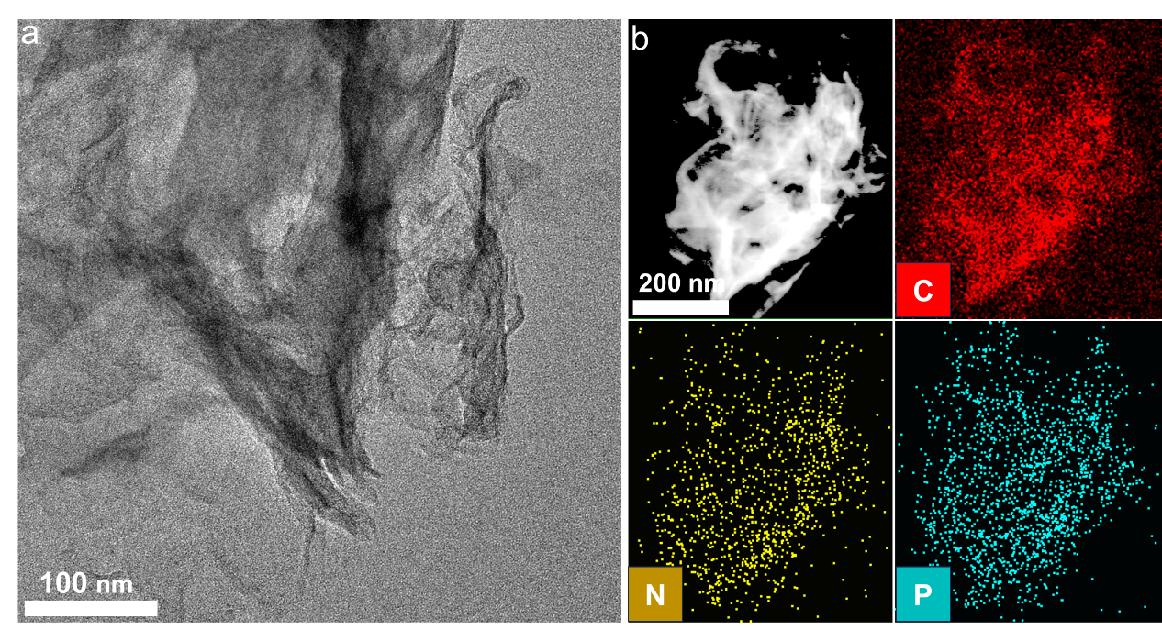
Supplementary Fig. 1. a TEM and b STEM with corresponding EDS elemental mapping images of NP-C.

Supplementary Fig. 2. FT-IR spectra of the as-prepared samples.

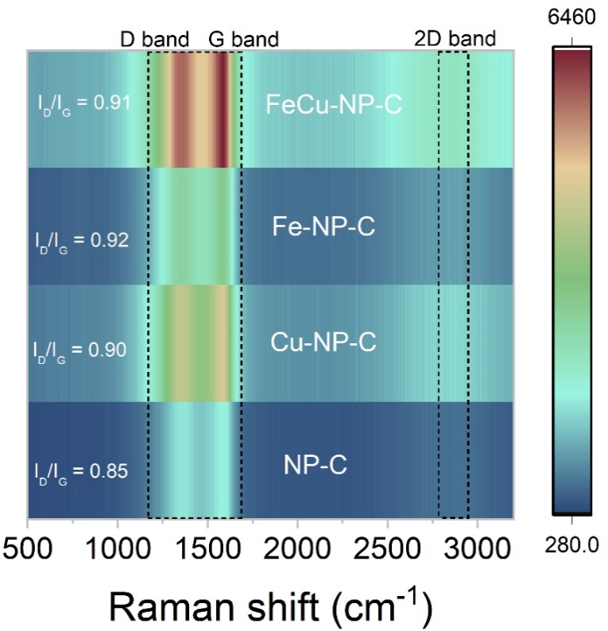
Supplementary Fig. 3. Raman spectra of the as-prepared samples.

Supplementary Fig. 4. a N₂ adsorption/desorption isotherms and b pore size distributions of P-CN, NP-C and FeCu-NP-C.

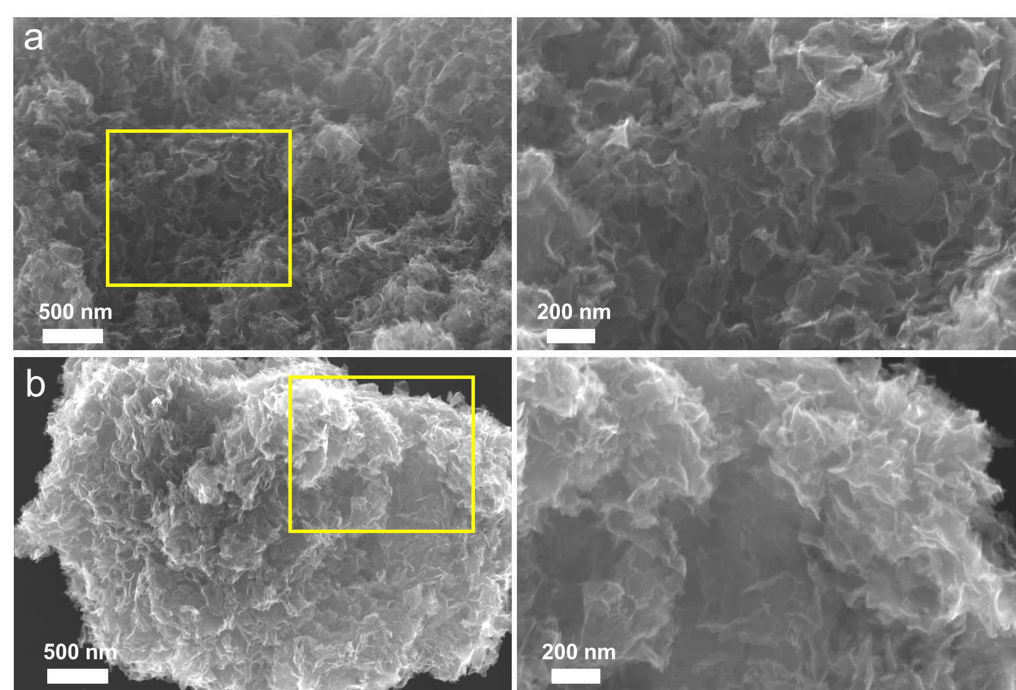
Supplementary Fig. 5. SEM images. a NP-C and b FeCu-NP-C.

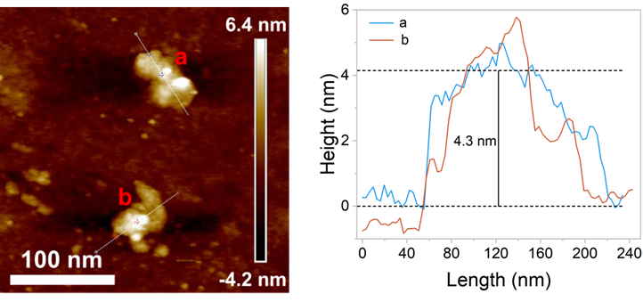
Supplementary Fig. 6. Three-dimensional and two-dimensional AFM images of FeCu-NP-C and the corresponding thickness.

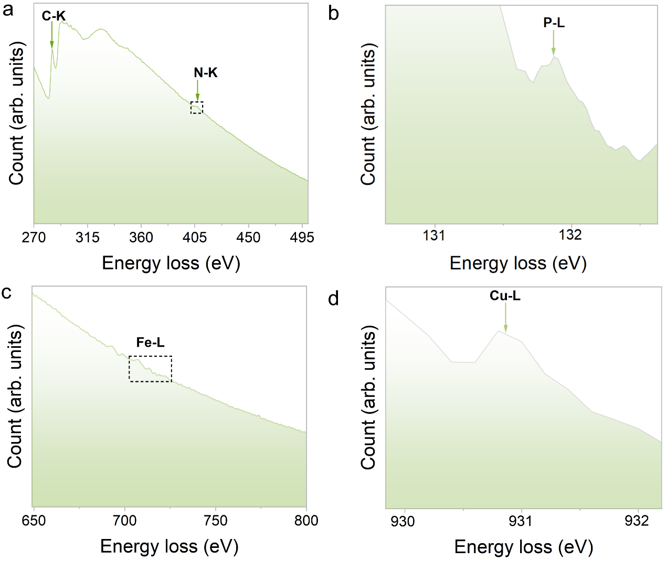
Supplementary Fig. 7. EELS spectra taken at the different sites. a C-K and N-K. b P-L. c Fe-L. d Cu-L.

Supplementary Fig. 8. a Statistical distribution and b statistical distance of Fe and Cu dual atoms.

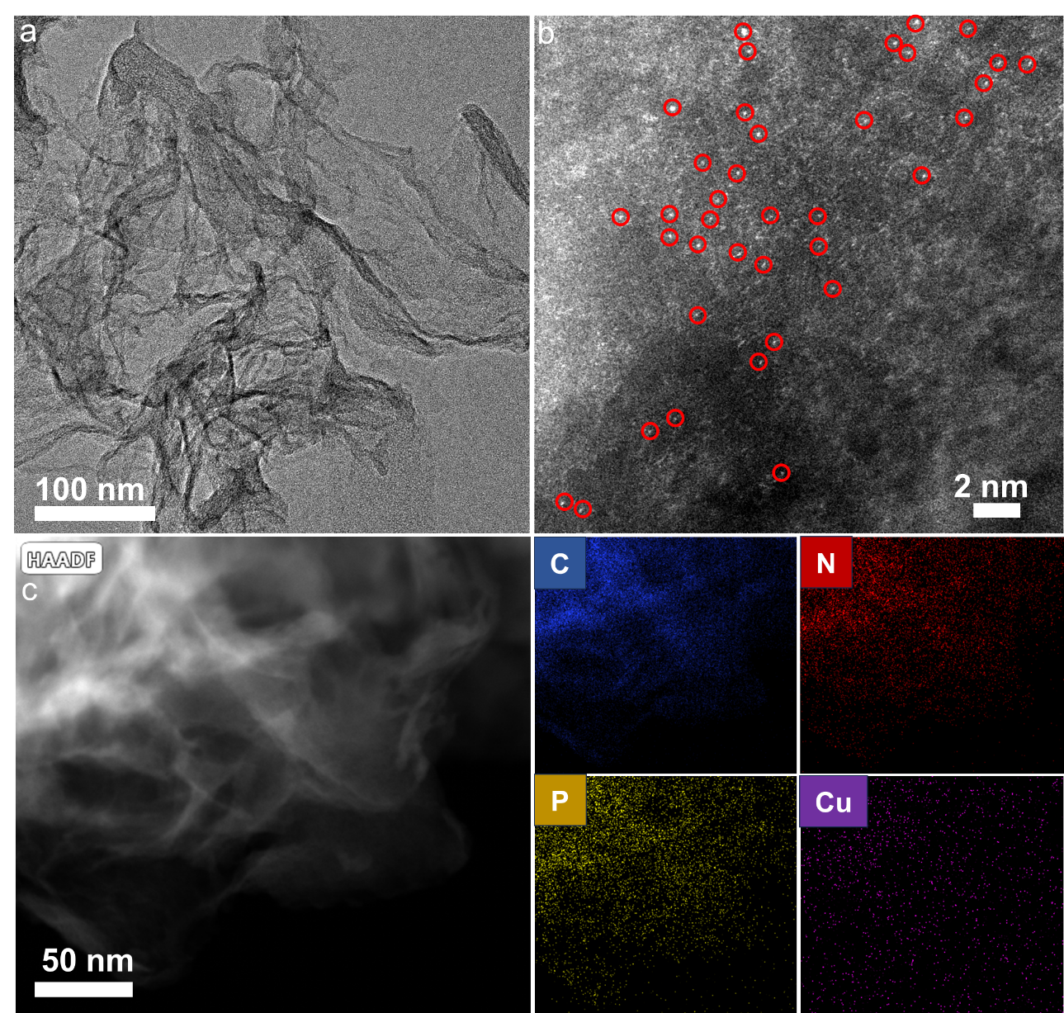
Supplementary Fig. 9. a TEM, b AC HAADF-STEM, and c STEM with corresponding EDS elemental mapping images of (Cu, C, P and N) of Cu-NP-C.

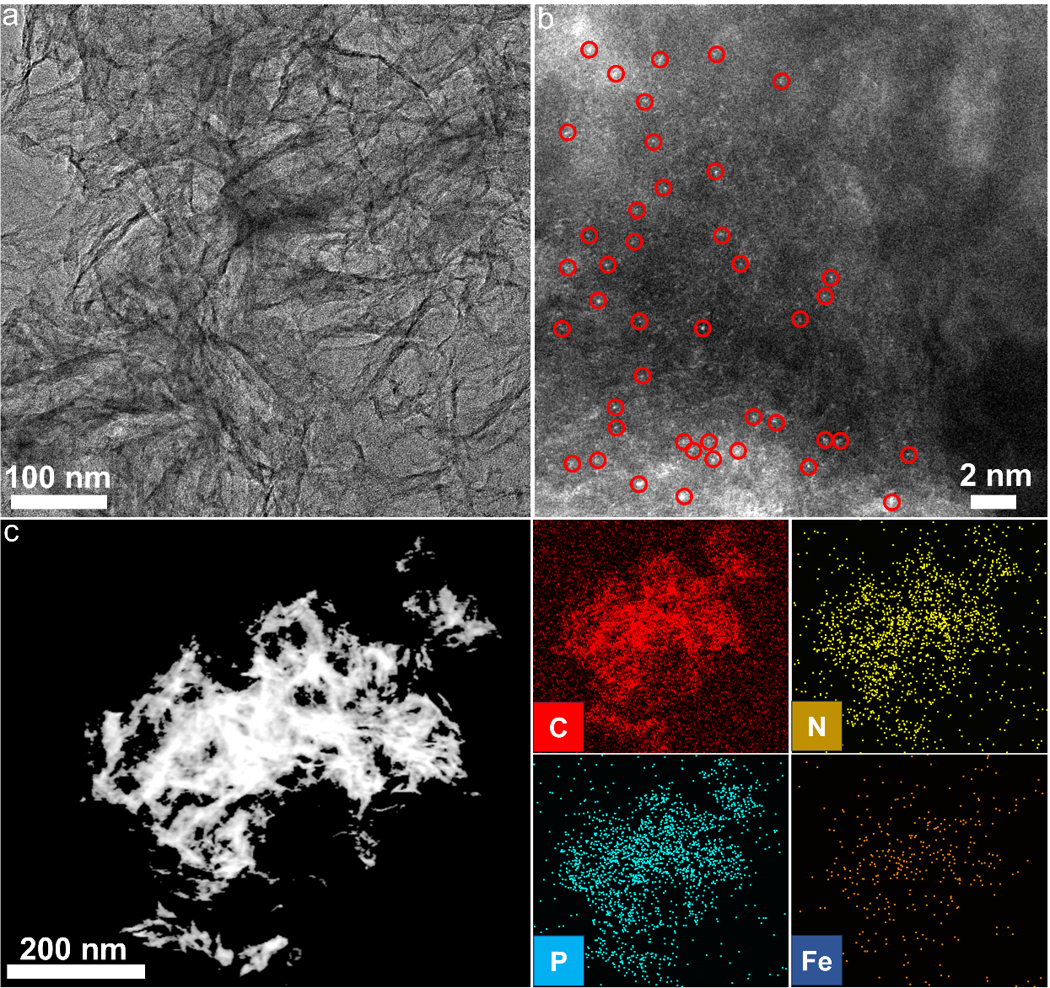
Supplementary Fig. 10. a TEM, b AC HAADF-STEM, and c STEM with corresponding EDS elemental mapping images of (Fe, C, P and N) of Fe-NP-C.

Supplementary Fig. 11. XPS spectra of the as-prepared samples.

Supplementary Fig. 12. XPS spectra of a C 1s, b N 1s, and c P 2p.
Note: The C-P peaks of Fe-NP-C, Cu-NP-C and FeCu-NP-C have a shift in XPS spectra of C 1s and P 2p, compared with that in NP-C (Supplementary Fig. 12), which can be ascribed to the P-coordination with Fe and Cu.

Supplementary Fig. 13. a Fe 2p XPS spectra of Fe-NP-C and FeCu-NP-C. b Cu 2p XPS spectra of Cu-NP-C and FeCu-NP-C.

Supplementary Fig. 14. Prediction of Fourier transformed k³-weighted EXAFS curve (k space and R space) for Fe foil, FeO, Fe₂O_{3,} and FePc. (k space: a, c, e and g; R space: b, d, f and h)
Supplementary Fig. 15. The wavelet transforms for the k³-weighted Fe K-edge and Cu K- K-edge EXAFS: a) Fe Foil, b) FeO, c) Fe₂O₃, d) Cu Foil, e) CuO and f) Cu₂O.

Supplementary Fig. 16. Prediction of Fourier transformed k³-weighted EXAFS curve (k space and R space) for Cu foil, Cu₂O, CuO, and CuPc. (k space: a, c, e and g; R space: b, d, f and h)
Supplementary Fig. 17. FT-EXAFS fitting curve in k space of FeCu-NP-C at the Fe and Cu K-edge.

Supplementary Fig. 18. Adsorption experiment of NP-C, Cu-NP-C, Fe-NP-C and FeCu-NP-C. Experimental conditions: [CIP] = 10 mg L⁻¹, [Catalysts] = 0.1 g L⁻¹. The error bars in the figure represent the standard deviations from triplicate tests.

Supplementary Fig. 19. Effect of a-b catalyst dosage on the CIP degradation. Correlation between reaction rate constant with c the catalyst dosage and d fitting lines between log(-dc/dt) and log [FeCu-NP-C]₀.

Supplementary Fig. 20. Effect of a-b PMS concentration on the CIP degradation. Correlation between reaction rate constant with c the catalyst dosage, and d fitting lines between log(-dc/dt) and log [PMS]₀.

Supplementary Fig. 21. The corresponding pseudo-first-order kinetic fitting on CIP degradation in various systems.

Supplementary Fig. 22. The PMS consumption and TOC removal rate after 15 min reaction in various systems.

Supplementary Fig. 23. The SO₄²⁻ concentration after 15 min reaction in various systems.

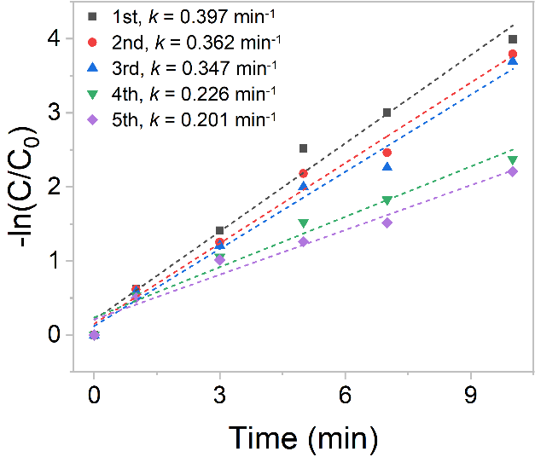
Supplementary Fig. 24. The corresponding pseudo-first-order kinetic fitting on CIP degradation for five recycle operations.
Supplementary Fig. 25. Characterization analysis of FeCu-NP-C after reaction: a XRD patterns, b Raman spectra, c XPS spectra and d FT-IR spectra.

Supplementary Fig. 26. Effect of initial pH on the CIP degradation.

Supplementary Fig. 27. Effect of a-b HA concentration, c-d different water matrices and ions on CIP degradation.

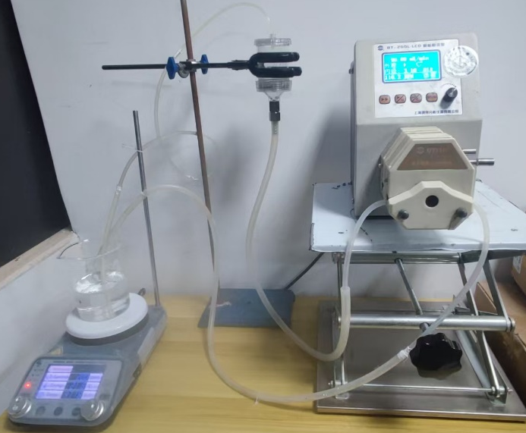
Supplementary Fig. 28. Photograph of the degradation of CIP by a continuous flow system with FeCu-NP-C membrane.

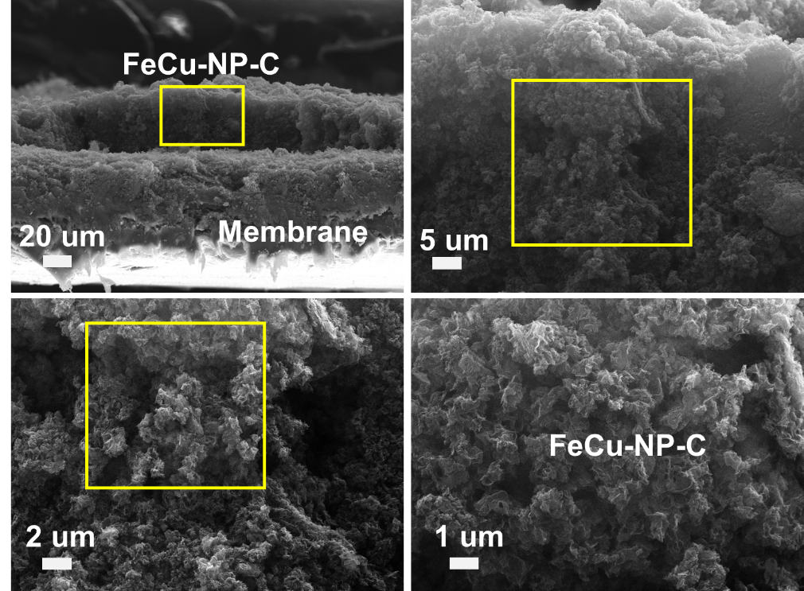
Supplementary Fig. 29. SEM image of FeCu-NP-C adsorbed on the membrane.

Supplementary Fig. 30. The corresponding pseudo-first-order kinetic fitting on CIP degradation over different scavengers in the FeCu-NP-C/PMS system.

Supplementary Fig. 31. a HPLC spectra of BA consumption and p-HBA production, and b UV-vis spectra of NBT solutions in the FeCu-NP-C/PMS systems.

Supplementary Fig. 32. Effect of different scavengers on CIP degradation in a Fe-NP-C/PMS system and c Cu-NP-C/PMS systems. b-d The corresponding pseudo-first-order kinetic fitting on CIP degradation.

Supplementary Fig. 33. Effect of EDTA and Na₂C₂O₄ on CIP degradation in the FeCu-NP-C/PMS system.

Supplementary Fig. 34. Standard curves: a-b PMSO and c-d PMSO₂.

Supplementary Fig. 35. a-b HPLC spectra of PMSO consumption and PMSO₂ production and c the pseudo-first-order reaction rate constants of PMSO₂ in the Fe-NP-C/PMS system.

Supplementary Fig. 36. a The PMSO consumption and PMSO₂ production, and b the pseudo-first-order reaction rate constants of PMSO₂ in the Fe-NP-C/PMS system.

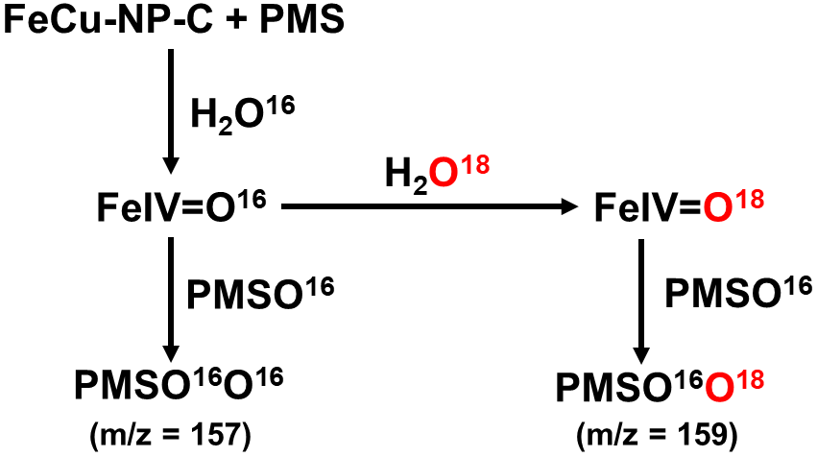
Supplementary Fig. 37. The schematic diagram of ¹⁸O-isotope-labeled PMSO₂ production process.

Supplementary Fig. 38. The degradation of probes in the various systems and the pseudo-first-order kinetic model.

Supplementary Fig. 39. In-situ EIS using Fe-NP-C at different PMS concentrations.

Supplementary Fig. 40. a Cyclic voltammetry (CV) curves, b Tafel profiles analysis of various systems and c Electrochemical impedance spectroscopy (EIS).

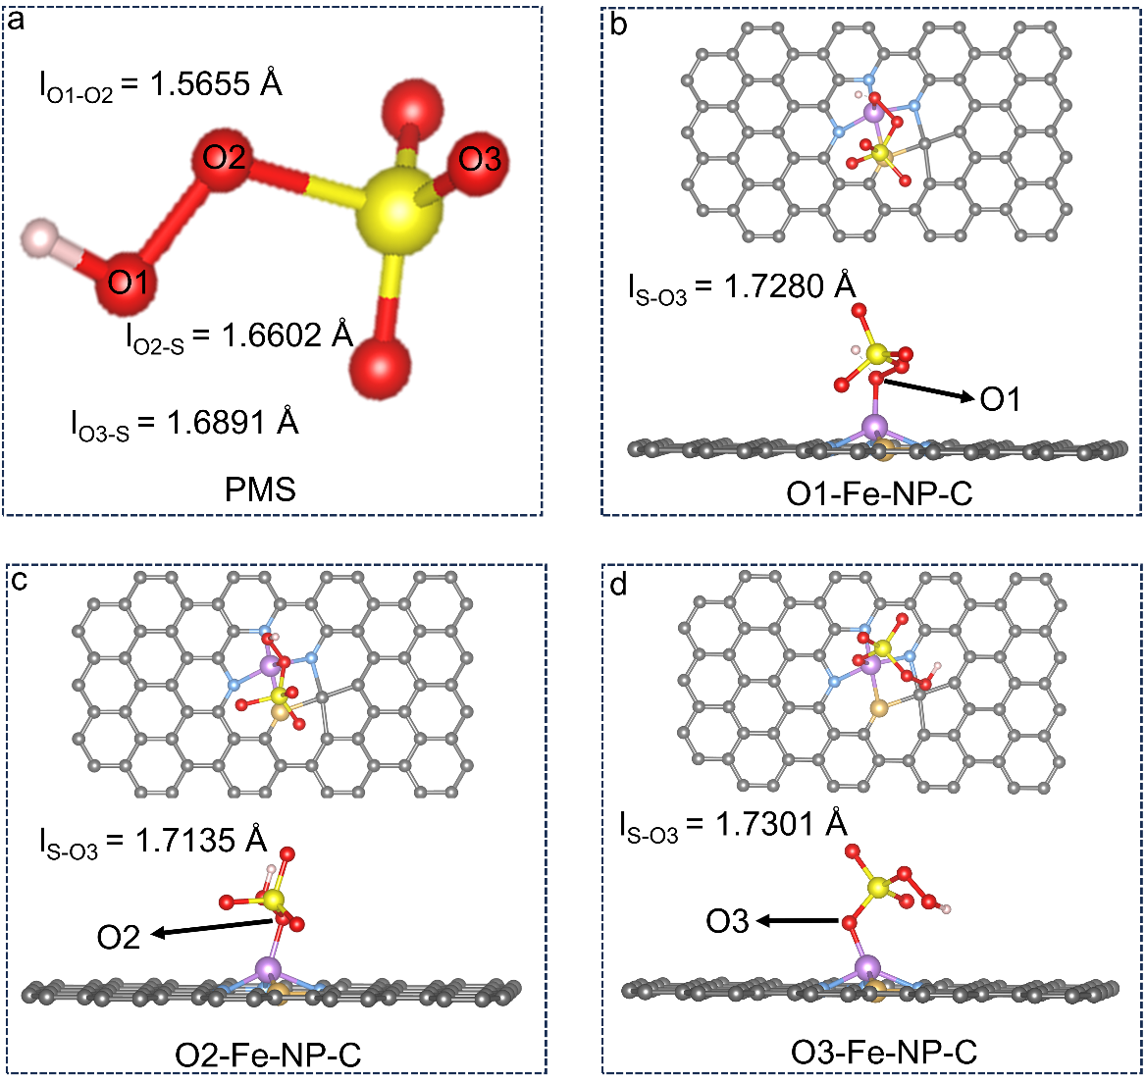
Supplementary Fig. 41. a The PMS structure. b-d PMS adsorption energy on different O sites by the Fe-NP-C catalyst.

Supplementary Fig. 42. PMS adsorption energy on different sites for Fe-NP-C.

Supplementary Fig. 43. The removal rate of CIP within 10 min in the FeCu-NP-C/PMS system with high salinity (The mixture of various ions including Na⁺, K⁺, Mg²⁺, Ca²⁺, Cl⁻, and SO₄²⁻ ).

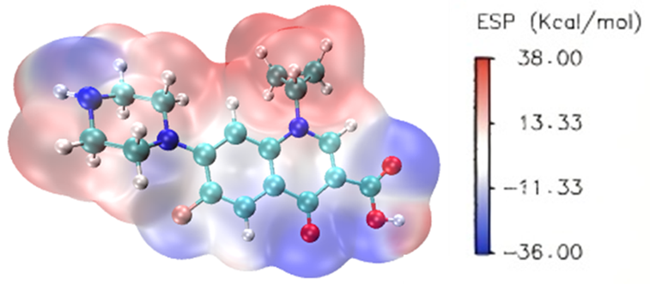
Supplementary Fig. 44. Surface potential distribution of CIP molecules.

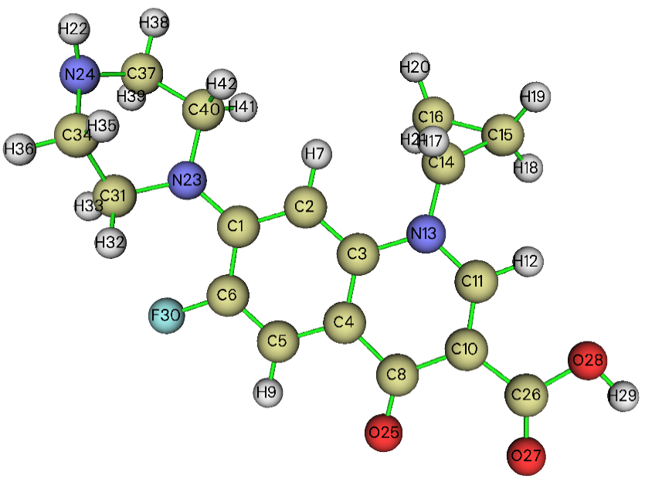
Supplementary Fig. 45. Chemical structure of Fukui index for CIP.

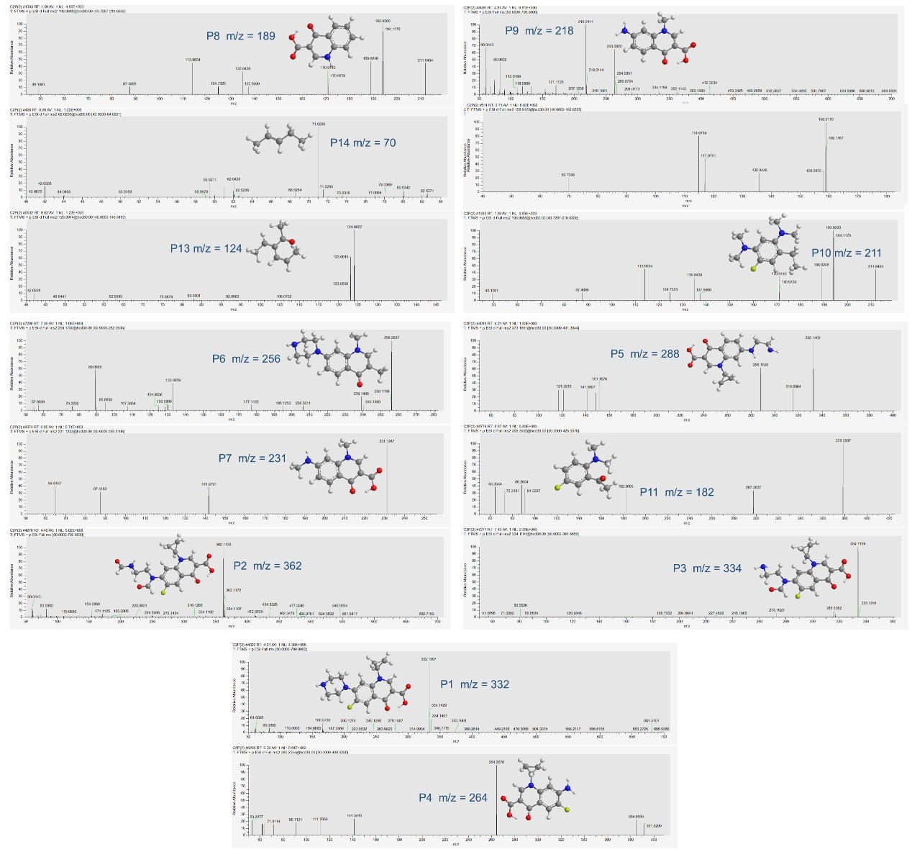
Supplementary Fig. 46. Mass spectrum of the intermediates of CIP degradation.

Supplementary Fig. 47. The proposed degradation pathway of CIP in the FeCu-NP-C/PMS system.
Supplementary Fig. 48. Toxicity evaluation of CIP and its degradation products: a Fathead minnow LC₅₀, b Daphnia magna LC₅₀, c Oral rat LD₅₀ Daphnia magna LC₅₀, d Bioaccumulation factor, e developmental toxicity and f mutagenicity.

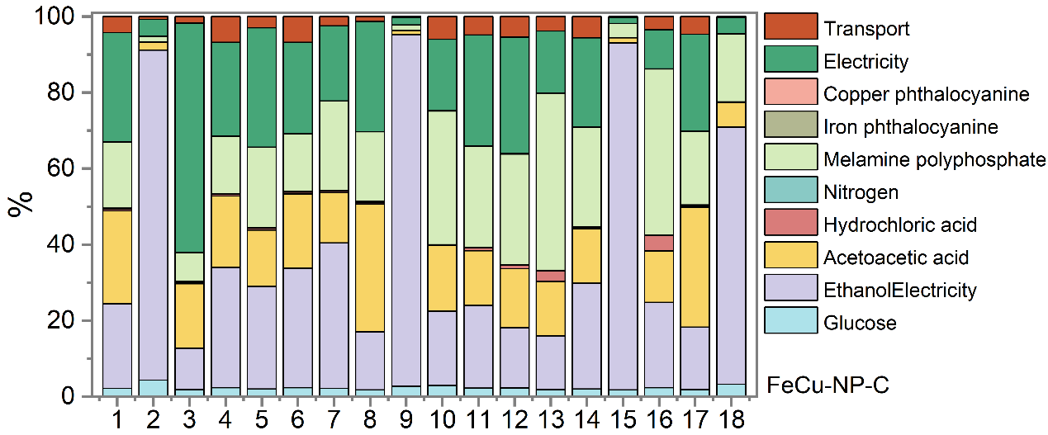
Supplementary Fig. 49. Sensitivity analyses of the production of 1 kg FeCu-NP-C stages in the lifecycle assessment.
Note: 1. Global warming; 2. Stratospheric ozone depletion; 3. Ionizing radiation; 4. Ozone formation, Human health; 5. Fine particulate matter formation; 6. Ozone formation, Terrestrial ecosystems; 7. Terrestrial acidification; 8. Freshwater eutrophication; 9. Marine eutrophication; 10. Terrestrial ecotoxicity; 11. Freshwater ecotoxicity; 12. Marine ecotoxicity; 13. Human carcinogenic toxicity;14. Human non-carcinogenic toxicity; 15. Land use; 16. Mineral resource scarcity; 17. Fossil resource scarcity; 18. Water consumption.

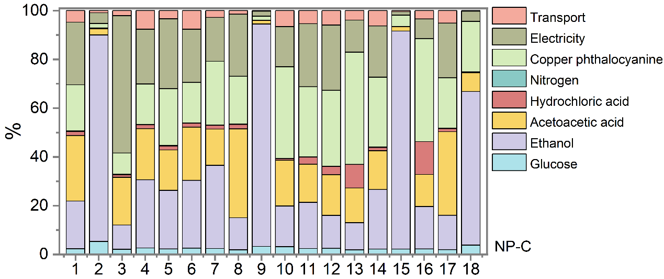
Supplementary Fig. 50. Sensitivity analyses of the production of 1 kg NP-C stages in the lifecycle assessment.

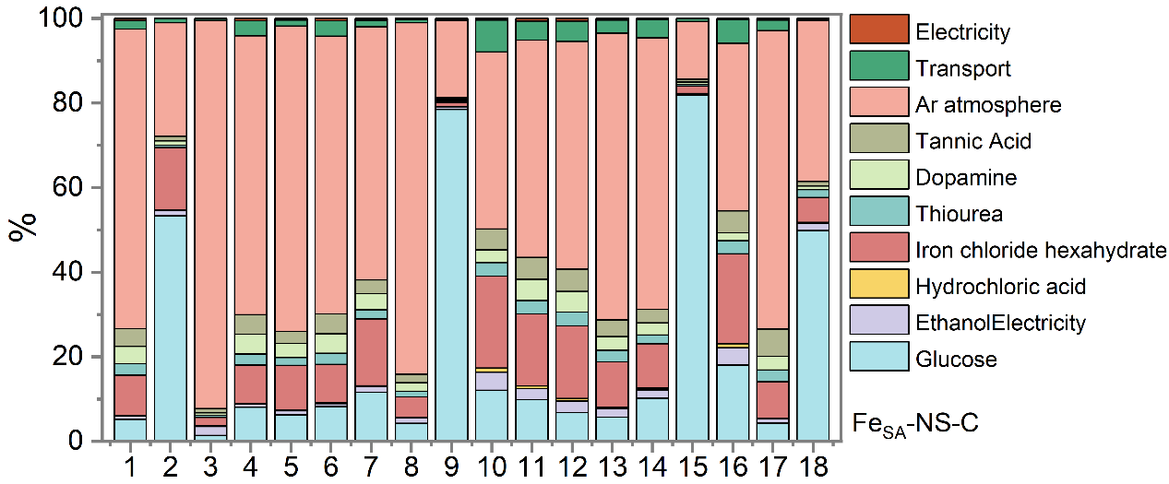
Supplementary Fig. 51. Sensitivity analyses of the production of 1 kg Fe_{SA}-NS-C stages in the lifecycle assessment.
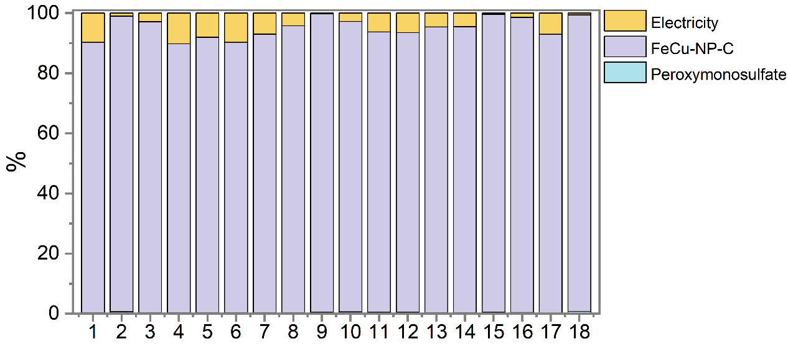
Supplementary Fig. 52. Sensitivity analyses of the FeCu-NP-C/PMS system treating simulated chemical CIP wastewater stages in the lifecycle assessment.

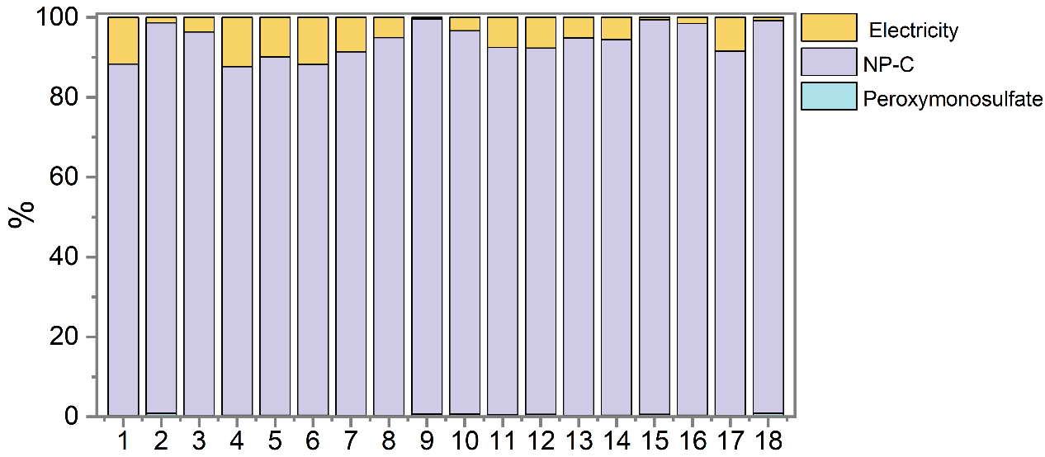 Supplementary Fig. 53. Sensitivity analyses of the NP-C/PMS system treating simulated chemical CIP wastewater stages in the lifecycle assessment.
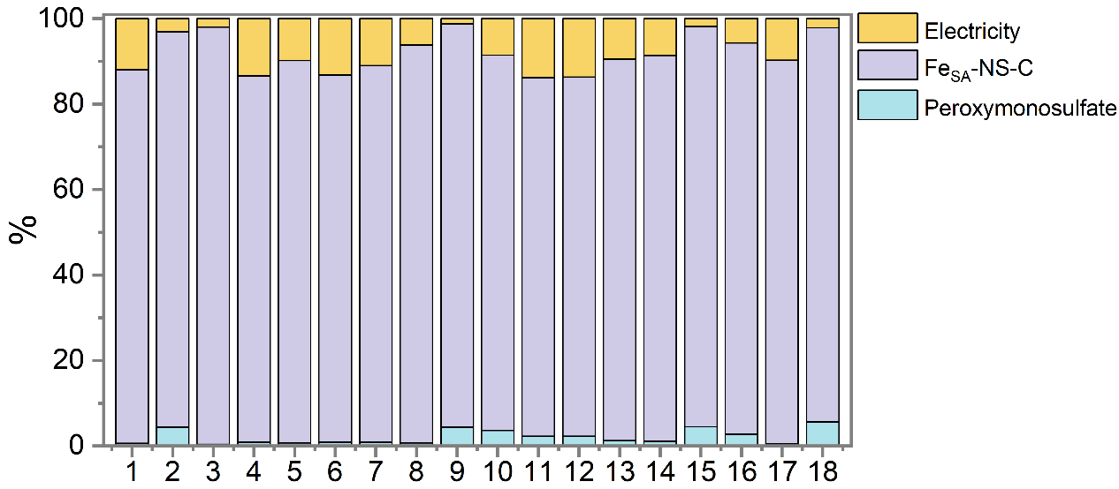
Supplementary Fig. 54. Sensitivity analyses of the Fe_{SA}-NS-C/PMS system treating simulated chemical BPA wastewater stages in the lifecycle assessment.

3. Supplementary Tables
Supplementary Table 1. Elemental compositions of as-prepared samples detected by ICP-OES.
Samples | Cu content (wt%) | Fe content (wt%)
Cu-NP-C | 0.405 | /
Fe-NP-C | / | 0.435
FeCu-NP-C | 0.478 | 0.540

Supplementary Table 2. BET surface area, pore-volume, and pore width for P-CN, NP-C and FeCu-NP-C.
Samples | BET surface area  (m² g⁻¹) | Pore volume  (cm³ g⁻¹) | Pore width  (nm)
P-CN | 0.76 | 0.0014 | 4.17
NP-C | 222.32 | 0.771 | 12.86
FeCu-NP-C | 451.13 | 0.854 | 12.23

Supplementary Table 3. Structural parameters of the FeCu-NP-C obtained from the EXAFS fittings.
Sample | Shell | CN | R (Å) | σ^² (10⁻² Å² ) | ∆E₀ (eV) | r-factor (%)
FeCu-NP-C | Fe-N | 3.1±0.5 | 1.98±0.03 | 0.9±0.2 | -9.5±3.3 | 0.6
FeCu-NP-C | Fe-P | 0.6±0.3 | 2.32±0.06 | 0.9±0.2 | -9.5±3.3 | 0.6
FeCu-NP-C | Fe-P-Cu | 1.3±0.4 | 2.96±0.03 | 0.9±0.2 | -9.5±3.3 | 0.6
FeCu-NP-C | Cu-N | 3.1±0.4 | 1.96±0.01 | 0.2±0.1 | -2.0±1.7 | 0.5
FeCu-NP-C | Cu-P | 0.5±0.2 | 2.34±0.02 | 0.2±0.1 | -2.0±1.7 | 0.5
FeCu-NP-C | Cu-P-Fe | 0.6±0.2 | 3.02±0.02 | 0.2±0.1 | -2.0±1.7 | 0.5
Note: ªCN is the coordination number for the absorber-backscatterer pair, R is the average absorber-backscatterer distance, σ² is the Debye-Waller factor, and ∆E₀ is the inner potential correction. S₀² was fixed to 0.83 as determined from Cu foil fitting. The data range used for data fitting in k-space (∆k) and R-space (∆R) is 3.0-11.8 Å⁻¹ and 1.0-2.9 Å, respectively.

Supplementary Table 4. Comparisons of contaminants degradation catalyzed by the FeCu-NP-C and previously reported SACs.
Catalysts | Contaminants | Catalyst dosage  (g L⁻¹) | PMS  (mM) | k  (min⁻¹) | k-value  (min⁻¹•M⁻¹) | Refs.
Co-N₃O₁ | CIP  5 mg L⁻¹ | 0.1 | 1.0 | 0.287 | 14.35 | ²
SAFe-OCN | phenol  9.4 mg L⁻¹ | 0.5 | 0.1 | 0.039 | 7.33 | ³
SA Co-N/C | NPX  10 mg L⁻¹ | 0.05 | 0.5 | 0.241 | 96.40 | ⁴
Fe-N₄ SACs | SMX  10 mg L⁻¹ | 0.1 | 1.0 | 0.48 | 48.00 | ⁵
SAMCC0.5 | phenol  20 mg L⁻¹ | 0.3 | 0.65 | 0.337 | 34.56 | ⁶
Fe₁/CN | 4-CP  12.9 mg L⁻¹ | 0.5 | 1.0 | 0.54 | 13.93 | ⁷
Co-SA | CIP  20 mg L⁻¹ | 0.2 | 1.0 | 0.14 | 14.00 | ⁸
SA-Fe-N₅ | APAP  4.54 mg L⁻¹ | 0.2 | 0.6 | 0.385 | 14.57 | ⁹
Fe-SAC | CQP  10 mg L⁻¹ | 0.1 | 5.0 | 0.128 | 2.56 | ¹⁰
FeCo-N/C | CAP  15.3 mg L⁻¹ | 0.05 | 1.3 | 0.32 | 75.32 | ¹¹
Fe-N-O-GC-350 | SMX  10 mg L⁻¹ | 0.1 | 0.4 | 0.24 | 60.00 | ¹²
Co-OCN | APPA  2 mg L⁻¹ | 0.1 | 0.1 | 0.068 | 13.60 | ¹³
Fe-SA/PHCNS | APPA  23 mg L⁻¹ | 0.1 | 0.6 | 0.437 | 167.52 | ¹⁴
SA-Fe-g-C₃N₄ | TC  20 mg L⁻¹ | 0.1 | 0.5 | 0.044 | 17.60 | ¹⁵
Fe-NP-C | CIP  10 mg L⁻¹ | 0.05 | 0.1 | 0.17 | 340.00 | This work
Cu-NP-C | CIP  10 mg L⁻¹ | 0.05 | 0.1 | 0.108 | 216.00 | This work
FeCu-NP-C | CIP  10 mg L⁻¹ | 0.05 | 0.1 | 0.397 | 794.00 | This work

Supplementary Table 5. Cost analysis for catalytic water purification in a continuous-flow FeCu-NP-C reactor.
Raw materials | Unit Price ($) | Quality required | Cost for 1 tonne pollutant (10⁻³ $)
FePc | 700 tonne⁻¹ | 0.053 g | 0.0371
CuPc | 800 tonne⁻¹ | 0.053 g | 0.0424
glucose | 450 tonne⁻¹ | 6.65 g | 2.99
melamine polyphosphate | 480 tonne⁻¹ | 13.33 g | 6.40
HCl | 15 tonne⁻¹ | 41.67 mL | 0.625
Estimated cost for 2.0 g catalyst 10.09
PMS | 1380 tonne⁻¹ | 30.7 g | 42.37
Total cost 52.46 (~0.052$)
Note: Based on the catalyst’s purification capacity of 500 L per gram, treating 1 tonne (1000 L) of a 10 ppm CIP solution requires 2.0 g of catalyst. Cost Estimation: Unit prices of chemicals were sourced from average market rates (August 2025) on www.made-in-china.com and www.100ppi.com/mprice. Calculations exclude packaging material costs and mass.

Supplementary Table 6. Stability constants of metal (Ion-inorganic coordination compounds).
Metal ion | Complexing agent | Lg K constant
Fe | H₂C₂O₄ | 16.2
Fe | EDTA | 14.33
Fe | SCN⁻ | 2.21
Cu | H₂C₂O₄ | 10.27
Cu | EDTA | 18.80
Cu | SCN⁻ | 1.90

Supplementary Table 7. Evaluated the acute toxicity of CIP and the main intermediates using Toxicity Estimation Software (T.E.S.T.) with the quantitative structure-activity relationship (QSAR) method.
Chemicals | Toxicity endpoints
Chemicals | Oral rat LD₅₀  (mg/kg) | Bioaccumulation factor | Fathead minnow LC50 (96 hr) (mg/L) | Daphnia magna LC₅₀ (48 hr) (mg/L) | Mutagenicity | Developmental toxicity
 |  |  |  |  |  | Predicted value | Predicted result
P1 | 3676.25 | 21.99 | 0.11 | 3.34 | 0.70 | 0.97 | Toxicant
P2 | 1033.39 | 44.97 | 0.23 | 58.86 | 0.63 | 0.96 | Toxicant
P3 | 1929.67 | 4.96 | 0.26 | 1.16 | 0.36 | 1.06 | Toxicant
P4 | 1252.96 | 4.93 | 0.21 | 0.14 | 0.58 | 0.87 | Toxicant
P5 | 1668.85 | 2.33 | 0.24 | 8.55 | 0.47 | 1.10 | Toxicant
P6 | 1281.89 | 17.32 | 2.88 | 8.82 | 0.57 | 0.79 | Toxicant
P7 | 2333.35 | / | 3.45 | 5.44 | 0.80 | 0.53 | Toxicant
P8 | 1048.80 | / | 3.95 | 13.79 | 0.71 | 0.60 | Toxicant
P9 | 843.94 | / | 17.37 | 1.57 | 0.90 | 0.98 | Toxicant
P10 | 322.13 | 30.46 | 10.48 | 2.32 | 0.35 | 0.71 | Toxicant
P11 | / | 8.81 | 19.17 | 10.42 | 0.64 | 0.69 | Toxicant
P12 | 5679.29 | 0.0614 | 13.30 | 26.44 | 0.36 | 0.25 | Non-toxicant
P13 | 1875.84 | 7.71 | 22.14 | 5.02 | 0.13 | 0.72 | Toxicant
P14 | 4078.18 | 28.84 | 15.89 | 9.57 | 0.02 | 0.45 | Non-toxicant

Supplementary Table 8. The selectivity and generation concentration of PMSO₂ by the FeCu-NP-C and previously reported SACs.
Catalysts | PMSO consumption (μM) | PMSO₂  generation  (μM) | Yield  of PMSO₂  (%) | Major  ROS | Refs.
Fe-N₄ SACs | 232 | 220 | 94.79 | Fe^{IV}=O | ⁵
Fe-N₅ | 90 | 80 | 88.89 | Fe^{IV}=O | ¹⁶
Fe-SAC | 31 | 25 | 80 | Fe^{IV}=O | ¹⁰
Fe-N-C | 375 | 300 | 80 | Fe^{IV}=O | ¹⁷
Fe-SA/PN-g-C₃N₄ | 100 | 96.4 | 96.41 | Fe^{IV}=O | ¹⁸
FeSA-N-CNT | 7 | 5 | 71.43 | Fe^{IV}=O | ¹⁹
Fe-SA/PHCNS | 45 | 44.1 | 98 | Fe^{IV}=O | ¹⁴
FeMn@NC-800 | 30 | 20 | 66.7 | FeMn=O | ²⁰
Co-OCN | 67 | 28 | 41.79 | Co^{IV=O} | ¹³
Mn-N₅ | 2.0 | 0.5 | 25 | Mn^{IV}=O | ²¹
CoN4S-CB | 50 | 46.9 | 93.8 | Co^{IV=O} | ²²
Co-P₁N₃@C | 384 | 375 | 97.65 | Co^{IV=O} | ²³
Fe_{1.0}-CN-TA_{2.0} | 24 | 21 | 86.71 | Fe^{IV}=O | ²⁴
Fe-NP-C | 124 | 118 | 95.3 | Fe^{IV}=O | This work
FeCu-NP-C | 1503 | 1500 | 99.8 | Fe^{IV}=O | This work

Supplementary Table 9. Life Cycle Inventory for the production of 1 kg FeCu-NP-C.
Item | Mass | Unit
Iron phthalocyanine | 40 | g
Copper phthalocyanine | 40 | g
Melamine polyphosphate | 10 | kg
Glucose | 5 | kg
Ethanol | 100 | L
Acetic acid | 10 | L
Hydrochloric acid | 5 | L
N₂ | 1800 | L
Transportation | 100 | km
Electricity | 156 | kwh
Sample | 1 | kg

Supplementary Table 10. Life Cycle Inventory for the production of 1 kg NP-C.
Item | Mass | Unit
Melamine polyphosphate | 10 | kg
Glucose | 5 | kg
Ethanol | 80 | L
Acetic acid | 10 | L
Hydrochloric acid | 5 | L
N₂ | 1150 | L
Transportation | 100 | km
Electricity | 128 | kw•h
Sample | 1 | kg

Supplementary Table 11. Life Cycle Inventory for the production of 1 kg Fe_{SA}-NS-C.
Item | Mass | Unit
Iron chloride hexahydrate | 1.5 | kg
Thiourea | 15 | kg
Dopamine | 2 | kg
Tannic acid | 4.5 | kg
Ethanol | 55 | L
Tris(hydroxymethyl)aminomethane | 10 | kg
Hydrochloric acid | 12 | L
Ar atmosphere | 2500 | L
Transportation | 100 | km
Electricity | 219 | kw•h
Sample | 1 | kg

Supplementary Table 12. Input materials and energy required in the catalyst application stage to degrade 1 kg CIP through FeCu-NP-C/PMS processes
Item | Mass | Unit
Catalyst | 5 | kg
Power supply | 200 | kw·h
Peroxymonosulfate  Ciprofloxacin | 3.07  1 | kg  kg
Wastewater (influent) | 100000 | L
Note: Calculations based on catalytic activity showed that 5 kg of FeCu-NP-C processes were required to treat 1 kg of CIP, respectively. Reaction condition: [Catalyst] = 50 mg L⁻¹; [PMS] = 0.1 mM; [CIP] = 10 mg L⁻¹; the single group reaction volume was 50 mL; 100% CIP degradation; t = 15 min.

Supplementary Table 13. Input materials and energy required in the catalyst application stage to degrade 1 kg CIP through NP-C/PMS processes
Item | Mass | Unit
Catalyst | 8 | kg
Power supply | 360 | kw·h
Peroxymonosulfate | 5 | kg
Ciprofloxacin | 1 | kg
Wastewater (influent) | 100000 | L
Note: Calculations based on catalytic activity showed that 8 kg of NP-C processes were required to treat 1 kg of CIP, respectively. Reaction condition: [Catalyst] = 50 mg L⁻¹; [PMS] = 0.1 mM; [CIP] = 10 mg L⁻¹; the single group reaction volume was 50 mL; 60% CIP degradation; t = 15 min.

Supplementary Table 14. Input materials and energy required in the catalyst application stage to degrade 1 kg BPA through Fe_{SA}-NS-C/PMS processes
Item | Mass | Unit
Catalyst | 2 | kg
Power supply | 240 | kw·h
Peroxymonosulfate | 7.7 | kg
Bisphenol A | 1 | kg
Wastewater (influent) | 100000 | L
Note: Calculations based on catalytic activity showed that 2 kg of Fe_{SA}-NS-C processes were required to treat 1 kg of BPA, respectively. Reaction condition: [Catalyst] = 20 mg L⁻¹; [PMS] = 0.25 mM; [BPA] = 10 mg L⁻¹; the single group reaction volume was 50 mL; 100% BPA degradation; t = 15 min.

Supplementary Table 15. HPLC conditions for detecting concentrations of organic contaminants.
Organic  compounds | Column temperature (ºC) | Flow rate  (mL·min⁻¹) | Wavelength  (nm) | Acetonitrile  (%) | Methanol  (%) | Ultrapure water  (%) | 0.1% phosphoric acid  (%) | 0.2%  formic acid  (%)
Bisphenol A  (BPA) | 30 | 1.0 | 210 | 60 | / | 40 | / | /
Paracetamol  (PCM) | 35 | 1.0 | 248 | / | 55 | 45 | / | /
Nitrobenzene  (NB) | 30 | 1.0 | 260 | / | 60 | 40 | / | /
Carbamazepine (CBZ) | 30 | 1.0 | 280 | / | 70 | 30 | / | /
Ciprofloxacin  (CIP) | 40 | 1.0 | 272 | / | 30 |  | / | 70
Metronidazole  (NMZ) | 40 | 1.0 | 318 | 20 | / | 80 | / | /
Tetracycline  (TC) | 30 | 0.4 | 355 | 18 | / | / | 82 | /
Furfuryl alcohol  (FFA) | 30 | 1.0 | 214 |  | 55 | / | / | 45
Benzoic acid  (BA) | 30 | 1.0 | 229 |  | 55 | / | / | 45
Methyl phenyl sulfoxide  (PMSO) | 30 | 1.0 | 215 | 30 | / | 70 | / | /
Methyl phenyl sulfone
(PMSO₂)

4. References
1. Hong, P. et al. Selenization governs the intrinsic activity of copper-cobalt complexes for enhanced non-radical Fenton-like oxidation toward organic contaminants. J. Hazard. Mater. 435, 128958 (2022).
2. Wang, Z. et al. Cobalt single atoms anchored on oxygen-doped tubular carbon nitride for efficient peroxymonosulfate activation: Simultaneous coordination structure and morphology modulation. Angew. Chem. Int. Ed. 61, e202202338 (2022).
3. Zhou, Z. et al. Fe-based single-atom catalysis for oxidizing contaminants of emerging concern by activating peroxides. J. Hazard. Mater. 418, 126294 (2021).
4. Peng, X. et al. Activation of peroxymonosulfate by single atom Co-N-C catalysts for high-efficient removal of chloroquine phosphate via non-radical pathways: Electron-transfer mechanism. Chem. Eng. J. 429, 132245 (2022).
5. Lin, Y. et al. Coordination engineering of heterogeneous high-valent Fe(IV)-oxo for safe removal of pollutants via powerful Fenton-like reactions. Nat. Commun. 15, 10032 (2024).
6. Chen, Z. et al. Single-atom Mo-Co catalyst with low biotoxicity for sustainable degradation of high-ionization-potential organic pollutants. Proc. Natl. Acad. Sci. 120, e2305933120 (2023).
7. Zhang, L.-S. et al. Carbon nitride supported high-loading Fe single-atom catalyst for activation of peroxymonosulfate to generate ¹O₂ with 100 % selectivity. Angew. Chem. Int. Ed. 60, 21751-21755 (2021).
8. Mi, X. et al. Almost 100 % peroxymonosulfate conversion to singlet oxygen on single-atom CoN₂₊₂ sites. Angew. Chem. Int. Ed. 60, 4588-4593 (2021).
9. Liu, C. et al. The “4 + 1” strategy fabrication of iron single-atom catalysts with selective high-valent iron-oxo species generation. Proc. Natl. Acad. Sci. 121, e2322283121 (2024).
10. Yang, M. et al. Versatile pathways for oxidating organics via peroxymonosulfate activation by different single atom catalysts confining with Fe-N₄ or Cu-N₄ sites. Chem. Eng. J. 451, 138606 (2023).
11. Zhao, Z. et al. Construction of dual active sites on diatomic metal (FeCo-N/C-X) catalysts for enhanced fenton-like catalysis. Appl. Catal. B: Environ. 309, 121256 (2022).
12. Wang, S., Xu, L. & Wang, J. Iron-based dual active site-mediated peroxymonosulfate activation for the degradation of emerging organic pollutants. Environ. Sci. Technol. 55, 15412-15422 (2021).
13. Wu, Q.-Y., Yang, Z.-W., Wang, Z.-W. & Wang, W.-L. Oxygen doping of cobalt-single-atom coordination enhances peroxymonosulfate activation and high-valent cobalt–oxo species formation. Proc. Natl. Acad. Sci. 120, e2219923120 (2023).
14. Wang, Z. et al. High-valent iron-oxo species mediated cyclic oxidation through single-atom Fe-N₆ sites with high peroxymonosulfate utilization rate. Appl. Catal. B: Environ. 305, 121049 (2022).
15. Peng, X. et al. Activation of peroxymonosulfate by single-atom Fe-g-C₃N₄ catalysts for high efficiency degradation of tetracycline via nonradical pathways: Role of high-valent iron-oxo species and Fe-N_{x} sites. Chem. Eng. J. 427, 130803 (2022).
16. Zhang, H.-C. et al. Axial n ligand-modulated ultrahigh activity and selectivity hyperoxide activation over single-atoms nanozymes. Adv. Sci. 10, 2205681 (2023).
17. Cheng, C. et al. Generation of Fe^{IV}=o and its contribution to Fenton-like reactions on a single-atom Fe−N−C catalyst. Angew. Chem. Int. Ed. 62, e202218510 (2023).
18. Liu, H.-Z. et al. Tailoring d-band center of high-valent metal-oxo species for pollutant removal via complete polymerization. Nat. Commun. 15, 2327 (2024).
19. Qian, K. et al. Single-atom Fe catalyst outperforms its homogeneous counterpart for activating peroxymonosulfate to achieve effective degradation of organic contaminants. Environ. Sci. Technol. 55, 7034-7043 (2021).
20. He, Y. et al. Fe-Mn oxycarbide anchored on N-doped carbon for enhanced fenton-like catalysis: Importance of high-valent metal-oxo species and singlet oxygen. Appl. Catal. B: Environ. 340, 123204 (2024).
21. Miao, J. et al. Single-atom MnN₅ catalytic sites enable efficient peroxymonosulfate activation by forming highly reactive Mn(IV)–oxo species. Environ. Sci. Technol. 57, 4266-4275 (2023).
22. Gu, C. et al. Bioinspired axial S-coordinated single-atom cobalt catalyst to efficient activate peroxymonosulfate for selective high-valent Co-oxo species generation. J. Hazard. Mater. 472, 134515 (2024).
23. Yang, Z., Yang, X., Zhang, W., Ai, J. & Wang, D. Local electric field driving selective formation of high-valent Co(IV)=O species by regulating coordination microenvironment of Co single atom. ACS ES&T Water 4, 3297-3308 (2024).
24. Cui, J. et al. Regulating the metal–support interaction: Double jump to reach the efficiency apex of the Fe-N₄-catalyzed Fenton-like reaction. ACS Catal. 12, 14954-14963 (2022).

