Blood-Based Circular RNAs Enable Early and Accurate Alzheimer’s Disease Diagnosis
Bridget Phillips^{1,2}, Jessie Sanford^{1,2}, Menghan Liu^{1,2}, Matt Johnson^{1,2}, Katherine Gong^{1,2}, Kristy Bergmann^{1,2}, Joseph Lowery^{1,2}, Allison Flynn^{1,2}, William Brock^{1,2}, Brenda Sanchez Montejo^{1,2}, Nicholas Sykora^{1,2}, John Budde^{1,2}, Nikolaos Mellios³, Timothy J. Hohman^{4,5}, Vaibhav A. Janve⁴, Reisa A. Sperling⁶, Rachel F. Buckley^{6,7,8}, Mabel Seto⁷, John C. Morris^{9,10,11}, Joel S. Perlmutter^{9,12}, Paul T. Kotzbauer⁹, Richard J. Perrin^{9,10,11}, Laura Ibanez^{1,2,9}, Carlos Cruchaga^{1,2,10,12}
Author affiliations:
¹Department of Psychiatry, Washington University School of Medicine, St. Louis, MO 63110, USA
²NeuroGenomics and Informatics Center, Washington University School of Medicine, St. Louis, MO 63110, USA
³Circular Genomics Inc, San Diego, CA 92121
⁴Vanderbilt Memory and Alzheimer’s Center, Vanderbilt University Medical Center, Nashville, TN, USA 37232
⁵Department of Neurology, Vanderbilt University Medical Center, Nashville, TN, USA
⁶Department of Neurology, Massachusetts General Hospital, Harvard Medical School, Boston, MA 02115
⁷Center for Alzheimer’s Research and Treatment, Brigham and Women’s Hospital, Harvard Medical School, Boston, MA
⁸School of Psychological Sciences, University of Melbourne, Melbourne, Victoria, Australia
⁹Department of Neurology, Washington University School of Medicine, St. Louis, MO 63110, USA
¹⁰Department of Pathology and Immunology, Washington University School of Medicine, St. Louis, MO 63110, USA
¹¹Knight Alzheimer Disease Research Center, Washington University School of Medicine, St. Louis, MO, USA
¹²Department of Radiology, Washington University School of Medicine, St. Louis, MO, USA

Correspondence to: Carlos Cruchaga, PhD
4444 Forest Park Ave, Washington University School of Medicine, St. Louis, MO 63110, USA
E-mail: cruchagac@wustl.edu

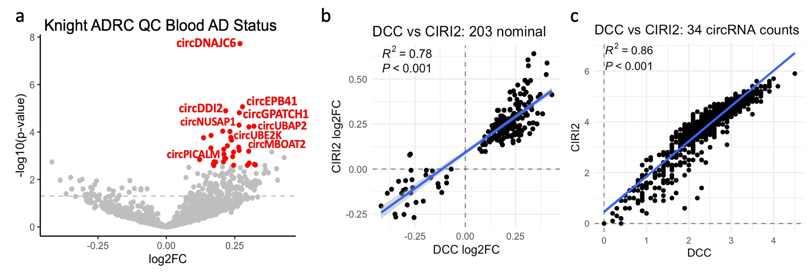
Supp. Figure 1 Correlation of circRNAs in AD blood. (a) Differential expression of AD vs CU status in Knight ADRC blood samples. Volcano plots have circRNA passing FDR correction as dots colored blue (down-regulated) and red (up-regulated). (b) Effect size (log₂FC) correlation of the 203 blood circRNAs nominal in DCC using DCC and CIRI2. CircRNA count correlation between DCC and CIRI2 of the average 34 circRNA read count in the blood samples.

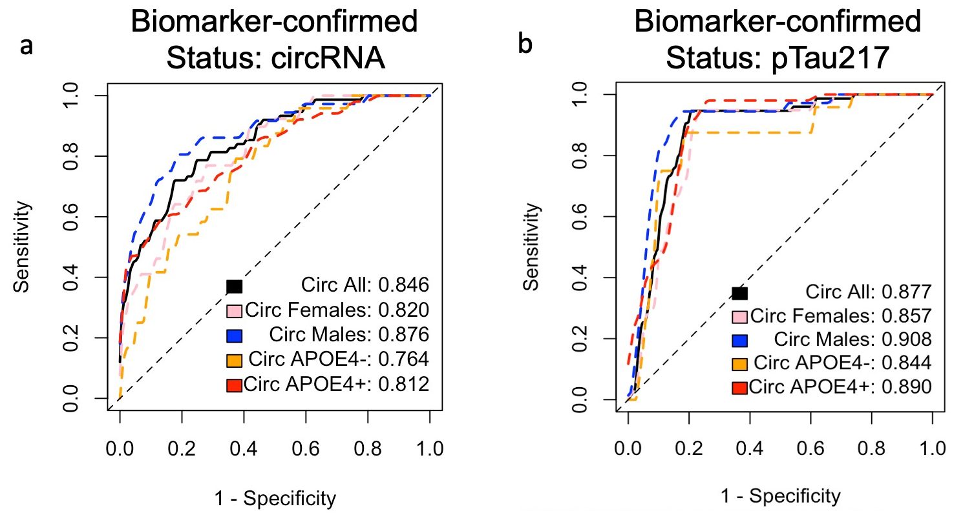
Supp. Figure 2 Blood circRNAs predict biomarker-confirmed status. ROC curve analysis of logistic models predicting biomarker-confirmed-status (75 AT+ AD, 238 AT- CU) using (a) 34 FDR blood circRNAs and (b) plasma pTau217 positivity alone. The circRNA models included circRNA counts and the covariates (age at draw, sex, median TIN, number of APOE4 alleles).

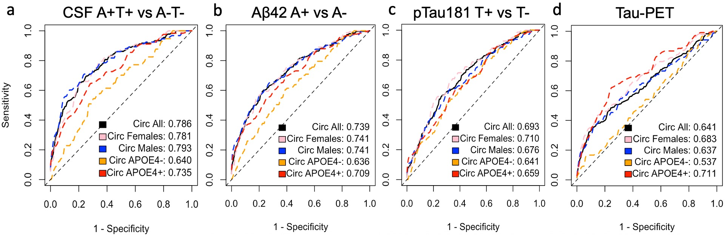
Supp. Figure 3 Blood circRNAs predict AD biomarker status. ROC curve analysis using the 34 status circRNAs with status as (a) CSF Aβ42/pTau181 positivity regardless of status (181 A+T+, 283 A-T-), (b) CSF Aβ42 (408 A-, 309 A+), (c) CSF pTau181 (418 T-, 299 T+), and (d) Tau-PET positivity (292 T-, 233 T+). The circRNA+covariate model included library-size normalized counts of the top status circRNAs and the covariates (age at draw, sex, median TIN, number of APOE4 alleles).

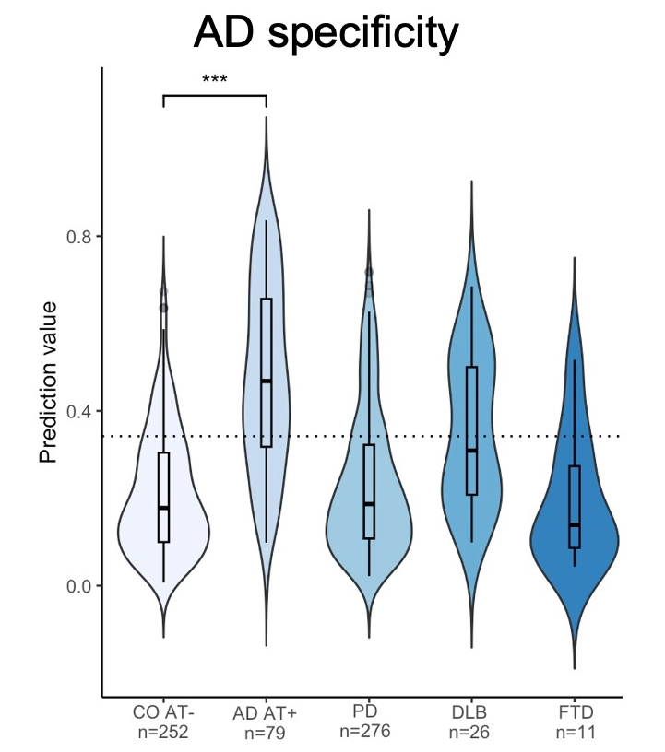
Supp. Figure 4 Specificity of AD prediction. Violin plot of AD vs CU prediction values over non-AD dementias from estimated onset. Dotted line of the 0.342 AUC threshold for AD vs CU classification using the 34 blood circRNAs.

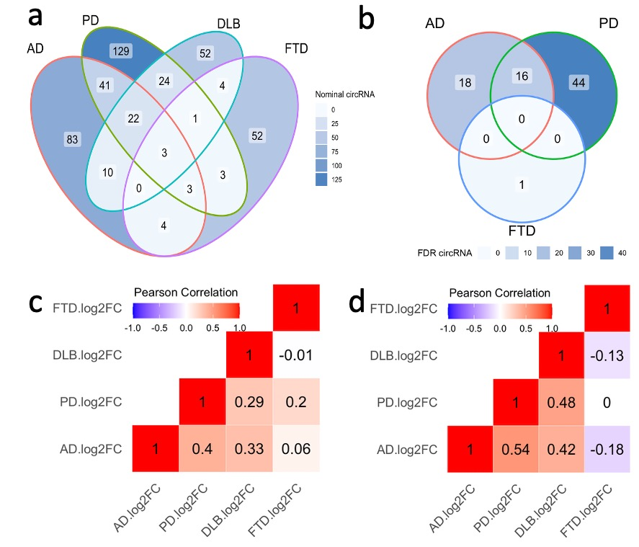

Supp. Figure 5 AD-specificity of blood circRNAs. Venn Diagrams of the circRNA transcripts in AD, PD, DLB, and FTD vs the same controls that were (a) nominally significant (P < 0.05) and (b) passed FDR correction. Correlation of effect sizes per disease for the (c) 431 nominal circRNA in at least one disease and (d) 166 nominal circRNA in AD status.

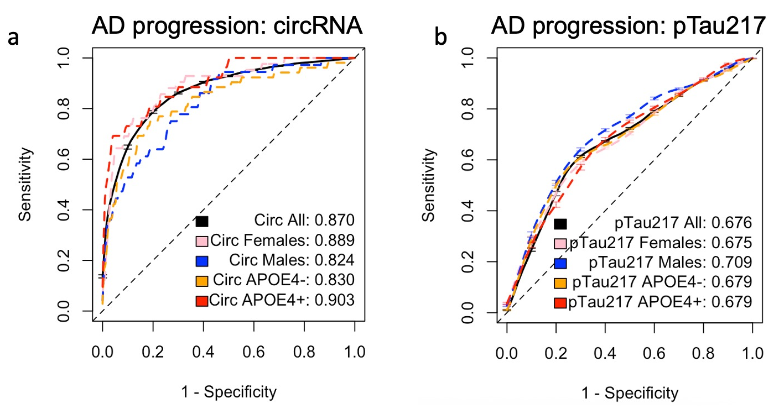
Supp. Figure 6 Blood circRNAs were more predictive of AD progression than pTau217. ROC curve analysis of logistic models predicting AD progression within 5-years in Knight ADRC blood control samples (n=688; 78 progressors, 610 CU) using (a) 34 FDR blood circRNAs and (b) pTau217 alone. The circRNA models included circRNA counts and the covariates (age at draw, sex, median TIN, number of APOE4 alleles).

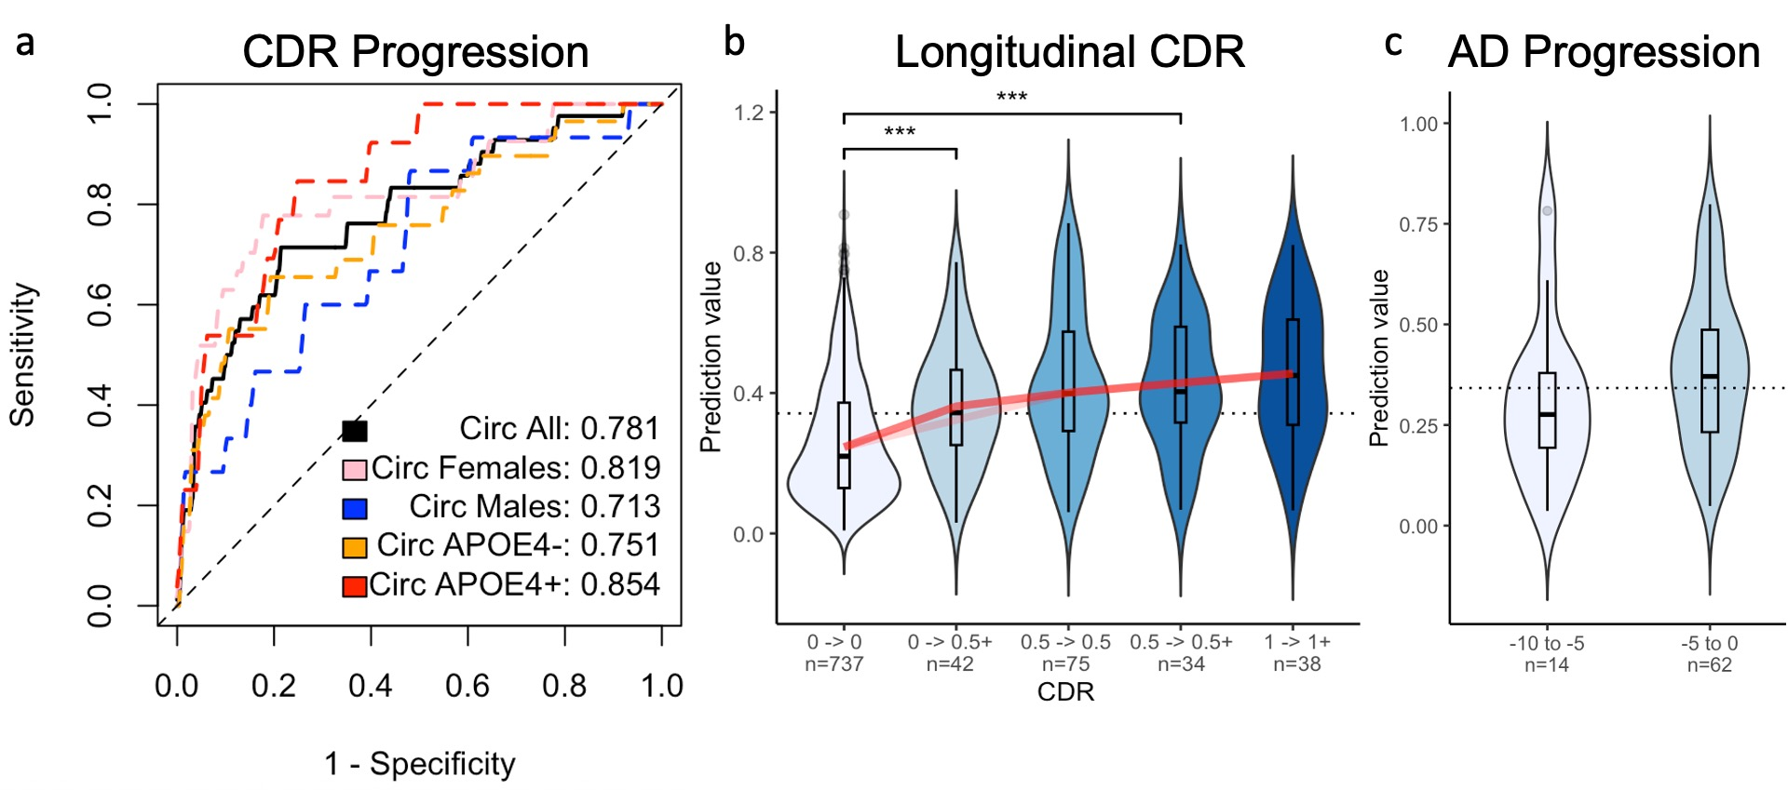
Supp. Figure 7 Prediction of CDR Progression. ROC curve analysis using the 34 status circRNAs with status as CDR progression using samples with CDR 0 at draw (42 progressors (CDR at last > 0), 737 CU). (b) Violin plot of AD prediction values per subset of CDR progression. (c) Violin plot of sporadic AD progressor prediction values over estimated time to onset (TTO) subsets. Dotted line of the 0.342 AUC threshold for AD vs CU classification using the 34 blood circRNAs. TTO was calculated based on the age at onset (AAO) subtracted from age at blood draw.

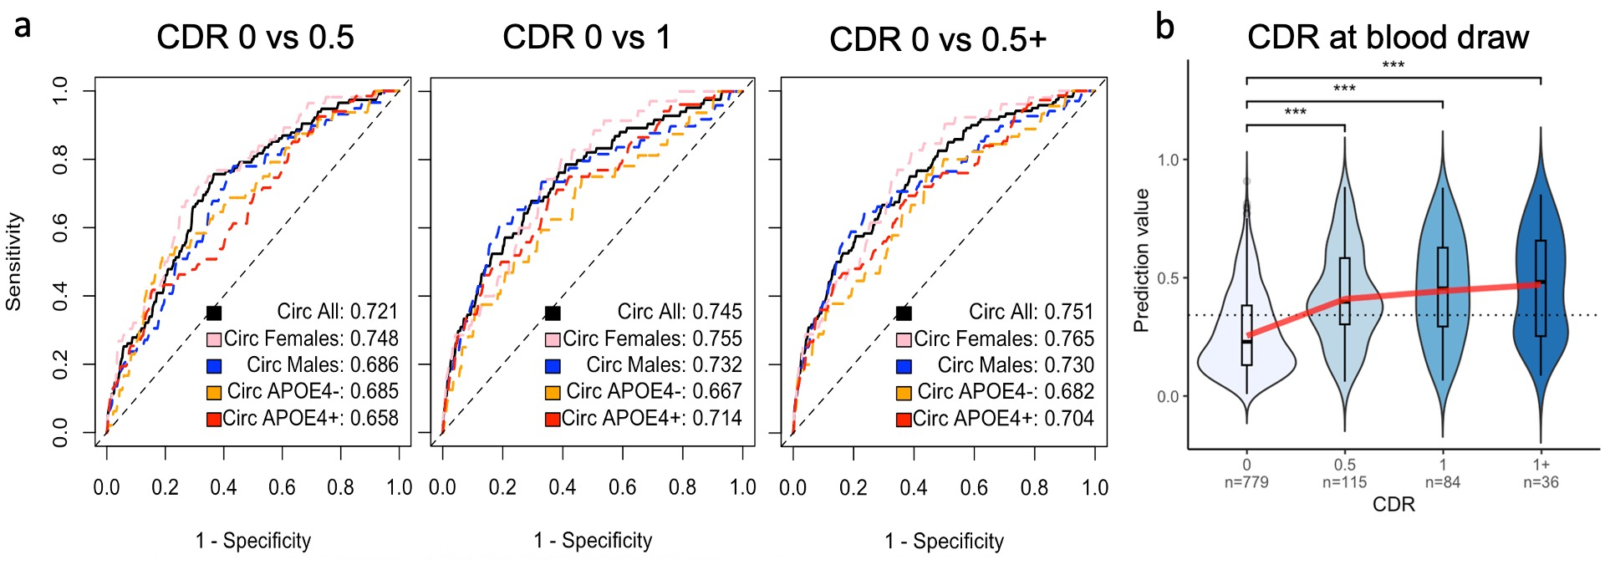
Supp. Figure 8 Blood circRNAs prediction of CDR at draw. (a) ROC curve analysis using the 34 status circRNAs with cross-sectional CDR (Clinical Dementia Rating) scores of CDR 0 vs 0.5 (779 CDR=0, 115 CDR=0.5), CDR 0 vs 1 (779 CDR=0, 84 CDR=1), and CDR 0 vs 0.5+ (779 CDR=0, 120 CDR > 0.5). The circRNA+covariate model included library-size normalized counts of the top status circRNAs and the covariates (age at draw, sex, median TIN, number of APOE4 alleles). (b) Violin plot of AD prediction value per subset of CDR. Dotted line of the 0.342 AUC threshold for AD vs CU classification using the 34 blood circRNAs. Red line of lowess curve.

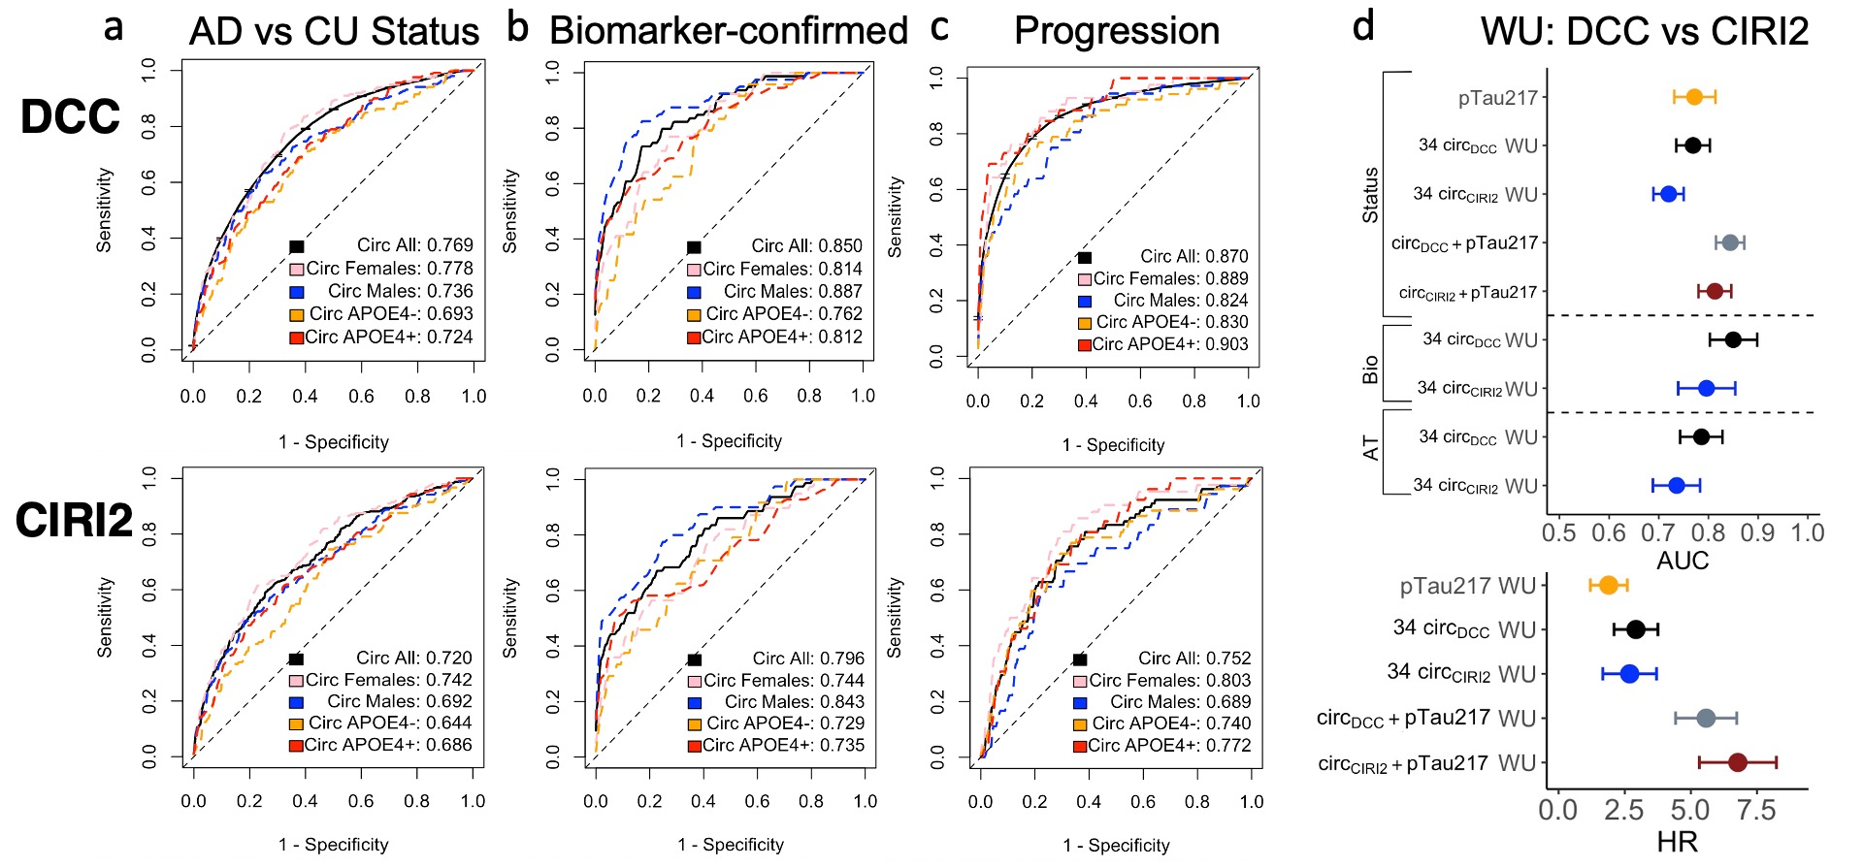
Supp. Figure 9 Bioinformatics replication of prediction models using CIRI2 counts. ROC curve analysis using DCC (top) and CIRI2 (bottom) read counts of the 34 circRNAs with status as (a) AD vs CU (405 AD, 816 CU), (b) biomarker-confirmed status (79 AT+ AD, 252 AT- CU), and (c) AD progression within 5-years (78 progressors, 610 CU). (d) Whisker plot of AD prediction using DCC and CIRI2 read counts of the 34 blood circRNAs in Knight ADRC blood (WU) compared to plasma pTau217 alone.

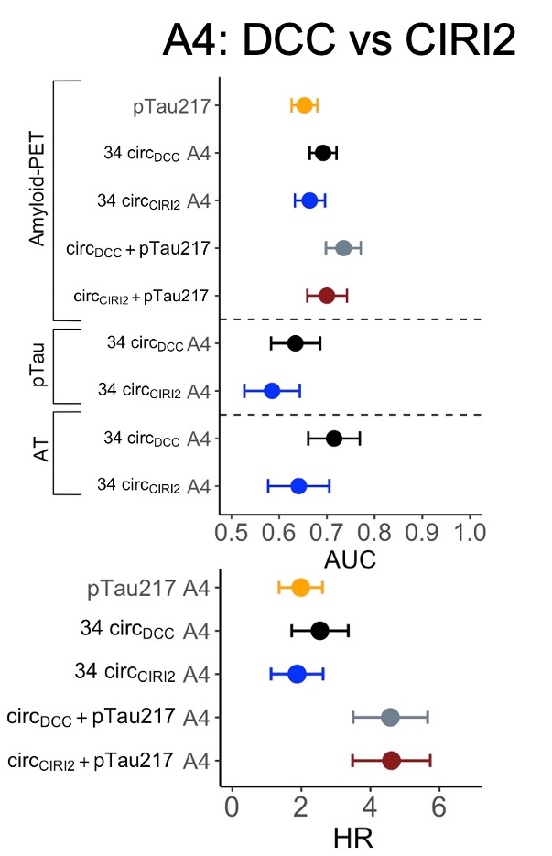
Supp. Figure 10 Prediction model replication in the independent A4 dataset. Whisker plot of AD prediction using DCC and CIRI2 read counts of the 34 blood circRNAs in A4 compared to pTau217 alone. Models includes Amyloid-PET A- vs A+ (457 A+, 1,310 A-), Plasma pTau217 (120 T+, 469 T-), A-T- vs A+T+ (131 A+T+, 285 A-T-), and hazard ratios (HR) of AD progression within 5 years (97 progressors, 221 CU).

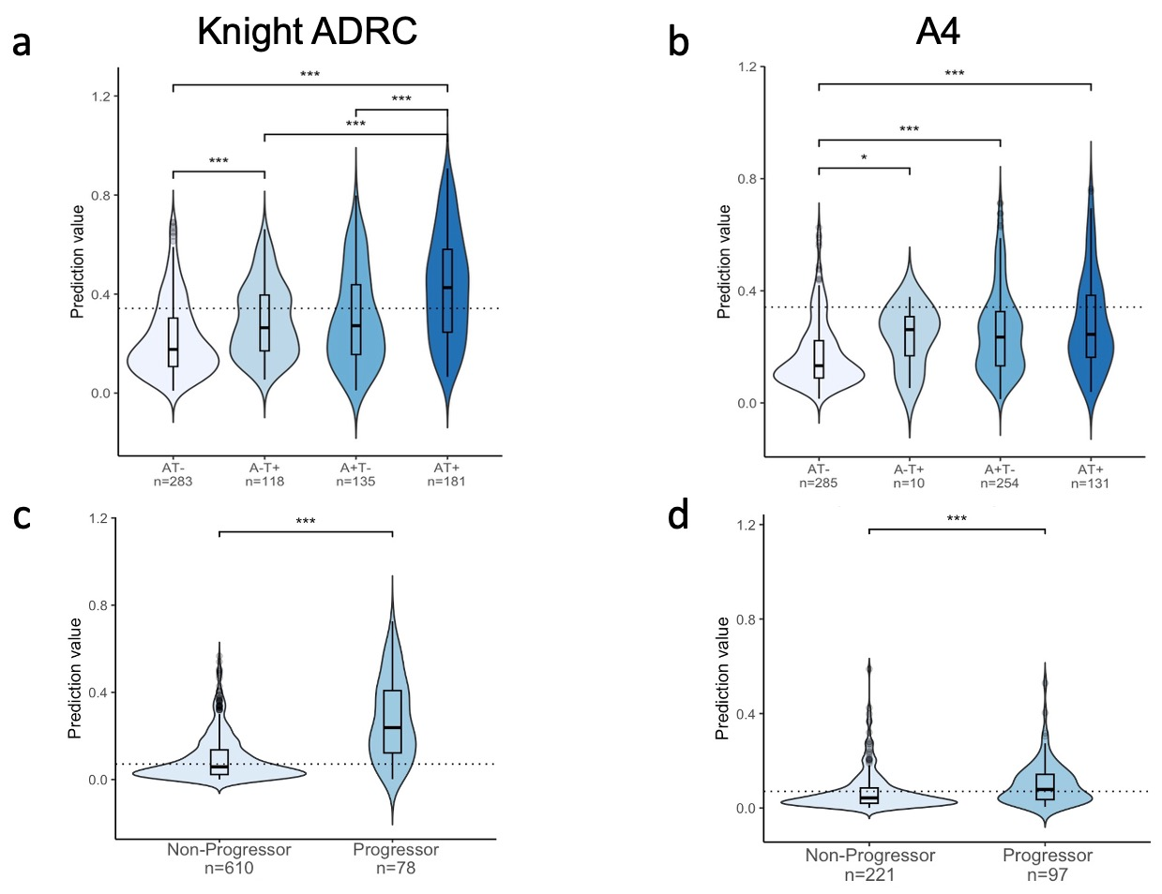
Supp. Figure 11 Prediction value comparisons in the independent A4 dataset. Violin plot of AD prediction value per subset of amyloid and tau biomarkers in (a) Knight ADRC and (b) A4. Dotted line of the 0.342 AUC threshold for AD vs CU classification. Violin plot of AD progression value in (c) Knight ADRC and (d) A4. Dotted line of the 0.071 AUC threshold for progressor vs non-progressor classification.

