Table I : Baseline Demographic, Clinical, Therapeutic Characteristics and Comorbidities
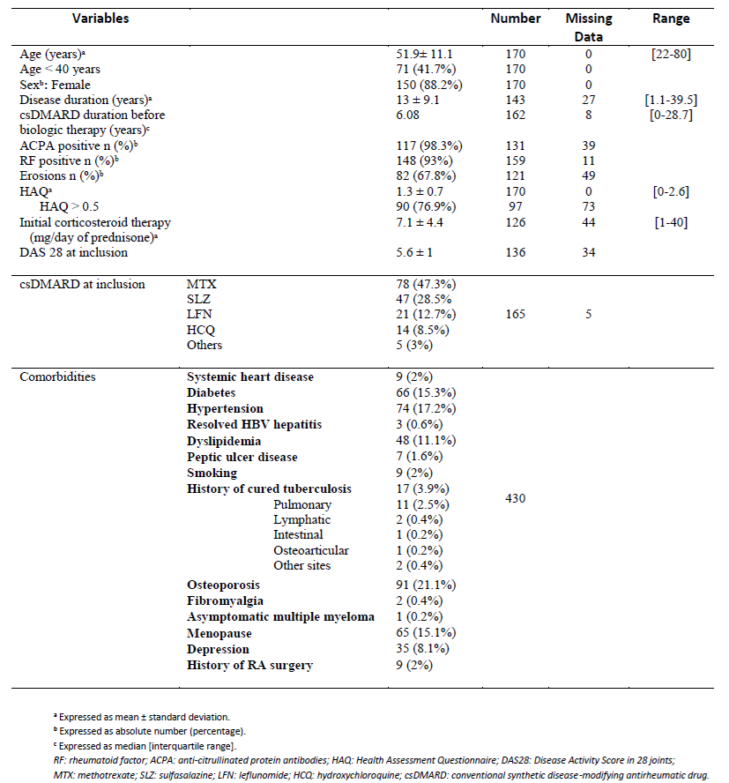

Table II : Comparative Table of Infectious Adverse Events (AE) under different bDMARDs: RTX, Anti-TNF, and TCZ
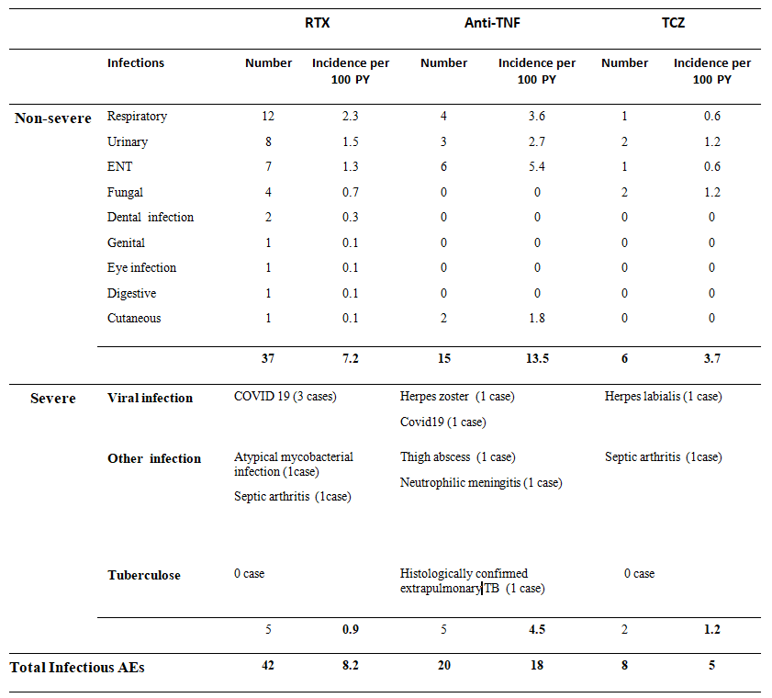

Table III : Non-infectious adverse events under RTX compared to Anti-TNF and TCZ in patients with RA from the RBSMR registry
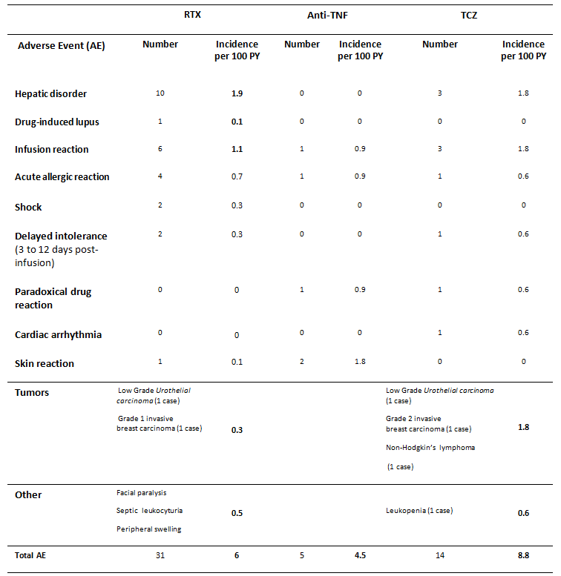
* The two patients concerned were receiving TCZ after prior treatment with RTX.

