Supplementary material
Table S1 Detailed geographic information of sampling sites of Ulva species along the coasts of Jeju Island, Korea between November 2019 and February 2021. Ulva specimens were collected during every season and thus they were sampled from every site four times.
Population ID | Sampling site | latitude | longitude
1 | Sinyang | 33°26'5.30"N | 126°55'22.79"E
2 | Ojo (Seongsan harbor) | 33°28'13.87"N | 126°55'20.90"E
3 | Tongbadal | 33°28'10.65"N | 126°55'24.51"E
4 | Jongdal | 33°28'22.10"N | 126°54'45.15"E
5 | Jongdal (cultivation) | 33°29'58.93"N | 126°54'40.82"E
6 | Hado | 33°30'42.01"N | 126°53'53.60"E
7 | inside Tokki-seom | 33°31'17.25"N | 126°53'59.70"E
8 | outside Tokki-seom | 33°31'18.58"N | 126°54'0.29"E
9 | Gimnyeong | 33°33'28.36"N | 126°45'29.69"E
10 | Gimnyeong harbor | 33°33'18.01"N | 126°44'17.19"E
11 | Hamdeok | 33°32'43.97"N | 126°39'47.93"E
12 | inside Hamdeok | 33°32'53.75"N | 126°39'20.21"E
13 | outside Hamdeok | 33°32'54.79"N | 126°39'22.53"E
14 | Bangsatab | 33°32'58.91"N | 126°38'51.04"E
15 | Jocheon | 33°32'19.38"N | 126°38'4.48"E
16 | Iho | 33°29'52.30"N | 126°27'7.23"E
17 | Aewol harbor | 33°28'2.89"N | 126°19'13.77"E
18 | outside Hallim harbor | 33°25'22.33"N | 126°15'46.20"E
19 | inside Hallim harbor | 33°25'22.01"N | 126°15'45.95"E
20 | Hyeopjae | 33°23'43.36"N | 126°14'24.36"E
21 | Geumneung | 33°23'23.61"N | 126°14'6.44"E
22 | Sincnang 1 | 33°20'37.41"N | 126°10'29.09"E
23 | inside Sincnang 1 | 33°20'46.60"N | 126°10'46.02"E
24 | outside Sinchang 1 | 33°20'47.24"N | 126°10'41.69"E
25 | Sinchang 2 | 33°20'35.00"N | 126°10'18.05"E
26 | Moseulpo harbor | 33°13'9.00"N | 126°14'59.50"E
27 | Hwasun | 33°14'23.27"N | 126°19'58.08"E
28 | Daepyeong | 33°14'13.56"N | 126°21'42.02"E
29 | Seogwipo harbor | 33°14'21.34"N | 126°33'31.84"E
30 | Wimi | 33°16'8.94"N | 126°39'20.34"E
31 | Pyoseon | 33°18'34.58"N | 126°49'52.98"E

Table S2 Detailed geographic information of sampling sites of Ulva species along the southern coastal area (the South Sea) of Korea in January 2021 - October 2021. Ulva specimens were collected during every season and thus they were sampled from every site four times.

Population ID | Sampling site | latitude | longitude
1 | Daldo 1 | 34°23'33.58"N | 126°38'33.82"E
2 | Daldo 2 | 34°23'29.46"N | 126°38'31.70"E
3 | Bulmok | 34°23'46.15"N | 126°42'15.03"E
4 | Daeya | 34°21'54.30"N | 126°43'51.04"E
5 | Yegye 1 | 34°48'58.54"N | 127°49'41.62"E
6 | Yegye 2 | 34°48'59.66"N | 127°49'40.75"E
7 | Yegye 3 | 34°49'18.40"N | 127°49'18.14"E
8 | Chamyeon | 34°54'49.64"N | 127°51'0.35"E
9 | Sulcheon | 34°56'45.61"N | 127°53'37.63"E
10 | Gyeonyu | 34°53'9.48"N | 128°28'10.45"E
11 | Deokho | 34°52'52.72"N | 128°28'33.26"E
12 | Daegeum | 34°58'15.60"N | 128°41'58.23"E
13 | Sagok | 34°53'59.00"N | 128°34'21.36"E
14 | Hitdo | 34°37'50.46"N | 127°38'9.47"E
15 | Baekya | 34°37'11.95"N | 127°38'28.71"E

Table S3 Detailed information on species name, GenBank accession number and relevant references for the 58 tufA DNA sequences used for the molecular phylogenetic analyses for Ulva species identification (Fig. 3, 4).
Ulva Species | Accession no. | reference | Ulva Species | Accession no. | reference
Ulva ohnoi | JN029335 | Kirkendale et al. (2013) | Ulva compressa | HQ610290 | Saunders and Kucera (2010)
Ulva ohnoi | MK992043 | Kang et al. (2019) | Ulva compressa | MK992195 | Kang et al. (2019)
Ulva ohnoi | MK992140 | Kang et al. (2019) | Ulva compressa | MK992200 | Kang et al. (2019)
Ulva ohnoi | MK992173 | Kang et al. (2019) | Ulva compressa | JN029292 | Kirkendale et al. (2013)
Ulva ohnoi | MK992157 | Kang et al. (2019) | Ulva howensis | JN029312 | Kirkendale et al. (2013)
Ulva ohnoi | MK992139 | Kang et al. (2019) | Ulva intestinalis | JN029320 | Kirkendale et al. (2013)
Ulva ohnoi | MK992218 | Kang et al. (2019) | Ulva intestinalis | AY454399 | O'Kelly et al. (2004)
Ulva lactuca | JN029306 | Kirkendale et al. ( 2013) | Ulva lobata | HQ610375 | Saunders and Kucera (2010)
Ulva lactuca | HQ610359 | Saunders and Kucera (2010) | Ulva arasakii | AB561079 | Matsumoto et al.( 2011)
Ulva laetevirens (U. rigida) | HQ610428 | Saunders and Kucera (2010) | Ulva arasakii | MK992082 | Kang et al. (2019)
Ulva laetevirens (U. rigida) | HE600178 | Wolf et al. (2012) | Ulva arasakii | MK992103 | Kang et al. (2019)
Ulva laetevirens (U. rigida) | JN029325 | Kirkendale et al. (2013) | Ulva arasakii | MK992104 | Kang et al. (2019)
Ulva laetevirens (U. rigida) | MK992167 | Kang et al. (2019) | Ulva pertusa (=Ulva australis) | MK992044 | Kang et al. (2019)
Ulva gigantea | HQ610297 | Saunders and Kucera (2010) | Ulva pertusa (=Ulva australis) | MK992080 | Kang et al. (2019)
Ulva californica | MK992051 | Kang et al. (2019) | Ulva pertusa (=Ulva australis) | MK992072 | Kang et al. (2019)
Ulva californica | MK992052 | Kang et al. (2019) | Ulva pertusa (=Ulva australis) | MK992045 | Kang et al. (2019)
Ulva californica | JN029283 | Kirkendale et al. (2013) | Ulva pertusa (=Ulva australis) | JN029265 | Kirkendale et al. (2013)
Ulva californica | KM255003 | Saunders (2014) | Ulva pertusa (=Ulva australis) | HQ610379 | Saunders and Kucera (2010)
Ulva californica | HQ610279 | Saunders and Kucera (2010) | Ulva pertusa (=Ulva australis) | KF195528 | Lawton et al. (2013)
Ulva torta | HQ610437 | Saunders and Kucera (2010) | Bliadingia sp. | MK992087 | Kang et al. (2019)
Ulva torta | MK992135 | Kang et al. (2019) | Bliadingia sp. | HQ610240 | Saunders and Kucera (2010)
Ulva torta | MK992178 | Kang et al. (2019) | Ulva stenophylla | HQ610434 | Saunders and Kucera (2010)
Ulva procera | MK992100 | Kang et al. (2019) | Ulva prolifera | EF595334 | Rinkel et al. (2012)
Ulva procera | MK992088 | Kang et al. (2019) | Ulva linza | HQ610368 | Saunders and Kucera (2010)
Ulva procera | MK992078 | Kang et al. (2019) | Ulva flexuosa | MK992051 | Kang et al. (2019)
Ulva procera | MK992108 | Kang et al. (2019) | Ulva flexuosa | MK992052 | Kang et al. (2019)
Ulva procera | MK992067 | Kang et al. (2019) | Ulva sp. | MK992131 | Kang et al. (2019)
Ulva procera | HQ610393 | Saunders and Kucera (2010) | Ulva sp. | MK992193 | Kang et al. (2019)
Ulva procera | MK992117 | Kang et al. (2019) | Ulva sp. | MK992144 | Kang et al. (2019)

Table S4 Results of partition by ABGD analyses for tufA markers. P, Prior intraspecific divergence (P); IP, Initial partition; RP, Recursive partition; Ng, Number of groups of the full data set (Ng).
Population | Jeju Island |  |  |  |  |  | South Sea
Locus | tufA |  |  |  |  |  | tufA
relative gap width (X) | X=1.0 |  | X=1.5 |  | X=2.0 |  | X=1.0 |  | X=1.5 |  | X=2.0
Prior intraspecific divergence (P) | IP | RP | IP | RP | IP | RP | IP | RP | IP | RP | IP | RP
0.0010 | 57 | - | 57 | - | 57 | - | 42 | - | 42 | - | 42 | -
0.0017 | 23 | 25 | 20 | 21 | 10 | 19 | 16 | 19 | 16 | 19 | 16 | 19
0.0028 | 23 | 25 | 20 | 21 | 10 | 19 | 16 | 19 | 16 | 19 | 16 | 19
0.0046 | 20 | - | 20 | - | 10 | 13 | 16 | 17 | 16 | 17 | 16 | -
0.0077 | 10 | 13 | 10 | 13 | 10 | 12 | 16 | - | 3 | - | 2 | 3
0.0129 | 10 | - | 10 | - | 10 | - | 13 | 14 | 3 | - | 2 | 3
0.0215 | 9 | - | 3 | 9 | 3 | 9 | 3 | - | 2 | 3 | 2 | 3
0.0359 | 9 | - | 3 | 9 | 3 | 9 | 3 | - | 2 | 3 | 2 | 3
0.0599 | 3 | 4 | 3 | 4 | 3 | 4 | 2 | 3 | 2 | 3 | 2 | 3
0.1000 | 1 | - | 1 | - | - | - | 2 | - | 2 | - | 2 | -

Table S5 Seasonal variation in Ulva community structure of Jeju Island.
Species | 2019.11 | 2020.05 | 2020.07 | 2021.02
U. australis (U. pertusa) | 6.40 | 36.18 | 37.71 | 31.25
U. ohnoi | 59.20 | 36.84 | 45.71 | 35.00
U. lactuca | 28.00 | 0.00 | 2.86 | 0.00
U. californica | 1.60 | 11.18 | 2.86 | 4.38
U. laetevirens (U. rigida) | 0.00 | 9.87 | 6.29 | 2.50
U. flexuosa | 0.80 | 1.32 | 1.71 | 3.75
U. arasakii | 0.00 | 1.32 | 0.00 | 0.00
U. compressa | 0.00 | 0.00 | 1.71 | 2.50
LPP sp. 1 (U. procera) | 3.20 | 1.97 | 0.57 | 12.50
LPP sp. 2 (U. prolifera ) | 0.00 | 0.00 | 0.00 | 0.00
unidentified | 0.00 | 1.32 | 0.57 | 3.13
Blidingia sp. | 0.80 | 0.00 | 0.00 | 4.38
Gayralia sp. | 0.00 | 0.00 | 0.00 | 0.63

Table S6 Seasonal variation in Ulva community structure of the South Sea.
Species | 2021.01 | 2021.04 | 2021.06 | 2021.10
U. pertusa (=U. australis) | 41.86 | 31.09 | 45.05 | 15.52
U. ohnoi | 1.16 | 3.36 | 1.10 | 43.10
U. lactuca | 0.00 | 0.00 | 0.00 | 12.07
U. californica | 4.65 | 2.52 | 5.49 | 10.34
U. laetevirens (U. rigida) | 4.65 | 12.61 | 4.40 | 6.90
U. flexuosa | 0.00 | 2.52 | 13.19 | 3.45
U. arasakii | 3.49 | 0.84 | 0.00 | 0.00
U. compressa | 0.00 | 5.88 | 0.00 | 0.00
LPP sp. 1 (U. procera) | 43.02 | 37.82 | 7.69 | 0.00
LPP sp. 2 (U. prolifera ) | 0.00 | 1.68 | 0.00 | 0.00
unidentified | 0.00 | 1.68 | 23.08 | 8.62
Blidingia sp. | 1.16 | 0.00 | 0.00 | 0.00

Supplementary Figures
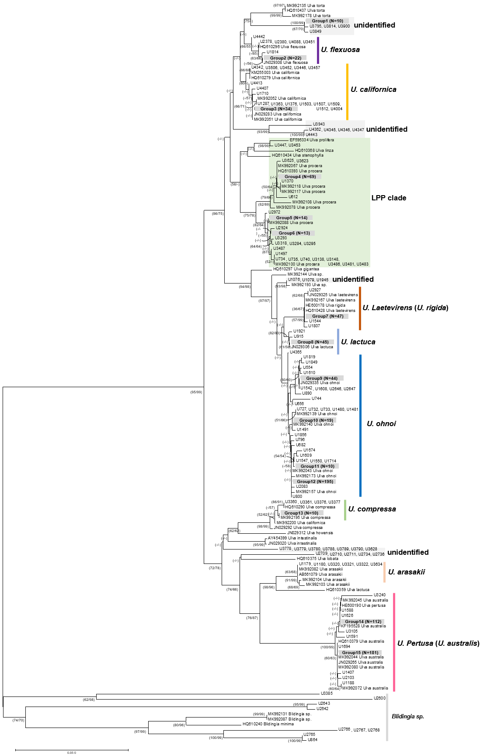
Figure S1 Neighbor-joining (NJ) phylogeny based on 1,023 tufA sequences (966 specimens from Jeju Island and the South Sea combined, plus 55 previously determined haplotype sequences and two unidentified haplotypes) of Ulva, with two sequences of Blidingia species as the outgroup. Reference sequences were obtained from GenBank and used for phylogenetic analysis to identify Ulva species. Specimens grouped within particular clades are labeled as “Group” with the total number of specimens indicated [e.g., Group 1 (N=40)]. Bootstrap values are shown on the nodes for both maximum likelihood (ML) and neighbor-joining (NJ) methods.
Figure S2 Proportion of benthic and floating individuals of U. ohnoi (N=209) and U. australis (= U. pertusa) (N=129) on Jeju Island. Proportions were calculated from relative abundance counts. Results of Chi-square tests (χ² = 16.51, p < 0.001) and preference index values (PI: U. ohnoi = 0.48, U. australis = 0.04) are provided. All the analyses were conducted in R (version 4.5.0; R Core Team, 2025).

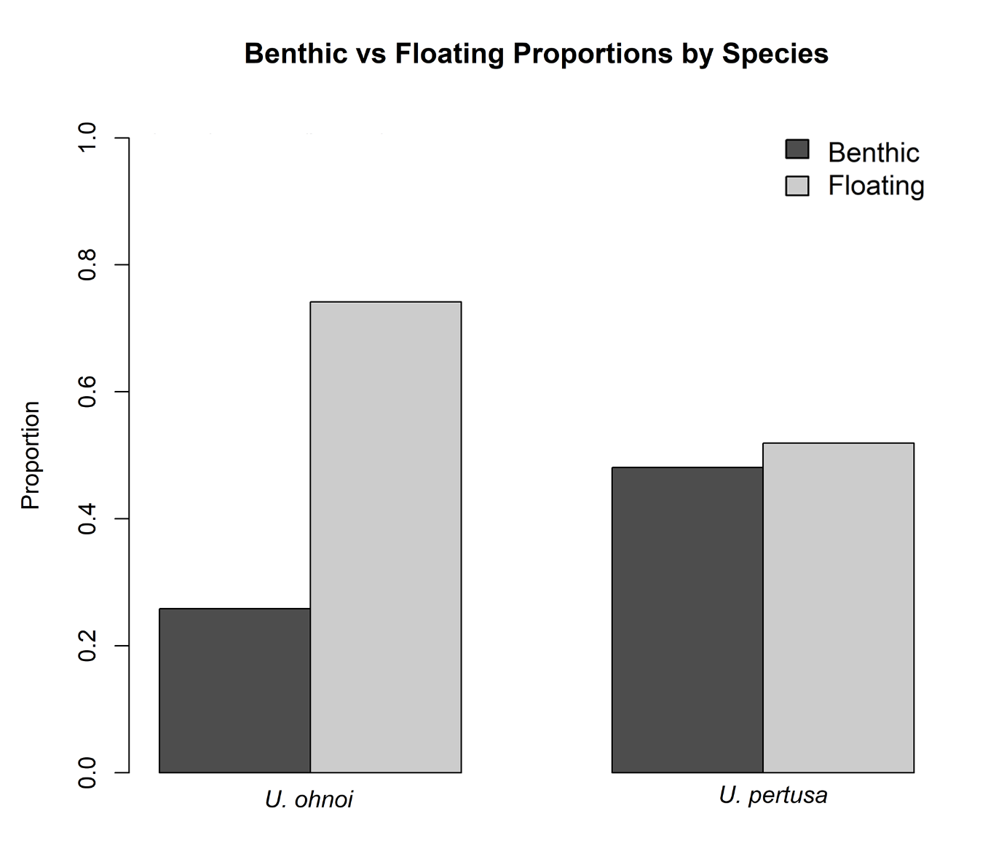
Figure S3 Comparisons of water quality parameters across four groups: Group 1 (Jeju Island) and Groups 2, 3, and 4 (Wando, Yeosu, and Geoje, representing the southern coasts), based on data collected in February 2021 (MEIS⁶⁴). Statistical analysis was performed using the Kruskal-Wallis test with Dunn's post hoc analysis and Bonferroni correction.
