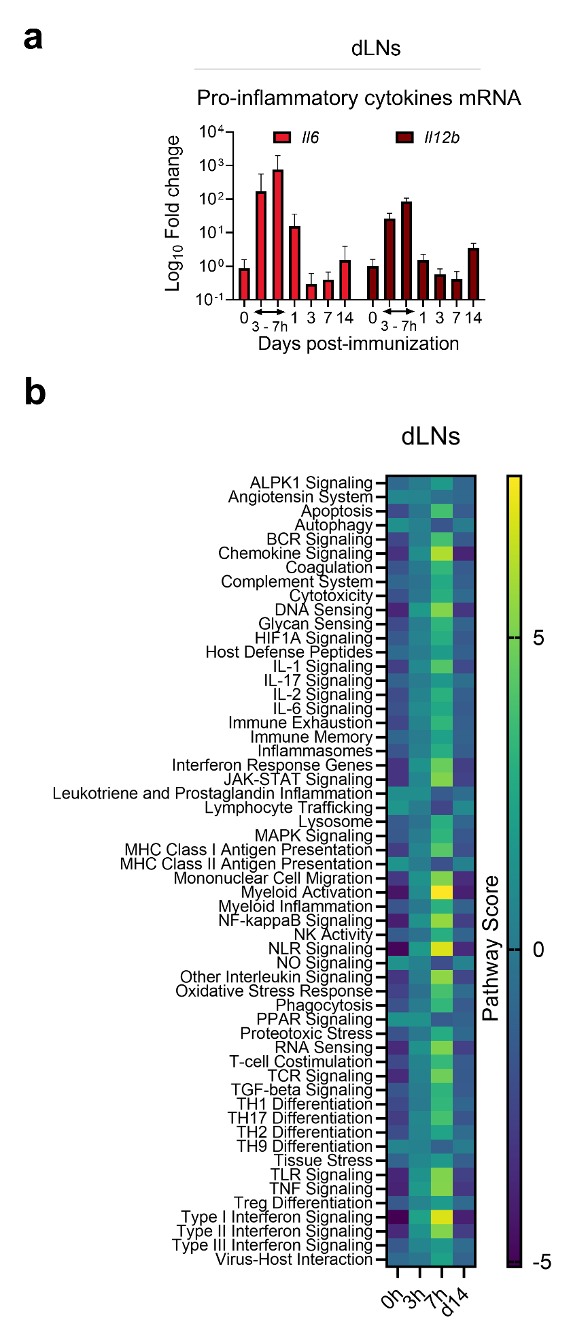
Supplementary Fig. 1 | Local innate responses in mice receiving intramuscular administration of repRNA/LION.
C57BL/6 mice received i.m. immunization with LION-formulated combination repRNA vaccine encoding VZVgE and NiV-G (5 μg each).
(a) Quantitative RT-PCR data using RNA isolated from immunized mice at the indicated time points with primers against the indicated genes. Data are shown as fold change relative to naïve mouse samples.
(b) Heatmap showing pathway scores calculated from NanoString transcript data using RNA isolated from immunized mice at the indicated time points. The lowest score is shown in dark blue and the highest score in yellow.
Data represent individual biological replicates (n = 3-4 per group), with bars indicating mean ± SD.
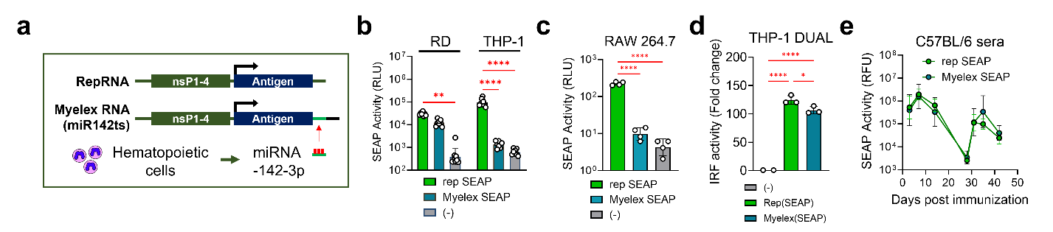
Supplementary Fig. 2 | Encoding of the miRNA-142-3p binding site enables repRNA to be silenced in myeloid cells.
(a) Schematic representation of the Myelex RNA design. The VEEV nsP1–4–encoding region, antigen-encoding region, subgenomic promoter (indicated by arrows), and microRNA-142-3p binding site are shown.
(b-d) RD and THP-1 cells (b), RAW 264.7 cells (c), or THP-1 DUAL cells (d) were transfected with either regular repRNA or Myelex RNA encoding SEAP, using lipofection, or left untreated. Transgene expression (b, c) and IRF activity (d) were measured the following day by SEAP reporter assay and IRF activity assay, respectively. RLU: Relative luminescence units.
(e) C57BL/6 mice received i.m. injection with either regular repRNA/LION or Myelex RNA/LION encoding SEAP (10 μg) twice, 4 weeks apart. Serum SEAP activity levels were determined by SEAP reporter assay.
Data represent individual biological replicates (n = 3-6 per group), with bars indicating mean ± SD (d) or geometric mean ± geometric SD (b, c, e). Statistical comparisons were performed using one-way (c, d), two-way (b) ANOVA, or Student’s unpaired two-tailed t-test (e). *p < 0.05, **p<0.01, ***p<0.001, ****p<0.0001.

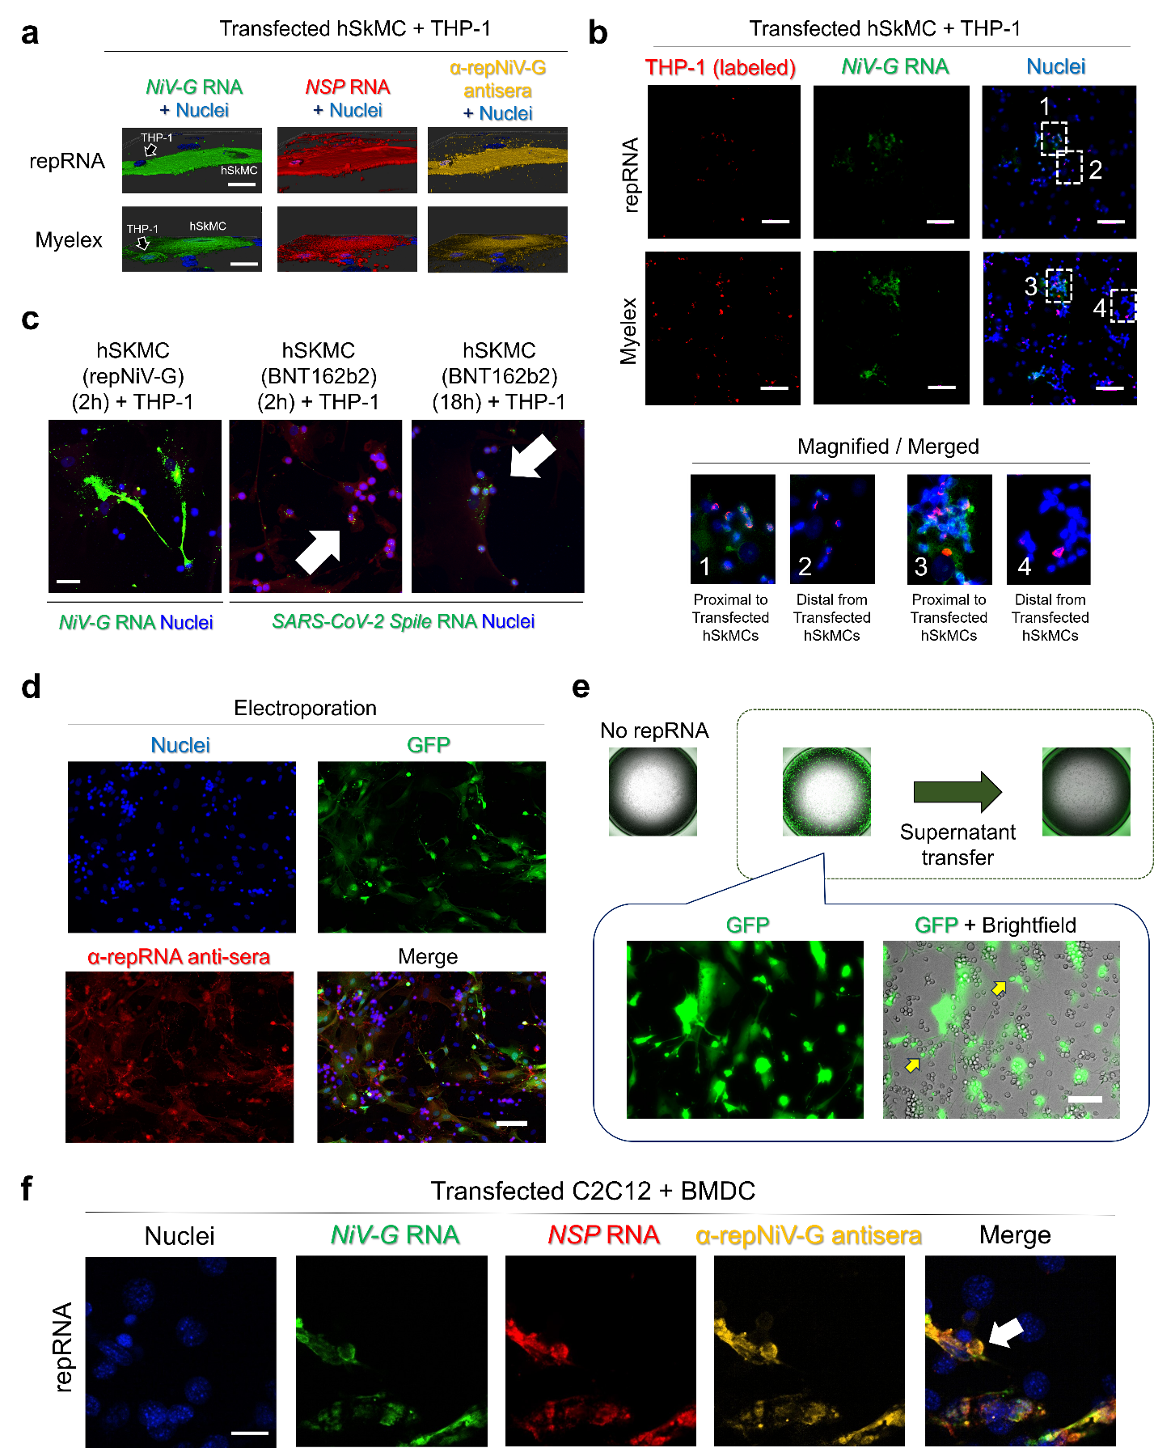
Supplementary Fig. 3 | RNA/protein transfer by hSkMCs is neither transfection-reagent specific, antigen specific, nor mediated by soluble factors.
(a) hSkMCs were transfected with repRNA or Myelex RNA encoding NiV-G using Lipofectamine 2000. Two hours later, cells were washed, and further two hours later, THP-1 cells were added. Following overnight culture, cells were fixed and stained by ISH using probes for VEEV nsP RNA (red) and NiV-G RNA (green), together with repNiV-G antisera (yellow) and DAPI (nuclei; blue). Images were acquired using confocal microscopy. Pseudo-3D images were generated using Imaris. Representative images are shown. Scale bars, 20 μm.
(b) Representative images of repRNA-transfected hSkMC + THP-1 co-culture, in which THP-1 cells were labelled in vitro with CM-DiI before adding to the culture (red) and NiV-G or SARS-CoV-2 RNA (green) was detected by ISH using probes against each sequence, and nuclei were detected by DAPI (blue). Images were acquired using fluorescence microscopy. Numbers correspond to matched magnified images. Scale bars, 100 μm.
(c) hSkMCs were transfected with repRNA encoding NiV-G using Lipofectamine 2000 or with BNT162b2 (modified RNA/LNP encoding SARS-CoV-2 spike). Two hours later, cells were washed, and 2 h later, THP-1 cells were added. Following 2 h or 18 h of co-culture, cells were fixed and stained by ISH using probes for NiV-G RNA or SARS-CoV-2 spike RNA (green), and DAPI (nuclei; blue). Images were acquired using fluorescence microscopy. Arrowheads indicate RNA detected in THP-1 cells. Representative images are shown. Scale bar, 50 μm.
(d-e) THP-1 cells were added to hSkMCs transfected with repRNA encoding GFP by electroporation.
(d) Following overnight culture, cells were fixed, stained with DAPI and sera from repRNA-immunized mice (to detect the repRNA backbone; α-repNiV-G anti-sera). Images were acquired using fluorescence microscopy. Scale bar, 100 μm.
(e) Following overnight culture, GFP⁺ cells were imaged by fluorescence microscopy. Culture supernatants were then transferred to naïve hSkMCs, which were cultured overnight and imaged to confirm the absence of protein transfer. Images were acquired using fluorescence microscopy. Scale bar, 100 μm.
(f) In vitro-differentiated bone marrow-derived dendritic cells (BMDCs) were co-cultured with C2C12 cells transfected with repRNA encoding NiV-G. Following overnight culture, cells were fixed and stained by DAPI (nuclei; blue), RNAscope ISH using probes for NiV-G RNA (green) and VEEV NSP RNA (red). Images were acquired using confocal microscopy. A sequential section was stained with repNiV-G antisera (yellow). Representative images are shown. Scale bar, 20 μm.

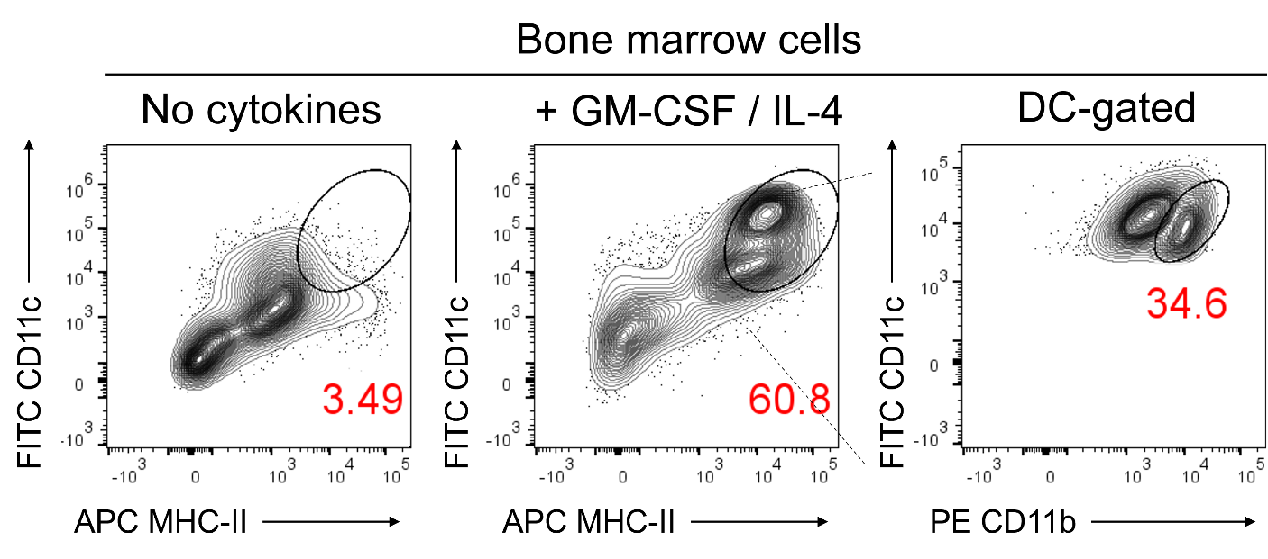
Supplementary Fig. 4 | Characterization of the in vitro–differentiated bone marrow dendritic cells in this study.
Bone marrow was isolated from C57BL/6 mice and cultured in vitro in the presence or absence of GM-CSF (10 ng/mL) and IL-4 (5 ng/mL). Frequencies of dendritic cells (DC; CD11c⁺ MHC-II⁺) were determined by flow cytometry. CD11b expression within the DC population was further analysed and is shown in the “DC-gated” panel.
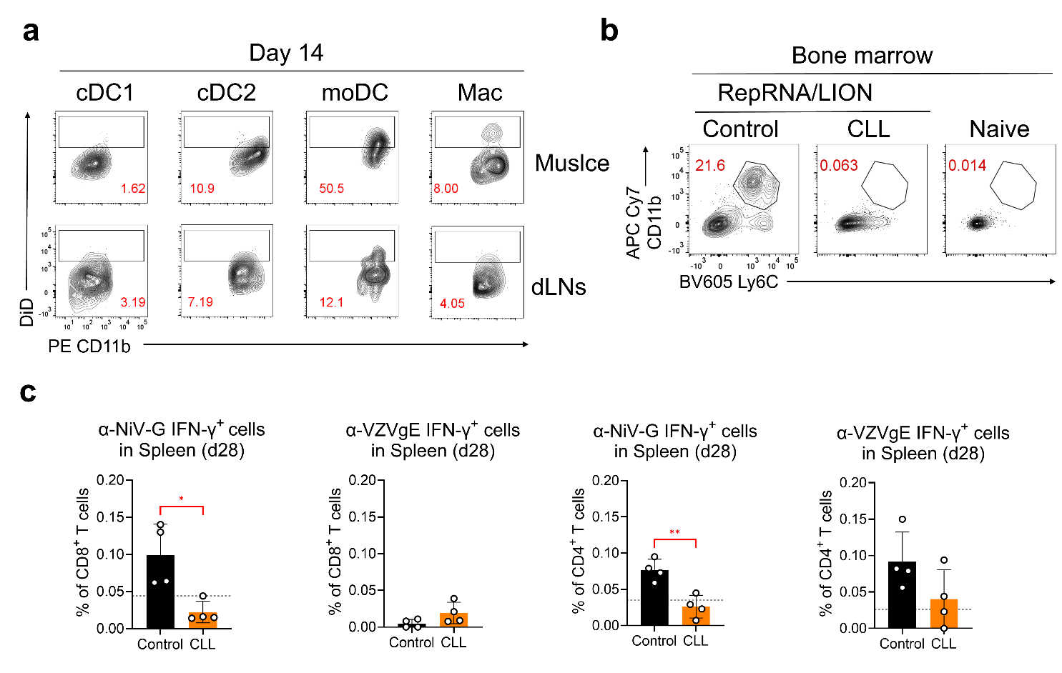
Supplementary Fig. 5 | Clodronate-loaded liposome treatment depleted repRNA/LION-induced expansion of monocytes in bone marrow.
(a) C57BL/6 mice received i.m. immunization with LION-formulated repRNA vaccine encoding NiV-G (20 μg). Mice subsequently received 200 µL of DiD-conjugated liposomes (Fluoroliposomes) twice per week. DiD expression on the indicated APCs on day 14 was assessed by flow cytometry.
(b, c) A cohort of C57BL/6 mice received i.m. immunization with LION-formulated combination repRNA vaccine encoding VZVgE and NiV-G (5 μg each). A subset subsequently received control lipids, while the other half received clodronate-loaded liposomes (CLL) twice per week.
(b) Frequencies of monocytes (CD11b⁺ Ly6C⁺) in live bone marrow at 4 weeks post-prime, determined by flow cytometry. Data from naïve mice are shown as a negative control.
(c) Frequencies of IFN-γ⁺ cells among CD8⁺ T cells and CD4⁺ T cells in response to NiV-G or VZVgE peptide mixes at 4 weeks post-prime.
Data represent individual biological replicates (n = 4 per group), with bars indicating mean ± SD. Dashed lines indicate values of naïve mice. Statistical comparisons were performed using Student’s unpaired two-tailed t-test. *p < 0.05, **p<0.01, ***p<0.001, ****p<0.0001.

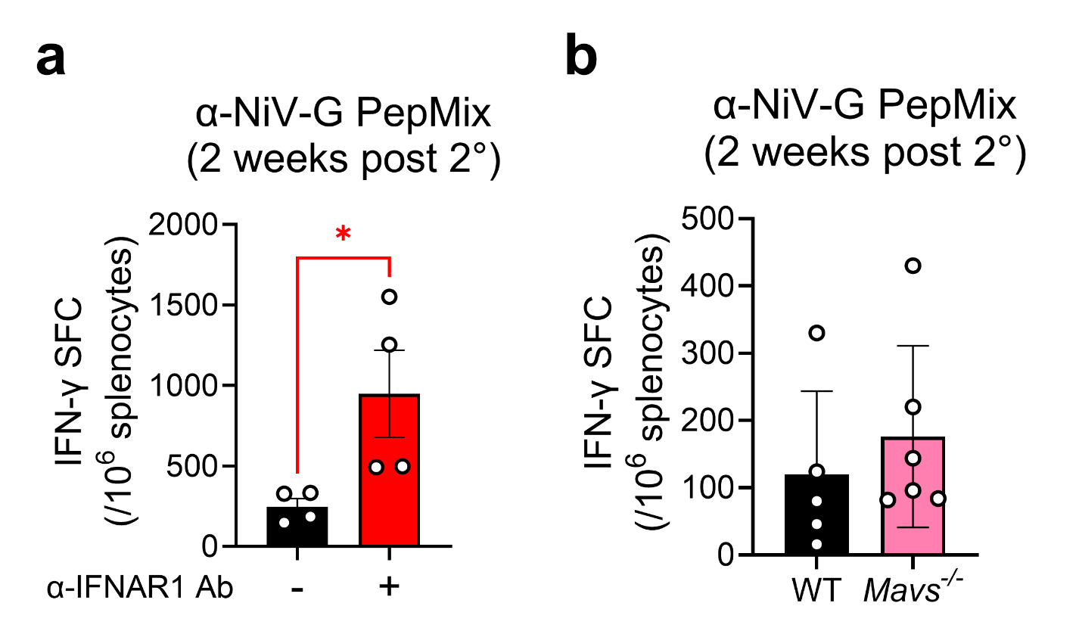
Supplementary Fig. 6 | IFNAR1 and MAVS are dispensable for the T-cell response to repRNA/LION.
C57BL/6 mice or MAVS-deficient (Mavs⁻/⁻) mice received intramuscular (i.m.) immunization with LION-formulated repRNA encoding NiV-G (10 μg) twice, 4 weeks apart. Then, IFN-γ–producing T-cell responses were quantified by ELISpot using their splenocytes.
(a) Spot-forming cells (SFCs) per million splenocytes in C57BL/6 mice treated intraperitoneally with either 1 mg control antibody (mouse IgG1) or 1 mg αIFNAR1 antibody (clone MAR1-5A3) one day prior to each immunization, assessed 2 weeks after the second dose.
(b) SFCs per million splenocytes in MAVS-deficient (Mavs⁻/⁻) mice and their wild-type (WT) littermate controls, assessed 2 weeks after the second dose.
Data represent individual biological replicates (n = 4–5 per group), with bars indicating mean ± SD and dots showing individual values. Statistical comparisons were performed using Student’s unpaired two-tailed t-test. *p < 0.05, **p<0.01, ***p<0.001, ****p<0.0001.

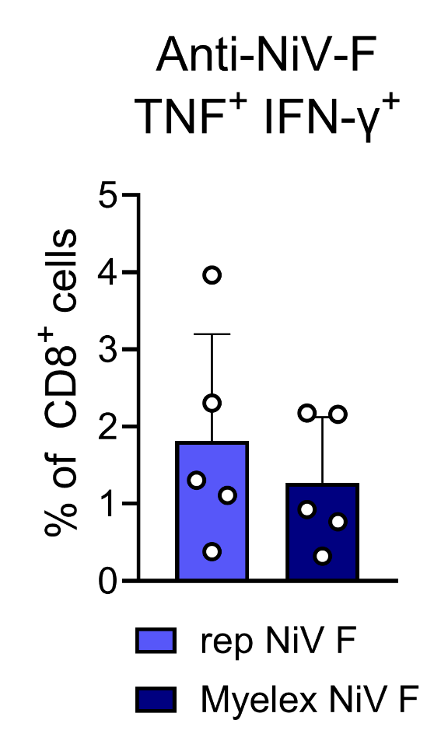
Supplementary Fig. 7 | Myelex NiV-F induces CD8+ T-cell response comparable to regular repRNA encoding NiV-F.
Frequencies of polyfunctional CD8⁺ T cells in splenocytes of mice receiving either regular repRNA/LION or Myelex RNA/LION encoding NiV-F (1 μg) intramuscularly, twice 28 days apart, and assessed 2 weeks after the second dose by intracellular cytokine staining for TNF and IFN-γ followed by flow cytometry.
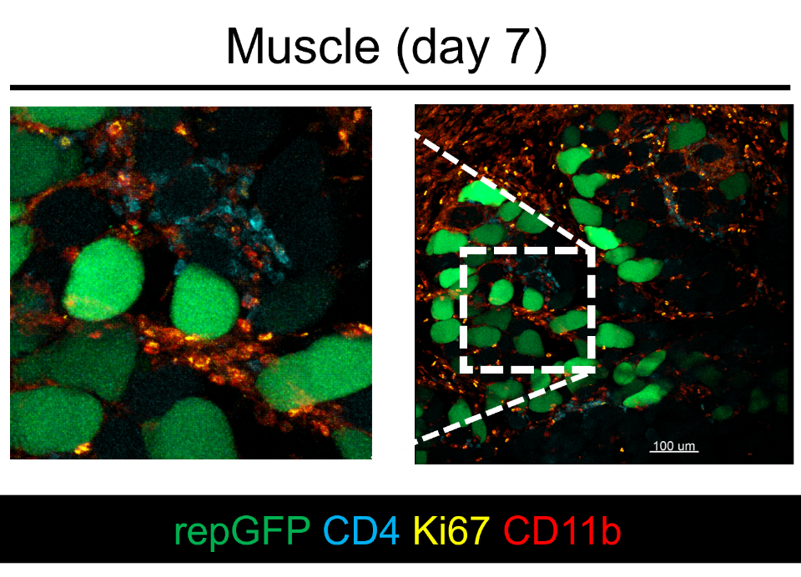
Supplementary Fig. 8 | CD4⁺ cells present near the transfected muscle cells on day 7 following i.m. immunization with repRNA/LION.
Balb/c mice received i.m. immunization with LION-formulated repRNA encoding GFP (10 µg). Seven days later, the injected muscle was sectioned, stained with fluorophore-conjugated antibodies against the indicated proteins, and imaged by multiplex confocal microscopy. Scale bar, 100 µm.

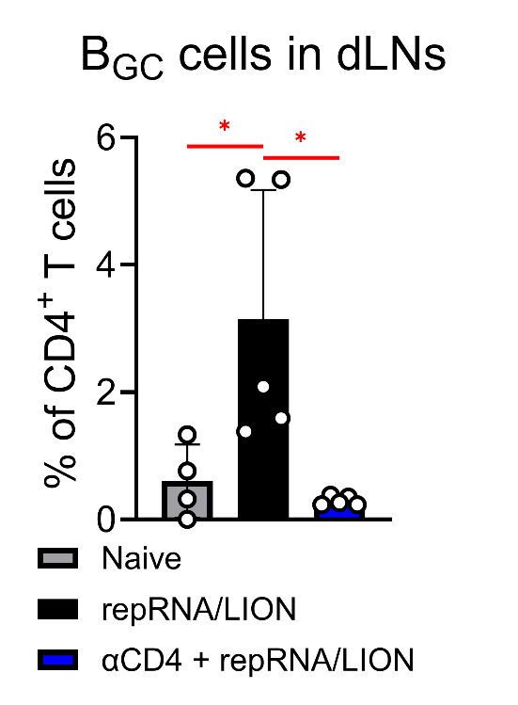
Supplementary Fig. 9 | CD4 depletion completely abolishes the induction of germinal centre B cells in dLNs during repRNA/LION immunization.
Frequencies of germinal centre B cells (B_{GC}; CD38⁻ CD95⁺) within the CD19⁺ B cell population, measured by flow cytometry in dLNs 2 weeks after the second i.m. immunization with LION-formulated combination repRNA encoding VZVgE and NiV-G (5 μg each). Data are shown for naïve mice, repRNA/LION-immunized mice, and repRNA/LION-immunized mice treated with αCD4 antibody (n = 4–5 per group). Bars represent mean ± SD, with individual biological replicates shown. Statistical comparisons were performed using one-way ANOVA; *p < 0.05, **p<0.01, ***p<0.001, ****p<0.0001.

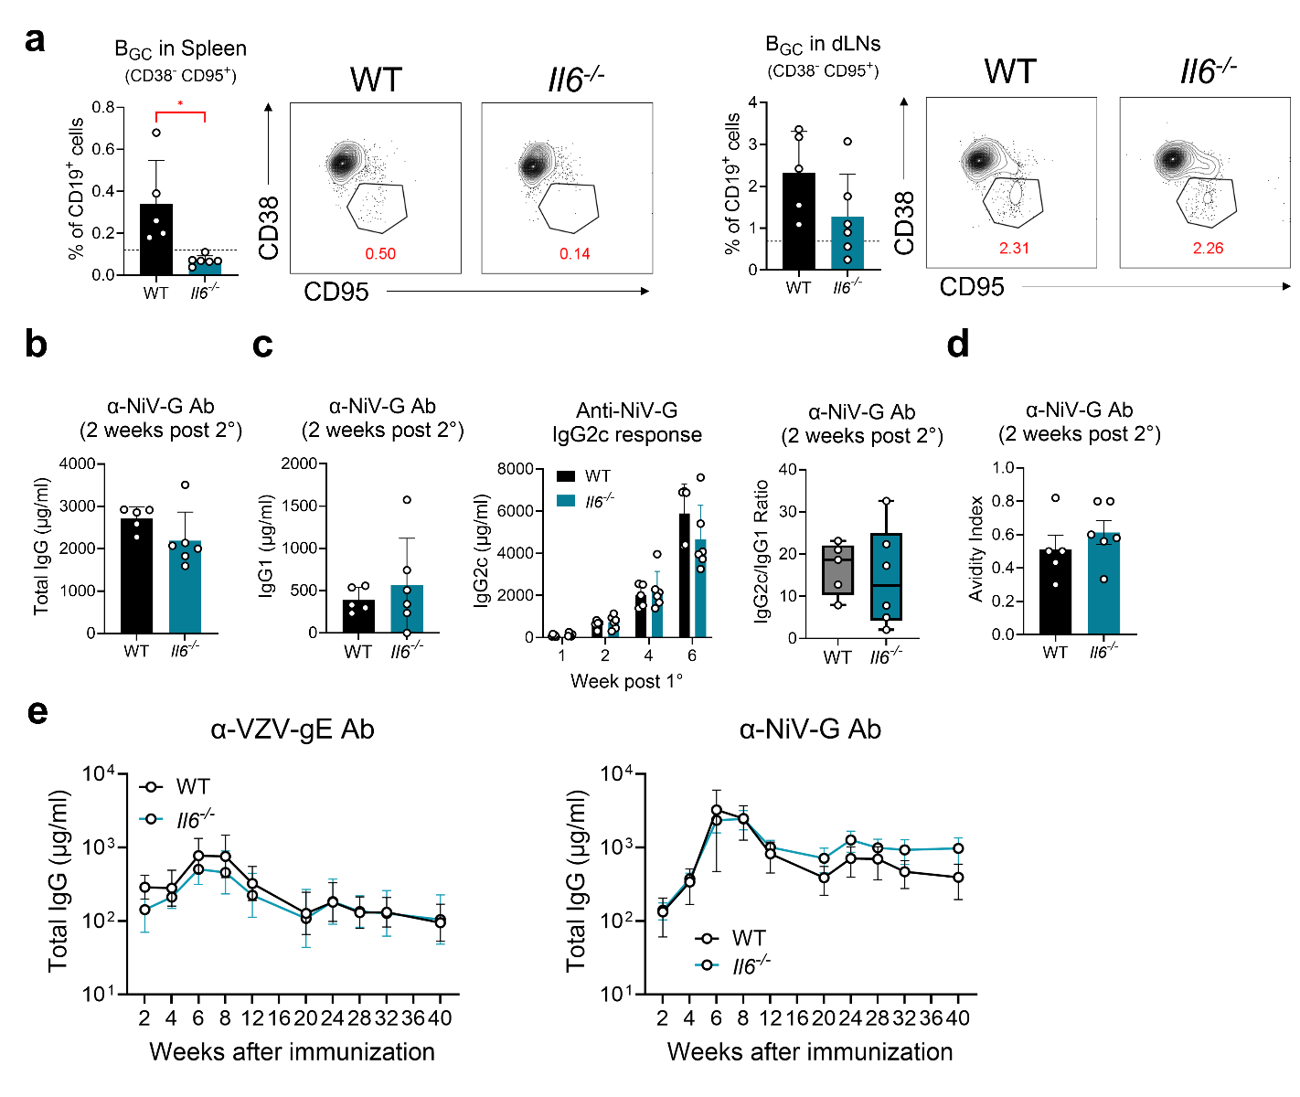
Supplementary Fig. 10 | IL-6 plays a key role in germinal centre responses following repRNA/LION administration but is not required for the antibody response.
Wild-type (WT) and IL-6–deficient (Il6⁻/⁻) mice received i.m. immunization with LION-formulated repRNA encoding either NiV-G (10 μg) (a-d) or a combination repRNA encoding VZVgE and NiV-G (5 μg each) twice, 4 weeks apart (e).
(a) Frequencies of germinal centre B cells (B_{GC}; CD38⁻ CD95⁺) among CD19⁺ cells in the spleen (left) and dLNs (right), assessed by flow cytometry two weeks after the second immunization.
(b) Serum αNiV-G IgG titres measured by ELISA two weeks after the booster dose.
(c) Isotype-specific αNiV-G IgG1 and IgG2c titres measured by ELISA two weeks after the booster dose. The IgG2c/IgG1 ratio is shown as a surrogate marker of Th1/Th2 skewing.
(d) Antibody avidity to NiV-G measured by bio-layer interferometry (BLI) two weeks after the booster dose.
(e) Longitudinal αVZVgE and αNiV-G IgG responses measured by ELISA over a 40-week period following the prime immunization.
Data represent individual biological replicates (n = 5 per group), with bars indicating mean ± SD (a-d) or geometric mean ± geometric SD (e). Statistical comparisons were performed using Student’s unpaired two-tailed t test. *p < 0.05, **p<0.01, ***p<0.001, ****p<0.0001.

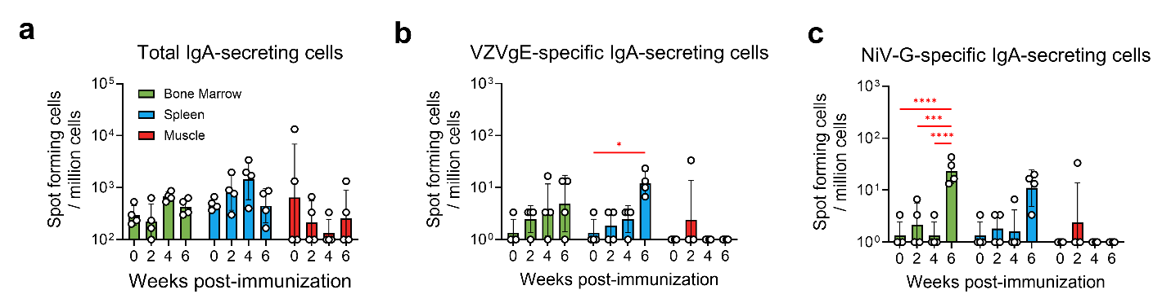
Supplementary Fig. 11 | Intramuscular administration of Il21⁻/⁻ mice with repRNA/LION induces the expansion of IgA-secreting cells in lymphoid tissues.
IL-21 receptor–deficient (Il21r⁻/⁻) mice received intramuscular (i.m.) immunization with LION-formulated combination repRNA encoding VZVgE and NiV-G (5 μg each) once or twice, 4 weeks apart.
(a-c) Spot-forming cells (SFCs) for total IgA-secreting cells (a), VZVgE-specific IgA-secreting cells (b), and NiV-G-specific IgA-secreting cells (c), as determined by ELISpot.
Data represent individual biological replicates (n = 4 per group), with bars indicating geometric mean ± geometric SD. Statistical comparisons were performed using two-way ANOVA. *p < 0.05, **p<0.01, **p<0.001, ****p<0.0001.

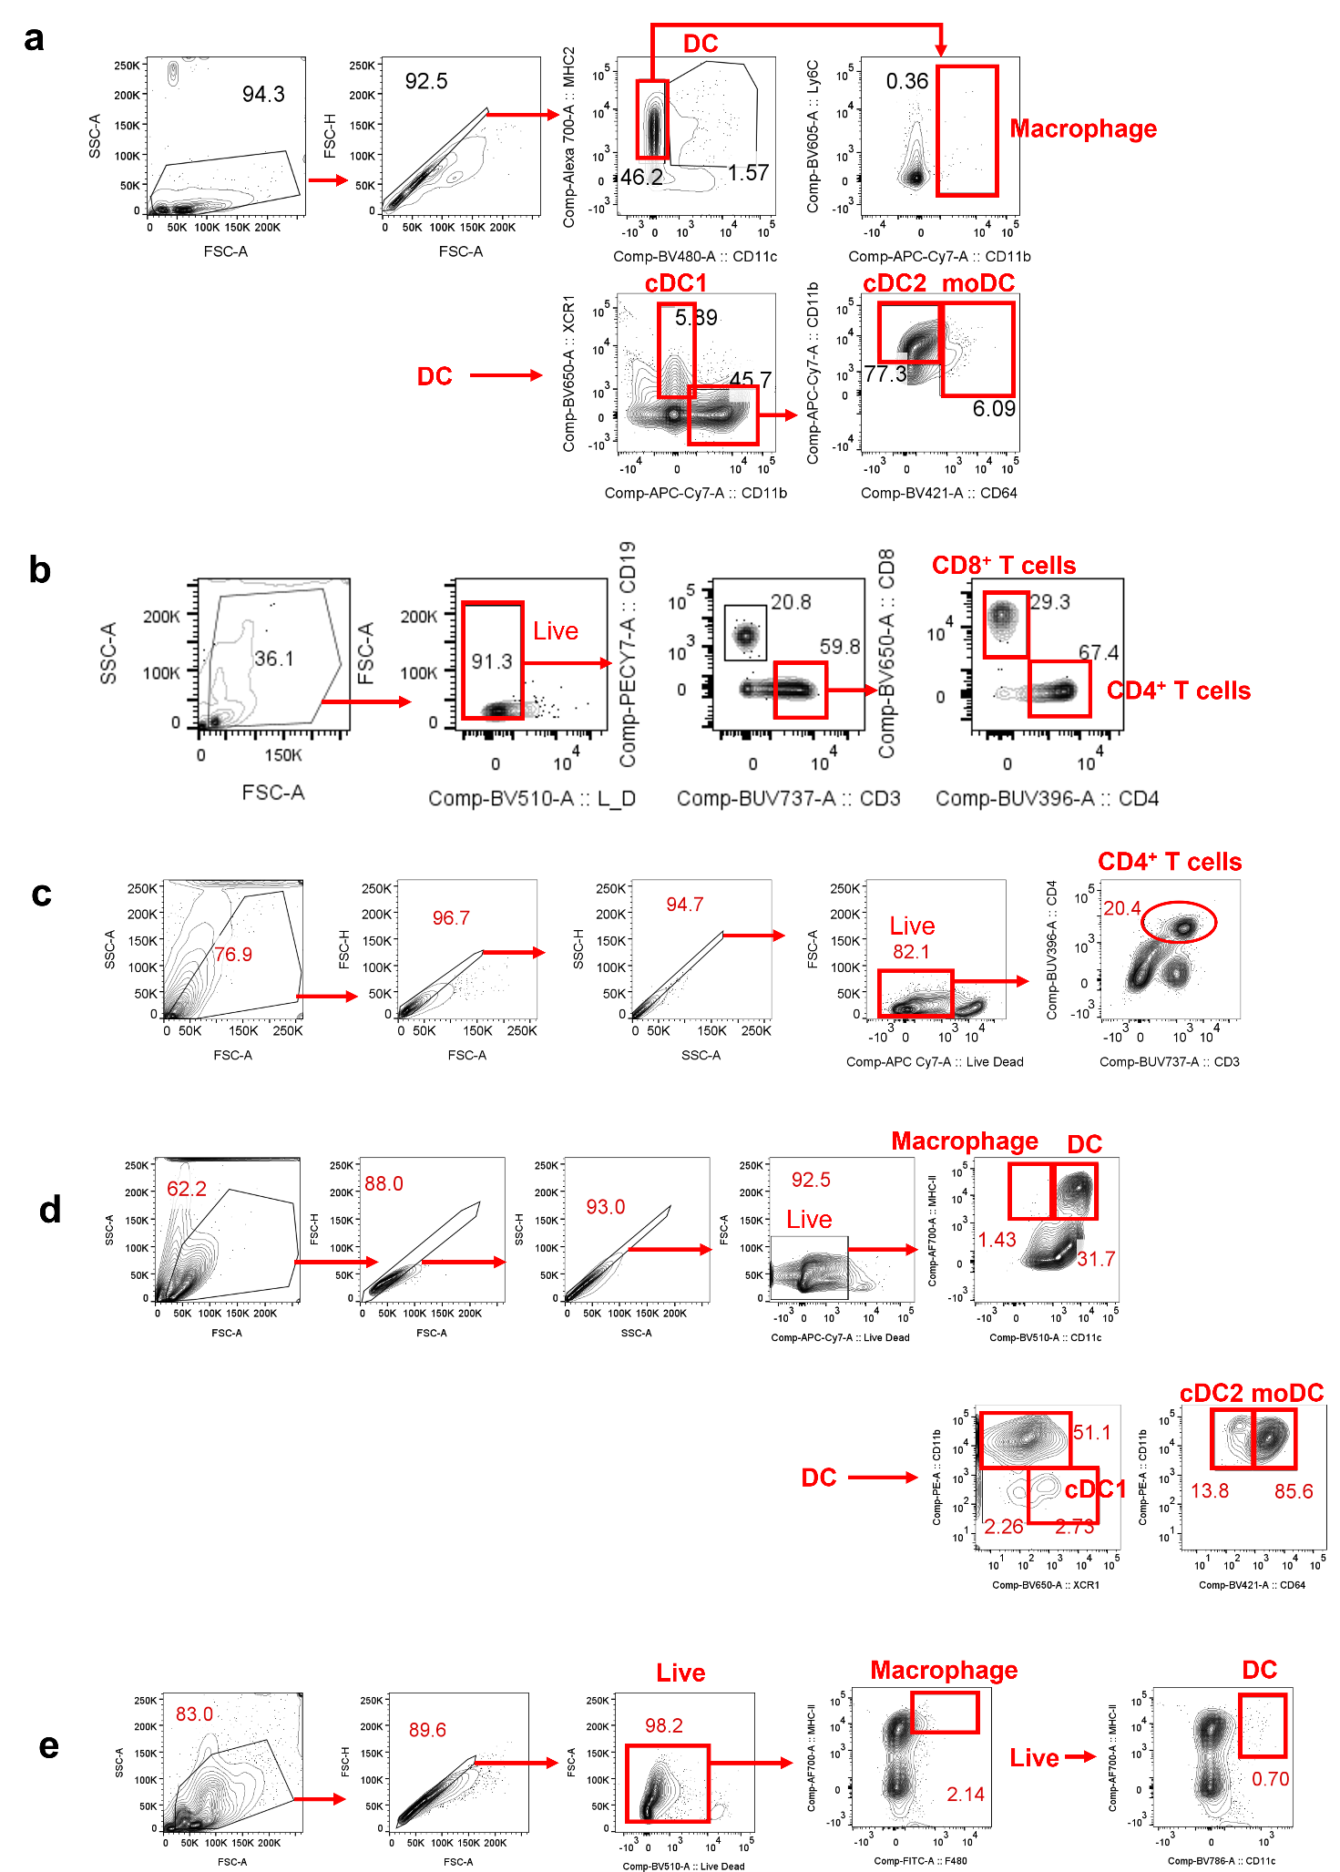
Supplementary Fig. 12 | Gating strategy for flow cytometry data
(a) Gating strategy for APCs in Figure 1, (b) Gating strategy for CD4⁺ and CD8⁺ T-cells in spleens, (c) Gating strategy for CD4⁺ T cells in dLNs and muscles, (d) Gating strategy for APCs in Supplementary Fig. 5a, (e) Gating strategy for APCs in Figure 3b and Supplementary Fig. 5b, are shown.

