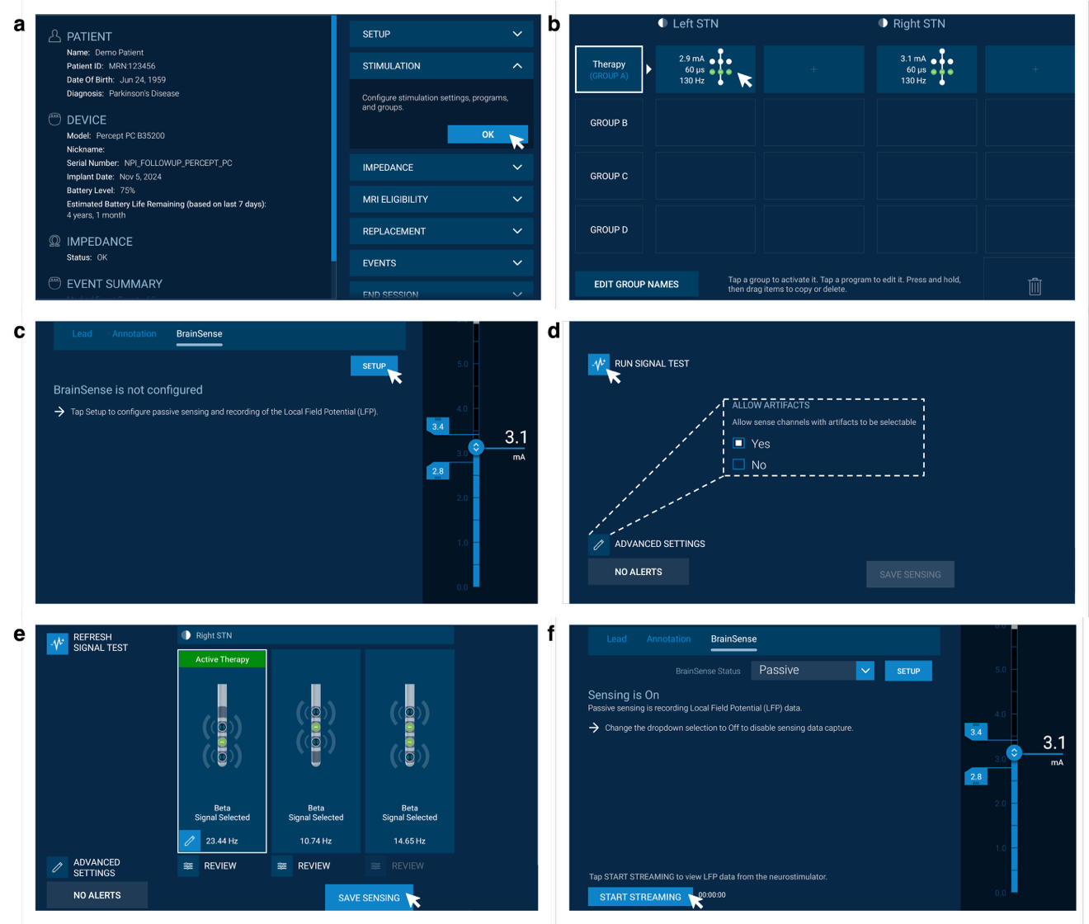
Supplementary Figure 1. Screenshots from the Medtronic tablet illustrating the steps required to configure BrainSense™ Streaming mode for local field potentials (LFP) recordings. a In the main menu, access the stimulation icon to begin the setup process. b Access the stimulation group you wish to configure BrainSense on. c Select BrainSense setup to proceed with the configuration options. d In advanced settings, allow sense channels with artefacts to be selectable, then run the test signal to verify functionality. e Select the BrainSense configuration you wish to use, noting that the indicated frequencies (e.g., 23.44 Hz, 10.74 Hz, 14.65 Hz) correspond to manually defined peaks, with power displayed in real-time on the tablet during LFP recordings. f BrainSense is configured and ready to be used.

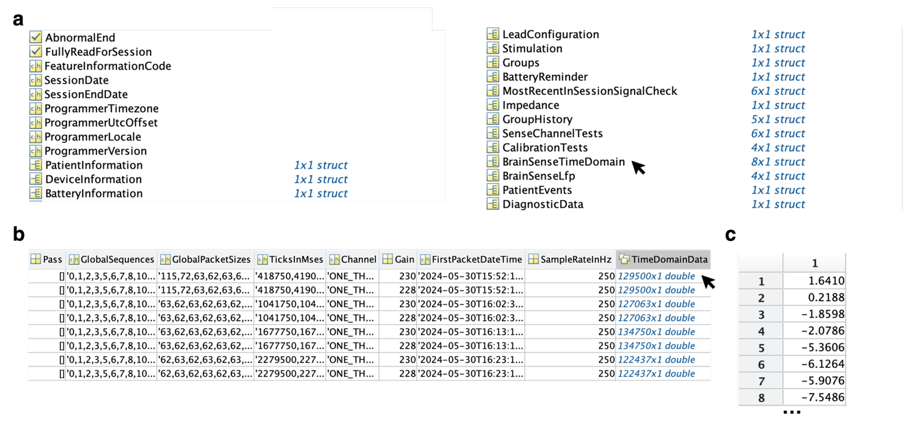Supplementary Figure 2: JSON extraction structure. a data structure in which BrainSense™ streaming data is stored in BrainSenseTimeDomain. b BrainSenseTimeDomain field in which each row corresponds to a specific recording. Raw LFP recordings are stored as matrices in the TimeDomainData column. c Eight first LFP samples recorded.

