Supplementary Information
Supplementary Information accompanies this paper and includes extended HRV–RTV analyses, raw physiological signal visualizations, and task performance data tables. These materials provide additional methodological details and robustness checks supporting the main results.

Grade | Transition | Quantile Math Performance | Lexile Reading Performance
Grade 2 (n=1) | Fall→Winter | Students averaged +240 points above national 50th percentile in fall, +210 points above in winter | Students averaged +350 points above national 50th percentile in fall, +330 points above in winter
Grade 2 (n=1) | Winter→Spring | Students averaged +330 points above national 50th percentile in winter, +280 points above in spring | Students averaged +210 points above national 50th percentile in winter, +385 points above in spring
Grade 3 (n=1) | Fall→Winter | Students averaged +135 points above national 50th percentile in fall, +380 points above in winter | Students averaged +100 points above national 50th percentile in fall, +46 points above in winter
Grade 3 (n=1) | Winter→Spring | Students averaged +380 points above national 50th percentile in winter, +345 points above in spring | Students averaged +100 points above national 50th percentile in winter, +260 points above in spring
Grade 4 (n=16) | Fall→Winter | Students averaged −152 points below national 50th percentile in fall, −123 points below in winter | Students averaged −40 points below national 50th percentile in fall, −47 points below in winter
Grade 4 (n=15) | Winter→Spring | Students averaged −111 points below national 50th percentile in winter, −86 points below in spring | Students averaged −60 points below national 50th percentile in winter, −33 points below in spring
Grade 5 (n=11) | Fall→Winter | Students averaged −72 points below national 50th percentile in fall, −26 points above in winter | Students averaged −42 points below national 50th percentile in fall, +46 points above in winter
Grade 5 (n=11) | Winter→Spring | Students averaged −26 points below national 50th percentile in winter, −25 points below in spring
Grade 5 (n=9) | Winter→Spring | - | Students averaged +108 points above national 50th percentile in winter, +114 points above in spring
Grade 6 (n=4) | Fall→Winter | Students averaged −144 points below national 50th percentile in fall, −98 points below in winter | Students averaged −214 points below national 50th percentile in fall, −162 points below in winter
Grade 6 (n=4) | Winter→Spring | Students averaged −98 points below national 50th percentile in winter, −41 points below in spring | Students averaged −162 points below national 50th percentile in winter, −245 points below in spring
Table 3: Quantile Mathematics and Lexile Reading Performance Detailed Data Analysis (Fig. 3)

Grade | Transition | IXL Math Performance
Grade 7 (n=12) | Before→After | Students averaged 495 points before intervention vs. national 50th percentile of 580 (difference: -85 points below national average); averaged 598 points after intervention vs. national 50th percentile of 580 (difference: +18 points above national average); growth: +103 points
Grade 8 (n=5) | Before→After | Students averaged 666 points before intervention vs. national 50th percentile of 650 (difference: +16 points above national average); averaged 706 points after intervention vs. national 50th percentile of 650 (difference: +56 points above national average); growth: +40 points
Table 4: IXL Mathematics Performance Detailed Data Analysis (Fig. 3)

Distress symptom | Users with overall increase | Users with overall decrease | Users with no net change | Average total change
Stress | 26 | 52 | 15 | -0.99
Anxiety | 27 | 37 | 29 | -0.49
Depression | 26 | 36 | 31 | -0.09
Table 5: Cumulative results across all Stress, Anxiety, and Depression.

Distress symptom | Before (mean) | After (mean) | Average Change | Paired t-test | Significant change
Stress | 7.89 (±4.61) | 6.90 (±4.93) | -0.99 (±3.70) | t=2.577, p=0.0116 | Yes (α=0.05)
Anxiety | 4.06 (±4.39) | 3.57 (±4.47) | -0.49 (±3.61) | t=1.322, p=0.1894 | No (α=0.05)
Depression | 4.35 (±4.42) | 4.27 (±4.86) | -0.09 (±3.50) | t=0.237, p=0.8132 | No (α=0.05)
Table 6: Before and after statistics for the DASS21-Y report.

Image type | True answers across all tests | False answers across all tests | Total count
City | 82244 (57.4%) | 61049 (42.6%) | 143293
Mountain | 11910 (74.4%) | 4097 (25.6%) | 16007
All | 94154 (59.1%) | 65146 (40.9%) | 159300
Table 7: Correct/incorrect responses based on images type

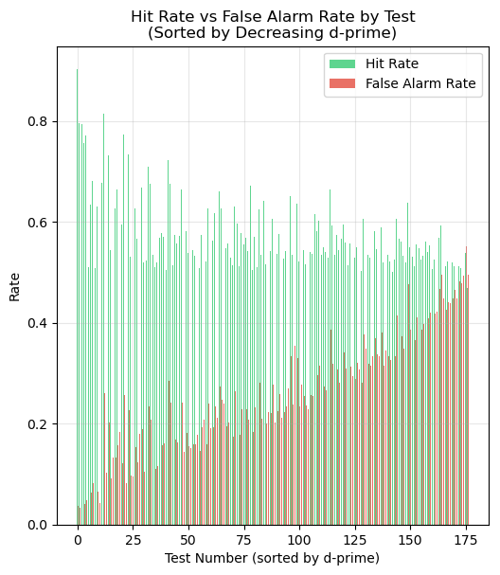 | 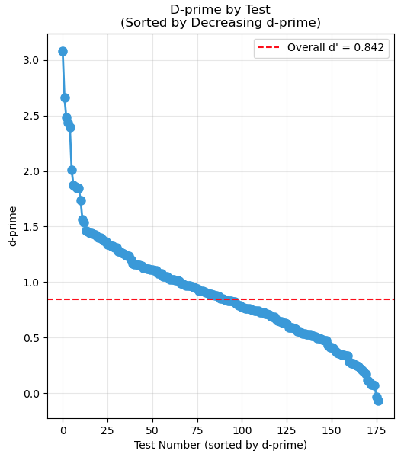
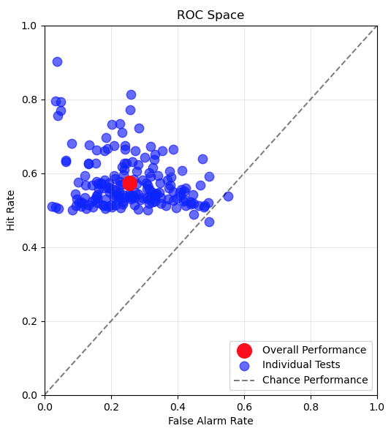 | 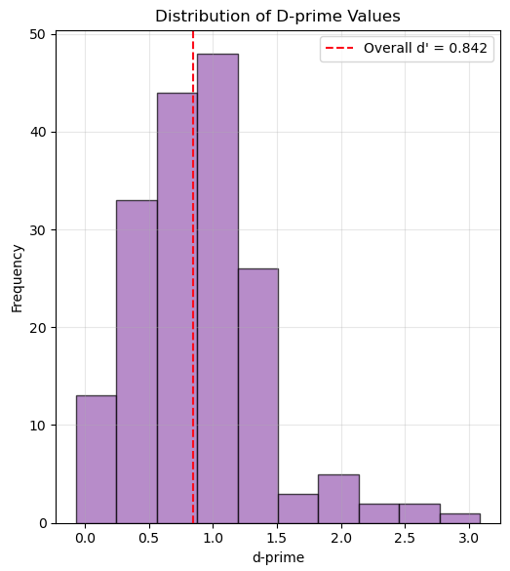

Total Tests: | 177 | Overall Hit Rate: | 0.574
Total City Trials: | 143293 | Overall False Alarm Rate: | 0.256
Total Mountain Trials: | 16007 | Overall d’: | 0.842
Total Hits: | 82244 | Mean Test d’: | 0.900
Total False Alarms: | 4097 | Std Test d’: | 0.504
Figure 8: Focus test results (hit rate, false alarm rate, d′). The hit rate (clicking on cities) was compared to the false alarm rate (clicking on mountains). Sensitivity analysis was performed by calculating the d’ statistic [21]. The results are summarized above.

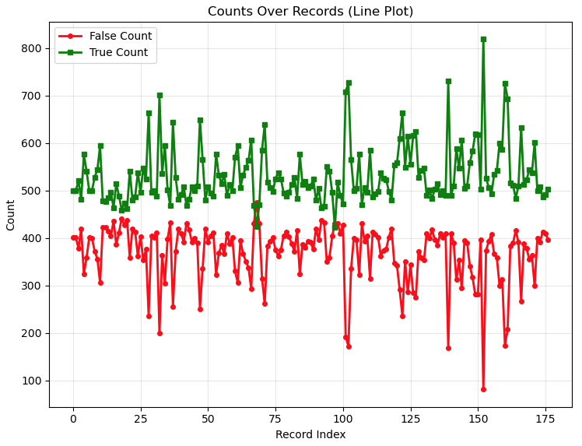 | 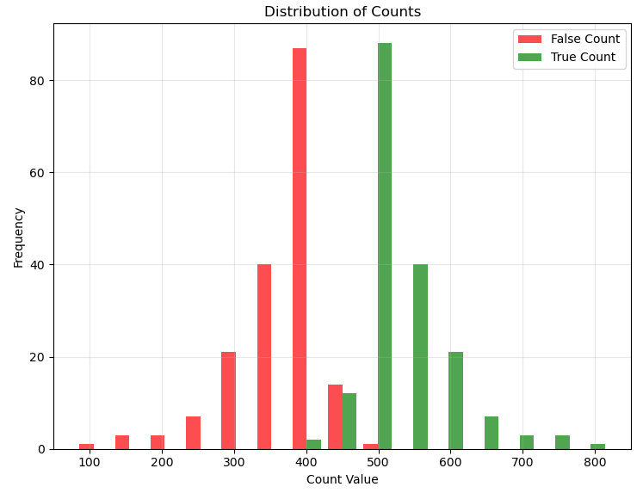
Figure 9: Number of correct/incorrect responses for the 177 focus tests and their frequency distributions. Students averaged 59.1% correct and 40.9% false responses. City hit rate was 57.4% and mountain false alarm rate 25.6%, matching [14]’s false alarms but far below its 97% hit rate—likely due to the brief 800 ms display and frustration from mistakes. The first significant difference between our study and that of [14] - The false alarm rate in [14] was between 25-30%, which aligns with our findings. But the hit rate in [14] was close to 97% which is much higher than ours. There are two reasons speculated for this: 1) the images are only shown for 800ms which is not enough for younger students to respond to, and 2) it was noticed that when they made a mistake oftentimes it would lead to frustration, which, in turn, would make them miss additional subsequent images.

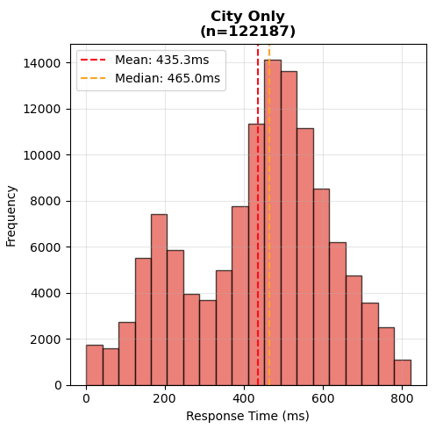 | 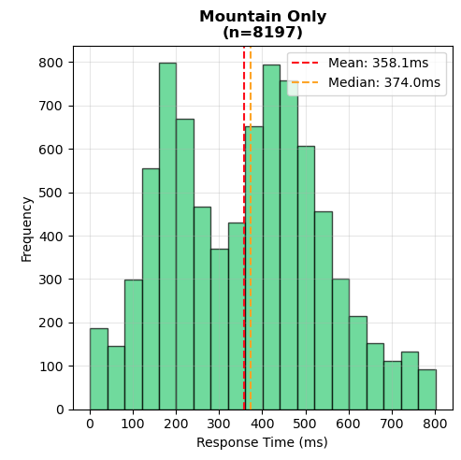
Figure 10: Binned response time distributions for city and mountain images. The mean response time is lower for cities (435.3ms) than for mountains (358.1ms) and there is a significant increase in the mountain graph for quick clicks (<250ms). The mean response time for a city was 435.3ms and for a mountain 358.2ms. Both graphs are bimodal and it was speculated that the first mode at ~200ms are clicks made instinctively, whereas the second mode, at ~420-440ms, corresponds to more conscious decisions. It is not surprising that the mean for cities is higher than for mountains, since given more time to think, students will make the correct decision to not click on mountains. It is also no surprise that the first mode in the mountain graph is relatively higher than the other since these clicks correspond to less conscious decisions.

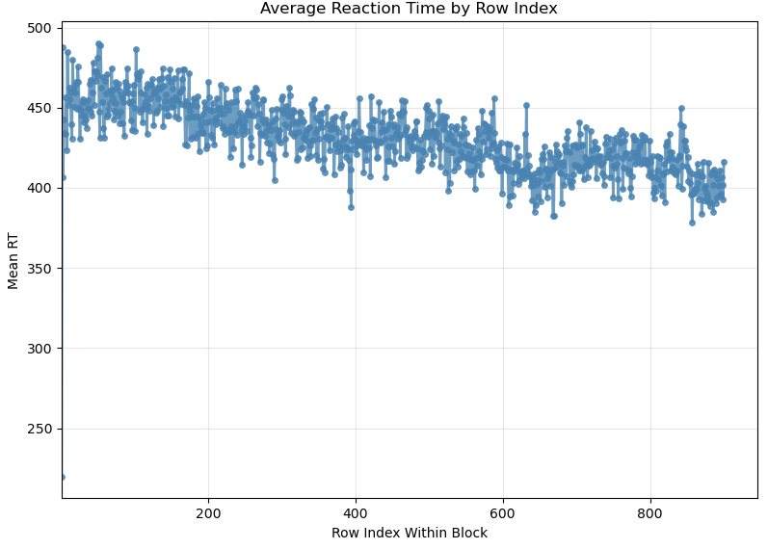 | 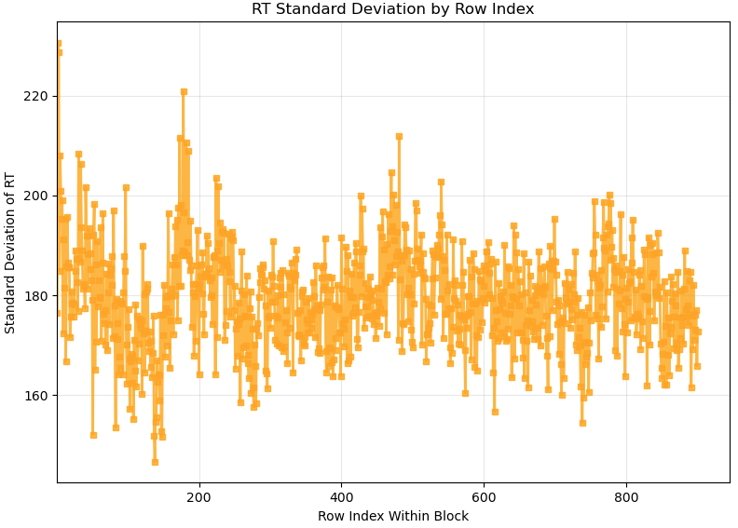
Figure 11: Average reaction time (left) and standard deviation (right) for each image position across all tests. Figure 10 shows the average reaction time for each of the 900 images across all 177 tests as well as the standard deviation of the reaction time for each image. There is a significant decrease in the reaction time as the focus test progresses, and the variability of the standard deviation also converges.

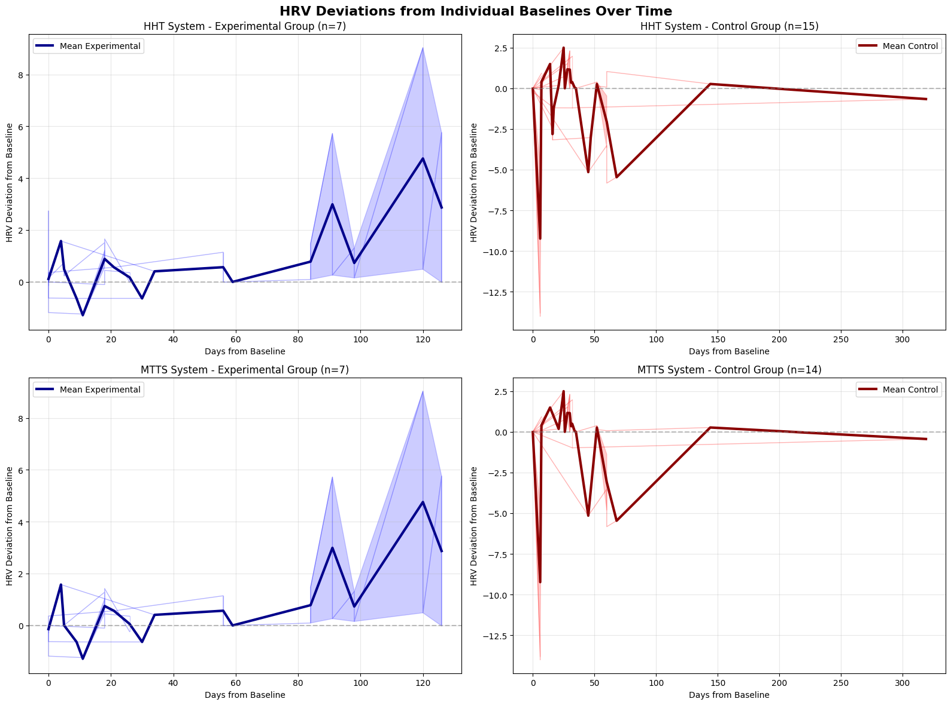
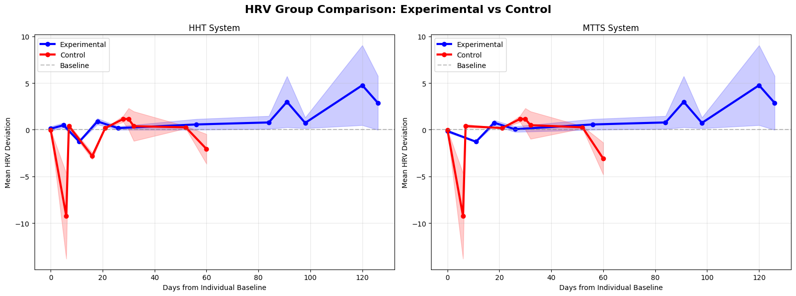
Figure 12: HRV Trajectory of Experimental and Control Groups

