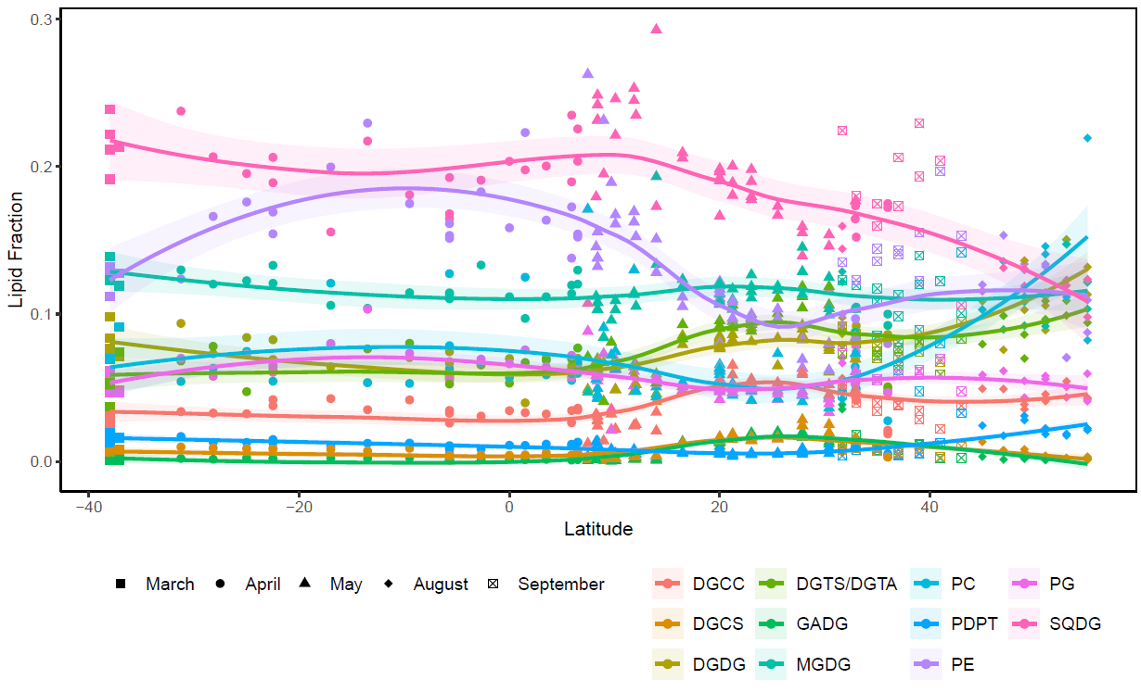
Supplementary Figure 1. Relative abundance of major polar lipids by latitude in particulate organic matter in the mixed layer of the Atlantic Ocean. Colored lines indicate loess-smoothed moving averages with a smoothing span of 0.75 and shaded areas indicate 95% confidence intervals.
DGCC – diacylglycerolcarboxyhydroxymethylcholine; DGCS – diacylglycerol carboxyhydroxysulfocholine (proposed nomenclature); DGDG – digalactosyldiacylglycerol; DGTS/DGTA – diacylglyceroltrimethylhomoserine and diacylglyceroltrimethylbetaalanine (indistinguishable isomers with our methods); GADG – glucuronosyldiacylglycerol; MGDG – monogalactosyldiacylglycerol; PC – phosphatidylcholine; PDPT – phosphatidyl-S,S-dimethylpropanethiol; PE – phosphatidylethanolamine; PG – phosphatidylglycerol; SQDG – sulfoquinovosyldiacylglycerol.

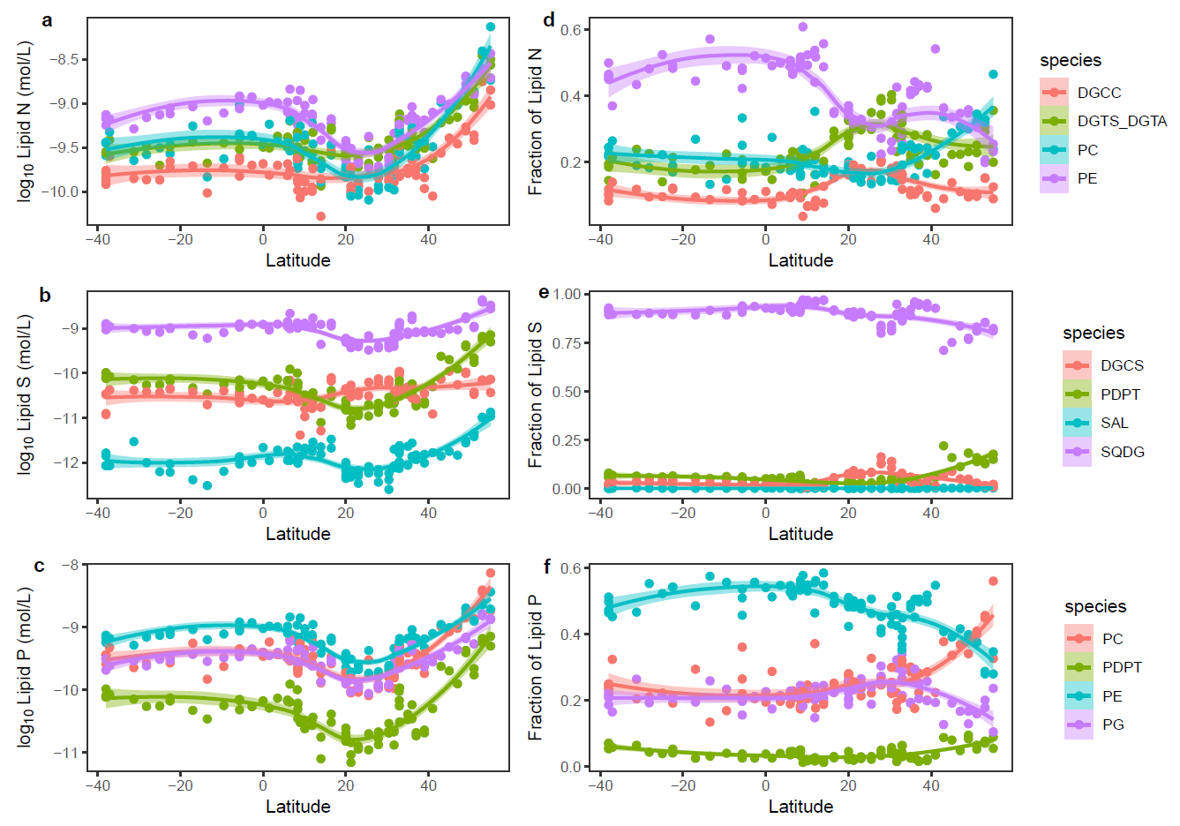
Supplementary Figure 2. Intact polar lipid (IPL) abundance by latitude in the mixed layer of the Atlantic Ocean in log₁₀-moles/L of total N, S, and P-based lipids (b, c, d); and fractional contribution to total lipid N (b), S (d), and P pools (f). All IPLs in this figure have at most one of each heteroatom (i.e N, P, S), so abundance in pmol/L (a, c, e) represents the abundance of both the membrane lipid and the heteroatom. Colored lines indicate loess-smoothed moving averages with a smoothing span of 0.75 and shaded areas indicate 95% confidence intervals. For visual clarity, the three least abundant N-based lipid classes are not shown.
DGCC – diacylglycerolcarboxyhydroxymethylcholine; DGCS – diacylglycerol carboxyhydroxysulfocholine (proposed nomenclature); DGDG – digalactosyldiacylglycerol; DGTS/DGTA – diacylglyceroltrimethylhomoserine and diacylglyceroltrimethylbetaalanine (indistinguishable isomers with our methods); GADG – glucuronosyldiacylglycerol; MGDG – monogalactosyldiacylglycerol; PC – phosphatidylcholine; PDPT – phosphatidyl-S,S-dimethylpropanethiol; PE – phosphatidylethanolamine; PG – phosphatidylglycerol; SQDG – sulfoquinovosyldiacylglycerol.

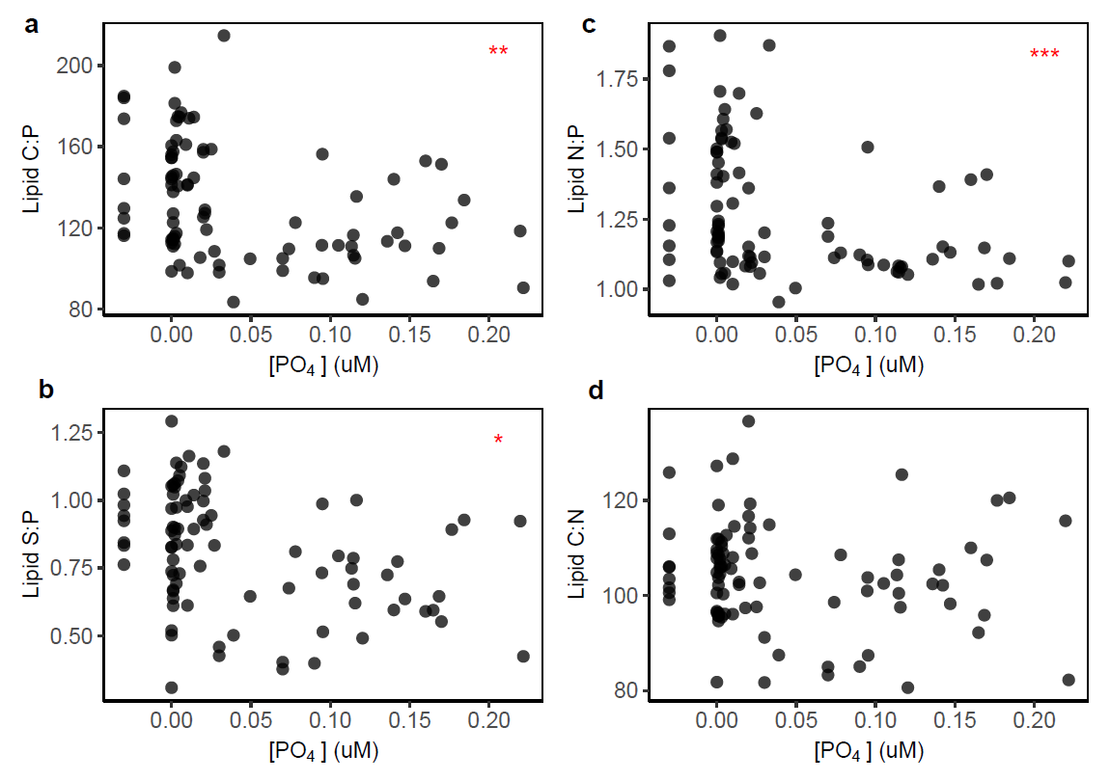Supplementary Figure 3. Relationships between particulate polar lipid stoichiometry and dissolved phosphate [PO4] in the mixed layer of the Atlantic Ocean. Membrane lipid C:P (a) , N:P (b) , S:P (c) , and C:N (d) versus [PO4]. Red asterisks indicate Spearman rank order correlation significant below a p-value threshold of 0.05 ((A) ** - Spearman ρ = -0.37, p < 0.001; (B) *** - Spearman ρ = -0.42, p < 0.0001; (C) * - Spearman ρ = -0.29, p < 0.01). [PO4] values below zero indicate Sargasso Sea samples where [PO4] was not measured and are not included in significance tests.

 | Min. | 1st Qu. | Median | Mean | 3rd Qu. | Max
Lipid C/POC | 0.01615 | 0.06249 | 0.08171 | 0.08159 | 0.09638 | 0.17205
Lipid N/PON | 0.001266 | 0.006625 | 0.008213 | 0.011308 | 0.013041 | 0.038310
Lipid P/POP | 0.01662 | 0.08186 | 0.09696 | 0.10227 | 0.11885 | 0.22829
Supplementary Table. 1 – Molar contributions of carbon, nitrogen, and phosphorus (C, N, P) in lipids as a proportion of total particulate organic C, N, and P in surface (≤50m) samples along the transect of cruise AE1319 in the western North Atlantic Ocean.

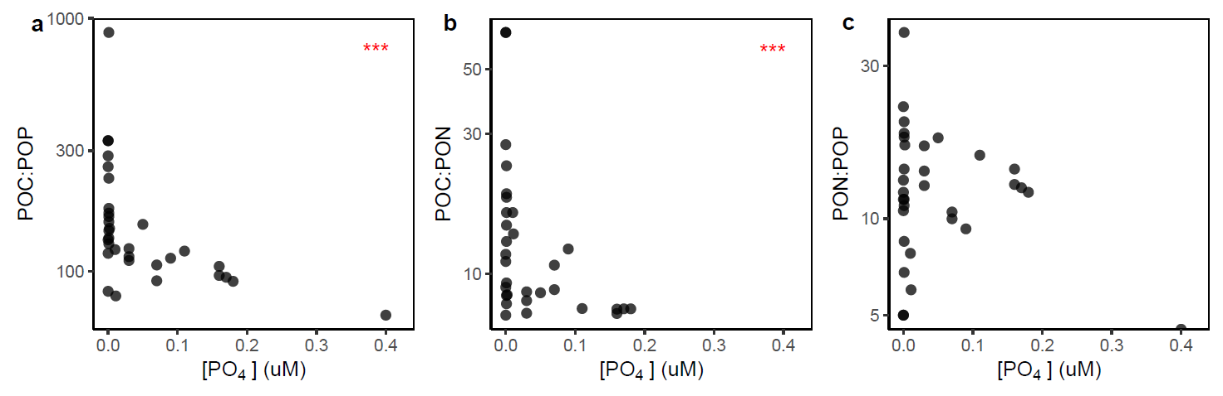
Supplemental Figure 4. Relationships between particulate organic carbon, nitrogen, and phosphorus (POC, PON, POP) ratios and dissolved phosphate ([PO₄]) in the surface North Atlantic (<50 m depth). As reported in Lomas et al. (2021), POC:POP and POC:PON were negatively correlated with [PO₄] (POC:POP Spearman ρ = -0.69, p < 0.0001; POC:PON Spearman ρ = -0.68, p < 0.0001; both indicated with asterisk), but PON:POP was not.

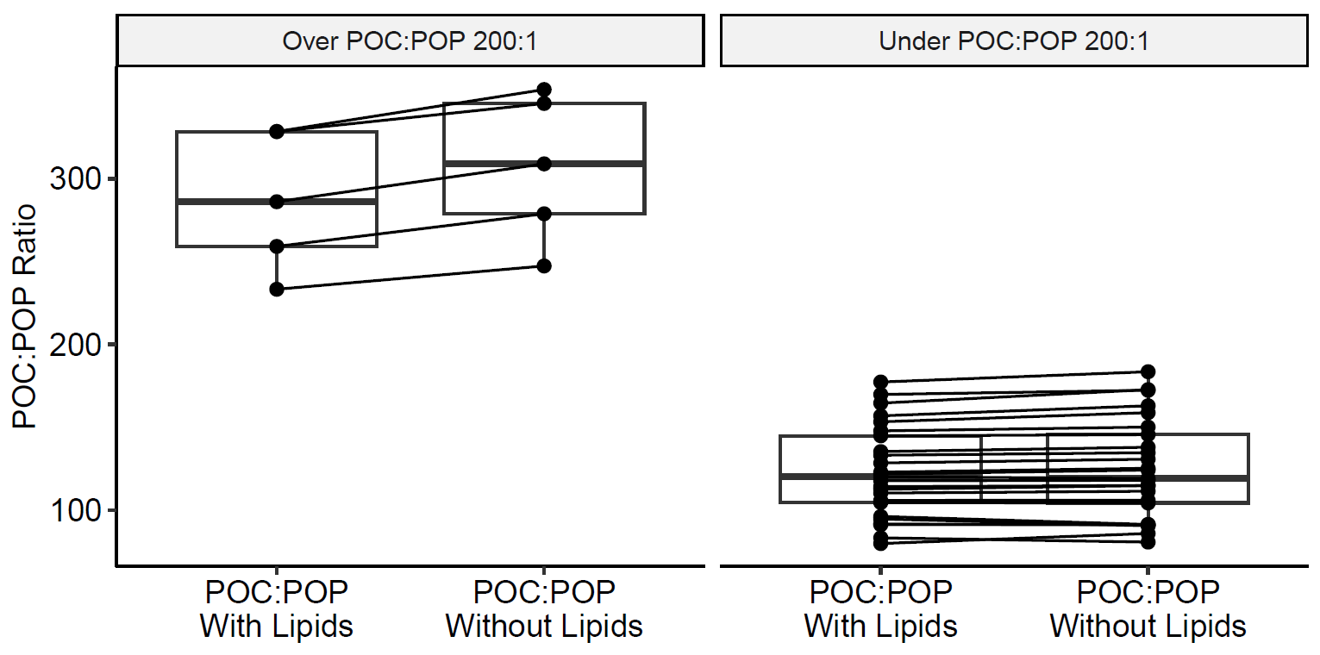
Supplemental Figure 5. Paired t-test of particulate organic carbon:phosphorus (POC:POP) ratios including lipid biomass and with lipid biomass removed, showing a significant increase in total POC:POP above 200:1 when lipid biomass is subtracted (p < 0.01, mean difference = 5.04, degrees of freedom = 10).

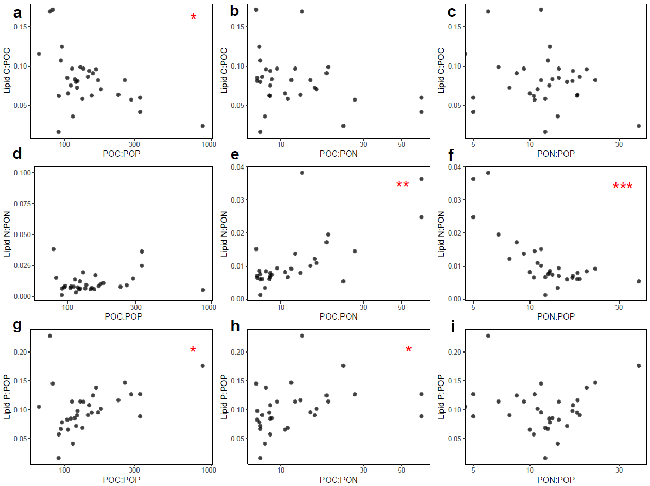Supplementary Figure 6. Lipid fractional elemental contribution to total elemental pools as a function of bulk C, N, P ratios. Red asterisks indicate Spearman rank order correlation significance under a threshold of p = 0.05. (A) Lipid C:POC vs POC:POP, Spearman ρ = -0.44, p = 0.012; (E) Lipid N:PON vs POC:PON, Spearman ρ = 0.58, p < 0.001; (F) Lipid N:PON vs PON:POP, Spearman ρ = -0.67, p < 0.0001; (G) Lipid P:POP vs POC:POP, Spearman ρ = 0.40, p = 0.026; (H) Lipid P:POP vs POC:PON, Spearman ρ = 0.41, p = 0.024.

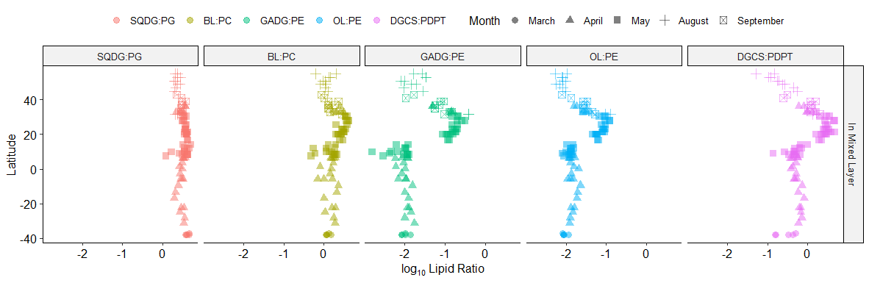
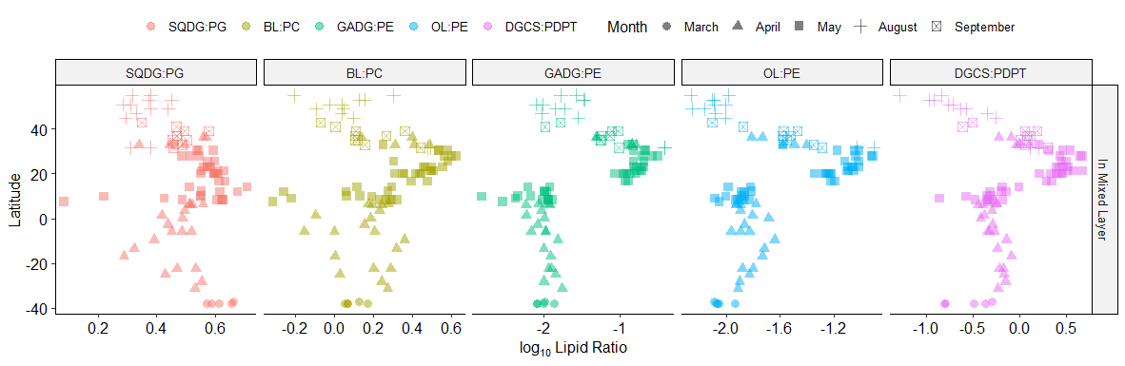

Supplementary Figure 7 – Lipid ratio indicators of microbial nutrient-stress in the mixed layer of the Atlantic Ocean by latitude (x-axis) on shared y-axes (top) and independent y-axes (bottom) to highlight the difference in ranges.

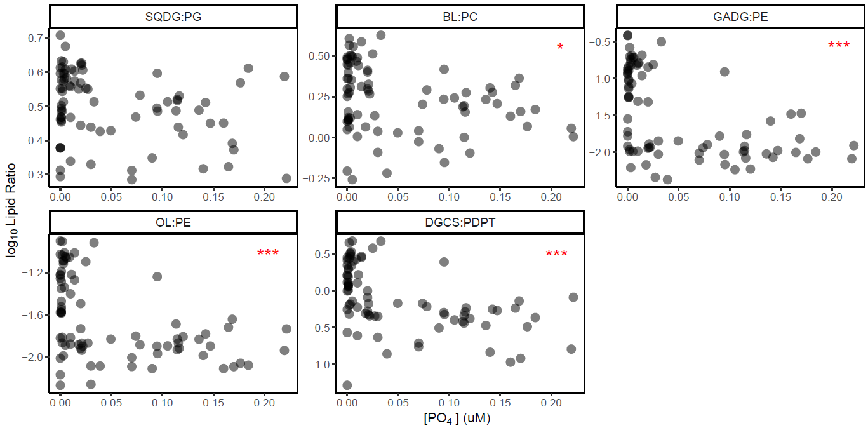
Supplementary Figure 8. Lipid ratio indicators of nutrient stress versus phosphate ([PO₄]) concentration (uM) in the mixed layer of the Atlantic Ocean. Red asterisks indicate statistical significance according to Spearman rank order correlation tests; BL:PC Spearman ρ = -0.28, p < 0.01; GADG:PE Spearman ρ = -0.55, p < 0.0001; OL:PE Spearman ρ = -0.46, p < 0.0001; DGCS:PDPT Spearman ρ = -0.54, p < 0.0001.

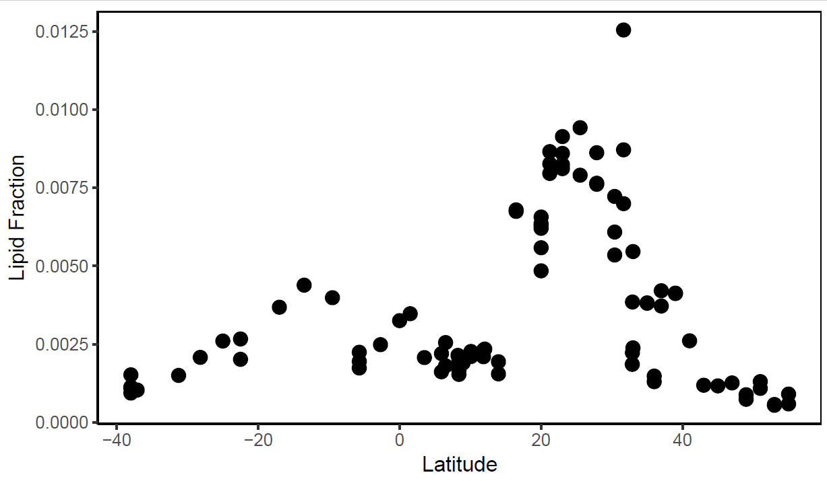
Supplemental Fig. 9. Relative abundance by latitude of N-based ornithine lipids in particulate organic matter in the mixed layer of the Atlantic Ocean.

Supplementary Table 2. Identification of haptophyte-specific sulfolipids, diacylglycerol carboxyhydroxysulfocholine (DGCS) and phosphatidyl-S,S-dimethylpropanethiol (PDPT) in the North Atlantic.
Compound Name | Elemental Formula | Theoretical Exact m/z | Measured m/z | Measured Deviation from Theoretical m/z (ppm) | Dominant Adduct | Fatty Acid Carbon Atoms | Fatty Acid Unsaturations
DGCS 36:2 | C46H84O8S1 | 797.5959675 | 797.59567 | 0.37136021 | [M+H]+ | 36 | 2
DGCS 36:10 | C46H68O8S1 | 781.4707668 | 781.46994 | 1.05410764 | [M+H]+ | 36 | 10
DGCS 38:9 | C48H74O8S1 | 811.5177171 | 811.51839 | -0.832793147 | [M+H]+ | 38 | 9
DGCS 38:10 | C48H72O8S1 | 809.502067 | 809.50131 | 0.938569312 | [M+H]+ | 38 | 10
DGCS 39:6 | C49H82O8S1 | 831.5803174 | 831.58028 | 0.046434391 | [M+H]+ | 39 | 6
DGCS 40:7 | C50H82O8S1 | 843.5803174 | 843.57915 | 1.378619425 | [M+H]+ | 40 | 7
DGCS 40:8 | C50H80O8S1 | 841.5646673 | 841.56502 | -0.42283084 | [M+H]+ | 40 | 8
DGCS 40:10 | C50H76O8S1 | 837.5333672 | 837.53347 | -0.126380249 | [M+H]+ | 40 | 10
DGCS 40:11 | C50H74O8S1 | 835.5177171 | 835.51765 | 0.074550781 | [M+H]+ | 40 | 11
DGCS 42:11 | C52H78O8S1 | 863.5490172 | 863.549 | 0.017246375 | [M+H]+ | 42 | 11
DGCS 44:12 | C54H80O8S1 | 889.5646673 | 889.56447 | 0.225838508 | [M+H]+ | 44 | 12
DGCS 36:6 | C46H76O8S1 | 789.5333672 | 789.5335 | -0.16517865 | [M+H]+ | 36 | 6
DGCS 38:6 | C48H80O8S1 | 817.5646673 | 817.56503 | -0.438776496 | [M+H]+ | 38 | 6
PDPT 32:5 | C40H69O8P1S1 | 741.4523534 | 741.45297 | -0.825253187 | [M+H]+ | 32 | 5
PDPT 33:5 | C41H71O8P1S1 | 755.4680035 | 755.46796 | 0.056668048 | [M+H]+ | 33 | 5
PDPT 34:5 | C42H73O8P1S1 | 769.4836535 | 769.48425 | -0.778550013 | [M+H]+ | 34 | 5
PDPT 34:8 | C42H67O8P1S1 | 763.4367033 | 763.43505 | 2.160624139 | [M+H]+ | 34 | 8
PDPT 36:10 | C44H67O8P1S1 | 787.4367033 | 787.43625 | 0.573534746 | [M+H]+ | 36 | 10
PDPT 36:6 | C44H75O8P1S1 | 795.4993036 | 795.49944 | -0.16941672 | [M+H]+ | 36 | 6
PDPT 36:7 | C44H73O8P1S1 | 793.4836535 | 793.48306 | 0.744423788 | [M+H]+ | 36 | 7
PDPT 38:10 | C46H71O8P1S1 | 815.4680035 | 815.46793 | 0.090514901 | [M+H]+ | 38 | 10
PDPT 38:5 | C46H81O8P1S1 | 825.5462539 | 825.54521 | 1.265413221 | [M+H]+ | 38 | 5
PDPT 38:6 | C46H79O8P1S1 | 823.5306038 | 823.53115 | -0.657816959 | [M+H]+ | 38 | 6
PDPT 38:7 | C46H77O8P1S1 | 821.5149537 | 821.51516 | -0.253169759 | [M+H]+ | 38 | 7
PDPT 40:10 | C48H75O8P1S1 | 843.4993036 | 843.50033 | -1.218649294 | [M+H]+ | 40 | 10
PDPT 40:11 | C48H73O8P1S1 | 841.4836535 | 841.48368 | -0.033818385 | [M+H]+ | 40 | 11
PDPT 40:6 | C48H83O8P1S1 | 851.5619039 | 851.5607 | 1.408875093 | [M+H]+ | 40 | 6
PDPT 42:11 | C50H77O8P1S1 | 869.5149537 | 869.51493 | 0.031508042 | [M+H]+ | 42 | 11
PDPT 44:12 | C52H79O8P1S1 | 895.5306038 | 895.53096 | -0.393587233 | [M+H]+ | 44 | 12

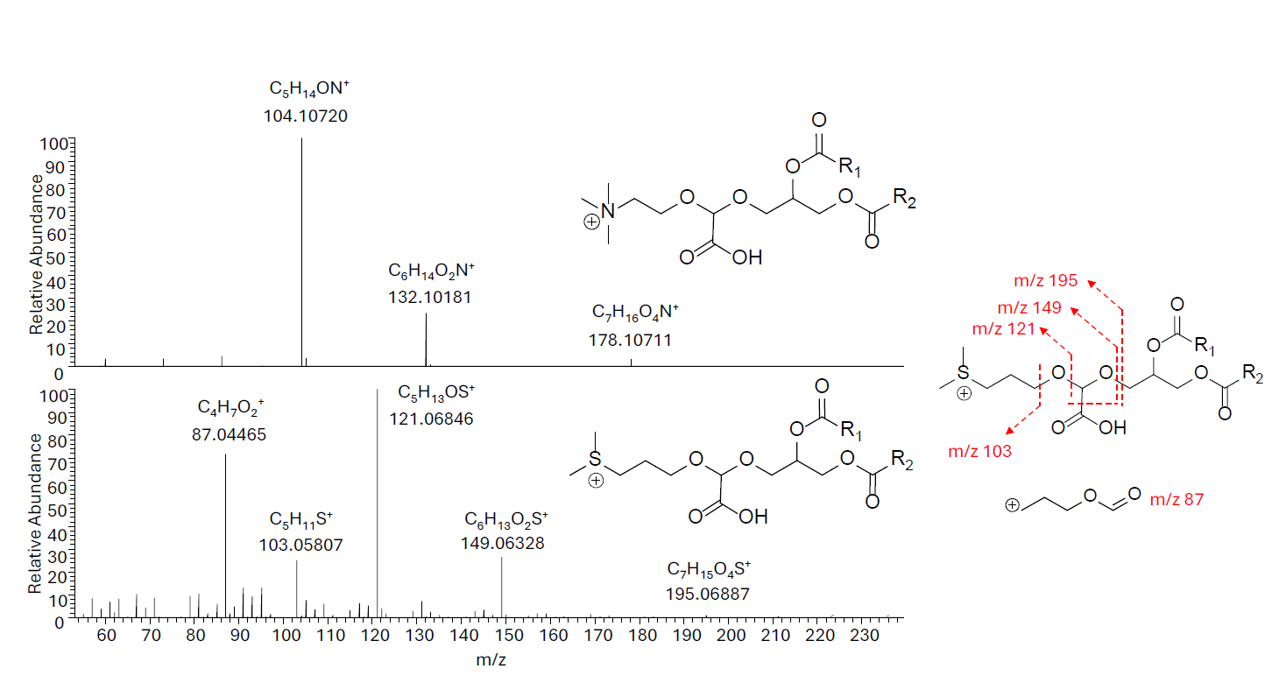
Supplementary Figure 10 – Mass spectral fragmentation patterns of betaine lipid diacyglyceryl carboxyhydroxymethylcholine (DGCC, top) and novel sulfolipid diacylglyceryl carboxyhydroxy sulfocholine (DGCS, bottom) in Gephyrocapsa huxleyi. MS/MS fragmentation patterns (right) showing five primary fragments with m/z 195.06856 (C₇H₁₅O₄S⁺, δ = 1.57 ppm), m/z 149.06308 (C₇H₁₅O₄S⁺, δ = 1.66 ppm), m/z 121.06816 (C₅H₁₃OS⁺, δ = 2.83 ppm), m/z 103.05760 (C₅H₁₁S⁺, δ = 4.93 ppm), and m/z 87.04406 (C₄H₇O₂⁺, δ = 7.05 ppm).

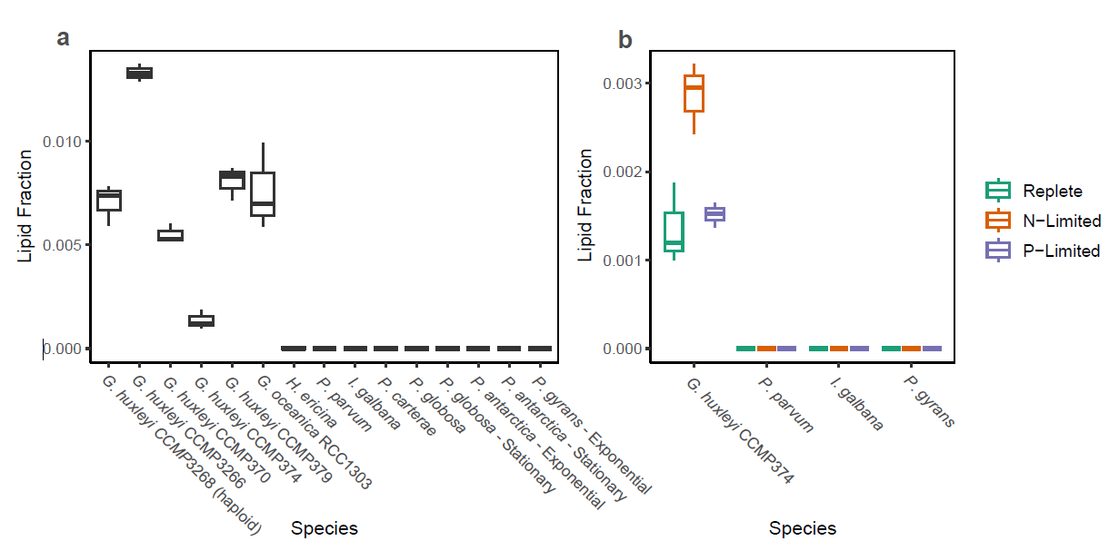
Supplementary Figure 11 – Expression of diacylglycerylcarboxyhydroxysulfocholine (DGCS) as a fraction of total polar lipids in nine species of haptophytes grown in replete nutrient conditions (left) and under nitrogen and phosphorus limited growth conditions in four species (right). DGCS lipid fraction was significantly greater under N-limited conditions (Welch’s t-test, p = 0.013), but not significantly different under P-limitation. DGCS has only been detected in Gephyrocapsa huxleyi and G. oceanica. Culture conditions and replicate information can be found in Lowenstein et al. (2022), except for G. oceanica strain RCC 1303, which was grown in f2-Si media on a 12:12 light dark cycle, at 18˚C, and 150 μmol photons cm⁻² s⁻¹, and analyzed in technical triplicate, with three samples of 5, 10, and 23 mL at ~5 × 10⁵ cells/mL. Samples were harvested at roughly mid-day in their light cycle, filtered onto GF/F filters, extracted within 30 seconds via a modified Bligh and Dyer extraction according to Popendorf et al. (2012), and thereafter followed identical sample and data processing protocols as the rest of the data in this manuscript.

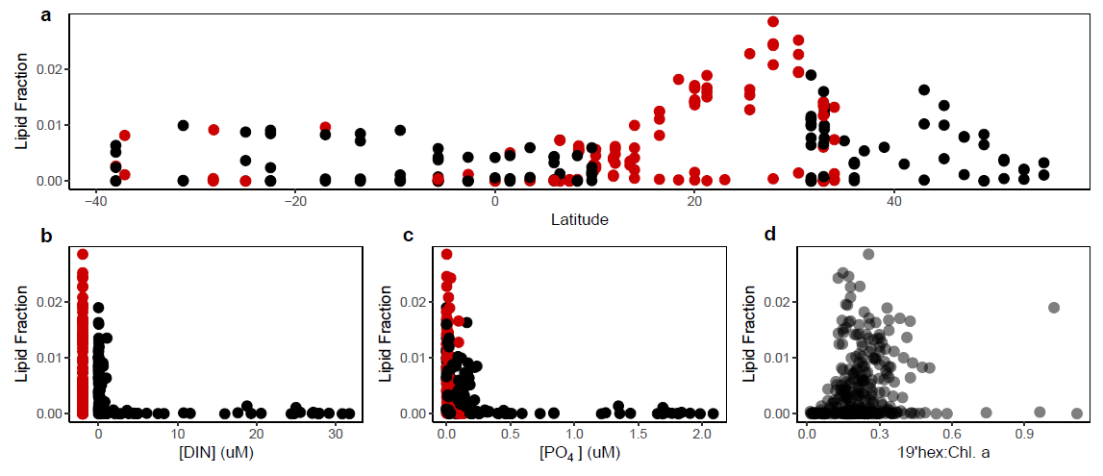
Supplementary Figure 12. Diacylglycerylcarboxyhydroxysulfocholine (DGCS) as a fraction of total particulate membrane lipids in the surface Atlantic Ocean (<~300m, top); lipid fraction vs. dissolved inorganic nitrogen concentration ([DIN] (μM) = [NO₃⁻] + [NO₂⁻], bottom left), Spearman’s rank order correlation ρ = -0.74, p < 2.2 × 10⁻¹⁶); DGCS lipid fraction vs dissolved phosphate ([PO₄]; bottom middle; Spearman’s ρ = -0.57, p < 2.2 × 10⁻¹⁶). Bottom right panel indicates DGCS fraction versus abundance of the haptophyte biomarker pigment, 19’hexanoyloxyfucoxanthin normalized to chlorophyll a abundance (i.e. an indicator of haptophyte relative abundance), indicating no significant relationship between DGCS fraction and haptophyte relative abundance. Red points indicate samples with no DIN data available, and were not included in the rank-order correlation test.

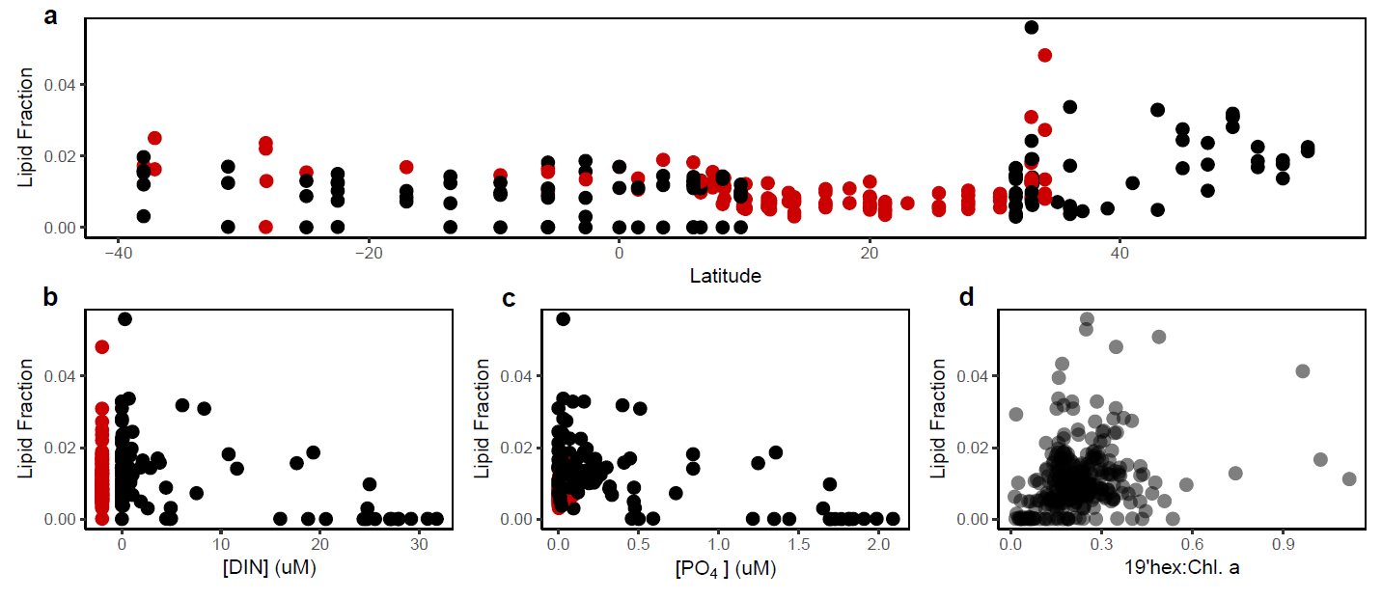
Supplementary Figure 13 – Haptophyte biomarker sulfur-based lipid, phosphatidyl-S,S-dimethylpropanethiol (PDPT), as a fraction of total polar lipids in the western North and South Atlantic Ocean (top); PDPT lipid fraction versus dissolved inorganic nitrogen concentration ([DIN] (μM) = [NO₃⁻] + [NO₂⁻]; bottom left; Spearman’s rank order correlation ρ = -0.29, p = 0.001); PDPT lipid fraction vs dissolved phosphate ([PO₄]; bottom middle; Spearman’s ρ = 0.11, p = 0.16); and PDPT lipid fraction versus the chlorophyll a-normalized relative abundance of the haptophyte biomarker pigment 19’hexanoyloxyfucoxanthin indicating no significant relationship between PDPT fraction and haptophyte relative abundance (bottom right). Red points indicate samples with no DIN data available, and were not included in the rank-order correlation test.

Supplementary Table 3. Mass spectral response factor correction slopes for quantification via mass spectral peak area with notes for lipid species which were commercially unavailable.
As mentioned in the methods section, to quantify lipid classes with no available commercial standard, after Heal et al. (2021), we used relative response factors from compounds with the most structurally similar headgroups.
However, for PDPT and DGCS, which have terminal dimethylsulfide moieties, we had no analogous standard. Therefore, we approximate a best match using phosphatidylethanolamine (PE), which has a phosphate group and a terminal amine in the headgroup, and phosphatidylcholine (PC), which has a phosphate group and a terminal choline, and ionizes roughly twice as efficiently as PE (Supplementary Table 3, below).
We expect the dimethylated sulfur and phosphate headgroup of PDPT to ionize roughly half as well as trimethylated nitrogen and phosphate in PC, as reduced sulfur typically ionizes less efficiently than reduced nitrogen in electrospray ionization due to its lower polarity. Therefore, we expect PDPT to ionize roughly equivalent to the terminal amine and phosphate in PE.
The other novel lipid class, DGCS, has an analogous structure to DGTS, with a carboxyl group in between the glycerolipid moiety and a methylated heteroatom terminus; however, the DGCS headgroup has a di-methylated sulfur moiety where DGTS has tri-methylated nitrogen, so DGTS should ionize roughly twice as well. Therefore, we used the standard coefficient for PC, which ionizes roughly half as efficiently as DGTS (Supplementary Table 3, below).
Using these standard coefficients, PDPT constituted on average 1% of total polar membrane lipids throughout the transect, with maximum of ~5.6%. If we quantitate using a more conservative coefficient from a more efficiently ionizing lipid like PC, PDPT comprises on average 0.5% of total lipids, with a maximum of 2.9%. If we quantify DGCS using the better-ionizing DGTS standard coefficient instead of PC, the average contribution of DGCS falls from 0.43% to 0.23%, and the maximum falls from 2.8 to 1.5% of total membrane lipids. However, this change does not affect the relationships with [PO₄] and DIN.
DGTS/DGTA - diacylglyceryl trimethyl homoserine, diacylglyceryl methyltrimethyl beta-alanine; SQDG – sulfoquinovosyldiacylglycerol; DGDG – digalactosyldiacylglycerol; PC – phosphatidylcholine; PE – phosphatidylethanolamine; DGCC – diacylglycerolcarboxyhydroxymethylcholine; MGDG – monogalactosyldiacylglycerol; DNPPE – dinitrophenol phosphatidylethanolamine (internal recovery standard); PG – phosphatidylglycerol; GADG – glucuronosyldiacylglycerol; PDPT – phosphatidyl-S,S-dimethylpropanethiol; DGCS – diacylglycerolcarboxyhydroxysulfocholine; BLL – betaine-like lipid; Ornithine – ornithine lipid; SAL – sulfur-based amino lipid; Glutamine – glutamine lipid; pigment – used for all pigment correction in Supplementary Figure 3.
(Heal, K. R. et al. Marine Community Metabolomes Carry Fingerprints of Phytoplankton Community Composition. mSystems 6, 10.1128/msystems.01334-20 (2021).)

Species | MS Response Factor | Notes
DGTS/DGTA | 1.86E+08 | Corrected using DGTS standard. DGTS and DGTA are indistinguishable isomers using this LC-MS method
SQDG | 25469262
DGDG | 15398891
PC | 99365882
PE | 50889145
DGCC | 1.86E+08 | Corrected using DGTS standard, also a betaine lipid
MGDG | 77973916
DNPPE | 42880083
PG | 47217489
GADG | 77973916 | Corrected using MGDG standard
PDPT | 50889145 | See Table caption
DGCS | 99365882 | See Table caption
BLL | 1.86E+08 | Corrected using DGTS standard
Ornithine | 1.86E+08 | Corrected using DGTS standard
SAL | 99365882 | Corrected using DGTS standard
Glutamine | 1.86E+08 | Corrected using DGTS standard
pigment | 45295792 | Corrected chloropigments using a chlorophyll a standard for approximate quantification
***

