Cultivation and characterization of halophilic archaea from Moroccan Atlantic salterns: insights into diversity and bioactive potential

Imane Charroud^{1,2}, Naima Boum’handi³, Mohamed Alouani², Altaf El Blidi⁴, Yannick Fleury⁵, Mohamed Jebbar^{1,*}
¹Univ Brest, CNRS, Ifremer, EMR 6002 BIOMEX, Unité Biologie et Écologie des Écosystèmes marins Profonds BEEP, F-29280 Plouzané, France
²Laboratory of Biotechnologies and Valorization of Natural Resources, Faculty of Sciences, Ibn Zohr University, B.P 8106, 80000 Agadir, Morocco
³Center Specialized in Valorization and Technology of Sea Products, National Fisheries Research Institute, F86P+FFW, Anza 8000, Morocco
⁴Laboratory of Sustainable Innovation and Applied Research, Polytechnic School of Agadir, Campus Universiapolis, Agadir 80000, Morocco
⁵Laboratory of Marine Biotechnology and Marine chemistry, UBS-UBO-CNRS EMR 6076, F-29334 Quimper, France
Corresponding Author: Mohamed.Jebbar@univ-brest.fr

Supplementary Information

Figure S1: Morphological diversity of halophilic archaeal colonies isolated on agar medium. Colonies display a range of pigmentation from pale pink to deep orange, characteristic of carotenoid-producing halophilic archaea. The image shows well-isolated colonies obtained after incubation under hypersaline conditions. 2

Table S1: Physicochemical parameters measured in the sediments of Oualidia (O) and Khenifiss (K) salterns. Temperature (°C), pH, salinity (‰), and dissolved oxygen (%) were recorded in situ for each sampling point (S1–S4) 2
Table S2: Representative Haloarchaeal strains isolated from Oualidia saltern sediments, selected from the initial collection based on differences in colony morphology, pigmentation, and growth responses under varying NaCl concentrations, temperatures, and pH. Growth tests were performed under standardized medium, temperature, and pH conditions. 3
Table S3: Representative Haloarchaeal strains isolated from Khenifiss saltern sediments, selected selected by colony morphology, pigmentation, and growth responses to NaCl, temperature under standarized medium. 4

Table S1: Physicochemical parameters measured in the sediments of Oualidia (O) and Khenifiss (K) salterns. Temperature (°C), pH, salinity (‰), and dissolved oxygen (%) were recorded in situ for each sampling point (S1–S4)
Sample | Temperature (°C) | pH | Salinity (‰)
O-S1 | 36.01 | 7.44 | 170
O-S2 | 36.03 | 7.47 | 167.04
O-S3 | 36.03 | 7.48 | 168
O-S4 | 36.07 | 7.50 | 171.2
K-S1 | 28.75 | 7.40 | 292
K-S2 | 28.32 | 7.44 | 289
K-S3 | 27.52 | 7.49 | 285
K-S4 | 28.28 | 7.45 | 289

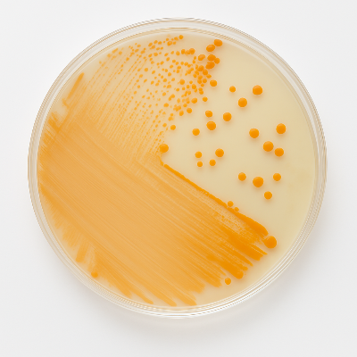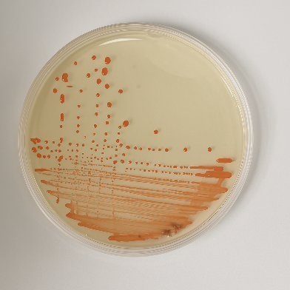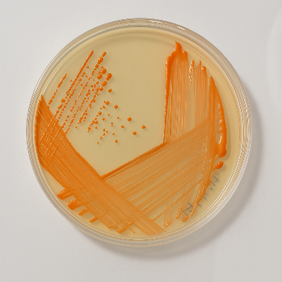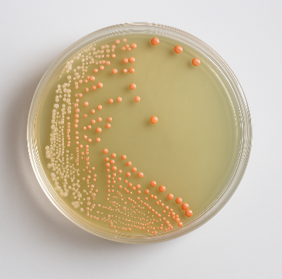
Figure S1: Morphological diversity of halophilic archaeal colonies isolated on agar medium. Colonies display a range of pigmentation from pale pink to deep orange, characteristic of carotenoid-producing halophilic archaea. The image shows well-isolated colonies obtained after incubation under hypersaline conditions.

Table S2: Representative Haloarchaeal strains isolated from Oualidia saltern sediments, selected from the initial collection based on differences in colony morphology, pigmentation, and growth responses under varying NaCl concentrations, temperatures, and pH. Growth tests were performed under standardized medium, temperature, and pH conditions.
Strain | Origin | Genbank Accession No. | Medium of isolation | Morphology on HM medium, 20%, 40°C, pH: 7.00 | NaCl (% w/v): range (optimum) | Temp. (°C) : range (optimum) | pH : range (optimum)
SDIO15 | O-S | PV248879 | HM | red, smooth, opaque | 10–30 (22) | 20–45 (40) | 6.0–8.5 (7.5)
SDI16 | O-S | PV248887 | DSMZ | pinkish red, smooth | 10–30 (20) | 25–55 (45) | 6.0–8.5 (7)
SDI39 | O-S | PV248881 | DSMZ | peach pink, smooth | 15–30 (25) | 25–ND (50) | 5.5–8.5 (8)
SDIO6 | O-S | PV248880 | HM | brigt orange, smooth, raised | 15–30 (20) | 30–55 (37) | 6.0–8.5 (7.5)
SDI23 | O-S | PV248885 | HM | deep red, smooth, small | 10–30 (20) | 20–55 (40) | 6.5–9.0 8
SDI22 | O-S | PV248886 | HM | pinkish red, smooth, large | 15–30 (22) | ND | ND
SDI19 | O-S | PV248882 | HM | deep red, small, smooth | 20–30 (22) | ND | 6.0–8.0 (7.0)
SDI24 | O-S | PV248884 | DSMZ | pinkish red, smooth | 10–30 (20) | 20-55 | ND
SDI14 | O-S | PV248883 | DSMZ | pinkish red, smooth | 10–30 (25) | 25–55 (50) | 6.0–8.0 (7)
SDI46 | O-S | PV248890 | DSMZ | coral red | 10–30 (15) | 35–50 (37) | 7.0–9.5 (7.5)
SDIP4 | O-S | PV248895 | HM | red, opaque, smooth | 15–30 (20) | 20–45 (37) | 7.0–
SDI38 | O-S | PV248892 | DSMZ | red, opaque | 10–30 (20) | 25–45 (40) | ND
SDI41 | O-S | PV248896 | DSMZ | red, translucent | 10–30 (15) | 25–50 (37) | ND
SDI03 | O-S | PV248893 | HM | red orange, opaque | 10–30 (15) | ND | ND
SDI36 | O-S | PV248894 | DSMZ | red, opaque | 15–30 (20) | ND | ND
SDI43 | O-S | PV248888 | DSMZ | red, opaque | 10–30 (20) | 20–45 (37) | ND
SDIE43 | O-S | PV248897 | HM | red, small, smooth | 10–30 (15) | ND | ND
SDI81 | O-S | PV248891 | HM | red, opaque, smooth | 15–30 (25) | 30–50 | 6.5–8.0 (7)
SDI47 | O-S | PV248889 | DSMZ | pinkish red, opaque | 10–25 (22) | ND | ND
SDIB3 | O-S | PV248898 | HM | red, small, flat, rough | 10–25 (23) | 35-45 | ND
SDI34 | O-S | PV248899 | HM | red, convex, smooth | 15–25 (20) | ND | 7.0–8.5 (7.5)
SDI01 | O-S | PV248900 | DSMZ | red, small, rough, irregular | 15–25 (20) | ND | ND
SDI18 | O-S | PV248901 | HM | bright orange, smooth | 15–25 (20) | ND | ND
SDII35 | O-S | PV248902 | HM | bright orange, smooth | 10–25 (15) | ND | ND
SDI44 | O-S | PV248907 | HM | red, mucoid | 10–30 (20) | 25–55 (40) | 5.5–8.0 (6.5)
SDI50 | O-S | PV248905 | HM | red orange, smooth, circular | 10–30 (25) | 25–55 (50) | 5.0–8.5 (7)
SDI05 | O-S | PV248903 | DSMZ | light pink, circular, rough | 10–25 (15) | 20–50 (37) | 5.5–8.0 (7)
SDIB5 | O-S | PV248904 | DSMZ | pink, convex | 7.5–25 (18) | 20-55 (37) | 5.0–8.5 (7)
SDI17 | O-S | PV248906 | HM | light orange, smooth, large | 10–25 (17) | 25-55 (45) | 6.0–8.5 (6.5)
SDI20 | O-S | PV248908 | HM | red, small, circular | 10–25 (20) | ND | 5.0–
SDI13 | O-S | PV248909 | HM | red orange, small, circular | 10–25 (20) | ND | ND
SDI94 | O-S | PV248916 | DSMZ | red, translucent | 15-30 (15) | ND | ND
SDI48 | O-S | PV248915 | HM | red orange, smooth, | 10–30 (25) | ND | ND
SDI30 | O-S | PV248913 | HM | red, smooth, opaque | 10–25 (25) | ND | ND
SDI30A | O-S | PV248914 | HM | red, smooth, opaque | 10–25 (25) | ND | ND
SDI02 | O-S | PV248912 | DSMZ | red, smooth, large | 15–30 (20) | ND | ND
SDI04 | O-S | PV248910 | DSMZ | dark red, rough | 15–30 (22) | ND | ND
SDIR04 | O-S | PV248917 | DSMZ | pink red, large | 10–30 (20) | ND | ND
SDI10 | O-S | PV248911 | DSMZ | red orange, large | 15–30 (20) | ND | ND
SDI31 | O-S | PV248918 | DSMZ | red | 15–25 (25) | 25–50 (37) | ND
SDI35 | O-S | PV248919 | DSMZ | light orange, large | 10–25 (20) | 20-55 (37) | 6.5-8.0 (7)
SDI45 | O-S | PV248920 | DSMZ | orange red | 15–25 (22) | 25-55 (45) | ND

Table S3: Representative Haloarchaeal strains isolated from Khenifiss saltern sediments, selected selected by colony morphology, pigmentation, and growth responses to NaCl, temperature under standarized medium.
Strain | Origin |  | Medium of isolation | Morphology on HM medium  (20%, 40°C, pH: 7.00) | NaCl (% w/v):  range (optimum) | Temp. (°C)
TSD140 | K-S | PX282994 | HM | red orange, convex, circular | 15-30% (21) | 20-50°C
TSDR102 | K-S | PX282998 | HM | pink red, convex, smooth | 10-30% (23) | 20-50°C
TSD100 | K-S | PX282993 | HM | light red, convex, smooth | 10-30% (20) | 20-55°C
TSD50 | K-S | PX282992 | HM | red orange, small, smooth | 10-25% (20) | 20-50°C
TSD02 | K-S | PX283008 | HM | bright red, medium,smooth, convex | 15-30% (25) | 25-55°C
TSDP2 | K-S | PX283009 | HM | bright red, small, smooth | 15-30% (25) | 25-55°C
TSD56 | K-S | PX283007 | HM | bright red, smooth, shiny | 15-30% (22) | 25-55°C
TSDP11 | K-S | PX283012 | HM | bright orange, smooth, opaque | 10-30% (20) | 25-55°C
TSD25 | K-S | PX283011 | HM | pink, very large | 10-25% (20) | 20-55°C
TSD102 | K-S | PX283030 | HM | orange red, smooth | 10-30% (20) | 25-55°C
TSD52 | K-S | PX283015 | HM | orange, convex | 10-30% (20) | 25-55°C
TSD22 | K-S | PX283031 | HM | orange, smooth, opaque | 10-30% (25) | 25-55°C
TSD19 | K-S | PX283014 | HM | red, smooth, opaque | 10-30% (22) | 25-55°C
TSDP1 | K-S | PX283003 | HM | bright red, punctiform, rough | 10-30% (25) | 25-50°C
TSD03 | K-S | PX283002 | HM | red, small, opaque | 10-30% (20) | 25-50°C
TSD53 | K-S | PX282997 | HM | orangre red, small, opaque | 10-30% (20) | 25-50°C
TSD09 | K-S | PX282996 | HM | red, medium, smooth | 10-30% (23) | 25-45°C
TSD07 | K-S | PX282995 | HM | red orange, smooth, opaque | 10-30% (20) | 25-45°C
TSD12 | K-S | PX282999 | HM | light red, large | 10-30% (25) | 25-55°C
TSD04 | K-S | PX283001 | HM | red, small, smooth | 10-30% (23) | 20-55°C
TSBK32 | K-S | PX283034 | HM | dark red, small, rough | 10-30% (20) | 20-55°C
TSD08 | K-S | PX283010 | HM | pink, transluent | 10-30% (20) | 25-55°C
TSD76 | K-S | PX283005 | HM | red pink, small, smooth | 10-30% (22) | 25-55°C
TSDOR2 | K-S | PX283006 | HM | red, small, rough | 10-30% (20) | 20-55°C
TSD31 | K-S | PX283004 | HM | red pink, large, smooth | 10-30% (20) | 20-45°C

