Graph 1: Discrimination Ability: Area Under the ROC Curve (AUC) | Graph 2: Residual Analysis & Sensitivity Checks
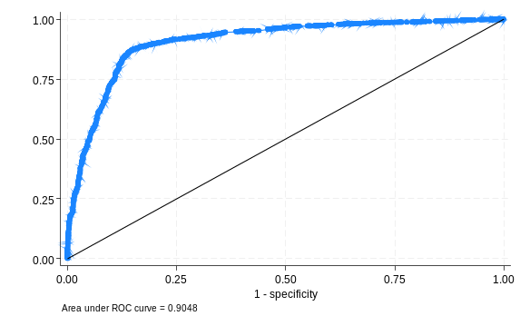 | 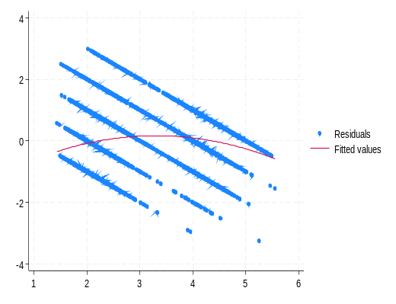

Graph 3: Average Odds of Individual Wealth Level in Twelve Sub-Saharan African Countries
