Supplementary information for
Ferritin light-chain contributes to hair cells function and survival by Petit et al.

This PDF file includes:
Supplementary Information SI1: Auditory phenotype in male and female Ftl1^{-/-} mice.
Supplementary Information SI2: Auditory phenotype Ftl1^{-/-} LT mice over 5 months of age.
Supplementary Information SI3: Recessive allele does not contribute to hearing loss.

Supplementary Information 1

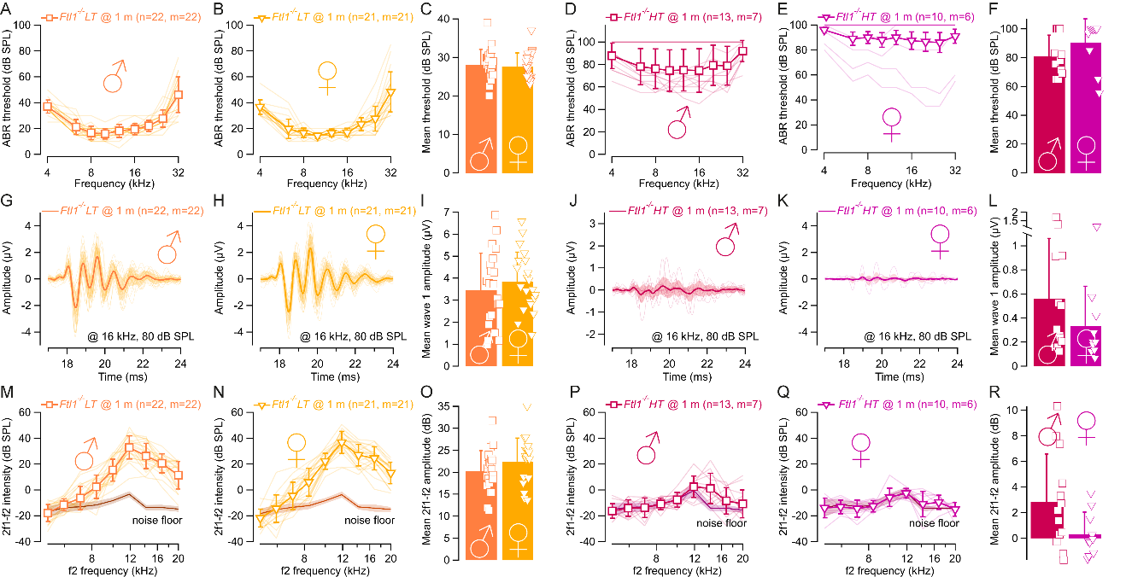
Supplementary Figure 1: Auditory phenotype in Ftl1^{-/-} mice does not show any preferential sex dependence. (A-B, D-E) audiograms, (G-H, J-K) ABR and (M-N, P-Q) distortion products of otoacoustic emissions in male Ftl1^{-/-} LT mice (A, G and M), female Ftl1^{-/-} LT mice (B, H and N), male Ftl1^{-/-} HT mice (D, J and P) and female Ftl1^{-/-} HT mice (E, K and Q) at 1 month of age. Thick lines indicate the mean ± SD. Mean threshold (C, F), ABR wave I amplitude (I, L) and mean DPOAEs (O, R) in male and female Ftl1^{-/-} LT mice (C, I and O) and Ftl1^{-/-} HT mice (F, L and R). n and m indicate the number of cochleas and mice, respectively.

Supplementary Information 2

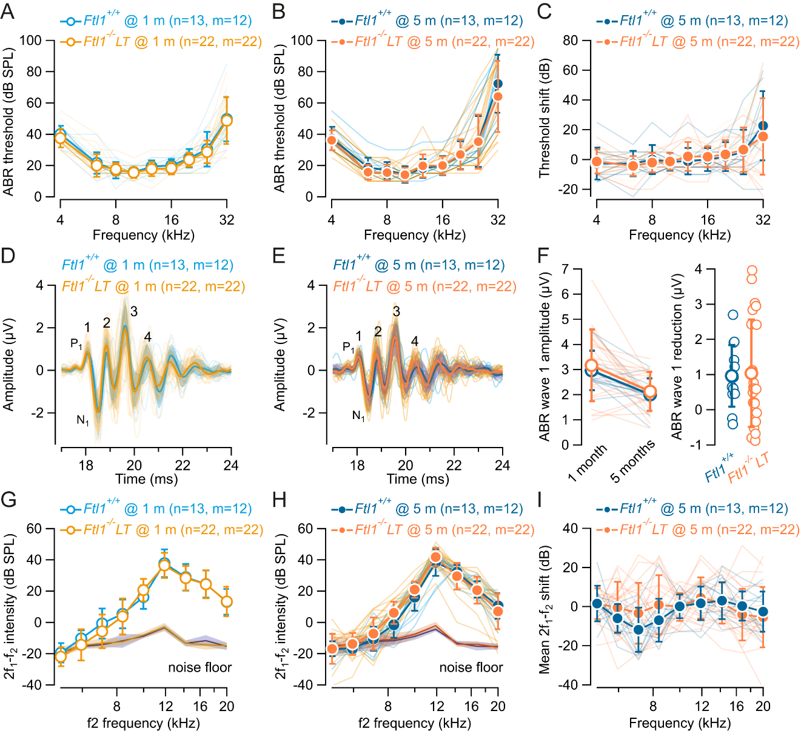

Supplementary Figure 2: Ftl1^{-/-} LT mice do not show hearing loss over 5 months of age. (A-B) audiograms, (D-E) ABR and (G-H) distortion products of otoacoustic emissions in wild-type Ftl1^{+/+} mice (blue) and knock-out mice Ftl1^{-/-} LT mice (green) at 1 month (A, D and G) and 5 months (B, E and H) of age. Thick lines indicate the mean ± SEM. (C, F and I) Threshold shift (C), ABR amplitude reduction (F) and DPOAEs reduction (I) over 5 months of age in wild-type Ftl1^{+/+} mice (blue) and knock-out mice Ftl1^{-/-} LT mice (green). n and m indicate the number of cochleas and mice, respectively.

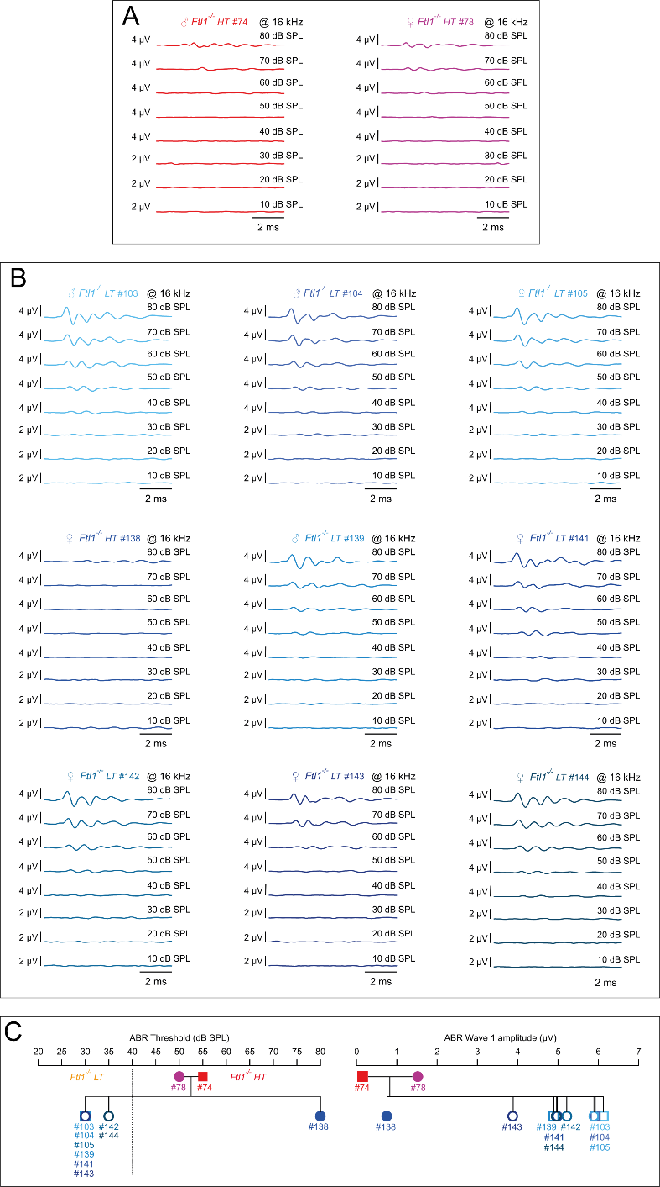
Supplementary Information 3

Supplementary Figure 3: An additional recessive allele is unlikely to contribute to hearing loss in Ftl1 deficient mice. (A) Mean ABR of one-month-old male (red) and female (purple) Ftl1^{-/-} HT mice breeders evoked by 16 kHz tone burst from 10 to 80 dB SPL. (B) Mean ABR of the offspring evoked by 16 kHz tone burst from 10 to 80 dB SPL. (C) ABR threshold and wave 1 amplitude of Ftl1^{-/-} HT breeders and their offspring probed at one month of age.

