Supplementary material

Use of Aureobasidium pullulans xylanase for simultaneous saccharification and fermentation in second-generation bioethanol production

Carla A. Lara^{1, 2,3,4}, Evelyn S. Oliveira², Susana Marques¹, Francisco Gírio¹, Giordana D. Arend⁵, César Fonseca¹, Carlos A. Rosa³

¹ Laboratório Nacional de Energia e Geologia, I.P., Unidade de Bioenergia, Estrada do Paço do Lumiar 22, 1649-038, Lisboa, Portugal
²Departamento de Alimentos, Faculdade de Farmácia, Universidade Federal de Minas Gerais, Belo Horizonte, Minas Gerais, 31270-901 Brazil
³Departamento de Microbiologia, ICB, C.P. 486, Universidade Federal de Minas Gerais, Belo Horizonte, Minas Gerais, 31270-901, Brazil
⁴UNIFAVENI Centro Universitário FAVENI, Rua do Rosário, 313 - Vila Camargos - Guarulhos – São Paulo - CEP 07111-080, Brazil
⁵Departamento de Engenharia Química e Engenharia de Alimentos, Universidade Federal de Santa Catarina, Florianópolis, 88040-970, Brazil

*Corresponding authors:
E-mail: Carlos A. Rosa: carlrosa@icb.ufmg.br; César Fonseca: cesfo@novonesis.com

Fig S1a
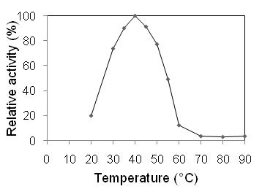
Fig S1b
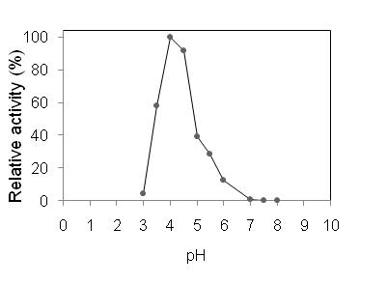
Figure S1. Xylanase activity profile at different temperatures (A) and pH (B) of the A. pullulans UFMG-CM-Y518 extracellular extractafter 48 h induction in xylan containing medium. The determination of the temperature was carried out at pH 5.5, and pH determination was done at 40 °C.

Fig S2
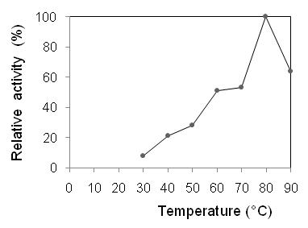
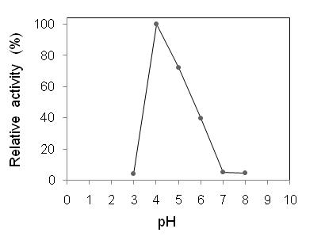
Figure S2.Beta-xylosidase activity profile of extracellular extract of A. pullulansUFMG-CM-Y518at different temperatures (A) and pH (B) after 48 h induction in xylan containing medium. The temperature assay was performed at pH 5.5, and the pH assaywas done at 70 °C.

Fig. S3
S3a
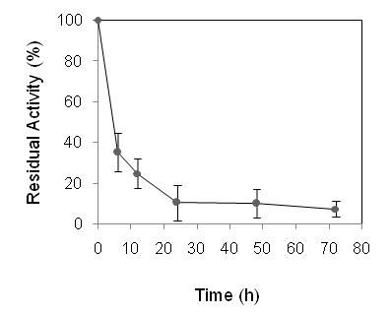
S3b
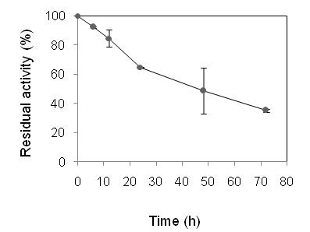
Figure S3. Stability of xylanase activity in extracellular extracts of Aureobasidium pullulansUFMG-CM-Y518, incubated for 72 h at 45 °C, pH 4.8 using acetate buffer in the absence (A) or presence of xylan as the substrate (B).

Fig. S4

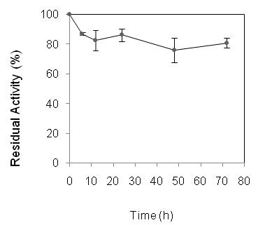
Figure S4.Stability of β-xylosidase activity in extracellular extracts of Aureobasidium pullulansUFMG-CM-Y518, incubated for 72 h at 45 °C, pH 4.8 using acetate buffer.

Fig. S5

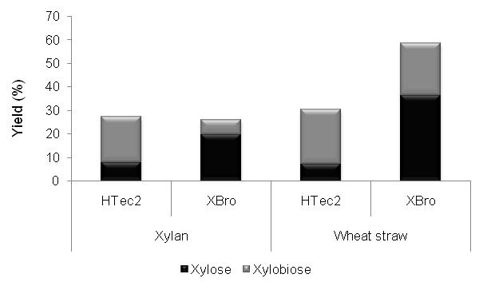
Figure S5. Yield of xylose and xylobiose from Cellic HTec2 and Aureobasidium pullulansUFMG-CM-Y518 (XBro) extract at 200 U g⁻¹ (xylan) in the enzymatic hydrolysis of the xylan fraction at 50 °C, pH 5.5 using commercial xylan [2% (w/v)] and pretreated wheat straw [10% (w/v) total solids].

Fig S6A

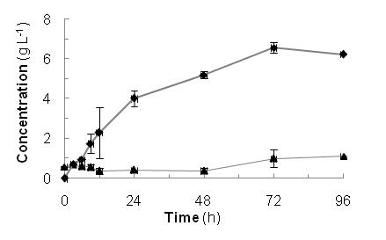
Fig S6B

Figure S6. Ethanol production by Spathaspora passalidarumUFMG-CM-Y469at 35 °C and 150 rpm under anaerobic conditions. (A) SSF process from beechwood xylan (30 g L⁻¹) using the extracellular extract of A. pullulansUFMG-CM-Y518(XBro). (B) Commercial D-xylose fermentation (30 g L⁻¹) supplemented with extracellular extract from Aureobasidium pullulansUFMG-CM-Y518(XBro) [concentrations of D-xylose (-▲-) and ethanol (--)].

Fig. S7
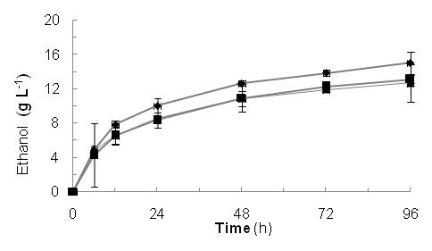
Figure S7. Ethanol production by SSF with S.cerevisiae Ethanol Red at 35 °C and 150 rpm under anaerobic conditions from wheat straw cellulose fraction by application of cellulase Cellic CTec2 [(-▲-) without supplementation; (--) supplemented with Cellic HTec2; (-■-) supplemented with A. pullulansUFMG-CM-Y518 extract].

