Figure 9C
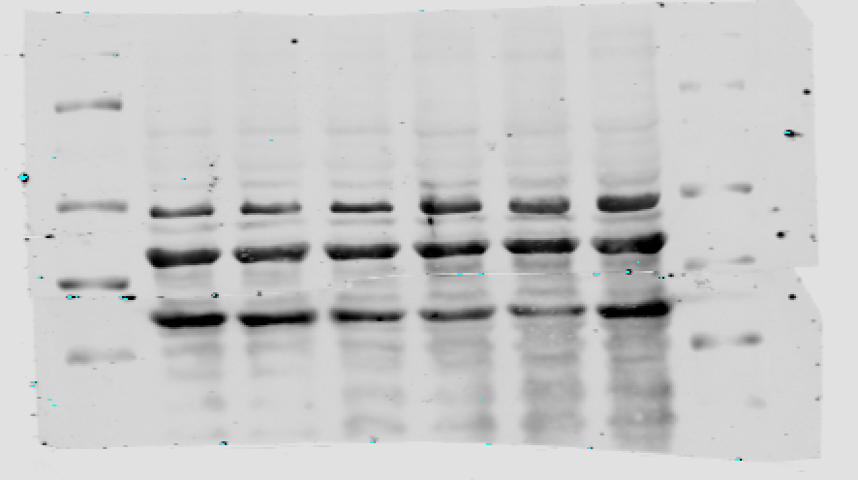
Figure 10B
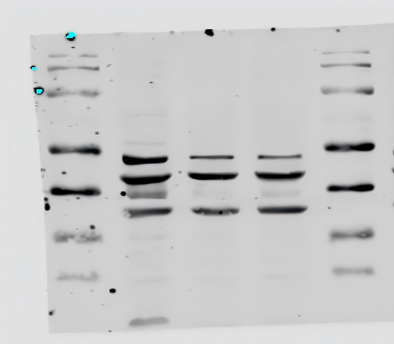
Figure 10D
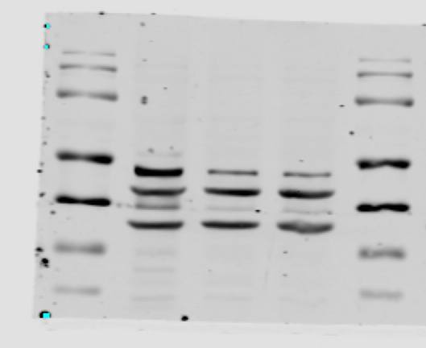
35KD
40KD
55KD
55KD
35KD
40KD
35KD
40KD
55KD

