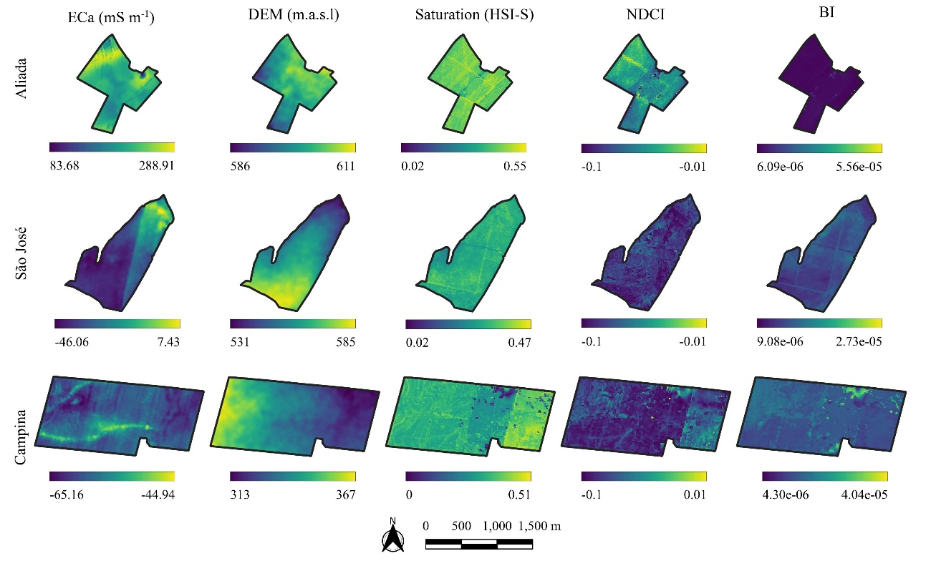
FigS1. Spatial distribution of the covariates used in study areas
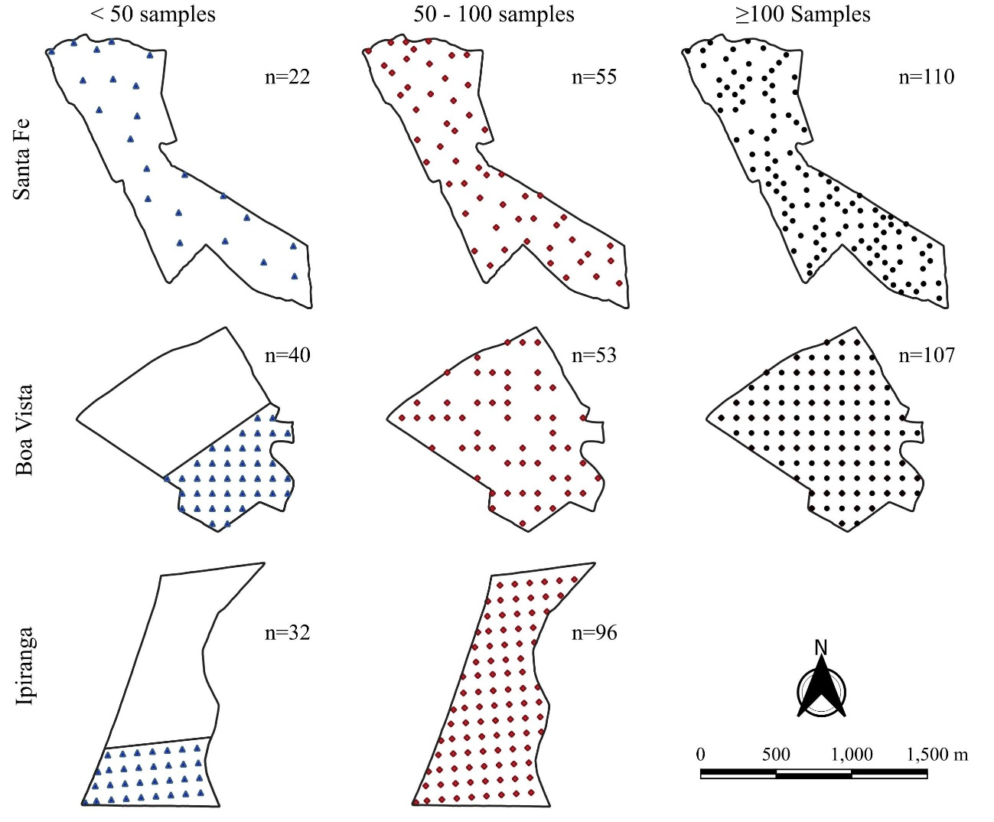
FigS2. Spatial distribution of samples in the validation areas for <50, 50–100, and ≥100 sample scenarios.

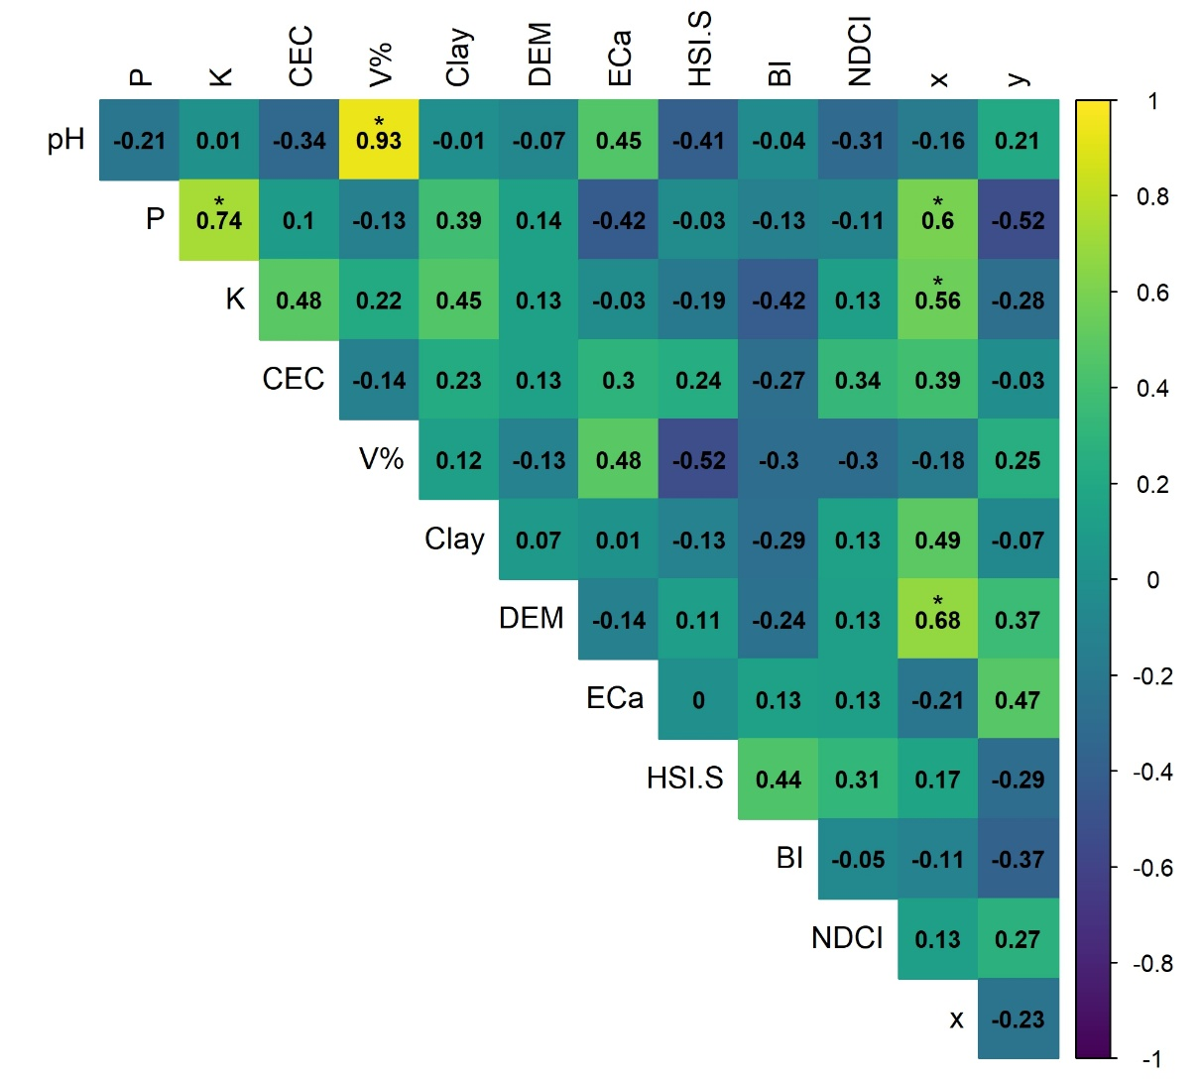
FigS3. Correlation matrix for Aliada farm in 0.2 samples ha⁻¹. P: phosphorus, K: potassium, CEC: cation exchange capacity, V%: base saturation, Clay: clay content, DEM: digital elevation model, ECa: apparent electrical conductivity, HSI.S: saturation component of the RGB to HSI transform, NDCI: normalized difference clay index, SBI: soil brightness index, x,y: spatial coordinates.
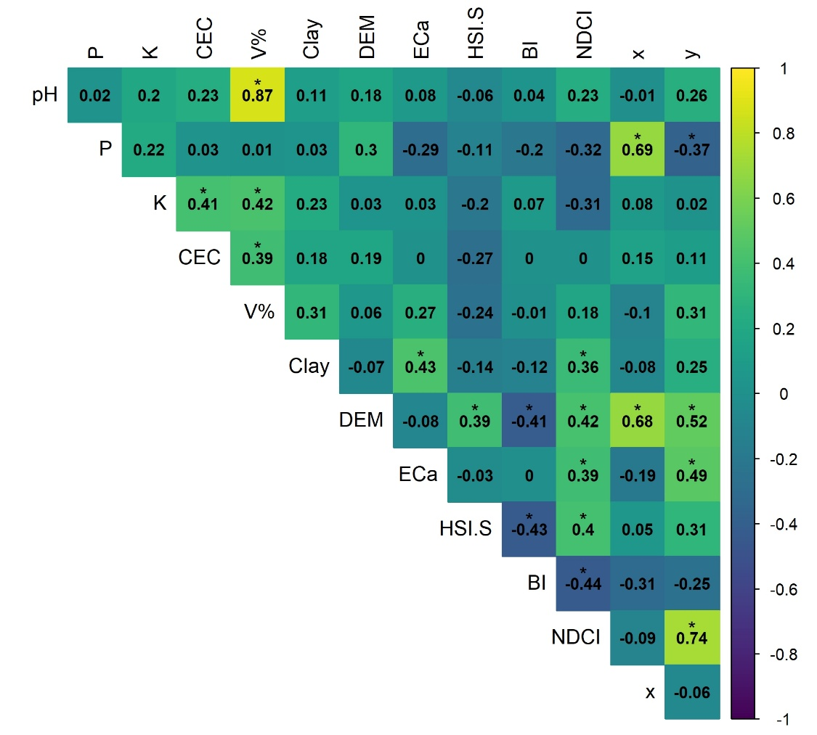
FigS4. Correlation matrix for Aliada farm in 0.5 samples ha⁻¹. P: phosphorus, K: potassium, CEC: cation exchange capacity, V%: base saturation, Clay: clay content, DEM: digital elevation model, ECa: apparent electrical conductivity, HSI.S: saturation component of the RGB to HSI transform, NDCI: normalized difference clay index, SBI: soil brightness index, x,y: spatial coordinates.
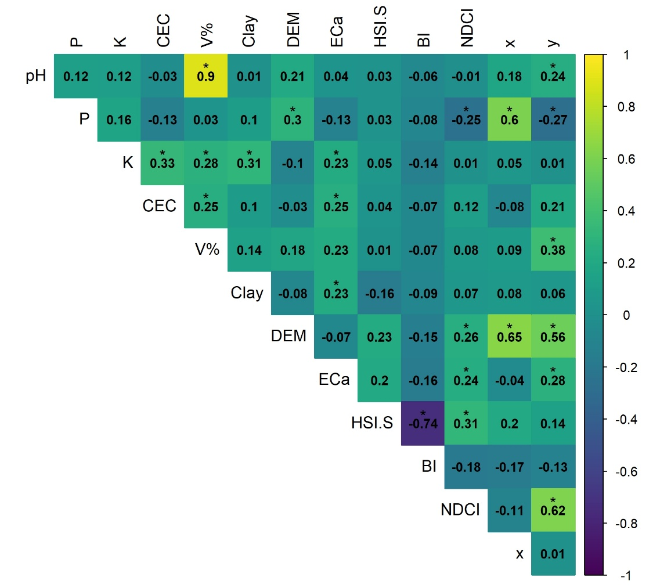
FigS5. Correlation matrix for Aliada farm in 1 sample ha⁻¹. P: phosphorus, K: potassium, CEC: cation exchange capacity, V%: base saturation, Clay: clay content, DEM: digital elevation model, ECa: apparent electrical conductivity, HSI.S: saturation component of the RGB to HSI transform, NDCI: normalized difference clay index, SBI: soil brightness index, x,y: spatial coordinates.
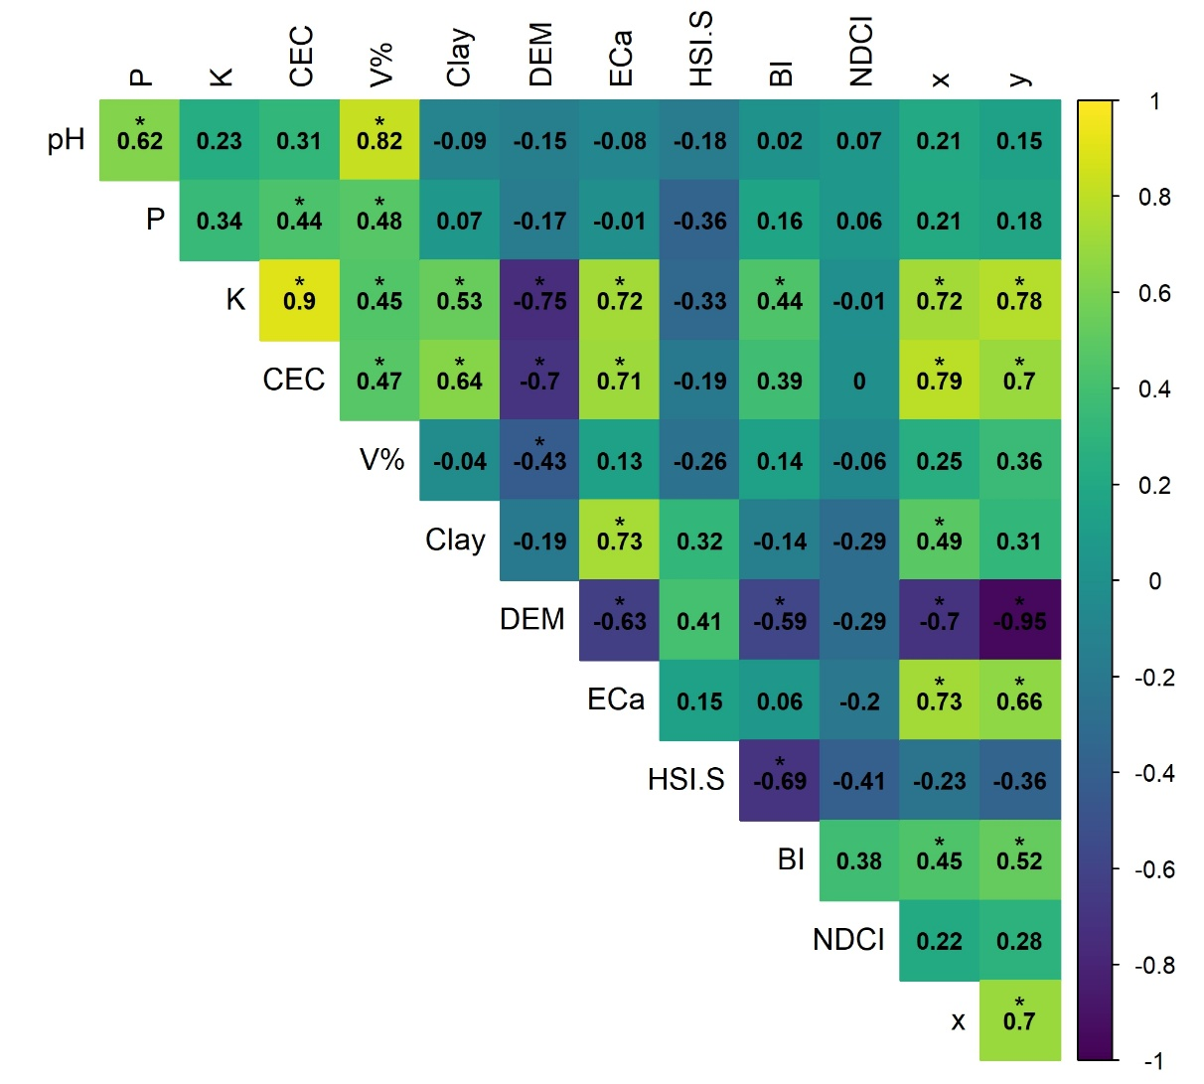
FigS6. Correlation matrix for São José farm in 0.2 samples ha⁻¹. P: phosphorus, K: potassium, CEC: cation exchange capacity, V%: base saturation, Clay: clay content, DEM: digital elevation model, ECa: apparent electrical conductivity, HSI.S: saturation component of the RGB to HSI transform, NDCI: normalized difference clay index, SBI: soil brightness index, x,y: spatial coordinates.
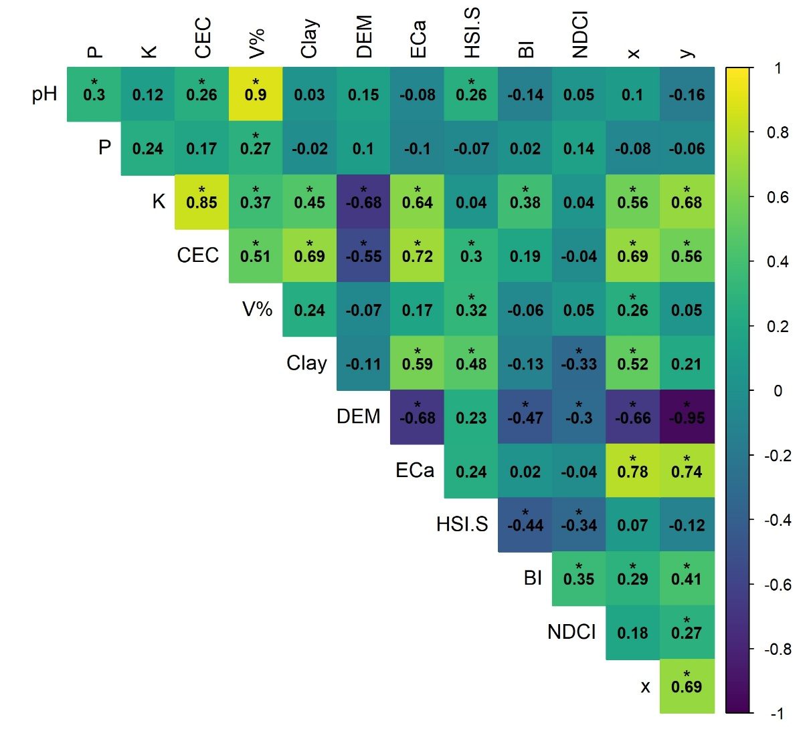
FigS7. Correlation matrix for São José farm in 0.5 samples ha⁻¹. P: phosphorus, K: potassium, CEC: cation exchange capacity, V%: base saturation, Clay: clay content, DEM: digital elevation model, ECa: apparent electrical conductivity, HSI.S: saturation component of the RGB to HSI transform, NDCI: normalized difference clay index, SBI: soil brightness index, x,y: spatial coordinates.
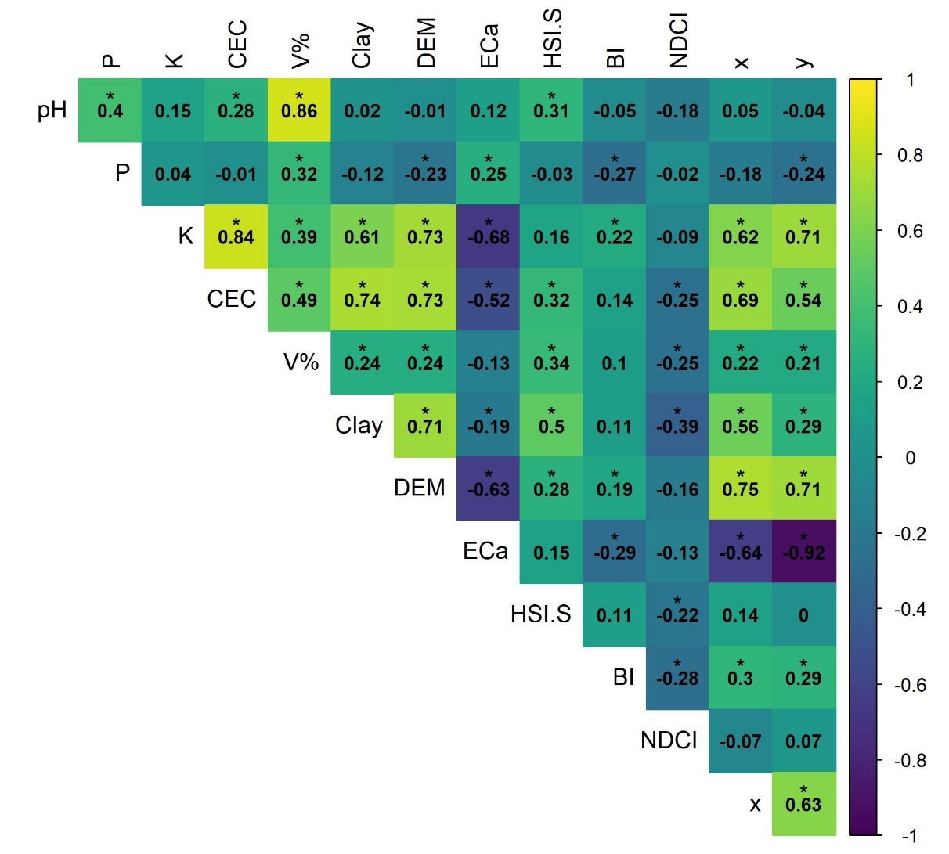
FigS8. Correlation matrix for São José farm in 1 sample ha⁻¹. P: phosphorus, K: potassium, CEC: cation exchange capacity, V%: base saturation, Clay: clay content, DEM: digital elevation model, ECa: apparent electrical conductivity, HSI.S: saturation component of the RGB to HSI transform, NDCI: normalized difference clay index, SBI: soil brightness index, x,y: spatial coordinates.
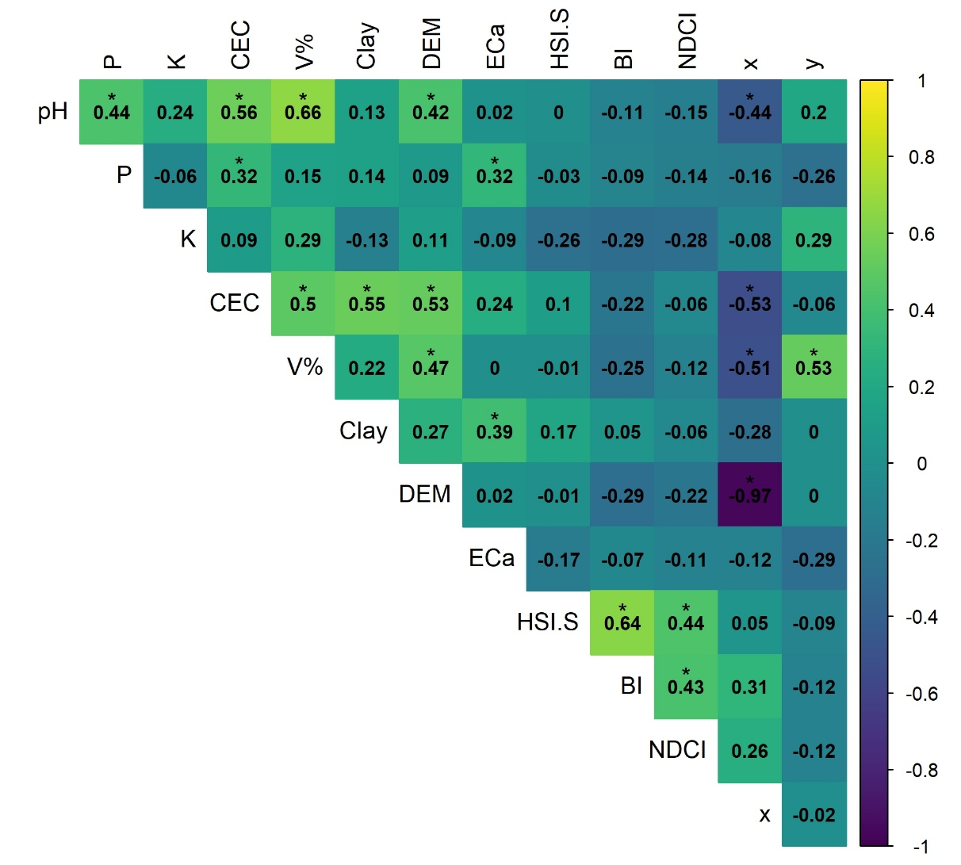
FigS9. Correlation matrix for Campina farm in 0.2 samples ha⁻¹. P: phosphorus, K: potassium, CEC: cation exchange capacity, V%: base saturation, Clay: clay content, DEM: digital elevation model, ECa: apparent electrical conductivity, HSI.S: saturation component of the RGB to HSI transform, NDCI: normalized difference clay index, SBI: soil brightness index, x,y: spatial coordinates.
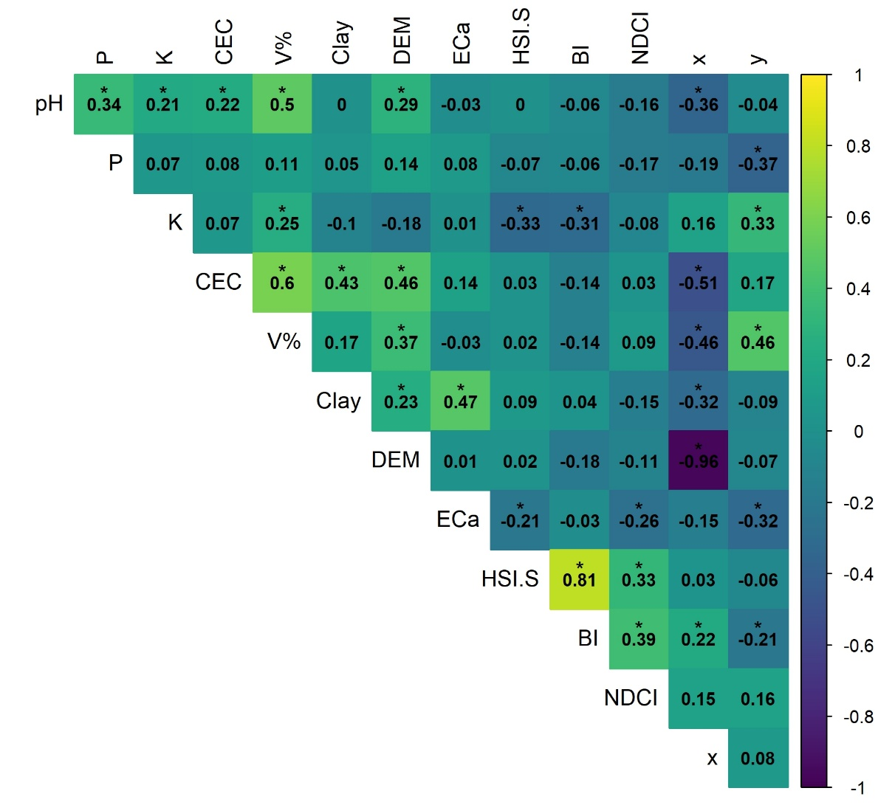
Fig10. Correlation matrix for Campina farm in 0.5 samples ha⁻¹. P: phosphorus, K: potassium, CEC: cation exchange capacity, V%: base saturation, Clay: clay content, DEM: digital elevation model, ECa: apparent electrical conductivity, HSI.S: saturation component of the RGB to HSI transform, NDCI: normalized difference clay index, SBI: soil brightness index, x,y: spatial coordinates.
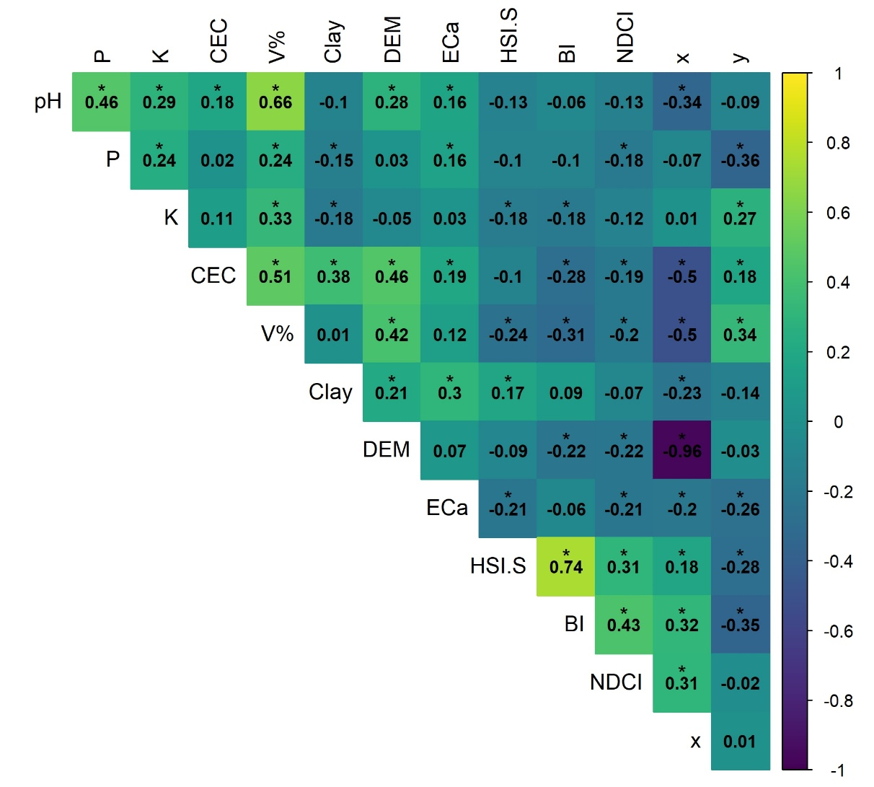
FigS11. Correlation matrix for Campina farm in 1 sample ha⁻¹. P: phosphorus, K: potassium, CEC: cation exchange capacity, V%: base saturation, Clay: clay content, DEM: digital elevation model, ECa: apparent electrical conductivity, HSI.S: saturation component of the RGB to HSI transform, NDCI: normalized difference clay index, SBI: soil brightness index, x,y: spatial coordinates.

Table S1. Comparison of interpolation methods: percentage difference in LCCC from the best method in scenarios of <50 samples. Bold values indicate methods within the 5% threshold.
Scenario | Spatial structure | Best performing method | LCCC difference relative to best method (%)
Scenario | Spatial structure | Best performing method | IDW | TPS | OK | RK | RFE | SVM
<50 | R_VL | TPS | 76.84 | 0.00 | - | 43.95 | 62.37 | 100.00
<50 | R_L | TPS | 25.46 | 0.00 | - | 53.64 | 59.90 | 55.69
<50 | R_M | TPS | 70.29 | 0.00 | - | 27.87 | 33.86 | 67.94
<50 | R_H | - | - | - | - | - | - | -
<50 | R_VH | IDW | 0.00 | 1.04 | - | 7.45 | 21.15 | 58.26
<50 | C_VL | - | - | - | - | - | - | -
<50 | C_L | - | - | - | - | - | - | -
<50 | C_M | - | - | - | - | - | - | -
<50 | C_H | TPS | 16.41 | 0.00 | - | 10.59 | 16.86 | 38.66
<50 | C_VH | TPS | 1.18 | 0.00 | - | 3.46 | 8.29 | 10.06

Table S2. Comparison of interpolation methods: percentage difference in LCCC from the best method in scenarios of 50 to 100 samples. Bold values indicate methods within the 5% threshold.
Scenario | Spatial structure | Best performing method | LCCC difference relative to best method (%)
Scenario | Spatial structure | Best performing method | IDW | TPS | OK | RK | RFE | SVM
50 - 100 | R_VL | - | - | - | - | - | - | -
50 - 100 | R_L | TPS | 51.59 | 0.00 | 43.94 | 36.09 | 40.32 | 55.79
50 - 100 | R_M | TPS | 9.88 | 0.00 | 26.84 | 37.94 | 41.37 | 58.97
50 - 100 | R_H | - | - | - | - | - | - | -
50 - 100 | R_VH | SVM | 32.18 | 26.45 | 24.16 | 26.44 | 33.09 | 0.00
50 - 100 | C_VL | - | - | - | - | - | - | -
50 - 100 | C_L | - | - | - | - | - | - | -
50 - 100 | C_M | - | - | - | - | - | - | -
50 - 100 | C_H | TPS | 0.78 | 0.00 | 0.75 | 8.55 | 18.17 | 29.12
50 - 100 | C_VH | OK | 6.91 | 5.25 | 0.00 | 0.93 | 1.78 | 2.68

Table S3. Comparison of interpolation methods: percentage difference in LCCC from the best method in scenarios of ≥ 100 samples. Bold values indicate methods within the 5% threshold.
Scenario | Spatial structure | Best performing method | LCCC difference relative to best method (%)
Scenario | Spatial structure | Best performing method | IDW | TPS | OK | RK | RFE | SVM
≥ 100 | C_VL | - | - | - | - | - | - | -
≥ 100 | C_L | TPS | 10.05 | 0.00 | 17.83 | 8.97 | 11.84 | 35.46
≥ 100 | C_M | TPS | 8.13 | 0.00 | 21.22 | 12.09 | 12.82 | 0.82
≥ 100 | C_H | IDW | 0.00 | 3.32 | 1.15 | 0.76 | 0.93 | 8.85
≥ 100 | C_VH | RK | 11.87 | 8.04 | 5.00 | 0.00 | 0.01 | 2.78

