Supplementary results
By re-scoring 123 species we found correspondence for 94 species (77%) (Supplementary Figure 15), with most mismatches being attributed to clear misidentifications by Durrer (e.g. Buphagus, which was not iridescent in five specimens, from three different collections), the use of different sexes (e.g., Rollulus roulroul), different subspecies/morphs (e.g. Philomachus pugnax). Most mis-identifications occurred in the class weak, with exclusion of these resulting in a correspondence of 86%.
For a subset of 105 species, we used reflectance spectrophotometry, color metrics and phylogenetic ANOVA’s (see Supplementary data 5, Supplementary Figure 10) to validate the existence of different iridescent categories. We made use of violin plots to compare color parameters between different iridescent color categories: Mean brightness (B2), Intensity (B3), Chroma (S3), Contrast (S6), Carotenoid chroma (S9) and Peaky chroma (S10) were compared between weak, moderate, strong and brilliant iridescence.
Intensity showed the smallest differences, which aligns with expectations since various color mechanisms (including carotenoids) can affect brightness, and iridescent colors are generally bright when viewed from the right angle. This lack of significant difference was particularly noticeable between closely related categories (e.g., weak vs. moderate, strong vs. brilliant). Nonetheless, Intensity alone still revealed significant differences among all other category combinations.
The strongest signals were observed in chroma and contrast, which makes sense given that iridescence produces a distinct peak-shaped reflectance curve, unlike other color mechanisms. There were no differences in carotenoid chroma, an anticipated result as this was used as a control, significant differences were observed in all other variables tested except for Mean brightness. These results confirm that there are measurable colorimetric differences between the categories, supporting the validity of using these classifications. The groups observed by eye, results from variations in the peak shape of reflectance curves.

Supplementary Figures

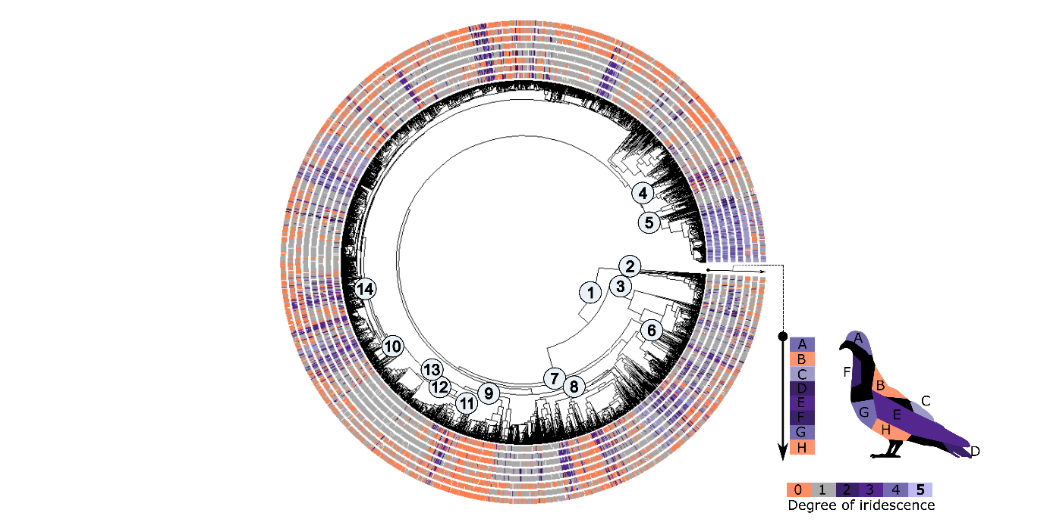
Supplementary figure 1. The phylogeny is surrounded by eight circles, each representing the presence or absence of different degrees of iridescence across male body patches (n=4230) (male strict dataset). The degrees of iridescence—weak, moderate, strong, and brilliant—are depicted in varying shades of purple, while grey and orange represent melanin-based and non-melanized colors, respectively. Node labels on the phylogeny correspond to 14 bird clades, for which ancestral states are available in Fig 3; 1) MRCA of birds, 2) Paleognathae, 3) Galloanseres, 4) Mirandornithes, 5) Strisores, 6) Aequornithes, 7) Neoaves, 8) Afroaves, 9) Australaves, 10) Passeriformes, 11) Eurylaimides, 12) Tyrannides, 13) Passeri, 14) Passerides.

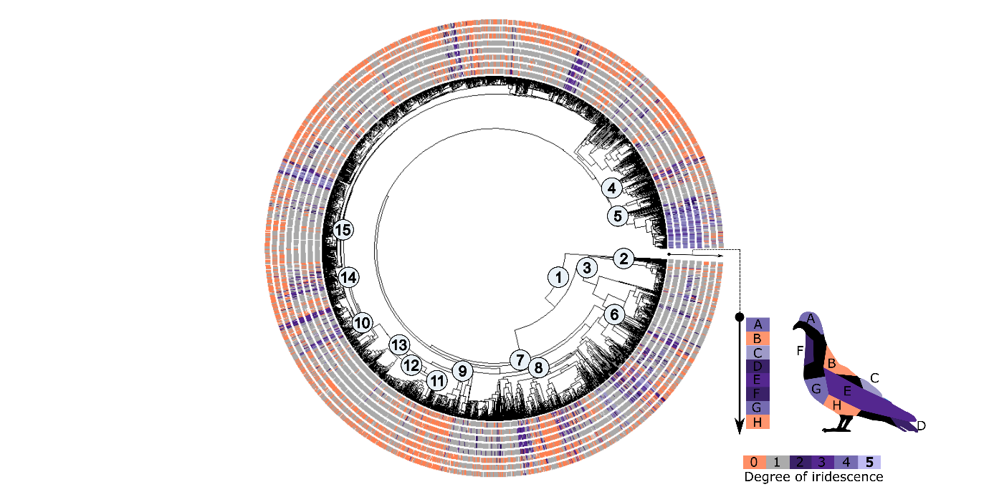
Supplementary figure 2. The phylogeny is surrounded by eight circles, each representing the presence or absence of different degrees of iridescence across female body patches (n=2903) (female strict dataset). The degrees of iridescence—weak, moderate, strong, and brilliant—are depicted in varying shades of purple, while grey and orange represent melanin-based and non-melanized colors, respectively. Node labels on the phylogeny correspond to 14 bird clades, for which ancestral states are available in Fig 3; 1) MRCA of birds, 2) Paleognathae, 3) Galloanseres, 4) Mirandornithes, 5) Strisores, 6) Aequornithes, 7) Neoaves, 8) Afroaves, 9) Australaves, 10) Passeriformes, 11) Eurylaimides, 12) Tyrannides, 13) Passeri, 14) Passerides, 15) Passerides.
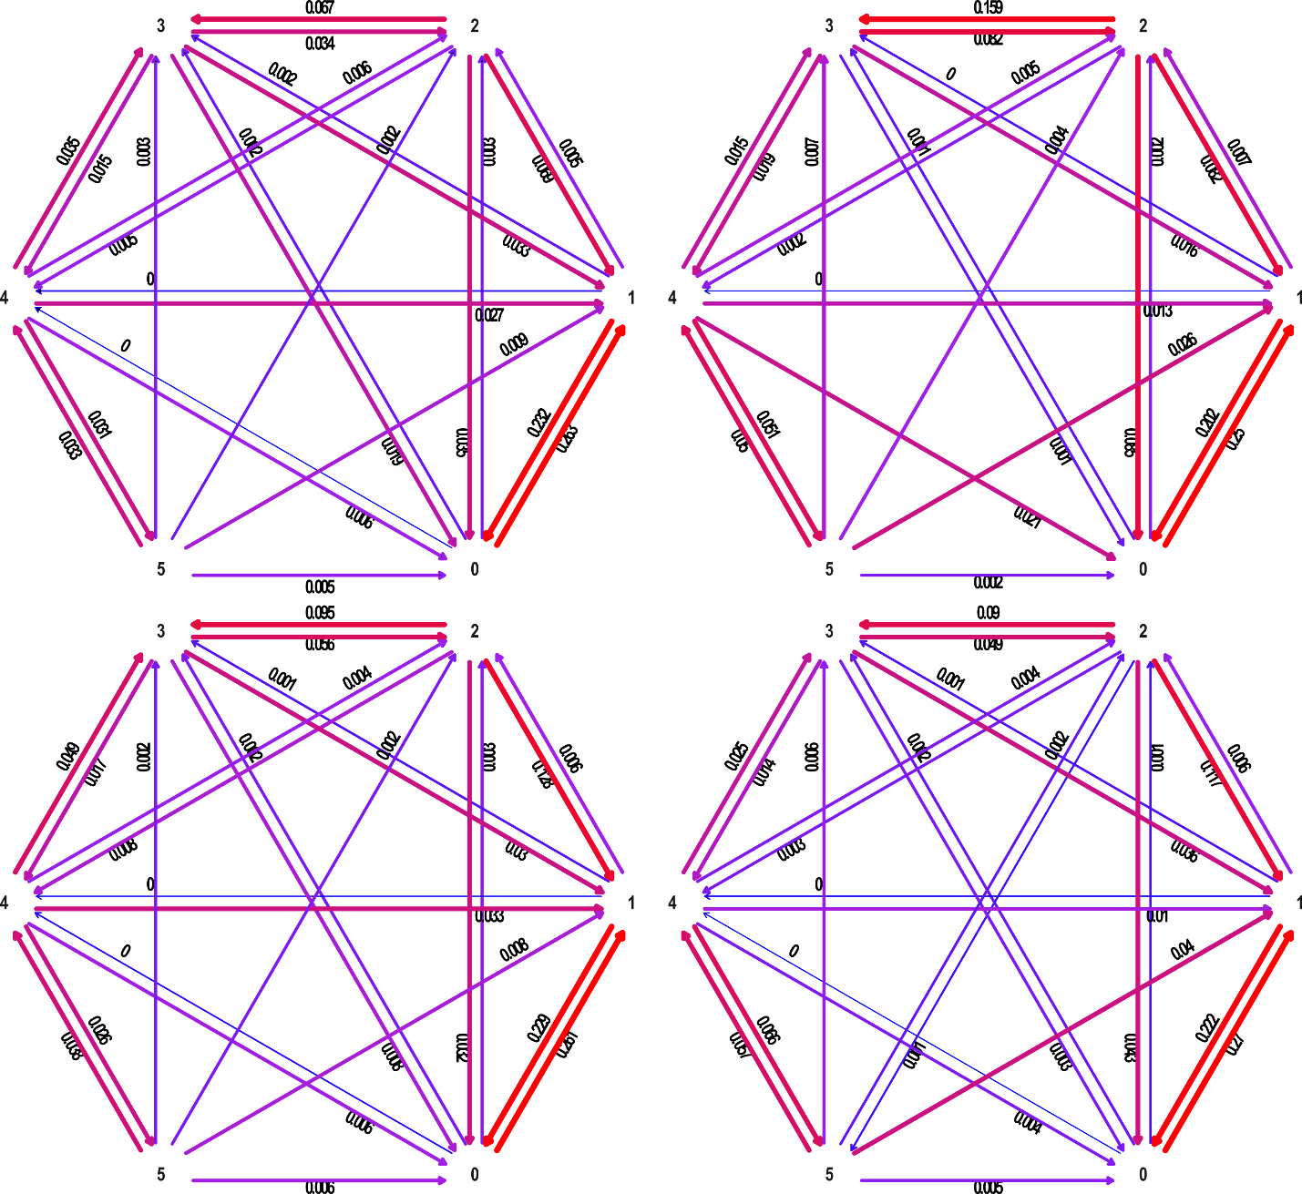
Supplementary Figure 3. Transition rate estimates between iridescence states (based on ARD model) for males (left) and females (right) in the strict (top) and extended (bottom) datasets. Transition rates are averaged across all patches within a dataset. All datasets used here were perturbated.
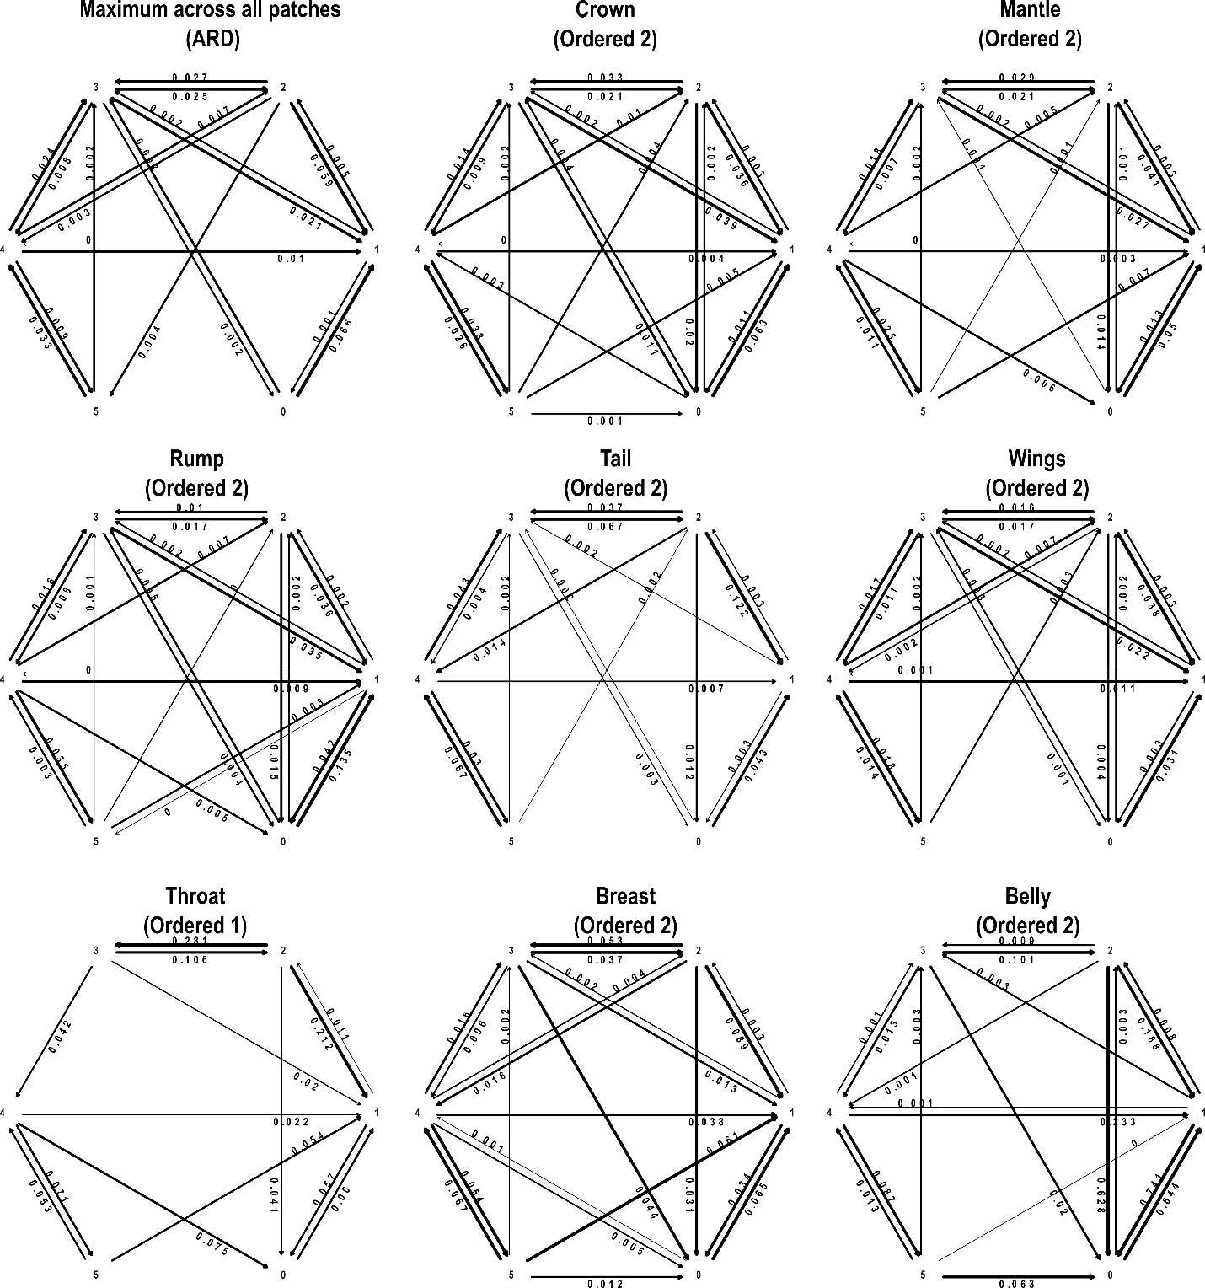
Supplementary Figure 4. Transition rate estimates between iridescence states (based on ARD model) for males, where 0 corresponds to non-melanized feathers, 1 to melanized feathers and 2-5 to different iridescent states (male dataset). The best model is shown for each patch.
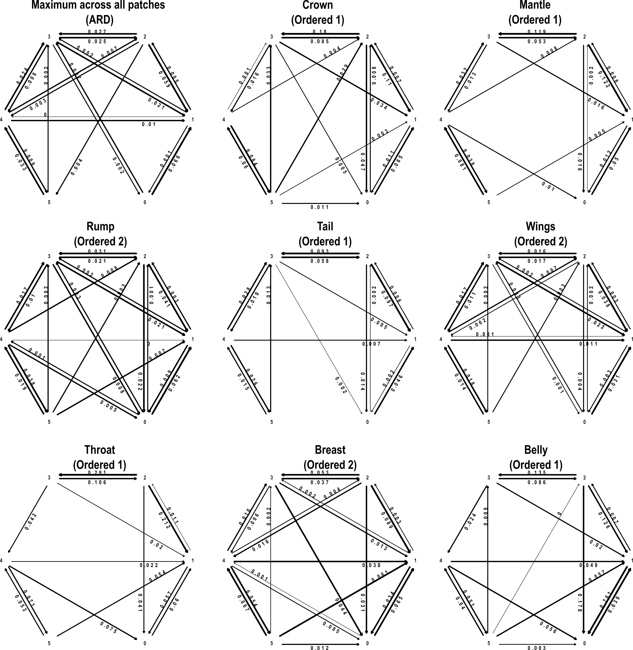
Supplementary Figure 5. Transition rate estimates between iridescence states (based on ARD model) for females, where 0 corresponds to non-melanized feathers, 1 to melanized feathers and 2-5 to different iridescent states (female dataset). The best model is shown for each patch.

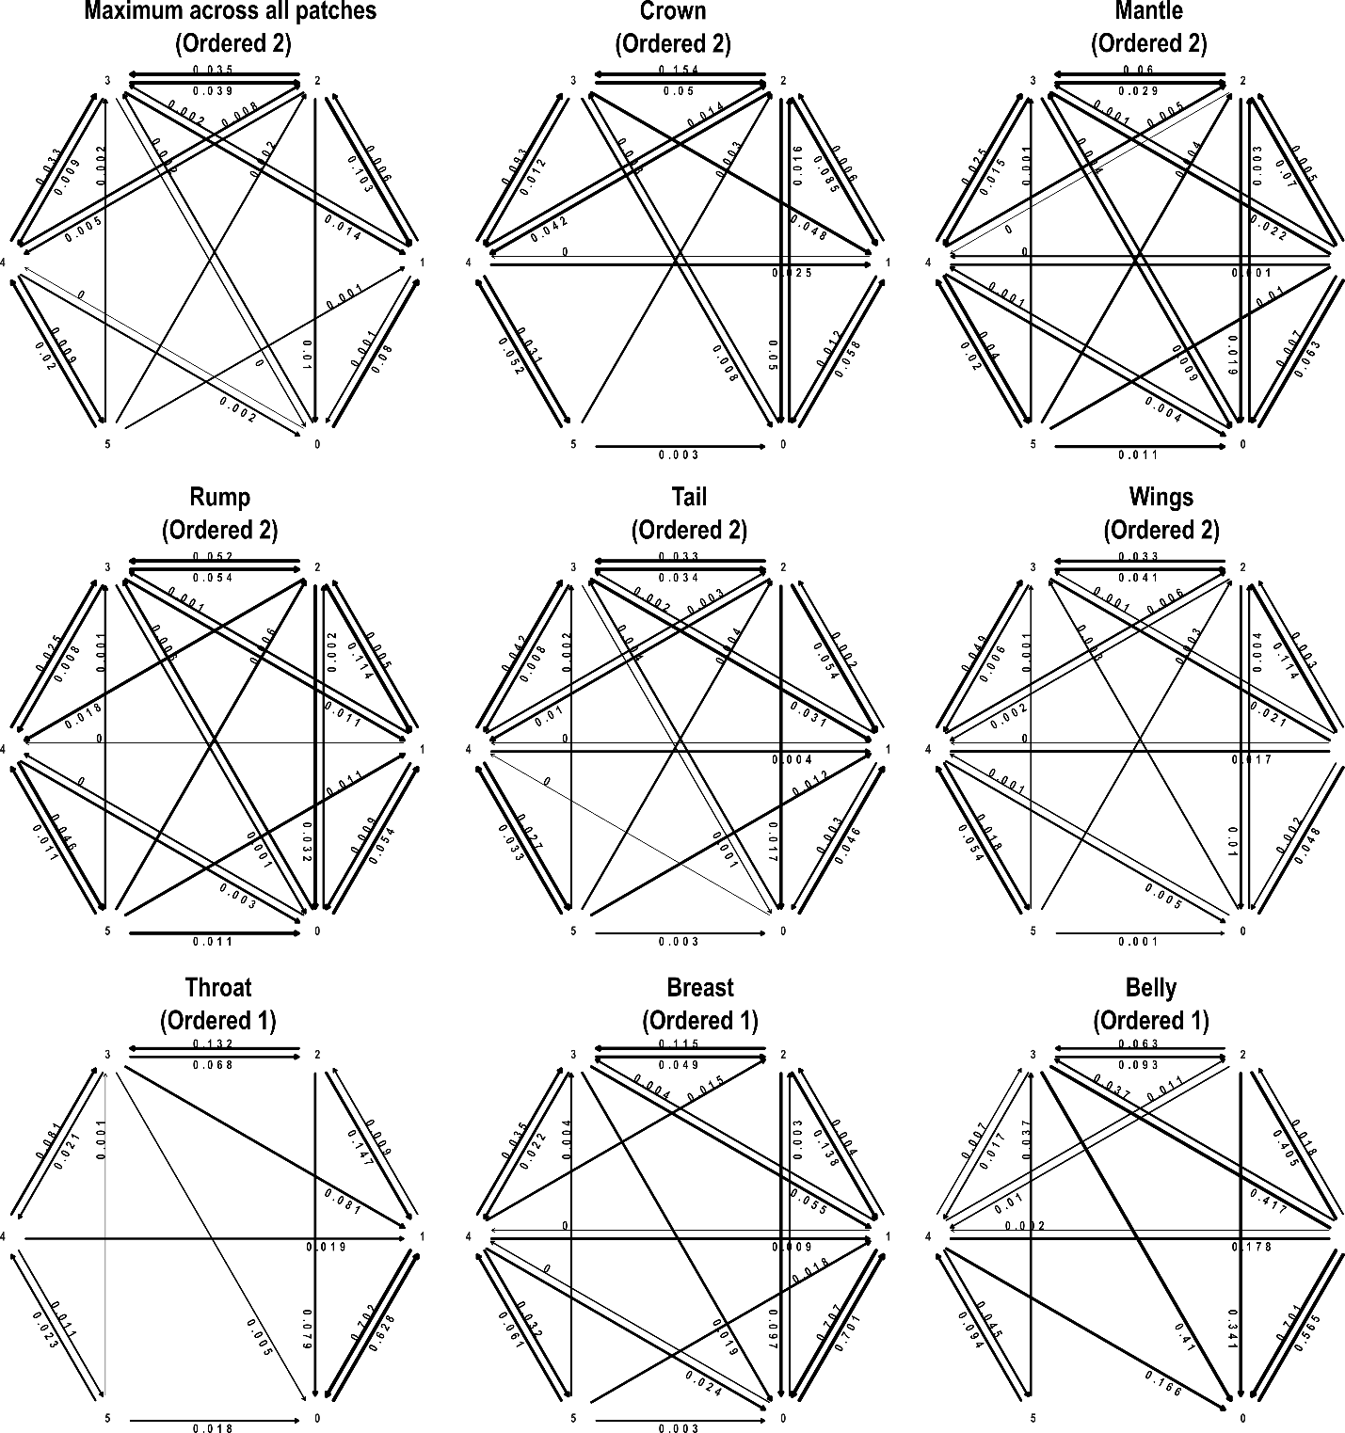
Supplementary Figure 6. Transition rate estimates between iridescence states (based on ARD model) for males, where 0 corresponds to non-melanized feathers, 1 to melanized feathers and 2-5 to different iridescent states (extended male dataset). The best model is shown for each patch.
Supplementary Figure 7. Transition rate estimates between iridescence states (based on ARD model) for females, where 0 corresponds to non-melanized feathers, 1 to melanized feathers and 2-5 to different iridescent states (extended female dataset). The best model is shown for each patch.
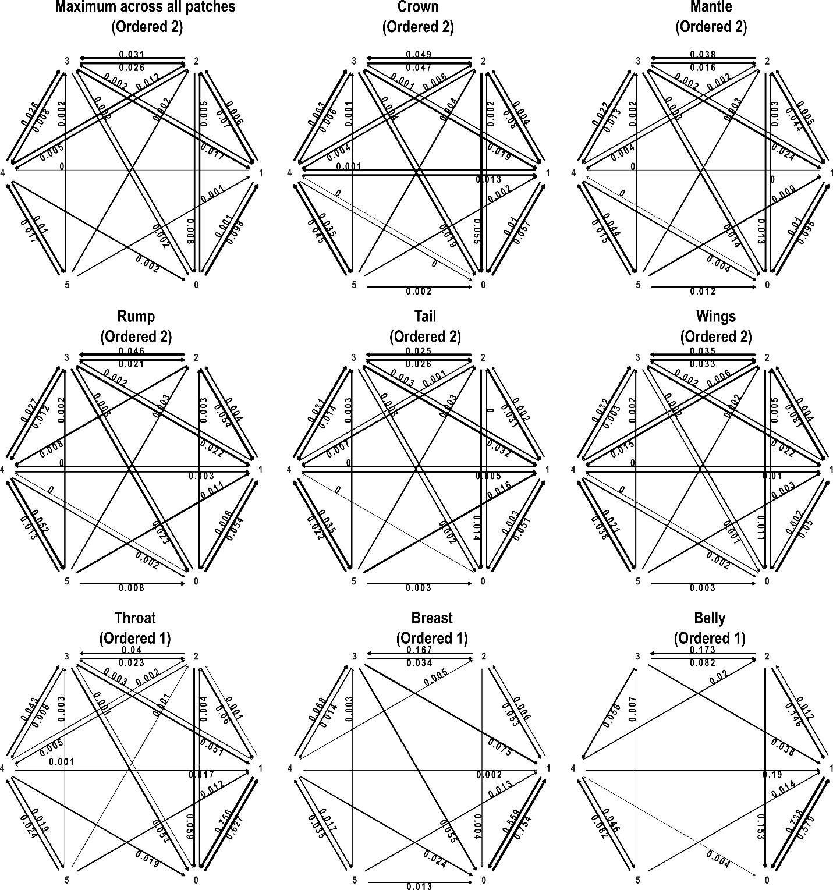
Supplementary Figure 8. Transition rate estimates between iridescence states (based on ARD model) for males, where 0 corresponds to non-melanized feathers, 1 to melanized feathers and 2-5 to different iridescent states (male dataset, perturbated). The best model is shown for each patch.

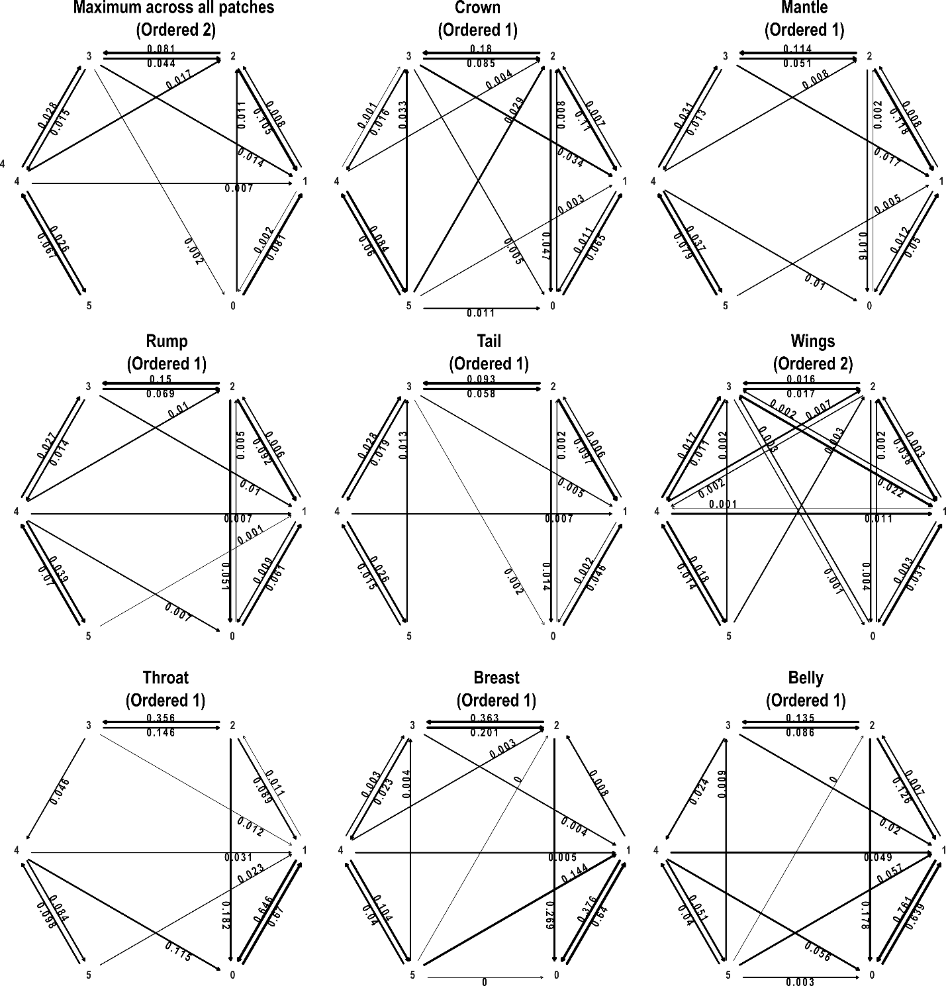
Supplementary Figure 9. Transition rate estimates between iridescence states (based on ARD model) for females, where 0 corresponds to non-melanized feathers, 1 to melanized feathers and 2-5 to different iridescent states (male dataset, perturbated). The best model is shown for each patch.

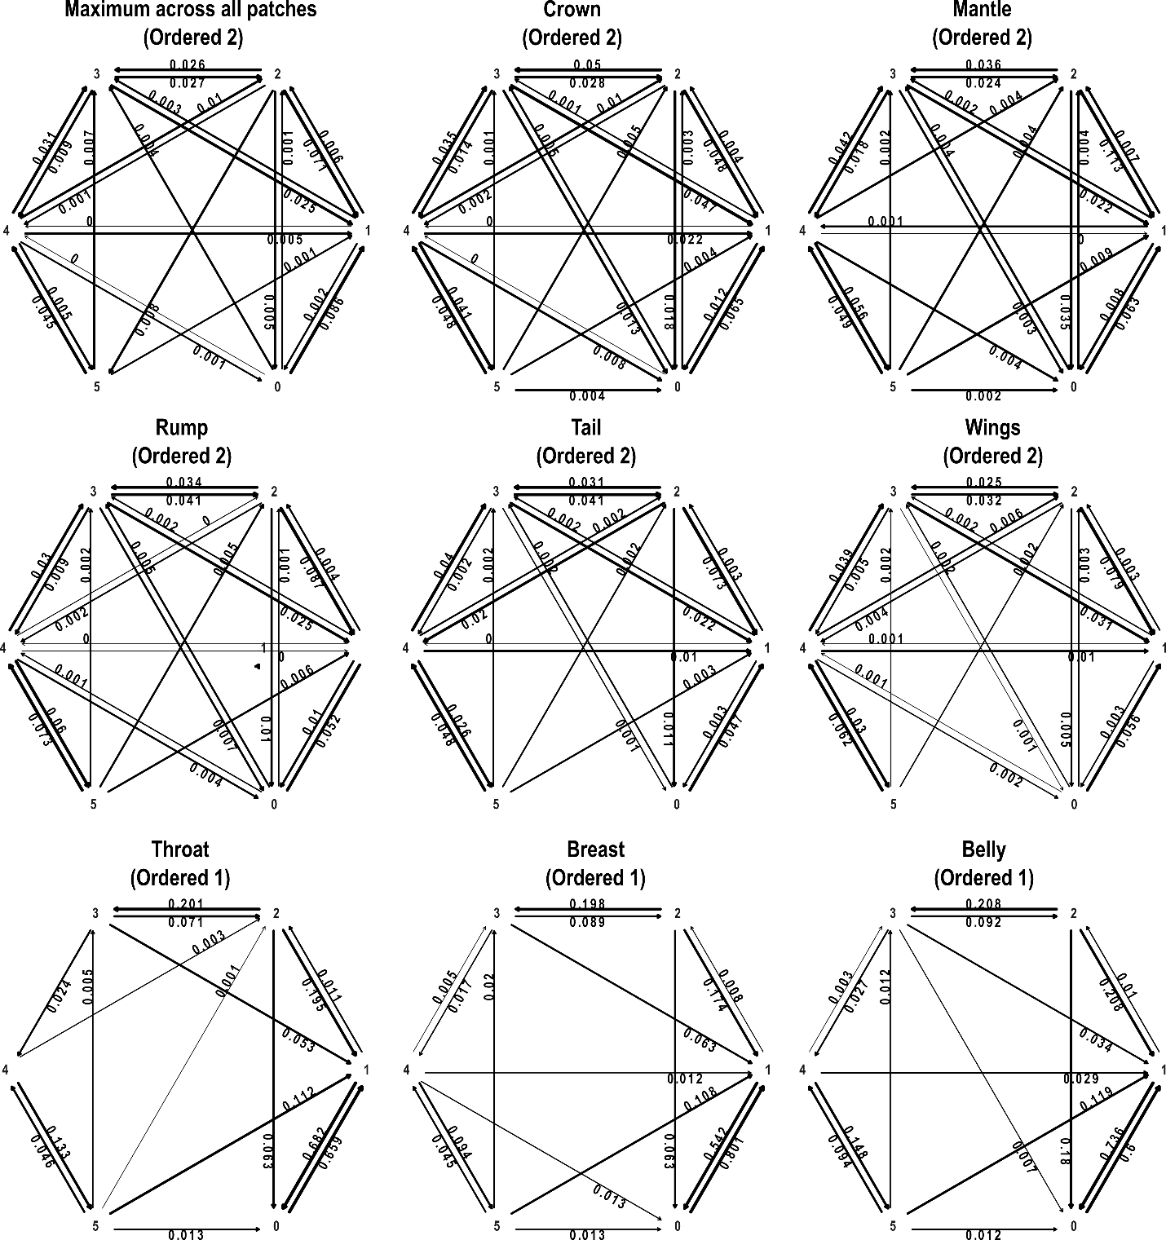
Supplementary Figure 10. Transition rate estimates between iridescence states (based on ARD model) for males, where 0 corresponds to non-melanized feathers, 1 to melanized feathers and 2-5 to different iridescent states (male extended dataset, perturbated). The best model is shown for each patch.
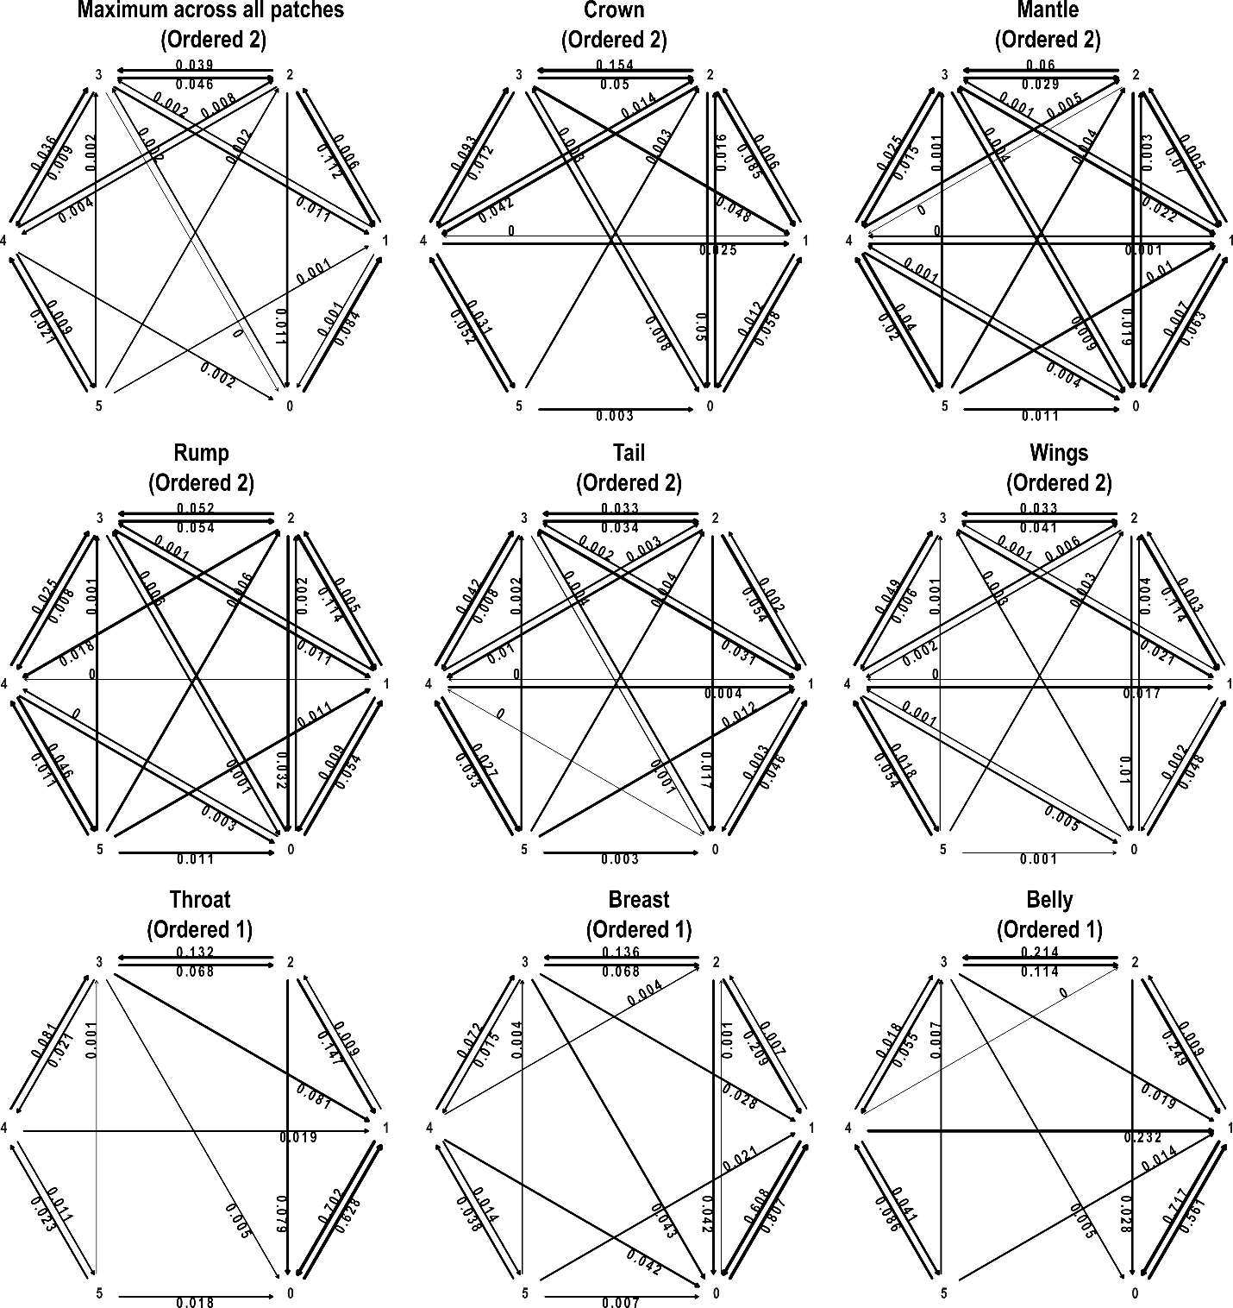Supplementary Figure 11. Transition rate estimates between iridescence states (based on ARD model) for females, where 0 corresponds to non-melanized feathers, 1 to melanized feathers and 2-5 to different iridescent states (female extended dataset, perturbated). The best model is shown for each patch.

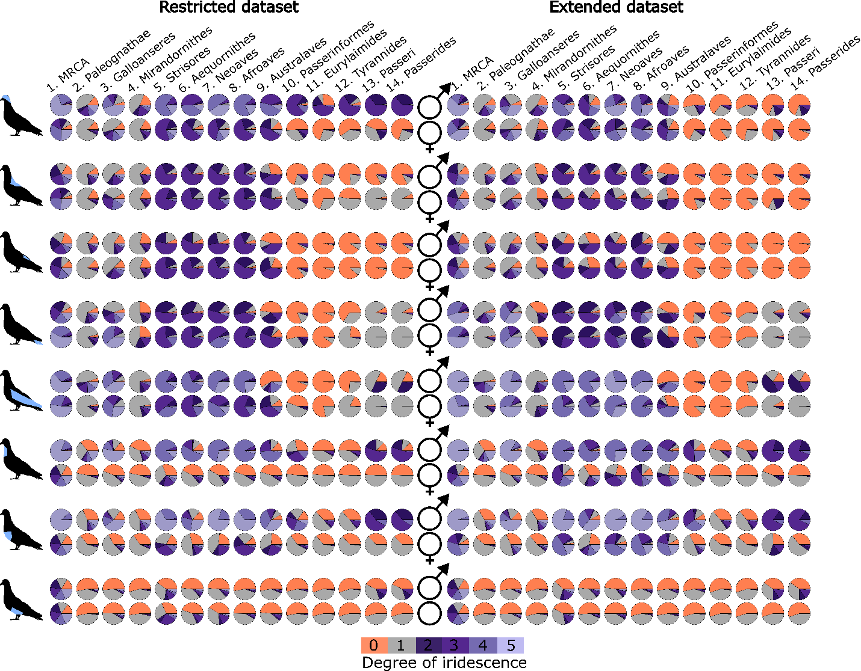
Supplementary figure 12. Ancestral state estimation for degree of iridescence for the perturbated dataset. Estimations are based on the strict (left) and extended (right) dataset showing for each row the respective patch is highlighted for males (top) and females (bottom). The degrees of iridescence—weak, moderate, strong, and brilliant—are depicted in varying shades of purple, while grey and orange represent melanin-based and non-melanized colors, respectively.

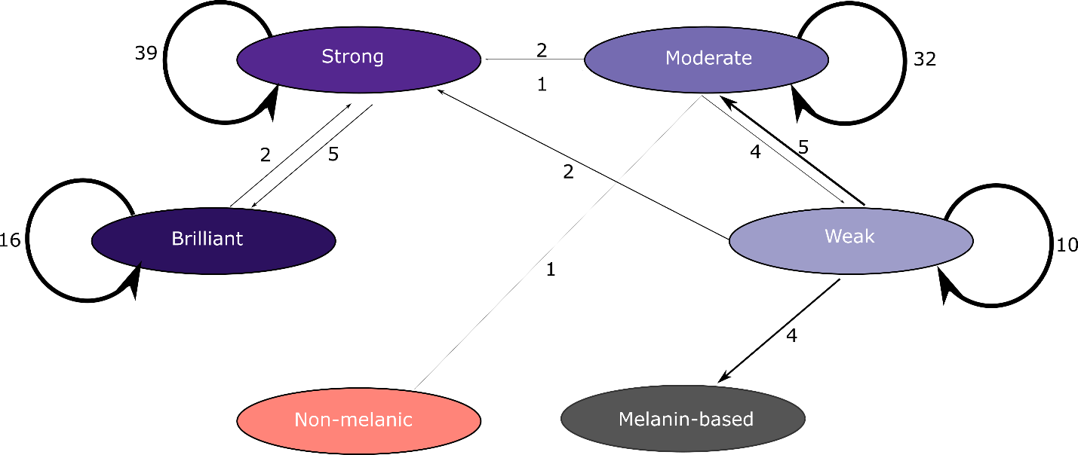
Supplementary Figure 13. Repeatability of the Auber and Durrer Classification System. Each ellipse represents a color category, with arrow thickness indicating the frequency of agreement or disagreement between scorers. Self-pointing arrows represent instances where scorers consistently classified a specimen within the same category. Arrows going from one (scored by us) to another (scored by Auber and Durrer) category indicate cases where the classification differed between scorers, with arrow thickness proportional to the number of discrepancies. Incoming arrows are score. Notice that some incongruence can be easily attributed to using non-corresponding specimens, as in the single non-iridescent scored by us, which corresponds to Philomachus pugnax, which includes both iridescent and non-iridescent morphs.

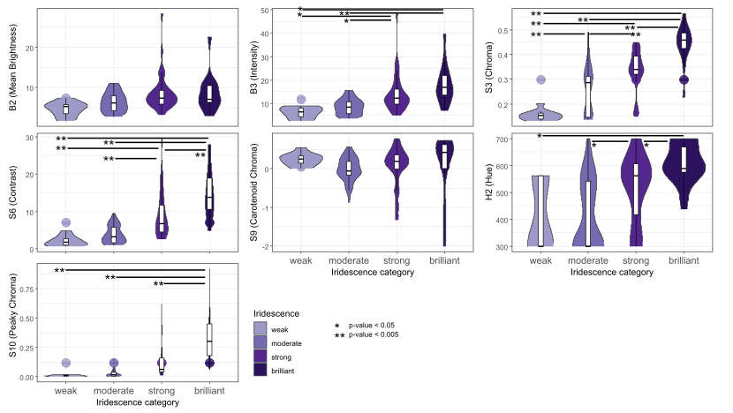
Supplementary Figure 14. Violin plots comparing color parameters between different iridescent color categories: Mean brightness (B2), Intensity (B3), Chroma (S3), Contrast (S6), Carotenoid chroma (S9) and Peaky chroma (S10) were compared between weak, moderate, strong and brilliant iridescence.

Supplementary Tables

Supplementary table 1. Evolutionary models tested: ER (equal rates), SYM (symmetrical rates), ARD (all rates different) and two ordered models where the evolution within iridescent categories is ordered (ordered 1) and a less strict ordered model where only the evolution of brilliant iridescent coloration is ordered (ordered 2). (Uploaded as a separate file)
Supplementary table 2. Model comparison of ER (equal rates), SYM (symmetrical rates), ARD (all rates different) and two ordered models where the evolution within iridescent categories is ordered (ordered 1) and a less strict ordered model where only the evolution of brilliant iridescent coloration is ordered (ordered 2). LnL values, parameter number, AIC and weighted AIC values are shown. The datasets used here are the original datasets. (Uploaded as a separate file)
Supplementary table 3. Model comparison of ER (equal rates), SYM (symmetrical rates), ARD (all rates different) and two ordered models where the evolution within iridescent categories is ordered (ordered 1) and a less strict ordered model where only the evolution of brilliant iridescent coloration is ordered (ordered 2). LnL values, parameter number, AIC and weighted AIC values are shown. The datasets used here are the perturbated datasets. (Uploaded as a separate file)
Supplementary table 4. Ancestral state estimations for all models, patches, sexes and datasets. (Uploaded as a separate file)

Supplementary table 5. Results of phylANOVA, comparing Mean brightness (B2), Intensity (B3), Chroma (S3), Contrast (S6), Carotenoid chroma (S9) and Peaky chroma (S10) between different iridescent color categories. Significant differences in bold.
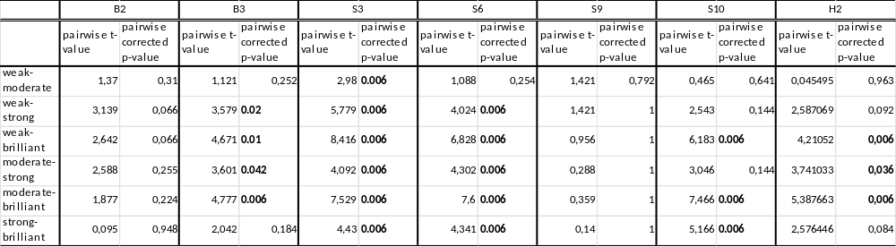

Supplementary table 6. Three different performance metrics (precision, recall and F1-score) based on reflectance data.
Class | Precision | Recall | F1-Score
weak | 0.455 | 0.556 | 0.5
moderate | 0.667 | 0.6 | 0.632
strong | 0.684 | 0.684 | 0.684
brilliant | 0.688 | 0.786 | 0.734
Supplementary table 7. Three different performance metrics (precision, recall and F1-score) based on a randomized model.

Class | Precision | Recall | F1-score
weak | 0.091 | 0.091 | 0.091
moderate | 0.194 | 0.200 | 0.197
strong | 0.316 | 0.316 | 0.316
brilliant | 0.200 | 0.214 | 0.207

