Supporting Information - JPH203 arrests LAT1 in the inwards-open conformation by displacing relevant water molecules
Katayun Bahrami¹*, Thales Kronenberger¹⁻³*, Azam Rashidian^{2,3}, Tuomo Laitinen¹, Prasanthi Medarametla¹, Kristiina M. Huttunen¹, Jarkko Rautio^{1#}, Antti Poso^{1#}

¹ School of Pharmacy, Faculty of Health Sciences, University of Eastern Finland, Kuopio 70211, Finland.
² German Center for Infection Research (DZIF), partner-site Tübingen, 72076 Tübingen, Germany.
³ Institute of Medical Microbiology and Hygiene, Interfaculty Institute of Microbiology and Infection Medicine (IMIT), University of Tübingen, Elfriede-Aulhorn-Str. 6, 72076 Tübingen, Germany.

* These authors equally contributed to this work.
#Corresponding authors: jarkko.rautio@uef.fi, antti.poso@uef.fi

Table of contents
Element | Page
Figure S1. Protein and ligand RMSD. Protein’s RMSF | S1
Table S1. Protein ligand interaction frequency | S2
Table S2. Trajectory clustering based on heavy atom RMSD of ligands | S2
Figure S2. Cluster representatives for compounds 1, 5, 12 and JPH | S3
Table S3. Principal component analyses. | S4
Figure S3. PC1 extreme motions and PCA scatter plots | S4
Figure S4. Extracellular distance measurement. | S5
Figure S5. Intracellular, mid-section, and H6/10 sub-pocket distance measurements. | S6
Figure S6. Relevant distances from the middle section for cpd1 and JPH | S7
Extra discussion - Protein-ligand interaction discussion on specific replicas | S8
Table S4. Frequencies of internal protein-protein interactions and contacts separated by replicas for Y248 | S9
Table S5. Frequencies of internal protein-protein interactions and contacts separated by replicas for Y103 | S10
Table S6. Frequencies of internal protein-protein interactions and contacts separated by replicas for S96 | S10
Table S7. Frequencies of internal protein-protein interactions and contacts separated by replicas for N404 | S11
Table S8. Frequencies of internal protein-protein interactions and contacts separated by replicas for R348 | S11
Extra discussion - Supplementary note on FEL analysis | S12
Figure S7. Free energy landscape (FEL) analysis. | S13
Figure S8. Distribution of all hydration sites obtained from WaterMap analysis | S14
Figure S9. Representation of high occupancy hydration sites. | S15
Table S9. Free energy (ΔG) of hydration sites for the inward open conformation | S16
Table S10. Free energy (ΔG) of hydration sites for the outward open conformation | S17

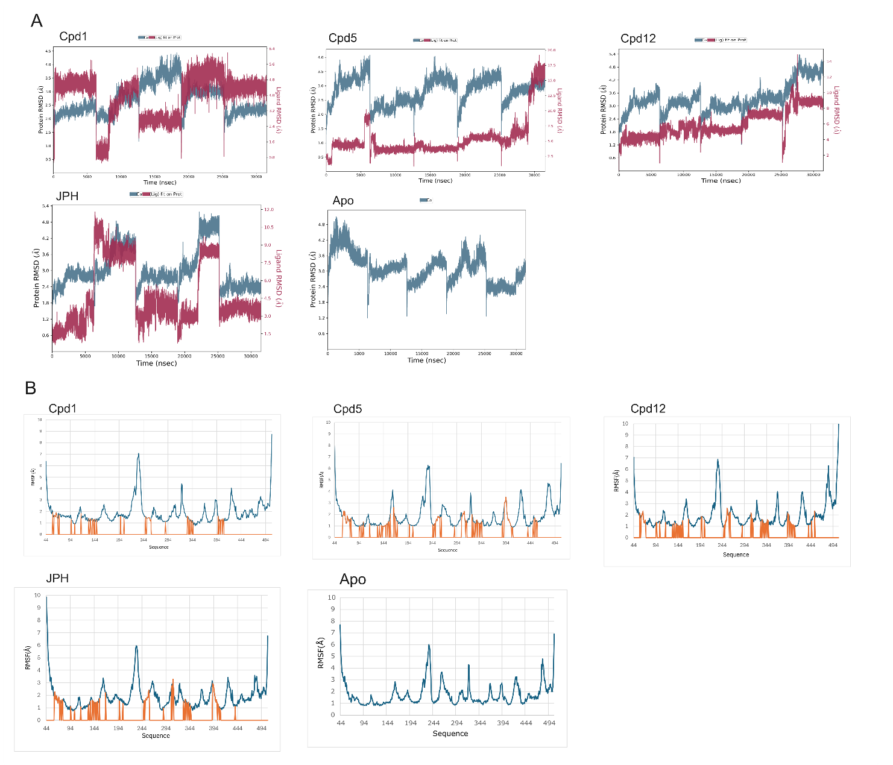
Figure S1. (A) Root mean square deviation (RMSD) for protein’s backbone (blue) and ligand heavy atoms (red line). (B) protein root mean square fluctuation (RMSF) plotted by residue, vertical orange lines point for residues in direct contact with the ligand.

Table S1. Cumulative frequency protein-ligand interactions/contacts along the full analyzed trajectory. Main interaction types (int) are coded as WB: water-bridge, HF: hydrophobic and HB: hydrogen bond.
Cpd | Y289 | Y248 | Y259 | S338 | F400 | N404 | W405 | E136 | S144 | K204
Int | WB | HF, WB | HB,WB,HF | HB,WB | HF | HB,WB | HF | HB,WB | HB,WB | Ionic, HB
Cpd1 | 58 | 6 | 47 | 27 | 28 | 38 | 63 | 9 | 1 | 1
Cpd5 | 18 | 10 | 24 | 43 | 35 | 38 | 66 | 8 | 16 | 25
Cpd12 | 3 | 29 | 43 | 42 | 42 | 27 | 24 | 1 | 33 | 47
JPH | 47 | 0 | 21 | 37 | 52 | 19 | 5 | 18 | 9 | 2

Table S2. Trajectory clustering based on heavy atom RMSD of ligands (cut-off: 1 Å of ligand’s heavy atoms). The RMSD comparing the cluster representative with the initial docking pose are available for each cluster (Cluster 1-5: C1-C5). Underlined clusters represent ligand’s flipping.
 | Cpd1 |  | Cpd5 |  | Cpd12 |  | JPH
 | Freq. % | RMSD | Freq. % | RMSD | Freq. % | RMSD | Freq. % | RMSD
C1 | 74 | 0.34 | 18 | 1.63 | 31 | 1.11 | 54 | 1.39
C2 | 12 | 0.62 | 11 | 1.5 | 21 | 1.87 | 13 | 1.37
C3 | 7 | 1.2 | 9 | 2.36 | 11 | 2.24 | 7 | 2.82
C4 | 4 | 1.07 | 5.7 | 2.06 | 10.3 | 2.66 | 7 | 1.97
C5 | 0.9 | 1.15 | 5.3 | 1.63 | 3.71 | 2.19 | 4 | 2.39

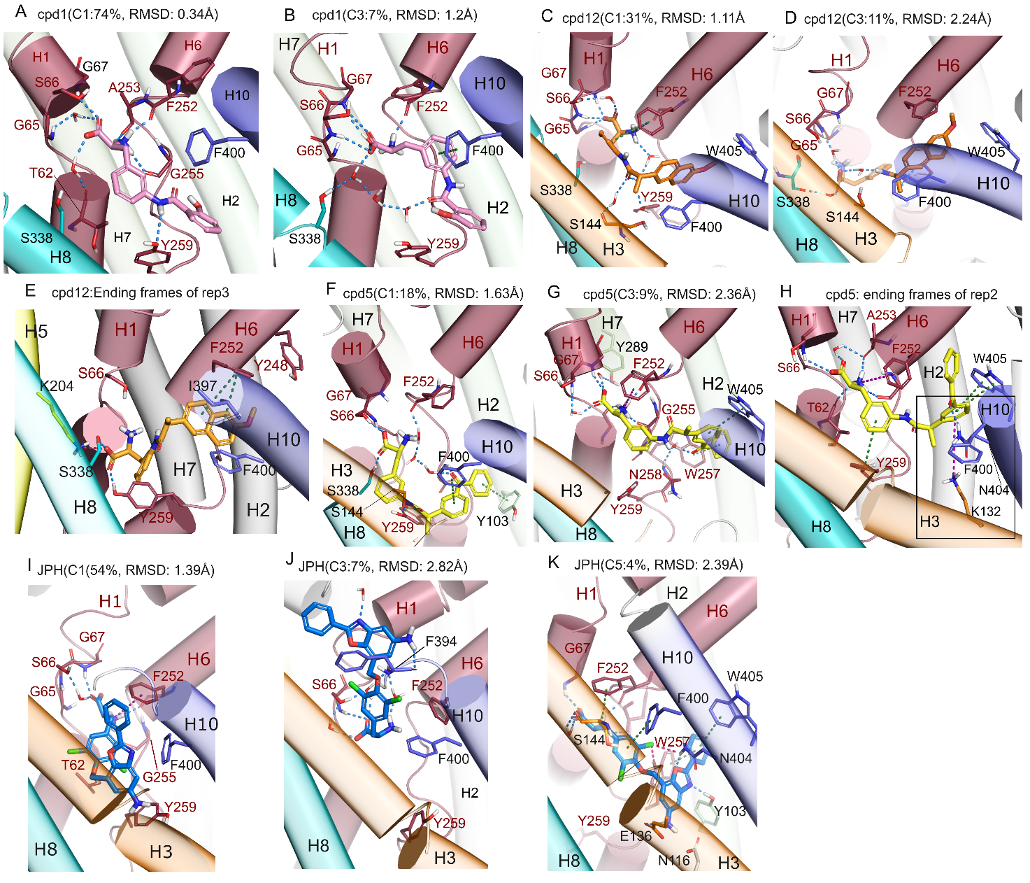
Figure S2. Cluster representatives based on ligand’s RMSD. Cluster 1 and 3 of cpd1 (A, B), cpd12 (C, D), ending frames of cpd12 in rep3 (E), clusters 1 and 3 of cpd5 (F,G), representative snapshot obtained from rep 2 of cpd5 (H) and clusters 1, 3, and 5 of JPH (I-K). Of note C1 of cpd5 (18% of the analyzed simulation time) differs significantly from its original binding mode (RMSD of 1.63 Å), with both the amino acid head and aromatic tail of the compound accommodating deeper in the transportation path (Figure S2C-D). H-bond or water bridge with S338 was observed in 4 clusters, denoting the ability of cpd5 to rotate toward H8. The tail was also displaced downward, leading to the rotation of the side chain of gating residues F252 and F400. Unlike cpd5, the ending naphthalene group of cpd12 stayed within the sub-pocket surrounded by hydrophobic residues of upper H6 and H10 in all clusters (Figure S2E-F). Instead, the amino acid head group was shifted toward cavity B, leading to a transverse pose in C3-C5 (RMSD>2 Å, Figure S2F). Ligand conformation deviates from main clusters, for instance cpd5 exhibited a stable cation–π interaction with K132 (H3) in the deeper region of cavity A and lastly, cpd12 in rep 2 the compound adopts a transverse pose leading to side chain rotation of Y248 (H6). However, none of them led to complete ligand flipping, which is important for a transport competent transition.

Table S3. Principal component analyses. Contributions of PC1 and PC2 for the overall system variance (in %) for each system.
System | PC1 | H1/H6/H7 | H11/H12 | H4/H9 | Upper H1/H6 | Upper H2/H7 | Lower H5 | Upper H10 | H3/H8
Apo | 46 | Yes | Yes | Yes |  |  |  |  | Yes
Cpd1 | 46 | Yes | Yes |  | Yes | Yes | Yes |  | Yes
Cpd5 | 36 | Yes | Yes | Yes |  |  | Inverted |  | Yes
Cpd12 | 28 | Inverted | Yes |  |  |  | Yes |  | Yes
JPH | 45 | Yes |  | Yes | Yes | Yes | Yes | Yes | Yes
System | PC2 | H1/H6/H7 | H11/H12 | H4/H9 | Upper H1/H6 | Upper H2/H7 | Lower H5 | Upper H10 | H3/H8
Apo | 15.5
Cpd1 | 22.8 | Yes |  |  |  |  | Yes |  | Yes
Cpd5 | 21.3 | Yes
Cpd12 | 21.9 |  | Yes |  | Yes
JPH | 23.4 |  | Yes |  | Yes |  | Yes |  | Yes

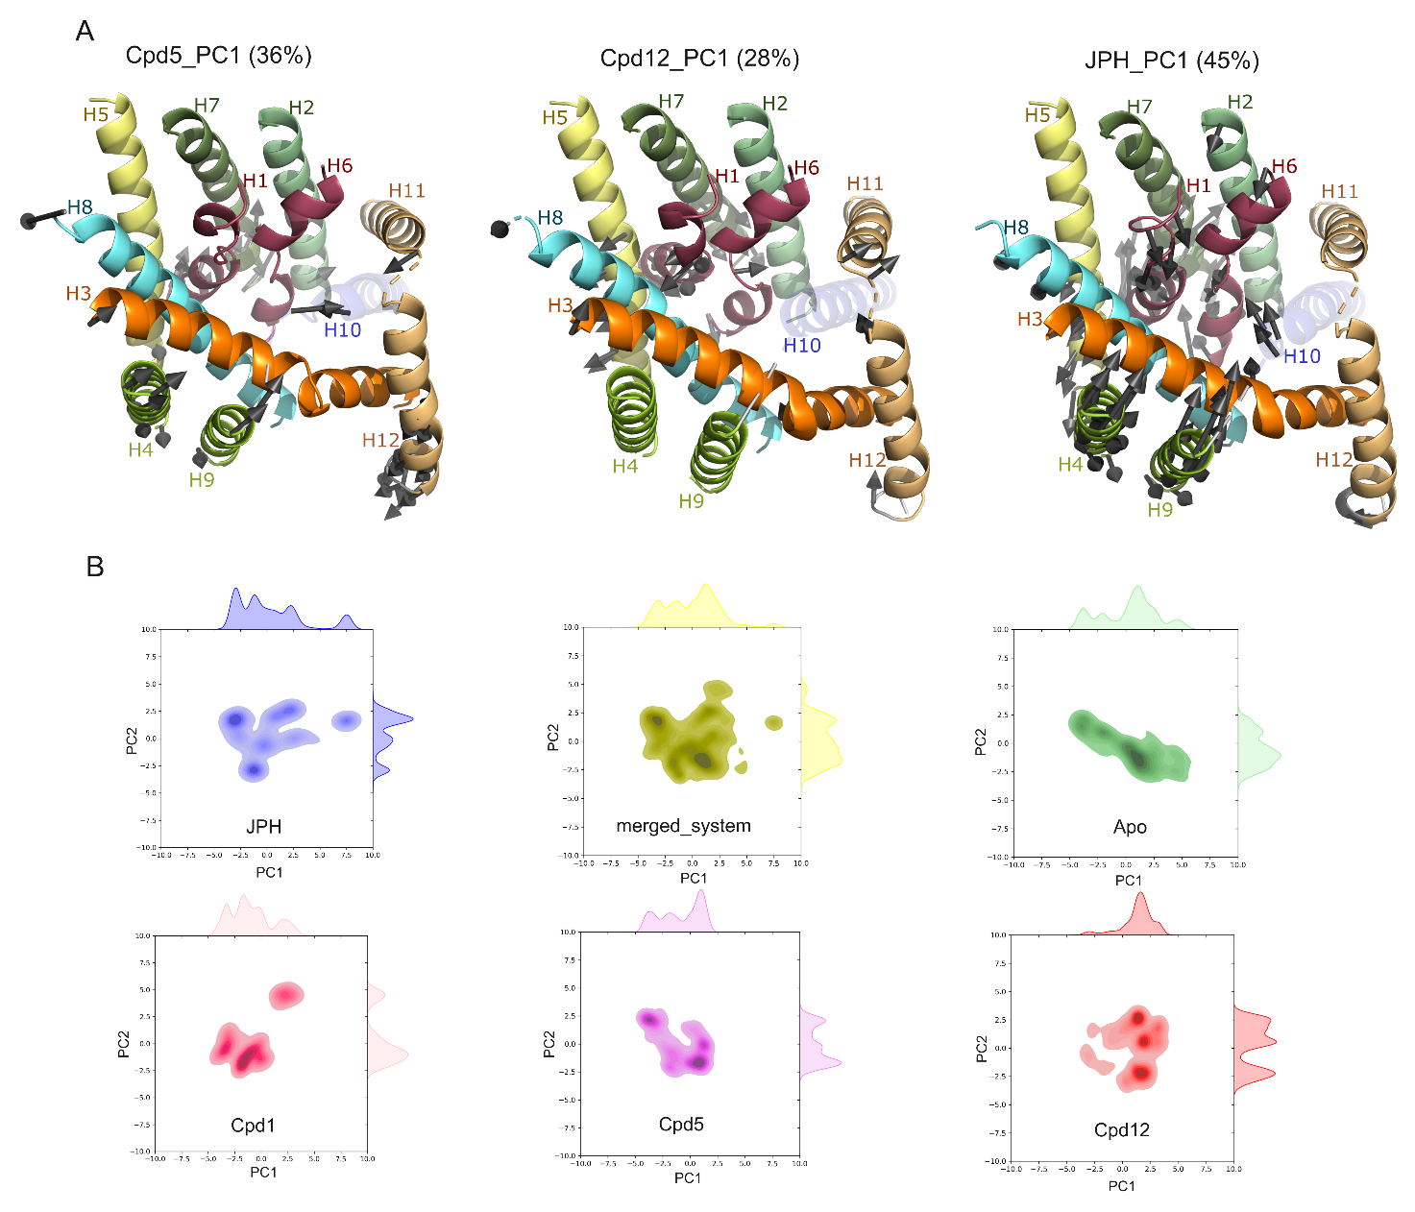
Figure S3. First extreme motions (PC1) of cpd5, cpd12 and JPH decomposed into relevant protein’s regions (A) and PCA scatter plots of all systems (B).

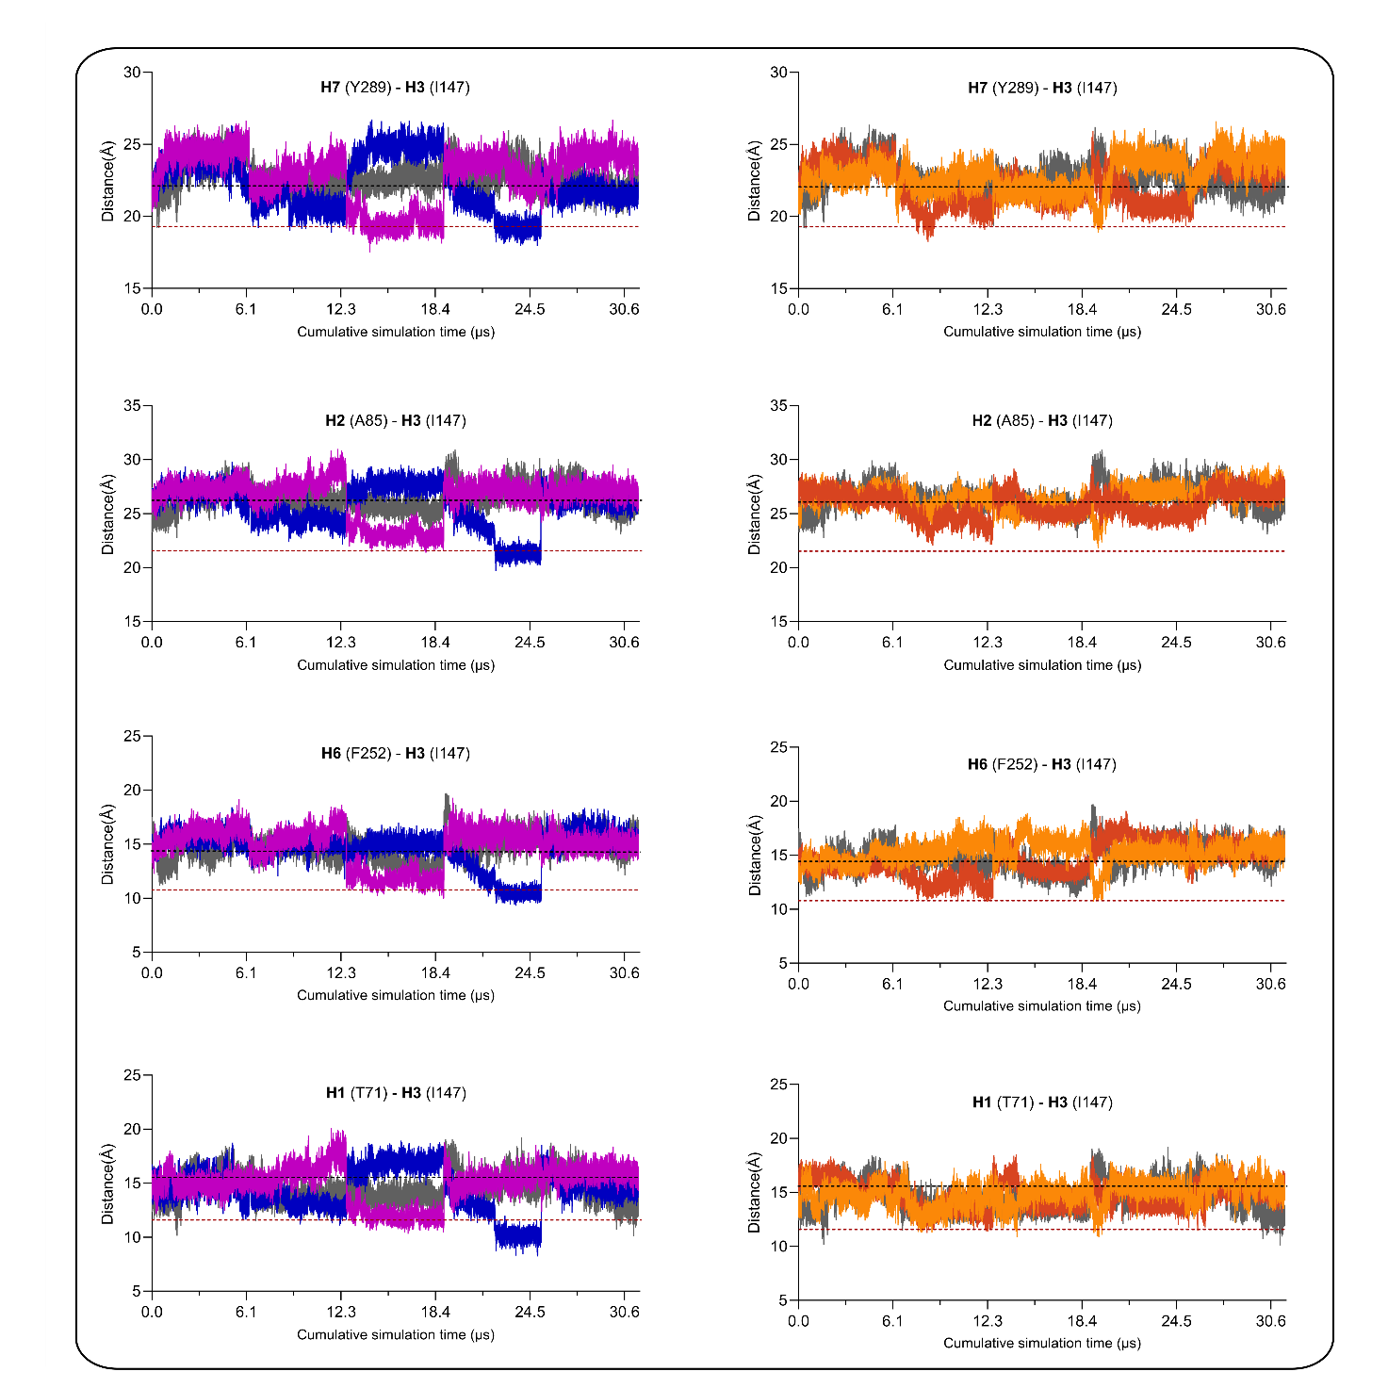
Figure S4. Extracellular distance measurement. The distance between C-alpha of I147 (H3) and residues of the bundle domain helices, Y289 (H7), A85 (H2), F252 (H6), and G55 (H1) throughout the simulation is shown. Cpd1, Cpd5, Cpd12, JPH and Apo simulation distances are shown in purple, orange, red, blue and grey colour, respectively. Black dashed line represents the outward open conformation, while red dashed line represents the inward open experimentally derived conformation.

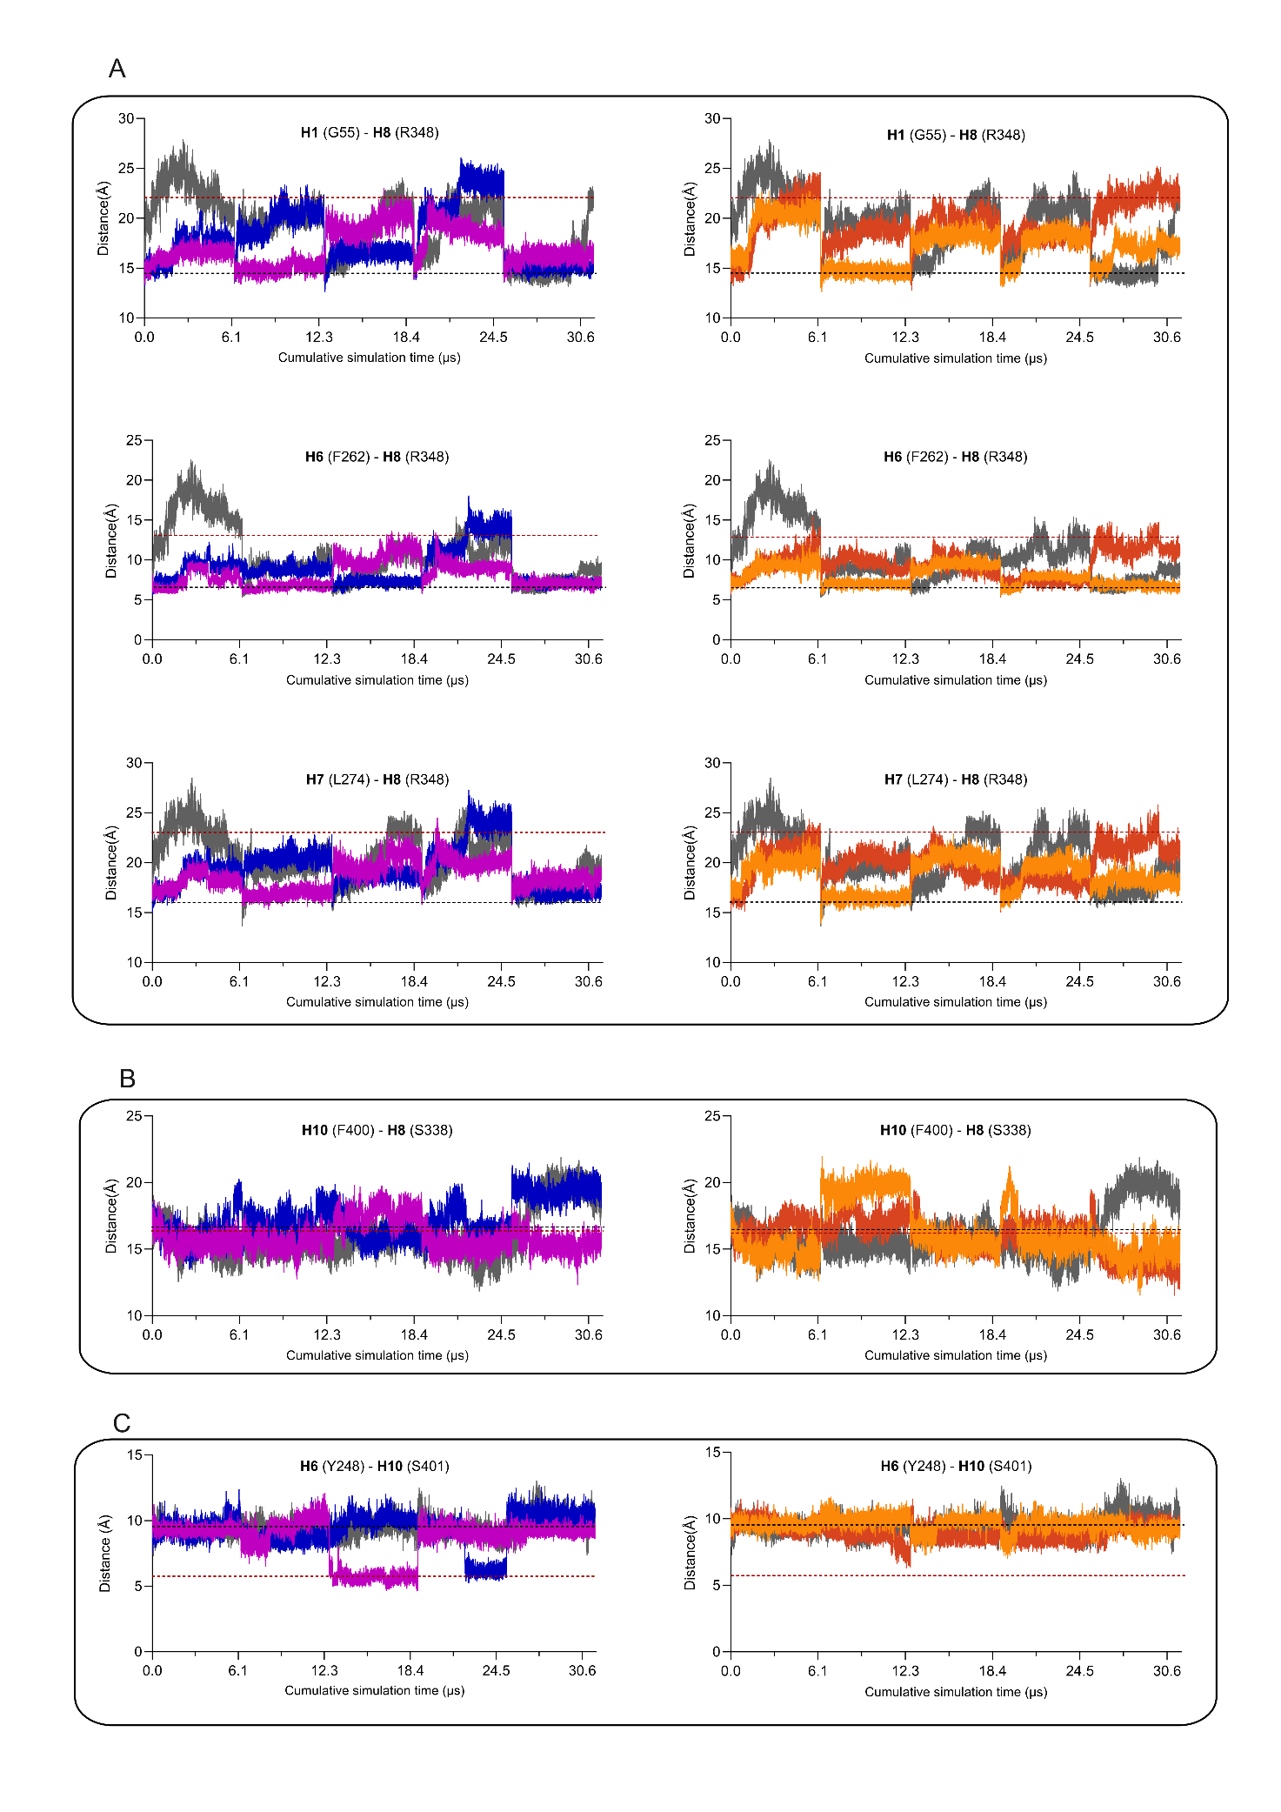
Figure S5. Intracellular, mid-section, and H6/10 sub-pocket distance measurements. (A) The distance between R348 (H8) and G55 (H1), F262 (H6), and L274 (H7) of the intracellular region of the bundle domain. (B) mid-section, F400 (H10)-S338 (H8) distances describing the expansion or contraction of the transporter. (C) distance between Y248 (H6) and S401 (H10) lining the H6/H10 sub-pocket. Colour codes are the same as Figure S4.

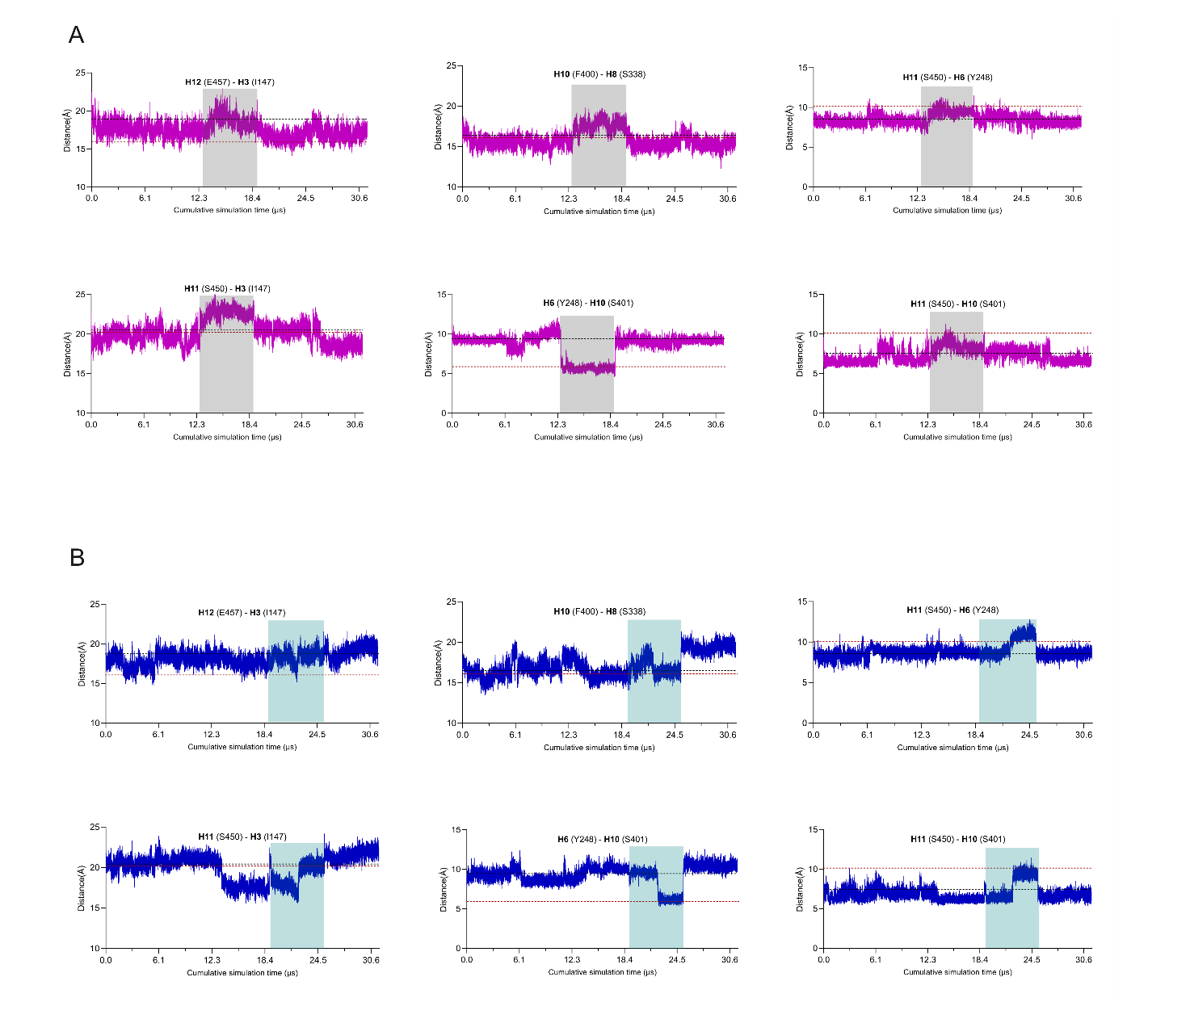
Figure S6. Relevant distances from the middle section for cpd1 (A) and JPH (B). Distance-over-time analysis between residues of H6 (Y248), H10 (F400, S401), H11 (S450), and H12 (E457), specifically for cpd1 and JPH.

Summary on the helix-helix distances
Our findings indicate that LAT1 undergoes a two-step conformational transition characterized by expansion and contraction of its mid-section (H8–H10). Expansion enables water influx from the extracellular H6/H10 sub-pocket to the transporter’s base near IH1, assisting in ligand reorientation, while contraction propels the ligand toward H8 and directs water flow toward the intracellular region. Our results also reveal that the benzoxazole tail of JPH rotates downward during the expansion phase, displacing unfavorable water molecules and stabilizing LAT1 in its inward-open conformation. This mechanism extends beyond the recently reported inhibitory mechanism from cryo-EM structures, which showed JPH blocking the outward-facing conformation^{11,22}.
We further demonstrated how larger substrates, whose tails occupy the H6/H10 sub-pocket, can influence LAT1’s residue–residue interactions, triggering coordinated helical movements and water flow. Cpd1—showing the best uptake profile and selectivity—was able to flip properly between H10 and H3 that expanded the mid-section, induced rotation of Y248 toward H11, and promoted the approach of H6 and H10. This motion facilitated water flow from the sub-pocket to the base of the transporter, preparing LAT1 for the subsequent contraction step driven by H10 rotation toward the central binding cavity. Cpd5, despite exhibiting sufficient tail flexibility to leave the H6/H10 sub-pocket toward the deeper H10-H3 region, failed as a whole – including its amino acid head group- to flip properly to expand the mid-section and trigger extracellular closure in this study. In contrast, the rigid naphthalene tail of Cpd12 remained firmly anchored within the H6/H10 sub-pocket. However, a shift of its amino acid head group allowed water flow between cavities A and B. Since leaving the H6/H10 sub-pocket is a prerequisite for conformational change, retention of the naphthalene moiety in this region provides molecular-level insight into the mechanism of action of inhibitors with large hydrophobic side chains, which had previously been proposed to prevent H10 rotation⁵.

Inner protein-protein interaction discussion on specific replicas
We observed that the side chain of Y103 (lower H2) faces the cavity, forming hydrogen bonds with D116 (IH1) and N261 (H6), as well as a hydrophobic contact with W257 (H6, see Table S5). Interaction of Y103 with JPH in replicate 4 reduces its contacts with D116 and N261 by ~50%. Conversely, when compound 1 occupies the deeper region of cavity A, a new interaction forms between Y103 and Y119 near D116, indicating that these regions move closer together. The residue S96, located in the mid-section of H2, forms an H-bond with W257 in the recognition site of H6 in the apo simulation (>50% of the simulation time, Table S6). Except for cpd12, this interaction is largely lost upon ligand binding and is mostly replaced by water bridges in other simulations. The loss of an H-bond may result from W257 participating in π-mediated interactions with the ligand. Notably, both interactions were absent in rep 3 of cpd1 and rep 4 of JPH, where the transporter adopts the inward-open conformation. In contrast, the loss of this interaction in rep 4 of cpd12 is due to a shift of its naphthalene moiety toward H2, increasing the S96–W257 distance from 8 to 12 Å.
N404 (H10) is highly involved in interactions with the compounds’ tail, both when accommodated in H6/H10 sub-pocket or in deeper cavity A, between H3 and H10. Monitoring its interaction (Table S7) showed its high participation in the water bridge (WB) with E136 and K132 (H3) and D116 (IH1). However, these WBs were totally absent when protein adopted the IO conformation in rep 3 of cpd1. Also, in the second phase of rep4 of JPH, upon its accommodation in deeper cavity A, N404 was still maintaining WB with K132. Interestingly, a direct H-bond between N404 and K132 was noticed in very stable replicas (rep 2 of cpd5 and rep 5 of apo simulation), in which the intracellular region was closed noticeably. This raises the idea that approaching these two residues might have a stabilizing effect on closing the intracellular region.
Lastly, R348 polar contacts (H8, Table S8) with residues in the lower region of H6, namely F262, Q265 and E266, are diminished or lost in replicas where the intracellular region undergoes substantial opening and H6 shifts outward surrounding (e.g., rep 3 and rep 4 of cpd1 and JPH, respectively, or rep 1 of ligand free simulation). Indicating that these hydrophilic contacts contribute to stabilizing closure of the intracellular region.

Table S4. Frequencies of internal protein-protein interactions and contacts separated by replicas for Y248 (res1) with other surrounding residues (res2). Main interaction type is coded as HB for Hbonds, WB for water-bridges and HF for hydrophobic.
System | Res1 | Res2 | rep1 | rep2 | rep3 | rep4 | rep5 | Main Type
cpd1 | Y248 | S401 | 0.85 | 0.43 | 0.35 | 0.54 | 0.77 | HB, WB
cpd1 | Y248 | S450 |  | 0.2 | 0.39 | 0.73 |  | HB
cpd1 | Y248 | T454 |  | 0.2 | 0.54 |  |  | HB, WB
cpd5 | Y248 | S401 | 0.53 |  | 0.69 | 0.43 | 0.67 | HB
cpd5 | Y248 | S450 |  | 0.79 | 0.2 | 0.23 | 0.2 | HB
cpd5 | Y248 | T454 |  | 0.9 | 0.21 |  |  | WB
cpd12 | Y248 | S401 | 0.89 | 0.74 | 0.59 | 0.51 | 0.71 | HB, WB
cpd12 | Y248 | S450 |  |  | 0.7 | 0.62 |  | HB
cpd12 | Y248 | T454 |  |  |  | 0.48 |  | WB
JPH | Y248 | S401 | 0.34 | 0.68 | 0.52 | 0.65 |  | HB, WB
JPH | Y248 | S450 | 0.38 | 0.82 |  | 0.33 | 0.56 | HB
JPH | Y248 | T454 | 0.33 | 0.65 |  |  | 0.7 | WB
APO | Y248 | S401 | 0.64 | 0.46 | 0.53 | 0.6 | 0.28 | HB
APO | Y248 | S450 |  | 0.42 | 0.28 |  | 0.52 | HB
APO | Y248 | T454 |  |  |  |  | 0.75 | WB

Table S5. Frequencies of internal protein-protein interactions and contacts separated by replicas for Y103 (res1) with other surrounding residues (res2). Main interaction type is coded as HB for Hbonds, WB for water-bridges and HF for hydrophobic.
System | Res1 | Res2 | rep1 | rep2 | rep3 | rep4 | rep5 | Main Type
cpd1 | Y103 | D116 | 0.89 | 0.95 | 0.99 | 0.89 | 0.91 | HB
cpd1 | Y103 | Y119 | 0.29 | 0.09 | 0.9 | 0.27 | 0.28 | HF
cpd1 | Y103 | W257 | 0.64 | 0.31 | 0.71 | 0.74 | 0.8 | HF
cpd1 | Y103 | N261 | 0.93 | 0.91 | 0.23 | 0.1 | 0.96 | HB
cpd5 | Y103 | E116 | 0.7 | 0.93 | 0.8 | 0.71 | 0.86 | HB
cpd5 | Y103 | Y119 | 0.06 | 0.28 | 0.04 | 0.33 | 0.22 | HF
cpd5 | Y103 | W257 | 0.39 | 0.83 | 0.42 | 0.38 | 0.27 | HF
cpd5 | Y103 | N261 | 0.8 | 0.84 | 0.9 | 0.12 | 0.02 | HB
cpd12 | Y103 | E116 | 0.67 | 0.78 | 0.85 | 0.4 | 0.88 | HB
cpd12 | Y103 | Y119 | 0.31 | 0.12 | 0.11 | 0.19 | 0.17 | HF
cpd12 | Y103 | W257 | 0.49 | 0.31 | 0.24 | 0.5 | 0.45 | HF
cpd12 | Y103 | N261 | 0.29 | 0.3 | 0.61 |  | 0.91 | HB
JPH | Y103 | E116 | 0.98 | 0.92 | 0.95 | 0.55 | 0.89 | HB
JPH | Y103 | Y119 | 0.15 | 0.13 | 0.21 | 0.16 | 0.19 | HF
JPH | Y103 | W257 | 0.28 | 0.12 | 0.74 | 0.29 | 0.87 | HF
JPH | Y103 | N261 | 0.95 |  | 0.83 | 0.55 | 0.93 | HB
Apo | Y103 | E116 | 0.92 | 0.78 | 0.91 | 0.72 | 0.97 | HB
Apo | Y103 | Y119 | 0.12 | 0.06 | 0.02 | 0.14 | 0.07 | HF
Apo | Y103 | W257 | 0.51 | 0.32 | 0.54 | 0.23 | 0.48 | HF
Apo | Y103 | N261 | 0.18 | 0.72 | 0.95 | 0.52 | 0.78 | HB

Table S6. Frequencies of internal protein-protein interactions and contacts separated by replicas for S96 (res1) with other surrounding residues (res2). Main interaction type is coded as HB for Hbonds, WB for water-bridges and HF for hydrophobic.
System | Res1 | Res2 | rep1 | rep2 | rep3 | rep4 | rep5 | Main Type
cpd1 | S96 | W257 | 0.01 | 0.19 |  |  |  | Hbond
cpd1 | S96 | W257 | 0.52 |  |  | 0.3 | 0.85 | WB
cpd5 | S96 | W257 | 0.33 | 0.06 |  |  | 0.18 | Hbond
cpd5 | S96 | W257 | 0.08 | 0.44 | 0.87 | 0.11 |  | WB
cpd12 | S96 | W257 | 0.63 | 0.84 | 0.54 |  | 0.48 | Hbond
cpd12 | S96 | W257 | 0.1 |  | 0.04 |  | 0.11 | WB
JPH | S96 | W257 |  | 0.13 |  | 0.08 |  | Hbond
JPH | S96 | W257 | 0.05 | 0.07 | 0.78 | 0.05 | 0.68 | WB
Apo | S96 | W257 | 0.51 | 0.71 | 0.98 | 0.57 | 0.91 | Hbond
Apo | S96 | W257 | 0.12 | 0.09 |  | 0.17 | 0.06 | WB

Table S7. Frequencies of internal protein-protein interactions and contacts separated by replicas for N404 (res1) with other surrounding residues (res2). Main interaction type is coded as HB for Hbonds, WB for water-bridges and HF for hydrophobic.
System | Res1 | Res2 | rep1 | rep2 | rep3 | rep4 | rep5 | Main Type
Cpd1 | N404 | Glu136 | 0.73 |  |  | 0.29 | 0.49 | WB
Cpd1 | N404 | Asp116 | 0.68 | 0.43 |  | 0.29 | 0.78 | WB
Cpd1 | N404 | W257 |  |  | 0.99 |  |  | HB
cpd5 | N404 | D136 |  | 0.47 |  | 0.34 | 0.33 | WB
cpd5 | N404 | E116 | 0.25 | 0.39 |  |  | 0.24 | WB
cpd5 | N404 | K132 |  | 0.53 |  |  |  | HB
cpd12 | N404 | D136 | 0.32 |  |  |  |  | WB
cpd12 | N404 | E116 | 0.25 |  | 0.27 |  | 0.26 | WB
cpd12 | N404 | Y103 |  | 0.34 | 0.22 |  |  | WB
cpd12 | N404 | W257 |  | 0.52 | 0.4 |  |  | WB
cpd12 | N404 | G255 |  |  | 0.39 |  |  | WB
cpd12 | N404 | N258 |  | 0.57 | 0.49 |  |  | WB
JPH | N404 | D136 |  |  | 0.22 |  | 0.53 | WB
JPH | N404 | E116 | 0.44 |  | 0.8 | 0.24 | 0.68 | WB
Apo | N404 | D136 | 0.23 |  | 0.23 | 0.37 | 0.38 | WB
Apo | N404 | E116 | 0.51 |  |  | 0.19 | 0.31 | WB
Apo | N404 | K132 |  |  |  |  | 0.51 | HB

Table S8. Frequencies of internal protein-protein interactions and contacts separated by replicas for R348 (res1) with other surrounding residues (res2). Main interaction type is coded as HB for Hbonds, WB for water-bridges and HF for hydrophobic.
System | Res1 | Res2 | rep1 | rep2 | rep3 | rep4 | rep5 | Main Type
cpd1 | R348 | F262 |  |  |  |  | 1.11 | HB
cpd1 | R348 | E265 |  |  |  | 0.53 |  | HB, WB
cpd1 | R348 | E266 | 1.85 | 2.21 | 0.84 | 1.54 | 1.6 | HB, WB,ionic
cpd5 | R348 | F262 | 0.44 |  | 0.55 | 0.85 |  | HB, WB, HF
cpd5 | R348 | E265 | 1.22 |  |  |  |  | HB
cpd5 | R348 | E266 | 0.47 | 2.12 | 1.74 | 1.86 | 2.04 | HB, WB, ionic
cpd12 | R348 | F262 |  |  | 0.22 | 0.39 |  | HB
cpd12 | R348 | E265 | 0.85 | 0 | 0.74 | 0.26 | 0.82 | HB, WB
cpd12 | R348 | E266 | 0.65 | 1.44 | 0.68 | 0.42 | 0 | HB, WB, ionic
JPH | R348 | F262 | 0.3 | 0.81 | 1.19 |  | 0.15 | HB, HF
JPH | R348 | E265 | 0.57 | 0.55 | 0 | 0.25 |  | HB, WB
JPH | R348 | E266 | 1.4 | 1.25 | 1.47 |  | 1.75 | HB, WB, ionic
APO | R348 | F262 |  | 0.33 |  | 0.2 | 0.26 | HB, HF
APO | R348 | E265 |  |  |  | 0.27 | 0.21 | HB, WB
APO | R348 | E266 |  | 0.63 | 0.58 | 0.41 | 0.62 | HB, WB, ionic

Supplementary note on FEL analysis: Free Energy Landscape (FEL) analysis. Gromacs Gibbs free energy landscape analysis was utilized to inspect the energetically favorable conformational states of LAT1. Principal component-based free energy landscape analysis was conducted using Gromacs sham module full trajectory. FEL was generated based on the radius of gyration (Rg) and RMSD to understand the interaction dynamics. Rg was calculated using the gmx gyrate which measures the compactness of the molecule during the simulation and RMSD was calculated using the gmx rms. RMSD provides the distance between C-alpha atoms during simulation in comparison with the initial conformation. Two FEL matrices generated based on the PC components and Rg-RMSD were converted to eps using the gmx xpm2ps. FEL provides relative Gibbs free energies of each conformation in trajectory based on Boltzmann distributions. Clustering (gmx cluster) was used to retrieve representative states and cluster centroids associated with local minima were analyzed.
FEL provides insights into the system’s stable states, energy barriers, and structural transitions within the given timescale. The radius of gyration (R_{g}) and RMSD-based FEL highlight differences between the systems (Figure S7A). While the ligand-free simulations displayed a single stable local energy minimum, at low R_{g} and low RMSD, the simulation of the compound-bound shows at least one extra conformation. The other red regions, i.e., metastable states, are within the basin indicating the native state. Energy landscape of cpd1’s simulations showed two states, one with the minimum of the local energy at the highest R_{g} and a similar RMSD to the apo form and another with the low R_{g} and higher RMSD. This indicates that cpd1 binding induces conformational changes that affect the compactness of the system. However, these two states are interconvertible without any energy barriers. Cpd5 exhibits a similar FEL pattern to the Apo form. However, the local energy minimum is distributed towards the highest RMSD and R_{g} in contrast to the Apo form. The free energy landscape of cpd12 has shown two distinct basins with the lowest energy minima located in a single basin at the highest RMSD and low R_{g} when compared with other ligand-bound systems. This displays the conformational flexibility and presence of unstable states in the second basin. In contrast to these ligand-bound systems, JPH shows fragmented, multiple stable states within the same basin implying conformational flexibility and possible induced fit mechanism to alter the transporter activity.
Further, representative structures were retrieved from the lowest energy minima (i.e. red bins where Gibbs free energy is around zero, Figure S7B) by clustering, displaying few conformational changes from the cluster centroid (see numbering in Figure S7A). Among the different simulated systems, loss of folding and conformational changes in the H1 are more evident for ligand-free, cpd12 and JPH’s simulations, while cpd1 retains H1-folding/position. In the ligand-free simulations, clusters showed major H10 conformational changes, extending towards the inner membrane of H1 and H6. Indeed, residue F400 closed the channel to exit the kink form (with a movement of distance ~4.9 Å) and display distinct open conformations on JPH and cpd1 simulations. We attribute those F400-changes to the positioning of cpd1’s hydrophobic tail, between H6 and H10 in one state (cpd1-2) and between H10 and H3 in another state (cpd1-1, Figure S7C). Those changes in the cpd1’s tail happen concomitantly with the Y248 shift in conformations. Aligning cpd1 clusters with the Apo form revealed that cpd1 bound LAT1 displayed an occluded conformation. Lastly, JPH relevant clusters (Figure S7D,E) reveal a distinct flip upwards of its hydrophobic tail, independently from the H1/H6 region as it happens to cpd1. This supports that cpd1 and JPH have distinct conformational behavior from the other simulated systems, and even when compared with each other.

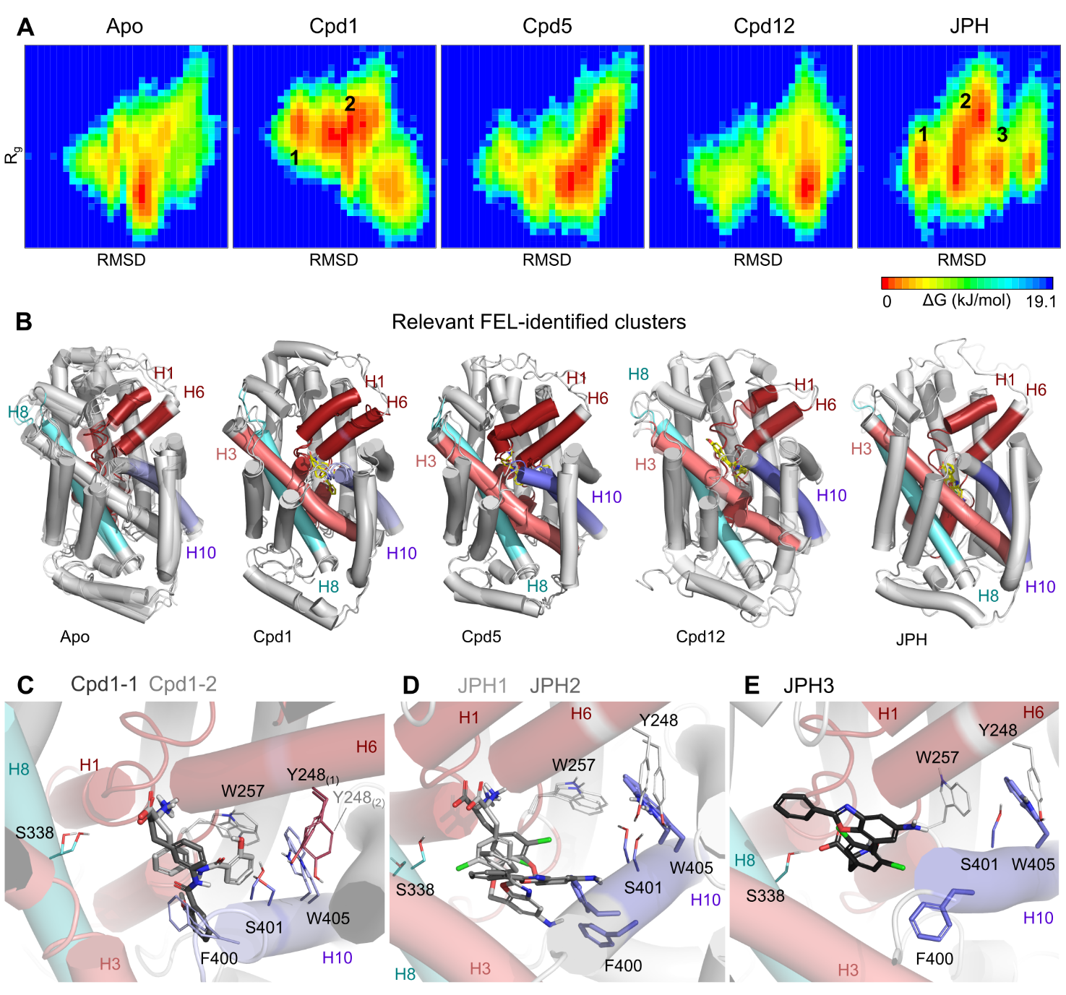
Figure S7. Free energy landscape analysis. (A) Gibbs free energy landscape of the studied systems. Red bins indicate the lowest energy bins, and green to blue indicate the highest energy bins. (B) corresponding cluster representatives of the lowest energy minima states of each system. (C-E) Relevant clusters from the FEL and the respective ligand orientation within the binding cavity for cpd1 (C) and JPH (D,E).

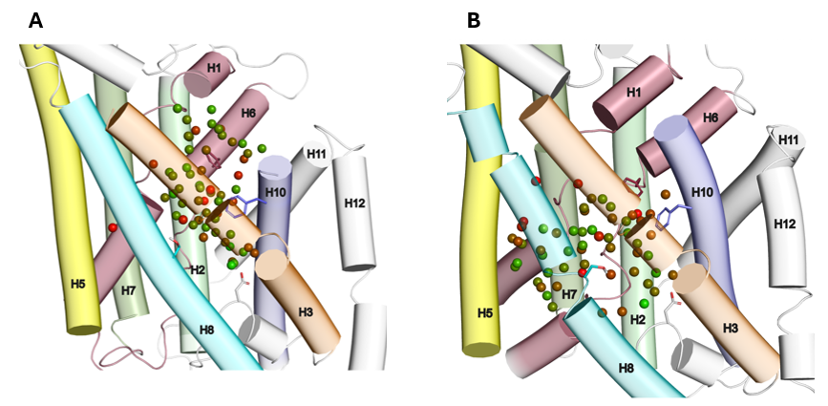
Figure S8. Visualization of the distribution of all hydration sites, independently from their occupancy values, obtained from WaterMap analysis for the experimentally derived structures: (A) OO-Apo and (B) IO-Apo.

In the final frames of rep 3 for cpd1, we noted increased favorable hydration around H8 and unfavorable sites in cavity A (Figure S8,S9), likely due to upper closure, mid-expansion, and lower opening of the transporter. A notable increase in the amount of water bridge between N404 and residues of H3 that was observed in very stable replicas (cpd5 rep2 and apo rep5) in which the intracellular region remained largely closed while the mid-section was expanded (Figure S8,S9) denotes high availability of water molecules in this region.
Cpd12’s naphthalene tail was anchored in the H6/10 sub-pocket. However, hydration sites in this region were largely unaffected. Instead, reorientation of its amino acid head group toward H8 and establishing a stable water bridge with K204 (H5) and T62 (H1, Figure S9), increased hydration sites among cavity B and deeper cavity A. Unlike cpd12, cpd5’s tail displayed high flexibility. We observed that while compound adopted a narrow binding mode (Figure S9), hydration sites around D116 were favored than other clusters in which its tail resided in the upper region and the F400-S338 distance in the mid-section of the transporter was increased to 19.4 Å (Figure S9). However, their "tail” moiety shifts into a deeper region of cavity A, leading to closure of extracellular gating residues (F252 and F400).

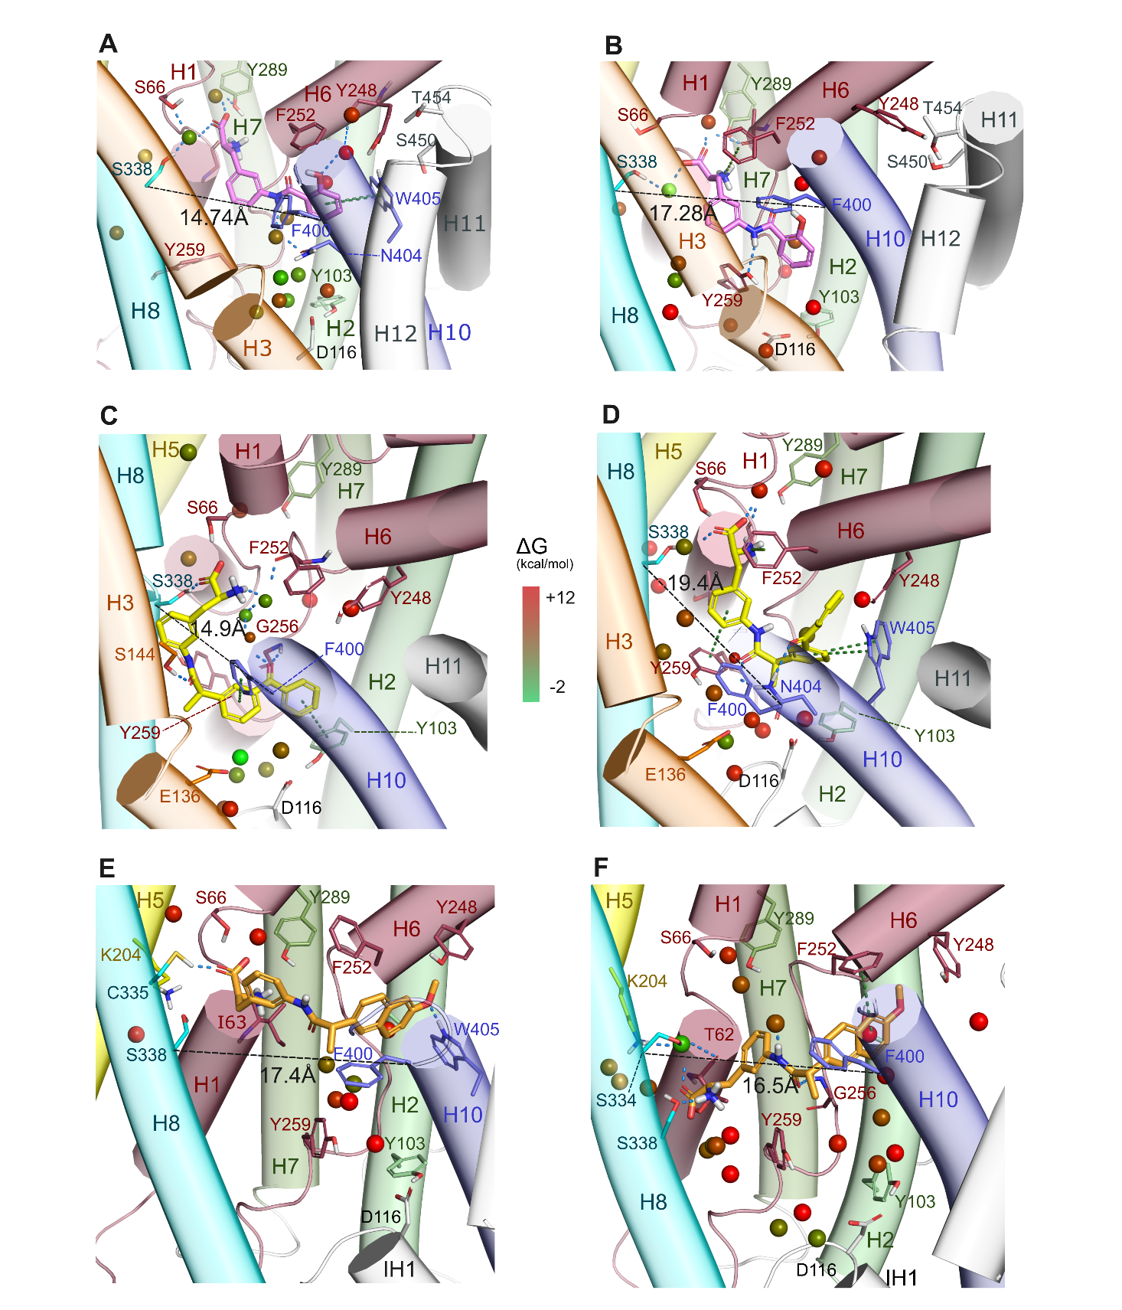

Figure S9. Representation of high occupancy hydration sites (>90% occupancy) of Cpd1 (A-B), cpd5 (C-D) and cpd12 (E-F). Colored by their predicted free binding energy from red (high energy and unfavorable) to green (with low energy and favorable to support water molecules).

Table S9. Free energy (ΔG) of hydration sites for the inward open conformation predicted using WaterMap (see methods), composed by the enthalpic (ΔH) and entropic (ΔS, for 37°C) terms. Occupancy (Occ., 0-1) states for the % of simulated time in which that hydration site was occupied by a water molecule.
IO - apo |  |  |  |  | IO - with Ligand
Site | Occ | dH | -@TdS | dG | Site | Occ | dH | -@TdS | dG
1 | 1 | 8.02 | 4.4 | 12.42 | 1 | 0.99 | -1.01 | 4.7 | 3.69
2 | 0.99 | -0.69 | 4.7 | 4.01 | 2 | 0.99 | -1.74 | 4.34 | 2.6
3 | 0.99 | 3.4 | 3.78 | 7.18 | 3 | 0.97 | -2.29 | 4.66 | 2.37
4 | 0.89 | 0.45 | 3.2 | 3.65 | 4 | 0.96 | 2.81 | 3.91 | 6.72
5 | 0.89 | -0.5 | 3.1 | 2.6 | 5 | 0.96 | -0.91 | 4.22 | 3.31
6 | 0.87 | 5.24 | 4.35 | 9.59 | 6 | 0.94 | -1.29 | 3.95 | 2.66
7 | 0.8 | 0.13 | 2.68 | 2.81 | 7 | 0.89 | 2.88 | 3.58 | 6.46
8 | 0.78 | 1.69 | 2.85 | 4.54 | 8 | 0.89 | 4.87 | 4.41 | 9.28
9 | 0.69 | 1.66 | 2.43 | 4.09 | 9 | 0.87 | 2.55 | 3.27 | 5.82
10 | 0.69 | -1.75 | 2.29 | 0.54 | 10 | 0.86 | -0.07 | 3.34 | 3.27
11 | 0.69 | 0.65 | 2.12 | 2.77 | 11 | 0.85 | -1.69 | 3.22 | 1.53
12 | 0.68 | 0.33 | 2.12 | 2.45 | 12 | 0.81 | 1.26 | 3.22 | 4.48
13 | 0.68 | 0.31 | 1.97 | 2.28 | 13 | 0.8 | 1.63 | 3.03 | 4.66
14 | 0.68 | 0.24 | 2.52 | 2.76 | 14 | 0.73 | -1.76 | 2.74 | 0.98
15 | 0.67 | -2.07 | 2.12 | 0.05 | 15 | 0.73 | 2.53 | 2.63 | 5.16
16 | 0.66 | 2.16 | 2.47 | 4.63 | 16 | 0.69 | 0.84 | 2.14 | 2.98
17 | 0.64 | 2.06 | 1.9 | 3.96 | 17 | 0.66 | -1.94 | 2.07 | 0.13
18 | 0.63 | -0.86 | 1.97 | 1.11 | 18 | 0.65 | 0.71 | 2.34 | 3.05
19 | 0.6 | 1.38 | 1.77 | 3.15 | 19 | 0.65 | -0.9 | 2.03 | 1.13
20 | 0.59 | 0.46 | 1.75 | 2.21 | 20 | 0.62 | 1.63 | 1.75 | 3.38
21 | 0.58 | -3.44 | 2.16 | -1.28 | 21 | 0.62 | 1.69 | 2.27 | 3.96
22 | 0.57 | 2.71 | 1.65 | 4.36 | 22 | 0.61 | 1.81 | 2.15 | 3.96
23 | 0.56 | 3.96 | 1.86 | 5.82 | 23 | 0.59 | 0.21 | 1.92 | 2.13
24 | 0.55 | 1.57 | 1.73 | 3.3 | 24 | 0.58 | 1.52 | 1.76 | 3.28
25 | 0.55 | 1.85 | 1.69 | 3.54 | 25 | 0.55 | -3.27 | 2.07 | -1.2
26 | 0.55 | -0.28 | 2.09 | 1.81 | 26 | 0.54 | -1.45 | 1.73 | 0.28
27 | 0.52 | 2.04 | 1.57 | 3.61 | 27 | 0.52 | 1.99 | 1.55 | 3.54
28 | 0.48 | 0.7 | 1.29 | 1.99 | 28 | 0.49 | 2.46 | 1.46 | 3.92
29 | 0.47 | -0.88 | 1.35 | 0.47 | 29 | 0.48 | 0.68 | 1.42 | 2.1
30 | 0.46 | -0.61 | 1.42 | 0.81 | 30 | 0.43 | 1.48 | 1.32 | 2.8
31 | 0.46 | 2.12 | 1.34 | 3.46 | 31 | 0.43 | 3.03 | 1.48 | 4.51
32 | 0.46 | 4.94 | 1.82 | 6.76 | 32 | 0.4 | 0.65 | 1.09 | 1.74
33 | 0.45 | 0.36 | 1.32 | 1.68 | 33 | 0.39 | 4.84 | 1.22 | 6.06
34 | 0.44 | -0.29 | 1.28 | 0.99 | 34 | 0.39 | -0.88 | 1.16 | 0.28
35 | 0.42 | 2.11 | 1.36 | 3.47 | 35 | 0.38 | 6.48 | 1.47 | 7.95
36 | 0.42 | 0.1 | 1.3 | 1.4 | 36 | 0.38 | 0.02 | 1.21 | 1.23
37 | 0.4 | 2.1 | 1.45 | 3.55 | 37 | 0.37 | 1.45 | 1.01 | 2.46
38 | 0.39 | -0.93 | 1.03 | 0.1 | 38 | 0.36 | 2.51 | 1.02 | 3.53
39 | 0.37 | -0.76 | 1.1 | 0.34 | 39 | 0.33 | 2.91 | 1.46 | 4.37
40 | 0.37 | 1.08 | 1.01 | 2.09 | 40 | 0.33 | 2.83 | 1.37 | 4.2
41 | 0.37 | 3.33 | 1.09 | 4.42 | 41 | 0.32 | 2.56 | 0.94 | 3.5
42 | 0.36 | 3.24 | 1.31 | 4.55 | 42 | 0.32 | -0.4 | 0.91 | 0.51
43 | 0.36 | 3.4 | 1.3 | 4.7 | 43 | 0.3 | 2.66 | 1.1 | 3.76
44 | 0.36 | -0.68 | 1.15 | 0.47 | 44 | 0.28 | 0.03 | 0.86 | 0.89
45 | 0.36 | -0.81 | 1.02 | 0.21
46 | 0.36 | 6.17 | 1.36 | 7.53
47 | 0.36 | 2.43 | 1.04 | 3.47
48 | 0.32 | 4.9 | 0.97 | 5.87
49 | 0.32 | 0.48 | 0.91 | 1.39
50 | 0.31 | 2.69 | 0.89 | 3.58
51 | 0.31 | 0.89 | 0.89 | 1.78
52 | 0.3 | -0.01 | 0.81 | 0.8
53 | 0.29 | 0.38 | 0.9 | 1.28
54 | 0.29 | 3.07 | 0.91 | 3.98
55 | 0.29 | 1.16 | 0.89 | 2.05
56 | 0.29 | 2.97 | 1.2 | 4.17
57 | 0.28 | 0.36 | 0.81 | 1.17

Table S10. Free energy (ΔG) of hydration sites for the outward open conformation predicted using WaterMap (see methods), composed by the enthalpic (ΔH) and entropic (ΔS, for 37°C) terms. Occupancy (Occ., 0-1) states for the % of simulated time in which that hydration site was occupied by a water molecule.
OO - apostructure |  |  |  |  | OO - with Ligand
Site | Occ | dH | -@TdS | dG | Site | Occ | dH | -@TdS | dG
1 | 1 | 3.25 | 4.15 | 7.4 | 1 | 1 | -2.13 | 5.61 | 3.48
2 | 0.99 | 0.71 | 4.78 | 5.49 | 2 | 1 | 6.92 | 5 | 11.92
3 | 0.99 | -5.66 | 4.58 | -1.08 | 3 | 1 | 3.49 | 4.28 | 7.77
4 | 0.92 | -2.53 | 3.42 | 0.89 | 4 | 1 | 1.94 | 4.52 | 6.46
5 | 0.87 | 0.84 | 3.18 | 4.02 | 5 | 0.99 | 1.58 | 3.91 | 5.49
6 | 0.85 | -1.89 | 2.76 | 0.87 | 6 | 0.96 | -4.09 | 4.02 | -0.07
7 | 0.83 | 3.06 | 2.88 | 5.94 | 7 | 0.96 | 5.6 | 3.24 | 8.84
8 | 0.82 | 2.12 | 2.93 | 5.05 | 8 | 0.95 | -3.12 | 3.72 | 0.6
9 | 0.82 | 0.31 | 2.78 | 3.09 | 9 | 0.94 | -0.61 | 3.97 | 3.36
10 | 0.82 | -2.49 | 3.21 | 0.72 | 10 | 0.93 | 6.16 | 3.27 | 9.43
11 | 0.81 | -0.13 | 2.95 | 2.82 | 11 | 0.91 | -2.57 | 3.65 | 1.08
12 | 0.75 | 3.58 | 3.36 | 6.94 | 12 | 0.87 | 1.86 | 3.47 | 5.33
13 | 0.72 | 1.95 | 2.25 | 4.2 | 13 | 0.84 | 3.07 | 2.88 | 5.95
14 | 0.72 | 0.07 | 2.39 | 2.46 | 14 | 0.82 | 3.22 | 3.64 | 6.86
15 | 0.71 | -0.51 | 2.62 | 2.11 | 15 | 0.82 | -0.54 | 3.13 | 2.59
16 | 0.7 | 2.44 | 2.28 | 4.72 | 16 | 0.8 | 5.06 | 3.37 | 8.43
17 | 0.67 | 3.81 | 2.11 | 5.92 | 17 | 0.77 | 1.08 | 2.93 | 4.01
18 | 0.65 | -1.57 | 2.04 | 0.47 | 18 | 0.71 | -2.71 | 2.79 | 0.08
19 | 0.64 | -0.15 | 2.07 | 1.92 | 19 | 0.7 | 0.4 | 2.53 | 2.93
20 | 0.63 | -0.35 | 1.83 | 1.48 | 20 | 0.68 | 1.74 | 2.32 | 4.06
21 | 0.61 | -3.6 | 2.07 | -1.53 | 21 | 0.66 | -1.45 | 2.02 | 0.57
22 | 0.59 | 1.99 | 2.11 | 4.1 | 22 | 0.65 | 2.35 | 2.44 | 4.79
23 | 0.56 | 3.52 | 1.64 | 5.16 | 23 | 0.65 | 2.58 | 2.25 | 4.83
24 | 0.54 | 1.62 | 1.54 | 3.16 | 24 | 0.65 | 4.47 | 2.2 | 6.67
25 | 0.52 | -0.94 | 1.79 | 0.85 | 25 | 0.64 | -4.23 | 2.42 | -1.81
26 | 0.52 | -0.1 | 1.66 | 1.56 | 26 | 0.58 | 0.97 | 2.14 | 3.11
27 | 0.51 | 2.78 | 1.58 | 4.36 | 27 | 0.57 | 2.34 | 1.71 | 4.05
28 | 0.46 | 3.7 | 1.36 | 5.06 | 28 | 0.57 | 1.12 | 1.69 | 2.81
29 | 0.46 | 0.66 | 1.27 | 1.93 | 29 | 0.53 | -2.39 | 2.05 | -0.34
30 | 0.46 | 1.88 | 1.24 | 3.12 | 30 | 0.52 | 1.44 | 1.63 | 3.07
31 | 0.44 | 0.54 | 1.31 | 1.85 | 31 | 0.5 | 2.04 | 2.3 | 4.34
32 | 0.43 | -0.31 | 1.25 | 0.94 | 32 | 0.43 | -0.23 | 1.51 | 1.28
33 | 0.4 | 0.25 | 1.32 | 1.57 | 33 | 0.42 | 0.31 | 1.2 | 1.51
34 | 0.39 | 0.11 | 1.03 | 1.14 | 34 | 0.41 | 3.11 | 1.16 | 4.27
35 | 0.39 | 1.91 | 1.05 | 2.96 | 35 | 0.4 | 7.45 | 1.33 | 8.78
36 | 0.38 | -0.7 | 1.29 | 0.59 | 36 | 0.4 | -0.42 | 1.1 | 0.68
37 | 0.38 | -0.64 | 1.18 | 0.54 | 37 | 0.4 | 0.24 | 1.13 | 1.37
38 | 0.38 | -0.33 | 1.07 | 0.74 | 38 | 0.39 | 0.15 | 1.13 | 1.28
39 | 0.37 | 1.26 | 1.09 | 2.35 | 39 | 0.38 | 0 | 1.18 | 1.18
40 | 0.37 | 1.63 | 1.66 | 3.29 | 40 | 0.35 | -2.16 | 1.29 | -0.87
41 | 0.36 | 2.55 | 0.98 | 3.53 | 41 | 0.35 | 0.85 | 0.96 | 1.81
42 | 0.36 | 0.63 | 0.95 | 1.58 | 42 | 0.34 | 3.23 | 0.85 | 4.08
43 | 0.36 | -0.96 | 0.96 | 0 | 43 | 0.28 | 3.83 | 0.76 | 4.59
44 | 0.34 | 1.04 | 0.9 | 1.94 | 44 | 0.28 | -0.47 | 0.97 | 0.5
45 | 0.34 | 2.56 | 0.96 | 3.52
46 | 0.34 | -1.27 | 1.14 | -0.13
47 | 0.33 | -0.39 | 1.18 | 0.79
48 | 0.33 | 0.84 | 0.95 | 1.79
49 | 0.32 | 5.96 | 0.94 | 6.9
50 | 0.3 | 1.29 | 0.81 | 2.1
51 | 0.3 | 1.68 | 0.87 | 2.55
52 | 0.3 | 2.93 | 0.88 | 3.81
53 | 0.29 | 1.21 | 0.84 | 2.05
54 | 0.29 | 0.98 | 0.76 | 1.74
55 | 0.29 | 0.4 | 0.94 | 1.34
56 | 0.29 | 0.2 | 0.87 | 1.07
57 | 0.28 | 1.05 | 0.75 | 1.8
58 | 0.28 | 1.8 | 0.78 | 2.58

