Supplementary data

Diverse Thermophilic Anaerobes from Indian Hot Springs Exhibit High Potential for Bioenergy Production from Lignocellulosic Biomass

Sai Suresh Hivarkar^{1,2}, Prashant K. Dhakephalkar^{1,2} and Sumit Singh Dagar^{1,2}*

¹Bioenergy Group, Agharkar Research Institute, Pune, India
²Savitribai Phule Pune University, Ganeshkhind, Pune, India

*Corresponding author:
Mailing address: Bioenergy Group, Agharkar Research Institute, Gopal Ganesh Agarkar Road, Pune – 411004, India.
E-mail: ssdagar@aripune.org, dagarsumit@gmail.com

Supplementary tables
Table S1. Summary of the reaction conditions used to estimate enzyme activities.
Enzyme activity | Buffer  (100 mM; pH 7.0±0.1) | Substrate | Reaction mixture |  | Culture supernatant  (ml) | Incubation time  (min)
Enzyme activity | Buffer  (100 mM; pH 7.0±0.1) | Substrate | Buffer  (ml) | Substrate  (mg) | Culture supernatant  (ml) | Incubation time  (min)
CMCase | Sodium phosphate | CMC | 0.15 | 1.5 | 0.05 | 30
Avicelase | Sodium phosphate | Avicel | 0.10 | 1 | 0.10 | 60
Xylanase | Sodium phosphate | Xylan | 0.15 | 1.5 | 0.05 | 30
β-glucosidase | Sodium phosphate | ρ-Nitrophenyl  β-D-glucopyranoside | 0.15 | 0.45 | 0.05 | 10
Acetyl esterase | Sodium phosphate | ρ-Nitrophenyl acetate | 1.9 | 0.36 | 0.10 | 10
ρ-coumaroyl esterase | 3-Morpholinopropanesulfonic acid | De-starched wheat bran | 0.5 | 50 | 0.50 | 30
Feruloyl esterase | 3-Morpholinopropanesulfonic acid | De-starched wheat bran | 0.5 | 50 | 0.50 | 30

Table S2. Summary of the geographical location and physicochemical characteristics of different hot springs.
Name of hot spring | State | Co-ordinates |  | pH  (±0.2) | Temperature  (±2°C) | Conductivity  (±10 µS) | Anions  (mg/Kg)
Name of hot spring | State | Latitude | Longitude
Aravali | Maharashtra | 17°18'58.6"N | 73°31'19.8"E | 9.1 | 42 | 2131 | 188 (c), 62 (s)
Chopada | Maharashtra | 21°15'57.6"N | 75°25'53.7"E | 8.8 | 41 | 421 | 496 (c)
Chumathang | Ladakh | 33°21'37.1"N | 78°19'23.7"E | 8.3 | 85 | 1601 | 95 (c), 137 (s)
Jakrem | Meghalaya | 25°24'26.0"N | 91°32'27.5"E | 8.9 | 45 | 1230 | 15 (c), 18 (s)
Puga | Ladakh | 33°13'21.6"N | 78°19'06.0"E | 8.8 | 82 | 2765 | 108 (c), 138 (s)
Rajwadi | Maharashtra | 17°14'12.4"N | 73°33'50.0"E | 8.0 | 51 | 1614 | 78 (c), 11 (s)
Shahada | Maharashtra | 21°43'45.0"N | 74°26'36.9"E | 8.2 | 25 | 384 | 67 (c), 138 (n)
Tural | Maharashtra | 17°14'57.6"N | 73°33'15.4"E | 7.9 | 61 | 1674 | 89 (c)
Unhavare | Maharashtra | 17°36'11.2"N | 73°19'10.7"E | 7.8 | 78 | 3999 | 294 (c), 18 (s)
Unkeshwar | Maharashtra | 19°51'21.7"N | 78°15'01.6"E | 7.7 | 30 | 1254 | 45 (p)
Legends: nd, not determined; c, chloride; n, nitrate; p, phosphate; s, sulphate
Permissible limit by World Health Organization (2017): Chloride, 250 mg/Kg; Nitrate, 50 mg/Kg; Sulphate, 250 mg/Kg

Table S3. Summary of positive enrichments (based on turbidity and ≥10% hydrogen) obtained from different hot springs grown under varying culture conditions.
Substrate | Incubation temperature (℃) | Name of the hot spring
Substrate | Incubation temperature (℃) | Aravali | Chopada | Chumathang | Jakrem | Puga | Rajwadi | Shahada | Tural | Unhavare | Unkeshwar
Cellulose | 40 | – | – | – | – | – | – | – | – | – | –
Cellulose | 55 | – | + | – | – | – | + | – | + | + | –
Cellulose | 70 | – | – | – | – | – | – | – | + | + | –
Cellulose | 85 | – | + | – | – | + | – | – | – | + | –
Xylan | 40 | + | – | – | – | – | – | – | – | – | –
Xylan | 55 | – | + | + | – | + | + | – | + | + | –
Xylan | 70 | – | + | + | – | – | – | – | + | + | –
Xylan | 85 | – | + | + | – | – | – | – | – | + | –
NDF | 40 | – | – | – | – | – | – | – | – | – | –
NDF | 55 | – | + | – | – | – | – | + | – | – | –
NDF | 70 | – | + | – | – | – | – | – | – | – | –
NDF | 85 | – | + | + | – | + | – | – | – | – | –
Lignin | 40 | – | – | – | – | – | – | – | – | – | –
Lignin | 55 | – | – | – | – | – | – | – | – | – | –
Lignin | 70 | – | – | – | – | – | – | – | – | – | –
Lignin | 85 | – | – | – | – | – | – | – | – | – | –
Legends: +, positive enrichment; –, negative enrichment

Supplementary Figures
Figure S1. Representative phase contrast images of Sporanaerobium hydrogeniformans XHS1971^{T} (a), Caloramator proteoclasticus strain AMU5567-5 (b), Caloramator coolhaasii strain XMT5567-6 (c), Thermoanaerobacter wiegelii strain XMU7067-6 (d), Bacillus thermozeamaize strain XMU8567-5 (e) and Caldicoprobacter guelmensis strain CMU5567-1 (f). Gram staining images of Caldibacillus thermoamylovorans XLC5596-1 (g), Thermoanaerobacterium aotearoense strain AMT5567-1 (h), Seramator thermalis strain XHS2771 (i), Pseudoclostridium thermosuccinogenes strain CUC_{P}55106-1 (j), Limnochordaceae bacterium strain XUC_{P}55106-1 (k) and Lacrimispora indolis strain XHS1791 (l)
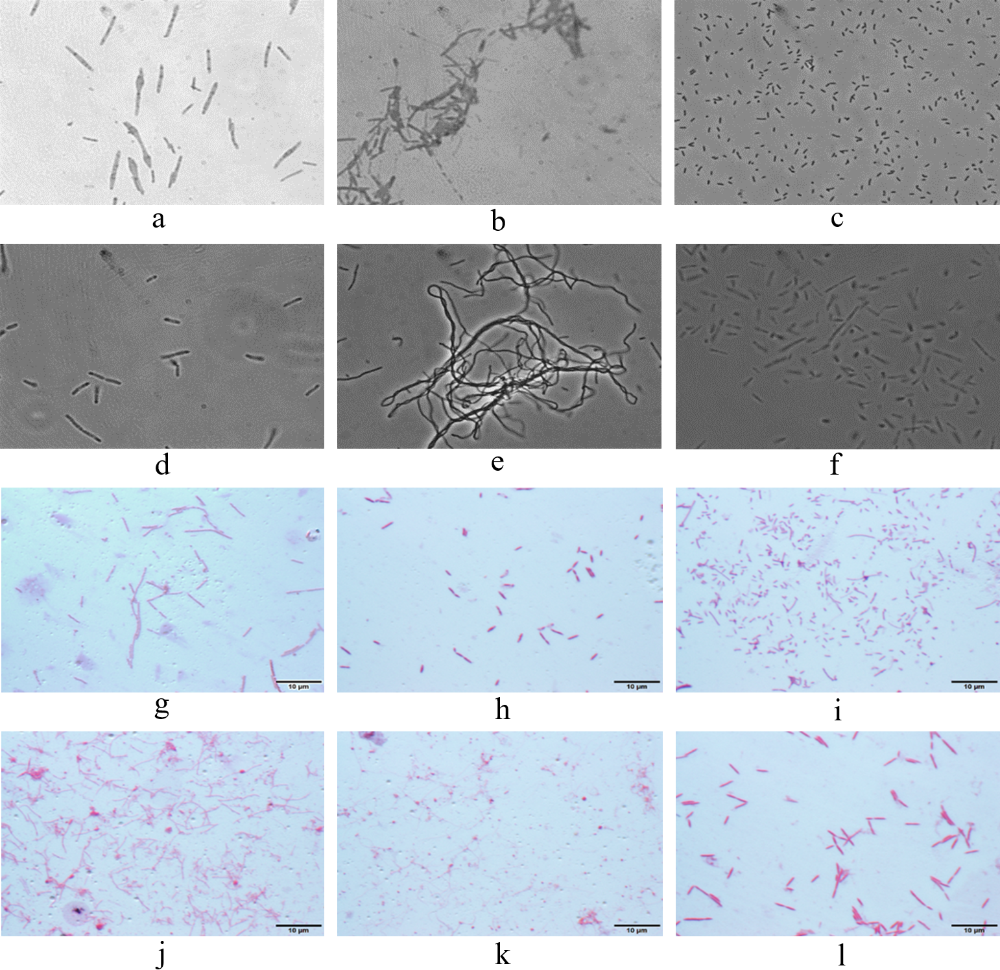

Figure S2. Representative RFLP gel images of cultures isolated from different hot springs. (A) Cultures isolated from cellulose-based enrichments and (B) Cultures isolated from xylan-based enrichments. The initial and last wells of each row in both pictures contain 100 bp and 50 bp ladders, respectively.
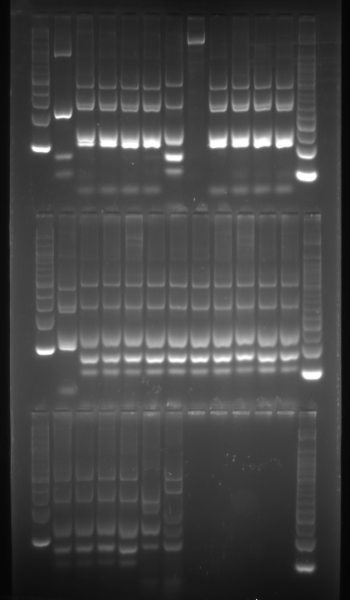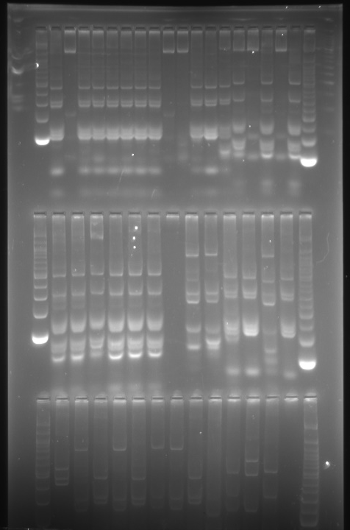
- (B)

Figure S3. Phylogenetic tree based on 16S rRNA gene sequences showing the phylogenetic position of Bacillus thermozeamaize strain XMU8567-5 (in blue) among the closest type strain and non-type strain sequences. Relatedness was inferred using the maximum-likelihood method in W-IQ-TREE and rooted with Staphylococcus aureus ATCC 12600^{T}. The GenBank accession number of each strain is listed in parentheses. The habitat of the sequence is written in orange. The scale bar indicates 0.02 nucleotide substitutions per site.
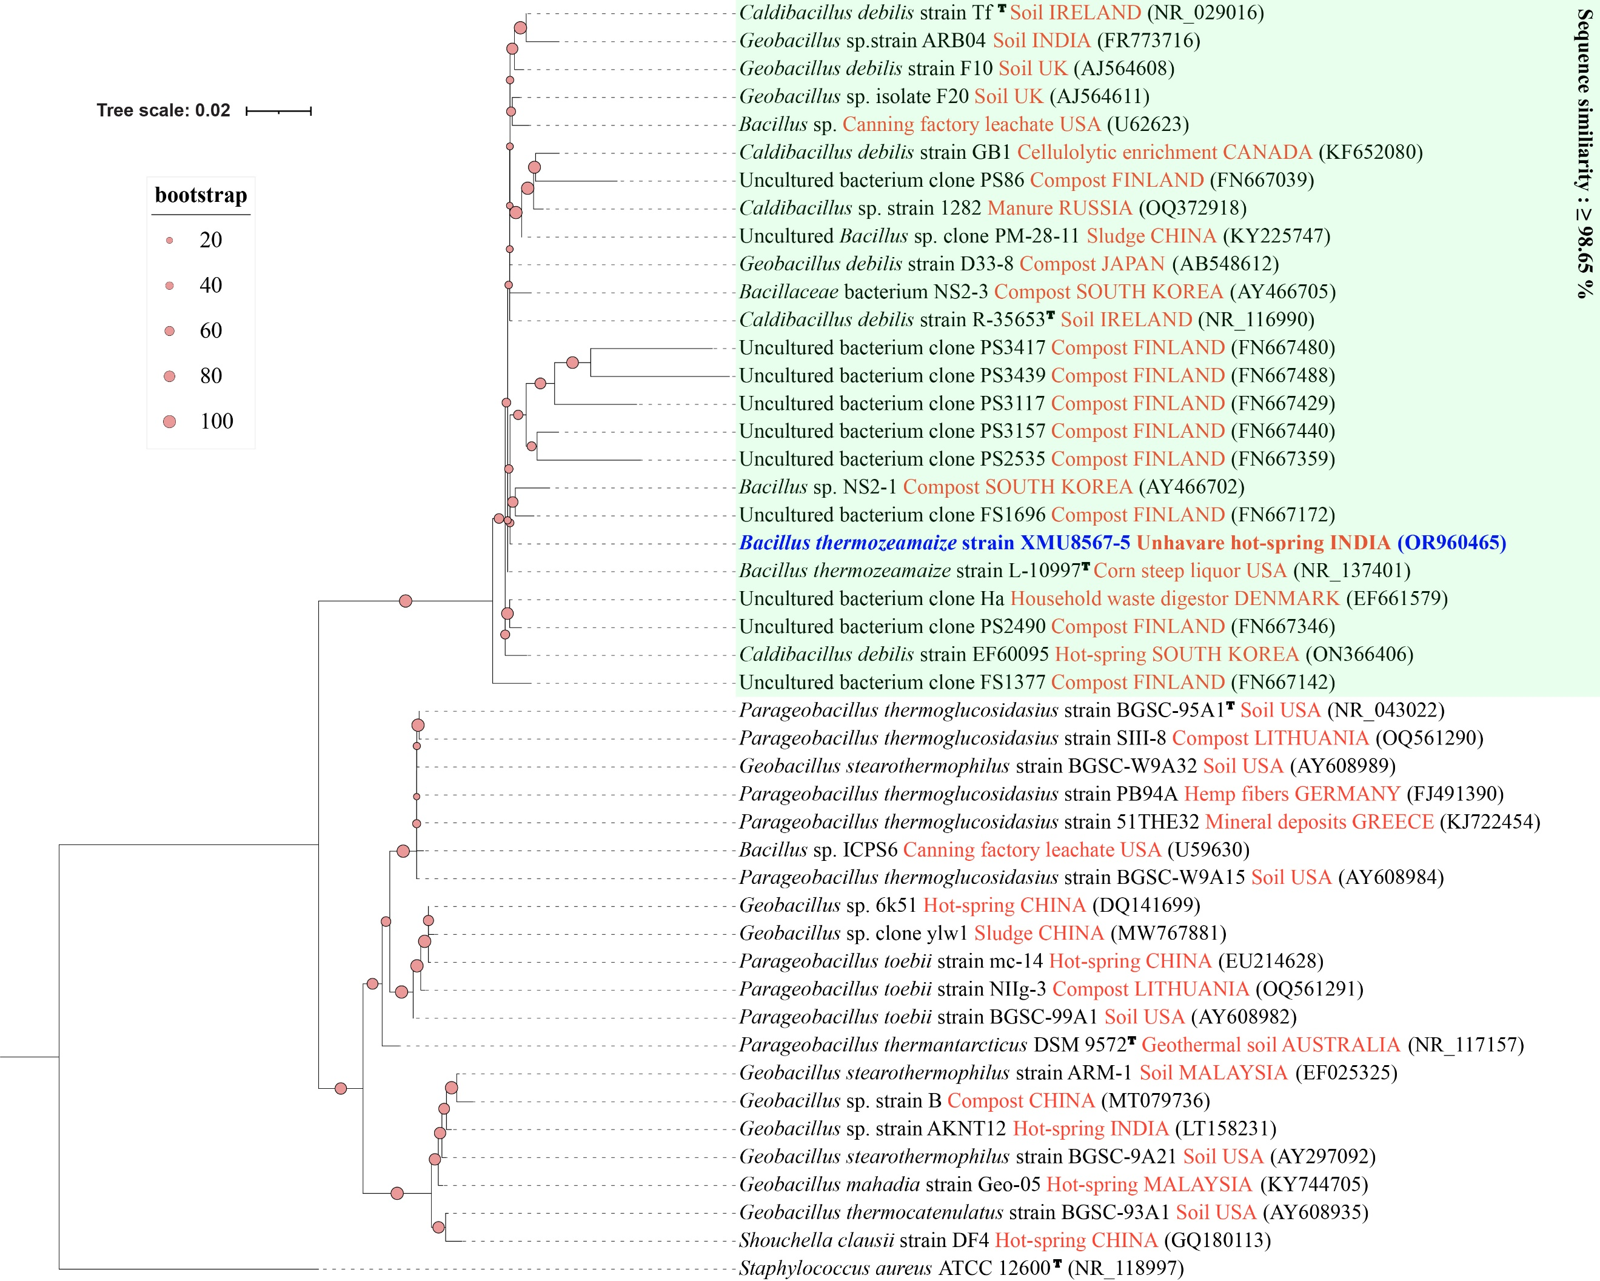

Figure S4. Phylogenetic tree based on 16S rRNA gene sequences showing the phylogenetic position of Caldibacillus thermoamylovorans strains (in blue) among the closest type strain and non-type strain sequences. Relatedness was inferred using the maximum-likelihood method in W-IQ-TREE and rooted with Corynebacterium glutamicum ATCC 13032^{T}. The GenBank accession number of each strain is listed in parentheses. The habitat of the sequence is written in orange. The scale bar indicates 0.02 nucleotide substitutions per site.
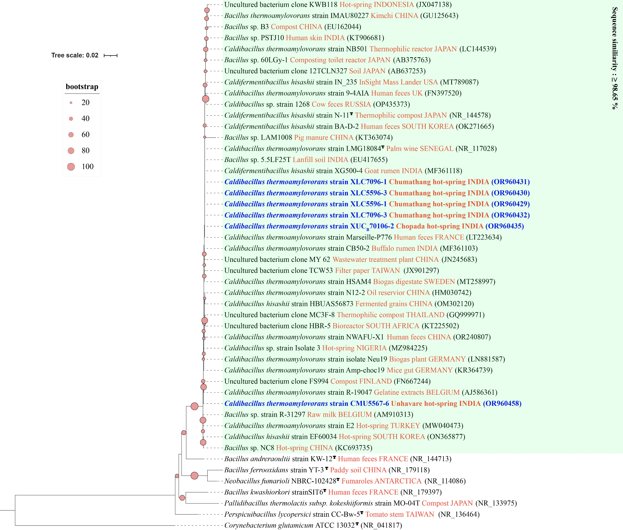

Figure S5. Phylogenetic tree based on 16S rRNA gene sequences showing the phylogenetic position of Caldicoprobacteraceae bacterium strains (in blue) among the closest type strain and non-type strain sequences. Relatedness was inferred using the maximum-likelihood method in W-IQ-TREE and rooted with Corynebacterium glutamicum ATCC 13032^{T}. The GenBank accession number of each strain is listed in parentheses. The habitat of the sequence is written in orange. The scale bar indicates 0.05 nucleotide substitutions per site.

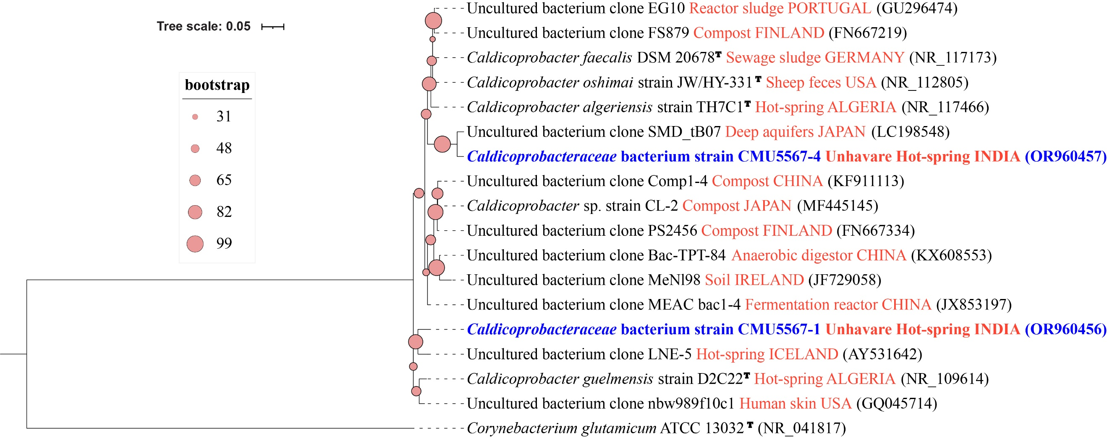

Figure S6. Phylogenetic tree based on 16S rRNA gene sequences showing the phylogenetic position of Caloramator coolhaasii, Caloramator proteoclasticus, and Caloramator viterbiensis strains (in blue) among the closest type strain and non-type strain sequences. Relatedness was inferred using the maximum-likelihood method in W-IQ-TREE and rooted with Corynebacterium glutamicum ATCC 13032^{T}. The GenBank accession number of each strain is listed in parentheses. The habitat of the sequence is written in orange. The scale bar indicates 0.05 nucleotide substitutions per site.

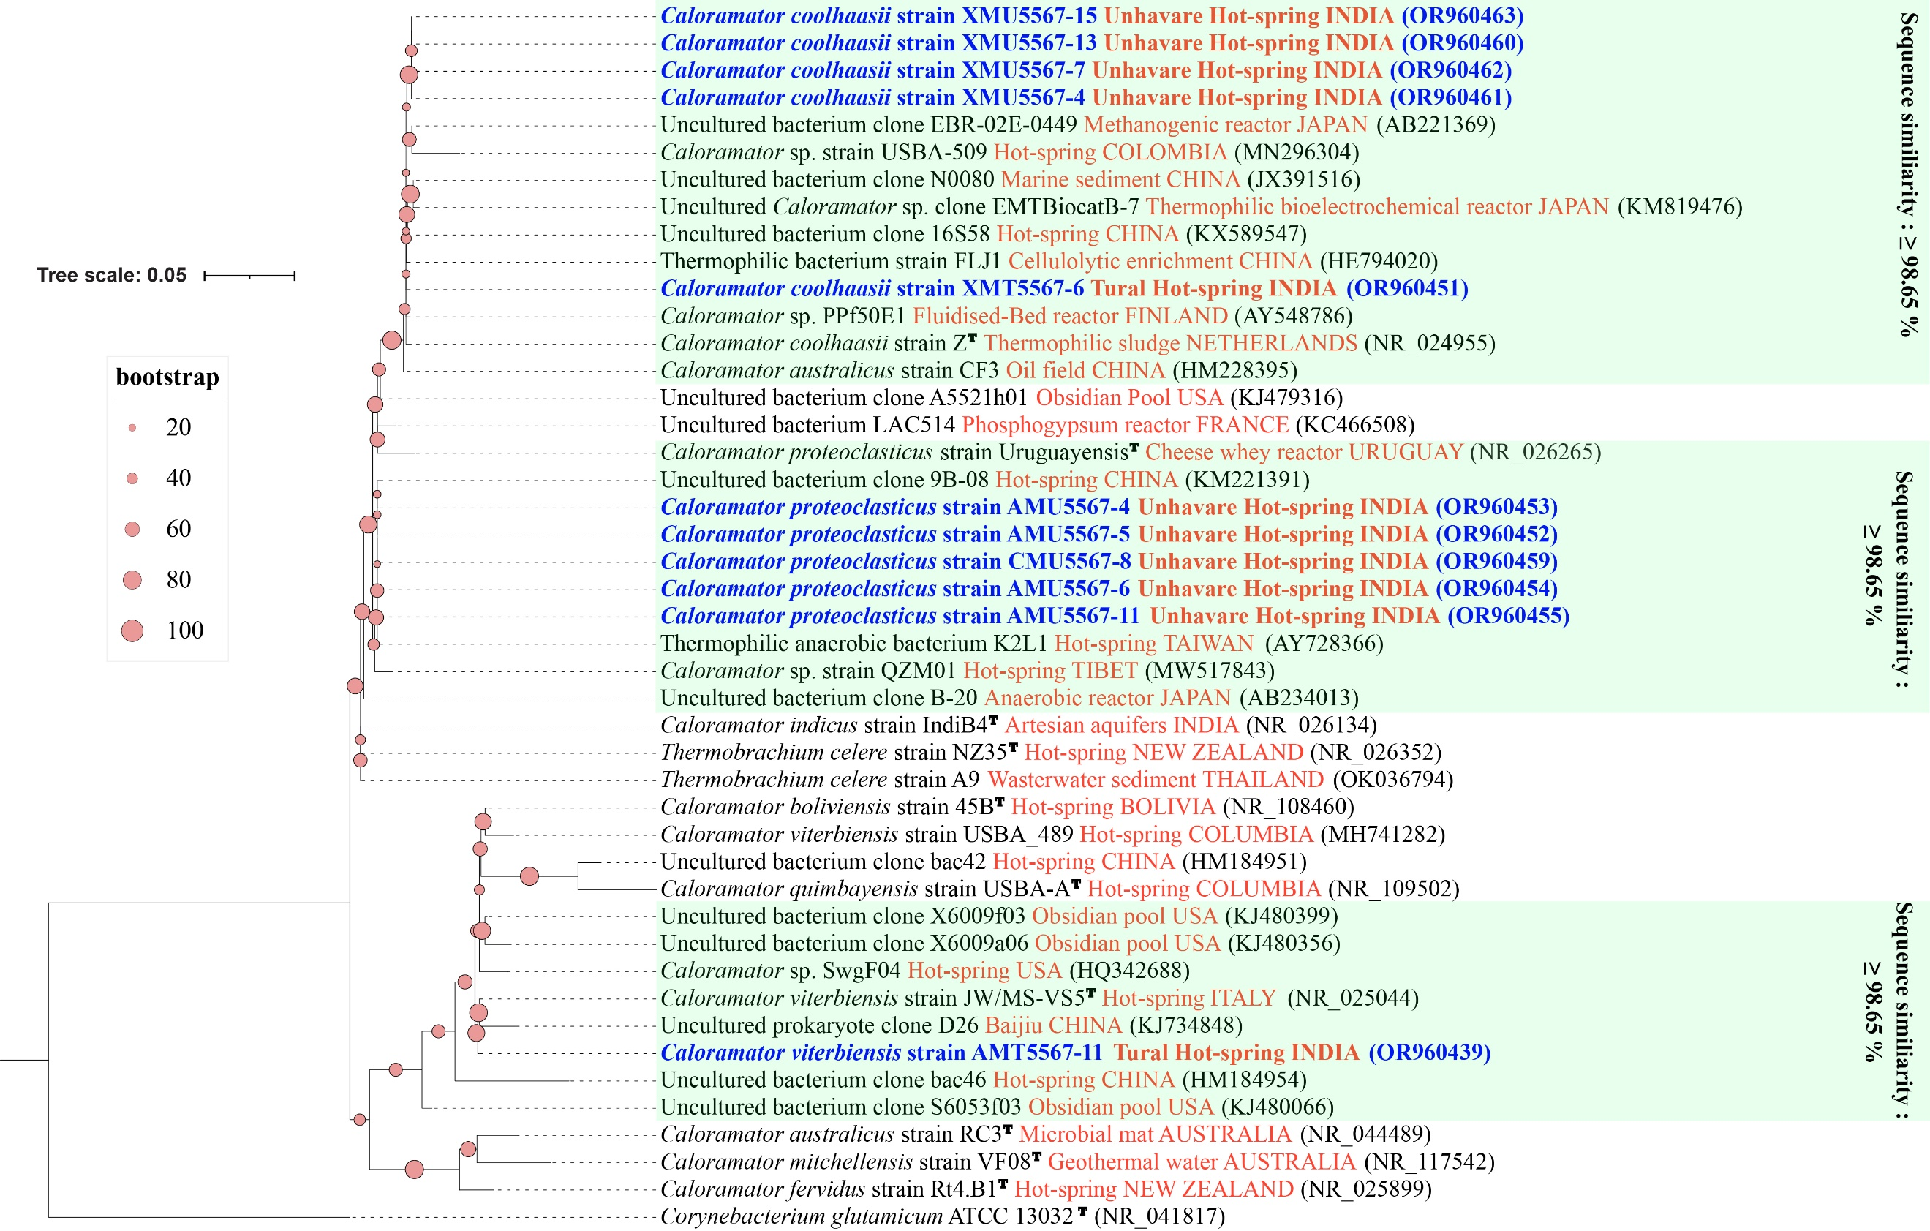

Figure S7. Phylogenetic tree based on 16S rRNA gene sequences showing the phylogenetic position of Clostridium thermobutyricum strain XMR5567-3 (in blue) among the closest type strain and non-type strain sequences. Relatedness was inferred using the maximum-likelihood method in W-IQ-TREE and rooted with Sporohalobacter salinus DSM 26781^{T}. The GenBank accession number of each strain is listed in parentheses. The habitat of the sequence is written in orange. The scale bar indicates 0.05 nucleotide substitutions per site.

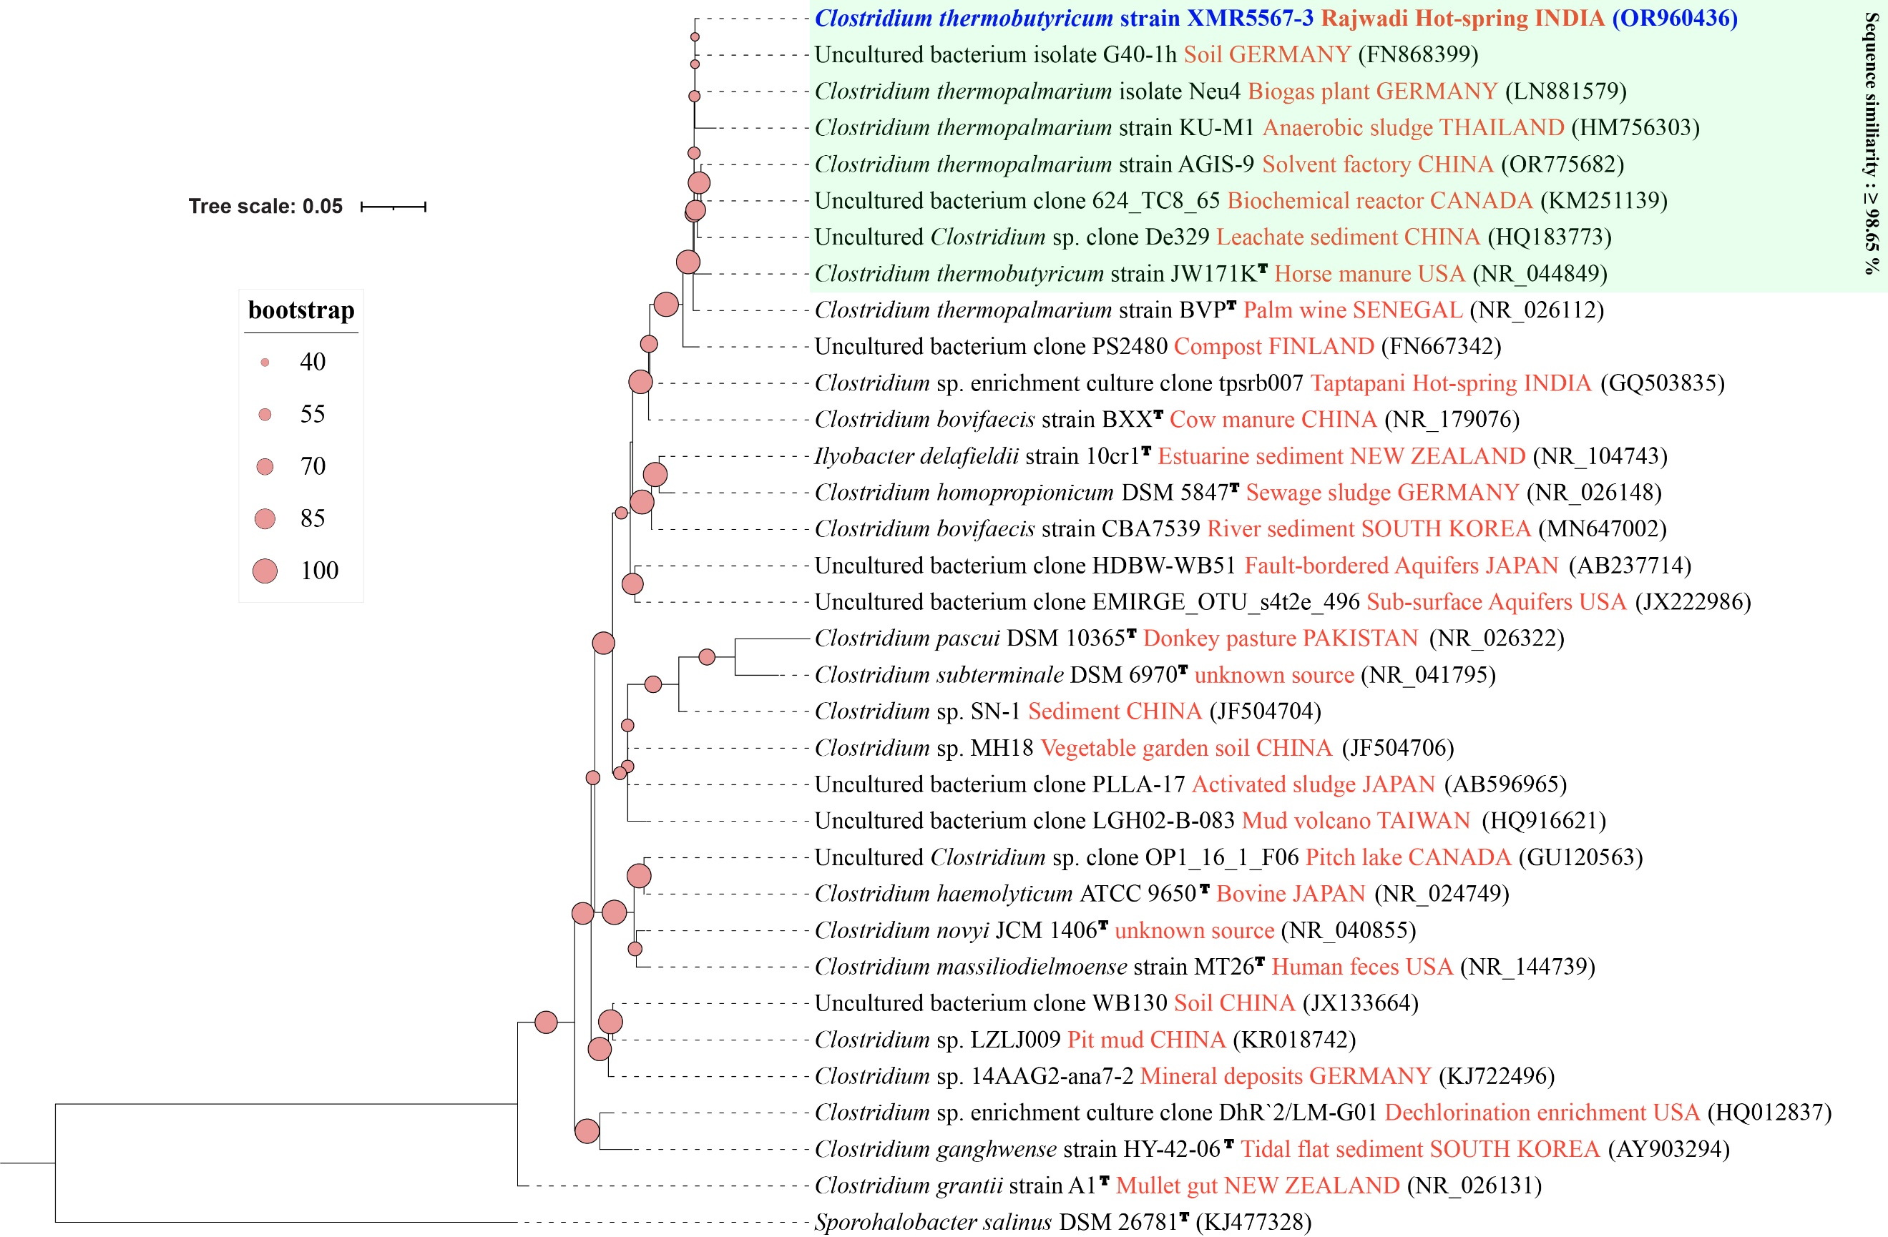

Figure S8. Phylogenetic tree based on 16S rRNA gene sequences showing the phylogenetic position of Lacrimispora indolis and Lacrimispora celerecrescens strains (in blue) among the closest type strain and non-type strain sequences. Relatedness was inferred using the maximum-likelihood method in W-IQ-TREE and rooted with Caldicoprobacter algeriensis DSM 22661^{T}. The GenBank accession number of each strain is listed in parentheses. The habitat of the sequence is written in orange. The scale bar indicates 0.05 nucleotide substitutions per site.

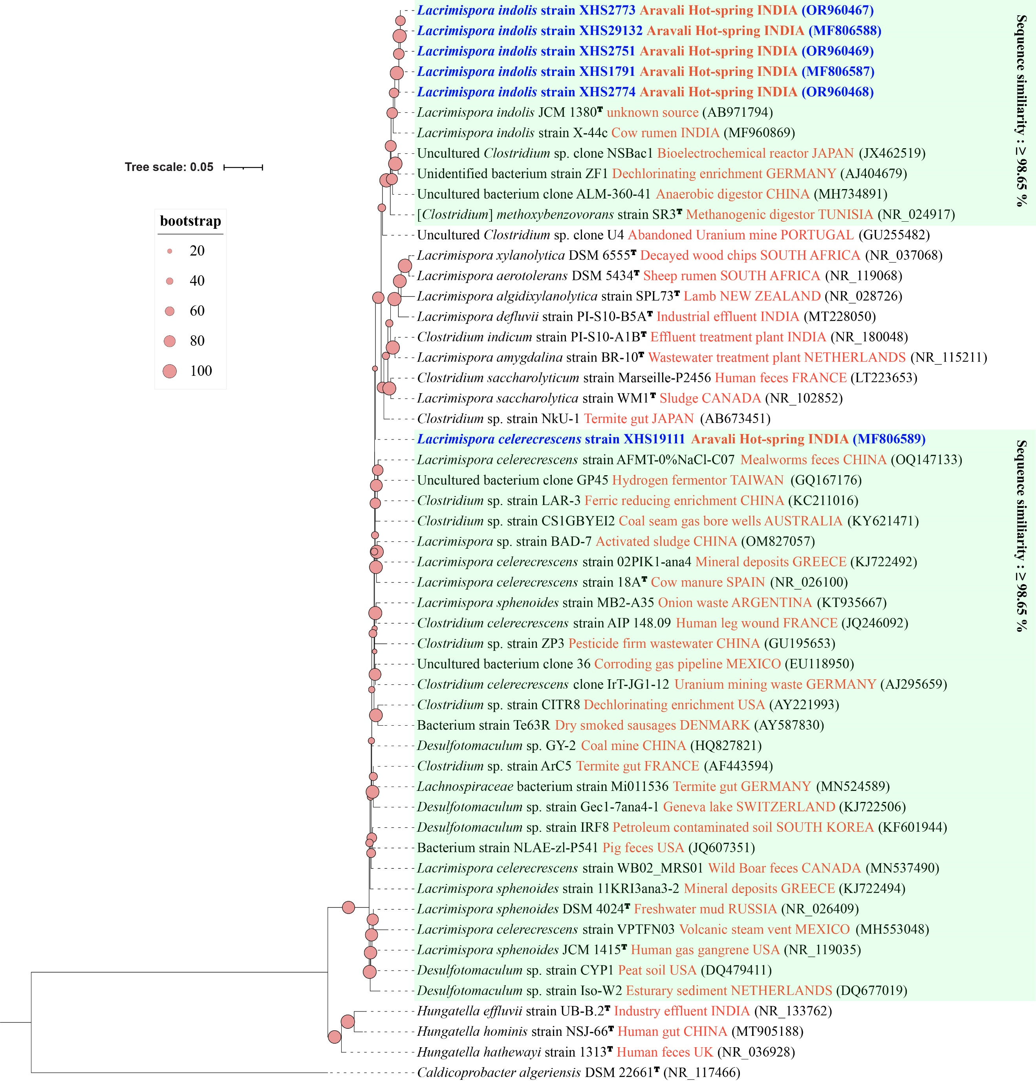

Figure S9. Phylogenetic tree based on 16S rRNA gene sequences showing the phylogenetic position of Limnochordaceae bacterium strain XUC_{P}55106-1 (in blue) among the closest type strain and non-type strain sequences. Relatedness was inferred using the maximum-likelihood method in W-IQ-TREE and rooted with Acetivibrio thermocellus ATCC 27405^{T}. The GenBank accession number of each strain is listed in parentheses. The habitat of the sequence is written in orange. The scale bar indicates 0.02 nucleotide substitutions per site.

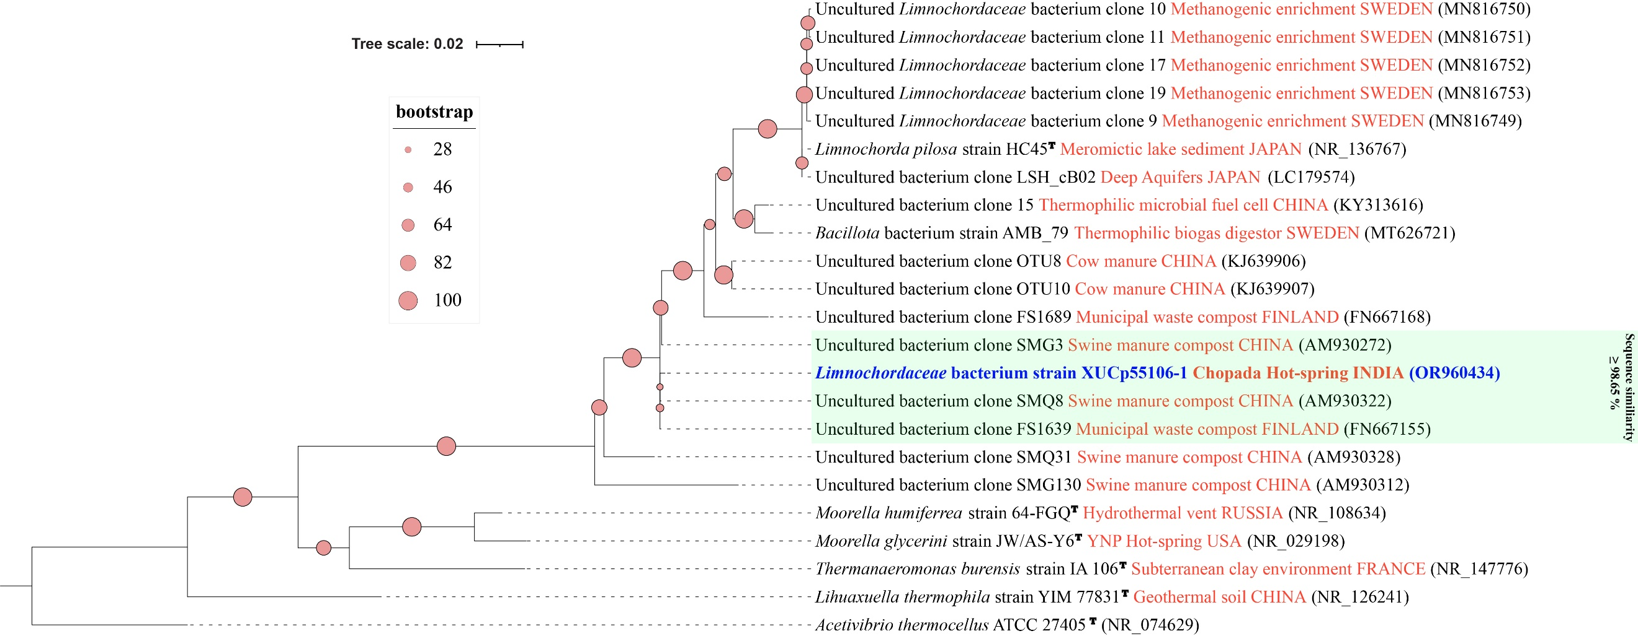

Figure S10. Phylogenetic tree based on 16S rRNA gene sequences showing the phylogenetic position of Pseudoclostridium thermosuccinogenes strains (in blue) among the closest type strain and non-type strain sequences. Relatedness was inferred using the maximum-likelihood method in W-IQ-TREE and rooted with Sporohalobacter salinus DSM 26781^{T}. The GenBank accession number of each strain is listed in parentheses. The habitat of the sequence is written in orange. The scale bar indicates 0.1 nucleotide substitutions per site.

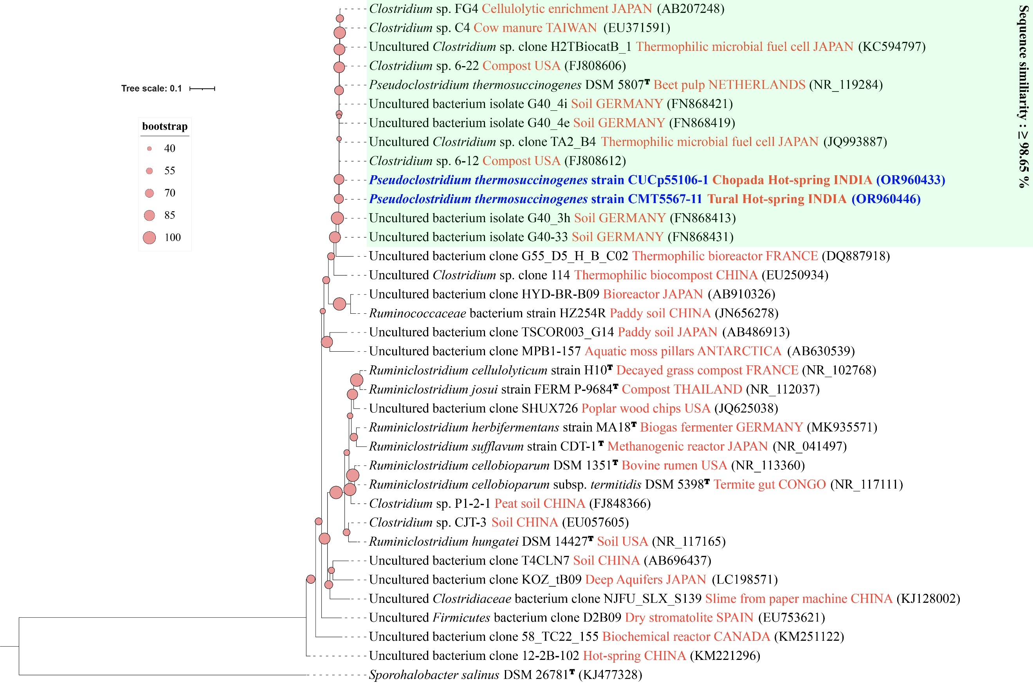

Figure S11. Phylogenetic tree based on 16S rRNA gene sequences showing the phylogenetic position of Seramator thermalis strain XHS2771 (in blue) among the closest type strain and non-type strain sequences. Relatedness was inferred using the maximum-likelihood method in W-IQ-TREE and rooted with Prevotella herbatica DSM 112534^{T}. The GenBank accession number of each strain is listed in parentheses. The habitat of the sequence is written in orange. The scale bar indicates 0.02 nucleotide substitutions per site.

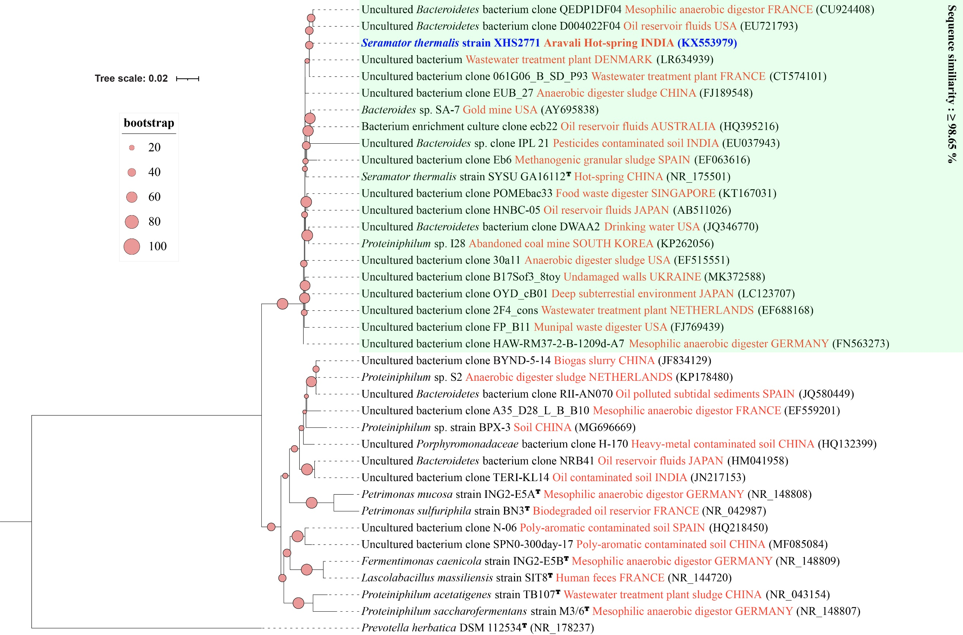

Figure S12. Phylogenetic tree based on 16S rRNA gene sequences showing the phylogenetic position of Sporanaerobium hydrogeniformans strain XHS1771^{T} (in blue) among the closest type strain and non-type strain sequences. Relatedness was inferred using the maximum-likelihood method in W-IQ-TREE and rooted with Thermoanaerobacter ethanolicus ATCC 31550^{T}. The GenBank accession number of each strain is listed in parentheses. The habitat of the sequence is written in orange. The scale bar indicates 0.1 nucleotide substitutions per site.

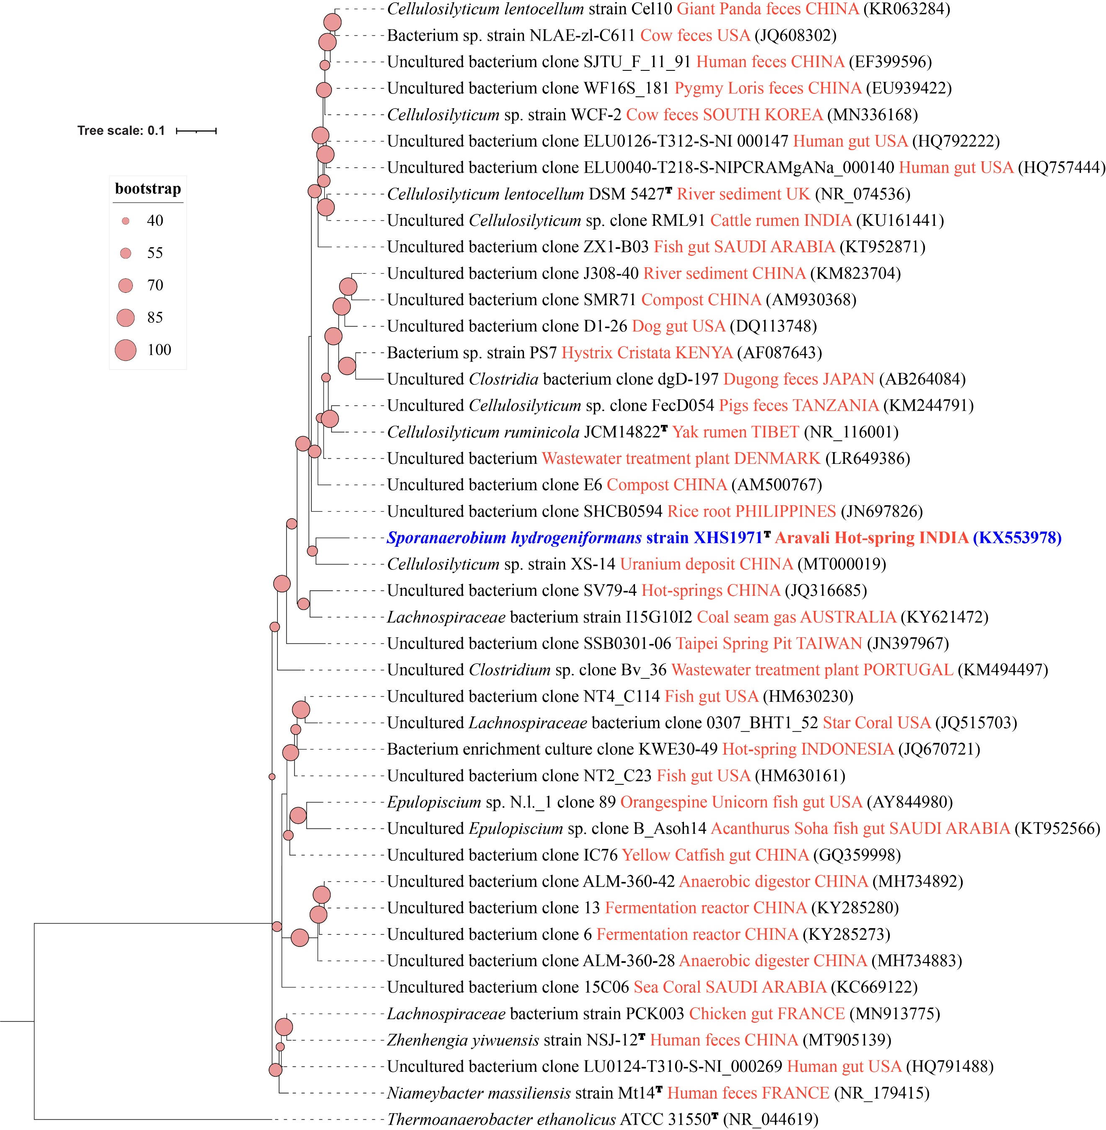

Figure S13. Phylogenetic tree based on 16S rRNA gene sequences showing the phylogenetic position of Tepidimicrobium ferriphilum strains (in blue) among the closest type strain and non-type strain sequences. Relatedness was inferred using the maximum-likelihood method in W-IQ-TREE and rooted with Anaerosalibacter massiliensis DSM 27308^{T}. The GenBank accession number of each strain is listed in parentheses. The habitat of the sequence is written in orange. The scale bar indicates 0.02 nucleotide substitutions per site.

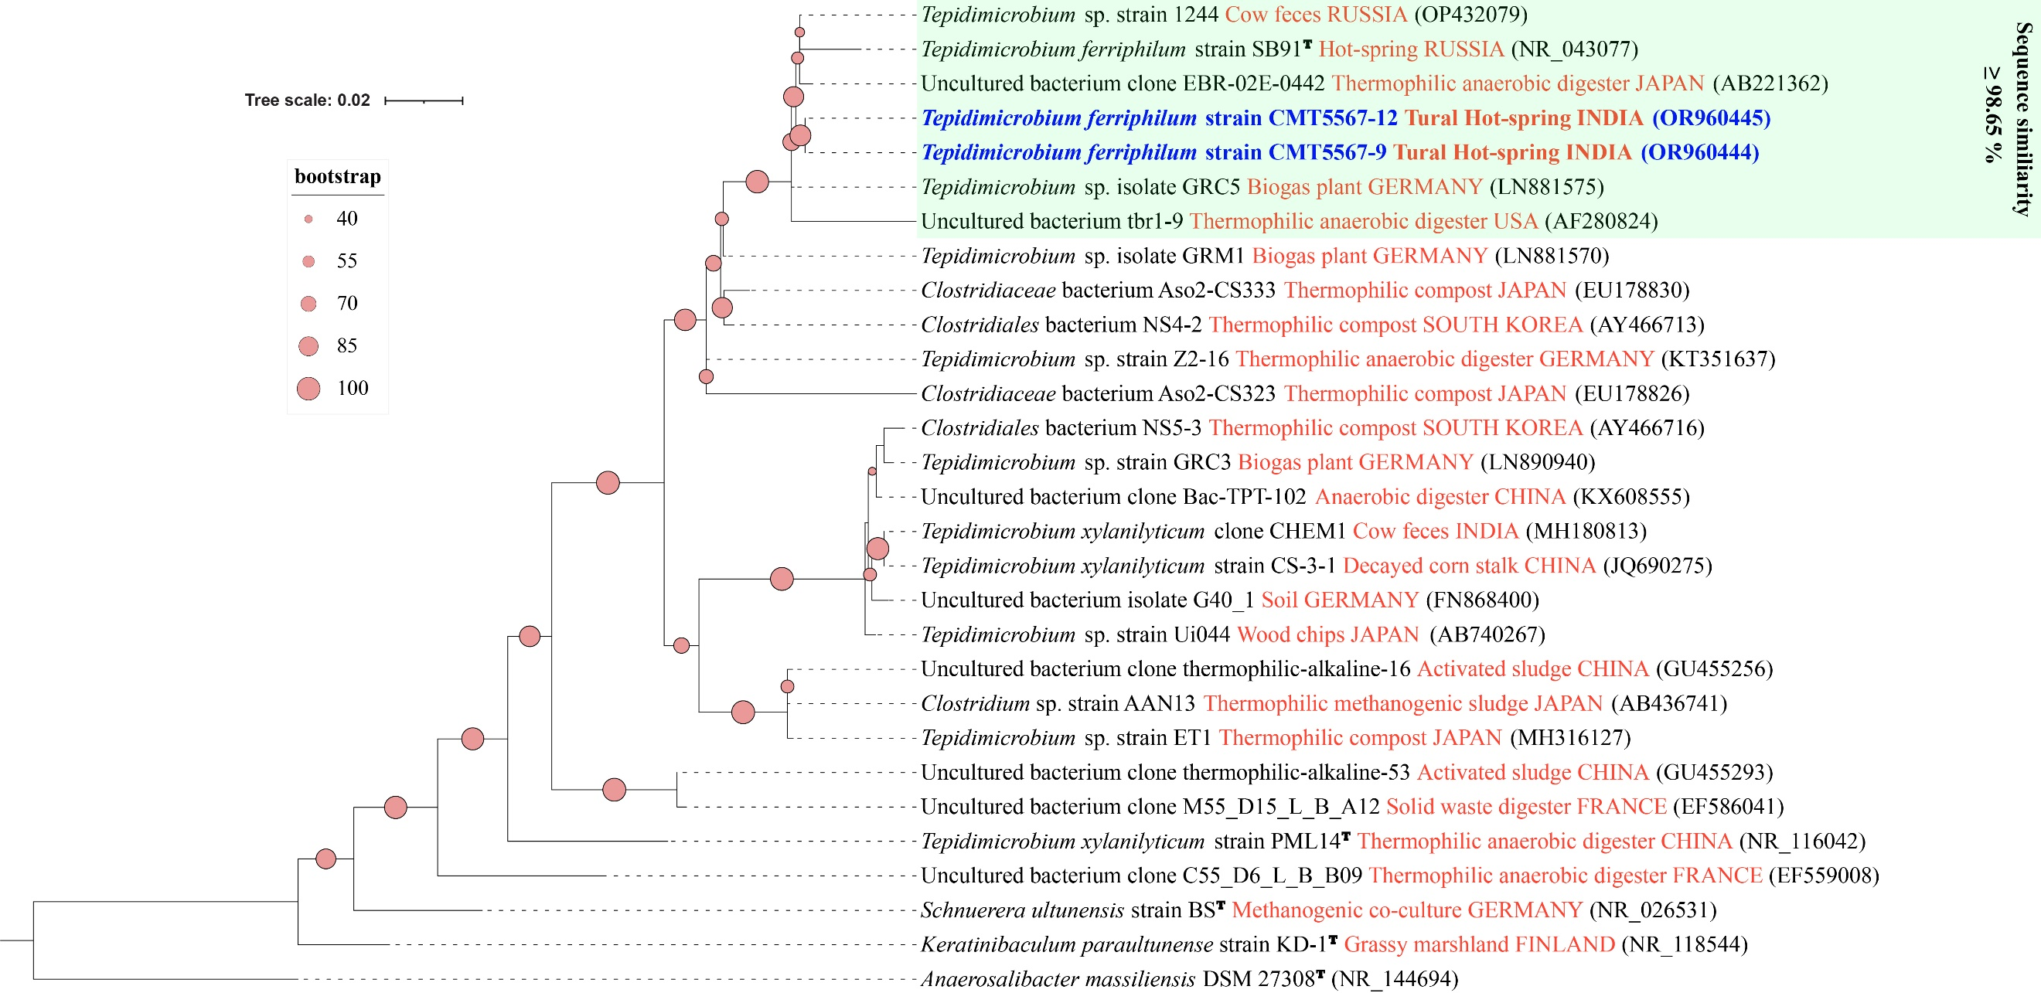

Figure S14. Phylogenetic tree based on 16S rRNA gene sequences showing the phylogenetic position of Thermoanaerobacter wiegelii strain XMU7067-6 (in blue) among the closest type strain and non-type strain sequences. Relatedness was inferred using the maximum-likelihood method in W-IQ-TREE and rooted with Pelotomaculum propionicicum DSM 15578^{T}. The GenBank accession number of each strain is listed in parentheses. The habitat of the sequence is written in orange. The scale bar indicates 0.02 nucleotide substitutions per site.

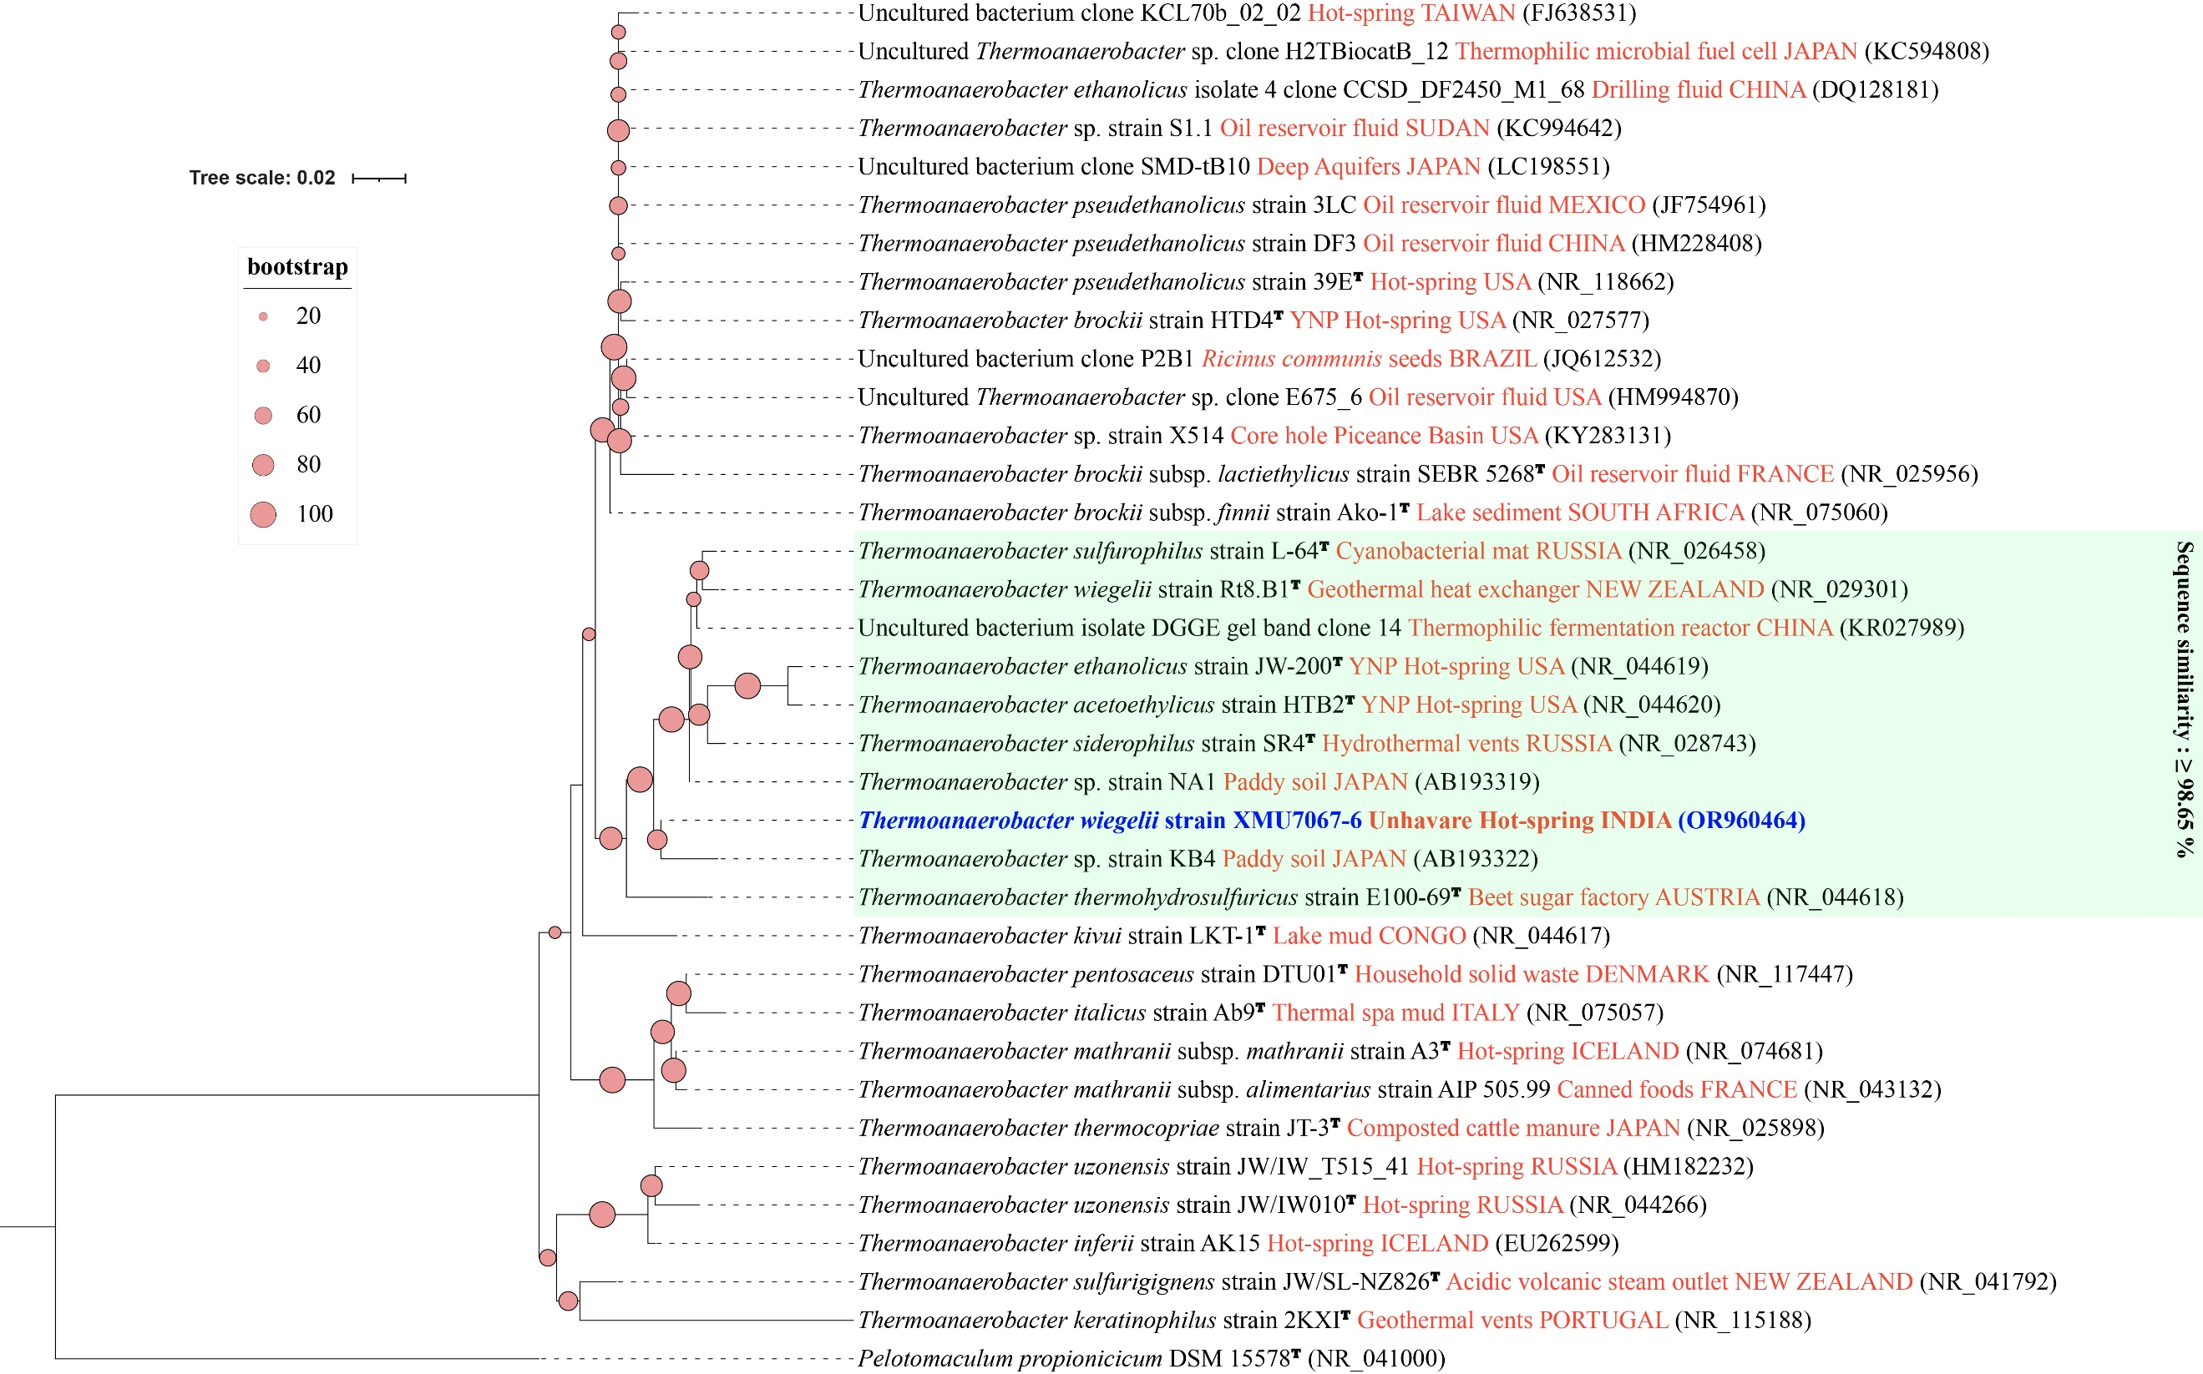

Figure S15. Phylogenetic tree based on 16S rRNA gene sequences showing the phylogenetic position of Thermoanaerobacterium aotearoense, Thermoanaerobacterium butyriciformans, and Thermoanaerobacterium thermostercoris strains (in blue) among the closest type strain and non-type strain sequences. Relatedness was inferred using the maximum-likelihood method in W-IQ-TREE and rooted with Thermoanaerobacter brockii DSM 1457^{T}. The GenBank accession number of each strain is listed in parentheses. The habitat of the sequence is written in orange. The scale bar indicates 0.02 nucleotide substitutions per site.

