Supporting Information
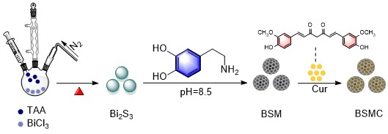
Fig. S1. Schematic diagram of synthesis of BSMC NPs

Fig. S2. SEM images of BSM NPs

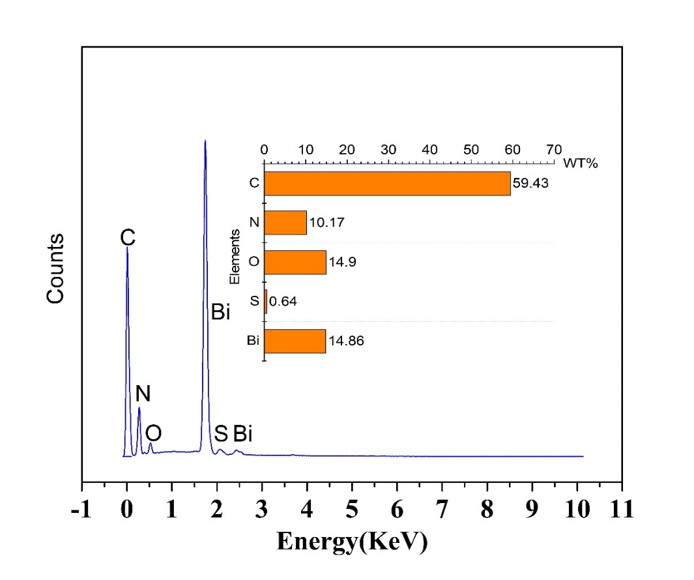
Fig. S3. Elemental analysis of BSMC NPs.

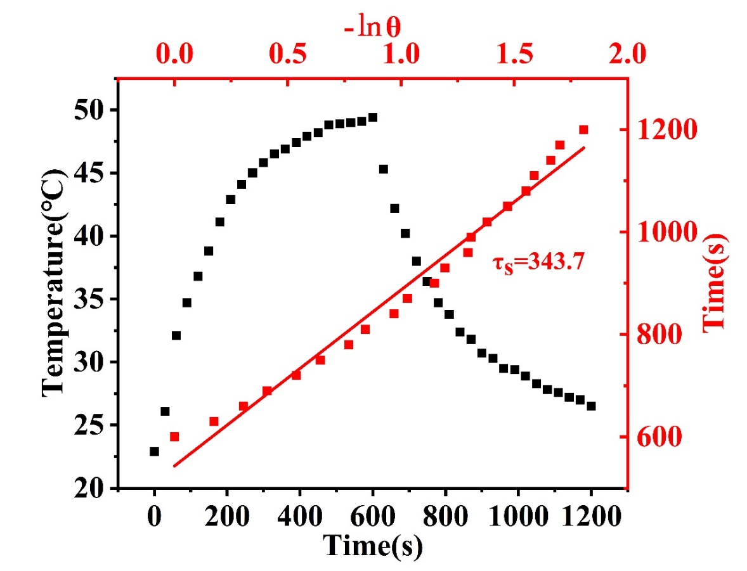
Fig. S4. Photothermal conversion efficiency of BSCM NPs.

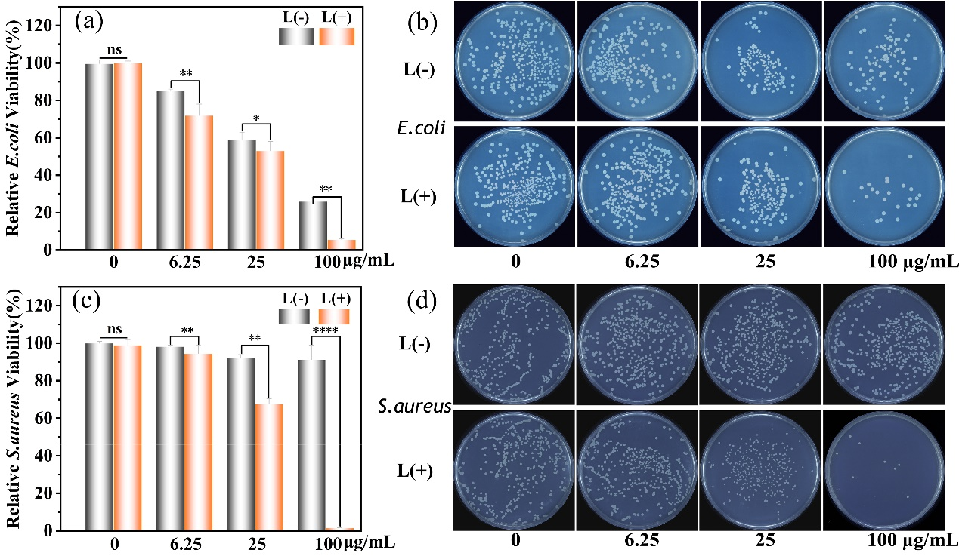
Fig. S5. Relative viability of E. coli (a) and S. aureus (c) incubated with BSMC with or without 808 nm laser irradiation. Photographs of bacterial colonies of E. coli (b) and S. aureus (d).

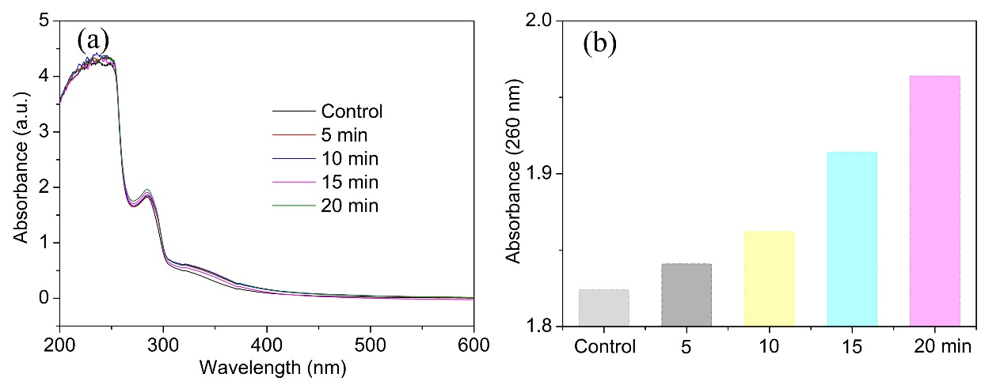
Fig. S6. Leak of cytoplasmic contents of S. aureus. (a) Absorption curve of cytoplasmic contents with different exposure times. (b) The intensity change in absorption at 260 nm.

