Supplementary Information for
Electrodepositing freestanding ultrathin membranes at the air-water interface
Aoran Cui^{1,2§}, Xiao Hong^{1§},Yue Liu^{1§}, Kenji Mochizuki^{3§}, Xuan Zhang³, Ning An¹, Xueyan Chen¹, Mi Yan¹, Zhaoyue Xia¹, Qilong Zhang^{1,4}, and Shikuan Yang^{1,2,5}*
¹School of Materials Science and Engineering, Zhejiang University, Hangzhou 310027, China
²Department of Medical Oncology, The First Affiliated Hospital, Zhejiang University School of Medicine, Hangzhou 310003, China
³Department of Chemistry, Zhejiang University, Hangzhou, 310028, China
⁴State Key Laboratory of Silicon Materials, School of Materials Science and Engineering, Zhejiang University, Hangzhou 310027, China
⁵State Key Laboratory of Baiyunobo Rare Earth Resource Researches and Comprehensive Utilization, Baotou Research Institution of Rare Earths, Baotou 014030, China
*Corresponding author. Email: shkyang@zju.edu.cn (S.K.)
§These authors contributed equally to this work.
Keywords: Freestanding nanofilm, electrodeposition, striped nanopattern, interface fabrication, sensor
Part I. Video description
Video S1. MD simulation of the assembly process of the Ag⁺ and the SD⁻ ions at the air-water interface when the temperature was decreased.
Video S2. Electrodepositing freestanding Ag nanofilms at the air-water interface under 10 V.
Video S3. Electrodepositing a freestanding Ag nanofilm with an area of > 100 cm² at the air-water interface.
Video S4. Wrinkles formed across the freestanding Ag nanofilm when knocked the table where the freestanding Ag nanofilm was placed.
Video S5. The intentionally cut cracks self-healed under external potentials.
Video S6. Electrodepositing a Ag nanofilm over a droplet sitting on a superhydrophobic surface.
Video S7. Ag nanofilm grew over the hydrogel surface above the electrolyte by several centimeters.
Video S8. Ag nanofilm wrapped the hydrogel bridge linking two electrolyte containers placed with the cathode and the anode, respectively.
Video S9. Ag nanofilm grew within the pores of a sponge above the electrolyte by several centimeters placed within the electrolyte solution.
Video S10. COMSOL simulations of the growing modes under low and high potentials.
Video S11. Ag nanofilms with striped patterns representing the letter “J” in Morse code prepared by programming the potential waveform.
Video S12. Striped Ag nanofilms electrodeposited at the air-electrolyte interface with an area of > 200 cm² within 25 min.
Video S13. Cu₂O microfilm grown over the hydrogen bubble and cracked to form thick microfilms when the bubble ascended to the water surface. The thick microfilms behaved as seeds for the ultrathin Cu₂O nanofilm growth at the air-water interface.
Part II. Supplementary figures
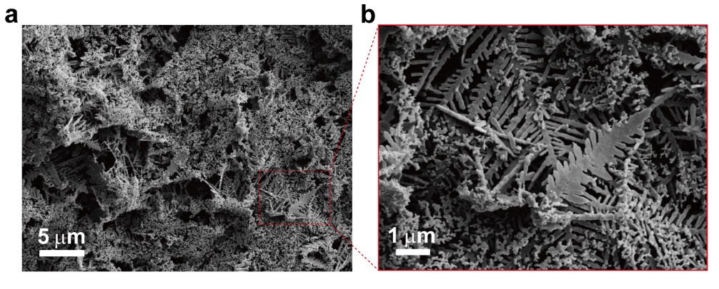
Supplementary Fig. 1. Morphology of the Ag membrane synthesized by locating the electrode tip right touching the surface of the bulk electrolyte reported by previous publications. The area of the membrane was less than 1 cm² with a thickness of ~ 5 μm. a) and b) Different magnifications.

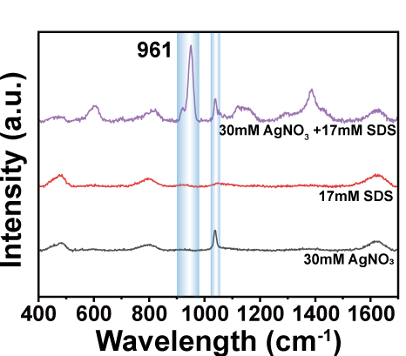
Supplementary Fig. 2. Raman characterization of the aqueous solutions. Raman spectra of the aqueous solutions composed of 30 mM silver nitrate (black curve), 17 mM SDS (red curve), and 30 mM silver nitrate and 17 mM SDS (purple curve). The appearance of the 961 cm⁻¹ Raman peak indicated the chemical binding between Ag⁺ ions and the sulfate heads in the electrolyte.

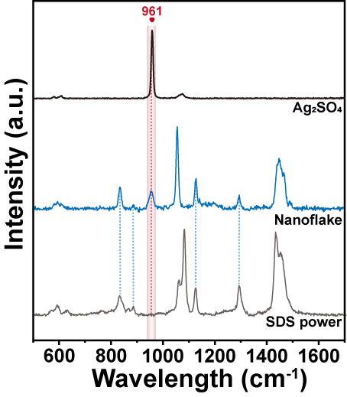
Supplementary Fig. 3. Raman characterization of the DS⁻ and Ag⁺ ion assembled nanoflakes. Raman spectra of SDS powder (gray curve), pure silver sulfate (black curve), and the nanoflakes formed by DS⁻ and Ag⁺ ions (blue curve). The emergence of the 961 cm⁻¹ Raman peak indicated the chemical binding between Ag⁺ ions and the DS⁻ ions within the assembled sandwich-like laminated nanoflake structures.

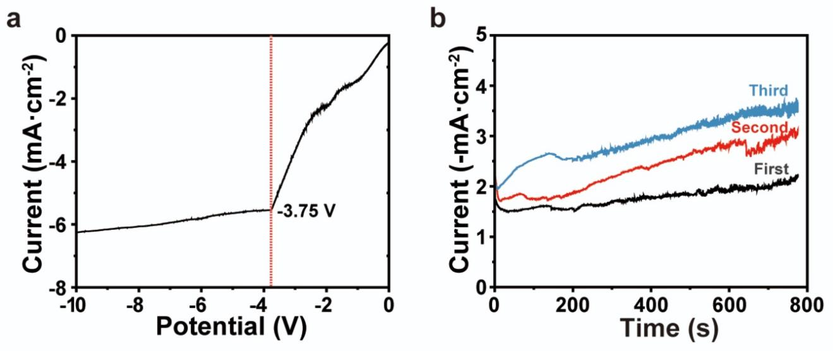
Supplementary Fig. 4. Electrochemical processes involved in the preparation of freestanding silver nanofilms. a) LSV curve. b) I–t curves for the successive three nanofilm deposition processes.

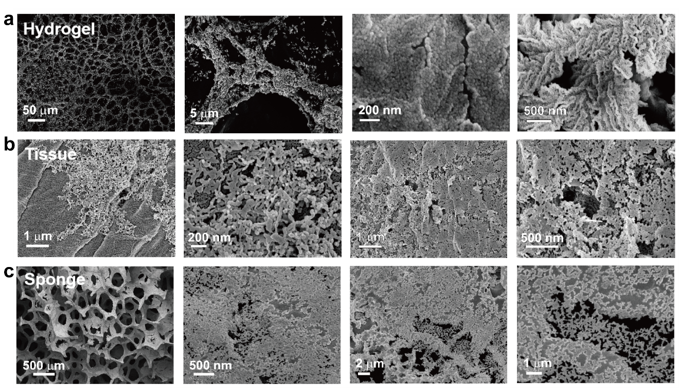
Supplementary Fig. 5. Morphology of Ag nanofilm growing along different electrolyte-absorbing surfaces. a) Ag nanofilm grew on the surface of a hydrogel. b) Ag nanofilm grew on the surface of a tissue paper. c) Ag nanofilm grew on the surface of a sponge.

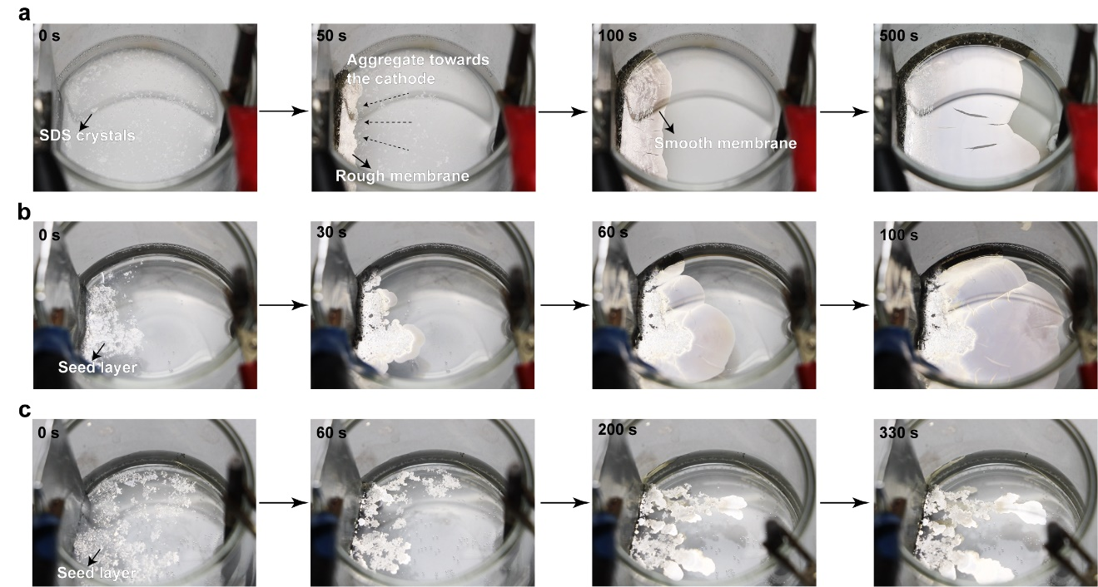
Supplementary Fig. 6. The growth process of Ag nanofilms under different conditions. a) Ag nanofilm grew at the air-water interface of the electrolyte containing SDS after transferring away the nanofilm for ten times. The DS⁻ and Ag⁺ assembled nanoflakes behaving as the seeds for the growth the Ag nanofilms. b) Transferring the seed layer to the surface of an electrolyte solution containing SDS but has not been treated by the heating-cooling process, the Ag nanofilm grew at the air-water surface. This suggested the importance of the seeds for the formation of Ag nanofilms. c) Ag nanofilm failed to grow after transferring the seed layer onto the silver nitrate solutions without SDS. This suggested the importance of the SDS for the formation of Ag nanofilms.

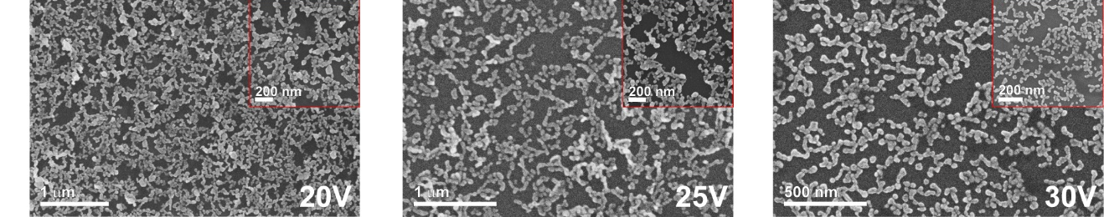
Supplementary Fig. 7. Morphology of Ag nanofilms prepared at different potentials. From left to right: 20 V, 25 V, and 30 V, respectively. Inset: enlarged observation.

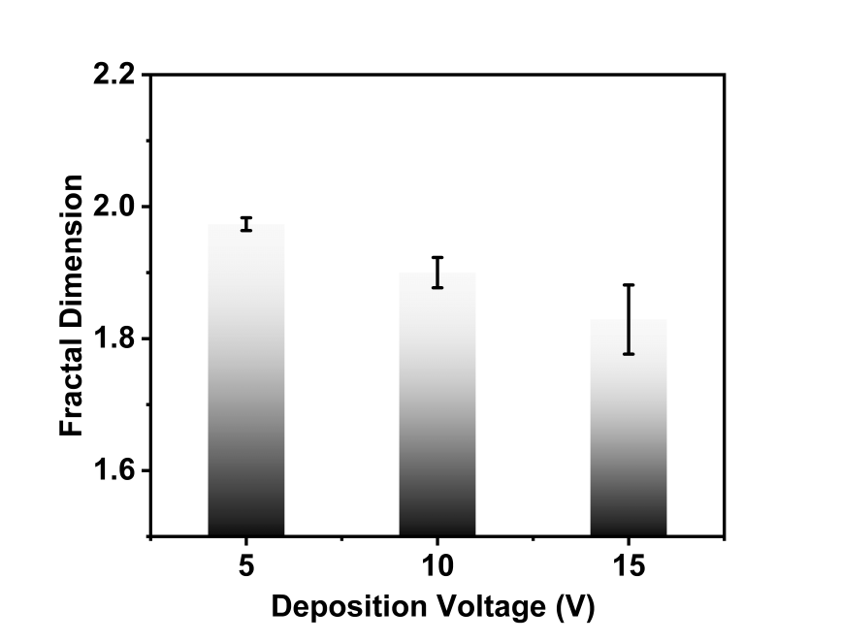
Supplementary Fig. 8. Fractal dimension of the nanofilms prepared under 5 V, 10 V, and 15 V.

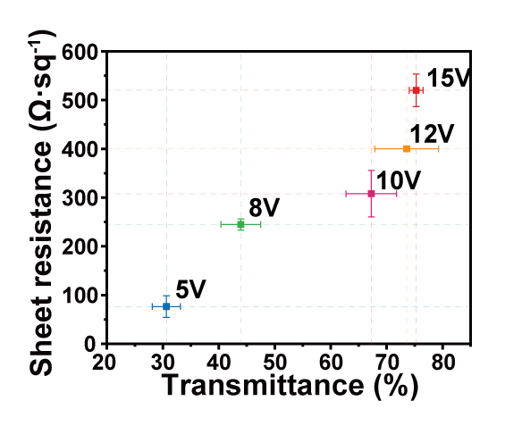
Supplementary Fig. 9. Conductivity and transparency of the Ag nanofilms fabricated at different potentials. Error bars obtained based on five independent experiments.
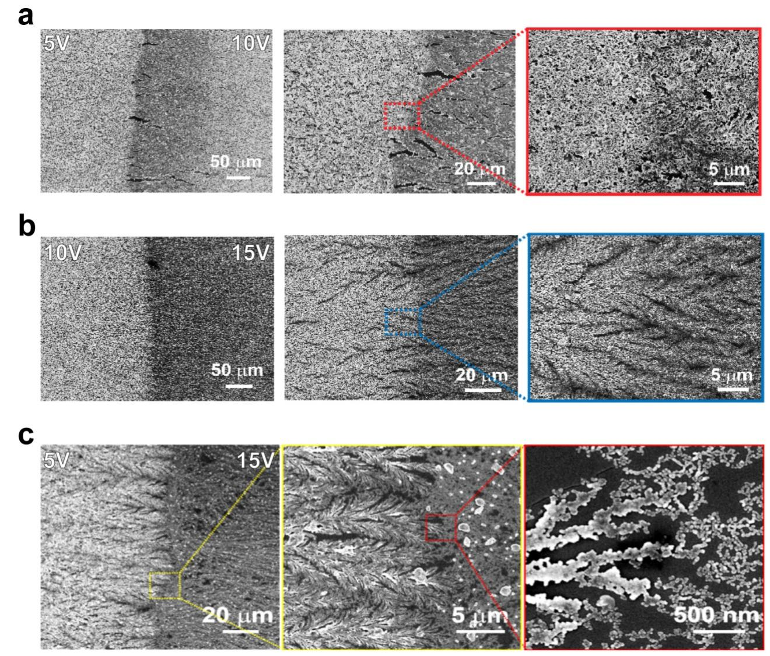
Supplementary Fig. 10. Morphology evolution of the Ag nanofilms when the potential was abruptly increased. a) The potential was increased from 5 V to 10 V. b) The potential was increased from 10 V to 15 V. c) The potential was increased from 5 V to 15 V. From left to right in a-c): Gradually enlarged observations.

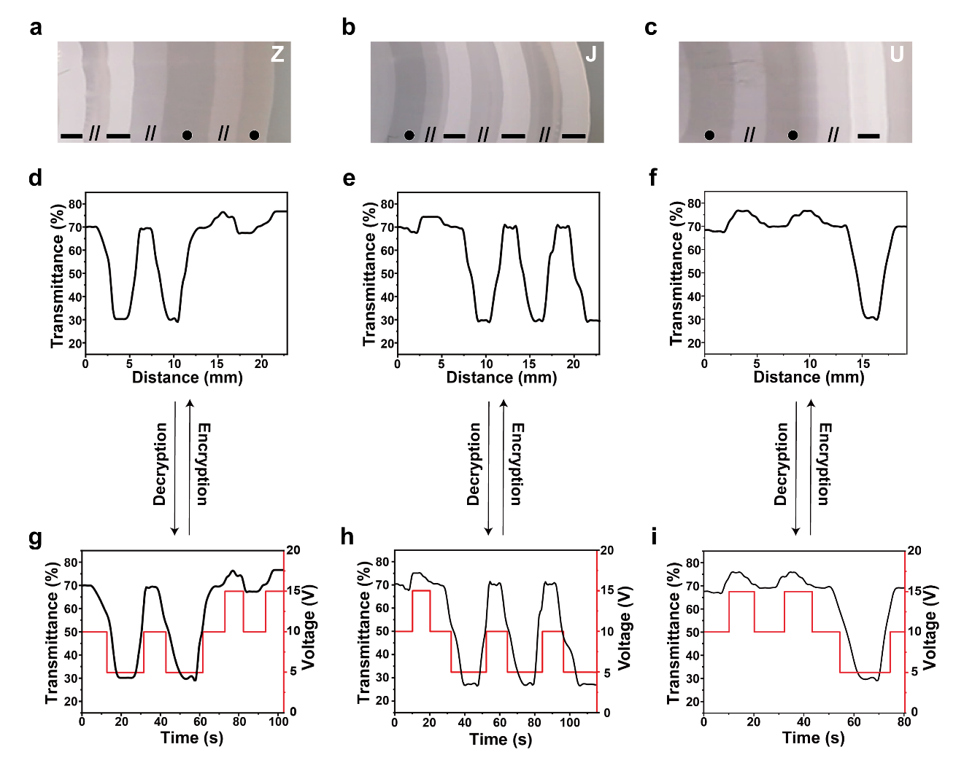Supplementary Fig. 11. The striped nanopatterns representing different letters in morse code fabricated by programming the potential waveforms. (a-c) Photograph of striped Ag nanofilm representing different letters in morse code. (d-f) The transmittance curves by scanning the striped Ag nanofilms from left to right corresponding to a-c), respectively. (g-i) The relationship between the transmittance curves and the potential waveforms used to fabricate the striped nanopatterns corresponding to a-c), respectively. Based on the transmittance curves, the potential waveforms could be predicted. The accuracy could be improved by reducing the light beam width and the step size during transmittance measurements.

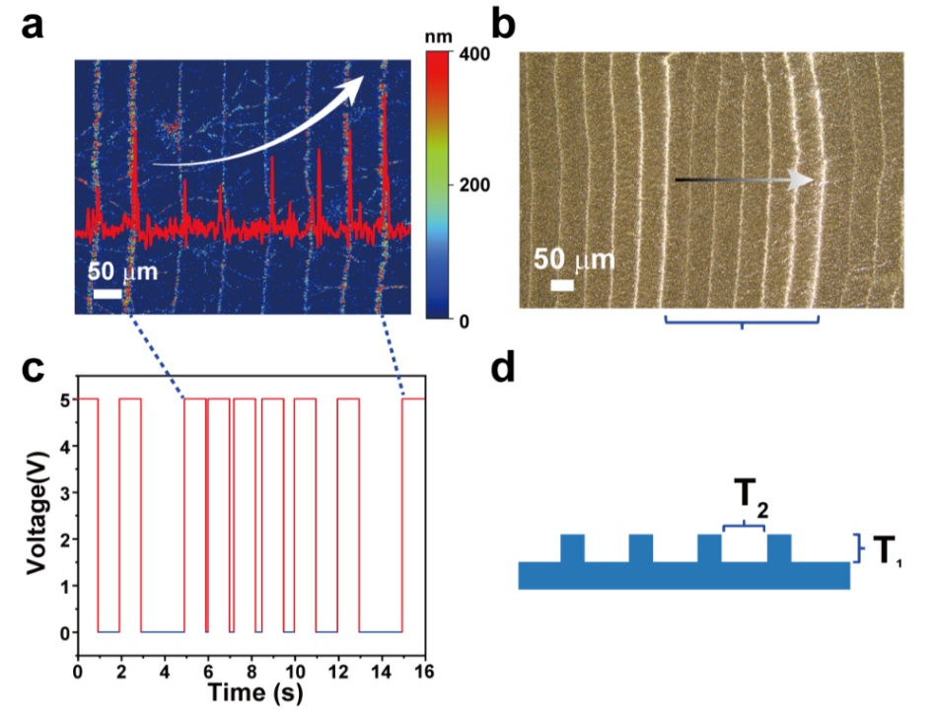
Supplementary Fig. 12. The influence of the duration time at 0 V on the nanoridge height. a) The microscopic topography images of the Ag nanofilm. As the duration time at 0 V was increased, the height of the nanoridge was increased. b) The optical microscope of Ag nanofilms with gradually higher nanoridges from left to right. c) The corresponding potential waveform to a). d) Schematic of the height T₁ and the inter-nanoridge distance T₂ of the striped nanopatterns.

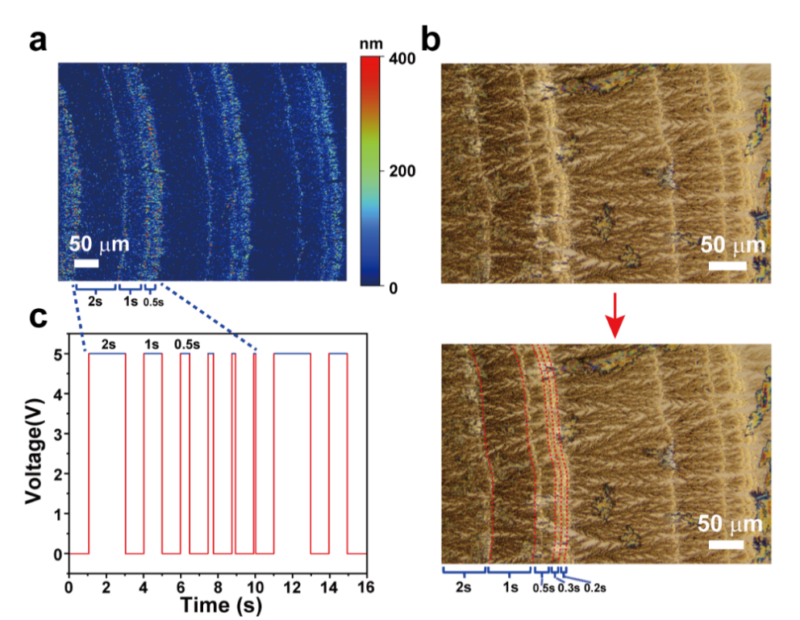
Supplementary Fig. 13. The influence of the duration time at 5 V on the inter-nanoridge distance. a) The microscopic topography images of the Ag nanofilm. As the duration time at 5 V was decreased, the inter-nanoridge distance was gradually reduced. b) The optical microscope of the corresponding Ag nanofilm. c) The corresponding potential waveform of a).

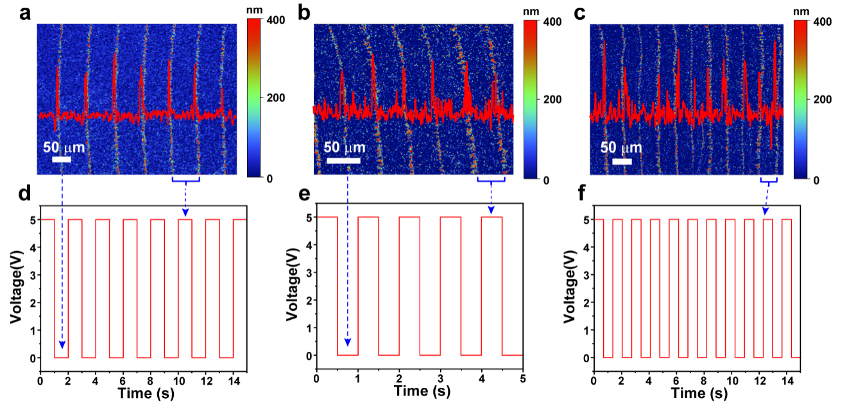
Supplementary Fig. 14. Ag nanofilms prepared with different pulse times. a) 1 s. b) 0.5 s. c) 0.25 s. a-c) The microscopic topography images of Ag nanofilms. d-f) The corresponding potential waveforms corresponding to a-c), respectively. As the pulse time was reduced, the inter-nanoridge distance was greatly decreased.

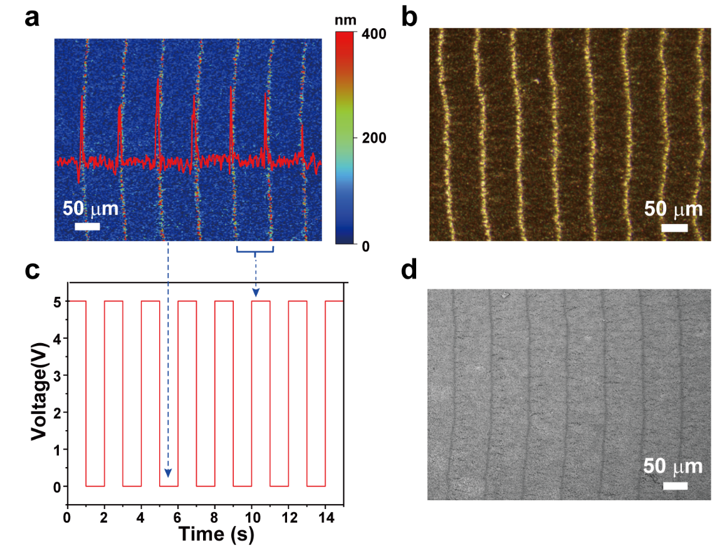
Supplementary Fig. 15. Design Ag nanofilms with periodic nanoridges. a) The microscopic topography images of the Ag nanofilm. b) The optical microscope image of the Ag nanofilm. c) The corresponding potential waveform used to create the nanoridge pattern. d) SEM image of the Ag nanofilm. The nanoridges presented as dark parallel lines.

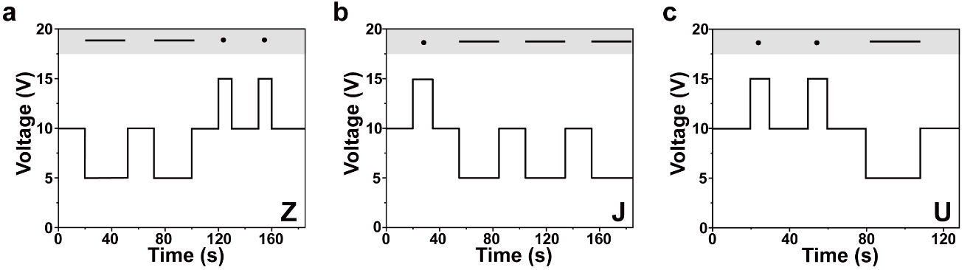
Supplementary Fig. 16. The potential waveforms used to create the nanoridge patterns shown in Fig. 4k representing “Z”, “J”, and “U” of the morse codes. a) Z. b) J. c) U.

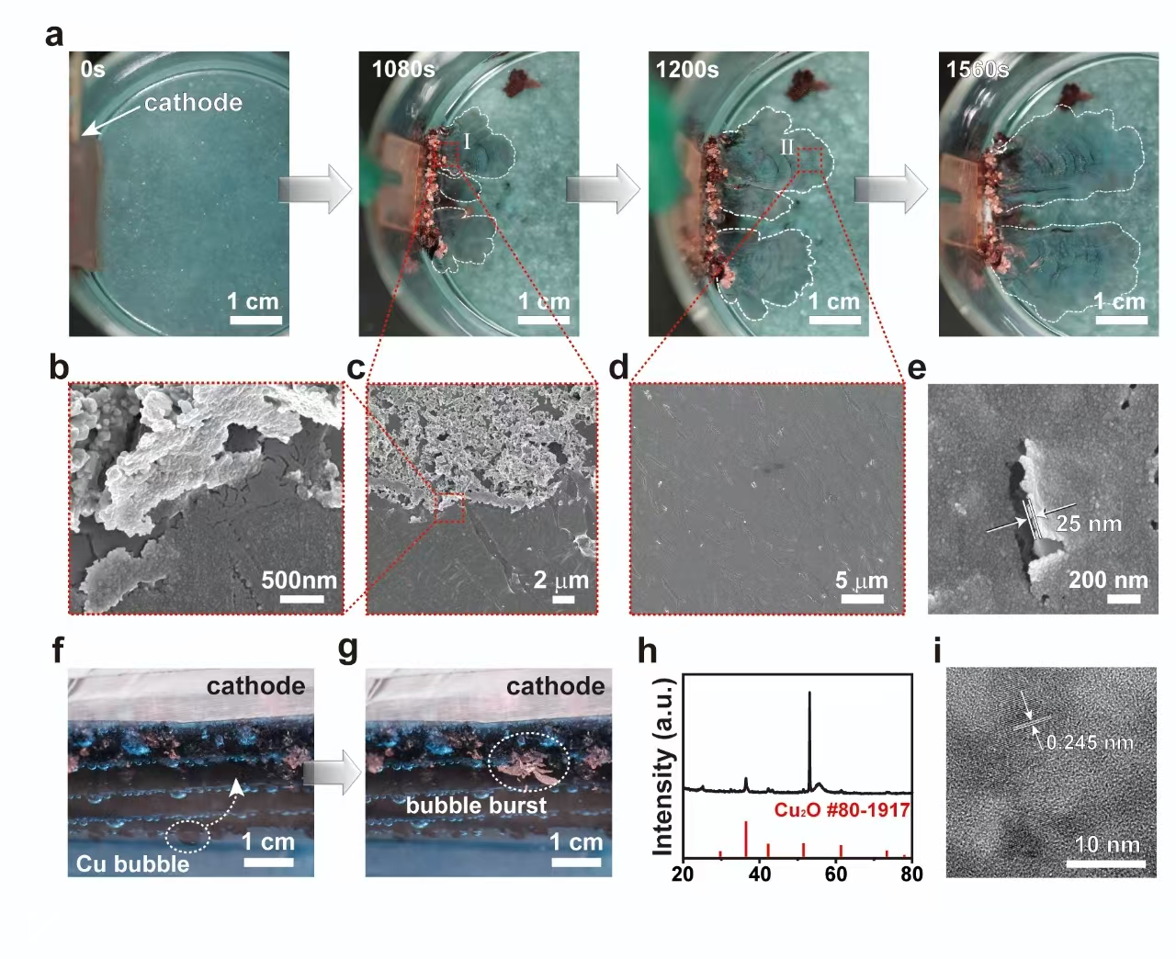
Supplementary Fig. 17. Freestanding Cu₂O nanofilms electrodeposited at the air-water interface. a) Photos of the Cu₂O nanofilms grown for different times. b) and c) Boundary area between the thick Cu₂O microfilms and the ultrathin Cu₂O nanofilms with different magnifications. d) Large-area ultrathin Cu₂O nanofilms. e) Thickness of the Cu₂O nanofilm. f) Thick Cu₂O microfilms wrapping the hydrogen bubbles. g) The Cu₂O-wrapped bubbles cracked, forming thick Cu₂O microfilms at the air-water interface. h) XRD pattern of the Cu₂O nanofilms. i) TEM image of the Cu₂O nanofilms with grains of about 10 nm.

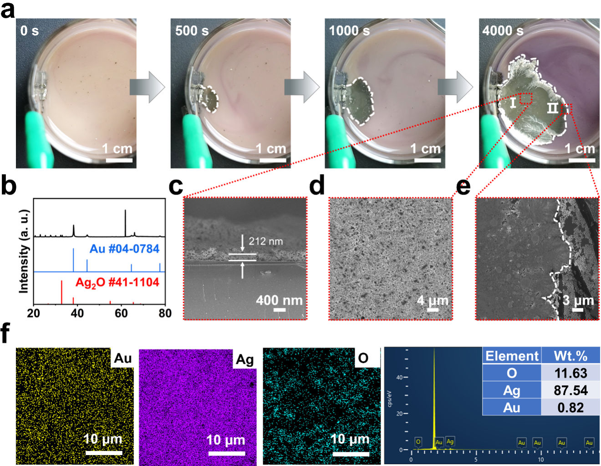
Supplementary Fig. 18. Freestanding Au-Ag₂O nanofilms electrodeposited at the air-water interface. a) Photos of the Au-Ag₂O nanofilms grown for different times. b) and c) XRD pattern of the nanofilm. c) Side-view of the nanofilm. d) Top-view of the nanofilm. e) Growing front of the nanofilm. f-h) Element mapping of the nanofilm. i) EDS of the nanofilm. The content of gold could be increased by increasing the deposition potentials. For example, the percentage of gold was increased to 12% under 5 V.
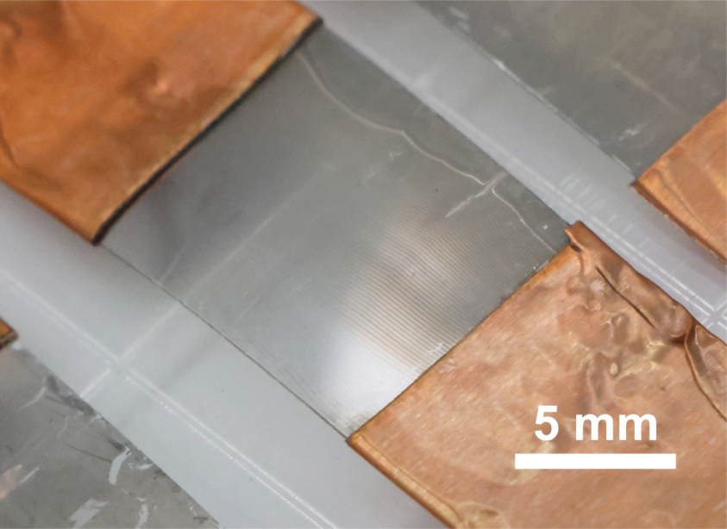
Supplementary Fig. 19. Transferring the freestanding Ag nanofilms with designed periodic nanoridges onto a piece of PET substrate to prepare the pressure sensors. The gray area is the Ag nanofilm and the orange areas are the copper electrodes.
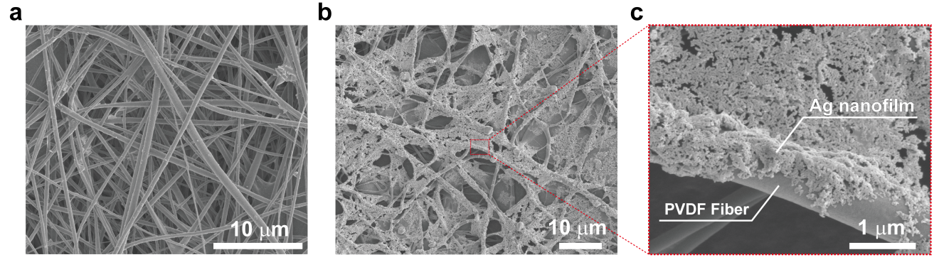
Supplementary Fig. 20. Morphology of PVDF/Ag nanofilm. a) The nanofibers of PVDF. b) and c) PVDF covered with Ag nanofilms.

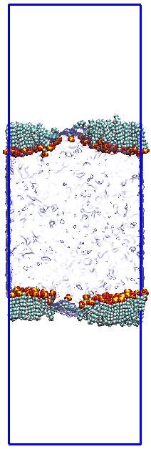
Supplementary Fig. 21. Schematic graph of the molecular dynamics simulation box and system settings.

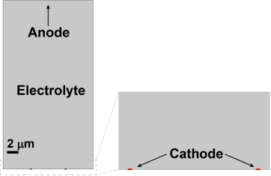
Supplementary Fig. 22. The COMSOL model used for the simulation of the electrodeposition of silver. The Tertiary Current Distribution and Level Set modules of COMSOL Multiphysics were expolited to simulate the deformation at the cathode surface during electrodeposition. The diffusion coefficient of Ag⁺ ions was set as 2 × 10⁻⁹ m² s⁻¹. The exchange current density was set as 100 A m⁻². The initial concentration of Ag⁺ ions was 0.03 M. The applied potential was 0.2 V and 0.7 V, corresponding to low and high potentials, respectively.

