Supplementary Figures
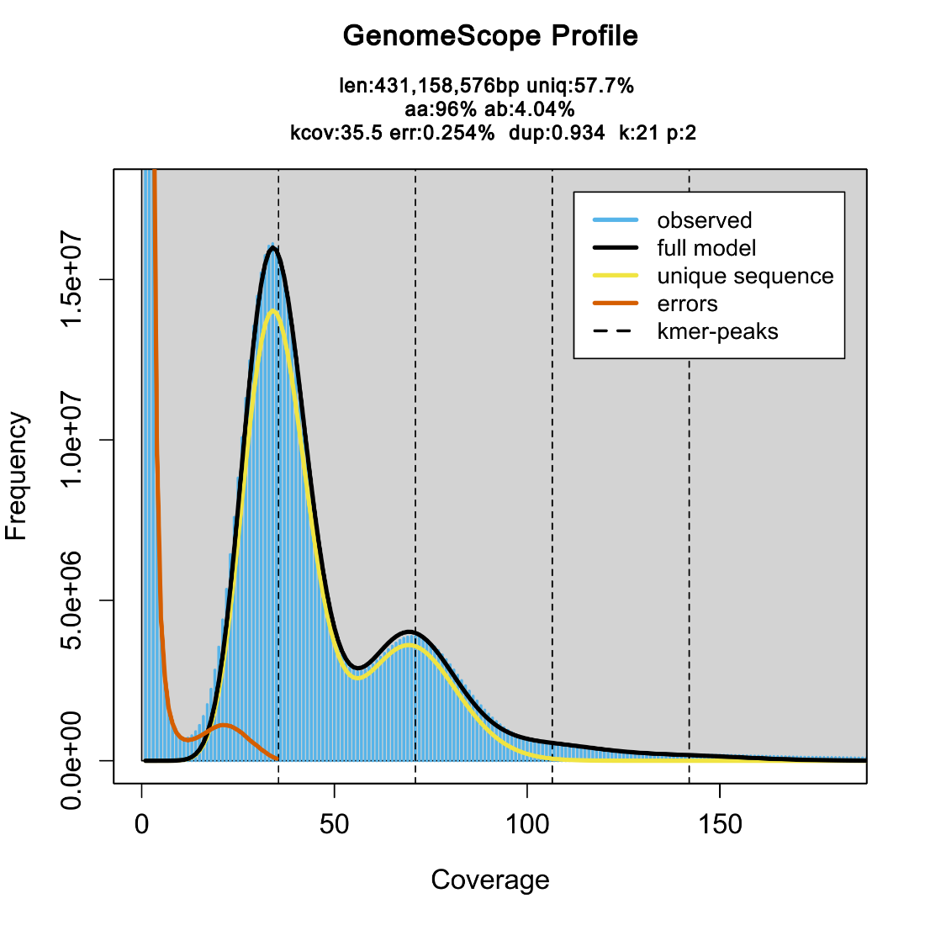
Figure S1. K-mer spectraum analysis of the RP genome. The 21-mer frequency spectrum (Jellyfish) fitted with GenomeScope2 to estimate genome size (~431 Mb), heterozygosity (4.04%), and repeat content (42.3%).

Figure S2. Distribution of telomeric and tandem repeat sequences in RP haplotypes.
(a, b) Telomeric repeat density (AAACCCT/AGGGTTT) along RPhapA and RPhapB chromosomes calculated in 100-kb windows.
(c) Tandem-repeat copy number (blue) and cumulative length (red) according to monomer size. The five most abundant repeat monomers are highlighted.

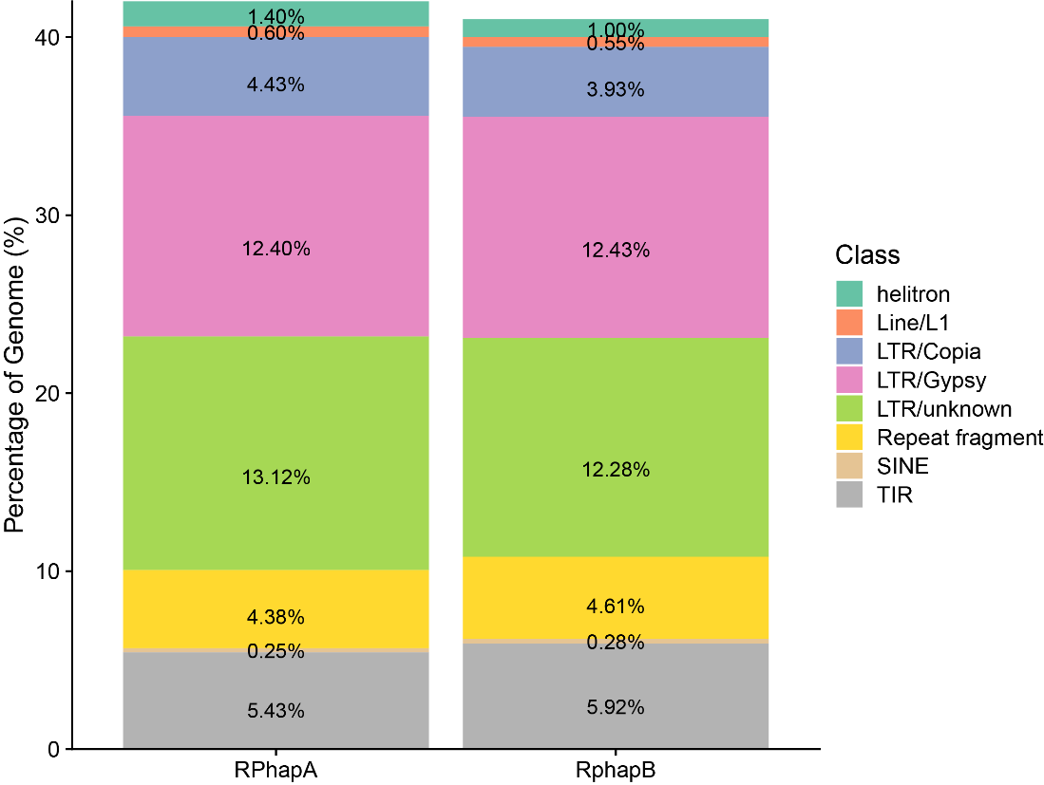
Figure S3. Repeat composition of the RPhapA and RPhapB assemblies. Stacked bar plot showing the proportion of major transposable-element class, including LTR, DNA TE, LINE, SINE, helitron, unknown, in each haplotype. LTR, long terminal repeat; TE, transposable element.

Figure S4. Chromosome-level ANI comparisons between RP haplotypes and cultivated longan genome. Average nucleotide identity (ANI) values between RP haplotypes and Jidanben (JDB; left) or Shixia (SX; right) were calculated across homologous chromosome regions.

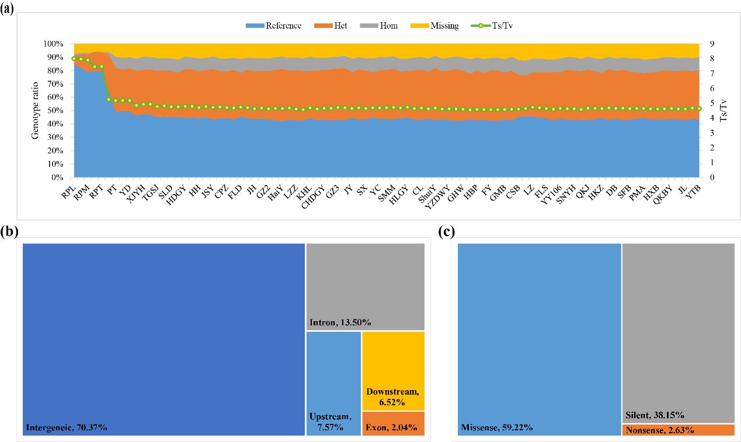
Figure S5. Genome-wide SNP characteristics across 91 longan accessions.
(a) SNP genotype distribution and transition/transversion (Ts/Tv) ratios.
(b) SNP distribution across genomic regions
(c) Functional effects of SNPs classified using SnpEff.

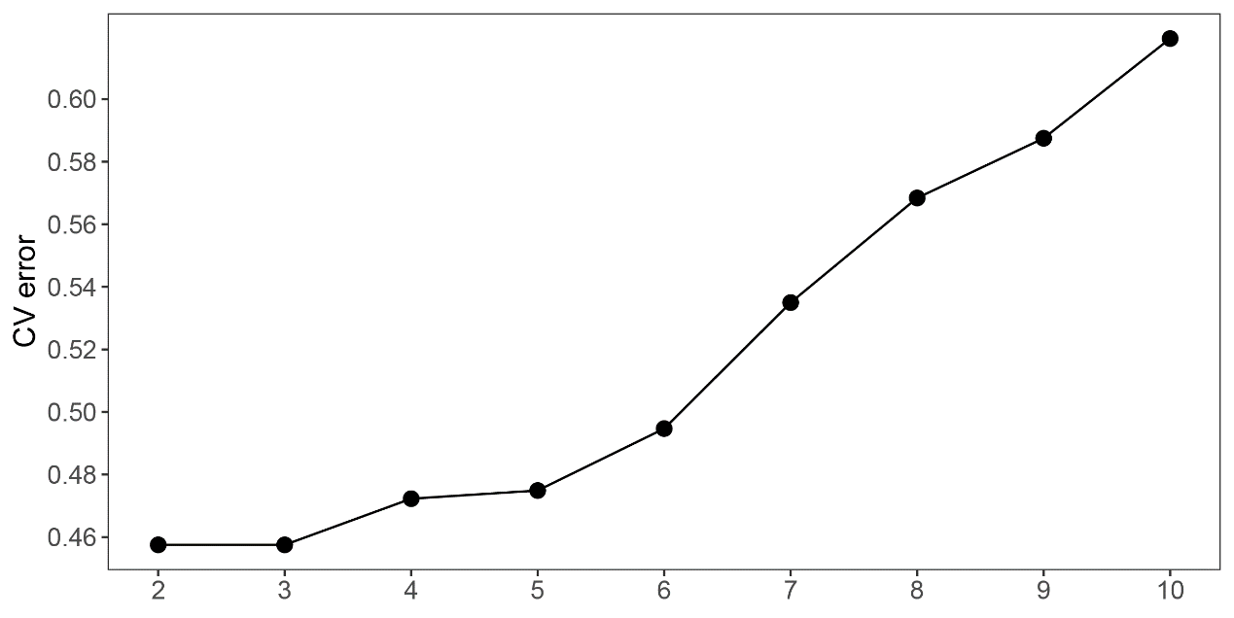
Figure S6. ADMIXTURE cross validation (CV) error for different K values.

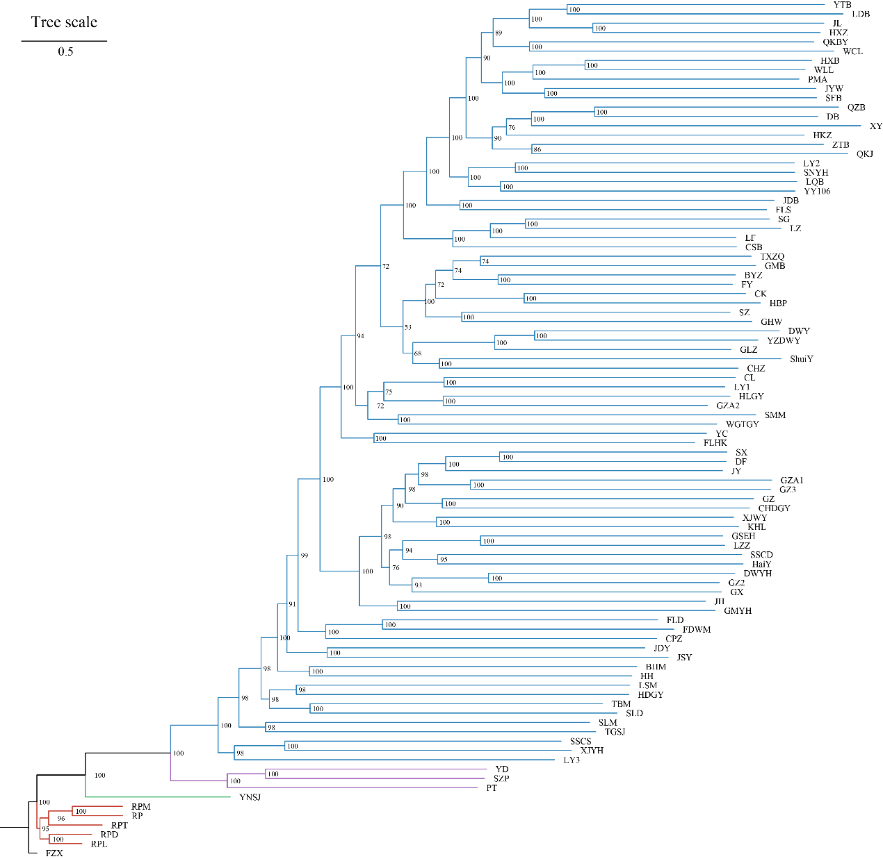 Figure S7. Maximum-likelihood phylogeny of longan accessions and the Litchi chinensis outgroup. The phylogenetic tree was constructed from genome-wide SNPs of 91 longan accessions and rooted with L. chinensis accession FZX. Bootstrap support values from 1,000 ultrafast bootstrap replicates are shown at nodes.

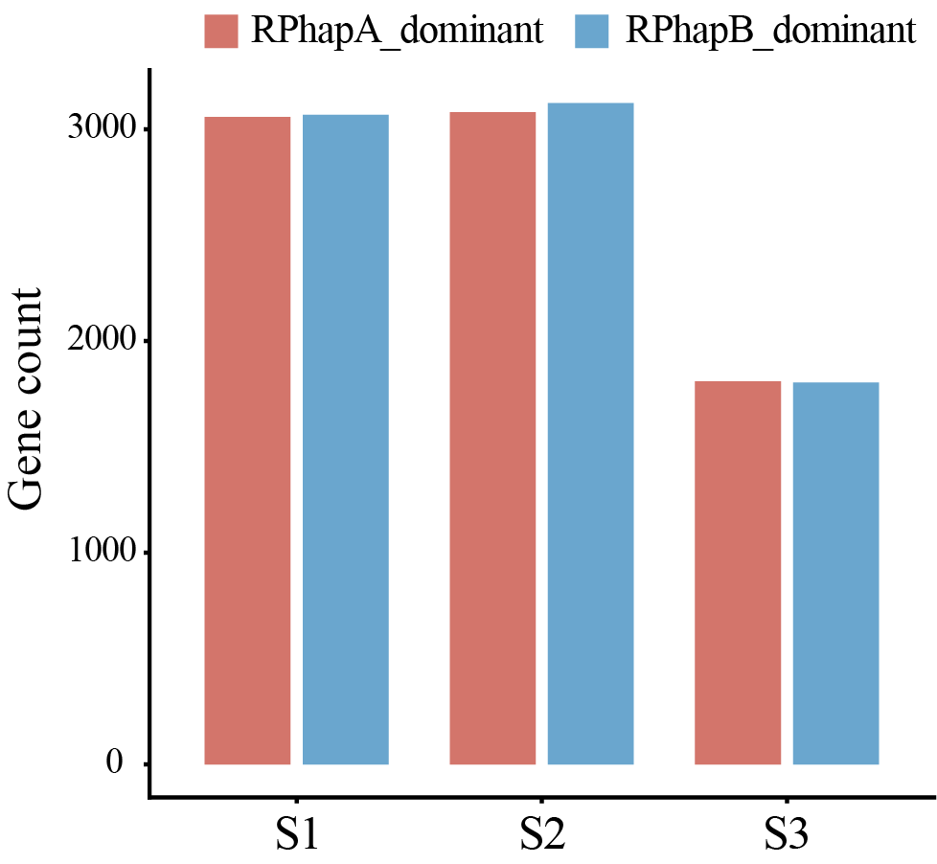
Figure S8. Numbers of haplotype-biased ASE genes during pericarp development. Numbers of RPhapA-biased and RPhapB-biased ASE genes across three developmental stages (S1–S3).

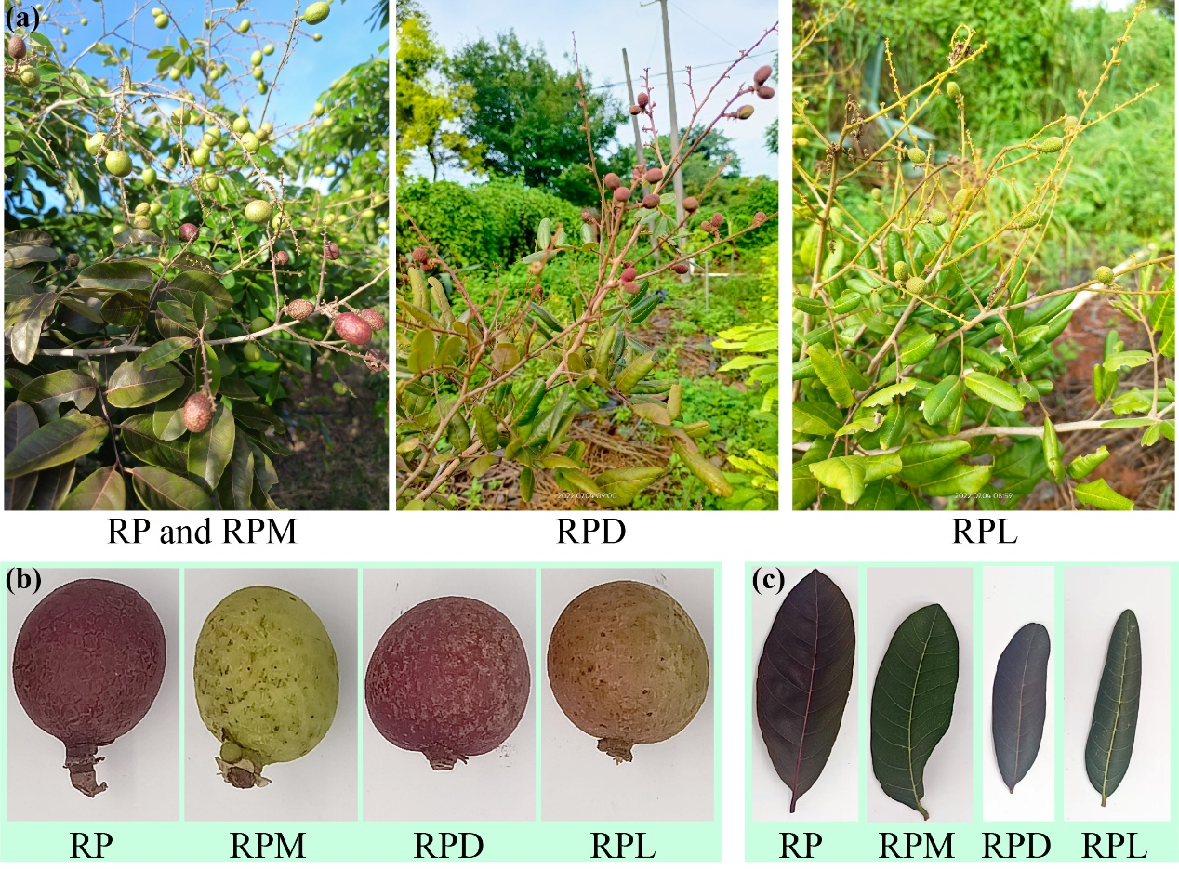
Figure S9. Phenotypic variation among red-skinned longan accessions and the yellowish-green pericarp bud sport RPM.
(a) Fruiting branches.
(b) Mature fruits.
(c) Mature leaves.

