Association Between Change in Body Mass Index and Depression Severity During a Three-Month Dietary Intervention: A Quasi-Experimental Study
Mehmood D. et al., 2025
APPENDICES
(ⅰ) DATA COLLECTION PROFORMA
HELLO GOOD DAY! I AM A STUDENT OF KING EDWARD MEDICAL UNIVERSITY, LAHORE. WE ARE CONDUCTING A STUDY ON “ASSOCIATION BETWEEN THE CHANGE IN BODY MASS INDEX AND DEPRESSION SCORE AFTER 3 MONTHS OF DIETARY INTERVENTION”. I WOULD LIKE TO ASSURE YOU THAT THE DATA IS ONLY FOR RESEARCH PURPOSE.
CASE NO----------------
SECTION-I: SOCIODEMOGRAPHIC
Name of patient: -----------------------------------------
S/D/W/O: --------------------------- Hospital Reg #:------------------------------
Age: - ----------------- Gender: - ------------------- Occupation: - --------------------
Address: - ----------------------------------------------------------------------------------------------------
Residence Status own: Yes (___)/No (___) rented: Yes (___)/No (___)
If student: Day scholar: Yes (___)/No (___) Hostelite: Yes (___)/No (___)
-If Hostelite, What is the frequency of going back to your home?
- Once a month(___)
- Twice a month(___)
- Once After every 2 months(___)
- Once After every 3 months(___)
Socio-economic State: independent (____)/ dependent (____)
- Salary of Parents/Guardian if dependent: <100,000(____) or >100,000(____)
- Monthly Income if independent:(____)
Medical problems or life event history:
- Chronic illness e.g. Diabetes, liver and heart disease: yes (___)/no (___).
- If diagnosed with Depression and taking prescribed anti-depressants: yes (___)/no (___).
- Family history of psychiatric or depressive diseases: yes (___)/no (___).
- Recent history (less than one month) of demise of loved once, trauma, any related grieving incident or profound life style change: yes (___)/no (___).

SECTION-II: ANTHROPOMETRIC MEASURE
Height: _______________ Weight: _________ Body Mass Index: _____________
Calories Intake: _______________
FOLLOW UP DATA
BMI at Baseline: ___________________
HAM-D Score at Baseline: _______________
BMI after 3 months (Follow up visit after 3 months): ___________________
HAM-D Score after 3 months (Follow up visit after 3 months): _______________
Change in BMI: ________________
Percent change in Body Mass Index: ___________
Change in HAM-D Score: ________________
Percent change in HAM-D score: _________

SECTION-III: HAMILTON DEPRESSION RATING SCALE (HDRS)
1. DEPRESSED MOOD (sadness, hopeless, helpless, worthless)
  - Absent.
  - These feeling states indicated only on questioning.
  - These feeling states spontaneously reported verbally.
  - Communicates feeling states non-verbally, i.e. through facial expression, posture, voice and tendency to weep.
  - Patient reports virtually only these feeling states in his/her spontaneous verbal and non-verbal communication.
2. FEELINGS OF GUILT
- Absent.
- Self-reproach, feels he/she has let people down.
- Ideas of guilt or rumination over past errors or sinful deeds.
- Present illness is a punishment. Delusions of guilt.
- Hears accusatory or denunciatory voices and/or experiences threatening visual hallucinations.
3. SUICIDE
  - Absent.
  - Feels life is not worth living.
  - Wishes he/she were dead or any thoughts of possible death to self.
  - Ideas or gestures of suicide.
  - Attempts at suicide (any serious attempt rate 4).

4. INSOMNIA: EARLY IN THE NIGHT
- No difficulty falling asleep.
- Complains of occasional difficulty falling asleep, i.e. more than 1⁄2 hour.
- Complains of nightly difficulty falling asleep.

5. INSOMNIA: MIDDLE OF THE NIGHT
- No difficulty.
- Patient complains of being restless and disturbed during the night.
- Waking during the night – any getting out of bed rates 2 (except for purposes of voiding).
6. INSOMNIA: EARLY HOURS OF THE MORNING
- No difficulty.
- Waking in early hours of the morning but goes back to sleep.
- Unable to fall asleep again if he/she gets out of bed.
7. WORK AND ACTIVITIES
- No difficulty.
- Thoughts and feelings of incapacity, fatigue or weakness related to activities, work or hobbies.
- Loss of interest in activity, hobbies or work – either directly reported by the patient or indirect in listlessness, indecision and vacillation (feels he/she has to push self to work or activities).
- | | Decrease in actual time spent in activities or decrease in productivity. Rate 3 if the patient does not spend at least three hours a day in activities (job or hobbies) excluding routine chores.
- Stopped working because of present illness. Rate 4 if patient engages in no activities except routine chores, or if patient fails to perform routine chores unassisted.
8. RETARDATION (slowness of thought and speech, impaired ability to concentrate, decreased motor activity)
- Normal speech and thought.
- Slight retardation during the interview.
- Obvious retardation during the interview.
- | | Interview difficult.
- | | Complete stupor.
9. AGITATION
- None.
- Fidgetiness.
- Playing with hands, hair, etc.
- Moving about, can’t sit still.
- Hand wringing, nail biting, hair-pulling, biting of lips.
10. ANXIETY PSYCHIC
- No difficulty.
- Subjective tension and irritability.
- Worrying about minor matters.
- Apprehensive attitude apparent in face or speech.
4 Fears expressed without questioning.
11. ANXIETY SOMATIC (physiological concomitants of anxiety) such as:
gastro-intestinal – dry mouth, wind, indigestion, diarrhea, cramps, belching
cardio-vascular – palpitations, headaches respiratory – hyperventilation, sighing urinary frequency
sweating
0 Absent.
1 Mild.
- Moderate.
- Severe.
- Incapacitating.
12. SOMATIC SYMPTOMS GASTRO-INTESTINAL
- None.
- Loss of appetite but eating without staff encouragement. Heavy feelings in abdomen.
- Difficulty eating without staff urging. Requests or requires laxatives or medication for bowels or medication for gastro-intestinal symptoms.
13. GENERAL SOMATIC SYMPTOMS
- None.
- Heaviness in limbs, back or head. Backaches, headaches, muscle aches. Loss of energy and fatigability.
- Any clear-cut symptom rates 2.

14. GENITAL SYMPTOMS (symptoms such as loss of libido, menstrual disturbances)
0 Absent.
1 Mild.
2 Severe.

15. HYPOCHONDRIASIS
- Not present.
- Self-absorption (bodily).
- Preoccupation with health.
- Frequent complaints, requests for help, etc.
- Hypochondriacal delusions.
16. LOSS OF WEIGHT (RATE EITHER a OR b)
- | | less than 1lb weight loss in week/ no weight loss
- | | greater than 1 lb weight loss in week/ probable weight loss
- | | greater than 2 lb weight loss in week/ definite weight loss
- | | Not assessed.
17. INSIGHT
- Acknowledges being depressed and ill.
- Acknowledges illness but attributes cause to bad food, climate, overwork, virus, need for rest, etc.
- Denies being ill at all.
Total Score: ___________

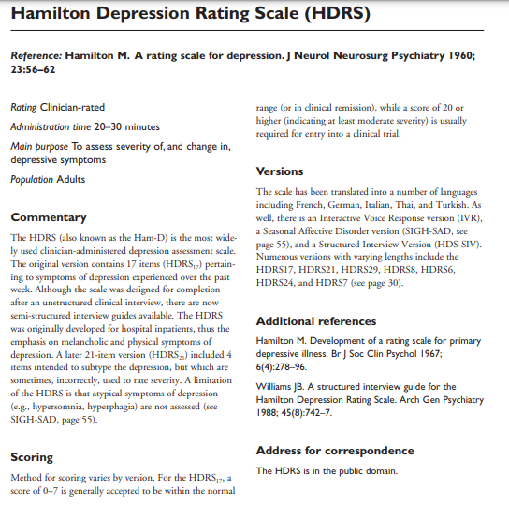
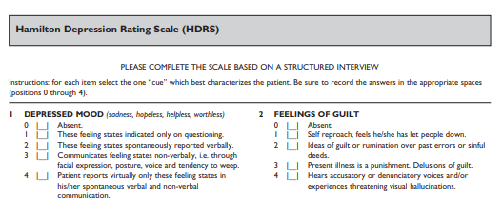

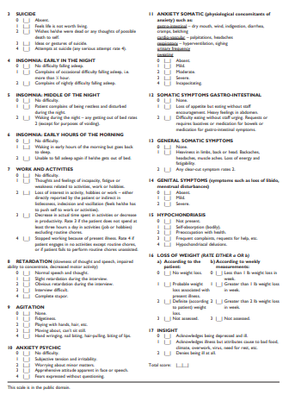
(ii)DIET CHART

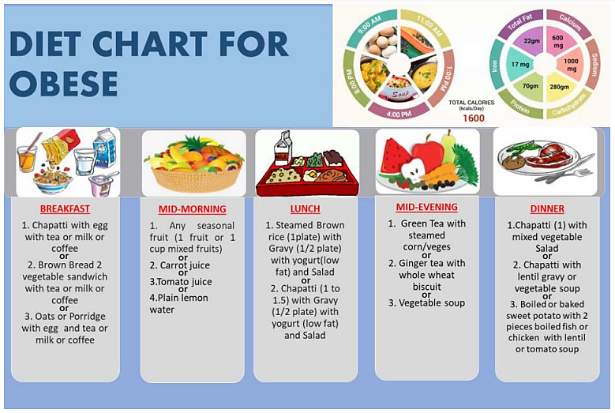

(iii)PATIENT INFORMED CONSENT IN ENGLISH
I agree to participate in the study “ASSOCIATION BETWEEN THE CHANGE IN BODY MASS INDEX AND DEPRESSION SCORE AFTER 3 MONTHS OF DIETARY INTERVENTION”
The doctor has informed me all the details of the study in detail. She has told me that the objectives of the study I agree to follow the diet plan given to me by the doctor. Due to this research Doctor will be able to inquire about the association between the change in body mass index and depression score after 3 months of dietary intervention.
I have also been informed in detail about possible benefits and side effects of the study. I understand that I am free to withdraw from the study whenever I want to and I have been told that my doctor will continue to give me all positive care even after my discontinuation of study. Furthermore, I allow my doctor or any other person authorized by my doctor to contact me at my home or at an address given by me for treatment and follow up.
I have been assured that the information provided by me will be kept confidential and will be used for research purpose only.

Patient Name: _________________ Witness Name: _________________
NIC No: _____________________ NIC No: ______________________
Signature: ____________________ Signature: ____________________

Doctor Signature:_______________
Date: _______________

(iv.) PATIENT INFORMED CONSENT IN URDU

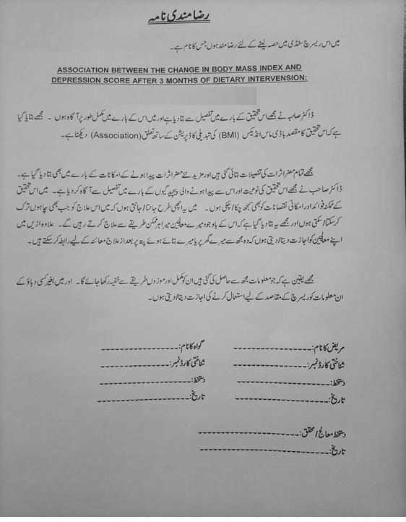

(v) BROCHURE AND SAFETY INFORMATION FOR PATIENT

