Supplementary material

T-Balance
The athlete begins by standing on one leg with the opposite hip and knee flexed to 90° and the hands in a prayer position at nipple line (Figure 1a). This position is held for three seconds. In one fluid motion, the athlete hinges at the hip, extending the hip and knee, bringing the trunk parallel to the floor, while extending both of arms out to 90° of abduction at the shoulder, creating a T-shape with the arms and the trunk (Figure 1b-1c). The athlete rotates forward as far as possible, while maintaining balance. Once reaching the T-position, the athlete then returns to the starting position (Figure 1d).
The athletes will undergo two trials for each condition, one with their eyes open and another with their eyes closed, for both sides.
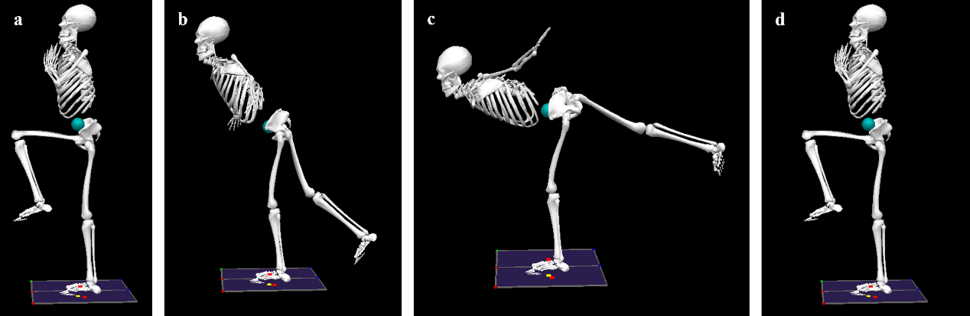
Figure 1: T‐Balance task: (a) stand on one leg with opposite hip and knee at 90° and hands in prayer; (b) hinge at the hip as the trunk lowers; (c) reach forward into the T‐position with arms abducted 90° and nonstance leg extended; (d) return upright.

Y-Balance
The goal of this test is to maintain single-leg balance on one leg while reaching as far as possible with the contralateral leg in three different directions using a Y-balance kit (Figure 2). The three movement directions are anterior, posteromedial and posterolateral, performed on each leg.
The starting position is standing on one leg at the stance plate with the toes of the foot at the red line, and the other leg touching down lightly just behind the plate (Figure 3a). The non-stance foot is reached out in the desired direction, pushing the reach indicator as far as they can while maintaining balance (Figure 3b-3d). The free foot must be returned to the starting position under control (Figure 3e). The subject may not touch down the free leg during the movement to keep balance or put their foot on top of the reach indicator to gain support and cannot kick out the indicator.
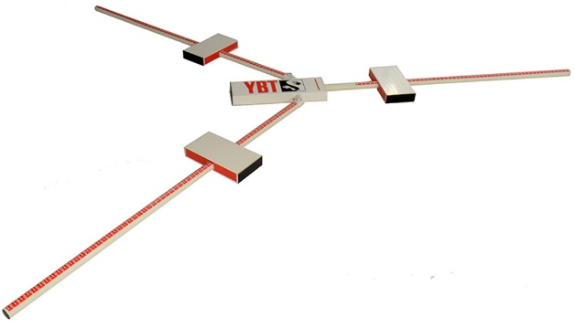
Figure 2: The Y‐Balance Test kit, displaying the central platform with three reaching arms/reach indicator used to measure multidirectional reach distances.
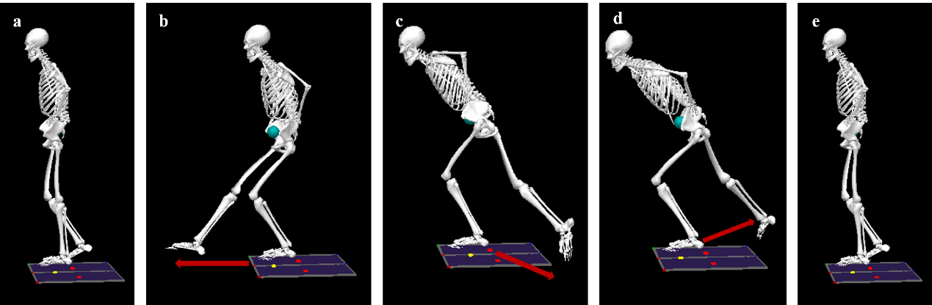
Figure 3: Y‐Balance test: (a) the subject stands on one leg with the toes aligned to the red start line and the contralateral foot lightly touching behind; (b–d) the free leg reaches as far as possible in the anterior, posteromedial, or posterolateral direction, pushing the reach indicator while maintaining single‐leg balance; (e) the reaching foot returns under control to the start position.

L-Hop
The athlete starts standing on both legs and jumps horizontally as far as he/she is able to (Figure 4a). Upon landing, the athlete lands on one foot and then jumps laterally as far as he/she can from the single planted foot (Figure 4b-4c) landing on the opposite foot (Figure 4d).
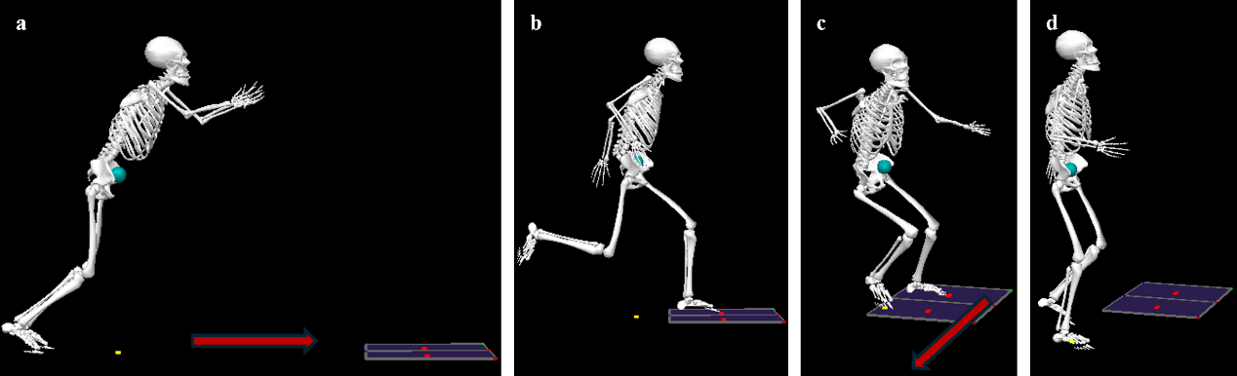
Figure 4: L‐Hop test: (a) athlete begins standing on both legs, jumps forward as far as possible; (b–c) upon landing on one foot, the athlete immediately jumps laterally as far as possible; (d) the athlete lands on the opposite foot.

Bilateral body-weight squat
Participants initiate the movement from an upright position with the knees and hips fully extended (Figure 5a). They will be asked to elevate their arms in front of themselves. To allow participants to exhibit their movement variability, there will be no further restrictions of the movement. A full repetition involves descending until both thighs dropped below or parallel to the ground, keeping the heels on the floor, and returning to the upright position (Figure 5b-5e). After hearing a verbal command to begin, the participants will control their movement pace to the metronome beat (40 beats per minute; Figure 5 bottom) to the best of their ability. The movement will be repeated 35 times.
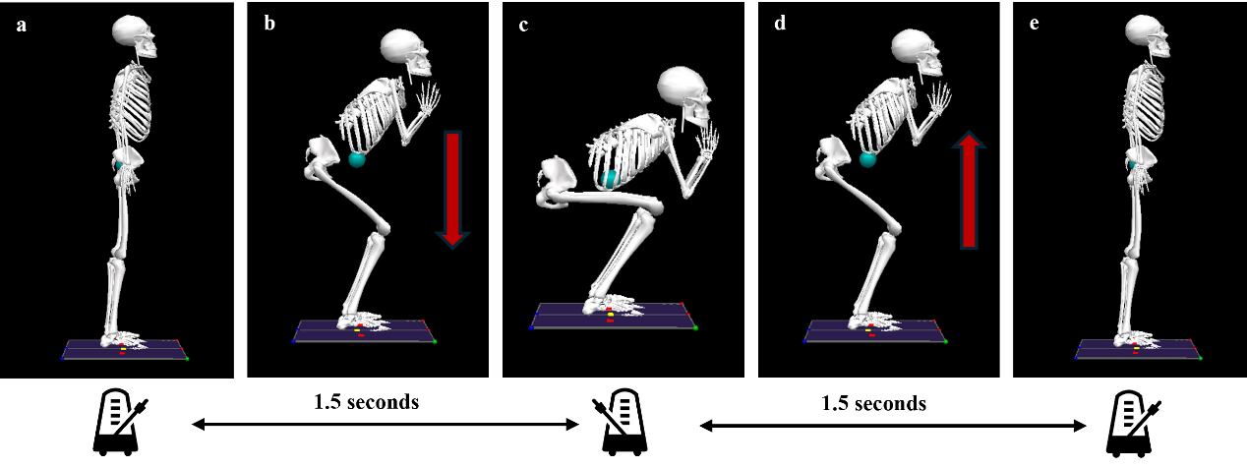
Figure 5: Squat task: (a) start upright with hips and knees fully extended; (b) descent toward thighs at least parallel to the floor; (c) bottom position; (d) ascent from the bottom; (e) return to full extension.

Countermovement jump
This movement is performed both on a single leg (left/right) and bilaterally. The athlete starts by standing on two force plates (Figure 6a). They then perform a quick downward movement (countermovement) before jumping as high as possible (Figure 6b). The athlete uses both arms and single leg/legs to generate maximal force and height (Figure 6c) and land on the force plates (Figure 6d). The jump should be performed with consistent countermovement depth and arm swing, maintaining extended hip, knee, and ankle joints during flight.
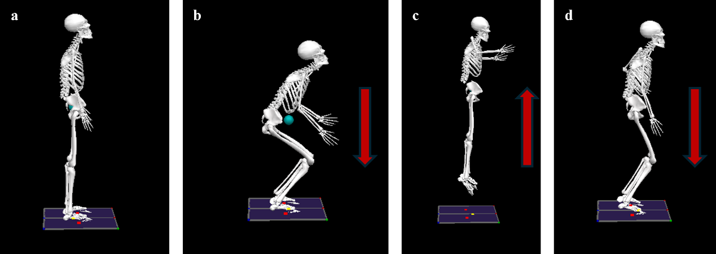
Figure 6: Countermovement jump (single‐leg and bilateral): (a) start upright on force plates; (b) rapid countermovement descent; (c) maximal vertical leap using arms and leg(s); (d) landing back onto the force plates. During flight, hips, knees, and ankles remain fully extended.

Broad jump
Participants stand on both of their feet, with each foot placed on a separate force plate (Figure 16a). They will be instructed to perform a broad jump, aiming to jump as far as they can (Figure 7b-7d). Each participant will complete this jump three times, and all of the three attempts will be recorded for analysis.
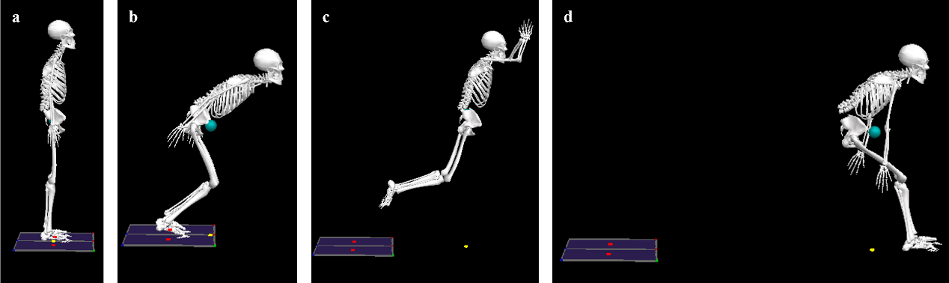
Figure 7: Broad jump: (a) standing on both feet, one on each force plate; (b) countermovement phase as the athlete prepares to jump; (c) airborne flight phase reaching maximal horizontal distance; (d) landing on the floor.

Reaction time tasks
The FITLIGHT Trainer (FITLIGHT Sports Corp., Ontario, Canada) is used to measure the reaction time (RT). Four lights will be placed in front of the participant drawing a semicircle with the radius of half of their leg length at 0°, 45°,135°and 180° (Figure 8).
To perform the task, the participant will stand at the origin of the semicircle, facing the lights with both their feet in contact with the floor. Two tests will be performed (simple RT and complex RT). The simple reaction test (SRT) and the complex reaction test (CRT) will be performed with both feet and consisted of 10 luminous stimuli. In this last one, the visual stimuli will be of two colors, blue or green; to the first, one has to tap with the left feet, while to the second, one has to tap with the right feet, while in the SRT, one needs to tap with the same foot during one trial. The setup for single leg SRT and CRT for lower limb is shown in Figure 8a and Figure 8b, respectively.
The same tasks will be performed by upper limbs. For the upper limbs, the Fitlights are fixed on the tripods at their waist height with the same configuration (Figure 8c).
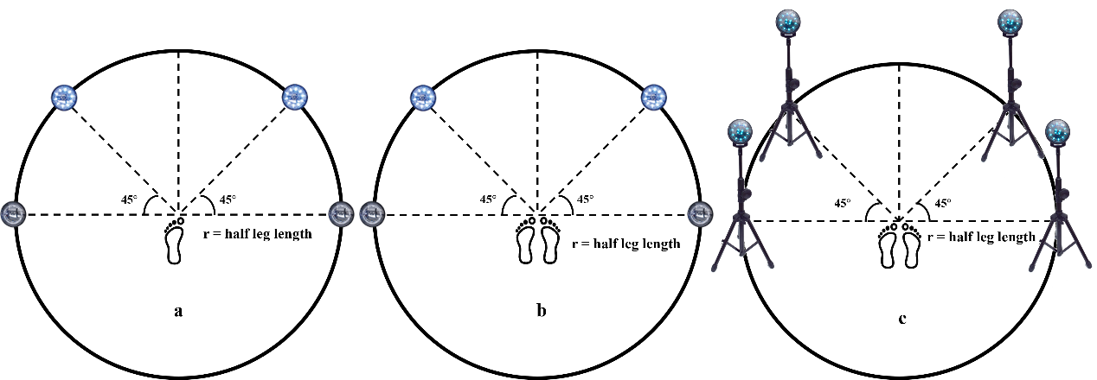
Figure 8: Reaction‐time task setups using the FITLIGHT Trainer in a semicircular arrangement (0°, 45°, 135°, 180°) at a radius equal to half the participant’s leg length. (a), the lower‐limb simple reaction time (SRT) task setup. (b), the lower‐limb complex reaction time (CRT) task setup. (c), the upper‐limb SRT/CRT tasks setup with the same semicircular layout mounted on tripods at waist height.

