Preparation of Room-temperature Self-healing Recyclable Polyurethane Elastomers Based on
Multiple Hydrogen/Nitrogen Coordination Boro-oxygen Bonds System
Yuchen Jiao^{a.c}, Ming Zhou^{a.b.c.g*}, Bo Pu^{d}, Xiaoling Yang^{a.c}, Chenyiting Li^{a.c}, Liangliang Xia^{a.c}, Guilin Deng^{a.c}, Yunyao Wei^{a.c}, Jing Zhong^{a.c}, Zheng Wu^{a.c}, Shi Chen^{a.c}, Jian Wang^{b.e*}, Yujun Zhou^{f}
ª School of New Energy and Materials, Southwest Petroleum University, Chengdu, Sichuan 610500, People’s Republic of China
^{b} National Key Laboratory of Oil and Gas Reservoir Geology and Exploitation, School of New Energy and Materials, Southwest Petroleum University, Chengdu, Sichuan 610500, People’s Republic of China
^{c} Research Center of Energy Polymer Materials, Southwest Petroleum University, Chengdu, Sichuan 610500, People’s Republic of China
^{d} CNPC Chuanqing Drilling Engineering Company Limited Safety, Environment, Quality Supervision and Testing Research Institute
^{e} College of Food and Biological Engineering, Chengdu University, Chengdu, 610106, China
^{f} College of Chemistry and Chemical Engineering, China West Normal University, Chengdu, 637002, China
^{g} Sichuan Provincial Engineering Research Center of Advanced Materials Manufacturing Technology for Shale Gas High-efficient Exploitation

*Corresponding author Ming Zhou (E-mail: mr.zhouming@163.com) and Jian Wang (E-mail: wangjian@cdu.edu.cn).

Table S1. PU_{PIPMB} series polyurethane elastomer production composition monomer
Elastomers | PTMEG-2000/mmol | IPDI/mmol | PDM/mmol | MOCA/mmol | FBA/mmol
PU_{HB-90/10} | 10.00 | 37.80 | 26.97 | 3.00 | 4.56
PU_{HB-80/20} | 10.00 | 37.80 | 24.46 | 5.96 | 5.45
PU_{HB-70/30} | 10.00 | 37.80 | 21.15 | 8.95 | 5.10
PU_{HB-60/40} | 10.00 | 37.80 | 17.98 | 11.91 | 4.70
PU_{HB-50/50} | 10.00 | 37.80 | 15.15 | 14.88 | 4.38
PU_{HB-30/70} | 10.00 | 37.80 | 8.63 | 120.97 | 4.03
PU_{HB-10/90} | 10.00 | 37.80 | 2.97 | 26.96 | 4.02

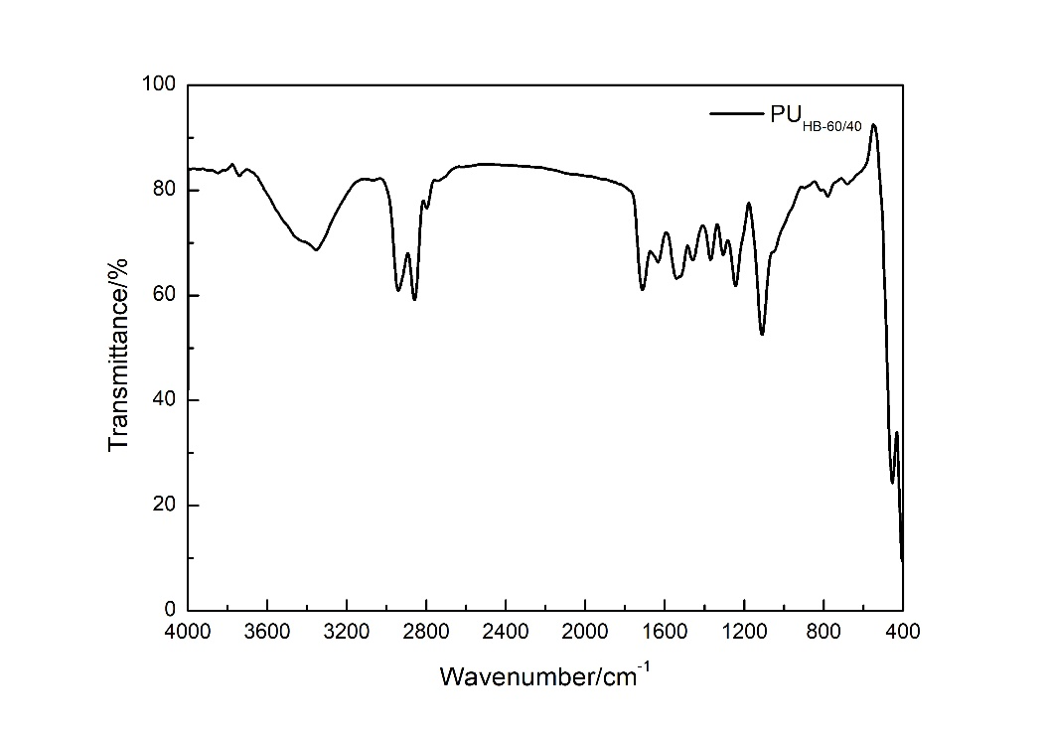
Figure S1. FTIR spectra of PU_{HB-60/40}

Table S2. FTIR data of PU_{HB-60/40}
Characteristic | Wavenumber(cm⁻¹)
H-bonded ν (N-H) | 3351
νa (CH₂) | 2935
νs (CH₂) | 2858
H-bonded ν (C=O) amide | 1704
H-bonded ν (C-N) + δ (N-H) amide | 1527
H-bonded ν (C-N) + δ (N-H) amide | 1241
ν (C-O-C) | 1106
ν (B-O) | 1367
δ (B₃O₃) | 675
δ (-C₇H) | 775
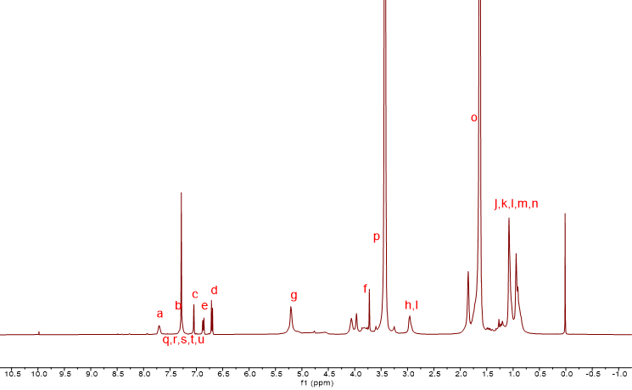
Figure. S2. ¹HNMR spectra of PU_{HB-60/40}
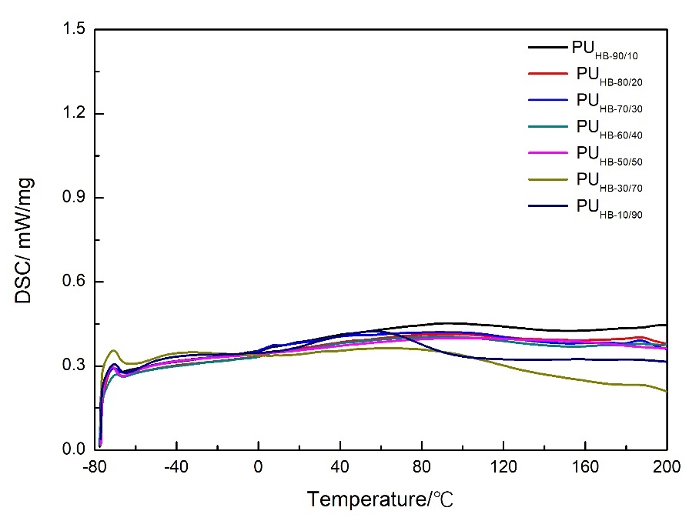
Figure S3. DSC map of PU_{PIPMB} series of room temperature self-healing polyurethane elastomers
Figure S4. WXAD diagram of PU_{PIPMB} series of room temperature self-healing polyurethane elastomers
Table S3. GPC test of PU_{PIPMB} series of room temperature self-healing polyurethane elastomers
Sample | M_{n}(g/mol) | M_{w}(g/mol) | PDI
PU_{HB-90/10} | 35434 | 59464 | 1.678
PU_{HB-80/20} | 32212 | 54642 | 1.696
PU_{HB-70/30} | 64231 | 118295 | 1.842
PU_{HB-60/40} | 65631 | 145637 | 2.219
PU_{HB-50/50} | 27654 | 48825 | 1.765
PU_{HB-30/70} | 113950 | 228669 | 2.006
PU_{HB-10/90} | 33813 | 57618 | 1.704

Table S4. Glass Transition temperature (Tg) of PU_{PIPMB} series of room temperature
self-healing polyurethane elastomers
Sample | T_{g}(°C)
PU_{HB-90/10} | ﹣40.2
PU_{HB-80/20} | ﹣41.0
PU_{HB-70/30} | ﹣44.8
PU_{HB-60/40} | ﹣41.4
PU_{HB-50/50} | ﹣56.1
PU_{HB-30/70} | ﹣48.2
PU_{HB-10/90} | ﹣52.6

(a)
(b)
Figure S3. AFM image of PU_{HB-60/40}: (a) Height map of AFM of PU_{HB-60/40}; (b) AFM 3D images of PU_{HB-60/40}
Table S5. Mechanical properties data of PU_{PIPMB} series of room temperature
self-healing polyurethane elastomers
Sample | Tensile Strength/MPa | Elongation at Break/% | Toughness/MJ·m⁻³
PU_{HB-90/10} | 6.1 | 2490 | 61.6
PU_{HB-80/20} | 2.7 | 2472 | 33.1
PU_{HB-70/30} | 11 | 2475 | 104.6
PU_{HB-60/40} | 18.8 | 2132 | 117
PU_{HB-50/50} | 1.8 | 2479 | 25.1
PU_{HB-30/70} | 17.1 | 2025 | 108.9
PU_{HB-10/90} | 11.6 | 1689 | 67.3

Table S6. Comparison of mechanical properties between PU_{HB-60/40} and recently reported relevant materials
Sample | Tensile strength/MPa | Elongation at break/% | Toughness/MJ.m⁻³
This study | 18.8 | 2132 | 117.0
Ref.35 | 1.1 | 229 | 6.5
Ref.36 | 5.72 | 1726 | 24.45
Ref.37 | 4.83 | 2010 | 65.49
Ref.38 | 1.3 | 2100 | ---
Ref.39 | 6.31 | 710 | ---
Ref.40 | 3.9 | 348.57 | ---
Ref.41 | 11 | 725.5 | 52.1
Ref.42 | 11.91 | 723.57 | 30.07
Ref.43 | 16.1 | 771 | ---

Table S7. Self-healing results of mechanical properties of polyurethane elastomers at 25°C±2°C for 48h (relative humidity 60%±2%)
Sample | Tensile strength (SE)/% | Elongation (SE)/% | Toughness (SE)/%
PU_{HB-90/10} | 77.0 | 99.2 | 86.0
PU_{HB-80/20} | 98.9 | 98.4 | 96.5
PU_{HB-70/30} | 87.7 | 84.0 | 83.1
PU_{HB-60/40} | 94.7 | 91.7 | 86.7
PU_{HB-50/50} | 90.3 | 99.8 | 95.7
PU_{HB-30/70} | 98.4 | 80.7 | 79.0
PU_{HB-10/90} | 72.9 | 92 | 80.7

Table S8. Trend of self-healing efficiency of mechanical properties of PU_{HB-60/40} over time
PU_{HB-60/40} | Tensile strength (SE)/% | Elongation (SE)/% | Toughness (SE)/%
12h | 28.7 | 55.4 | 24.6
24h | 41.4 | 63.6 | 37.1
36h | 78.1 | 90.2 | 74.6
48h | 94.7 | 91.7 | 86.7

Table S9. 48h self-healing efficiency of PU_{HB-60/40} at room temperature under different relative humidity
Relative humidity | Tensile strength (SE)/% | Elongation (SE)/% | Toughness (SE)/%
60% | 94.7 | 91.7 | 86.7
70% | 81.5 | 97.8 | 83.0
80% | 74.5 | 100.0 | 83.0
90% | 70.3 | 87.5 | 67.8

Table S10. 48h efficiency of self-healing at room temperature after PU_{HB-60/40} immersion
and conventional treatment
PU_{HB-60/40} | Tensile strength (SE)/% | Elongation (SE)/% | Toughness (SE)/%
Healed for 48h at 25℃  (Water) | 90.8 | 92.3 | 84.5
Healed for 48h at 25℃ | 95.6 | 91.7 | 87.5
Table S11. Mechanical properties data of PU_{HB-60/40} cyclic preparation
Sample | Tensile strength/MPa | Elongation/% | Toughness/MJ·m⁻³
Original | 18.8 | 2132 | 117
1st recycle | 18.1 | 2130 | 115
3rd recycle | 17.1 | 2255 | 108
5th recycle | 17.3 | 2154 | 108

