Supplementary Materials
Table S1 F values of two-way ANOVA on soil properties between different sites and soil compartments.
Soil properties | F value and significance
Soil properties | site | soil | site × soil
pH | 53.915*** | 27.322*** | 2.892
EC | 182.129*** | 2.619 | 0.110
MC | 2.958 | 28.724*** | 2.529
SOC | 18.179*** | 30.346*** | 7.518**
NO₃⁻-N | 9.926** | 3.861 | 4.028*
NH₄⁺-N | 29.209*** | 27.617*** | 9.646**
TN | 12.895*** | 25.842*** | 3.162
TP | 11.869*** | 10.557** | 0.005
N:P | 8.097** | 18.697*** | 2.704
ACP | 44.429*** | 152.052*** | 37.068***
β-GC | 17.432*** | 35.129*** | 9.510**
NAG | 16.119*** | 56.384*** | 17.191***
Notes: the asterisks indicate significant main effects or interactions. *, p < 0.05; **, p < 0.01; ***, p < 0.001. pH, soil pH; EC, soil electricity conductivity; MC, soil moisture content; SOC, soil organic carbon content; NO₃⁻-N, soil nitrate nitrogen content; NH₄⁺-N, soil ammonium nitrogen content; TN, soil total nitrogen content; TP, soil total phosphorus content; N:P, soil total nitrogen to total phosphorus ratio; ACP, soil acid phosphatase activity; β-GC, soil β-glucosidase activity; NAG, soil N-acetyl-β-D-glucosidase activity.

Table S2 Results of two-way PERMANOVA (Bray-Curtis distances) testing the effects of habitat and soil compartment on bacteria community composition.
Bacteria | Df | Sum of Sqs | R² | F | p
site | 2 | 2.789993 | 0.290859 | 4.925885 | 0.001
soil | 1 | 0.674947 | 0.070364 | 2.38331 | 0.003
site × soil | 2 | 1.029764 | 0.107354 | 1.818105 | 0.005
Residual | 18 | 5.097549 | 0.531423
Total | 23 | 9.592253 | 1

Table S3 Results of two-way PERMANOVA (Bray-Curtis distances) testing the effects of habitat and soil compartment on fungi community composition.
Fungi | Df | Sum of Sqs | R² | F | p
site | 2 | 1.736372 | 0.167262 | 2.279696 | 0.001
soil | 1 | 0.707535 | 0.068156 | 1.857856 | 0.004
site × soil | 2 | 1.082242 | 0.104251 | 1.420884 | 0.008
Residual | 18 | 6.855012 | 0.660332
Total | 23 | 10.38116 | 1
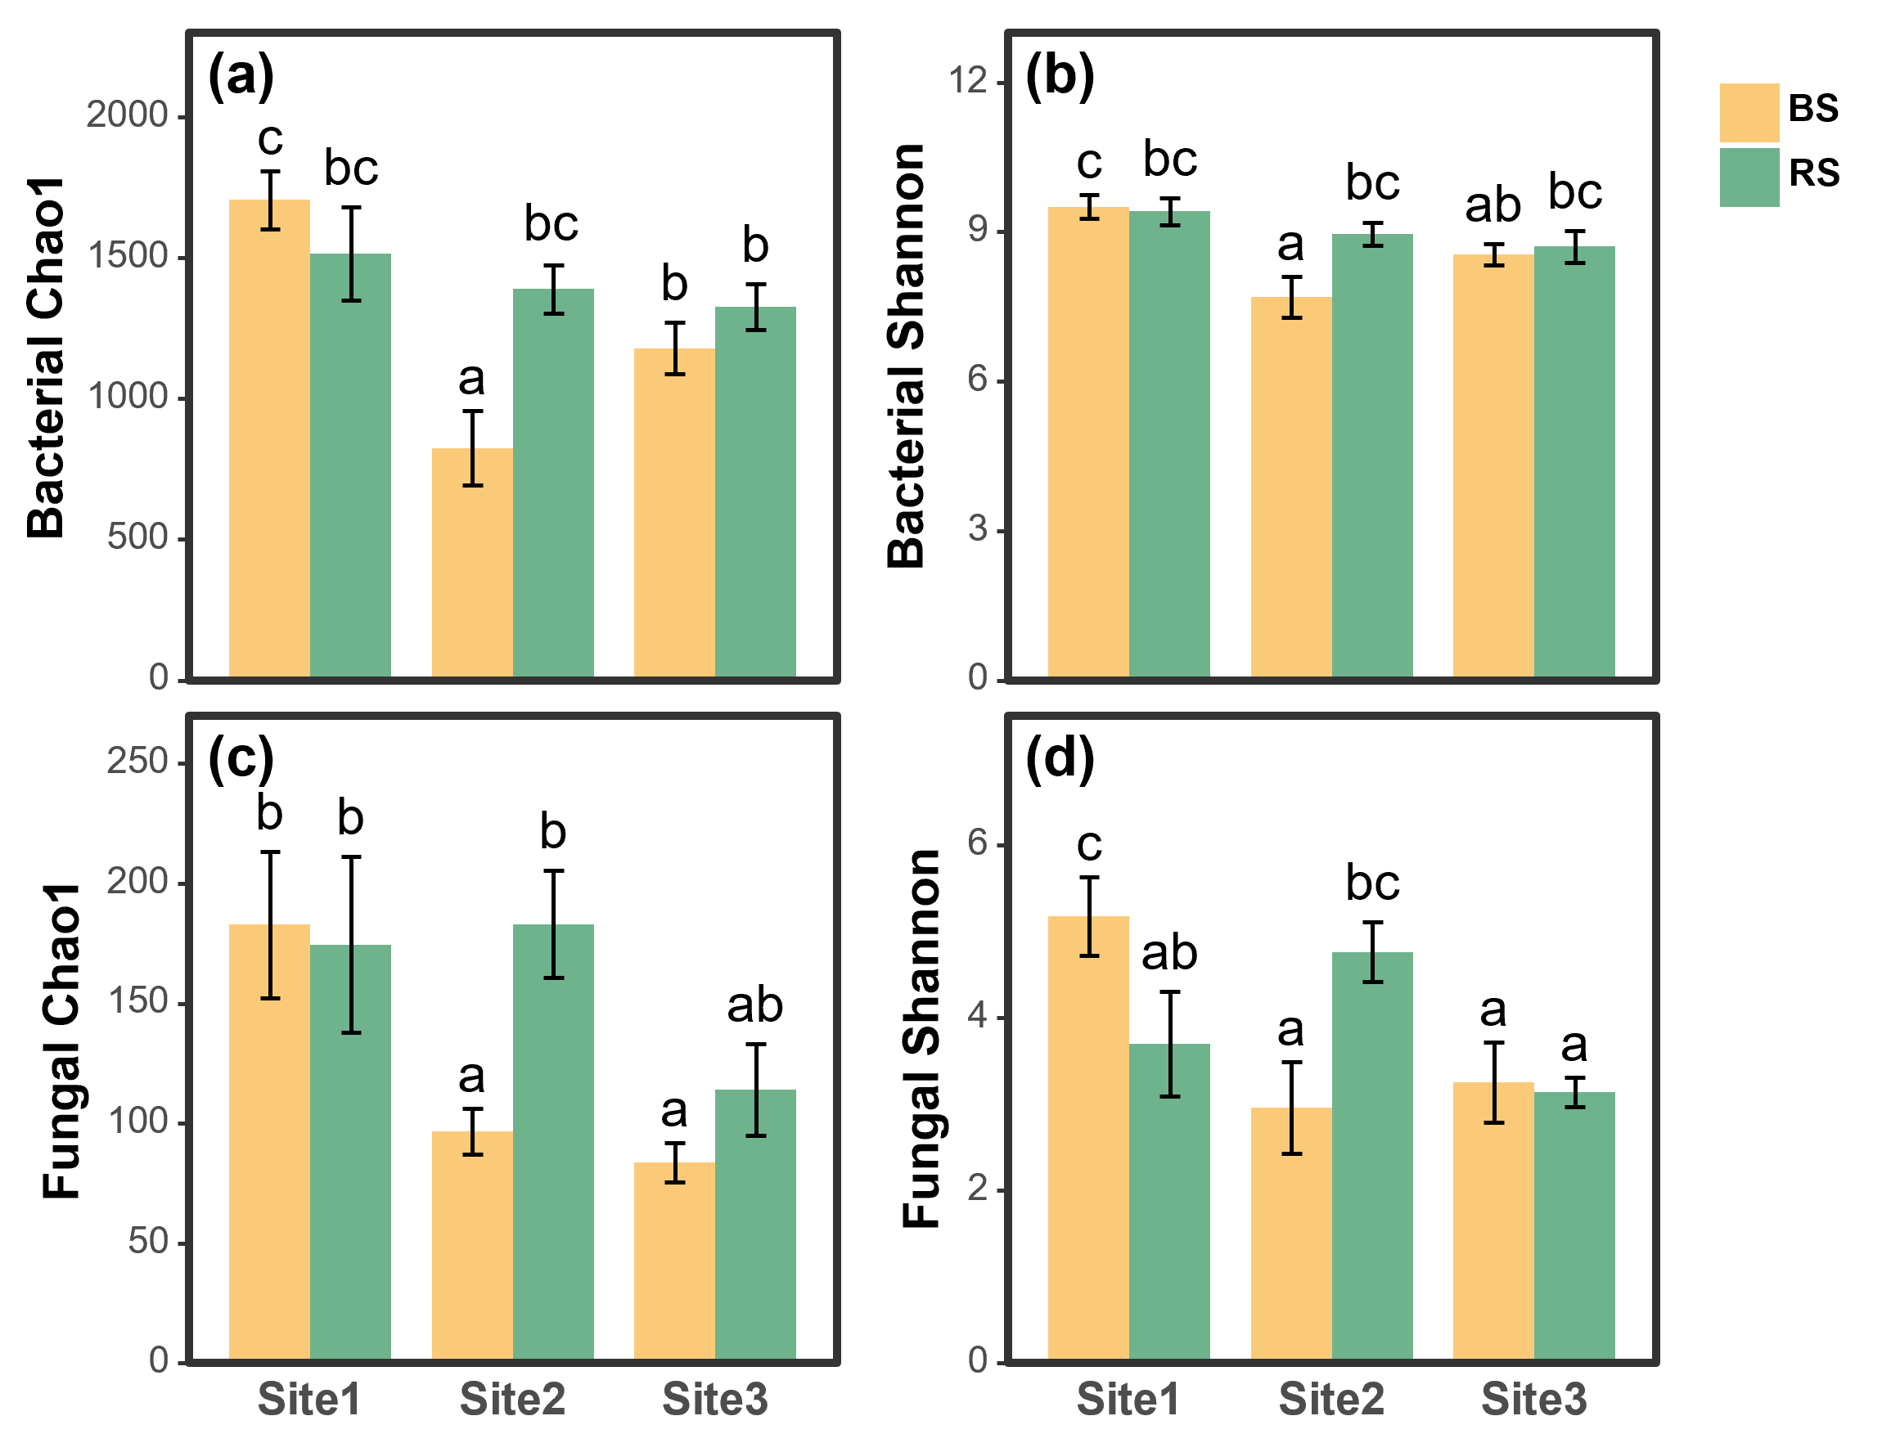
Fig. S1 Soil microbial α-diversity indices in three habitats. Different lowercase letters indicate significant difference among different habitats at the p < 0.05 level.
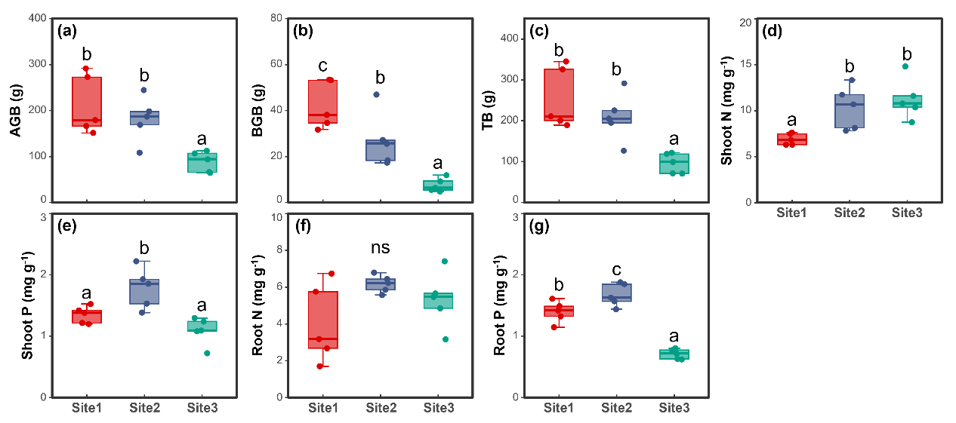
Fig. S2 Tissue element content and biomass of S. salsa in three habitats. Different lowercase letters indicate significant difference among the three habitats at the p < 0.05 level, “ns” denotes no statistically significant differences among three habitats. (a) Biomass of aboveground part in the sample; (b) biomass of belowground part in the sample; (c) total biomass of S. salsa in the sample; (d) nitrogen content in aboveground tissues; (e) phosphorus content in aboveground tissues; (f) nitrogen content in belowground tissues; (g) phosphorus content in belowground tissues.

