Supplementary Fig. S1 | Clustering diagnostics: silhouette curve and cluster sizes (k = 2–6)
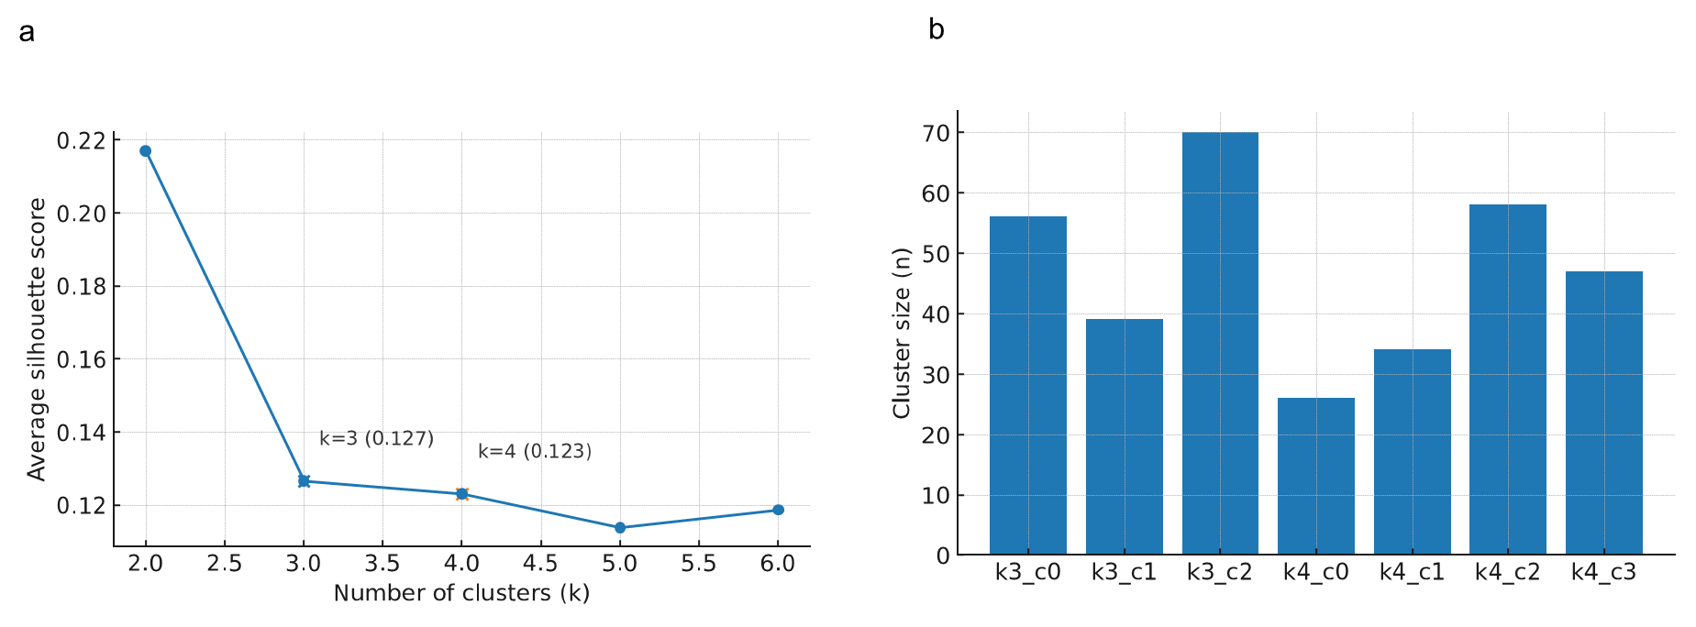
a, Silhouette curve. The 13 functional indicators were z-standardized and k-means (k-means++ initialization, n_init = 100, fixed seed) was fitted for k = 2–6. The average silhouette peaked at k = 3 (0.127) and slightly decreased at k = 4 (0.123; ΔS_{4−3} = −0.004). Silhouette width was the primary selection criterion; when gains were marginal (ΔS < 0.02), the more parsimonious solution was preferred, and k = 3 was retained for primary analyses.
b, Cluster sizes. For k = 3: 70/56/39; for k = 4: 61/44/34/26 (minimum 26, 15.8% of N = 165). Sizes were reasonably balanced and acceptable at k = 4 as well.
For completeness, Calinski–Harabasz decreased 31.49→27.51 and Davies–Bouldin improved 2.204→1.906.

Supplementary Table S1 | Baseline characteristics by skin profile (unweighted)
Values are unweighted descriptive statistics. Age is reported as mean (SD); all other variables are shown as n (%). Percentages use non-missing denominators within each column (All and Profiles 0–2). Post-weighting covariate balance is shown in Fig. 3 (Love plot; threshold |SMD| < 0.1).

Supplementary Table S2 | Pairwise effect sizes (Cohen’s d) between skin profiles for the 13 functional indicators.
Rows list the functional indicators; columns report pairwise contrasts 0 vs 1, 0 vs 2, and 1 vs 2 (sign = mean of the left profile minus the right). The table also includes max |d| per indicator and the pair at max. Values are unweighted Cohen’s d using the pooled s.d., computed on non-missing observations per contrast, and rounded to three decimals. Positive values indicate higher means in the left profile, negative the opposite. These values underlie Fig. 2c (heat map) and Fig. 2d (ranking). For reference, conventional thresholds are d ≈ 0.2 (small), 0.5 (medium), 0.8 (large).

Supplementary Table S3a | Summary of stabilized IPTW weights after primary trimming (Option A).
Summary statistics of stabilized inverse-probability weights (IPTW) for the three-level exposure (Profiles 0–2) under the prespecified global 1st/99th-percentile trimming (thresholds 0.4368 / 2.6360). Columns: N, Min, 1st pct, Median, IQR, Mean, 99th pct, Max, ESS (weighted effective sample size), and Trimmed (n, %). Trimmed (n, %) counts observations excluded for weights below/above the thresholds (denominator: N = 165). ESS = (∑wᵢ) ² / ∑wᵢ². Post-weighting covariate balance (|SMD|<0.1) is shown in Fig. 3a; the weight distribution (histogram/KDE) in Fig. 3b.

Supplementary Table S3b | Summary of stabilized IPTW weights after winsorization (sensitivity analysis).
Same layout as S3a, but with winsorization at the global 1st/99th percentiles: weights below/above the thresholds are replaced at the cutoffs (no exclusion). Columns: N, Min, 1st pct, Median, IQR, Mean, 99th pct, Max, ESS, and Winsorized (n, % replaced). This table supports the sensitivity analysis comparing trimming vs winsorization; see Supplementary Fig. S6 (agreement) and Supplementary Table S7 (side-by-side estimates). Supplementary Table S3| Summary of stabilized IPTW weights and winsorization (Option A)
Supplementary Fig. S2 | Propensity-score overlap by profile (multinominal PS)
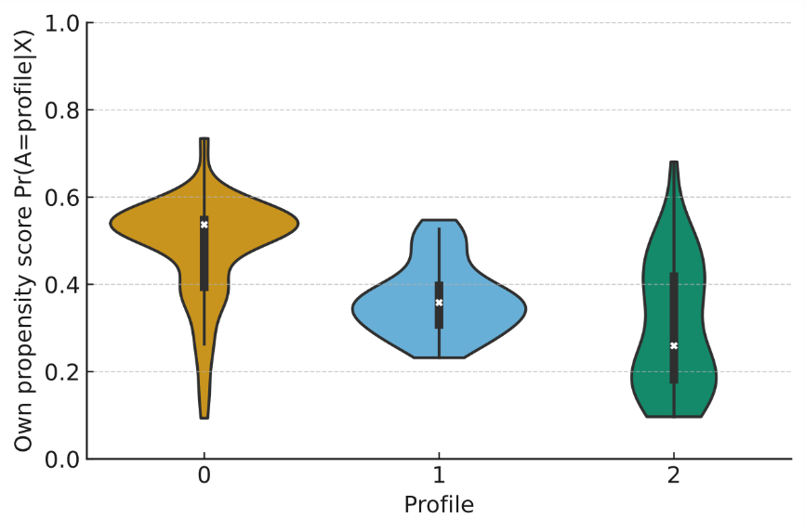
Violin plots show the distribution of own-treatment probabilities $Pr⁡(A=a|X)$ within each profile (Profiles 0-2), estimated from a multinominal propensity model using age, sex, skincare habit, and current smoking as covariates. Substantial overlap without mass near 0 or 1 supports the positivity assumption for IPTW-based causal estimation.

Supplementary Table S4 | Outcome-specific analyzed sample sizes after weighting/trimming (primary analysis).
Counts of non-missing observations entering each outcome model after stabilized IPTW and global 1st/99th-percentile trimming (Option A). Denominators vary by outcome due to outcome-specific missingness; exposure, confounders, and weights were required to be non-missing for inclusion. The weighted ESS for the trimmed weighting population is reported; per-outcome analytic N may be smaller if the outcome itself is missing.

Supplementary Table S5 | Binary outcomes: IPTW-weighted marginal odds ratios (OR) with 95% CI
Stabilized IPTW were estimated from age, sex (female = 1), skincare habit (yes = 1), and current smoking (yes = 1) using a multinomial propensity model for the three-level exposure (Profiles 0–2). Weighted marginal structural logistic models report population-average effects for Profile 1 vs 0 and Profile 2 vs 0. Columns list the point-estimate OR and 95% CI for each outcome (wrinkle, turnover, transparency, seborrheic dermatitis, rosacea, redness, acne). Primary analyses applied global 1st/99th-percentile trimming (Option A) uniformly across outcomes. Outcome-specific analyzed N are provided in Supplementary Table S4.

Supplementary Table S6 | Continuous outcomes: IPTW-weighted standardized coefficients (β) with 95% CI
Using the same stabilized IPTW and primary trimming (Option A) as in S5, weighted marginal structural linear models estimate population-average effects for Profile 1 vs 0 and Profile 2 vs 0. Outcomes include cheek/forehead domains for wrinkle, brown spot, red spot, pore, and texture, plus color parameters L*, a*, b*. Reported β are standardized (denominator = weighted SD of each outcome in the analytic sample). Columns list β and 95% CI. Outcome-specific analyzed N appear in Supplementary Table S4.

Supplementary Fig. S3 | Agreement between trimming and winsorization of stabilized IPTW.
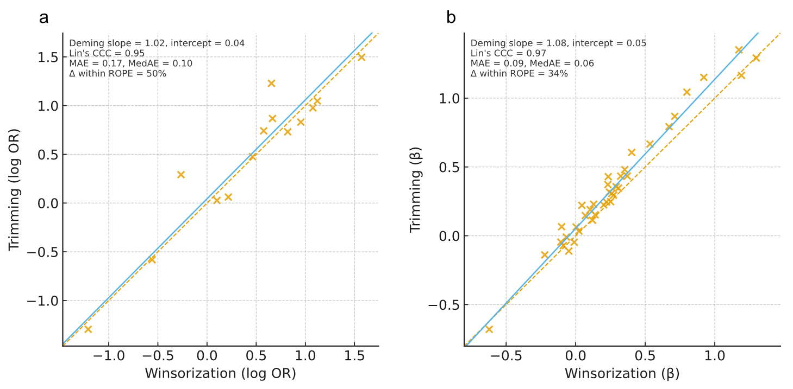
Panels compare estimates from winsorization (x-axis) versus percentile trimming (y-axis) for (a) binary outcomes (log OR) and (b) continuous outcomes (standardized β). Dashed line: identity. Solid line: Deming regression (error-in-variables). Lin’s concordance correlation coefficients (CCC), mean absolute error (MAE), and median absolute error (MedAE) are reported within each panel. Agreement was high (CCC≈0.95–0.97) with slopes near unity, indicating that the choice between trimming and winsorization has minimal impact on effect estimates.

Supplementary Methods
Inclusion/exclusion criteria
Inclusion criteria
Able and willing to provide written informed consent.
Healthy Japanese women aged 18–39 years at the start of the study year.
Exclusion criteria
Pregnant, possibly pregnant, or breastfeeding at the time of the health survey.
Current, physician-treated dermatologic disease such as atopic dermatitis or contact dermatitis.
Any other condition judged by the principal investigator to make participation inappropriate.
Note: Eligibility criteria were prespecified before enrollment and applied uniformly.

Device models and measurements
Unless otherwise noted, measurements were obtained at the cheek by trained staff following manufacturer instructions, under stable indoor conditions (temperature 21–24 °C, relative humidity 40–60%).
- Transepidermal water loss (TEWL): Tewameter TM300 (Courage + Khazaka, Germany).
- Stratum corneum hydration (surface): Corneometer CM825 (Courage + Khazaka, Germany).
- Water-holding capacity (hydration capacity): SKICON (Yayoi, Japan).
- Hydration homogeneity (spatial uniformity): MoistureMap MM 200 (Courage + Khazaka, Germany).
- Sebum amount: Sebumeter (Courage + Khazaka, Germany).
- Skin thickness: DermaLab ultrasound system (Cortex Technology, Denmark).
- Collagen content (dermal echogenicity): DermaLab ultrasound system (Cortex Technology, Denmark).
- Skin surface temperature: TH9100 PMV/PWV infrared thermography (Nippon Avionics, Japan).
- Dermal hydration: MoistureMeter-D (Delfin Technologies, Finland).

Detailed outcome definitions, image processing, and quality control
Binary outcome definitions and dichotomization
- Dermatologist-adjudicated endpoints: acne, seborrheic dermatitis, and rosacea were assessed as present/absent by a board-certified dermatologist based on standardized facial inspection.
- Specialist-graded endpoints: wrinkle, turnover (desquamation), transparency, and redness were graded by trained cosmetic evaluators using a prespecified ordinal scale under standardized lighting and viewing conditions. Following the analysis plan, each was collapsed to binary by thresholding at the median of the observed scale within the study dataset (i.e., values ≥ median coded as “high,” < median as “low”).
Continuous outcomes (image-derived)
Image-derived metrics for wrinkle, brown spot, red spot, pore, and texture were computed using the manufacturer’s software from standardized facial images acquired with VISIA Evolution (Canfield Scientific, USA). Outcomes were generated separately for cheek and forehead regions using the system’s default region-of-interest templates; no manual retouching was applied. Skin-color parameters (L*, a**, b***) were measured using a Chroma Meter (Konica Minolta, Japan) and analyzed as continuous variables.
Image acquisition and processing
Facial images were captured by trained staff under stable indoor conditions (temperature 21–24 °C; relative humidity 40–60%) following the manufacturer’s instructions. Camera settings, subject positioning, and facial orientation were standardized using the built-in alignment guides. All image processing used the vendor’s validated software with default analysis settings; batch processing was applied to ensure consistent handling across participants.
Quality control (QC)
QC procedures were prespecified and applied uniformly:
- Visual QC excluded images with motion blur, misalignment, occlusions (e.g., hair, mask), or obvious artifacts.
- Participants were instructed to remove makeup prior to imaging; images with residual cosmetics interfering with detection were excluded.
- For colorimetry (L*, a*, b*), measurements followed the device manual; values outside the device’s operational range or flagged by the system were re-measured.
- Continuous outcomes with software warnings or failed extractions were set to missing and excluded listwise for the corresponding analysis.
- Raters (dermatologist and cosmetic evaluators) were trained and followed written SOPs; evaluations were performed blinded to clustering assignment and covariates.

