Immobilization of laccase on magnetic cellulose beads for enhanced biodegradation of bisphenol A and a metal-complex dye

Gulay Bayramoglu*^{1,2}, and Mehmet Yakup Arica¹

¹Biochemical Processing and Biomaterial Research Laboratory, Gazi University, 06500 Teknikokullar, Ankara, Turkey
²Department of Chemistry, Faculty of Sciences, Gazi University, 06500 Teknikokullar, Ankara, Turkey

Correspondence authors:
*Email: g_bayramoglu@hotmail.com

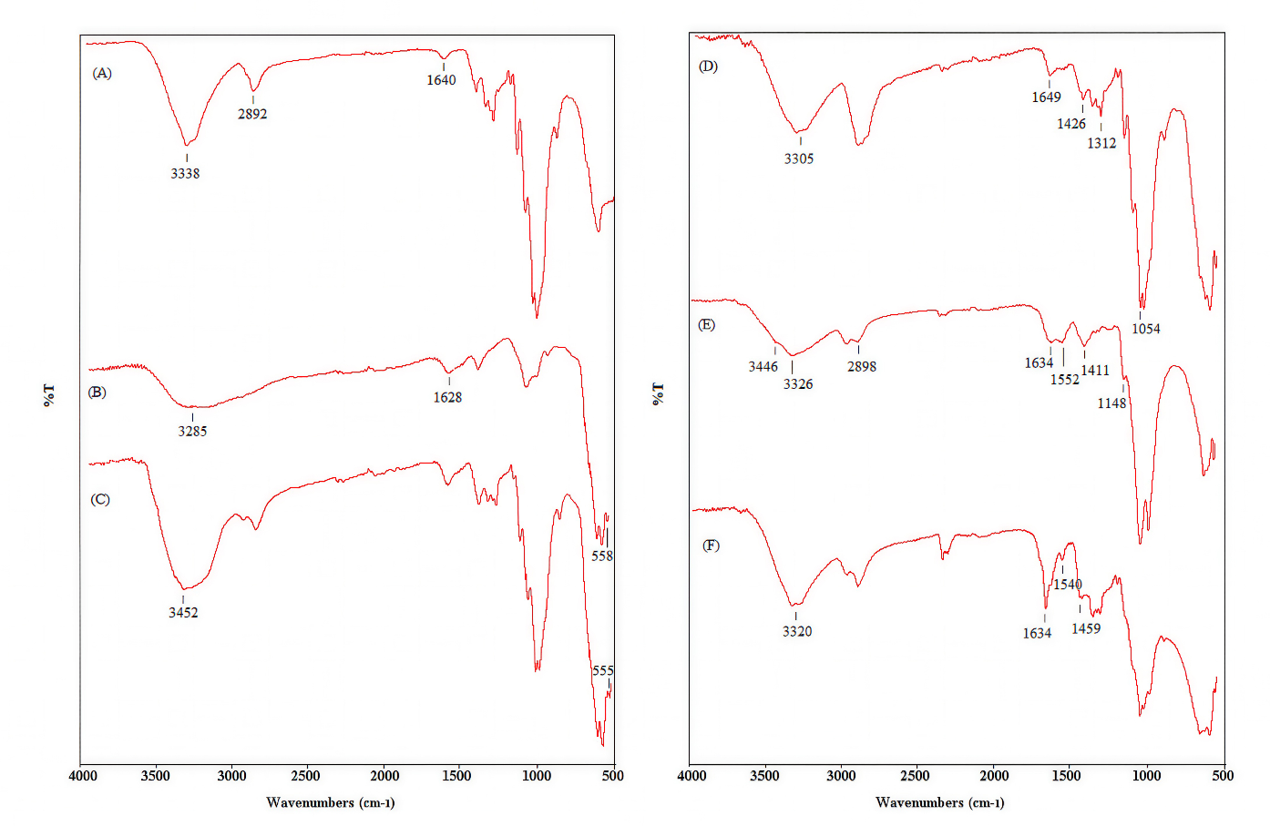
Figure S1. FTIR spectra of pure cellulose (A), magnetic particles (B), MCB (C), MCB@PDA-HMDA (D), MCB@PDA-HMDA-Cu(II)-Lac, and MCB@PDA-HMDA-GA-Lac

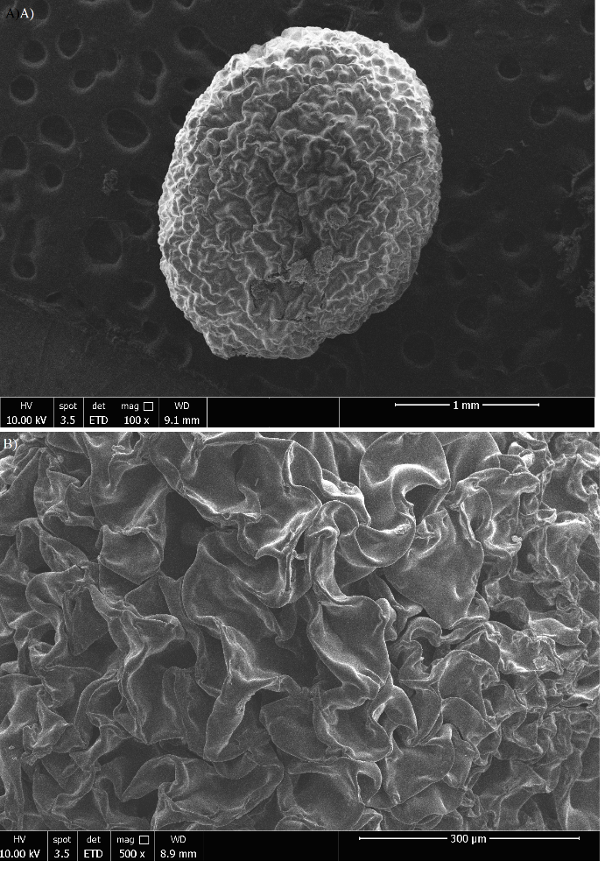
Figure S2. SEM image of the MCB@PDA-HMDA beads (A), and surface structure of the MCB@PDA-HMDA beads (B)

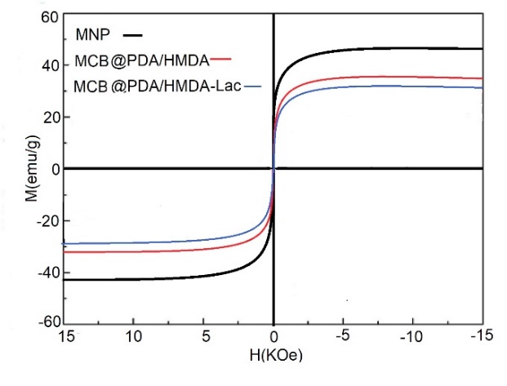
Figure S3. The magnetization curves of the MNP, MCB@PDA-HMDA, and MCB@PDA-HMDA-Lac beads at room temperature

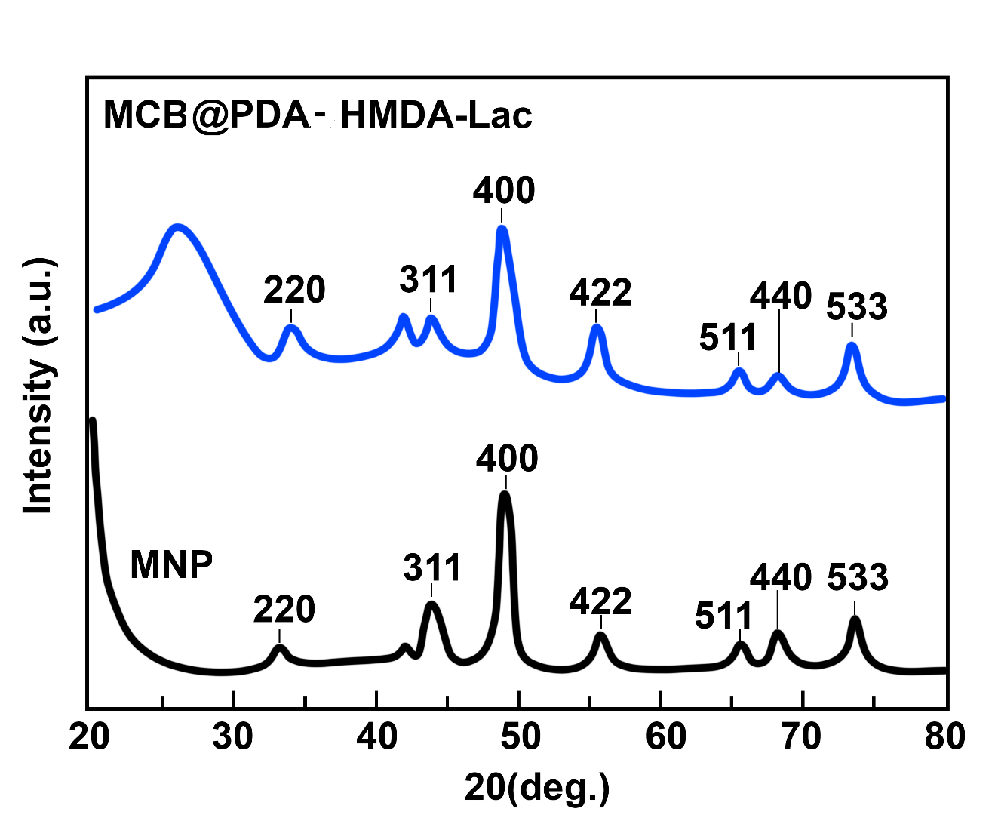

Figure S4. XRD patterns of Fe₃O₄ (MNPs) and MCB@PDA-HMDA-GA-Lac beads

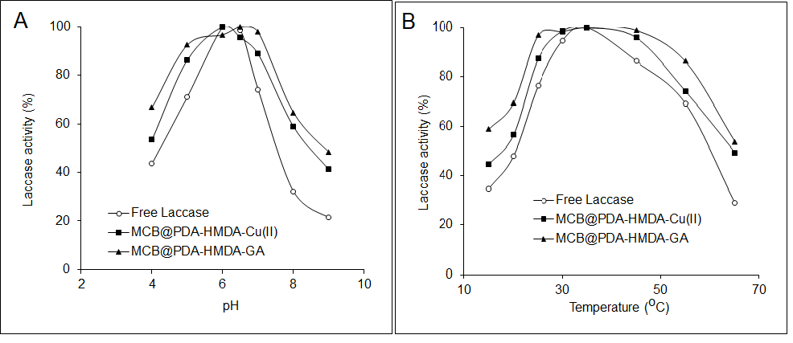
Figure S5. Effect of pH on the activity of laccase preparations (A), Effect of temperature on the activity of laccase preparations (B)

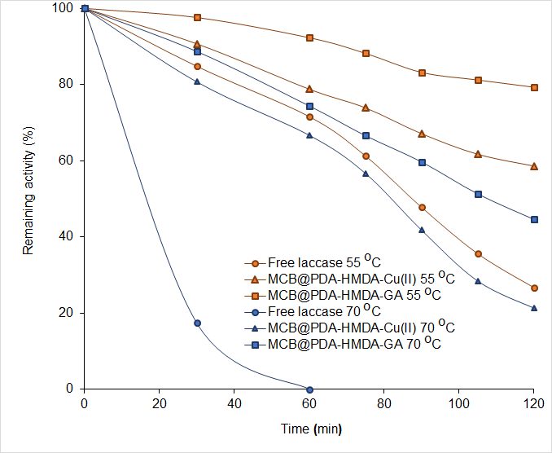
Figure S6. Thermal stabilities of MCB@PDA-HMDA-GA-Lac and MCB@PDA-HMDA-Cu(II)-Lac at two different temperatures.

Table S1. Growth inhibition test of C. vulgaris grown with three different initial concentrations of BPA, and RG-5 (i.e., 5, 10, and 25 mg/L)
 | Initial concentration of chemicals (mg/L) | Biomass dry weight (mg/L) | Biomass recovery  (%)
Control | 0 | 0.817±0.037 | 100
BPA | 5 | 0.795±0.026 | 97
 | 10 | 0.568±0.039 | 69
 | 25 | 0.358±0.053 | 43
RG-5 | 5 | 0.693±0.024 | 85
 | 10 | 0.275±0.057 | 34
 | 25 | 0.173±0.043 | 21
DP - BPA | 25 | 0.834±0.065 | 102
DP - RG-5 | 25 | 0.196±0.048 | 23
DP: Degradation product was obtained after 120 treatments with MCB@PDA-HMDA-Cu(II)-Lac preparation

