Table S1: Search strategy for online databases.
PubMed/MEDLINE:
1 "Osteoarthritis"[Mesh] OR Osteoarthritis[TIAB] OR Osteoarthritides[TIAB] OR Degenerative Arthritides[TIAB] OR Degenerative Arthritis[TIAB] OR Osteoarthrosis[TIAB] OR Osteoarthroses[TIAB] OR Osteoarthrosis Deformans[TIAB] OR Arthrosis[TIAB] OR Arthroses[TIAB] OR Joint Degeneration[TIAB] OR Cartilage Degeneration[TIAB] OR Wear-and-Tear Arthritis[TIAB] OR Degenerative Joint Disease[TIAB] OR Articular Cartilage Degeneration[TIAB] OR Knee Osteoarthritis[TIAB] OR Hip Osteoarthritis[TIAB] OR Hand Osteoarthritis[TIAB] OR Spinal Osteoarthritis[TIAB] OR "OA"[TIAB] OR Chronic Joint Disease[TIAB] OR Anterior Knee Pain Syndrome[TIAB] OR Patellofemoral Syndrome[TIAB] OR Patellofemoral Pain[TIAB] OR Patellofemoral Pains[TIAB] OR Knee pain [TIAB] OR Joint Diseases [TIAB] OR "Patellofemoral Pain Syndrome"[Mesh]
2 "Methotrexate"[Mesh] OR Amethopterin[TIAB] OR Mexate[TIAB] OR Methotrexate Hydrate[TIAB] OR Methotrexate Sodium[TIAB] OR Methotrexate[TIAB] OR Rheumatrex[TIAB]
3 Randomized Controlled Trial [TIAB] OR RCT [TIAB] OR Randomized Clinical Trial [TIAB] OR Controlled Clinical Trial [TIAB] OR Randomized Controlled Clinical Trial [TIAB] OR Randomized Clinical Study [TIAB] OR Randomized Intervention Study [TIAB] OR Controlled Randomized Study [TIAB] OR Controlled Randomized Clinical Trial [TIAB] OR Randomized Assignment Trial [TIAB] OR randomized[tiab] OR placebo[tiab] OR randomly [tiab] OR trial[tiab] OR groups[tiab]
4 #1 AND #2 AND #3

Embase:
1 Osteoarthritis/exp OR Osteoarthritis:ti,ab OR Osteoarthritides:ti,ab OR 'Degenerative Arthritides':ti,ab OR 'Degenerative Arthritis':ti,ab OR Osteoarthrosis:ti,ab OR Osteoarthroses:ti,ab OR 'Osteoarthrosis Deformans':ti,ab OR Arthrosis:ti,ab OR Arthroses:ti,ab OR 'Joint Degeneration':ti,ab OR 'Cartilage Degeneration':ti,ab OR 'Wear-and-Tear Arthritis':ti,ab OR 'Degenerative Joint Disease':ti,ab OR 'Articular Cartilage Degeneration':ti,ab OR 'Knee Osteoarthritis':ti,ab OR 'Hip Osteoarthritis':ti,ab OR 'Hand Osteoarthritis':ti,ab OR 'Spinal Osteoarthritis':ti,ab OR OA:ti,ab OR 'Chronic Joint Disease':ti,ab OR 'Anterior Knee Pain Syndrome':ti,ab OR 'Patellofemoral Syndrome':ti,ab OR 'Patellofemoral Pain':ti,ab OR 'Patellofemoral Pains':ti,ab OR 'Knee pain':ti,ab OR 'Joint Diseases':ti,ab OR 'Patellofemoral Pain Syndrome'/exp
2 'methotrexate'/exp OR amethopterin:ti,ab OR mexate:ti,ab OR 'methotrexate hydrate':ti,ab OR 'methotrexate sodium':ti,ab OR methotrexate:ti,ab OR rheumatrex:ti,ab
3 'randomized controlled trial':ti,ab OR rct:ti,ab OR 'randomized clinical trial':ti,ab OR 'controlled clinical trial':ti,ab OR 'randomized controlled clinical trial':ti,ab OR 'randomized clinical study':ti,ab OR 'randomized intervention study':ti,ab OR 'controlled randomized study':ti,ab OR 'controlled randomized clinical trial':ti,ab OR 'randomized assignment trial':ti,ab OR randomized:ti,ab OR placebo:ti,ab OR randomly:ti,ab OR trial:ti,ab OR groups:ti,ab
4 #1 AND #2 AND #3

The Cochrane Library:
1 Osteoarthritis:ti,ab OR Osteoarthritides:ti,ab OR "Degenerative Arthritides":ti,ab OR "Degenerative Arthritis":ti,ab OR Osteoarthrosis:ti,ab OR Osteoarthroses:ti,ab OR "Osteoarthrosis Deformans":ti,ab OR Arthrosis:ti,ab OR Arthroses:ti,ab OR "Joint Degeneration":ti,ab OR "Cartilage Degeneration":ti,ab OR "Wear-and-Tear Arthritis":ti,ab OR "Degenerative Joint Disease":ti,ab OR "Articular Cartilage Degeneration":ti,ab OR "Knee Osteoarthritis":ti,ab OR "Hip Osteoarthritis":ti,ab OR "Hand Osteoarthritis":ti,ab OR "Spinal Osteoarthritis":ti,ab OR OA:ti,ab OR "Chronic Joint Disease":ti,ab OR "Anterior Knee Pain Syndrome":ti,ab OR "Patellofemoral Syndrome":ti,ab OR "Patellofemoral Pain":ti,ab OR "Patellofemoral Pains":ti,ab OR "Knee pain":ti,ab OR "Joint Diseases":ti,ab
2 [mh Methotrexate] OR Amethopterin:ti,ab OR Mexate:ti,ab OR "Methotrexate Hydrate":ti,ab OR "Methotrexate Sodium":ti,ab OR Methotrexate:ti,ab OR Rheumatrex:ti,ab

3 #1 AND #2
Supplementary Figure S1. Quality assessment of included trials.
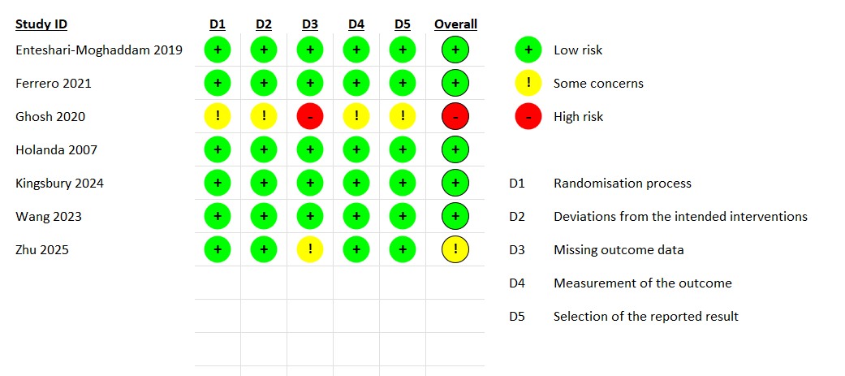
Supplementary Figure S2. Subgroup analysis for pain.
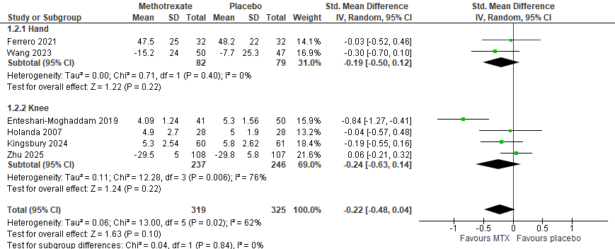

Supplementary Figure S3. Subgroup analysis for stiffness.

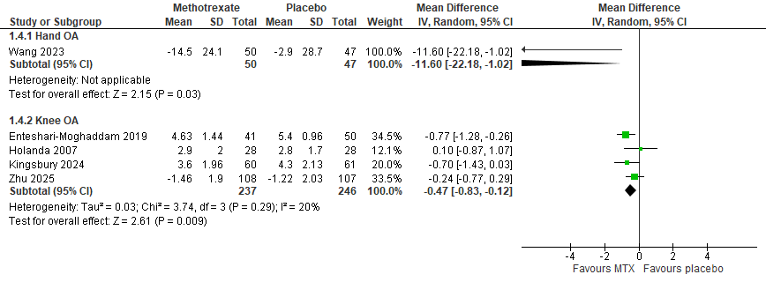

Supplementary Figure S4. Subgroup analysis for physical function.

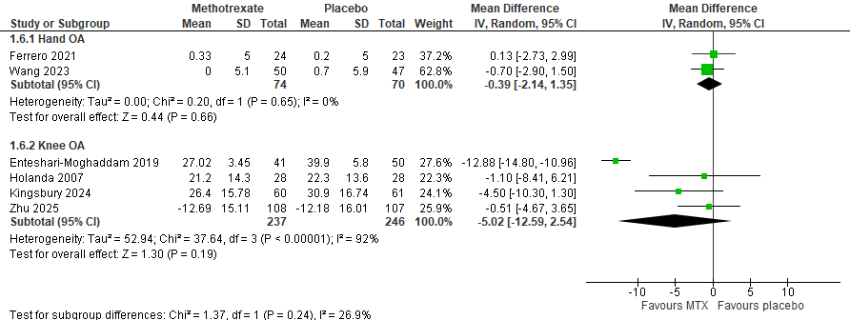

Supplementary Figure S5. Effect of methotrexate versus placebo on WOMAC total score.
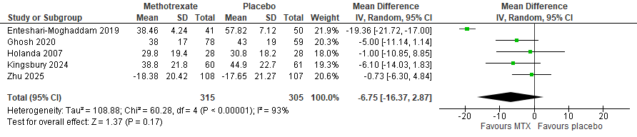

Supplementary Figure S6. Effect of methotrexate versus placebo on the quality of life.
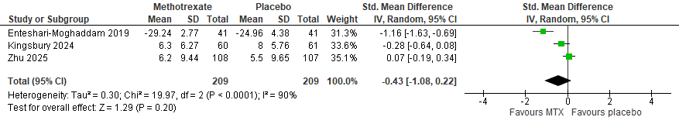

Supplementary Figure S7. Effect of methotrexate versus placebo on adverse events.
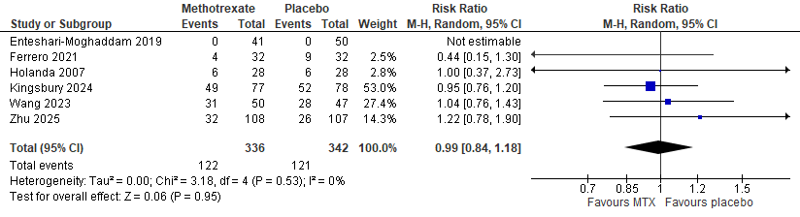

Supplementary Figure S8. Effect of methotrexate versus placebo on serious adverse events.
