Supplementary Files
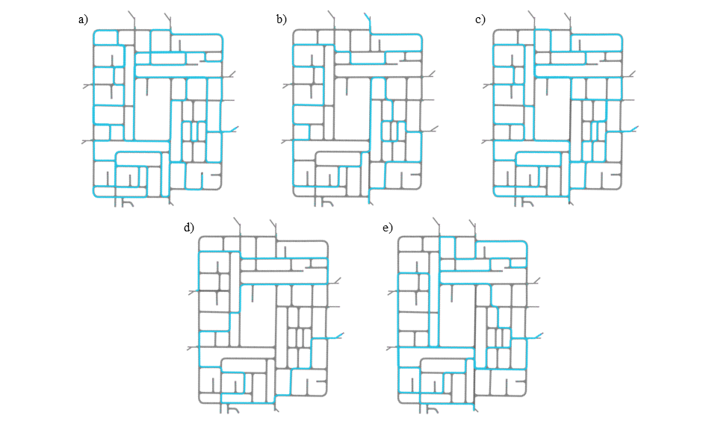
Figure S1 Optimized Routes of the a) Conventional Waste Collection, b) Sensor-based Waste Collection (Low-service Day), c) Sensor-based Waste Collection (High-service Day), d) Knowledge-based Waste Collection (Low-service Day), and e) Knowledge-based Waste Collection (High-service Day)

