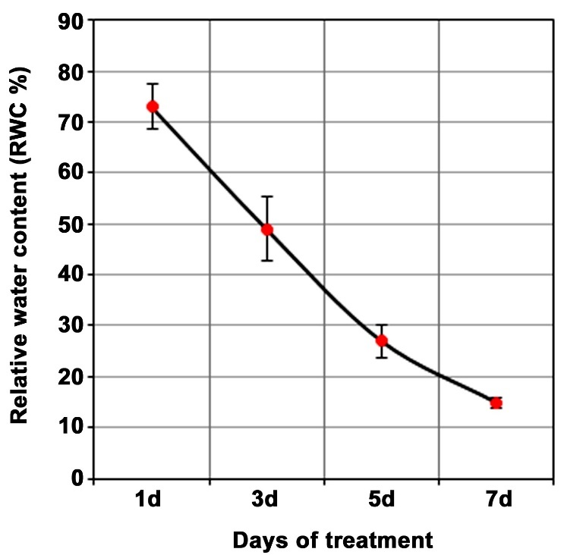

Supplementary File S1. Progressive decline in RWC (%) of Trentepohlia sp. after 1, 3, 5, and 7 days of desiccation stress. The data presented are means of three replicates + SE.

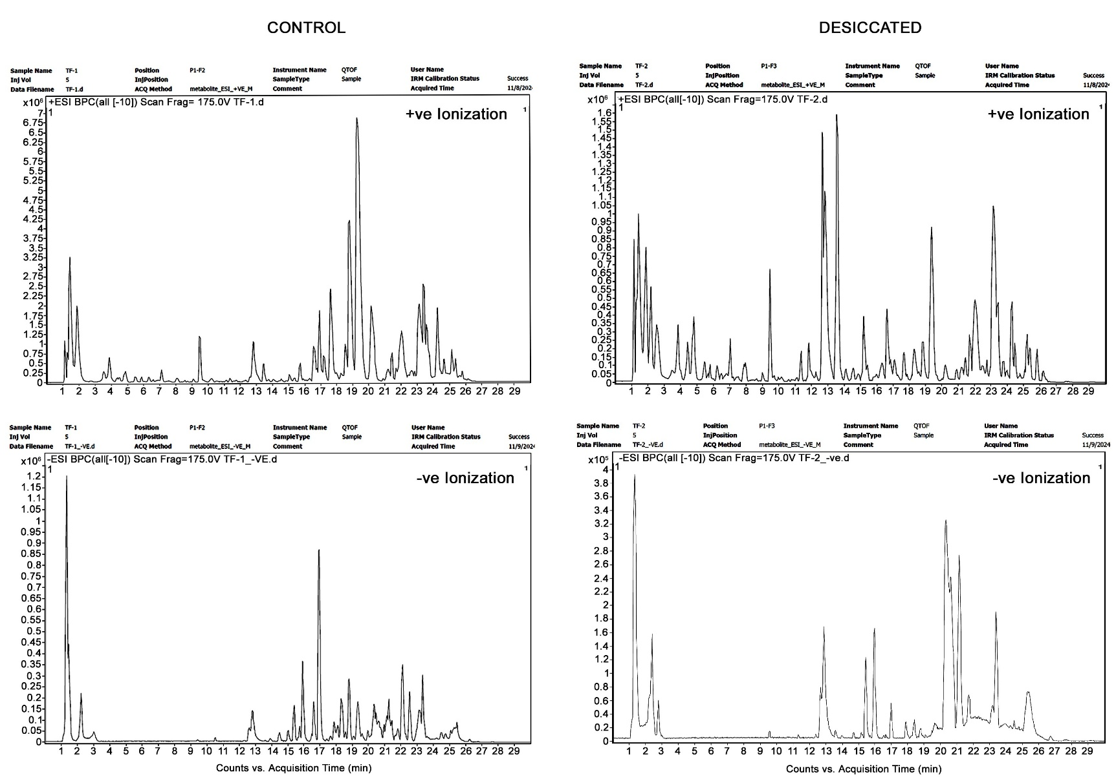
Supplementary File S2. The LC chromatograms under positive (+ve) and negative (-ve) ionization mode, representing the changes in metabolic profiles of Trentepholia sp. under desiccation stress and control.
Supplementary File S3. Metabolites identified in methanolic extracts of Trentepohlia sp. under control and desiccated stress using HRLC-MS at positive (+ve) and negative (-ve) ionization modes

S.No. | Name of the metabolite | Chemical Formula | Molecular weight | Treatments
 |  |  |  | Control | Desiccated
1 | Pyrenylsulfate | C₁₆H₁₀O₄S | 298.03 | + | -
2 | 3-indolepropinoic acid | C₁₂H₁₃NO₃ | 219.09 | + | -
3 | 3-oxo-12,18, 28-ursadienoic acid | C₃₀H₄₄O₃ | 452.32 | + | -
4 | (-)-Ormosanine | C₂₀H₃₅N₃ | 317.28 | + | +
5 | Ornaline | C₁₀H₁₈N₂O₆ | 262.11 | + | +
6 | Isomugineic acid | C₁₂H₂₀N₂O₈ | 320.12 | + | +
7 | 1,3,6-tri-O-galloylglucose | C₂₇H₂₄O₁₈ | 636.09 | + | -
8 | Lucidenic acid M | C₂₇H₄₂O₆ | 462.29 | + | -
9 | Avermectin A1b aglycone | C₃₄H₄₈O₈ | 585.33 | + | +
10 | Oxidized dinoflagellate luciferin | C₃₃H₃₈N₄O₇ | 602.27 | + | +
11 | CerP(d18:1/12:0) | C₃₀H₆₀NO₆P | 561.42 | + | +
12 | Ganosporelactone A | C₃₀H₄₀O₇ | 512.27 | + | +
13 | Maltulose | C₁₂H₂₂O₁₁ | 342.11 | + | +
14 | Citric acid | C₆H₈O₇ | 192.02 | + | -
15 | Oxalosuccinic acid | C6H6O7 | 190.00 | + | -
16 | Auriculoside | C₂₂H₂₆O₁₀ | 450.15 | + | -
17 | Cercosporin | C₂₉H₂₆O₁₀ | 534.15 | + | -
18 | Ascorbyl stearate | C₂₄H₄₂O₇ | 442.29 | + | -
19 | LysoPE(20:2(11Z.14Z)/0:0) | C₂₅H₄₈NO₇P | 505.31 | + | +
20 | Gingerglycolipid | C₃₃H₆₀O₁₄ | 680.39 | + | +
21 | Spinoside A | C₃₉H₅₆O₁₂ | 716.37 | + | -
22 | 10`-apo-β-carotene | C₂₇H₃₆O | 376.28 | + | -
23 | Harderoporphyrin | C₃₆H₃₆N₄O₆ | 608.26 | + | -
24 | Carboxyspermidine | C₁₇H₁₇N₃O₂ | 175.13 | - | +
25 | Arginine | C₆H₁₃N₅O₄ | 219.09 | - | +
26 | Morroniside | C₁₇H₂₆O₁₁ | 406.14 | - | +
27 | 2-pyrolidone-5-carboxyllic acid | C₅H₇NO₃ | 129.04 | - | +
28 | Tyrosyl-glutamate | C₁₄H₁₈N₂O₆ | 310.11 | - | +

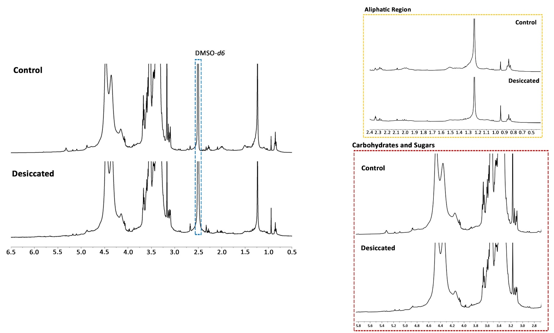

Supplementary File S4. The ¹H-NMR spectrum represents the changes in metabolic profiles of Trentepholia sp. under desiccation stress and control.
Supplementary File S5. Metabolites identified from a ¹H-NMR spectrum of methanolic extracts of Trentepohlia sp.

S. No. | Name of the metabolites | Chemical Shifts  (δ ppm)
1 | Leucine | 1.28
2 | Isoleucine | 0.91
3 | Valine | 1.06
4 | Alanine | 1.48
5 | Arginine | 1.98
6 | Glutamate | 2.02
7 | GABA | 2.30
8 | Glycine | 3.58
9 | Proline | 3.35
10 | Threonine | 3.55
11 | Asparagine | 2.88
12 | α-linoleic acid | 0.85
13 | Lactate | 1.32
14 | Acetate | 1.92
15 | Succinate | 2.39
16 | Citrate | 2.56
17 | Choline | 3.21
18 | Ascorbate | 3.67
19 | Arabinose | 3.55
20 | Trehalose | 3.69
21 | Fructose | 4.11
22 | Sucrose | 3.83, 4.05
23 | Myoinositol | 3.53
24 | Glycerol | 3.71
25 | Unknown Compounds | 4.4-5.6

Supplementary File S6. Fold change in metabolites in Trentepohlia sp. under desiccation stress compared to the control, identified using HRLC-MS analysis

Metabolites | Desiccation vs Control
Metabolites | FC (↑↓) | log2(FC)
Carboxyspermidine | 29.435 | 4.8795
Pyrenylsulfate | 0.045671 | -4.4526
Tyrosyl-glutamate | 11.216 | 3.4875
Arginine | 8.8431 | 3.1445
Morroniside | 7.1887 | 2.8457
3-oxo-12,18, 28-ursadienoic acid | 0.18024 | -2.472
3-indolepropinoic acid | 0.18557 | -2.4299
2-pyrolidone-5-carboxyllic acid | 5.0654 | 2.3407
1,3,6-tri-O-galloylglucose | 0.23362 | -2.0978
Oxalosuccinic acid | 0.23649 | -2.0801
Auriculoside | 0.26877 | -1.8956
Lucidenic acid M | 0.28365 | -1.8178
Gingerglycolipid | 3.4185 | 1.7734
LysoPE(20:2(11Z.14Z)/0:0) | 2.8859 | 1.529
Lowest Value Highest Value

Supplementary File S7. Fold change in metabolites in Trentepohlia sp. under desiccation stress compared to the control, identified using ¹H-NMR analysis.
Metabolites | Desiccation vs Control
Metabolites | FC (↑↓) | log2(FC)
Citrate | 3927 | 11.939
myoinositol | 0.00025465 | -11.939
Arabinose | 0.00061252 | -10.673
Threonine | 797.05 | 9.6385
Maltose | 0.0012546 | -9.6385
Valine | 574.69 | 9.1666
Ascorbate | 0.0017401 | -9.1666
Glycine | 0.0022002 | -8.8281
Acetate | 312.83 | 8.2892
Sucrose | 290.15 | 8.1806
Alanine | 227.25 | 7.8281
Trehalose | 217.26 | 7.7633
Isoleucine | 0.010136 | -6.6243
Cysteine | 27.121 | 4.7613
Lactate | 0.036872 | -4.7613
Proline | 0.087501 | -3.5145
Succinate | 0.14474 | -2.7885
GABA | 0.20235 | -2.3051
Pyruvate | 0.21135 | -2.2423
Asparagine | 0.22483 | -2.1531
Linolenic Acid | 0.26594 | -1.9108
Leucine | 0.42212 | -1.2443
Choline | 0.43691 | -1.1946
Lowest Value Highest Value

