Supporting Online Material for

Determination of regional attenuation using moderate earthquakes at the Dead Sea transform
Nadav Wetzler*, Esteban J. Chaves

* To whom correspondence should be addressed. E-mail: nadavw@gsi.gov.il

This file includes: Three supporting figures
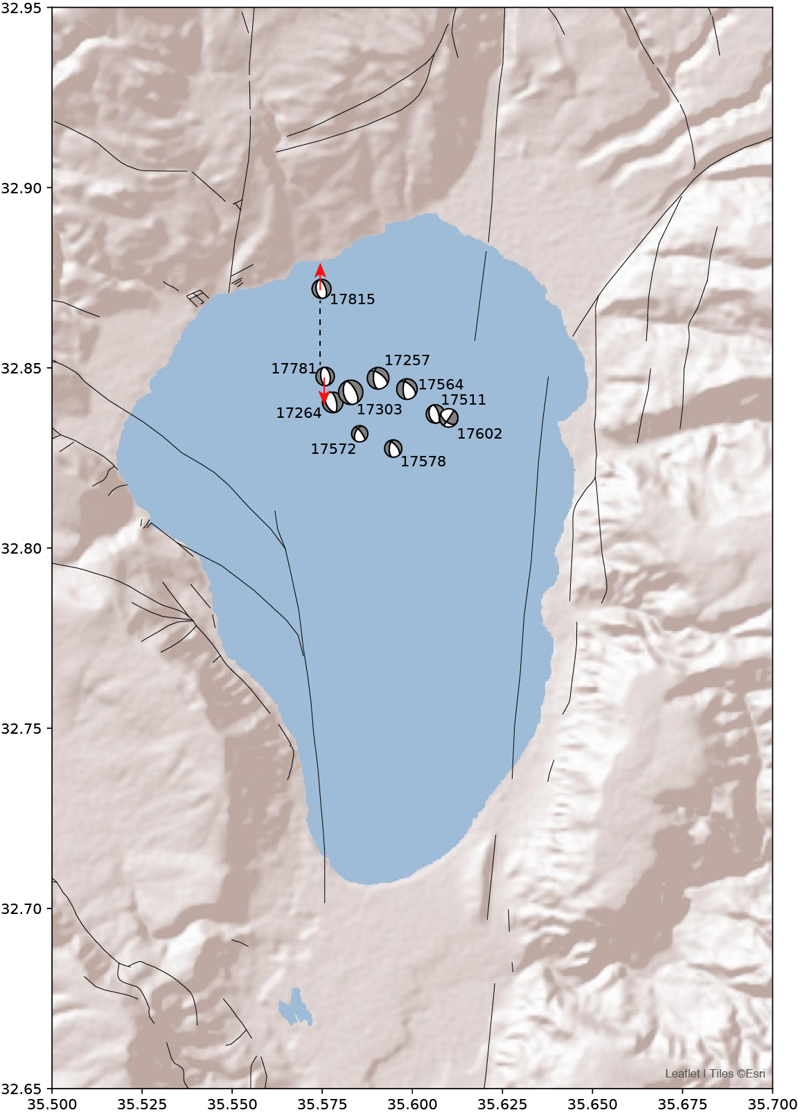
Figure S1. Focal mechanism solutions of the 10 selected target events, with magnitude range 3.2 – 4.5, located at the lake Kinneret during the earthquakes sequence of July 2018. Focal mechanisms are from Wetzler et al. (2019), and faults are shown by the black lines (modified after Sharon et al., 2020). Event id number (Table 1) is presented next to each beachball. The rupture directivity of two selected earthquakes is illustrated by the red arrows and the interpreted fault is shown by the dashed line.

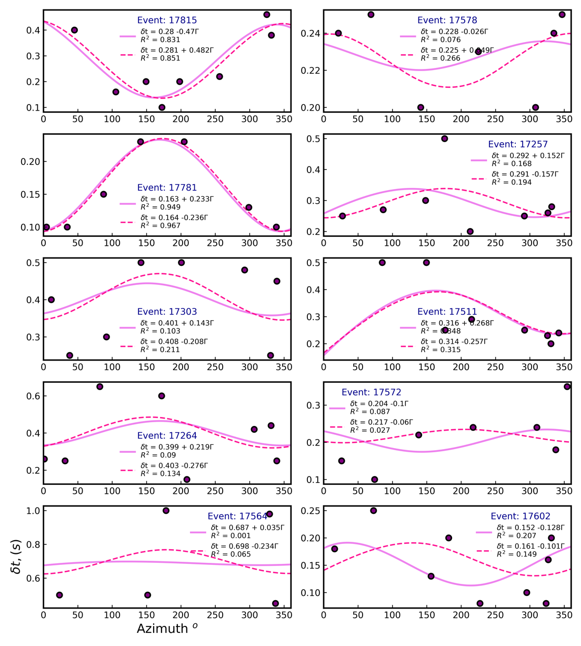

Figure S2. Directivity patterns for the 10 target events fitted for the two nodal planes with the magenta line mark the 1st nodal planes and dashed red line represents the 2nd plane. The focal plane solutions are from Wetzler et al., (2019).

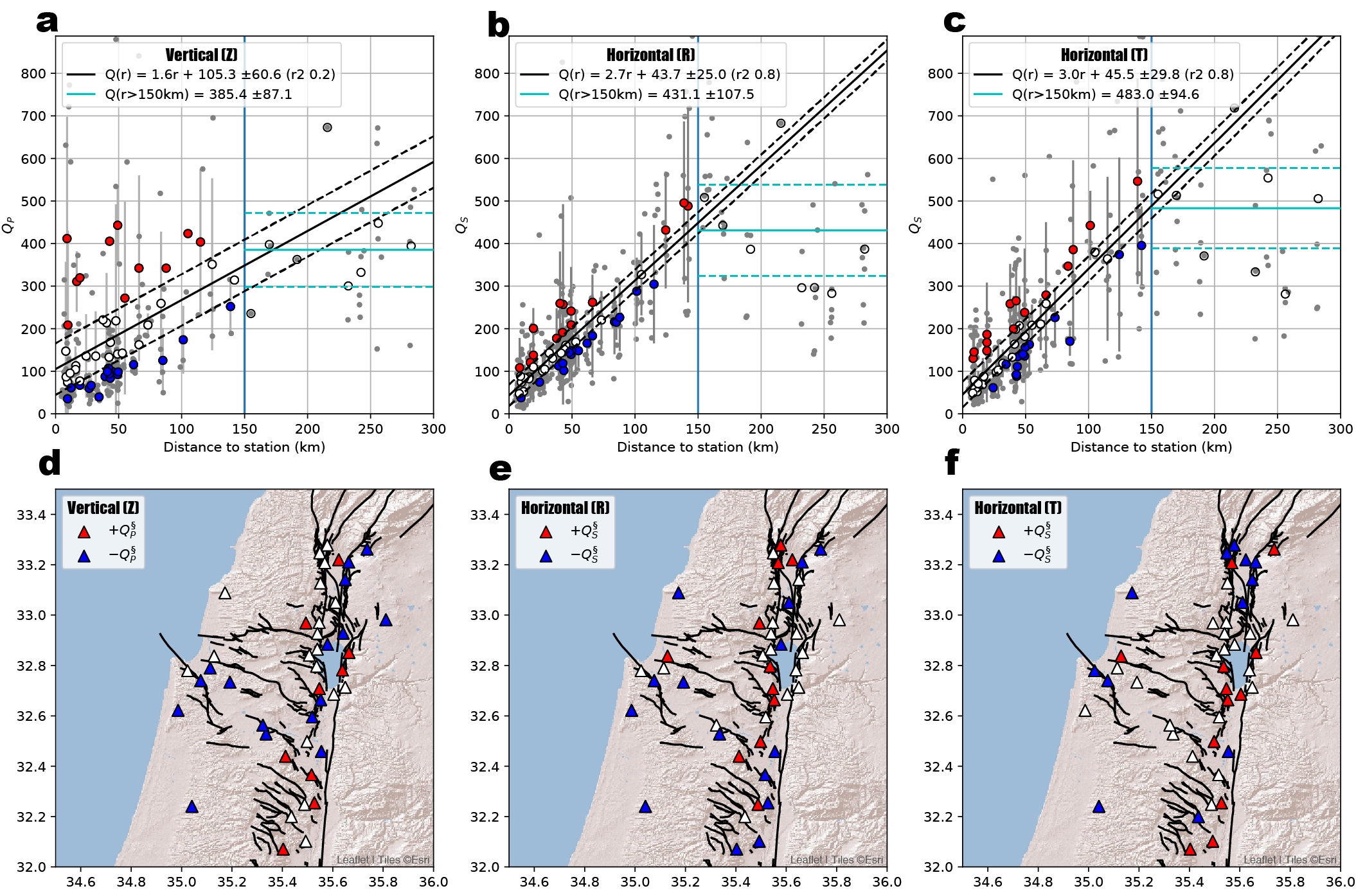
Figure S3. The quality parameters, Q, with r² value ≥ 0.8 and a signal-to-noise threshold ≥ 3.0, calculated for the amplitude spectra fit (Fig. S4), are plotted (gray dots) as a function of the distance to the earthquakes, for the three channels: vertical (a), horizontal radial (b), and transverse (c). The mean Q at each station is shown by the collared circles, with the vertical lines indicating the uncertainty level by the standard deviation. A linear fit (up to a distance of 150 km, blue vertical lines) is shown by the black solid lines, with the 1st standard deviation (dashed lines). Positive (red circles) or negative (blue circles) represent stations with mean attenuation values higher or lower than the fit, labeled here as Q§. The average Q at distances > 150 km is shown by the pale blue horizontal line, with the uncertainty level represented by the dashed lines. Stations located up to a distance of 150 km are plotted on a map (triangles) with the corresponding colors. Faults are shown by the black lines (modified after Sharon et al., 2020).

