Supplement
Supplemental Tables:
Supplemental Table 1: Median, 1st and 3rd quartile [Q1,Q3] for contrast and contrast-to-noise ratios are reported as $Median [Q1\text{-}Q3]$, for images reconstructed using OSEM. [¹⁸F]DCFPyL included 37 lesions manually segmented from 33 prostate cancer patients. Spheres (4-16mm) were measured for epoxy infused with 28.8 kBq/mL and 57.6 kBq/mL [²²Na]NaCl.
 | Contrast_{mean} (kBq/mL) | Contrast_{max} (kBq/mL) | CNR_{mean} | CNR_{max}
[¹⁸F]DCFPyL | 7.15 [5.5-17.1] | 10.41 [7.7-28.6] | 26.0 [17.4-60.0] | 41.2 [29.6-102.5]
²²Na Spheres (57.6 kBq/mL) | 4.47 [3.0-6.0] | 6.07 [4.2-8.0] | 31.2 [14.9-57.3] | 48.2 [22.4-76.2]
²²Na Spheres (28.8 kBq/mL) | 5.61 [4.8-6.0] | 6.64 [5.6-6.8] | 32.7 [25.3-51.5] | 40.2 [27.7-60.4]

Supplemental Table 2: Linear fits between measured and true metabolic tumour volume (MTV).
 | OSEM (24 subsets) | OSEM (32 subsets) | BSREM (32 subsets)
40% Fixed Threshold (FT) | y= -0.61x+1.62  R²=0.018 | y= -0.32x+1.1  R²=0.00091 | y= -2.17x+4.47  R²=0.081
Gradient-based | y= 0.12x+0.17  R²=0.76 | y= 0.11x+0.16  R²=0.77 | y= 0.19x+0.14  R²=0.80

Supplemental Table 3: Mean values and 1st / 3rd quartile (shown in square brackets) for the measured lesions in the [¹⁸F]DCFPyL scan reconstructed with OSEM and BSREM algorithms.
Metric | OSEM (24 subsets) | OSEM (32 subsets) | BSREM (32 subsets)
SUV_{max} | 42.7 [12.3 – 84.4] | 48.0 [14.0 – 95.5] | 36.3 [9.8 – 60.0]
SUV_{peak} | 13.5 [5.9 – 19.6] | 14.2 [6.7 – 21.6] | 13.0 [5.4 – 20.8]
SUV_{apex} | 22.4 [8.5 – 39.9] | 24.3 [9.6 – 43.7] | 20.9 [7.4 – 39.2]
SUV_{mean} (40% FT) | 28.3 [6.9 – 57.4] | 32.9 [8.8 – 64.7] | 24.3 [5.6 – 40.1]
SUV_{mean} (gradient) | 26.6 [9.1 – 48.1] | 28.7 [10.5 – 50.8] | 23.8 [8.3 – 42.6]
MTV (40% FT) | 0.88 [0.38 – 1.09] | 0.68 [0.32 – 0.66] | 1.86 [0.29 – 3.67]
MTV (gradient) | 0.24 [0.20 – 0.26] | 0.28 [0.25 – 0.32] | 0.29 [0.21 – 0.34]

Supplemental Figures:
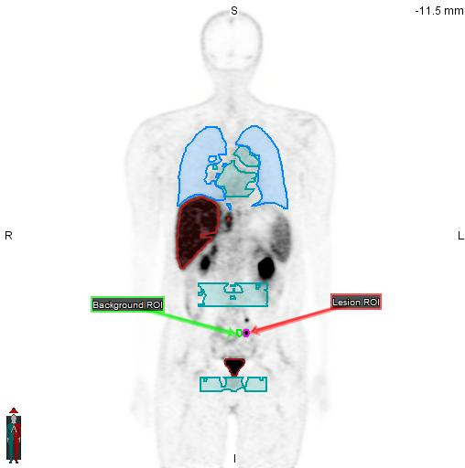
Supplemental Figure 1: Lesion and organ ROI segmentations (MIM Software) of [¹⁸F]DCFPyL PET patient.
af

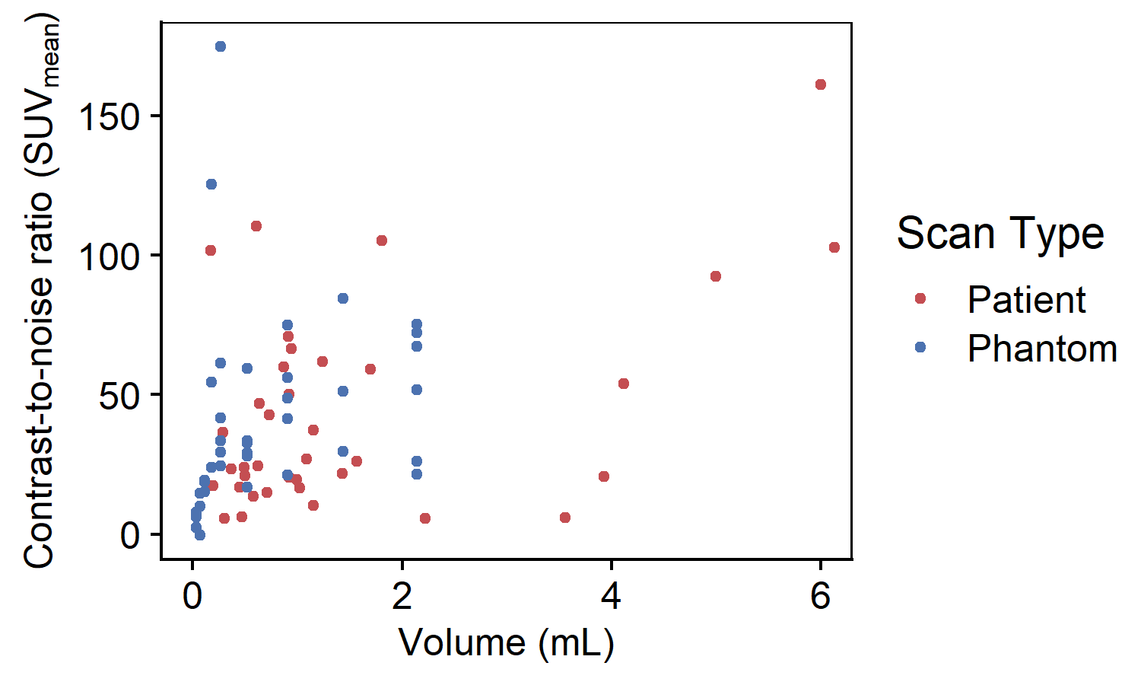
Supplemental Figure 2: SUV_{mean} contrast-to-noise ratio vs. volume for OSEM reconstructed images. (Red) 37 lesions manually segmented from 33 prostate cancer patients scanned with ¹⁸F-DCFPyL. Median [Q1 – Q3] of CNR was 26.0 [17.4 – 60.0], while volume was 0.91mL [0.61 – 1.58]. (Blue) 39 PET Edge+ segmentations of 57.4 kBq/mL lesions with background resembling [¹⁸F]DCFPyL (1.8 kBq/mL).

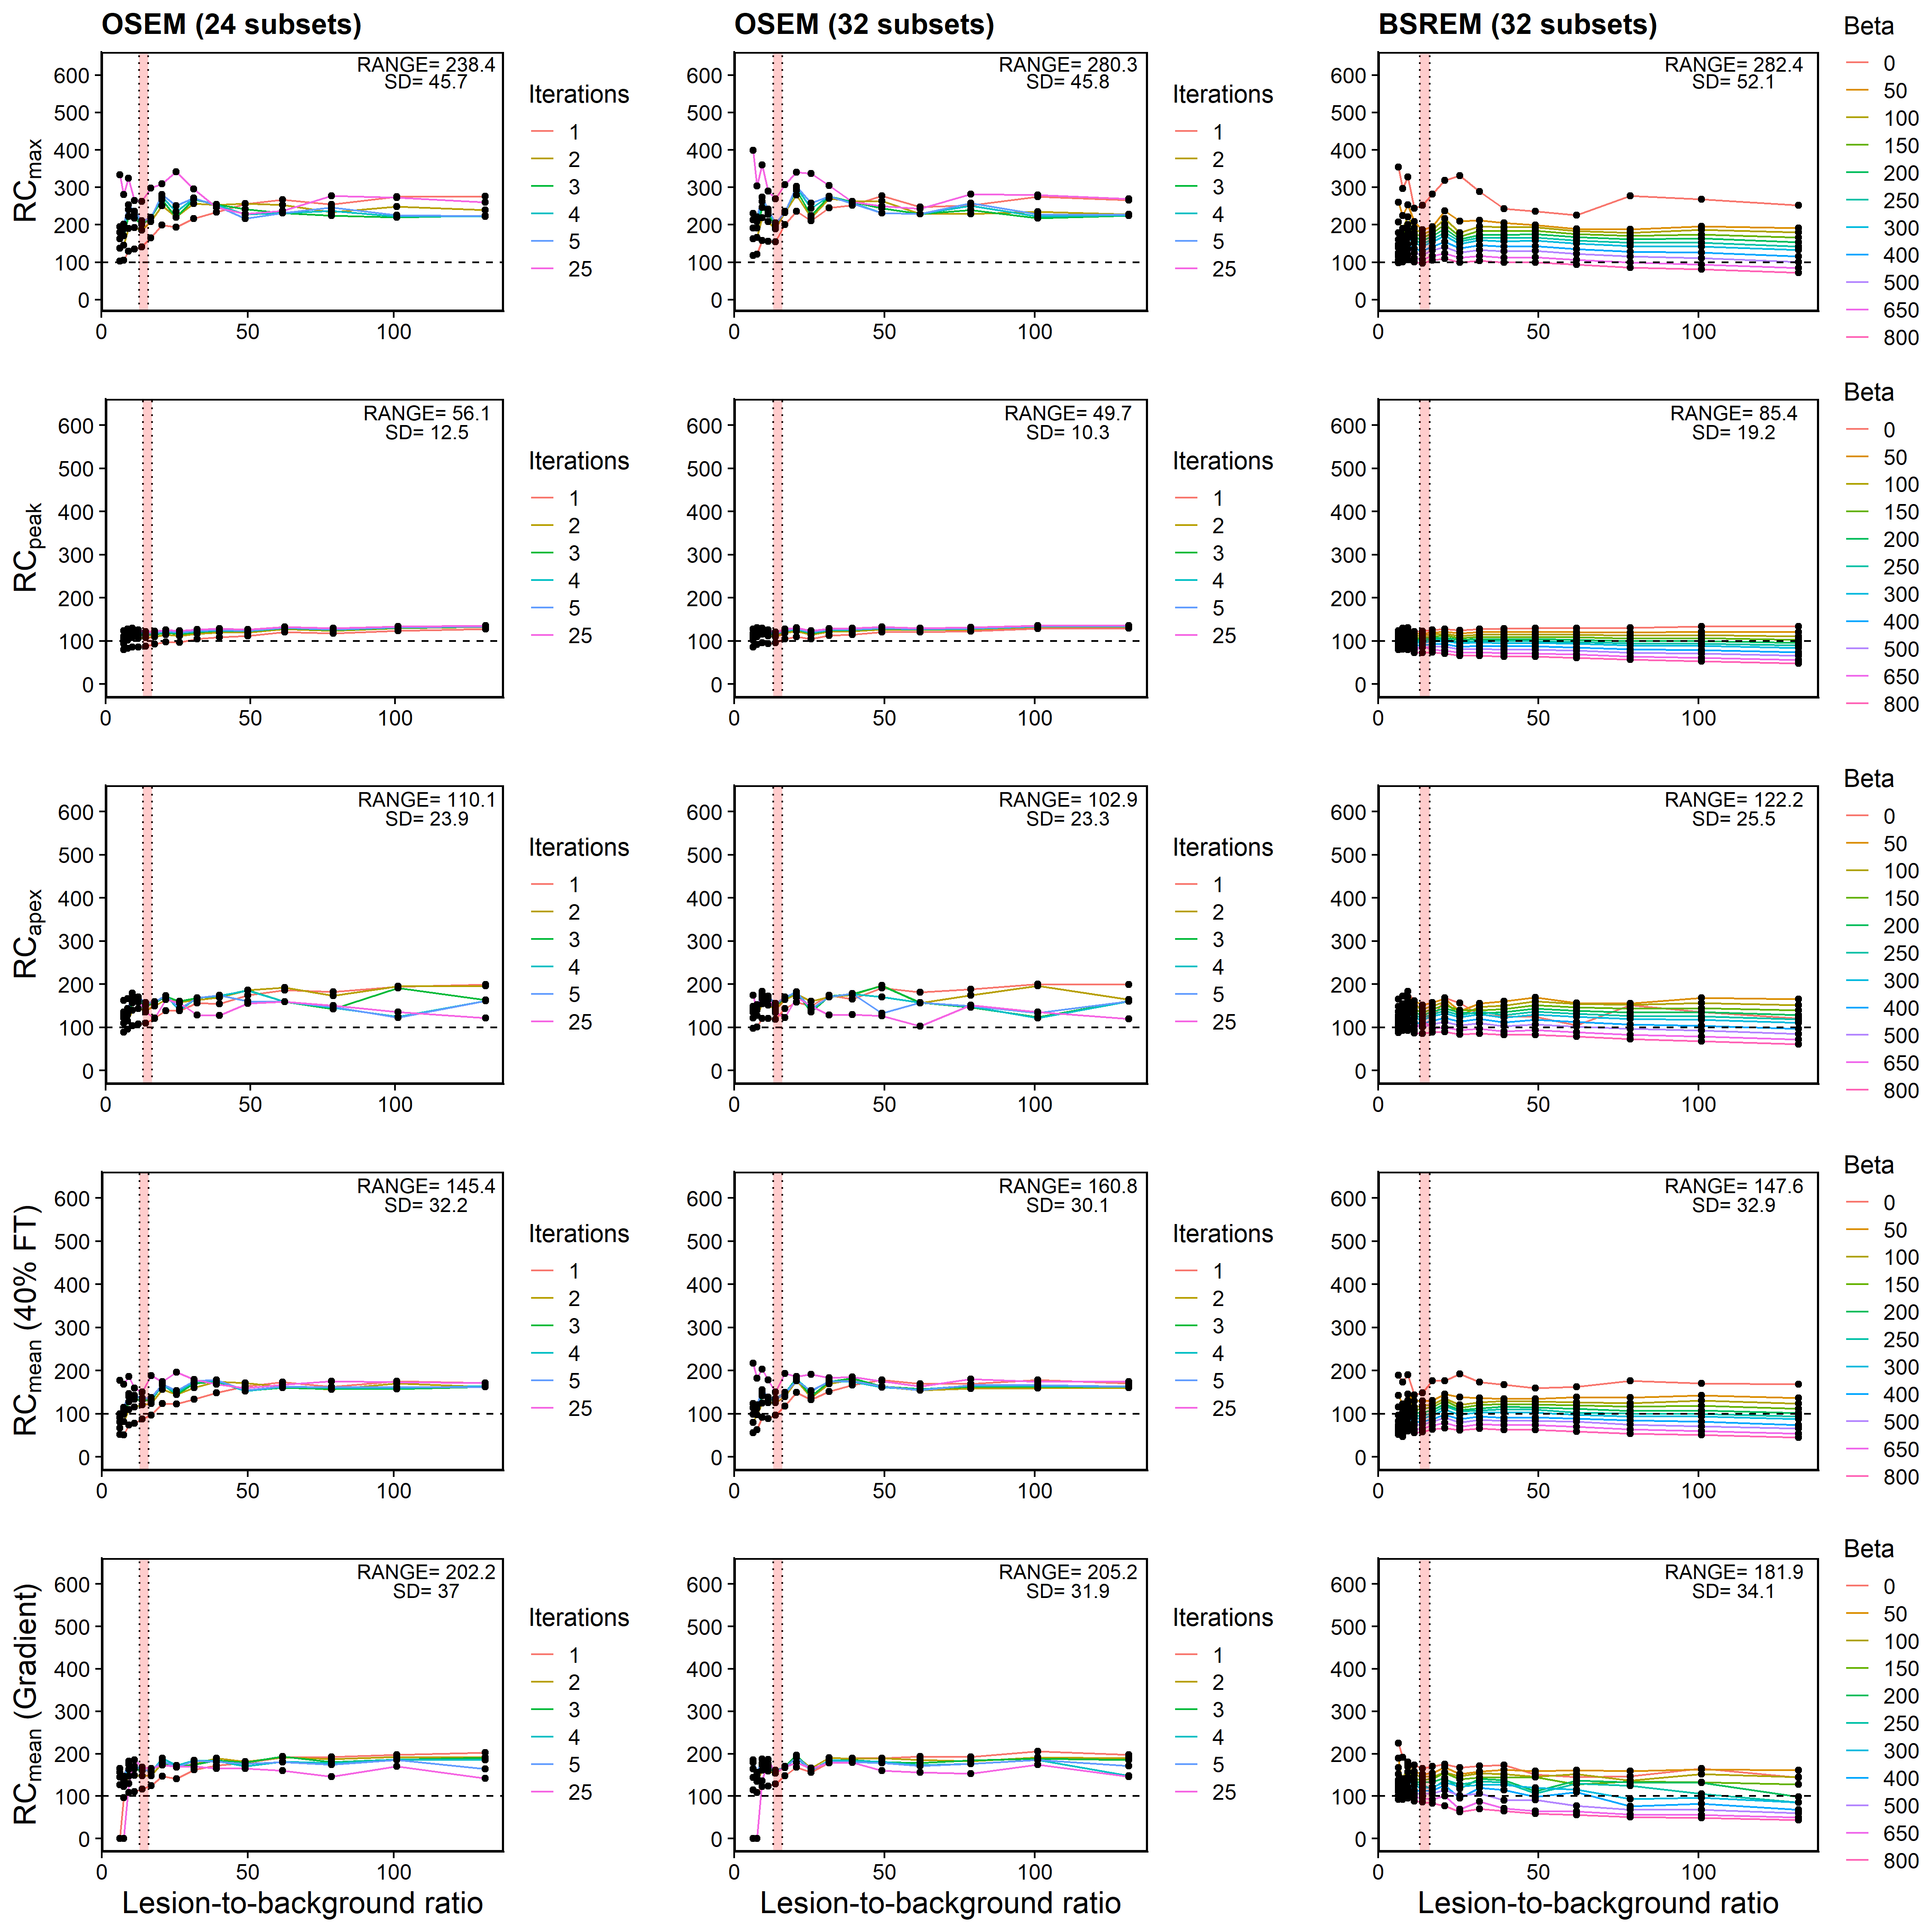
Supplemental Figure 3: Recovery concentration coefficient versus lesion-to-background ratio for 16mm lesion measured in Probe-IQ pelvis. (Top to bottom) Max, Peak, Apex, and Mean (40% FT and gradient). (Left to right) Reconstruction algorithms using OSEM+PSF (24 and 32 subsets respectively) and BSREM. Range and standard deviation of recovery coefficients annotated on plots. [¹⁸F]DCFPyL background activity levels represented by red shaded region.

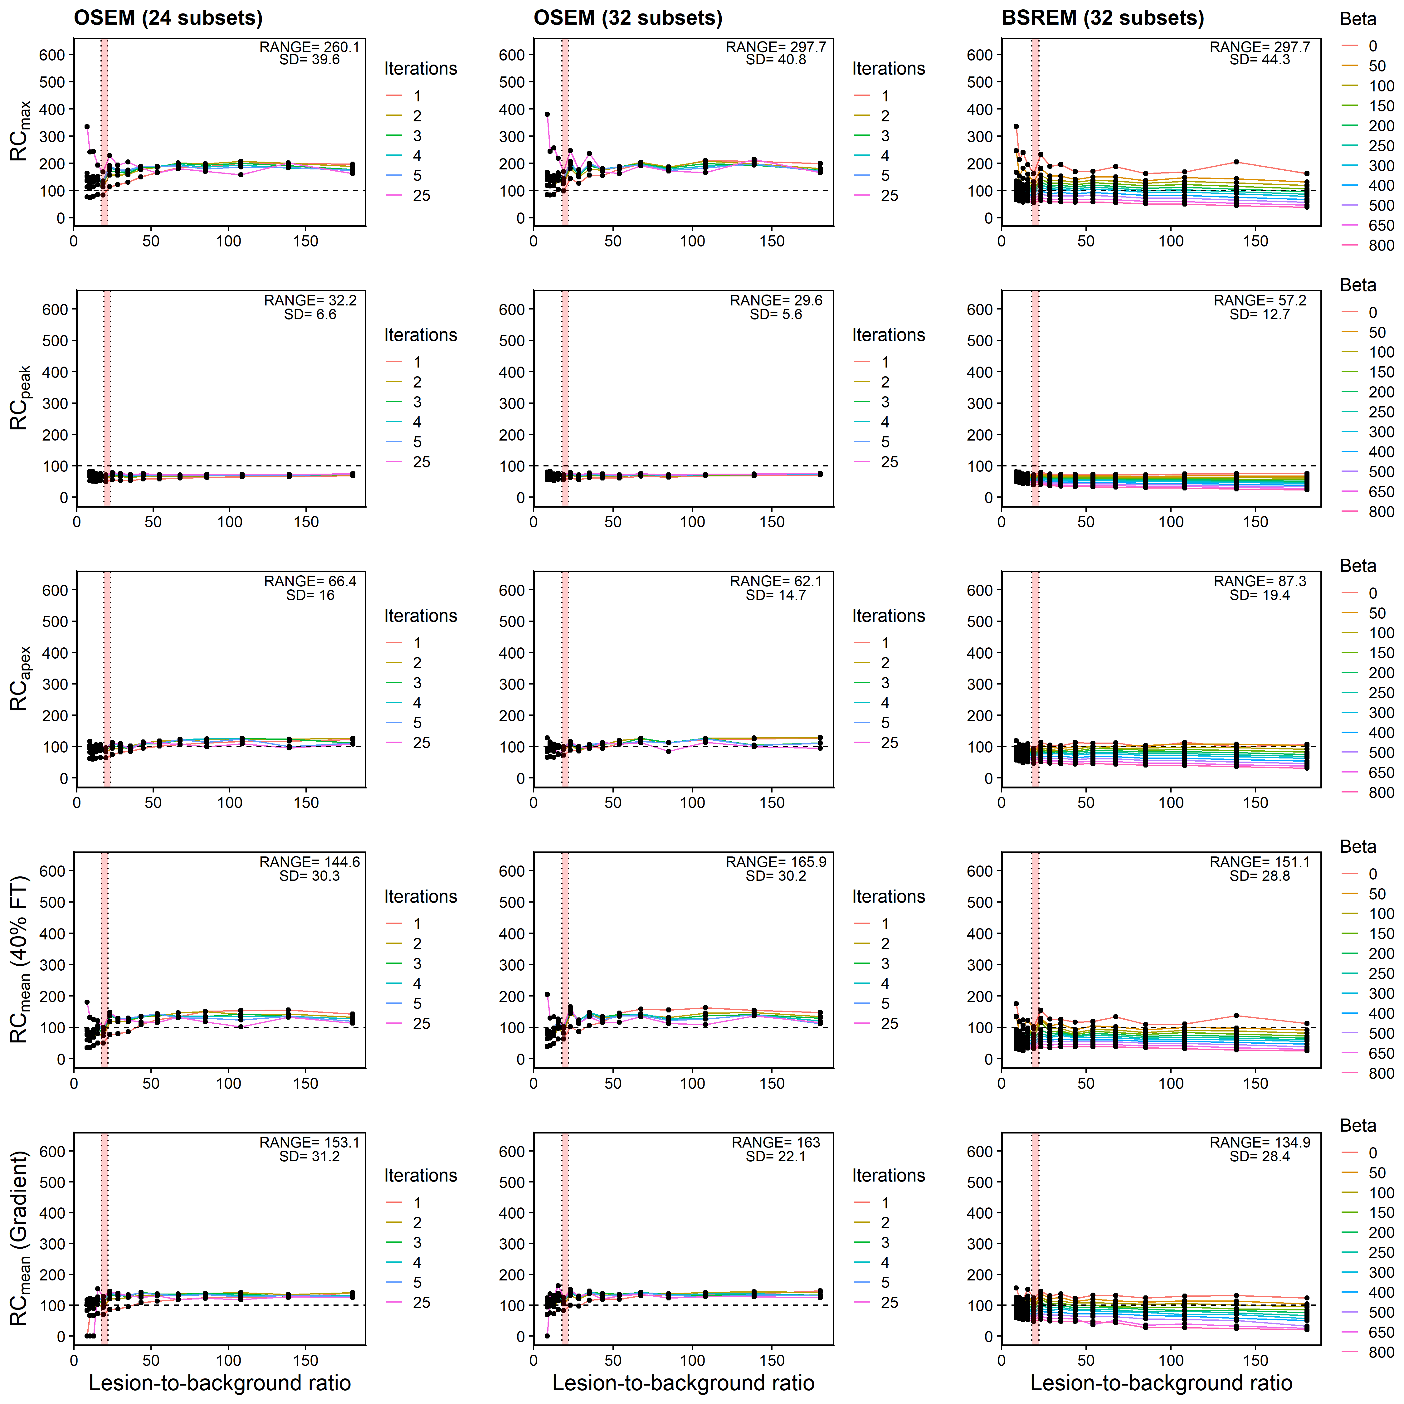
Supplemental Figure 4: Recovery concentration coefficient versus lesion-to-background ratio for 12mm lesion measured in Probe-IQ pelvis. (Top to bottom) Max, Peak, Apex, and Mean (40% FT and gradient). (Left to right) Reconstruction algorithms using OSEM+PSF (24 and 32 subsets respectively) and BSREM. Range and standard deviation of recovery coefficients annotated on plots. [¹⁸F]DCFPyL background activity levels represented by red shaded region.

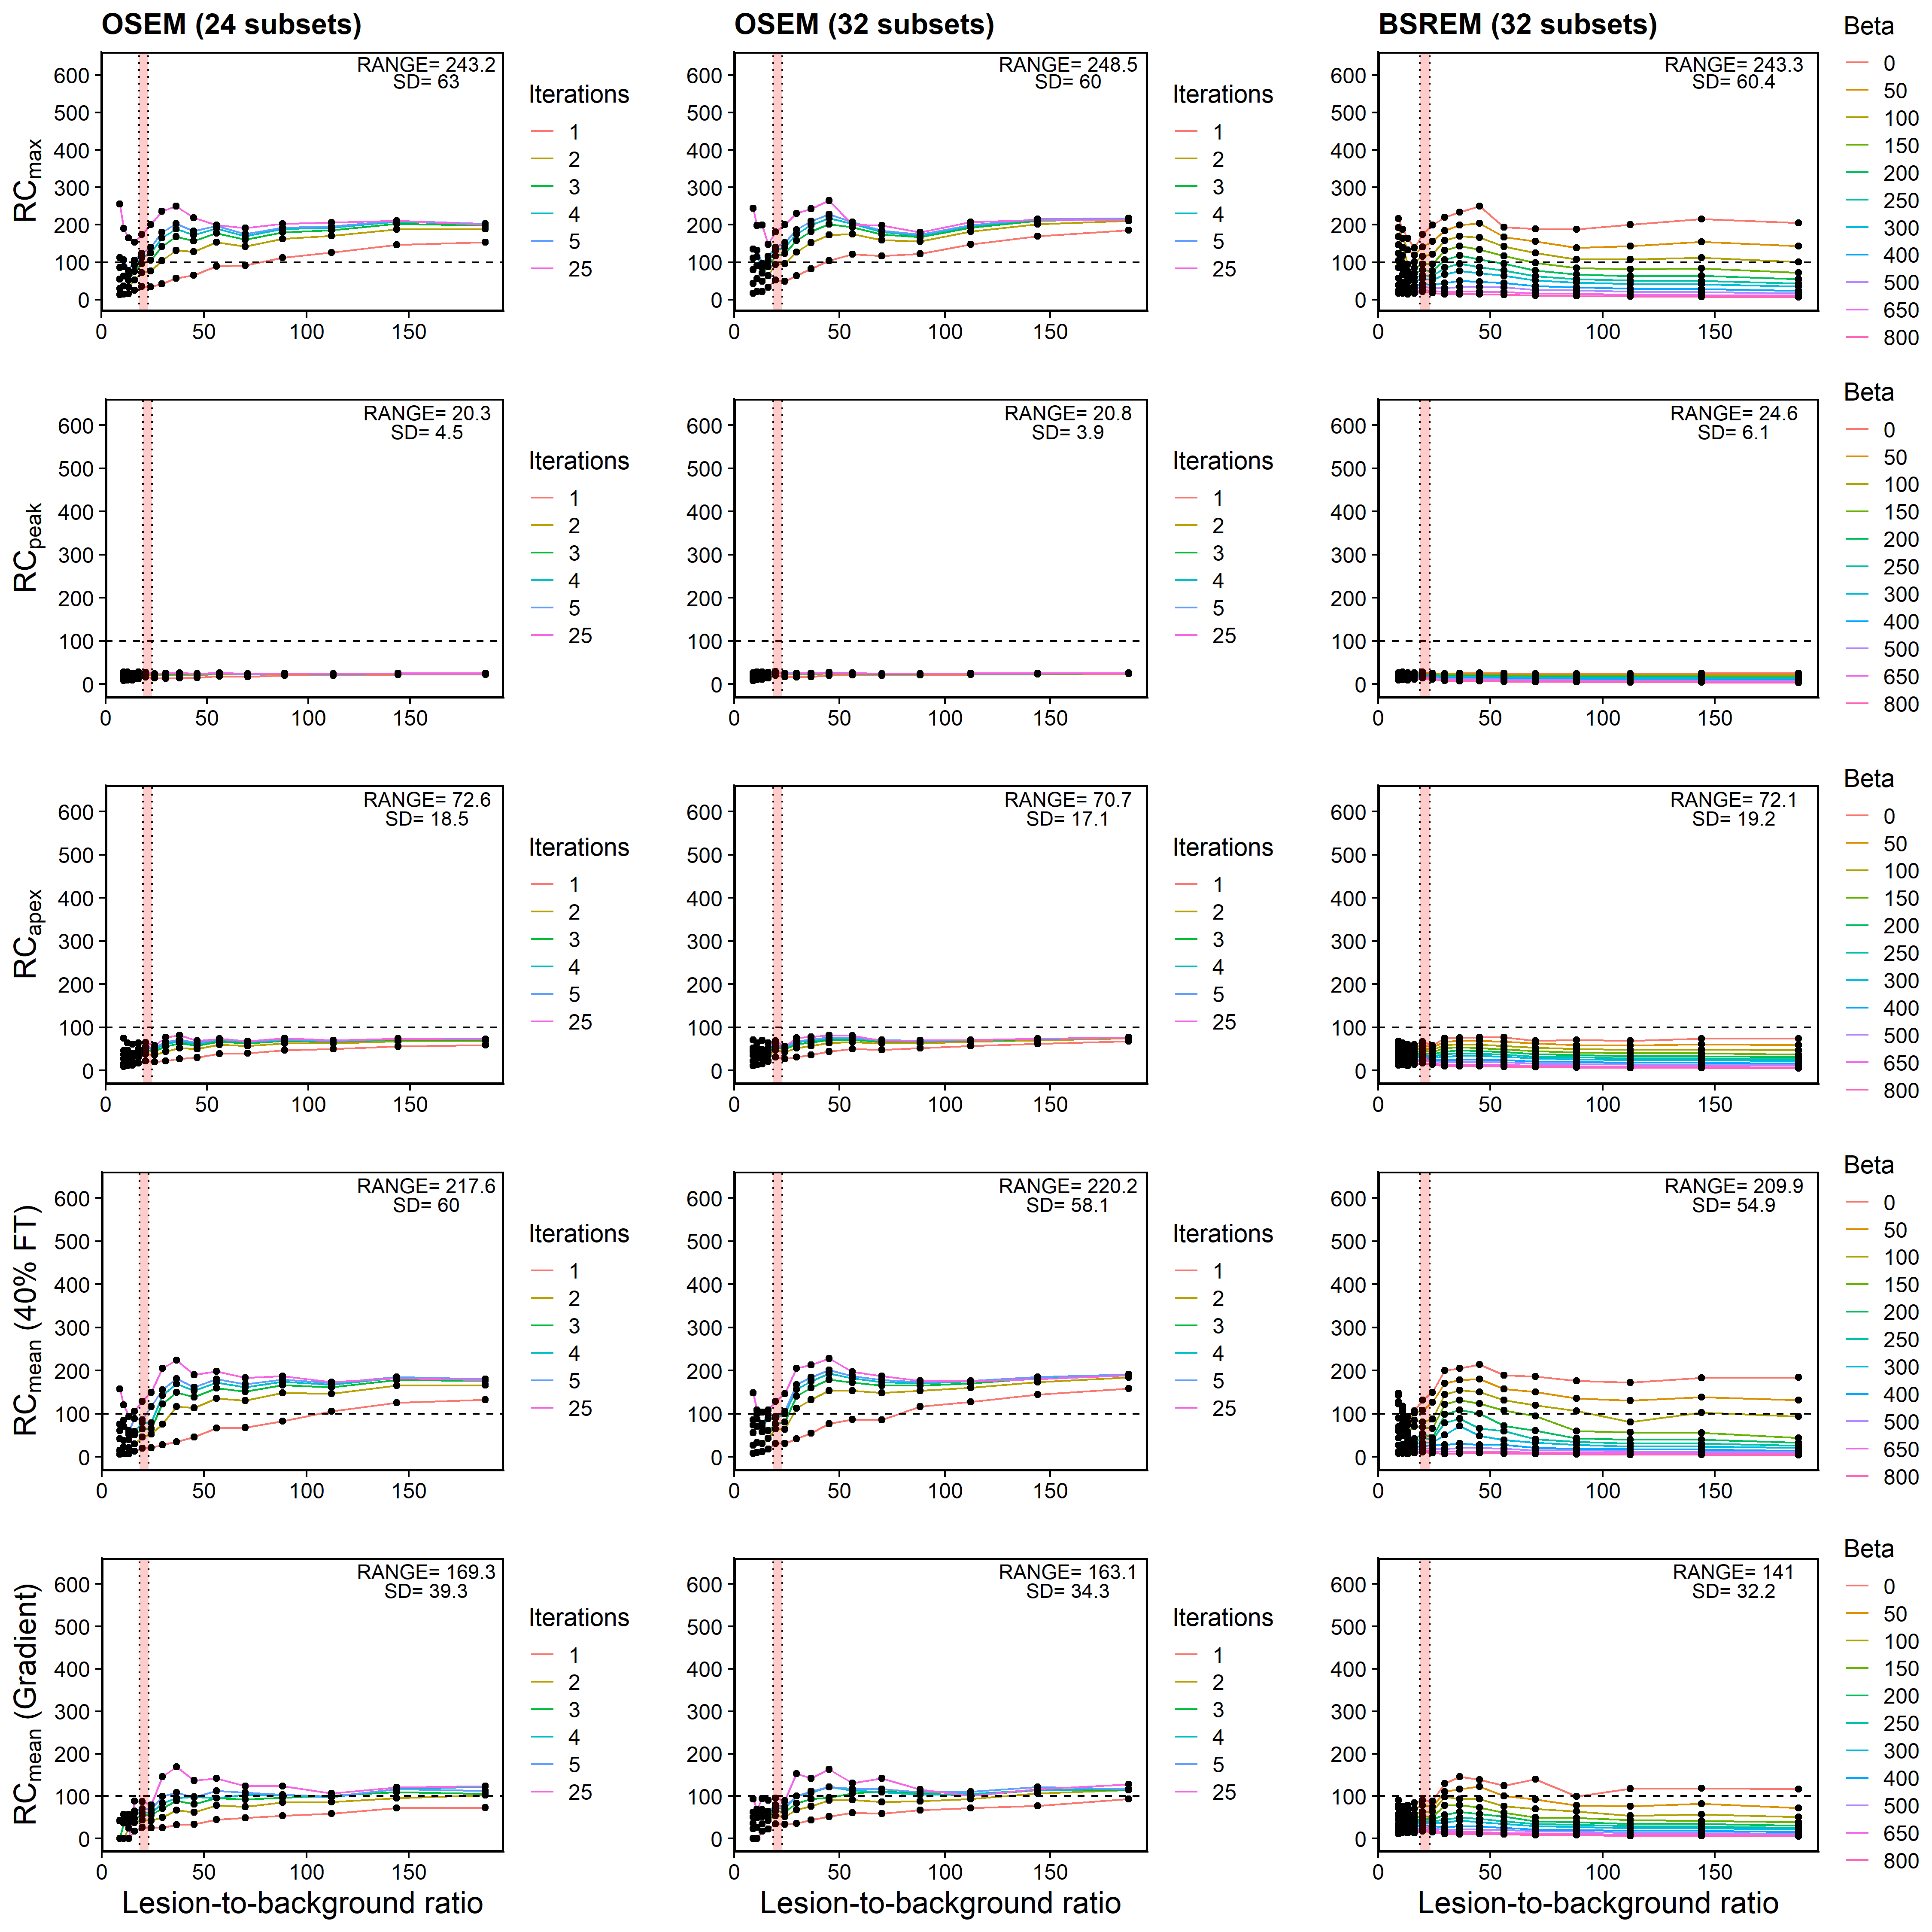Supplemental Figure 5: Recovery concentration coefficient versus lesion-to-background ratio for 8mm lesion measured in Probe-IQ pelvis. (Top to bottom) Max, Peak, Apex, and Mean (40% FT and gradient). (Left to right) Reconstruction algorithms using OSEM+PSF (24 and 32 subsets respectively) and BSREM. Range and standard deviation of recovery coefficients annotated on plots. [¹⁸F]DCFPyL background activity levels represented by red shaded region.

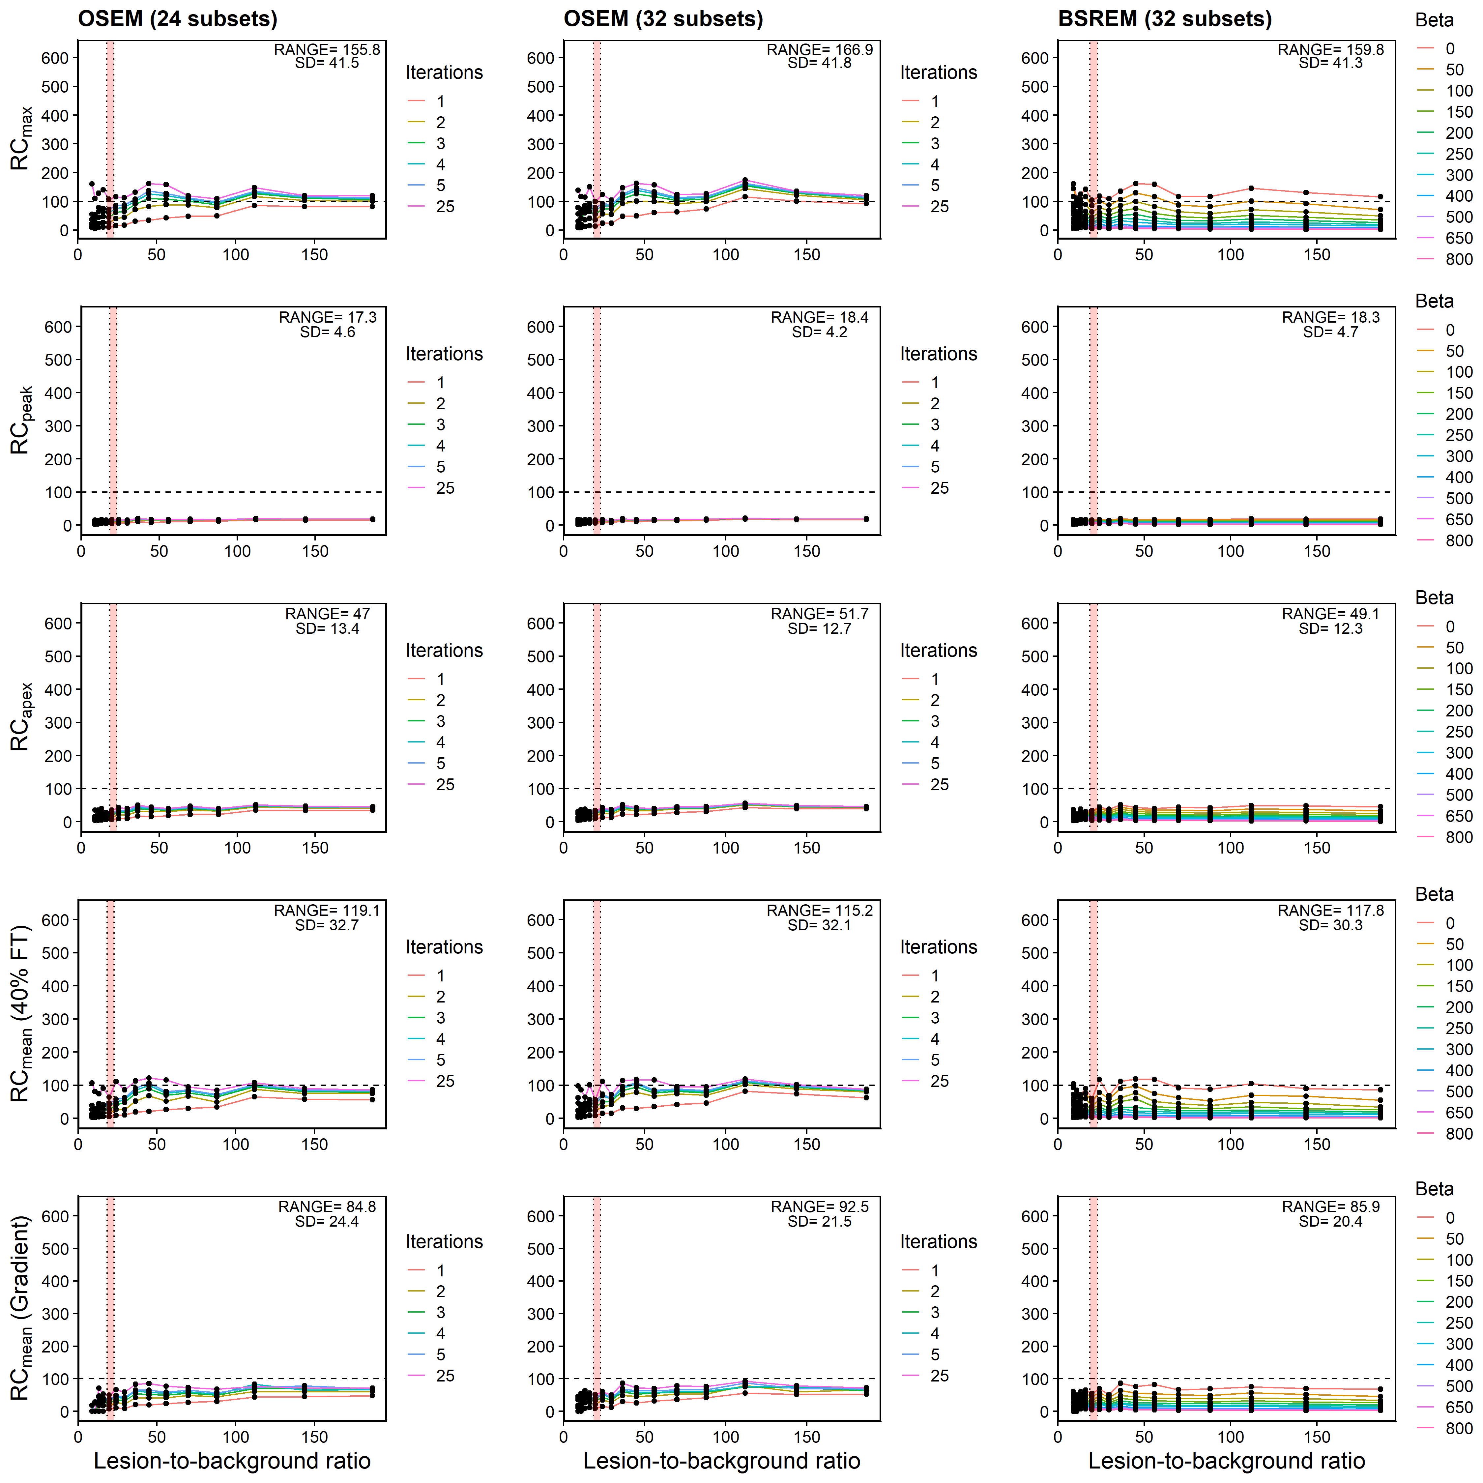
Supplemental Figure 6: Recovery concentration coefficient versus lesion-to-background ratio for 7mm lesion measured in Probe-IQ pelvis. (Top to bottom) Max, Peak, Apex, and Mean (40% FT and gradient). (Left to right) Reconstruction algorithms using OSEM+PSF (24 and 32 subsets respectively) and BSREM. Range and standard deviation of recovery coefficients annotated on plots. [¹⁸F]DCFPyL background activity levels represented by red shaded region.

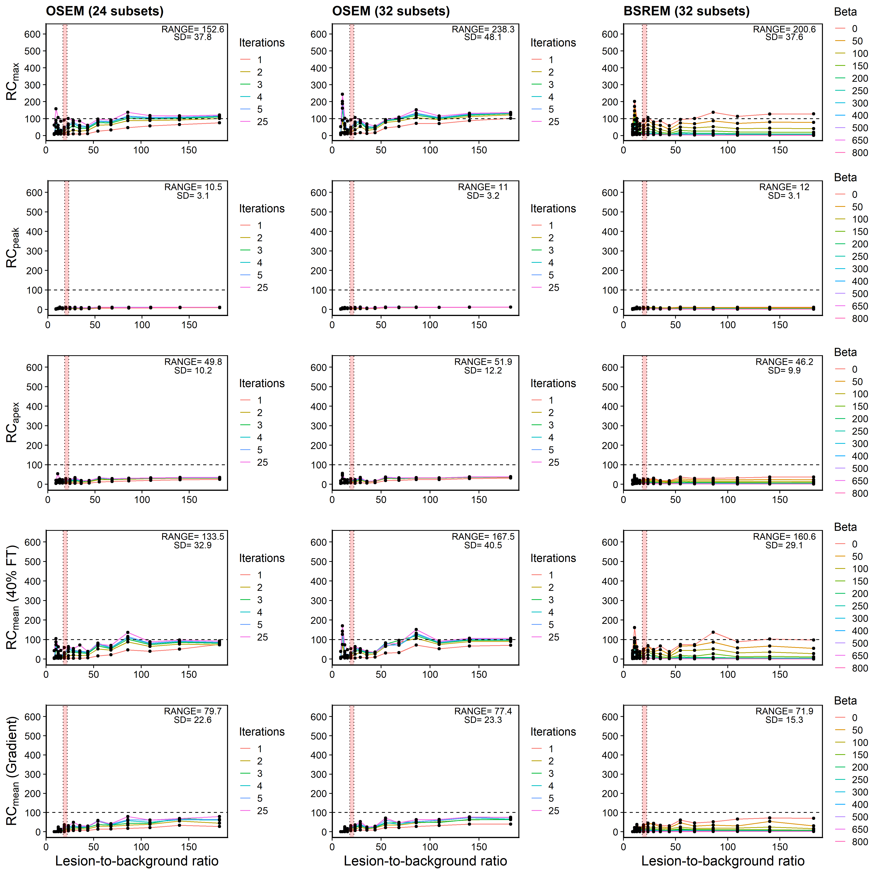
Supplemental Figure 7: Recovery concentration coefficient versus lesion-to-background ratio for 6mm lesion measured in Probe-IQ pelvis. (Top to bottom) Max, Peak, Apex, and Mean (40% FT and gradient). (Left to right) Reconstruction algorithms using OSEM+PSF (24 and 32 subsets respectively) and BSREM. Range and standard deviation of recovery coefficients annotated on plots. [¹⁸F]DCFPyL background activity levels represented by red shaded region.

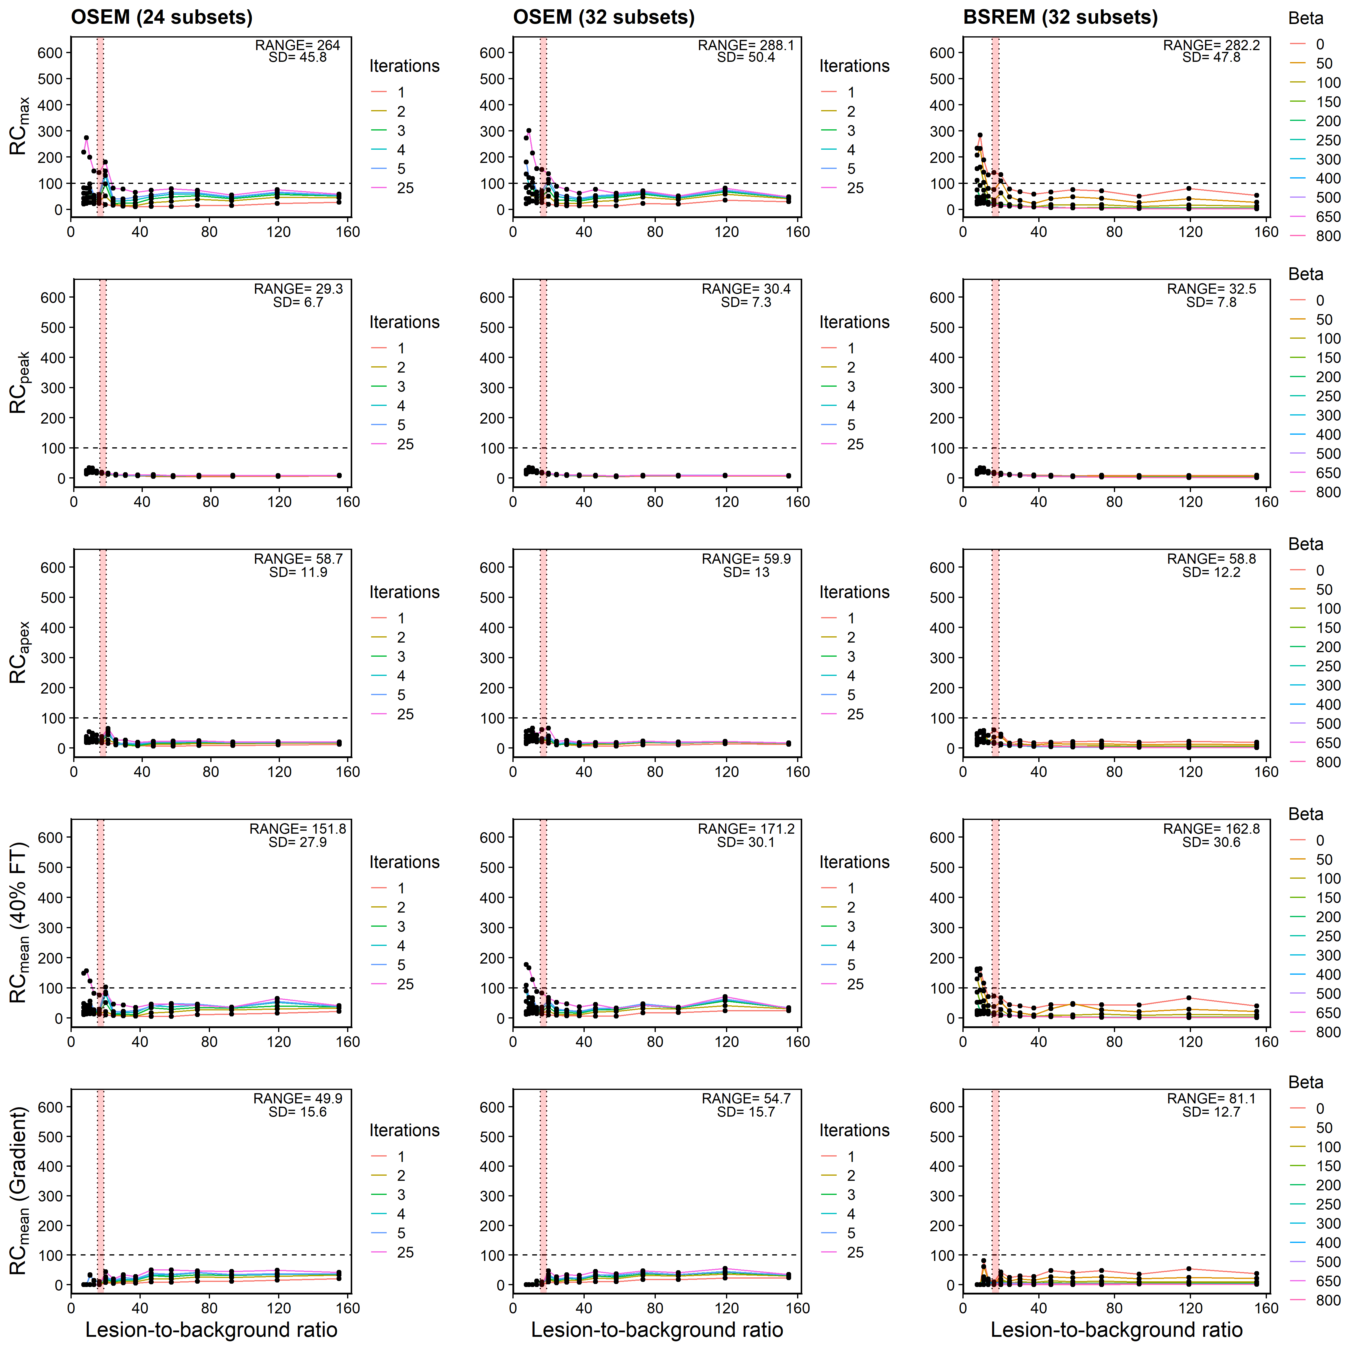
Supplemental Figure 8: Recovery concentration coefficient versus lesion-to-background ratio for 5mm lesion measured in Probe-IQ pelvis. (Top to bottom) Max, Peak, Apex, and Mean (40% FT and gradient). (Left to right) Reconstruction algorithms using OSEM+PSF (24 and 32 subsets respectively) and BSREM. Range and standard deviation of recovery coefficients annotated on plots. [¹⁸F]DCFPyL background activity levels represented by red shaded region.

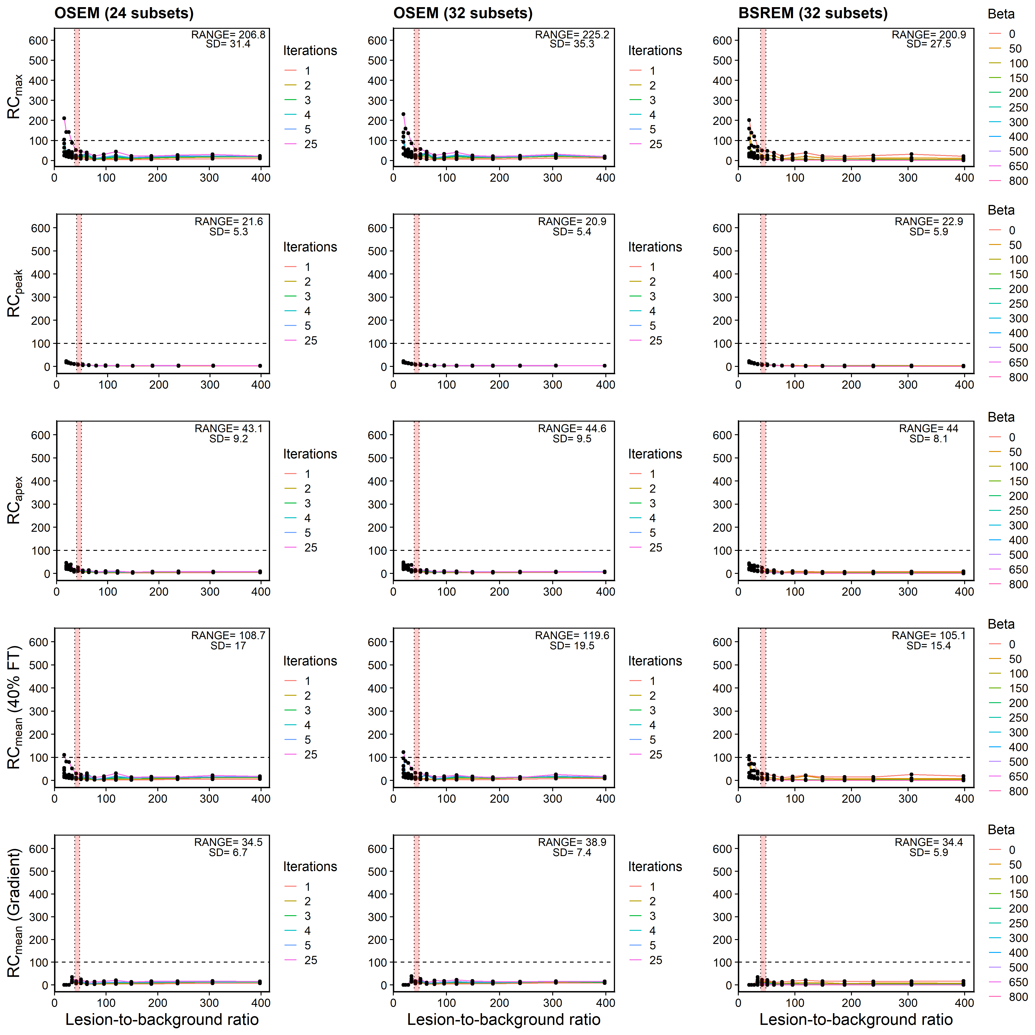Supplemental Figure 9: Recovery concentration coefficient versus lesion-to-background ratio for 4mm lesion measured in Probe-IQ pelvis. (Top to bottom) Max, Peak, Apex, and Mean (40% FT and gradient). (Left to right) Reconstruction algorithms using OSEM+PSF (24 and 32 subsets respectively) and BSREM. Range and standard deviation of recovery coefficients annotated on plots. [¹⁸F]DCFPyL background activity levels represented by red shaded region.

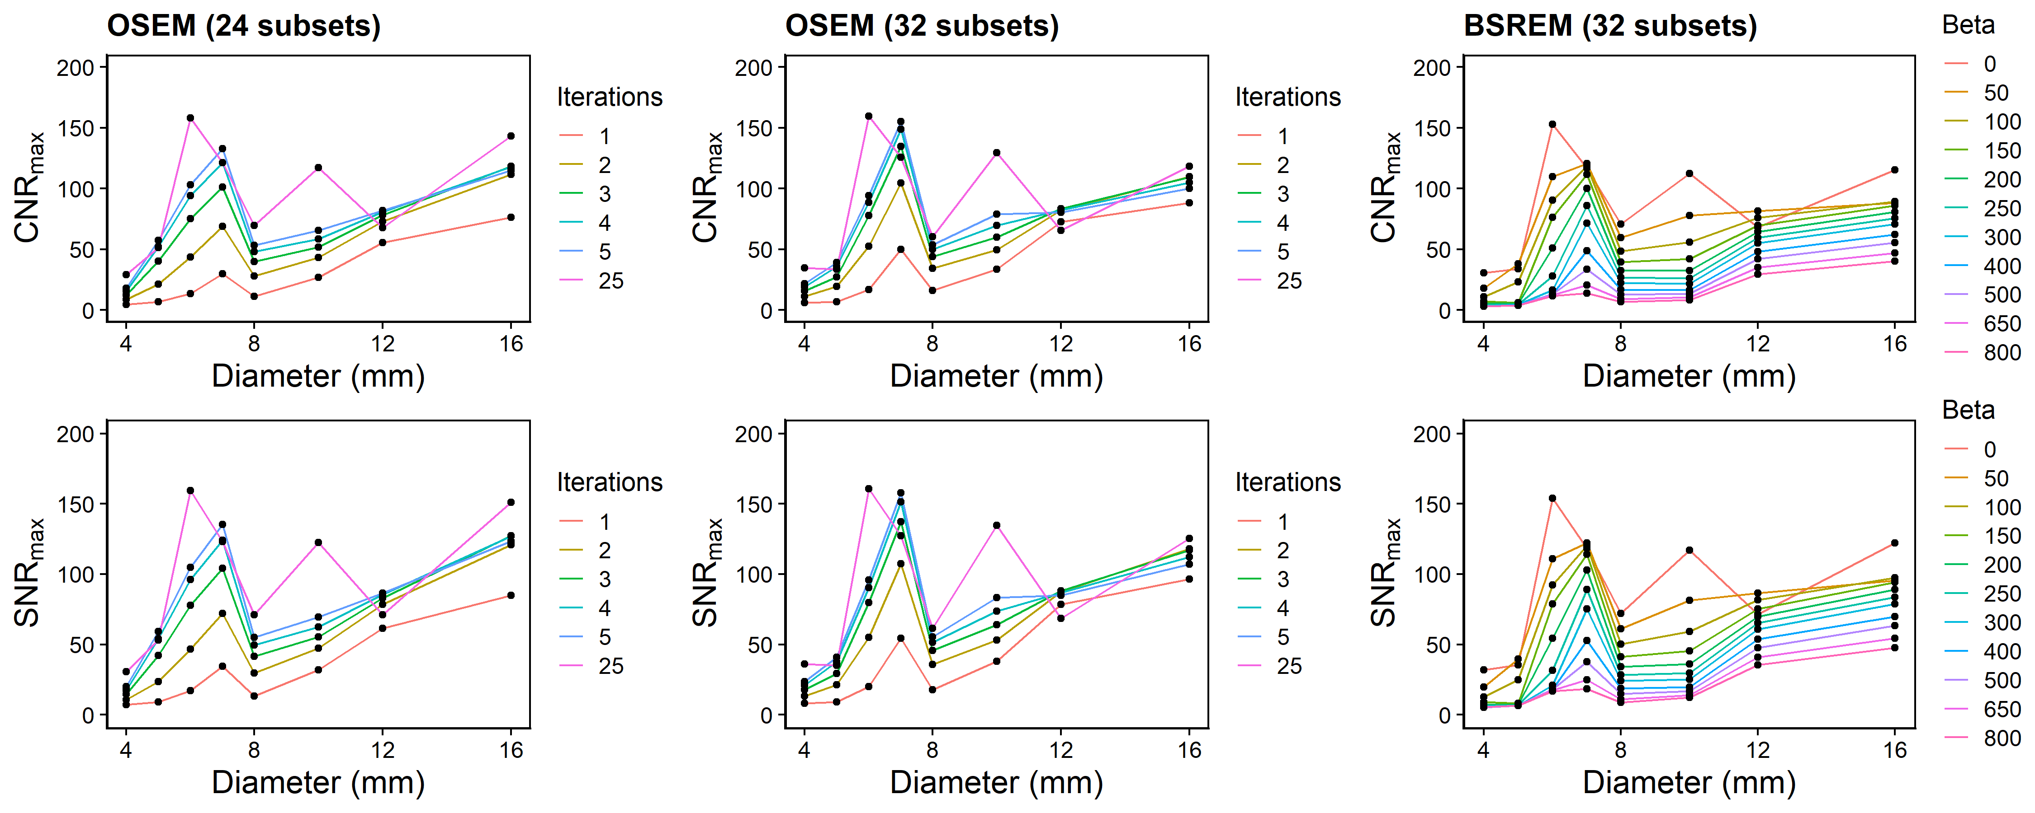
Supplemental Figure 10: (Top to bottom) Contrast-to-noise ratio and signal-to-noise ratio vs. lesion diameter using RC_{max} metric. (Left to right) Reconstruction algorithms using OSEM+PSF (24 and 32 subsets respectively) and BSREM.

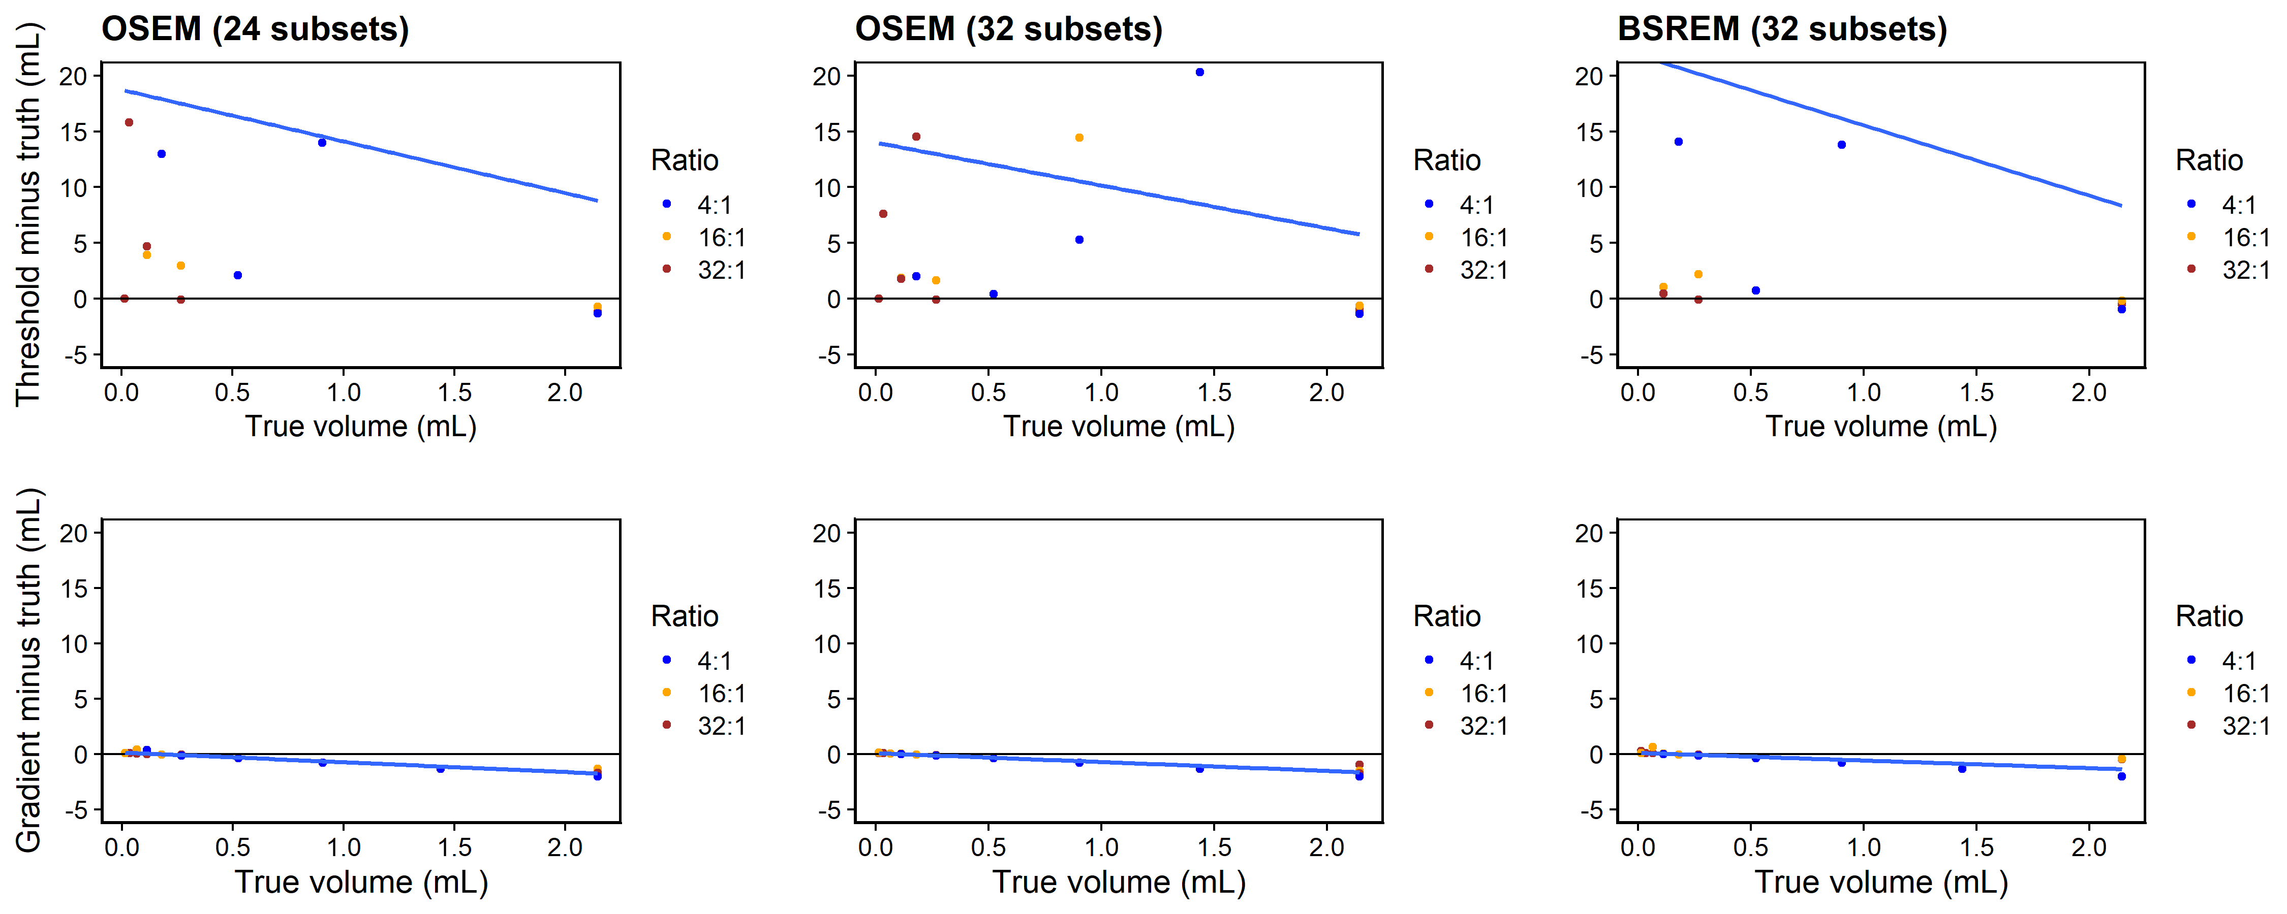
Supplemental Figure 11: Difference between segmented volume and truth, plotted vs. true volume for anthropomorphic phantom. (Top to bottom) 40% SUV_{max} fixed threshold and gradient-based methods. (Left to right) Reconstruction algorithms using OSEM+PSF (24 and 32 subsets respectively) and BSREM. Blue line indicates overall fit.

