Supplementary Materials
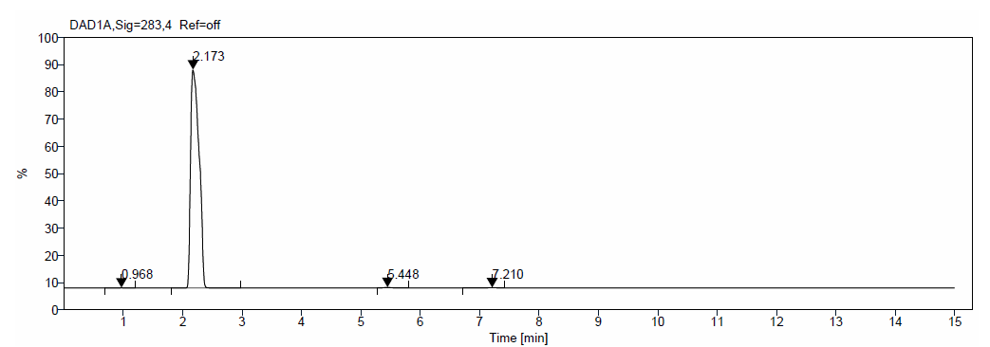
Figure S1: High performance liquid chromatography chromatogram of capsaicin at 283 nm.
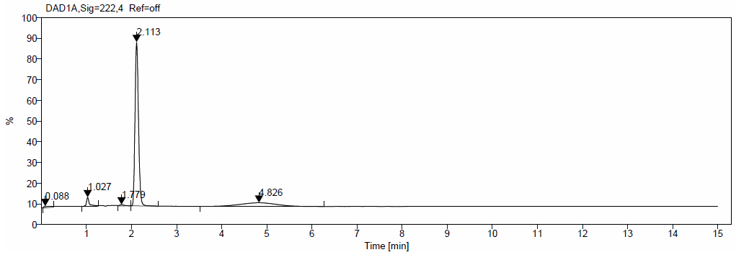
Figure S2: High performance liquid chromatography chromatogram of metformin at 222 nm.
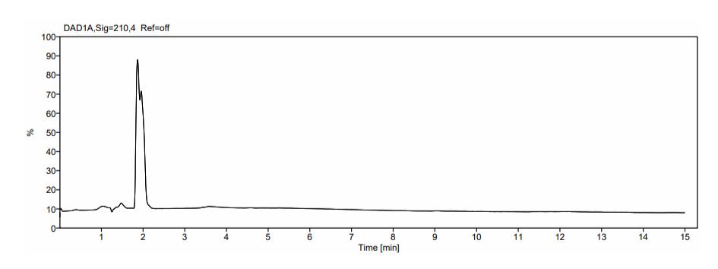
Figure S3: High performance liquid chromatography chromatogram of gabapentin at 210 nm.

