Supplement
Table S1. Complete baseline characteristics of the glioblastoma cohort, including demographic, clinical, molecular, surgical, treatment, volumetric, and recurrence data.
Characteristic | N = 67¹
Age | 73.7 (65.0, 88.0)
Gender
male | 37 (55%)
female | 30 (45%)
Karnofsky-Index [%] | 60 (30, 100)
unknown | 5
MGMT-status
unmethylated | 24 (36%)
methylated | 36 (54%)
unknown | 7 (10%)
IDH
wild-type | 56 (84%)
unkown | 11 (16%)
TERT-mutation
present | 11 (16%)
unknown | 56 (84%)
EGFR amplification
absent | 1 (1.5%)
present | 4 (6.0%)
unkown | 62 (93%)
Resection status (EOR classification)
gross total resection | 28 (42%)
near total resection | 17 (25%)
subtotal resection | 2 (3.0%)
biospy | 16 (24%)
unknown | 4 (6.0%)
Radiotherapy - scheme
normofractionated | 15 (22%)
hypofractionated | 43 (64%)
ultrahypofrationated | 9 (13%)
Radiotherapy duration [days] | 21 (19, 23)
Total dose [Gy] | 40 (5, 60)
Temozolomide
no | 25 (37%)
yes | 42 (63%)
Concurrent Chemoradiotherapy
no | 43 (65%)
yes | 23 (35%)
unknown | 1
simultaneous Chemoradiotherapy
no | 29 (43%)
yes | 38 (57%)
Nr. of cycles completed
0 | 43 (64%)
1 | 7 (10%)
2 | 1 (1.5%)
3 | 1 (1.5%)
4 | 1 (1.5%)
6 | 8 (12%)
unknown | 6 (9.0%)
Dexamethasone
yes | 21 (31%)
no | 43 (64%)
unknown | 3 (4.5%)
Tumor site
frontal lobe | 12 (18%)
temporal lobe | 16 (24%)
parietal lobe | 7 (10%)
occipital lobe | 5 (7.5%)
cerebellum | 1 (1.5%)
corpus callosum | 1 (1.5%)
brainstem | 1 (1.5%)
pons | 1 (1.5%)
white matter | 3 (4.5%)
frontal and temporal lobe | 4 (6.0%)
frontal and parietal lobe | 2 (3.0%)
temporal and parietal lobe | 2 (3.0%)
temporal and occipital lobe | 1 (1.5%)
temporal lobe and brainstem | 1 (1.5%)
parietal and occipital lobe | 1 (1.5%)
cerebellum and white matter | 1 (1.5%)
frontal lobe, cerebellum und white matter | 1 (1.5%)
frontal lobe, corpus callosum and brainstem | 1 (1.5%)
temporal, parietal and occipital lobe | 1 (1.5%)
parietal and occipital lobe and corpus callosum | 2 (3.0%)
cerebellum, brainstem and pons | 1 (1.5%)
frontal, temporal, parietal and occipital lobe | 2 (3.0%)
GTV [cm³] | 205, 40, 1,201
Unknown | 7
GTV recurrence [cm³] | 32, 31, 28
Unknown | 52
CTV [cm³] | 149, 142, 75
Unknown | 24
CTV recurrence [cm³] | 38, 29, 44
Unknown | 62
Recurrence
In-field | 3 (4.6%)
Out-field | 14 (22%)
unknown | 50 (75%)
Radiology showing rest of malignoma
no | 18 (27%)
yes | 37 (55%)
unknwon | 12 (18%)
TTF-treatment
no | 55 (82%)
yes | 6 (9.0%)
unknown | 6 (9.0%)
¹ Mean (Min, Max); n (%); Median (Min, Max); Median (Q1, Q3); Mean, Median, SD

Table S2. Tests of the proportional hazards (PH) assumption for overall survival (OS) and progression-free survival (PFS) in patients with glioblastoma.
Shown are results for individual covariates and the global model based on Schoenfeld residuals. No relevant violations of the PH assumption were observed for either OS or PFS models.

Test of the proportional hazards assumption for OS:
chisq df p
Age 2.41e-06 1 0.999
Gender 9.75e-02 1 0.755
Karnofsky 1.97e+00 1 0.160
Temozolomide 6.40e-01 1 0.424
Resection_status 3.60e+00 1 0.058
GLOBAL 7.87e+00 5 0.164

Test of the proportional hazards assumption for PFS:

chisq df p
Age 0.2269 1 0.634
Gender 0.0697 1 0.792
Karnofsky 0.7661 1 0.381
Temozolomide 2.2767 1 0.131
Resection_status 6.6249 1 0.010
GLOBAL 9.6369 5 0.086

Figure S1. Kaplan–Meier curves of PFS stratified by age (<70 vs. ≥70 years) in patients with glioblastoma.
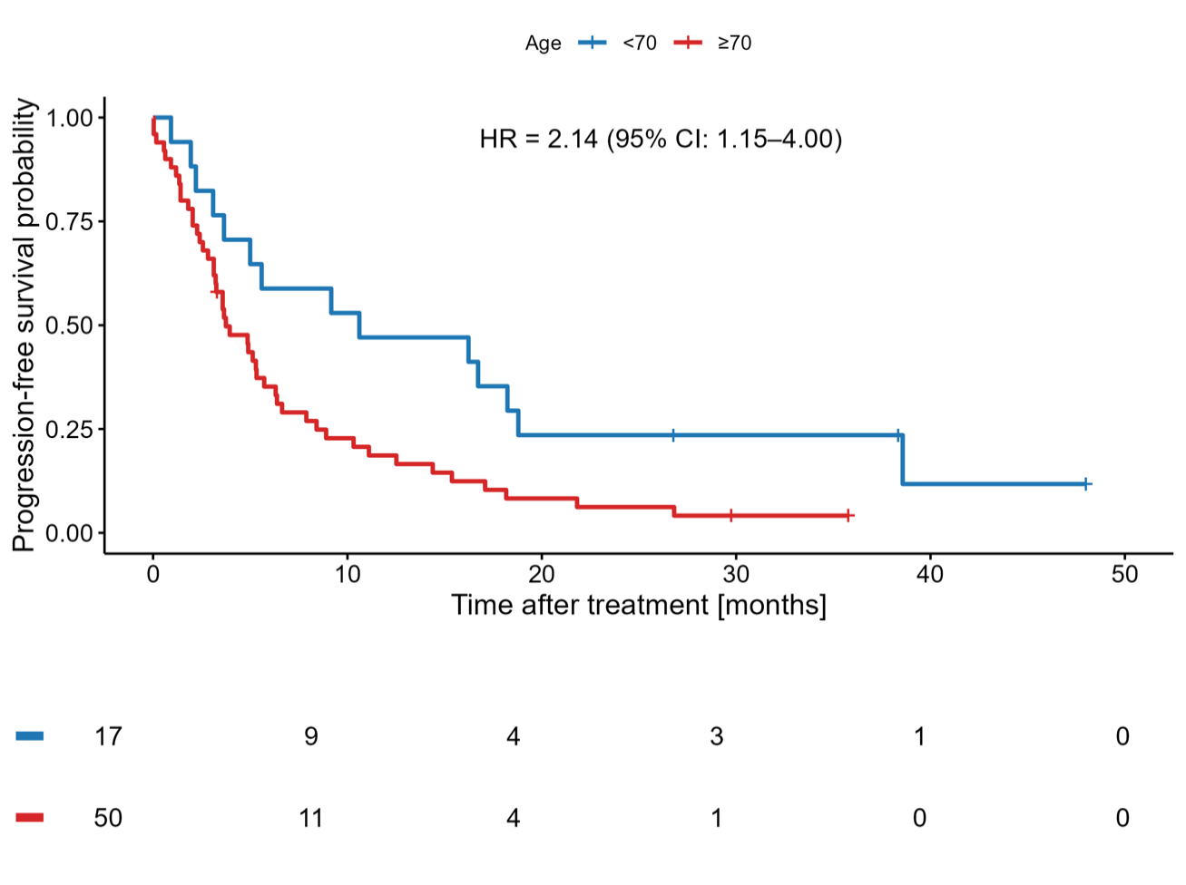

Figure S2. Kaplan–Meier curves of PFS stratified by temozolomide treatment (yes vs. no) in patients with glioblastoma.
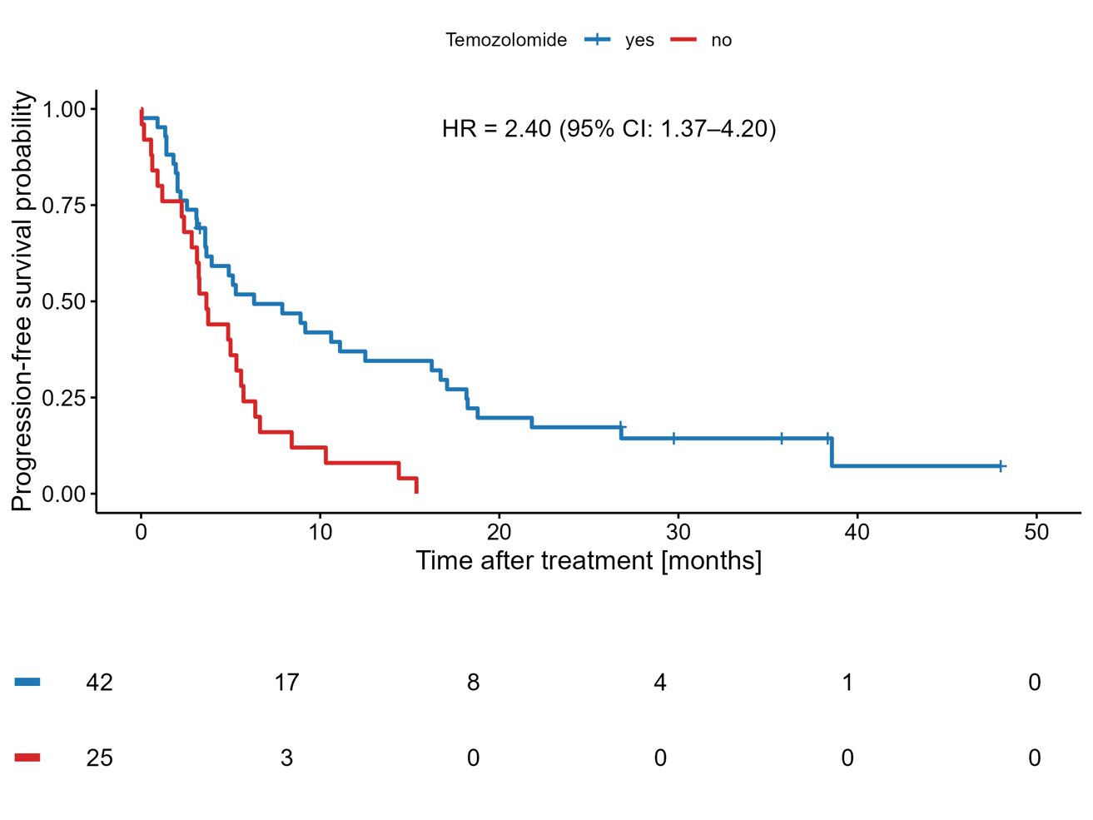

Figure S3. Kaplan–Meier curves of progression-free survival (PFS) stratified by Karnofsky Performance Status (KPS; <70% vs. ≥70%) in patients with glioblastoma.
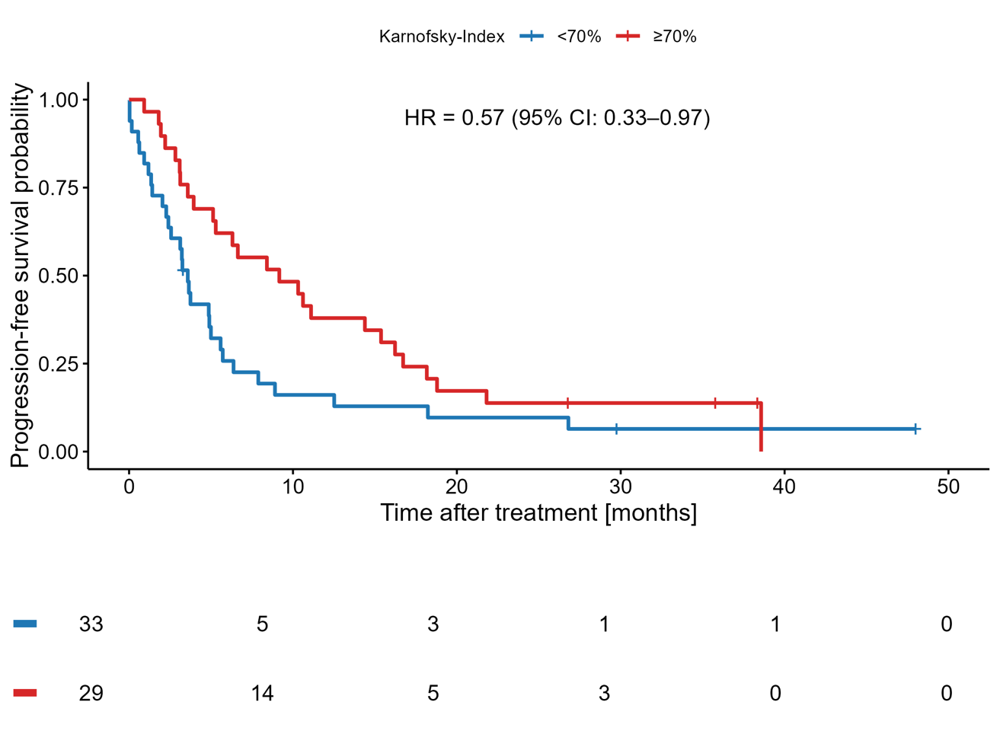

Figure S4. Kaplan–Meier curves of progression-free survival (PFS) stratified by gross tumor volume (GTV) using an optimal cut-off of 31.8 cm³ determined by log-rank testing.
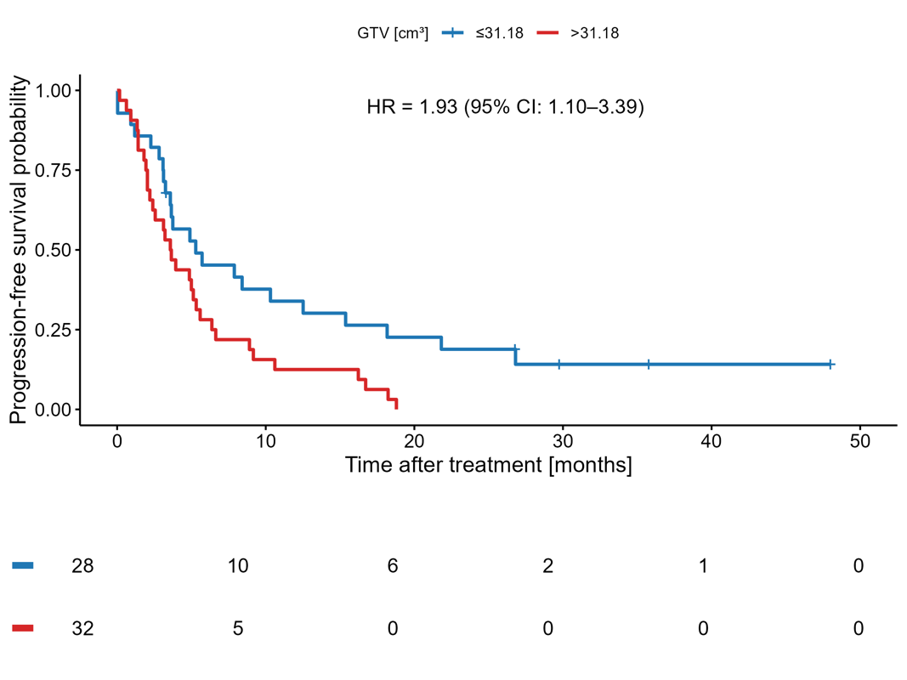
Figure S5. Schoenfeld residual plots for the main prognostic covariates included in the Cox regression models for OS and PFS.
OS:
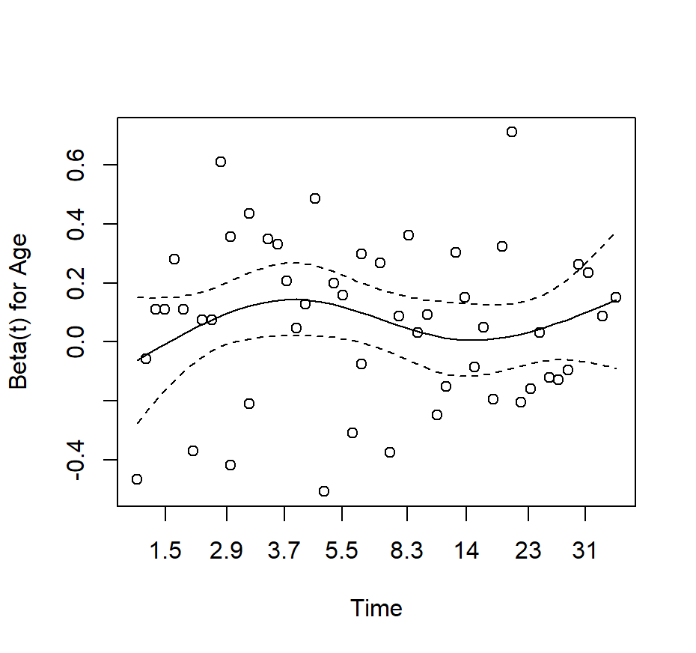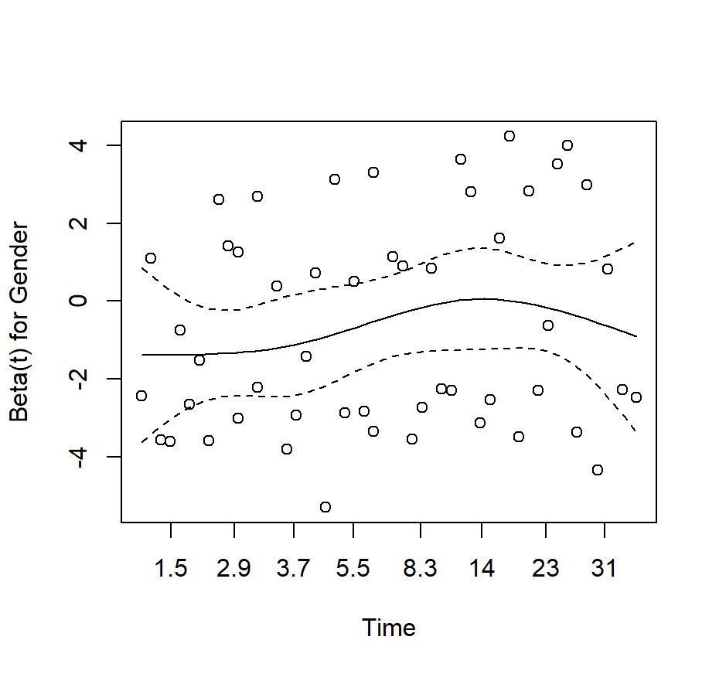
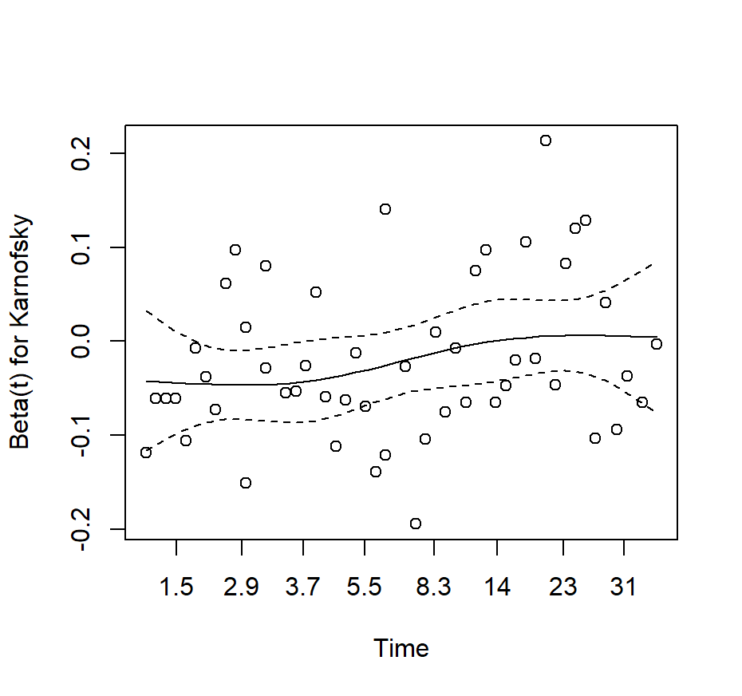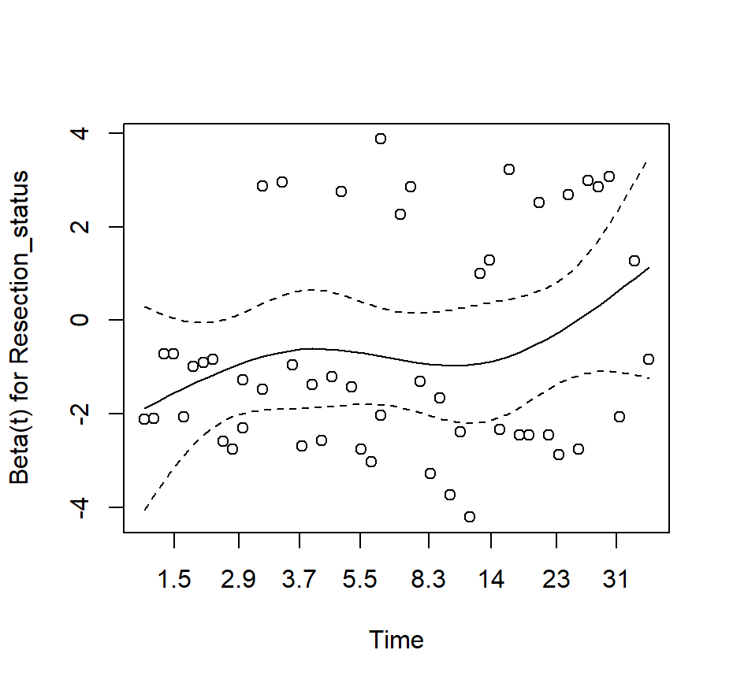
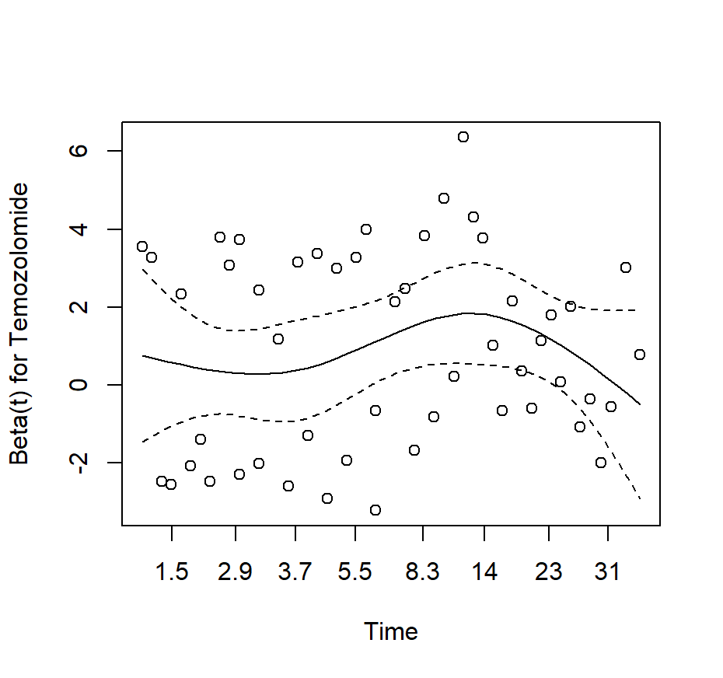
PFS:
