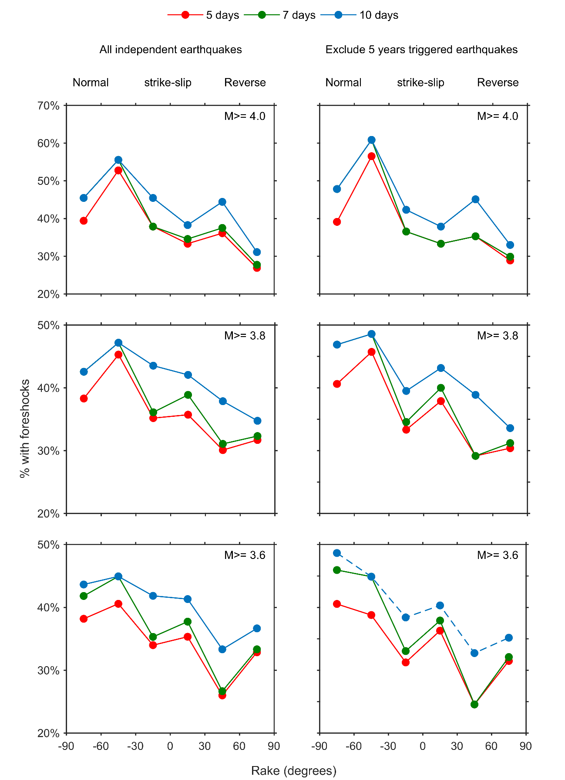
Figure S1. The foreshock occurrence rates as a function of rake for various criteria of including (left) and deleting (right) possible triggered events following the 2011 Tohoku-oki earthquake. The colored lines show different time windows used for the definition of foreshocks. The blue dash line is the criteria used in our study.

