Supplemental Table 1. PCR primers for sequencing mutation sites in various genes of the IHH signaling pathway
Primer name | Primer sequence (5’-3’) | PCR product size | Purpose
IHH-1144-F | CAGCTGTCTCTACACACGTG | 443bp | PCR-Sanger sequencing of p.H382Y variant of IHH
IHH-1144-R | GTGTTGCCCAGTCAAGTCTC | 443bp | PCR-Sanger sequencing of p.H382Y variant of IHH
SMO-1643-1798-F | GAGATCAAGAATCGCCCGAG | 842bp | PCR-Sanger sequencing of p.V600M and p.T548I variant of SMO
SMO-1643-1798-R | GAATGGGTGTGTGAGCGATG | 842bp | PCR-Sanger sequencing of p.V600M and p.T548I variant of SMO
SUFU-1027-F1 | GATCTCAACTCTGCCCACTCC | 714bp | PCR-Sanger sequencing of p.R343C variant of SUFU
SUFU-1027-R1 | GTCCCCAGGCTCCTAAACAG | 714bp | PCR-Sanger sequencing of p.R343C variant of SUFU
GLI1-1528-F2 | CCATCTCTTACCTGCTTAGCCC | 837bp | PCR-Sanger sequencing of p.R510W variant of GLI1
GLI1-1528-R2 | GTTGTGCAGGTTGTGTGCTG | 837bp | PCR-Sanger sequencing of p.R510W variant of GLI1
GLI1-1965-F | CTTATGCCTGCCCAGCACTAC | 452bp | PCR-Sanger sequencing of p.Q655H variant of GLI1
GLI1-1965-R | CCCAGAGTATCAGTAGGTGGG | 452bp | PCR-Sanger sequencing of p.Q655H variant of GLI1
GLI2-2203-F | CCTCTGAGTCTGAGCCTTCTTG | 574bp | PCR-Sanger sequencing of p.E735K variant of GLI2
GLI2-2203-R | CCTTTGGCTAATCTCACCCCTG | 574bp | PCR-Sanger sequencing of p.E735K variant of GLI2
GLI2-2345-F1 | GTATGCCCTAGCTACTCCAGAG | 442bp | PCR-Sanger sequencing of p.L782P variant of GLI2
GLI2-2345-R1 | CTGGAGAAGTAGGGGGAGATG | 442bp | PCR-Sanger sequencing of p.L782P variant of GLI2
GLI4-464-F | CTATCCGCCTCTGCCGTTTC | 615bp | PCR-Sanger sequencing of p.P155H variant of GLI4
GLI4-464-R | CCGCACTTGTAGGGCTTCTC | 615bp | PCR-Sanger sequencing of p.P155H variant of GLI4
GLI4-980-F | CCTGCGGCAAGAGTTTCAAG | 709bp | PCR-Sanger sequencing of p.D327G variant of GLI4
GLI4-980-R | CGGCTCCCACTTCCAACAATC | 709bp | PCR-Sanger sequencing of p.D327G variant of GLI4
BOC-1860-F | GGGTCTTAGCTCAAAGCCCAG | 595bp | PCR-Sanger sequencing of p.E620D variant of BOC
BOC-1860-R | GATGGCTCTGGATGCTCTTCTG | 595bp | PCR-Sanger sequencing of p.E620D variant of BOC
BOC-1439-F | CTCAGCAGGTAAACCAGGAGAC | 658bp | PCR-Sanger sequencing of p.S480L variant of BOC
BOC-1439-R | GGGACTAGAAGCCAGTGTGAG | 658bp | PCR-Sanger sequencing of p.S480L variant of BOC
GAS1-253-F | CAAGAAGTGGGCAGGACTTG | 742bp | PCR-Sanger sequencing of p.P85S variant of GAS1
GAS1-253-R | GCCAGCATGTCCTCAATGAC | 742bp | PCR-Sanger sequencing of p.P85S variant of GAS1
GAS1-865-F | CCTACTGCGGCAAAGTCTTC | 573bp | PCR-Sanger sequencing of p.G289S variant of GAS1
GAS1-865-R | CTATCTGTCCCAAGCCACAG | 573bp | PCR-Sanger sequencing of p.G289S variant of GAS1
CDON-250-F | CTCTCCTCTTTTCTCCCCTG | 465bp | PCR-Sanger sequencing of p.I84V variant of CDON
CDON-250-R | CAGCAAGAGTCAAGGCTGAG | 465bp | PCR-Sanger sequencing of p.I84V variant of CDON
CDON-3359-F | CTTCCCAGTAGCTAATGGCC | 558bp | PCR-Sanger sequencing of p.C1120Y variant of CDON
CDON-3359-R | CTGAGTAGGGACTGGTTCCAC | 558bp | PCR-Sanger sequencing of p.C1120Y variant of CDON
PTCH1-605-F | GCCATACACCTCCCATTAGC | 576bp | PCR-Sanger sequencing of p.K202R variant of PTCH1
PTCH1-605-R | CTCTCTCTGACCAGTGTGTCC | 576bp | PCR-Sanger sequencing of p.K202R variant of PTCH1
PTCH1-2893-F | GACCCAGTGTCATGAAGAGG | 471bp | PCR-Sanger sequencing of p.V965L variant of PTCH1
PTCH1-2893-R | GCTGGTCTTGAACTCCTTGACC | 471bp | PCR-Sanger sequencing of p.V965L variant of PTCH1
PTCH1-3392-F | CCACAGCCCACATTTATGGG | 519bp | PCR-Sanger sequencing of p.P1131L variant of PTCH1
PTCH1-3392-R | GTTCCGAGGGTTGTGAGAAC | 519bp | PCR-Sanger sequencing of p.P1131L variant of PTCH1
PTCH2-1126-1289-F | CGGGGTGACTATCAGACACATG | 674bp | PCR-Sanger sequencing of p.H376Y and p.V430A variant of PTCH2
PTCH2-1126-1289-R | CAGGAATACGTCATCCACGC | 674bp
PTCH2-1463-F | CTATCTGCTCATGGTGGGTC | 737bp | PCR-Sanger sequencing of p.Q488L variant of PTCH2
PTCH2-1463-R | CCGTGTCAAAGTGGAGTGAAG | 737bp | PCR-Sanger sequencing of p.Q488L variant of PTCH2

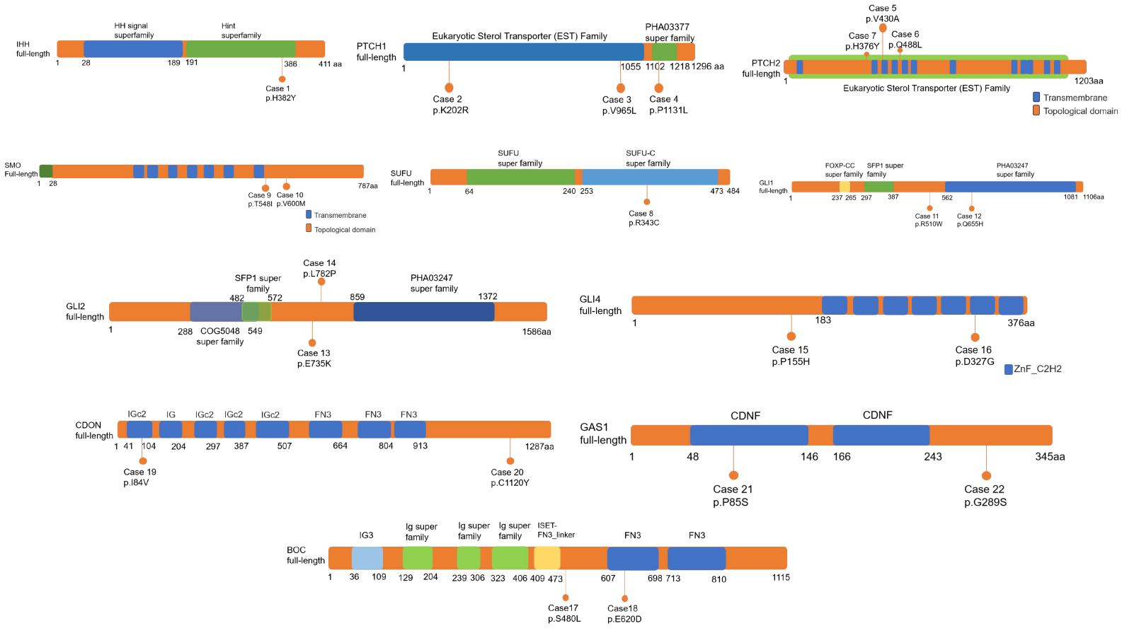
Supplemental Fig. 1

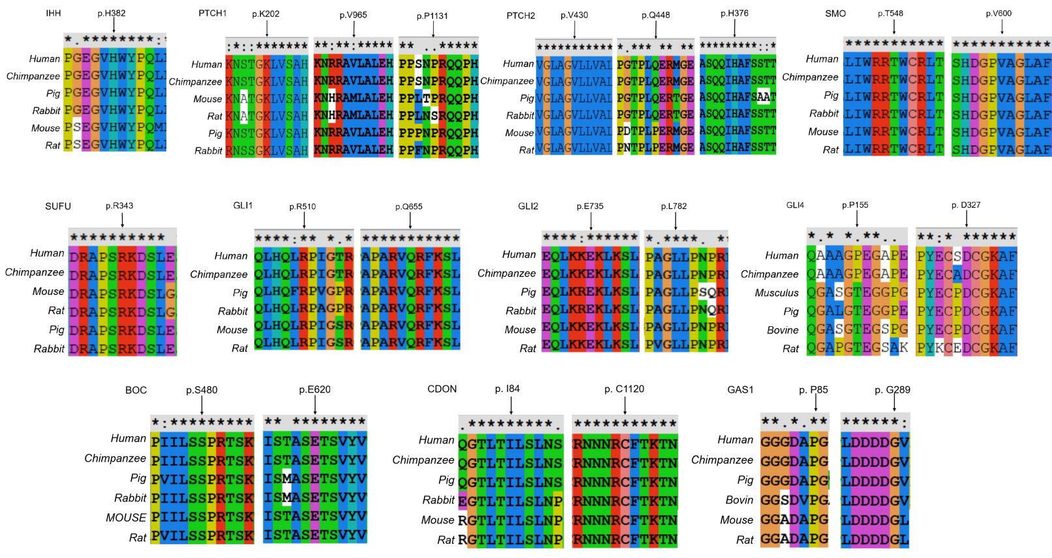
Supplemental Fig. 2

