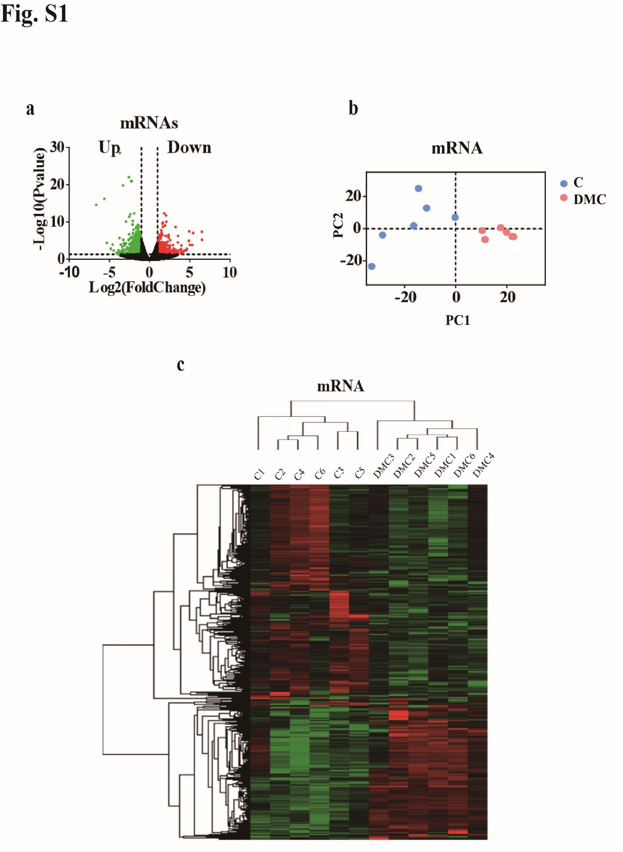
Fig. S1 Characteristics of mRNAs transcription in DMC. (a) Differentially expressed mRNAs were identified from a Volcano plot of DMC patients compared to normal controls. The vertical black lines respectively correspond to two-fold up- and down-regulations; and the horizontal black line represents a p-value of 0.05. The red and green points in the plot represent differentially expressed genes with statistical significance for up- and down- regulation, respectively. (b) Differential mRNA expression profiles are hierarchical cluster analyzed and shown as a heatmap, wherein up-regulated genes are depicted in red and down-regulated genes are depicted in green. (c) Principal component analysis also showed the mRNAs are distinguishable between DMC and healthy control.

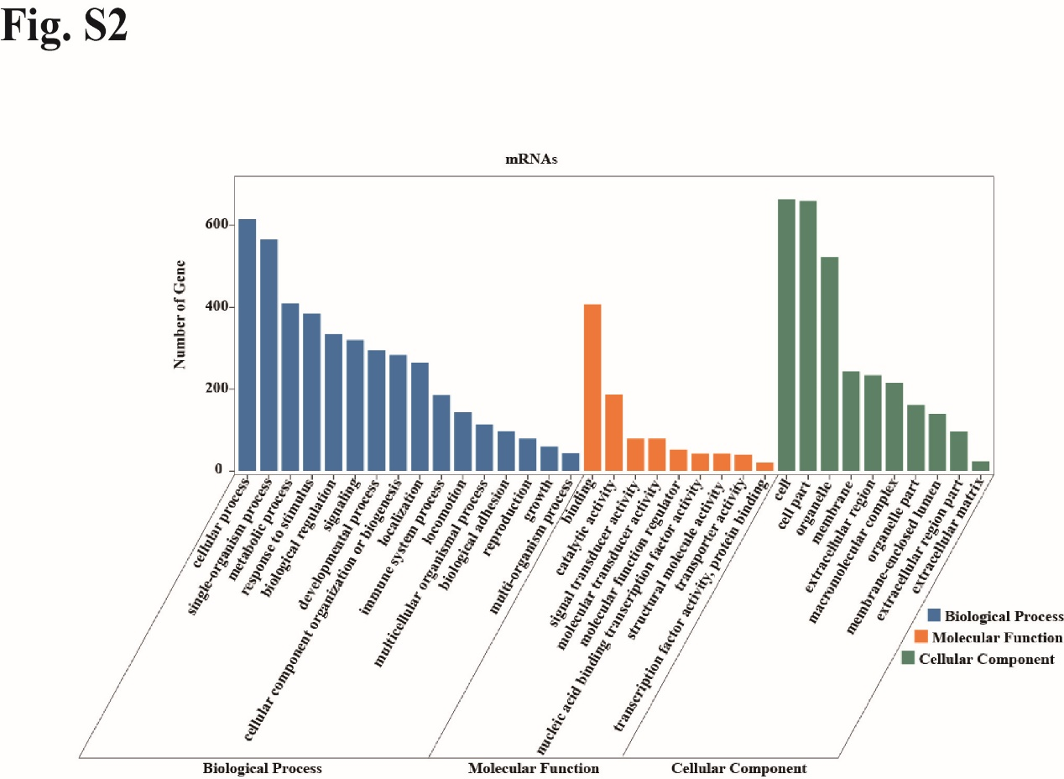
Fig. S2 Gene ontology enrichment analysis of mRNAs in DMC. GO analysis of DMC-mRNAs in biological processes, molecular functions, and cellular components.

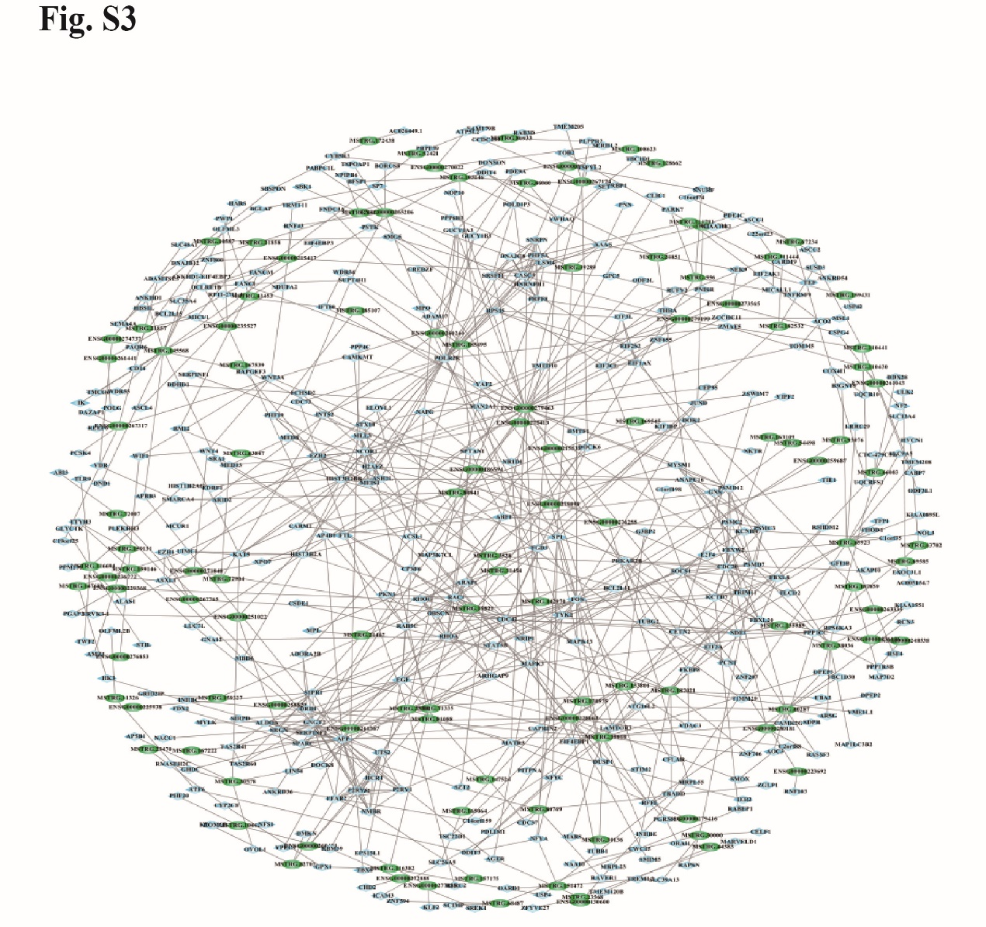
Fig. S3 Co-expression networks of lncRNA-mRNA in DMC, consisted with 117 lncRNAs and 392 mRNAs.

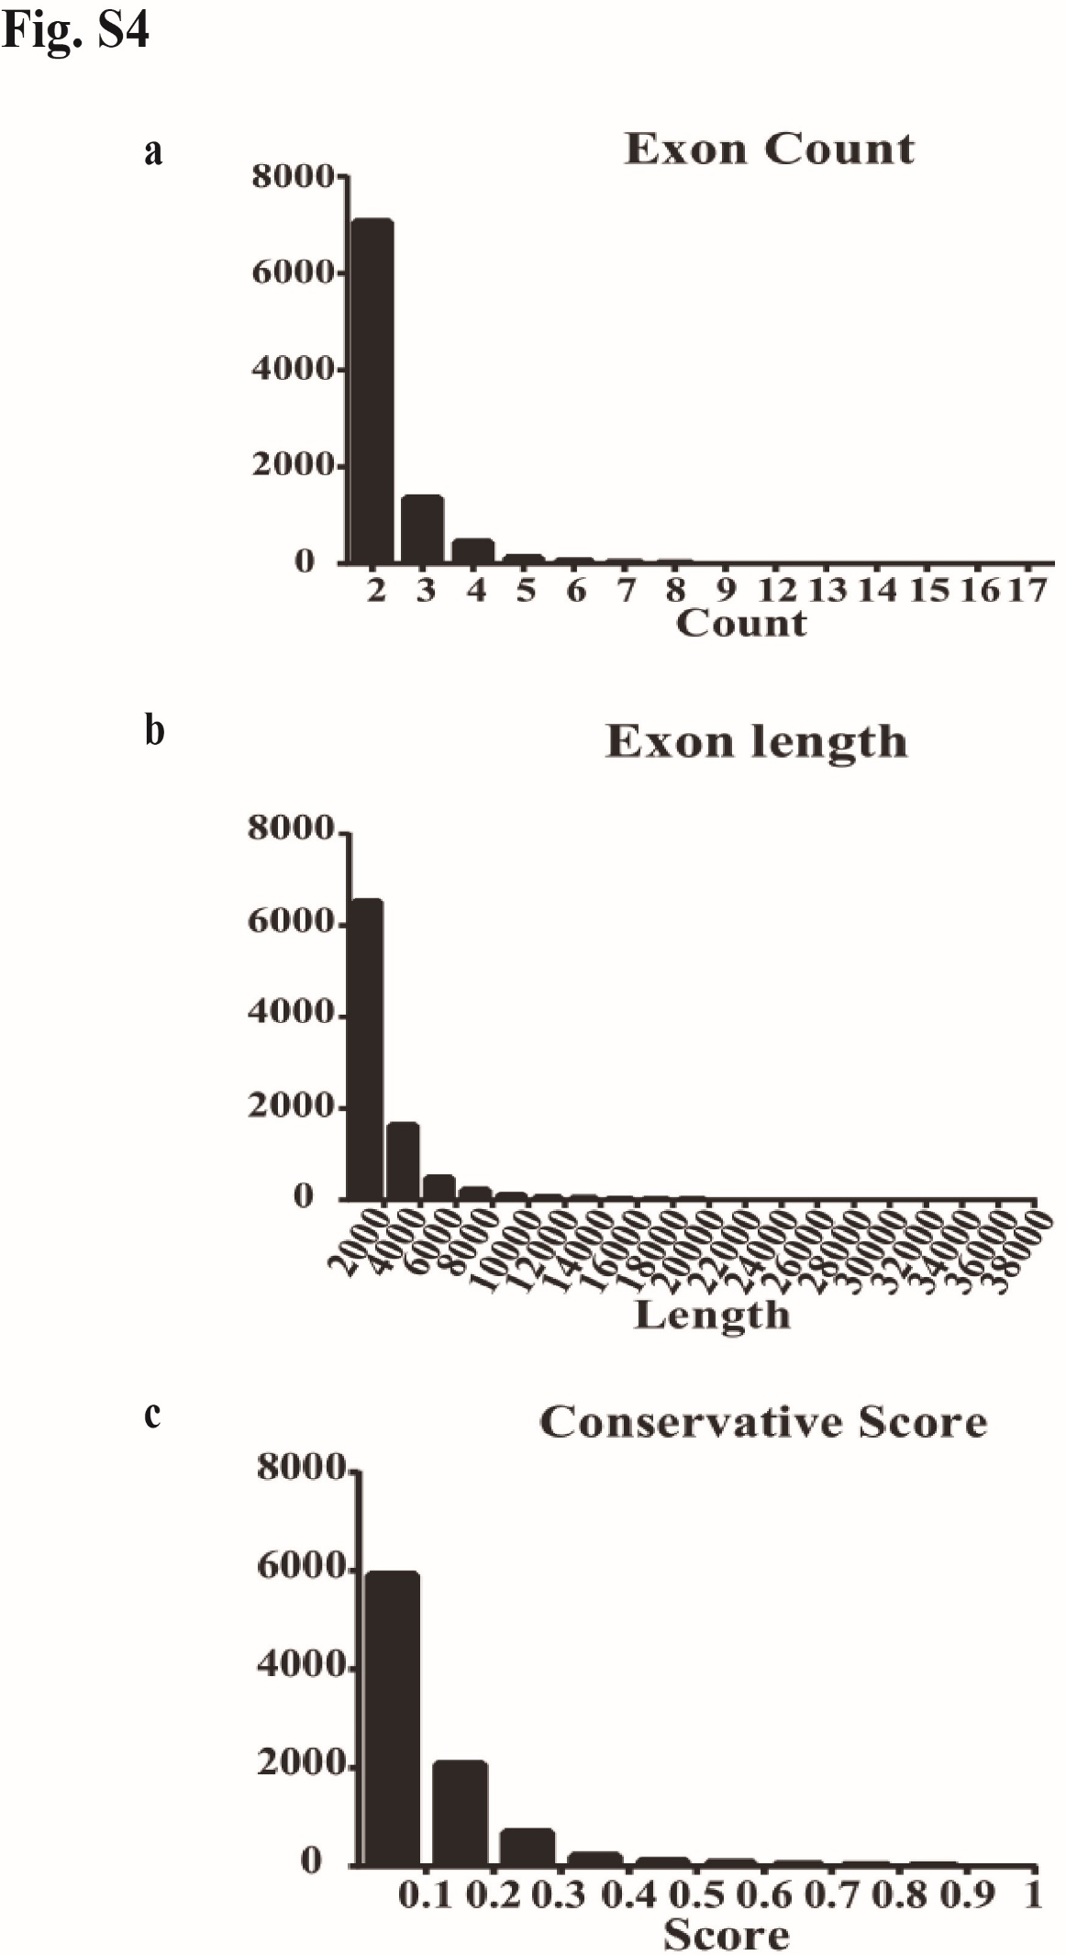
Fig. S4 Characteristics of Novel lncRNAs in DMC. (a) The transcripts of novel lncRNAs were mainly distributed in 2 and 3 exons. (b) Most amount of novel lncRNA transcripts in length are less than 2000 nt. (c) The transcripts of novel lncRNAs are distributed at the conservation score range.

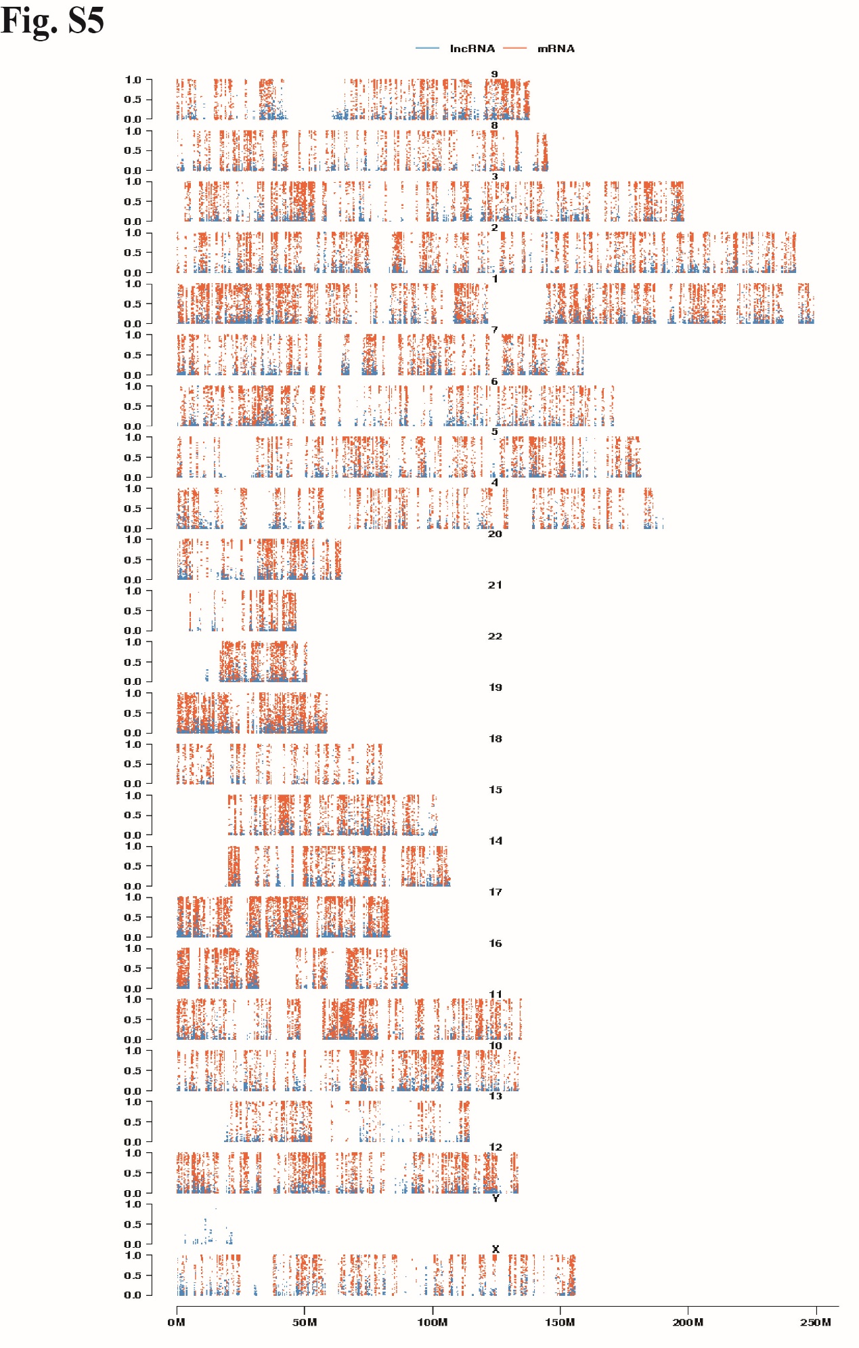
Fig. S5 The conservation score of novel lncRNAs on each chromosome.

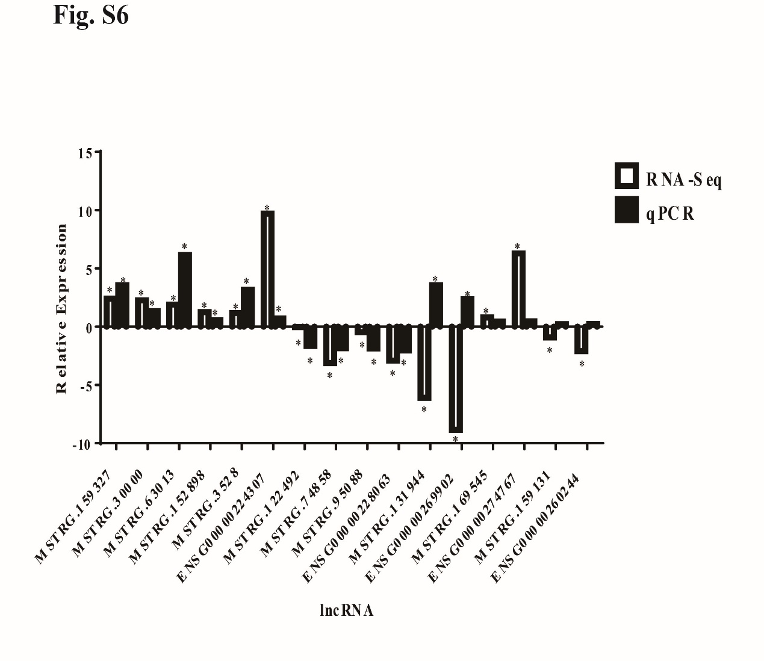
Fig. S6 Comparison of sequencing data and validation results of 16 lncRNAs. qRT-PCR was used to validate 16 lncRNAs expression levels compared to sequencing data. The white column indicates transcriptome sequencing data, and the black column indicates qRT-PCR amplification verification results. "*" indicates that the expression of lncRNA is significantly different between DMC patients and health controls.

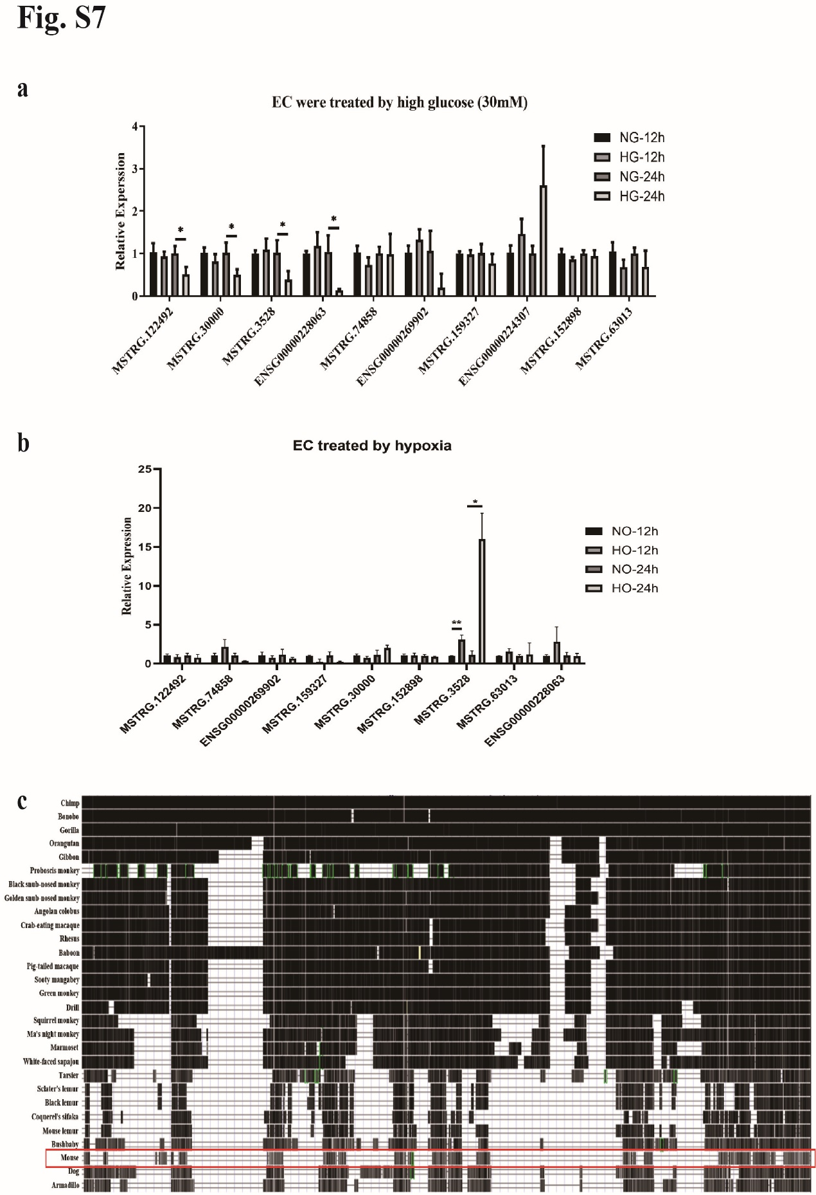
Fig. S7 LncRNA expression in HUVEC treated with high glucose or induced by hypoxia and the conservation of LYPLAL1-DT. (a) The lncRNAs expression in HUVEC after treated with 30 mM glucose for 12h and 24h. (b) The lncRNAs expression in HUVEC after induced by hypoxia for 12h and 24h. (c) The conservation of LYPLAL1-DT in a verity of species according to UCSC Genome Browser.

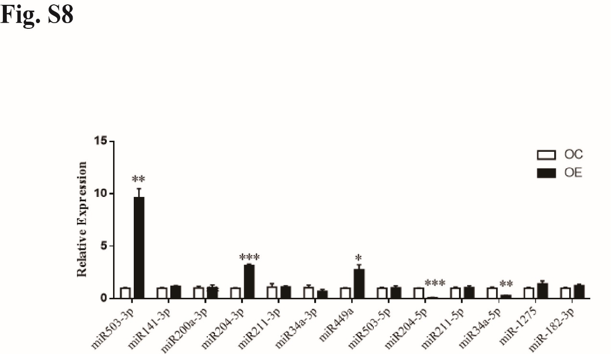
Fig. S8 Predicted miRNAs were quantified in LYPLAL1-DT-OC/OE via qRT-PCR. 13 miRNAs that have potential binding sites with LYPLAL1-DT were predicted by TargetScan and miRcode. “*” indicated significant difference with p<0.05, “**” indicated p<0.01 and “***” indicated p<0.001.

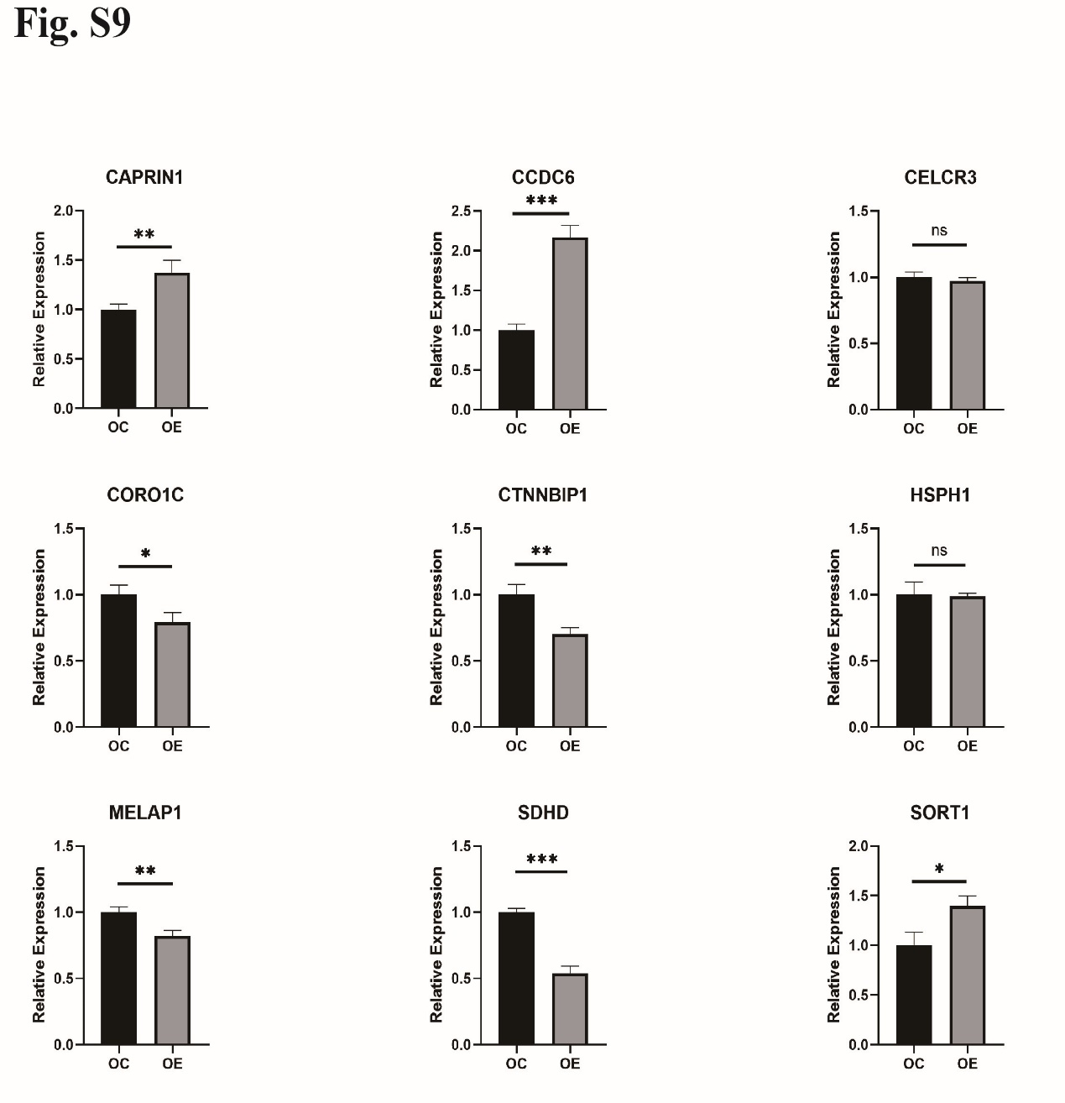
Fig. S9 Predicted target genes were quantified in LYPLAL1-DT-OC/OE via qRT-PCR. The target mRNAs that have potential binding sites with miR-204-5p were predicted by STARBASE. 9 of 37 predicted genes were quantified in LYPLAL1-DT-OC/OE via qRT-PCR.

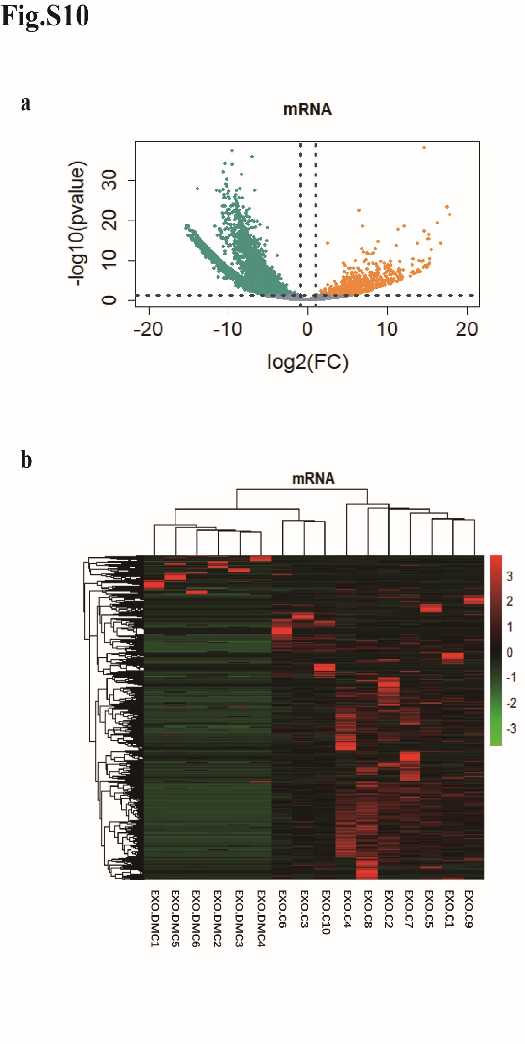
Fig. S10 Differentially expressed mRNAs from exosomes extracted from DMC patients’ serum. DE-mRNAs were identified from a Volcano plot (a) and hierarchical cluster analyzed, shown as a heatmap (b).

